1. Write a query to have the following Output

|  |  |  |  |  |  |  |
| --- | --- | --- | --- | --- | --- | --- |
| Inv No. | Inv. Date | Cust Id | Cust Name | Gross Sales | Disc. Amt | Net Amount |
| 2324-001 | 01-jan-24 | C1001 | Zeal Electronics | 5735.25 | 733.02 | 5002.23 |
| 2324-002 |  |  |  |  |  |  |
| 2324-003 |  |  |  |  |  |  |
| 2324-004 |  |  |  |  |  |  |
| 2324-005 |  |  |  |  |  |  |
| 2324-006 |  |  |  |  |  |  |
| 2324-007 |  |  |  |  |  |  |

**QUERY**

SELECT sil_inv_no, sih_inv_date,

sih_cust_id, cust_name,

SUM(Round(sil_inv_qty*sil_unit_price)) "Gross Salary",

SUM(Round ((sil_inv_qty*sil_unit_price/100)*sil_disc_pct)) "Discount",

SUM(Round((sil_inv_qty*sil_unit_price) - ((sil_inv_qty*sil_unit_price/100)*sil_disc_pct))) "Net_Amount"

FROM sales_inv_ln_srini,

sales_inv_hdr_srini,

cust_master_srini

WHERE sil_inv_no=sih_inv_no and

sih_cust_id=cust_id

GROUP BY sil_inv_no,sih_inv_date,

sih_cust_id,cust_name;

**OUTPUT**

1. Write a query to have the following Output

|  |  |  |  |  |
| --- | --- | --- | --- | --- |
| Cust Id | Cust Name | Gross Sales | Disc. Amt | Net Amount |
| C1001 | Zeal Electronics | XXXX | XXXX | XXXX |
|  |  |  |  |  |
|  |  |  |  |  |

**QUERY**

SELECT sih_cust_id,cust_name,

SUM(Round(sil_inv_qty*sil_unit_price))"Gross Salary",

SUM(Round((sil_inv_qty*sil_unit_price/100)*sil_disc_pct)) " Discount",

SUM(Round((sil_inv_qty*sil_unit_price) - ((sil_inv_qty*sil_unit_price/100)*

sil_disc_pct))) "Net_amount"

FROM sales_inv_ln_srini,

sales_inv_hdr_srini,

cust_master_srini

WHERE sil_inv_no=sih_inv_no and

sih_cust_id=cust_id

GROUP BY sih_cust_id,cust_name;

**OUTPUT**

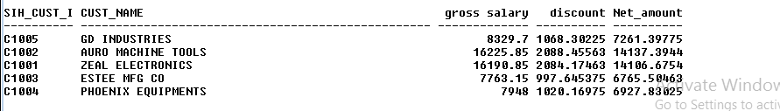

1. Write a query to have the following Output

|  |  |  |  |
| --- | --- | --- | --- |
| Cust Group | Gross Sales | Disc. Amt | Net Amount |
| Group 1 | XXXX | XXXX | XXXX |
| Group 2 | XXXX | XXXX | XXXX |
| Group 3 | XXXX | XXXX | XXXX |

**QUERY**

SELECT cust_group,

SUM(Round(sil_inv_qty*sil_unit_price))"Gross Salary",

SUM(Round((sil_inv_qty*sil_unit_price/100)*sil_disc_pct)) “Discount”,

SUM(Round((sil_inv_qty*sil_unit_price)-((sil_inv_qty*sil_unit_price/100)*

sil_disc_pct))) “Net_amount”

FROM sales_inv_ln_srini,

sales_inv_hdr_srini,

cust_master_srini

WHERE sil_inv_no = sih_inv_no and

sih_cust_id = cust_id

GROUP BY cust_group;

**OUTPUT**

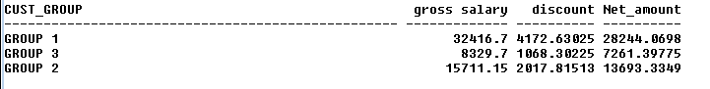

1. Write a query to have the following Output

|  |  |  |  |
| --- | --- | --- | --- |
| CITY NAME | Gross Sales | Disc. Amt | Net Amount |
| CHENNAI | XXXX | XXXX | XXXX |
| PUDUCHERRY | XXXX | XXXX | XXXX |
| BANGALORE | XXXX | XXXX | XXXX |
| CALICUT | XXXX | XXXX | XXXX |

**QUERY**

SELECT city_name,

SUM(Round(sil_inv_qty*sil_unit_price)) "Gross Salary",

SUM(Round((sil_inv_qty*sil_unit_price/100)*sil_disc_pct)) "Discount",

SUM(Round((sil_inv_qty*sil_unit_price)-((sil_inv_qty*sil_unit_price/100)*

sil_disc_pct))) "Net_amount"

FROM sales_inv_ln_srini,

sales_inv_hdr_srini,

cust_master_srini

WHERE sil_inv_no=sih_inv_no and

sih_cust_id=cust_id

GROUP BY city_name;

**OUTPUT**

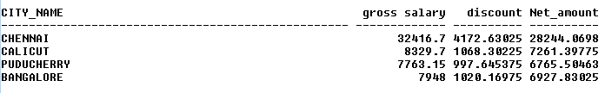

1. Write a query to have the following Output

|  |  |  |  |
| --- | --- | --- | --- |
| STATE | Gross Sales | Disc. Amt | Net Amount |
| TAMILNADU | XXXX | XXXX | XXXX |
| PUDUCHERRY | XXXX | XXXX | XXXX |
| KARNATAKA | XXXX | XXXX | XXXX |
| KERALA | XXXX | XXXX | XXXX |

**QUERY**

SELECT state_name,

SUM(Round(sil_inv_qty*sil_unit_price))"Gross Salary",

SUM(Round((sil_inv_qty*sil_unit_price/100)*sil_disc_pct))"Discount",

SUM(Round((sil_inv_qty*sil_unit_price) - ((sil_inv_qty*sil_unit_price/100)*

sil_disc_pct)))"Net_amount"

FROM sales_inv_ln_srini,

sales_inv_hdr_srini,

cust_master_srini

WHERE sil_inv_no = sih_inv_no and

sih_cust_id = cust_id

GROUP BY state_name;

**OUTPUT**

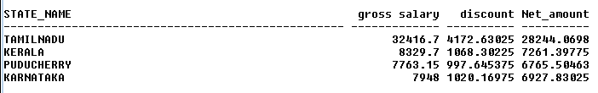

1. Write a query to have the following Output

|  |  |  |  |  |  |
| --- | --- | --- | --- | --- | --- |
| Cust Id | Cust Name | Month | Gross Sales | Disc. Amt | Net Amount |
| C1001 | Zeal Electronics | Jan-24 | XXXX | XXXX | XXXX |
| C1001 | Zeal Electronics | Feb-24 | XXXX | XXXX | XXXX |
|  |  |  |  |  |  |

**QUERY**

SELECT sih_cust_id,cust_name,TO_CHAR(b.sih_inv_date,'mon-yy')“Month”,

SUM(Round(sil_inv_qty*sil_unit_price))“Gross_Salary",

SUM(Round((sil_inv_qty*sil_unit_price/100)*sil_disc_pct))”Discount”

SUM(Round((sil_inv_qty*sil_unit_price)- ((sil_inv_qty*sil_unit_price/100)*sil_disc_pct))) "netamount"

FROM sales_inv_ln_srini,

sales_inv_hdr_srini,

cust_master_srini

WHERE sil_inv_no=sih_inv_no and

sih_cust_id=cust_id

GROUP BY sih_cust_id,cust_name,sih_inv_date;

**OUTPUT**

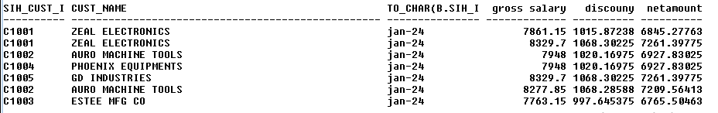

1. Write a query to have the following Output

|  |  |  |  |  |
| --- | --- | --- | --- | --- |
| Cust Group | Month | Gross Sales | Disc. Amt | Net Amount |
| Group 1 | Jan-24 | XXXX | XXXX | XXXX |
| Group 1 | Feb-24 | XXXX | XXXX | XXXX |
| Group 2 | Jan-24 | XXXX | XXXX | XXXX |

**QUERY**

SELECT cust_group,to_char(Sih_inv_date,'mon-yy'),

SUM (Round(sil_inv_qty*sil_unit_price))“Gross_Salary",

SUM (Round((sil_inv_qty*sil_unit_price/100)*sil_disc_pct))"Discount",

SUM (Round((sil_inv_qty*sil_unit_price)-((sil_inv_qty*sil_unit_price/100)*

sil_disc_pct)))"Net_amount"

FROM sales_inv_ln_srini,

sales_inv_hdr_srini,

cust_master_srini

WHERE sil_inv_no=sih_inv_no and

sih_cust_id=cust_id

GROUP BY cust_group,to_char(Sih_inv_date,'mon-yy');

**OUTPUT**

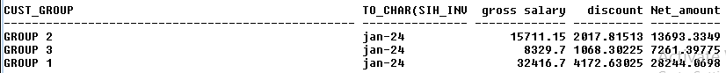

1. Write a query to have the following Output

|  |  |  |  |  |
| --- | --- | --- | --- | --- |
| CITY NAME | Month | Gross Sales | Disc. Amt | Net Amount |
| CHENNAI | Jan-24 | XXXX | XXXX | XXXX |
| CHENNAI | Feb-24 | XXXX | XXXX | XXXX |
| PUDUCHERRY |  | XXXX | XXXX | XXXX |
| BANGALORE |  | XXXX | XXXX | XXXX |
| CALICUT |  | XXXX | XXXX | XXXX |

**QUERY**

SELECT city_name,to_char(Sih_inv_date,'mon-yy')”Month”,

SUM(Round(sil_inv_qty*sil_unit_price))"Gross salary",

SUM(Round((sil_inv_qty*sil_unit_price/100)*sil_disc_pct))"Discount",

SUM(Round(( a.sil_inv_qty* a.sil_unit_price)-((sil_inv_qty*sil_unit_price/100)*

a.sil_disc_pct)))"Net_amount"

FROM sales_inv_ln_srini,

sales_inv_hdr_srini,

cust_master_srini

WHERE sil_inv_no=sih_inv_no and

sih_cust_id=cust_id

GROUP BY city_name,Sih_inv_date;

**OUTPUT**

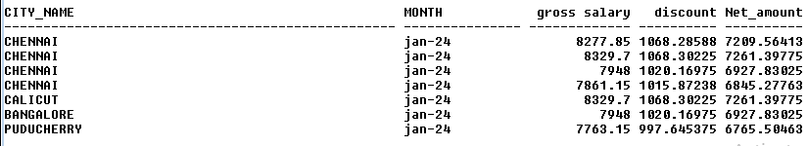

1. Write a query to have the following Output

|  |  |  |  |  |
| --- | --- | --- | --- | --- |
| STATE | Month | Gross Sales | Disc. Amt | Net Amount |
| TAMILNADU | Jan-24 | XXXX | XXXX | XXXX |
| TAMILNADU | Feb-24 | XXXX | XXXX | XXXX |
| PUDUCHERRY |  | XXXX | XXXX | XXXX |
| KARNATAKA |  | XXXX | XXXX | XXXX |
| KERALA |  | XXXX | XXXX | XXXX |

**QUERY**

SELECT state_name,to_char(Sih_inv_date,'mon-yy') as Month,

SUM(Round(sil_inv_qty*sil_unit_price))"Gross salary",

SUM(Round((sil_inv_qty*sil_unit_price/100)*sil_disc_pct))"Discount",

SUM(Round(( a.sil_inv_qty*sil_unit_price)-((sil_inv_qty*sil_unit_price/100)*

sil_disc_pct)))"Net_amount"

FROM sales_inv_ln_srini,

sales_inv_hdr_srini,

cust_master_srini

WHERE sil_inv_no=sih_inv_no and

sih_cust_id=cust_id

GROUP BY state_name,Sih_inv_date;

**OUTPUT**

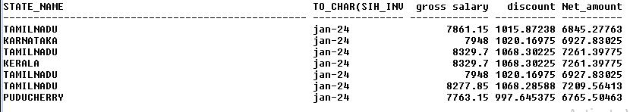

1. Write a query to have the following Output

|  |  |  |  |  |
| --- | --- | --- | --- | --- |
| Month | No. of Invoices | Gross Sales | Disc. Amt | Net Amount |
| Jan-24 | 5 | XXXX | XXXX | XXXX |
| Feb-24 | 5 | XXXX | XXXX | XXXX |
| Mar-24 |  | XXXX | XXXX | XXXX |

**QUERY**

SELECT to_char(b.sih_inv_date,'mon-yy')”Month”,COUNT(b.sih_inv_no)”Count”,

SUM(Round(sil_inv_qty*sil_unit_price))"Gross salary",

SUM(Round((sil_inv_qty*sil_unit_price/100)*sil_disc_pct))"Discount",

SUM(Round(( a.sil_inv_qty*sil_unit_price)-((sil_inv_qty*sil_unit_price/100)*

sil_disc_pct)))"Net_amount"

FROM cust_master_srini,

sales_inv_hdr_srini,

sales_inv_ln_srini

WHERE cust_id=sih_cust_id and

sih_inv_no=sil_inv_no

GROUP BY to_char(sih_inv_date,'mon-yy');

**OUTPUT**

