1. Write a query to have the following Output

|  |  |  |  |  |  |  |
| --- | --- | --- | --- | --- | --- | --- |
| Inv No. | Inv. Date | Cust Id | Cust Name | Gross Sales | Disc. Amt | Net Amount |
| 2324-001 | 01-jan-24 | C1001 | Zeal Electronics | 5735.25 | 733.02 | 5002.23 |
| 2324-002 |  |  |  |  |  |  |
| 2324-003 |  |  |  |  |  |  |
| 2324-004 |  |  |  |  |  |  |
| 2324-005 |  |  |  |  |  |  |
| 2324-006 |  |  |  |  |  |  |
| 2324-007 |  |  |  |  |  |  |

**QUERY**

SELECT a.sil_inv_no, b.sih_inv_date,

b.sih_cust_id, c.cust_name,

SUM((a. sil_inv_qty*a. sil_unit_price)) " gross salary",

SUM((( a.sil_inv_qty* a.sil_unit_price/100)* a.sil_disc_pct)) " discount",

SUM((( a.sil_inv_qty* a.sil_unit_price) - ((a.sil_inv_qty* a.sil_unit_price/100)*

a.sil_disc_pct))) "Net_amount" FROM

SALES_INV_LN_SRINI a , SALES_INV_HDR_SRINI b,CUST_MASTER_SRINI c

WHERE a. sil_inv_no=b. sih_inv_no and

b. sih_cust_id=c. cust_id

GROUP BY a.sil_inv_no, b.sih_inv_date,

b.sih_cust_id, c.cust_name ;

**OUTPUT**

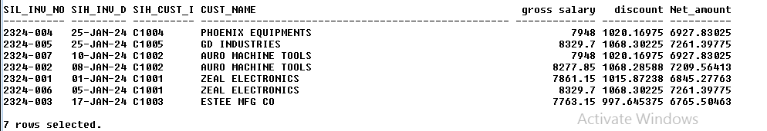

1. Write a query to have the following Output

|  |  |  |  |  |
| --- | --- | --- | --- | --- |
| Cust Id | Cust Name | Gross Sales | Disc. Amt | Net Amount |
| C1001 | Zeal Electronics | XXXX | XXXX | XXXX |
|  |  |  |  |  |
|  |  |  |  |  |

**QUERY**

SELECT b.sih_cust_id, c.cust_name,

SUM((a. sil_inv_qty*a. sil_unit_price)) " gross salary",

SUM((( a.sil_inv_qty* a.sil_unit_price/100)* a.sil_disc_pct)) " discount",

SUM((( a.sil_inv_qty* a.sil_unit_price)- ((a.sil_inv_qty* a.sil_unit_price/100)*

a.sil_disc_pct))) "Net_amount" FROM

SALES_INV_LN_SRINI a , SALES_INV_HDR_SRINI b,CUST_MASTER_SRINI c

WHERE a. sil_inv_no=b. sih_inv_no and

b. sih_cust_id=c. cust_id

GROUP BY b.sih_cust_id, c.cust_name ;

**OUTPUT**

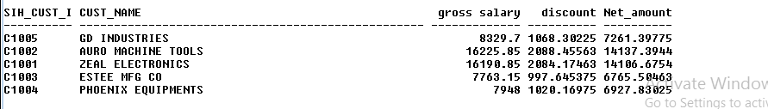

1. Write a query to have the following Output

|  |  |  |  |
| --- | --- | --- | --- |
| Cust Group | Gross Sales | Disc. Amt | Net Amount |
| Group 1 | XXXX | XXXX | XXXX |
| Group 2 | XXXX | XXXX | XXXX |
| Group 3 | XXXX | XXXX | XXXX |

**QUERY**

SELECT c.cust_group,

SUM((a. sil_inv_qty * a. sil_unit_price)) " gross salary",

SUM((( a.sil_inv_qty * a.sil_unit_price/100)* a.sil_disc_pct)) " discount",

SUM((( a.sil_inv_qty * a.sil_unit_price)- ((a.sil_inv_qty* a.sil_unit_price/100)*

a.sil_disc_pct))) "Net_amount" FROM

SALES_INV_LN_SRINI a , SALES_INV_HDR_SRINI b,CUST_MASTER_SRINI c

WHERE a. sil_inv_no=b. sih_inv_no and

b. sih_cust_id=c. cust_id

GROUP BY c.cust_group;

**OUTPUT**

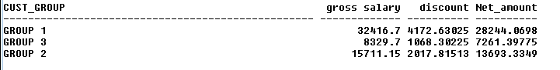

1. Write a query to have the following Output

|  |  |  |  |
| --- | --- | --- | --- |
| CITY NAME | Gross Sales | Disc. Amt | Net Amount |
| CHENNAI | XXXX | XXXX | XXXX |
| PUDUCHERRY | XXXX | XXXX | XXXX |
| BANGALORE | XXXX | XXXX | XXXX |
| CALICUT | XXXX | XXXX | XXXX |

**QUERY**

SELECT c.city_name,

SUM((a. sil_inv_qty*a. sil_unit_price)) " gross salary",

SUM((( a.sil_inv_qty* a.sil_unit_price/100)* a.sil_disc_pct)) " discount",

SUM((( a.sil_inv_qty* a.sil_unit_price)- ((a.sil_inv_qty* a.sil_unit_price/100)*

a.sil_disc_pct))) "Net_amount" FROM

SALES_INV_LN_SRINI a , SALES_INV_HDR_SRINI b,CUST_MASTER_SRINI c

WHERE a. sil_inv_no=b. sih_inv_no and

b. sih_cust_id=c. cust_id

GROUP BY c.city_name;

**OUTPUT**

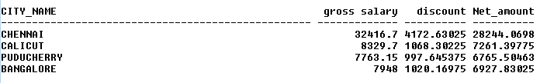

1. Write a query to have the following Output

|  |  |  |  |
| --- | --- | --- | --- |
| STATE | Gross Sales | Disc. Amt | Net Amount |
| TAMILNADU | XXXX | XXXX | XXXX |
| PUDUCHERRY | XXXX | XXXX | XXXX |
| KARNATAKA | XXXX | XXXX | XXXX |
| KERALA | XXXX | XXXX | XXXX |

**QUERY**

SELECT c.state_name,

SUM((a. sil_inv_qty*a. sil_unit_price)) " gross salary",

SUM((( a.sil_inv_qty* a.sil_unit_price/100)* a.sil_disc_pct)) " discount",

SUM((( a.sil_inv_qty* a.sil_unit_price)- ((a.sil_inv_qty* a.sil_unit_price/100)*

a.sil_disc_pct))) "Net_amount" FROM

SALES_INV_LN_SRINI a , SALES_INV_HDR_SRINI b,CUST_MASTER_SRINI c

WHERE a. sil_inv_no=b. sih_inv_no and

b. sih_cust_id=c. cust_id

GROUP BY c.state_name;

**OUTPUT**

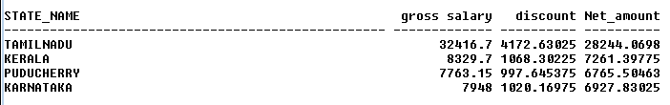

1. Write a query to have the following Output

|  |  |  |  |  |  |
| --- | --- | --- | --- | --- | --- |
| Cust Id | Cust Name | Month | Gross Sales | Disc. Amt | Net Amount |
| C1001 | Zeal Electronics | Jan-24 | XXXX | XXXX | XXXX |
| C1001 | Zeal Electronics | Feb-24 | XXXX | XXXX | XXXX |
|  |  |  |  |  |  |

**QUERY**

SELECT

b.sih_cust_id, c.cust_name,TO_CHAR(b. sih_inv_date,'mon-yy'),

SUM((a. sil_inv_qty*a. sil_unit_price)) " gross salary",

SUM((( a.sil_inv_qty* a.sil_unit_price/100)* a.sil_disc_pct)) " discouny",

SUM((( a.sil_inv_qty* a.sil_unit_price)- ((a.sil_inv_qty* a.sil_unit_price/100)*

a.sil_disc_pct))) "netamount" FROM

SALES_INV_LN_SRINI a , SALES_INV_HDR_SRINI b,CUST_MASTER_SRINI c

WHERE a. sil_inv_no=b. sih_inv_no and

b. sih_cust_id=c. cust_id

GROUP BY b.sih_cust_id, c.cust_name,B.SIH_INV_DATE ;

**OUTPUT**

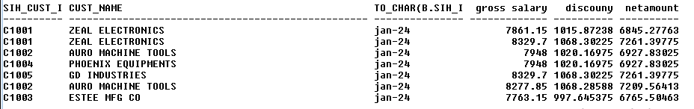

1. Write a query to have the following Output

|  |  |  |  |  |
| --- | --- | --- | --- | --- |
| Cust Group | Month | Gross Sales | Disc. Amt | Net Amount |
| Group 1 | Jan-24 | XXXX | XXXX | XXXX |
| Group 1 | Feb-24 | XXXX | XXXX | XXXX |
| Group 2 | Jan-24 | XXXX | XXXX | XXXX |

**QUERY**

SELECT c.cust_group,to_char(Sih_inv_date,'mon-yy'),

SUM((a. sil_inv_qty*a. sil_unit_price)) " gross salary",

SUM((( a.sil_inv_qty* a.sil_unit_price/100)* a.sil_disc_pct)) " discount",

SUM((( a.sil_inv_qty* a.sil_unit_price)- ((a.sil_inv_qty* a.sil_unit_price/100)*

a.sil_disc_pct))) "Net_amount" FROM

SALES_INV_LN_SRINI a ,SALES_INV_HDR_SRINI b,CUST_MASTER_SRINI c

WHERE a. sil_inv_no=b. sih_inv_no and

b. sih_cust_id=c. cust_id

GROUP BY c.cust_group,to_char(Sih_inv_date,'mon-yy');

**OUTPUT**

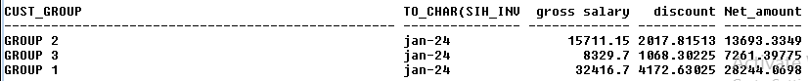

1. Write a query to have the following Output

|  |  |  |  |  |
| --- | --- | --- | --- | --- |
| CITY NAME | Month | Gross Sales | Disc. Amt | Net Amount |
| CHENNAI | Jan-24 | XXXX | XXXX | XXXX |
| CHENNAI | Feb-24 | XXXX | XXXX | XXXX |
| PUDUCHERRY |  | XXXX | XXXX | XXXX |
| BANGALORE |  | XXXX | XXXX | XXXX |
| CALICUT |  | XXXX | XXXX | XXXX |

**QUERY**

SELECT c.city_name,to_char(Sih_inv_date,'mon-yy') AS Month ,

SUM((a. sil_inv_qty*a. sil_unit_price)) " gross salary",

SUM((( a.sil_inv_qty* a.sil_unit_price/100)* a.sil_disc_pct)) " discount",

SUM((( a.sil_inv_qty* a.sil_unit_price)- ((a.sil_inv_qty* a.sil_unit_price/100)*

a.sil_disc_pct))) "Net_amount" FROM

SALES_INV_LN_SRINI a , SALES_INV_HDR_SRINI b,CUST_MASTER_SRINI c

WHERE a. sil_inv_no=b. sih_inv_no and

b. sih_cust_id=c. cust_id

GROUP BY c.city_name,b.Sih_inv_date;

**OUTPUT**

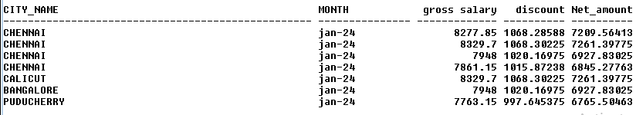

1. Write a query to have the following Output

|  |  |  |  |  |
| --- | --- | --- | --- | --- |
| STATE | Month | Gross Sales | Disc. Amt | Net Amount |
| TAMILNADU | Jan-24 | XXXX | XXXX | XXXX |
| TAMILNADU | Feb-24 | XXXX | XXXX | XXXX |
| PUDUCHERRY |  | XXXX | XXXX | XXXX |
| KARNATAKA |  | XXXX | XXXX | XXXX |
| KERALA |  | XXXX | XXXX | XXXX |

**QUERY**

SELECT c.state_name,to_char(Sih_inv_date,'mon-yy'),

SUM((a. sil_inv_qty*a. sil_unit_price)) " gross salary",

SUM((( a.sil_inv_qty* a.sil_unit_price/100)* a.sil_disc_pct)) " discount",

SUM((( a.sil_inv_qty* a.sil_unit_price)- ((a.sil_inv_qty* a.sil_unit_price/100)*

a.sil_disc_pct))) "Net_amount" FROM

SALES_INV_LN_SRINI a , SALES_INV_HDR_SRINI b,CUST_MASTER_SRINI c

WHERE a. sil_inv_no=b. sih_inv_no and

b. sih_cust_id=c. cust_id

GROUP BY c.state_name,b.Sih_inv_date;

**OUTPUT**

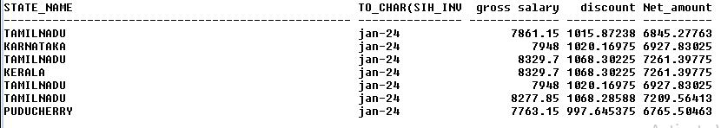

1. Write a query to have the following Output

|  |  |  |  |  |
| --- | --- | --- | --- | --- |
| Month | No. of Invoices | Gross Sales | Disc. Amt | Net Amount |
| Jan-24 | 5 | XXXX | XXXX | XXXX |
| Feb-24 | 5 | XXXX | XXXX | XXXX |
| Mar-24 |  | XXXX | XXXX | XXXX |

**QUERY**

SELECT TO_CHAR(b. sih_inv_date,'mon-yy') as Month,COUNT(b.sih_inv_no)as Count,

SUM((c. sil_inv_qty*c. sil_unit_price)) " gross salary",

SUM((( c.sil_inv_qty* c.sil_unit_price/100)* c.sil_disc_pct)) " discount",

SUM((( c.sil_inv_qty* c.sil_unit_price)- ((c.sil_inv_qty* c.sil_unit_price/100)*

c.sil_disc_pct))) "Net_amount"

FROM CUST_MASTER_SRINI a, SALES_INV_HDR_SRINI b, SALES_INV_LN_SRINI c

WHERE a.cust_id=b.sih_cust_id and

b.sih_inv_no=c.sil_inv_no

GROUP BY TO_CHAR(b. sih_inv_date,'mon-yy');

**OUTPUT**

