Conversion Table (Mission Form)

This form helps you to keep track of the conversion of ASCII characters to decimal (DEC), hexadecimal (HEX), and binary (BIN) representation.

ASCII characters: Hello Qcamp!

ASCII character | DEC Representation | HEX Representation | BIN Representation
[STX]
H
e
l
l
o
[Space]
Q
c
a
m
p
!
[ETX]

Conversion Table (Blank Form)

This form helps you to keep track of the conversion of ASCII characters to decimal (DEC), hexadecimal (HEX), and binary (BIN) representation.

ASCII characters:

ASCII character | DEC Representation | HEX Representation | BIN Representation

ASCII Table

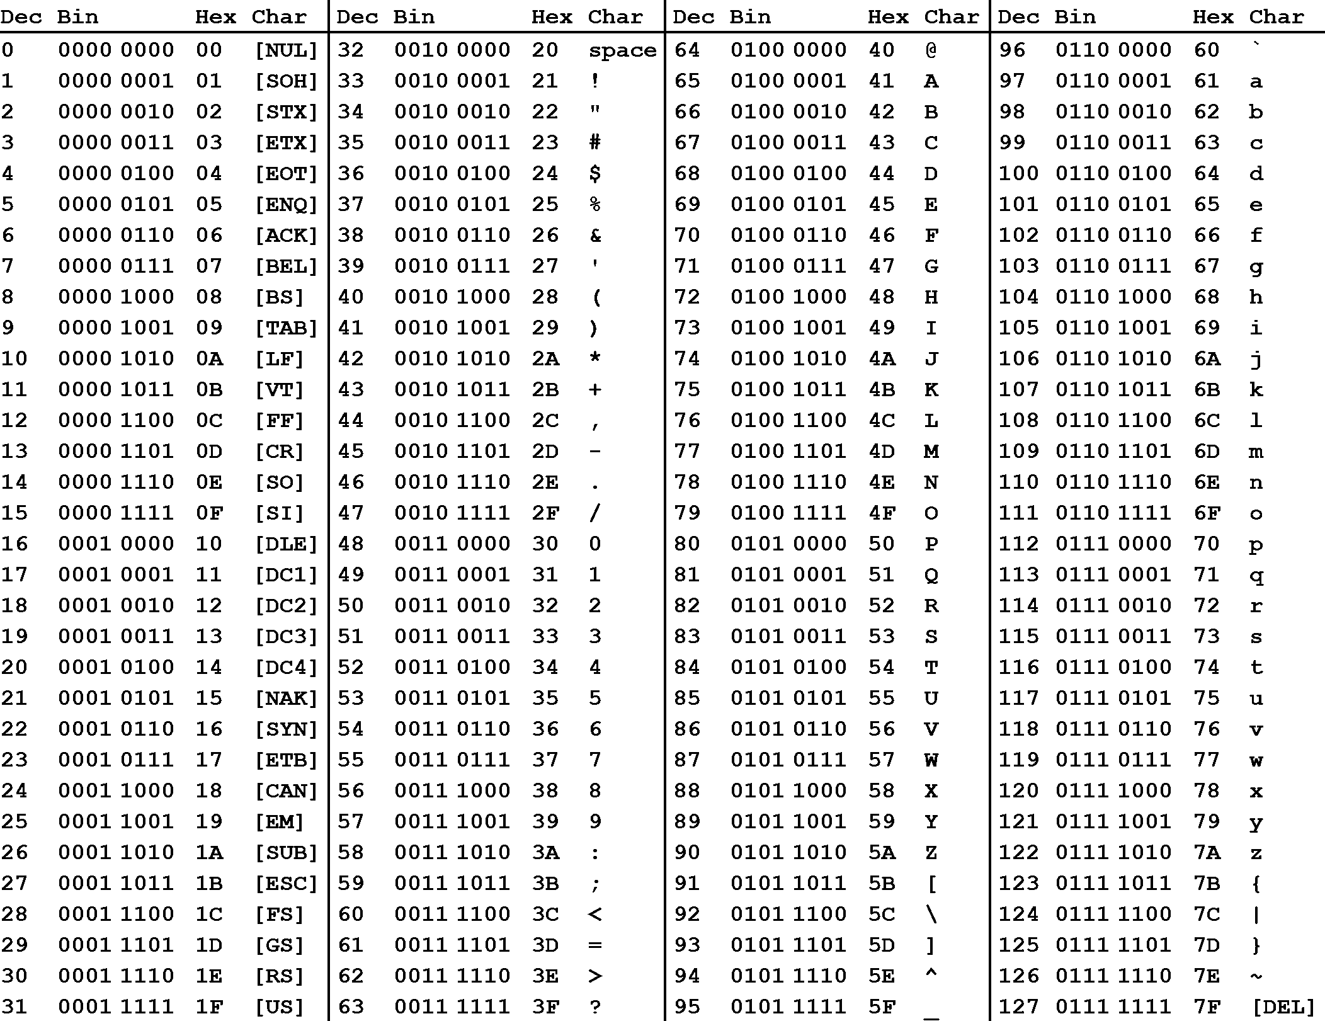

Source: https://cdn.sparkfun.com/assets/home_page_posts/2/1/2/1/ascii_table_1.zip

