HEX-BIN-DEC Fast Conversion Table

HEX (0x) | BIN (0b) | DEC |  | HEX (0x) | BIN (0b) | DEC
0 | 0000 | 0 |  | 8 | 1000 | 8
1 | 0001 | 1 |  | 9 | 1001 | 9
2 | 0010 | 2 |  | A | 1010 | 10
3 | 0011 | 3 |  | B | 1011 | 11
4 | 0100 | 4 |  | C | 1100 | 12
5 | 0101 | 5 |  | D | 1101 | 13
6 | 0110 | 6 |  | E | 1110 | 14
7 | 0111 | 7 |  | F | 1111 | 15

ASCII Table

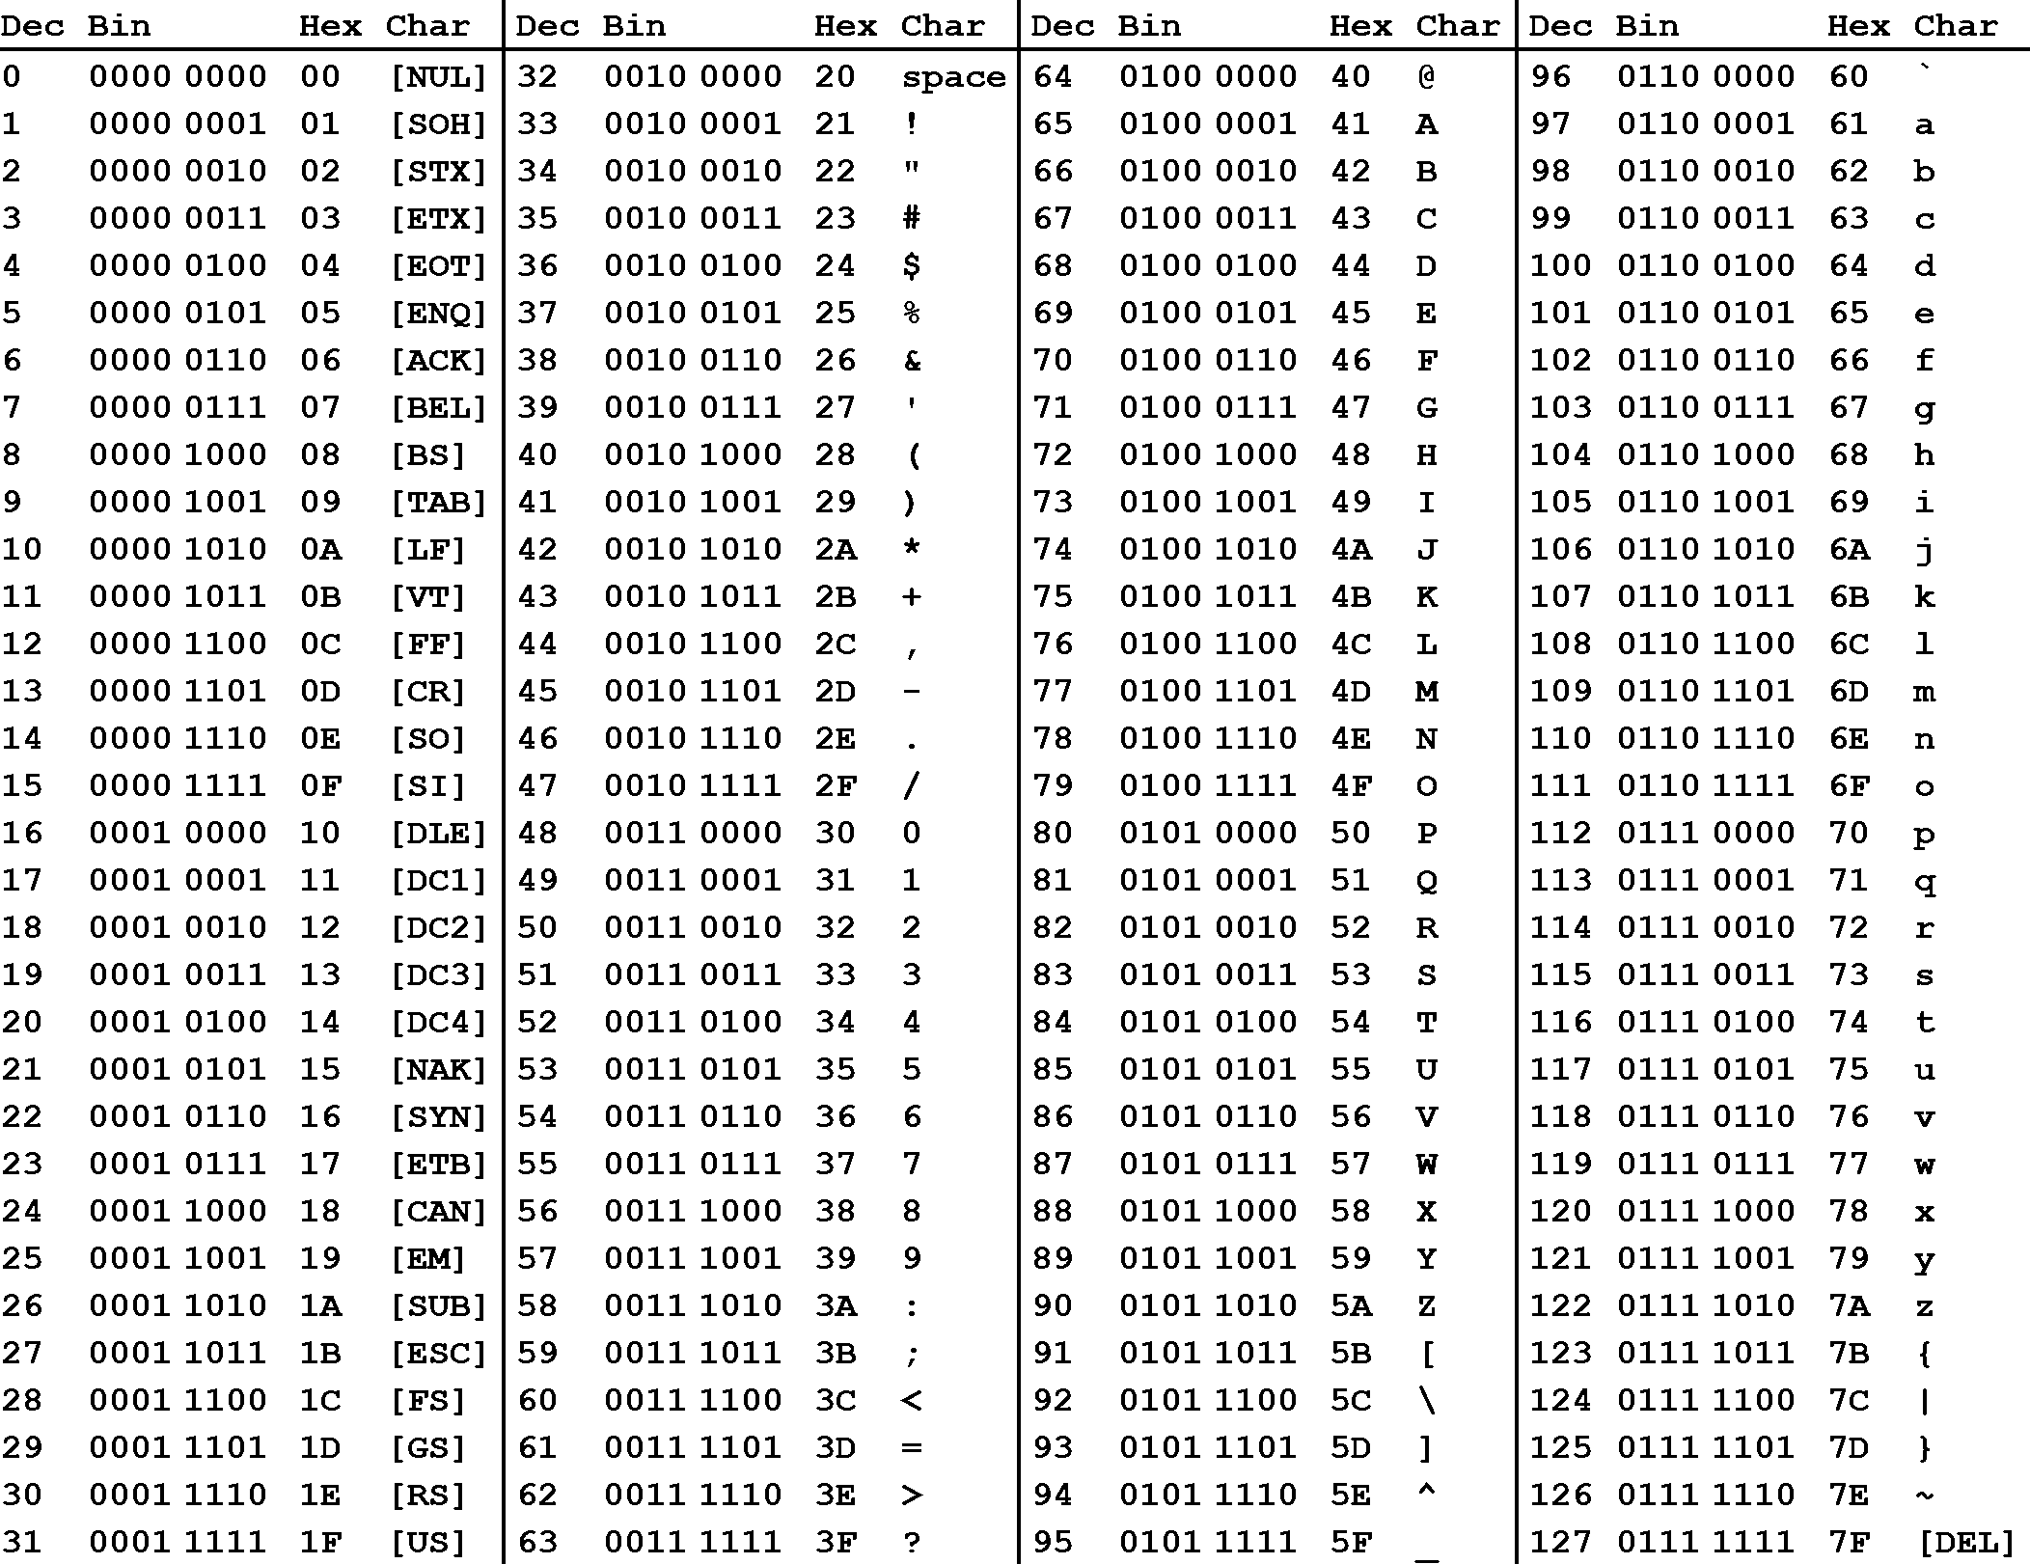
Source: https://cdn.sparkfun.com/assets/home_page_posts/2/1/2/1/ascii_table_1.zip
