**Student Name:**

**PES**

**2020 ACCOUNTING UNIT 3**

## Outcome 2

## PREPARING AND INTERPRETING ACCOUNTING REPORTS

**QUESTION BOOK**

**Structure of book**

|  |  |  |
| --- | --- | --- |
| *Number of*  *Questions* | *Number of questions*  *to be answered* | *Number of*  *marks* |
| 5 | 5 | 40 |

* Students are permitted to bring into the SAC room: pens, pencils, highlighters, erasers, sharpeners, rulers and one scientific calculator.
* Students are NOT permitted to bring into the SAC room: blank sheets of paper and/or white out liquid/tape.

**Materials supplied**

* Question Book of 5 pages.
* Answer Book of 8 pages.

**Instructions**

* Write your name and your teacher’s name in the space provided on the front page of both this Question Book and the Answer Book.
* Answer all questions in the Answer Book.

**At the end of the task**

* Place this Question Book on top of the Answer Book and wait for both to be collected.

**Students are not permitted to bring mobile phones and/or any other unauthorized electronic devices into the SAC room.**

**Question 1** (20 marks)

Friso Supplies reports annually on 31 December. The business applies a 100% mark up on sales.

The business provides the following information:

|  |  |  |
| --- | --- | --- |
|  | **31 December 2019** | **31 December 2020** |
| **INCOME STATEMENT** |  |  |
| **Net Profit** | 95 000 | 110 000 |
|  |  |  |
| **BALANCE SHEET** |  |  |
| Accounts Receivable | 26 000 | 15 000 |
| Inventory | 20 500 | 23 000 |
| Bank | (2 000) | (9 000) |
| Accounts Payable | 19 000 | 28 550 |
| Capital | 440 000 | 610 000 |

**Additional Information**

* Drawings by the owner were all cash
* In August 2020 the owner contributed $85 000 additional capital comprising $65 000 cash and $20 000 Vehicle
* Purchases of inventory were on credit with credit terms of 4/10, n30. The discount is always taken
* Sales Returns were $5 000 plus GST. All inventory returned is returned to the supplier in the same reporting period
* Other Expenses paid during the year totalled $ 105 500 which included interest $500 and wages $55 000
* A payment of $13 000 was made to the Australian Taxation Office in December 2020 as a GST Settlement
* Sales were $300 000 of which 20% were cash

1. Reconstruct the following ledger accounts for the year ended 31 December 2020:
   * Capital account to determine drawings for the year ended 31 December 2020
   * Accounts Payable and Inventory to determine the payments to accounts payable

9 marks

1. Explain with reference to an accounting assumption why some ledger accounts are closed while others are balanced.

3 marks

1. Prepare the Cash Flow from Operating Activities section of the Cash flow Statement for the year ended 31 December 2020.

5 marks

1. Explain, giving **one** example how the Net Cash Flow from Operations can be lower than the Net Profit for the same period.

3 marks

**Question 2** (4 marks)

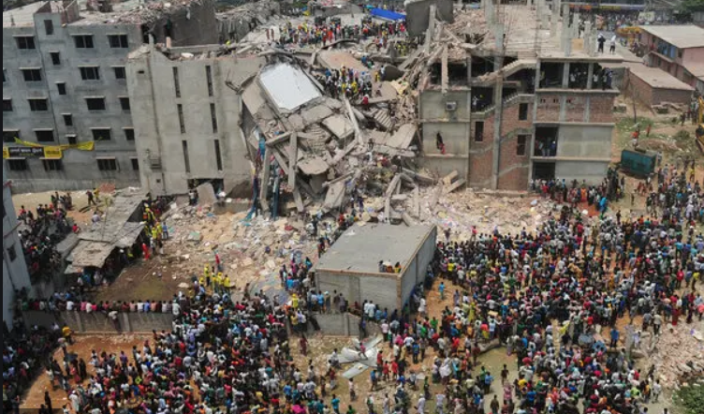

*The 2013 Dhaka garment factory collapse was a structural failure that occurred in Bangladesh, where an eight-story commercial building called Rana Plaza collapsed.*

*The Rana Plaza collapse was the worst disaster in the history of the garment industry. It killed 1138 workers and injured over a thousand more.*

You have discovered that your suppliers produce goods in factories that may not be safe or comply with Australian conditions. Changing suppliers would mean higher costs and therefore could result in less profit.

With reference to ethical considerations, discuss the potential impact of your business maintaining its existing suppliers.

**Question 3** (7 marks)

ProGo sells a wide range of waterproof cameras. The business uses the Identified Cost inventory cost assignment method and all inventory is marked up by 50%.

# Inventory Card

|  |  |  |  |  |  |  |  |  |  |  |
| --- | --- | --- | --- | --- | --- | --- | --- | --- | --- | --- |
| **Item: ProGo Waterproof camera Code: PGH20**  **Supplier: GoPro Ltd** | | | |  | **Cost Assignment Method: Identified Cost** | | | | | |
| **Date 2019** | **Document** | **IN** | | | **OUT** | | | **BALANCE** | | |
| **Qty** | **Cost** | **Total** | **Qty** | **Cost** | **Total** | **Qty** | **Cost** | **Total** |
| Mar. 1 | Balance |  |  |  |  |  |  | 10 | 250 | 2 500 |
| 5 | 225 | 1 125 |
| 3 | CrN. 23 | 1 | 225 | 225 |  |  |  | 10 | 250 | 495 |
| 6 | 225 | 1 350 |
| 6 | Inv. 564 |  |  |  | 3 | 250 | 750 | 7 | 250 | 2 750 |
| 2 | 225 | 450 | 4 | 225 | 900 |
| 12 | Memo 43 |  |  |  | 7 | 40 | 280 | 11 | 210 | 2 310 |
| 4 | 15 | 60 |

**a.** Record the following transactions in the Inventory Card provided:

|  |  |  |
| --- | --- | --- |
| * 22 March | The owner withdrew two of the ProGo waterproof cameras to use as gifts for his friends (Memo 46). |  |
| * 30 March | A physical stocktake revealed that there were 8 items on hand (Memo 47). | 2 marks |

|  |  |  |
| --- | --- | --- |
| **b.** | Describe the transactions that have led to the entries in the Inventory Card on: |  |
|  | * 3 March |
|  | * 12 March. | 2 marks |
| **c.** | Describe the effects that Memo 43 would have on the financial reports of ProGo | 3 marks |

**Question 4** (5 marks)

Huilong Li commenced business on 1 March 2020. During the month of March, the following transactions occurred:

* Cash contribution of $15 000
* Contribution of Equipment that had originally cost $6 600 including GST but now has a value of $3 500
* Office Furniture purchased for cash from OfficeWorx for $2 200 plus GST
* Purchased inventory on credit from Cao Ltd for $8 000 plus GST. Inventory will be marked up by 100%.
* Took out a $5 000 loan to be repaid by February 2021 and negotiated a bank overdraft with CCG Bank for $10 000
* Donated $100 of inventory to the local football club to promote his new business
* Sold inventory on credit with a cost price of $350 to J Chen.

Prepare the Balance Sheet for the business at 31 March 2020.

**Question 5** (4 marks)

Joel Rotar owns a business specialising in the selling of acoustic guitars. The business uses the FIFO

Cost assignment method and all inventory is marked up by 50%.

The following financial summary is provided for the quarter ended 31 March 2020.

|  |  |  |  |
| --- | --- | --- | --- |
| Receipts from Accounts Receivable | 55 000 | Drawings Inventory | 400 |
| Wages | 7 800 | Cash Sales | 32 000 |
| Sales Returns | 2 800 | Credit Sales | 47 000 |
| Discount Revenue | 140 | Insurance on Premises | 2 500 |
| Custom Duties | 430 | Delivery to customers | 150 |
| Discount Expense | 620 | Interest Expense | 200 |
| Inventory on hand | 40 240 | Payments to Accounts Payable | 42 000 |
| Inventory Write Down | 700 | Advertising | 650 |

**Additional Information:**

A physical stocktake revealed inventory on hand to be $40 500

Prepare an Income Statement extract up to an including to Other Revenue for the quarter ended 31 March 2020.

**END OF QUESTION**