**BIOLOGY**

**Insert School Logo**

**UNIT 3**

**2020**

**Name**:

**Teacher**:

**Time allowed for this paper**

Reading time before commencing work: ten minutes

Working time: three hours

**Materials required/recommended for this paper**

***To be provided by the supervisor***

This Question/Answer booklet

Multiple-choice answer sheet

***To be provided by the candidate***

Standard items: pens (blue/black preferred), pencils (including coloured), sharpener, correction fluid/tape, eraser, ruler, highlighters

Special items: non-programmable calculators approved for use in this examination

**Important note to candidates**

No other items may be taken into the examination room. It is **your** responsibility to ensure that

you do not have any unauthorised material. If you have any unauthorised material with you, hand

it to the supervisor **before** reading any further.

**Structure of this paper**

|  |  |  |  |  |  |
| --- | --- | --- | --- | --- | --- |
| Section | Number of questions available | Number of questions to be answered | Suggested working time (minutes) | Marks available | Percentage of examination |
| Section One  Multiple-choice | 30 | 30 | 40 | 30 | 30 |
| Section Two  Short answer | 5 | 5 | 90 | 100 | 50 |
| Section Three  Extended answer  Part A | 2 | 1 | 50 | 40 | 20 |
| Part B | 2 | 1 |
|  |  |  |  | **Total** | 100 |

**Instructions to candidates**

1. The rules for the conduct of the Western Australian external examinations are detailed in the *Year 12 Information Handbook 2020*. Sitting this examination implies that you agree to abide by these rules.

2. Write your answers in this Question/Answer booklet preferably using a blue/black pen. Do not use erasable or gel pens.

3. Answer the questions according to the following instructions.

Section One: Answer all questions on the separate Multiple-choice answer sheet provided. For each question, shade the box to indicate your answer. Use only a blue or black pen to shade the boxes. Do not use erasable or gel pens. If you make a mistake, place a cross through that square, then shade your new answer. Do not erase or use correction fluid/tape. Marks will not be deducted for incorrect answers. No marks will be given if more than one answer is completed for any question.

Section Two: Write your answers in this Question/Answer booklet. Wherever possible, confine your answers to the line spaces provided.

Section Three: Consists of two parts each with two questions. You must answer one question from each part. Tick the box next to the question you are answering. Write your answers in this Question/Answer booklet.

4. You must be careful to confine your answers to the specific questions asked and to follow any instructions that are specific to a particular question.

5. Supplementary pages for planning/continuing your answers to questions are provided at the end of this Question/Answer booklet. If you use these pages to continue an answer, indicate at the original answer where the answer is continued, i.e. give the page number.

**Section One: Multiple-choice 30% (30 Marks)**

This section has **30** questions. Answer **all** questions on the separate Multiple-choice answer sheet provided. For each question, shade a box to indicate your answer. Use only a blue or black pen to shade the boxes. Do not use erasable or gel pens. If you make a mistake, place a cross through that square, then shade your new answer. Do not erase or use correction fluid/tape. Marks will not be deducted for incorrect answers. No marks will be given if more than one answer is completed for any question.

Suggested working time: 40 minutes.

1. The 'genetic code' is said to be universal because

(a) it codes for the same characteristics in all living organisms.

(b) ancient bacteria contain the same DNA as found in the mitochondria of living cells.

(c) it is found in chromosomes of all living things.

(d) it is comprised of the same four nitrogenous bases in all living organisms.

2. Gametes are produced through the process of meiosis. At the end of meiosis I, there are

(a) two cells with double the amount of genetic material as the parent cell.

(b) four cells with half the amount of genetic material as the parent cell.

(c) two cells with half the amount of genetic material as the parent cell.

(d) two cells with the same amount of genetic material as the parent cell.

3. Artificial insemination can alter the genetic composition of a population because it

(a) ensures only male genomes are affected.

(b) decreases the chance of crossing over occurring.

(c) results in the production of many genetically identical offspring.

(d) increases the frequency of certain alleles in the gene pool.

4. When gene flow between populations is very high,

(a) deleterious traits are more likely to be maintained in the gene pool.

(b) natural selection does not occur.

(c) the risk of inbreeding is increased.

(d) the frequency of dominant traits increases.

5. The observable traits in species' populations can change over time due to natural selection. Given this information, it can be assumed that natural selection acts on

(a) genotypes.

(b) phenotypes.

(c) gamete production.

(d) alleles.

Question 6 relates to the information below.

The pedigree below represents a family with one member affected by a genetic disorder.

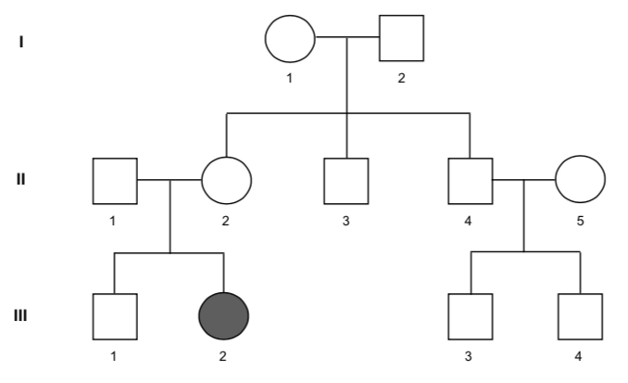

6. From the information presented in the pedigree, it may be concluded that

(a) it is an X-linked recessive disorder.

(b) II 2, II 3 and II 4 have a 25% chance of carrying the disorder.

(c) I 2 and II 2 are heterozygous for the disorder.

(d) III 1 must be heterozygous for the disorder.

7. Dog breeders choose specific individuals to mate, based on the presence of certain characteristics. This type of selective breeding will **most** likely result in

(a) the development of a new adaptation of monetary value.

(b) a decrease in the genetic diversity of the particular dog breed.

(c) an increase in the genetic diversity of the particular dog breed.

(d) an increase in spontaneous genetic mutations in the resulting offspring.

8. Nucleic acids are comprised of which combination of the following elements?

A Carbon

B Oxygen

C Hydrogen

D Sulphur

E Potassium

F Phosphorus

(a) A, B, C, E and F

(b) A, B, C, and F

(c) B, C, F

(d) A, C, D and F

9. DNA base sequences that are located in the same region of a gene of different species, can be compared to establish the degree of ancestral relatedness. A specific base sequence of four different *Eucalyptus* species found in the southwest of Western Australia are shown below.

*Eucalyptus gomphocephala* AAT GGC CCT GCA ATC GCC ATA TCC CAA TTG

*Eucalyptus marginata* AAT GGC GCT CCT AAC GCC ATA TCC CAA TTG

*Eucalyptus diversicolor* AAT GGC CCT GCA ACC TCC ATT ACC CAA TTG

*Eucalyptus patens* AAT GCC GCT CCT AAC GCC ATA TCG CAA TTG

Using this information, the species **most** closely related are

(a) *E. gomphocephala* and *E. patens.*

(b) *E. gomphocephala* and *E.* *diversicolor.*

(c) *E. marginata* and *E. patens.*

(d) *E. marginata* and *E.* *diversicolor.*

10. A forensic specialist was sent **three** small fragments of DNA from a crime scene. Before any analysis could be conducted, the DNA required copying. The specialist used PCR to increase the amount of DNA she had to work with. How many fragments of DNA will result if the original fragments are run through the PCR **three** times?

(a) 243

(b) 24

(c) 81

(d) 36

11. Phenotypic variation is dependent upon

(a) natural selection.

(b) multiple alleles.

(c) alternative alleles.

(d) gene flow.

12. DNA replication follows a precise series of steps in order to construct an accurate product. Which of the following **best** summarises the process of DNA replication?

(a) DNA strands unwind → double helix → complementary base-pairing → two DNA helices.

(b) DNA strands unwind → complementary base-pairing → mRNA molecule → DNA strands rewind.

(c) Double helix → complementary base-pairing → mRNA → polypeptide.

(d) Double helix → DNA strands unwind → complementary base-pairing → two DNA helices.

13. Offspring that possess recombinant DNA show greater genetic diversity than their parental counterparts. 'Recombinant offspring' will **only** arise if

(a) alleles are linked.

(b) crossing over between homologous chromosomes has occurred during meiosis.

(c) alleles are independently assorted during meiosis.

(d) multiple alleles for a single trait are present in the parental genomes.

14. Gel electrophoresis involves the movement of DNA fragments through a gel medium. The speed at which the DNA fragments move through the gel is **not** affected by the

(a) radioactive dye applied to the gel.

(b) molecular weight of the fragments.

(c) components of the gel medium.

(d) voltage applied to the gel.

15. Which of the following types of biological evidence is **not** used to construct phylogenetic trees?

(a) Mitochondrial DNA

(b) Proteins

(c) Fossil remains

(d) Embryos

16. In a population of owls, two different phenotypes for feather colouration exist - grey and brown. Matings between grey owls produce all grey offspring. Most of the brown owls produce all brown offspring regardless of their mate's colour. Given this information, it could be concluded that the

(a) the brown allele is recessive.

(b) the grey allele is recessive.

(c) the grey allele is dominant.

(d) feather colouration of the owls is controlled by multiple alleles.

17. Which of the following scenarios **best** represents the founder effect?

(a) All the quokkas on Rottnest Island were killed by a virus and the population was re-established using a small population from southwest WA.

(b) The drying of Australia's terrestrial environment after the last ice age separated an ancestral species of grey kangaroo into two distinct species - the western grey and the eastern grey kangaroo.

(c) Dieback infection eradicated an endemic species of *Banksia* from a forest ecosystem.

(d) Feral cats and foxes dramatically reduced woylie numbers to critical levels before the population slowly recovered.

18. Gene probes can be used to determine whether a person is carrying the gene for a hereditary disease. Gene probes work by

(a) making the gene in question radioactive so it can be visualised under an ultraviolet light.

(b) binding to a DNA sequence specific to the target allele.

(c) splicing the target DNA sequence from the patient's genome.

(d) determining the size and position of the target allele.

Question 19 relates to the images below.

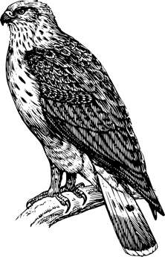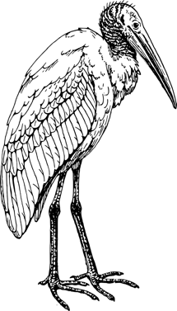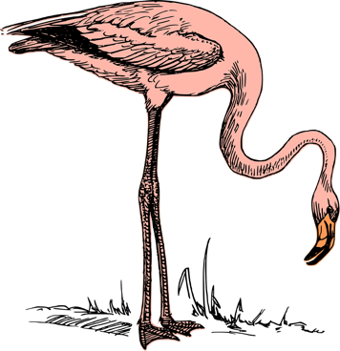

19. Natural selection states that the birds shown above possess different foot structures due to

(a) adaptations to different habitats and food sources.

(b) random changes.

(c) sexual selection.

(d) inherited acquired traits.

20. A vestigial trait or organ is

(a) functional but of a reduced size.

(b) only functional in evolutionary related species.

(c) non-functional in all species, past and present.

(d) only present in highly evolved organisms.

Question 21 relates to the diagram below.

21. The graph above shows the heterozygosity frequencies for alleles in different animal taxa. The diversity and survival of which taxa would be most undermined by a catastrophic event resulting in permanent change in the environment?

(a) Molluscs

(b) Birds

(c) Crustaceans

(d) Mammals

22. Mutations are essential to all living organisms because they

(a) allow the production of food that is better tasting and of greater nutritional value.

(b) produce altered proteins that can change the way cells function.

(c) can result in the development of different traits that improve their chance of survival and reproductive success.

(d) create genetic diseases that help control population growth.

23. Okazaki fragments are involved in the synthesis of new DNA strands. On which structure would you **most** likely find an Okazaki fragment?

(a) Leading strand.

(b) Lagging strand.

(c) Attached to DNA polymerase.

(d) 3' to 5' DNA template.

24. Which of the following statements regarding chromosomes is **incorrect**?

(a) A sperm cell contains the same number of chromosomes as an ovum.

(b) Different species have a different number of chromosomes in their cells.

(c) The genetic composition of chromosomes at the beginning of meiosis is the same as at the end of meiosis.

(d) Mitotic division results in daughter cells with chromosomes of identical genetic composition.

25. Nearly every species on Earth shows phenotypic variation over geographic and environmental gradients. A PhD student was planning an investigation regarding the variation in flower stalk length of a common species of native orchid. She wanted to know whether variation was due to environmental factors or genetics. Which of the following methods would produce the **most** reliable data for her investigation?

(a) Translocating individual plants to the alternate environments.

(b) Raising individual plants under identical environmental conditions.

(c) Growing genetically identical plants in the different environments.

(d) All of the above.

26. Ultra-violet light, x-rays and gamma rays are considered mutagens. The reason for this is because they

(a) double the number of chromosomes in the nucleus.

(b) give rise to organisms of unusual size and shape.

(c) cause people to develop cancer.

(d) change the base sequence of a DNA molecule.

27. A protein is said to be denatured when the

(a) amino acids are not in their correct order.

(b) quaternary structure has been damaged.

(c) tertiary structure is not folded correctly.

(d) hydrogen bonds are broken and the secondary spiral structure unravels.

Question 28 relates to the images below.

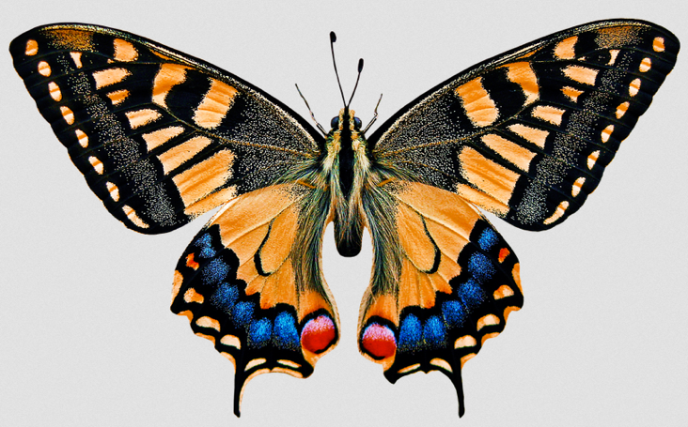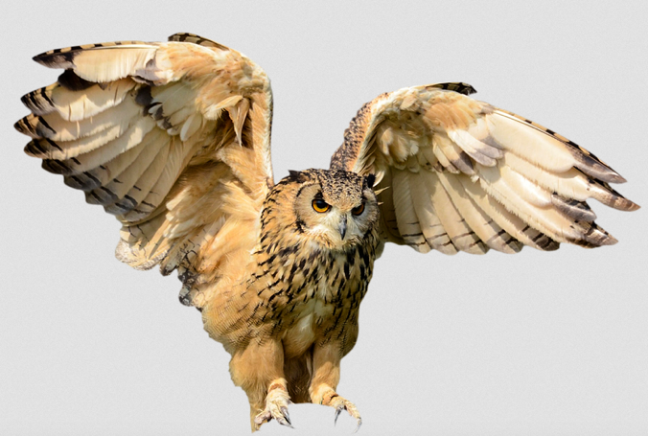

28. The organisms in the image above possess wings that have a similar function but a different structure. This is an example of

(a) convergent evolution.

(b) parallel evolution.

(c) divergent evolution.

(d) close evolutionary relatedness.

29. Our genetic code can be translated into 20 different amino acids. However, the four bases can be combined to produce 64 codons. What is the **most** likely explanation for this discrepancy?

(a) 44 of the resulting amino acids are non-functional, organic molecules.

(b) Only 20 amino acids can be synthesised by all living organisms.

(c) Some amino acids can be translated by multiple codons.

(d) The additional codons are located within introns and therefore not translated.

30. Which of the following shows the correct methods for the transfer of genetic material for eukaryotic and prokaryotic cells?

|  |  |  |
| --- | --- | --- |
|  | **Eukaryotic** | **Prokaryotic** |
| (a) | Mitosis and meiosis | Mitosis and meiosis |
| (b) | Meiosis and mitosis | Binary fission and conjugation |
| (c) | Binary fission and meiosis | Conjugation and mitosis |
| (d) | Binary fission and conjugation | Mitosis and meiosis |

**End of Section One**

**Section Two: Short answer 50% (100 Marks)**

This section has **five** questions. Answer **all** questions. Write your answers in the spaces provided.

Supplementary pages for planning/continuing your answers to questions are provided at the end of this Question/Answer booklet. If you use these pages to continue an answer, indicate at the original answer where the answer is continued, i.e. give the page number.

Suggested working time: 90 minutes.

**Question 31 (20 marks)**

Most people of European descent can tolerate the consumption of dairy products; milk, cheese and yoghurt made from cow, sheep and goat's milk. Milk contains a sugar called lactose that is digested in the small intestine of mammals by the enzyme lactase. Lactase is responsible for the breakdown of lactose into glucose and galactose which are then absorbed into the bloodstream.

Lactase-persistence is the term used to describe the trait that allows people to continue synthesising lactase after weaning. This trait is the result of a mutation on chromosome 2, within the gene that regulates the lactase gene, LCT. In all mammals, except humans and guinea pigs, the gene that codes for this enzyme is inactivated shortly after weaning. After this time, the consumption of milk often causes illness and diarrhoea.

The mutation for lactase-persistence is believed to have originated during the early Neolithic era, around 10,000 years ago. Archaeological evidence suggests that this mutation corresponded with the domestication of cattle in northern Europe. The mutation was revealed to be a single-nucleotide polymorphism, where cytosine has been substituted with thymine.

(a) Identify the term given to mutations involving single base substitution. (1 mark)

(b) Explain the effect of 'switching off' the lactase (LCT) gene on cellular processes.

(3 marks)

(c) Suggest the most appropriate genetic test which could be used to discover if a person was carrying the lactase-persistent mutation. Explain your response. (2 marks)

(d) The persistence of this mutation over 10,000 years can be attributed to natural selection. Explain how natural selection has shaped the evolution of lactase- persistence in early human populations. (4 marks)

(e) Lactase-persistence is an autosomal-dominant trait. Explain what is meant by

(i) autosomal dominant (2 marks)

(ii) autosomal recessive (2 marks)

(f) Alleles for the lactase-persistent trait are represented by 'L' and 'l'. Complete the Punnett squares below to show a cross between a lactose-intolerant female, and a male carrying the lactase-persistence trait. For each cross, identify the genotypic and phenotypic frequencies of the offspring.

(i) Cross 1 - heterozygous male. (2 marks)

|  |  |  |
| --- | --- | --- |
|  |  |  |
|  |  |  |
|  |  |  |

Genotype frequency:

Phenotype frequency:

(ii) Cross 2 - homozygous male. (2 marks)

|  |  |  |
| --- | --- | --- |
|  |  |  |
|  |  |  |
|  |  |  |

Genotype frequency:

Phenotype frequency:

(g) Suggest why autosomal dominance has allowed for the perpetuation of the lactase-persistent trait in humans. (2 marks)

**Question 32 (20 marks)**

(a) Contrast the structure and packaging of genetic material between prokaryotic and eukaryotic cells. (8 marks)

|  |  |
| --- | --- |
| **Prokaryotic cells** | **Eukaryotic cells** |
|  |  |
|  |  |
|  |  |
|  |  |

A biology class was analysing the nitrogenous base composition of a particular gene from five different plant species. The data they collected is presented in the table below.

**Table 1**: Percentage composition of thymine and cytosine in five plant species.

|  |  |  |
| --- | --- | --- |
| **Species** | **% Thymine** | **% Cytosine** |
| **1** | 16 | 34 |
| **2** | 36 | 14 |
| **3** | 28 | 22 |
| **4** | 19 | 31 |
| **5** | 32 | 18 |

(b) Graph the relationship between the percentage (%) composition of thymine and cytosine in the plant species from Table 1. Include a line of best fit on your graph. (5 marks)



*A spare grid is provided at the end of this Question/Answer booklet. If you need to use it, cross out this attempt and indicate clearly that you have redrawn it on the spare page.*

(c) Identify the relationship between thymine and cytosine as shown in your graph.

(1 mark)

(d) Explain the reason for this relationship in the percentage composition of thymine and cytosine. (3 marks)

Based on the data, it was concluded that the five plants were unlikely to be in the same genus.

(e) Is this conclusion valid? Explain your reasoning. (3 marks)

**Question 33 (20 marks)**

Many biotechnology procedures require large amounts of DNA to obtain accurate and useful data. Often, DNA samples collected from crime scenes, fossils or degraded tissues are small and fragmented. Polymerase Chain Reaction (PCR) is a technique specifically developed to synthesise large amounts of DNA in a short period of time. PCR involves three main processes that simulate normal cellular DNA replication.

(a) Complete the table below by comparing the structure and/or function of the molecules involved in DNA replication with the equivalent PCR molecule or process.

(6 marks)

|  |  |  |
| --- | --- | --- |
| **Molecule /enzyme** | **DNA replication** | **PCR equivalent** |
| Helicase |  |  |
| Primer |  |  |
| DNA Polymerase |  |  |

The PCR technique does not involve Okazaki fragments or DNA ligase.

(b) Explain why these molecules are **not** required in PCR. (2 marks)

*Taq* Polymerase is an enzyme found in the heat tolerant bacteria *Thermus aquaticus* and is most active at around 70oC. *Taq* Polymerase is a vital component of PCR.

(c) Suggest **two** characteristics of *Taq* Polymerase that explain its importance to the PCR technique. (2 marks)

The illegal wildlife trade industry earns around $20 billion US annually. Many animal products such as horns, teeth, hair and skin are illegally harvested and processed for use in traditional Eastern medicines. Prosecution of persons involved in trafficking requires accurate identification of the species used in these products. Geneticists can extract mitochondrial DNA (mtDNA) from these products and once processed, it can be compared to data from a 'gene bank'.

(d) Explain **two** reasons for using mtDNA instead of nuclear DNA in this particular type of genetic analyses. (2 marks)

The cytochrome *b* gene is located within the genome of mtDNA. The gene is approximately 1140 base pairs long in most eukaryotic cells. Cytochrome *b* is widely used in wildlife forensics in a technique known as mitochondrial DNA restricted fragment length polymorphism (mtDNA-RFLP). Using this technique allows the creation of species-specific genetic 'fingerprints' from small gene fragments.

Fragments of cytochrome *b* were recovered from two separate samples of ivory powder confiscated from a wildlife trafficker. The fragments were 402 base pairs long and originated from the same region on the gene; between base pairs 11476 and 11878. These fragments were amplified using PCR and then treated with three different restriction endonucleases prior to electrophoretic analysis; *Alu* I, *Hae* III and *Hinf* I.

(e) Explain how the use of these restriction enzymes can produce the species-specific genetic 'fingerprints' from the gene fragments. (4 marks)

Samples were loaded into the agarose gel wells with comparison samples from known species. The resulting 'gel' is shown below.

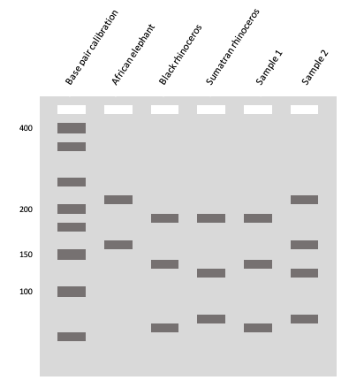

(f) Using the gel 'fingerprints' above, predict which species the samples most closely resemble. Justify your response. (2 marks)

Sample 1

Sample 2

(g) Variation in base sequences between different species is the result of genetic mutation. However, scientists have discovered that mutation of the third base in a codon sequence seldom leads to amino acid exchange. Explain why this is the case.

(2 marks)

**Question 34 (20 marks)**

Palaeontologists study fossils to obtain information about the history of life on Earth.

(a) Identify the type of information that scientists can observe directly from fossils.

(3 marks)

(b) Define the term 'transitional fossil'. Use an example to explain how transitional fossils are important to our understanding of evolutionary change. (4 marks)

(c) Explain the purpose of an index fossil in palaeontology. (2 marks)

Like many birds, the Splendid Fairy-wren (*Malurus splendens*) is represented by different male and female forms. The adult male has brilliant blue plumage while the non-breeding male, female and juvenile is grey-brown with a muted blue tail.

(d) State the name given to this phenomenon. (1 mark)

During mating season, the male Splendid Fairy-wren has been observed presenting females with pink and purple flower petals and flaring their cheek feathers. New research has found that breeding males will sing their courtship songs following the call of the predatory Grey Butcherbird (*Cracticus torquatus*).

(e) Define 'sexual selection'. (2 marks)

(f) Explain why the appearance and behaviour of the Splendid Fairy-wren is considered an example of sexual selection. (2 marks)

(g) Sexual selection is not considered an example of adaptive or natural selection. Explain why this is the case. (4 marks)

(h) Identify **two** other evolutionary processes that are **not** influenced by natural selection.

(2 marks)

**Question 35 (20 marks)**

The diagram below shows embryos from **eight** different vertebrate species.

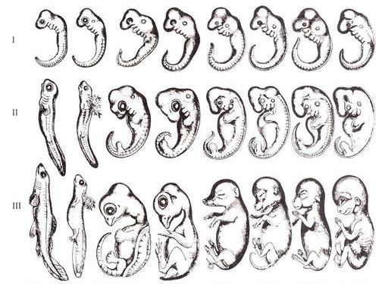

(a) Identify **two** structures, common to each developing embryo, used in comparative embryology. (2 marks)

(b) Explain how comparative embryology provides evidence to suggest ancestral relatedness of these vertebrate species. (3 marks)

Birds and bats both possess wings used for flight. Comparison of the external anatomy may suggest they descend from a recent common ancestor. However, upon examination of their bone structures, it is clear that their wings and associated arm structures are both analogous and homologous, respectively.

(c) Define the terms;

(i) Homologous structure (2 marks)

(ii) Analogous structure (2 marks)

The phylogenetic tree below is a simplified representation of the evolutionary path of bats and birds.

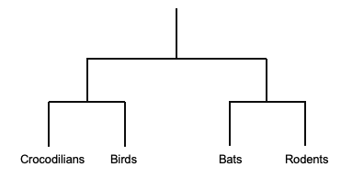

(d) Using the information provided in the previous image and phylogenetic tree, explain how it is possible for birds and bats to possess both homologous and analogous structures adapted for flight. (4 marks)

(e) Identify and briefly outline the technique used to measure the genetic relatedness between different species. (4 marks)

Molecular clocks are an essential tool for evolutionary biologists. Scientists can use DNA, amino acids and proteins from different species to estimate evolutionary divergence times.

However, molecular clock dating does not provide an absolute timeframe. As such, molecular clocks are calibrated against the fossil record to narrow estimates of divergence.

(f) Suggest why calibrating the molecular clock against the fossil record can help scientists provide a more precise timeframe for species divergence. (1 mark)

(g) Explain why there is a lack of precision when measuring divergence patterns of evolution. (2 marks)

**End of Section Two**

**Section Three: Extended answer 20% (40 marks)**

This section contains **four** questions.

Questions 36 and 37 form Part A. Questions 38 and 39 form Part B.Answer **one** question from Part A and **one** question from Part B.

Use black or blue pen for this section. Do not use erasable or gel pens. Only graphs and diagrams may be drawn in pencil. Responses can include: labelled diagrams with explanatory notes; lists of points with linking sentences; labelled tables and/or graphs; and/or annotated flow diagrams with introductory notes.

Supplementary pages for planning/continuing your answers to questions are provided at the end of this Question/Answer booklet. If you use these pages to continue an answer, indicate at the original answer where the answer is continued, i.e. give the page number.

Suggested working time: 50 minutes

**Part A**

Choose **either** Question 36 **or** Question 37.

Indicate the question you will answer by ticking the box next to the question. Write your answer on pages 27 - 30. When you have answered your first question, turn to page 31 and indicate on that page the second question you will answer.

**Question 36 (20 marks)**

(a) Explain how complementary base-pairing enables replication, transcription and translation to occur.

(10 marks)

Fraternal twins, Jake and Leo, are so dissimilar in appearance and personality that they are rarely considered as brothers.

(b) Explain how meiosis can generate such variation in genetic traits inherited by the twins.

(10 marks)

**Question 37 (20 marks)**

(a) Discuss gene mutations and the affect they can have on cellular function. (10 marks)

(b) Explain the use of bacterial plasmids in the creation of transgenic plants to improve agricultural productivity. Use specific examples to support your response.

(10 marks)

Question number:

Question number:

Question number:

Question number:

**Part B**

Choose **either** Question 38 **or** Question 39.

Indicate the question you will answer by ticking the box next to the question. Write your answer on the pages provided.

**Question 38 (20 marks)**

The rock pocket mouse (*Chaetodipus intermedius*) is a nocturnal mammal endemic to the deserts of America's southwest. Most mice are sand coloured, providing them with camouflage from predatory birds. However, populations of a dark-haired rock pocket mouse have been found living on basalt outcrops in Arizona. These dark-haired rock pocket mice possess a mutant version of the *Mc1r* gene which controls the synthesis of hair pigment.

(a) Explain how the dark-haired form of the rock pocket mouse has emerged as a successful phenotypic variation to the normal 'wild-type' sand-coloured mouse. (10 marks)

(b) Discuss the concept of gene flow and explain how disruption to gene flow can contribute to allopatric speciation.

(10 marks)

**Question 39 (20 marks)**

Underneath the rainforest of Mexico's Yucatan Peninsula lies an expansive, underground limestone cave system flooded with freshwater. The cave system opens into the rainforest through small freshwater pools, called Cenotes (*sen-oh-tays*). These Cenotes have been isolated from each other (and other aquatic ecosystems) for thousands of years. Each Cenote has its own diverse ecosystem, of which many support species endemic to individual pools.

(a) Discuss the mechanisms that may have influenced the evolution of new species in individual Cenotes, from common ancestors.

(10 marks)

"*The extinction of species, each one a pilgrim of four billion years of evolution, is an irreversible loss. The ending of the lines of so many creatures with whom we have travelled this far is an occasion of profound sorrow and grief...But the loss of lineages and all their future young is not something to accept. It must be rigorously and intelligently resisted*."

(b) Explain why reduced genetic diversity in small populations of endangered species puts them at greater risk of extinction. Discuss how scientists use modern technology to reduce extinction rates and maintain biodiversity. (10 marks)

**End of questions**

Question number:

Question number:

Question number:

Question number:

Supplementary page

Question number:

Supplementary page

Question number:

Spare grid

**ACKNOWLEDGEMENTS**

**Question 19**

Images of birds - CC BY-SA 3.0

Pixabay

**Question 28**

Image of owl and butterfly - CC BY-SA 3.0

Pixabay

**Question 35 (a - b)**

Vertebrate embryos

**Question 35 (c)**

Bird and bat wing skeleton diagrams - CC BY-SA 3.0

© Arizona Board of Regents / ASU Ask A Biologist.

All other diagrams and graphs are author constructed.