**2013**

#### VCE

**Chemistry**

**Trial Examination**

**Suggested Answers**



|  |  |
| --- | --- |
| **Kilbaha Multimedia Publishing**  **PO Box 2227**  **Kew Vic 3101**  **Australia** | **Tel: (03) 9018 5376**  **Fax: (03) 9817 4334**  [**kilbaha@gmail.com**](mailto:kilbaha@gmail.com)  [**http://kilbaha.com.au**](http://kilbaha.com.au) |

**IMPORTANT COPYRIGHT NOTICE**

1. This material is copyright. Subject to statutory exception and to the provisions of the relevant

collective licensing agreements, no reproduction of any part may take place without the written

permission of Kilbaha Pty Ltd.

1. The contents of this work are copyrighted. Unauthorised copying of any part of this work is

illegal and detrimental to the interests of the author.

1. For authorised copying within Australia please check that your institution has a licence from

<http://www.copyright.com.au/>. This permits the copying of small parts of the material, in

limited quantities, within the conditions set out in the licence.

1. All of these pages must be counted in Copyright Agency Limited (CAL) surveys
2. This file must not be uploaded to the Internet.

**These answers have no official status.**

While every care has been taken, no guarantee is given that these answers are free from error. Please contact us if you believe you have found an error.

**CAUTION NEEDED!**

All Web Links when created linked to appropriate Web Sites. Teachers and parents must always check links before using them with students to ensure that students are protected from unsuitable Web Content. Kilbaha Multimedia Publishing is not responsible for links that have been changed in this document or links that have been redirected.

**Answer Summary for Multiple-Choice Questions**

**2013 Kilbaha VCE Chemistry Trial Examination**

|  |  |  |  |
| --- | --- | --- | --- |
| Q1 | C | Q16 | A |
| Q2 | D | Q17 | A |
| Q3 | B | Q18 | D |
| Q4 | A | Q19 | A |
| Q5 | B | Q20 | C |
| Q6 | C | Q21 | A |
| Q7 | C | Q22 | C |
| Q8 | B | Q23 | D |
| Q9 | C | Q24 | D |
| Q10 | D | Q25 | B |
| Q11 | D | Q26 | D |
| Q12 | A | Q27 | B |
| Q13 | A | Q28 | D |
| Q14 | B | Q29 | C |
| Q15 | B | Q30 | A |

|  |  |  |  |  |  |  |  |  |  |
| --- | --- | --- | --- | --- | --- | --- | --- | --- | --- |
| **ONE ANSWER PER LINE** | | | | | **ONE ANSWER PER LINE** | | | | |
| 1. | A | B |  | D | 16. |  | B | C | D |
| 2. | A | B | C |  | 17. |  | B | C | D |
| 3. | A |  | C | D | 18. | A | B | C |  |
| 4. |  | B | C | D | 19. |  | B | C | D |
| 5. | A |  | C | D | 20. | A | B |  | D |
| 6. | A | B |  | D | 21. |  | B | C | D |
| 7. | A | B |  | D | 22. | A | B |  | D |
| 8. | A |  | C | D | 23. | A | B | C |  |
| 9. | A | B |  | D | 24. | A | B | C |  |
| 10. | A | B | C |  | 25. | A |  | C | D |
| 11. | A | B | C |  | 26. | A | B | C |  |
| 12. |  | B | C | D | 27. | A |  | C | D |
| 13. |  | B | C | D | 28. | A | B | C |  |
| 14. | A |  | C | D | 29. | A | B |  | D |
| 15. | A |  | C | D | 30. |  | B | C | D |

Answer distribution: A 8 B 7 C 7 D 8

**Question 1 ANS C**

In mass spectroscopy, a magnetic field causes molecular ions of different mass to move in different curved paths. The mass to charge ratio enables the determination of the relative molecular mass and the identification of simple fragments of the molecule.

**Study Design Reference**

Principles and applications of spectroscopic techniques (excluding features of instrumentation and

operation), and interpretation of qualitative and quantitative data from: mass spectroscopy including determination of molecular ion peak and relative molecular mass, and identification of simple fragments.

**Web Link**

<http://www.chemguide.co.uk/analysis/masspec/fragment.html#top>

**Question 2 ANS D**

Thin layer chromatography can be used to separate the colours in black ink. A finely divided adsorbent material forms a surface on glass or aluminium. This is the stationary phase. A solvent is used as the mobile phase. The colour components are **adsorbed** onto the layer and **desorbed** into the solvent at different rates. This causes separation to occur.

**Study Design Reference**

Principles and applications of chromatographic techniques (excluding features of instrumentation

and operation), and interpretation of qualitative and quantitative data from:– thin layer chromatography (TLC), including calculation of Rf

**Web Link**

# <http://www.chemguide.co.uk/analysis/chromatography/paper.html>

# Question 3 ANS B

The powdered iron catalyst increases the rate of both the forward and the reverse reactions by the same amount and, hence, increases the rate at which equilibrium is achieved. As long as the temperature remains constant, there is no change in the equilibrium yield of ammonia.

**Study Design Reference**

Collision theory and factors that affect the rate of a reaction including temperature, pressure,

concentration and use of catalysts. Application of equilibrium and rate principles to the industrial production of one of ammonia, sulfuric acid, nitric acid: – factors affecting the production of the selected chemical.

**Web Link**

<http://www.chemguide.co.uk/physical/equilibria/haber.html>

**Question 4 ANS A**

A solution of NaOH absorbs CO2 according to the equation:

2NaOH(aq) + CO2(g) → Na2CO3(aq) + H2O(l)

This is a **less alkaline** solution than NaOH. Hence, the **pH decreases.** Note that the evaporation of water would cause the pH to increase as the concentration of hydroxide ions increased. **C** is incorrect. NaOH does not react with either nitrogen or oxygen. **B** and **D** are incorrect.

**Study Design Reference**

Volumetric analysis. The application of chemical equations to volumetric and gravimetric analyses. pH as a measure of strength of acids and bases.

**Web Link**

<http://www.chemistry.adelaide.edu.au/external/soc-rel/content/standard.htm>

**Question 5 ANS B**

.

Therefore, when [HY] = [Y-], .

Hence, [H+] = 10-6 M

⇒ pH = 6

**Study Design Reference**

pH as a measure of strength of acids and bases. *Ka* for weak acids

**Web Link**

<http://www.chemguide.co.uk/physical/acidbaseeqia/acids.html#top>

**Question 6 ANS C**

The *Rf* value is defined as, .

Since the distance moved by the solvent is fixed at a particular time, amino acid **H** will move twice as far on the plate as amino acid **G** since the *Rf* value of **H** is double the *Rf* value of **G**.

**Study Design Reference**

Thin layer chromatography (TLC), including calculation of *Rf*.

**Web Link**

<http://www.chemguide.co.uk/analysis/chromatography/thinlayer.html#top>

**Question 7 ANS C**

By inspection from the graph, when the absorbance is 72%, the concentration of sodium ions

is 0.025 M. Hence, in 1 L, there are 0.025 mole of sodium ions. Hence, the number of mole of sodium chloride = 0.025 mol. Mass of sodium chloride = 0.025 × (23.0 + 35.5) = 1.46 g

**Study Design Reference**

Atomic absorption spectroscopy (AAS) including electron transitions and use of calibration

graph to determine amount of analyte.

**Web Link**

<http://www.files.chem.vt.edu/chem-ed/spec/atomic/aa.html>

# Question 8 ANS B

1 m3 = 1000 dm3 = 1000 L = 103 L

Number of mole of Br- in 1 m3 = 0.0009 × 103.



**Study Design Reference**

Calculations including amount of solids, liquids and gases; concentration.

**Web Link**

<http://www.ausetute.com.au/massmole.html>

**Question 9 ANS C**

Let the hydrocarbon be C*x*H*y* . This reacts with oxygen according to the equation:

C*x*H*y* + (*x* + *y*/4)O2 → *x*CO2 + (*y*/2)H2O

Since *n*(CO2) = *n*(H2O) , *x* = *y*/2. Therefore, the hydrocarbon **could be** C3H6.

(You could also find the answer by writing balanced chemical equations for each of the alternatives A, B , C and D.)

**Study Design Reference**

Common reactions of organic compounds including equations.

**Web Link**

<http://www.webqc.org/balance.php>

**Question 10 ANS D**

In this reaction, 2H2O2(aq) → 2H2O(l) + O2(g), the oxidation number of oxygen is changing from

–1 in hydrogen peroxide to –2 in water and 0 in oxygen gas. Hence, this is a redox reaction in which the hydrogen peroxide is acting as both an oxidant (oxidation number decreases, electrons accepted) and a reductant (oxidation number increases, electrons donated). The half-equations from Page 4 of the Data Book that produce the overall equation 2H2O2(aq) → 2H2O(l) + O2(g) are:

H2O2(aq) + 2H+(aq) + 2e–  2H2O(l) +1.77 (1)

O2(g) + 2H+(aq) + 2e–  H2O2(aq) +0.68 (2)

To obtain the overall equation, reverse equation (2) and add it to equation (1).

**Study Design Reference**

Use of the electrochemical series in predicting the products of redox reactions and deducing overall

equations from redox half equations. The writing of balanced chemical equations, including the use of oxidation numbers to write redox equations.

**Web Link**

<http://www.chemguide.co.uk/physical/redoxeqia/ecs.html>

**Question 11 ANS D**

To this equilibrium system, extra product in the form of H3O+ is added.

According to Le Chatelier’s Principle, this will shift the equilibrium to the left. When equilibrium is re-established at constant temperature, there will be more HCOOH, more H3O+ (**A** is incorrect) and less HCOO- (**B** is incorrect).

However, the concentration fraction  will not have changed since the temperature has not changed. (**C** is incorrect).

**Study Design Reference**

Equilibrium: representation of reversible and non-reversible reactions: homogeneous equilibria and

the equilibrium law (equilibrium expressions restricted to use of concentrations), Le Chatelier’s

Principle and factors which affect the position of equilibrium.

**Web Link**

<http://www.chemguide.co.uk/physical/equilibria/lechatelier.html#top>

# Question 12 ANS A

According to Le Chatelier’s Principle, since the forward reaction is exothermic, a temperature decrease at constant volume will favour this forward reaction which tends to increase the temperature. Therefore, the number of mole of NO2 in the equilibrium mixture will increase.

**Study Design Reference**

Le Chatelier’s Principle and factors which affect the position of equilibrium.

**Web Link**

<http://www.chemguide.co.uk/physical/equilibria/lechatelier.html>

**Question 13 ANS A**

Benzoic acid, being a weak acid, is not fully ionised in solution. (Data Book Page 11- *K*a = 6.4 × 10-5). Hence, the concentration of hydronium ions and, therefore the pH, will be different for benzoic acid than for hydrochloric acid which is a strong acid and fully ionised in solution to hydronium ions and chloride ions. The ionisation of each of these acids are shown by the following equations:

1. C6H5COOH(aq) + H2O(l)  H3O+(aq) + C6H5COO-(aq)
2. HCl(aq) + H2O(l) → H3O+(aq) + Cl-(aq)

**Study Design Reference**

pH as a measure of strength of acids and bases; *K*w, *K*a for weak acids.

**Web Link**

<http://www.chemguide.co.uk/physical/acidbaseeqia/acids.html#top>

**Question 14 ANS B**

From the Data Book on Page 11, the *K*a value of ethanoic acid is 1.7 × 10-5

 `

This is closest to 3.

**Study Design Reference**

pH as a measure of strength of acids and bases; *K*w, *K*a for weak acids.

**Web Link**

<http://www.chemguide.co.uk/physical/acidbaseeqia/acids.html#top>

**Question 15 ANS B**

This polymer is formed by addition polymerisation in which the carbon-carbon double bond breaks down during the formation of the polymer. The carbon to oxygen double bond in the side chain does not change during the polymerisation. Hence, one of the double bonds remains in the repeating unit in the polymer chain as shown below.

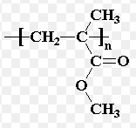

**Study Design Reference**

Common reactions of organic compounds including equations: addition reactions of alkenes

**Web Link**

<http://www.chemguide.co.uk/organicprops/alkenes/polymerisation.html#top>

**Question 16 ANS A**

Butanoic acid is CH3CH2CH2COOH and ethanol is CH3CH2OH. Remember that you must count the carbon atom in the COOH group when naming alkanoic acids.

Hence, ethyl butanoate is CH3CH2CH2COOCH2CH3

**Study Design Reference**

Structure including molecular, structural and semi-structural formulae, and International Union

of Pure and Applied Chemistry (IUPAC) nomenclature of alkanes, alkenes, amines, haloalkanes,

alkanols (CnH2n+1OH), alkanoic acids (CnH2n+1COOH) and esters up to C10.

**Web Link**

<http://www.chemguide.co.uk/basicorg/conventions/names.html#top>

**Question 17 ANS A**

n(H+) initially = n(H­Cl) initially = 4 mol.

n(OH-) initially = n(NaOH) initially = 2 mol.

From the equation, n(OH-) reacting = 2 (there is 2 mol of H+ in excess)

Energy released (exothermic reaction, H is negative) = 2 × 56 = 112 kJ.

**Important note:** H = . This means per mole of equation **as written**.

If the equation were written 2OH-(aq) + 2H+(aq)  2H2O(l),

then H would be written H = 

**Study Design Reference**

The use of ΔH notation. Application of calorimetry to measure energy changes in chemical reactions in solution calorimetry.

**Web Link**

<http://www.chemguide.co.uk/physical/energetics/neutralisation.html#top>

### Question 18 ANS D

In this galvanic cell, the Fe3+(aq) ions accept one electron and are reduced to Fe2+(aq) ions since the Fe3+(aq) ion (+0.77V) is a stronger oxidant than the Zn2+(aq) ion (-0.76V). See Page 4 of the Data Book – The electrochemical series. This is a reduction reaction occurring by definition at the cathode and occurs at the positive electrode because electrons are flowing in.

**Study Design Reference**

Use of the electrochemical series in predicting the products of redox reactions. The chemical principles, half-equations and overall equations of simple primary and secondary galvanic cells

**Web Link**

<http://chemed.chem.wisc.edu/chempaths/GenChem-Textbook/Galvanic-Cells-699.html>

### Question 19 ANS A

The overall equation for the reaction is 2H2(g) + O2(g) → 2H2O(l). The hydrogen gas and the oxygen gas must appear in the reactants not the products. Hence, **C** and **D** are incorrect. In this reaction, the oxidation number of hydrogen changes from 0 in H2(g) to +1 in H2O(l). This is oxidation. In this reaction, the oxidation number of oxygen changes from 0 in O2(g) to -2 in H2O(l). This is reduction.

The anode is the electrode at which oxidation occurs. **B** is incorrect.

The anode reaction is H2(g) + 2OH-(aq)→ 2H2O(l) + 2e-

The cathode is the electrode at which reduction occurs.

The cathode reaction is O2(g) + 2H2O(l) + 4e-→ 4OH-(aq)

**Study Design Reference**

Use of the electrochemical series in predicting the products of redox reactions and deducing overall

equations from redox half equations.

**Web Link**

<http://www.chemguide.co.uk/physical/redoxeqia/ecs.html#top>

### Question 20 ANS C

See the electrochemical series on Page 4 of the Data Book. Water molecules accept electrons more readily than sodium ions. A water molecule is a stronger oxidant (-0.83 V) than

a sodium ion (-2.71 V). Hence, in the presence of water, sodium ions will not accept electrons to produce sodium metal. Molten sodium salts must be used in electrolysis to produce sodium metal. Cl-(aq) is a reductant not an oxidant. **A** is incorrect. Na(s) is a stronger reductant than H2(g).

**B** is incorrect. Na(s) is a stronger reductant than Cl-(aq). **D** is incorrect.

**Study Design Reference**

Comparison of electrolytic cells using molten and aqueous electrolytes

**Web Link**

<http://chemed.chem.purdue.edu/genchem/topicreview/bp/ch20/faraday.php>

### Question 21 ANS A

When glucose and fructose combine to produce sucrose, water is eliminated and an ether linkage

-C-O-C- is formed between the two monosaccharides. This is a condensation reaction as shown below.

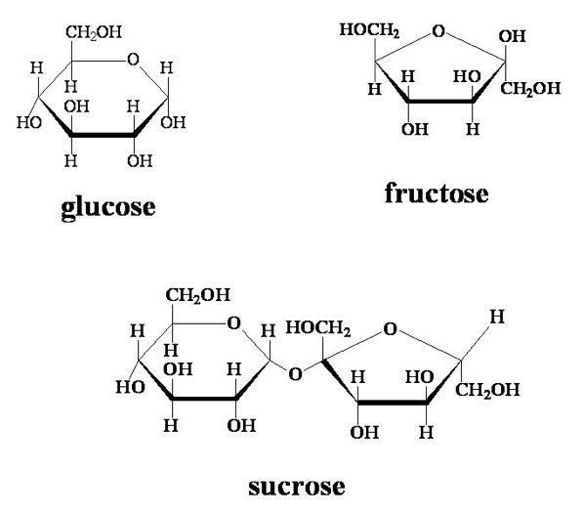+ H2O

A hydrolysis reaction involves the addition of water. **B** and **D** are incorrect.

An ester linkage is –COOC-. **C** is incorrect.

**Study Design Reference**

Condensation and polymerisation reactions that produce large biomolecules including carbohydrates, proteins and DNA

**Web Link**

<http://www.princeton.edu/~achaney/tmve/wiki100k/docs/Ether.html>

### Question 22 ANS C

The molecule glycerol has the formula C3H5(OH)3. Three carboxylic acid molecules, R-COOH, will react with the three hydroxyl groups in the glycerol to form three ester linkages, -O-C-O-R,

where R is C*n*H2*n*+1 for a saturated fatty acid and C*n*H2*n*-1 for a carboxylic acid containing one double bond. A sample reaction is shown below. Three water molecules are produced for each triglyceride formed.

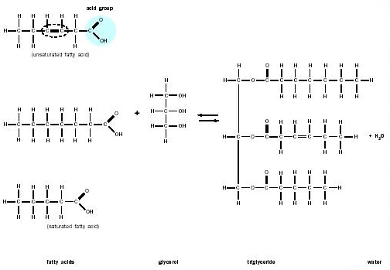

double bond

+ 3H2O

**Study Design Reference**

Condensation reactions that produce lipids (limited to triglycerides)

**Web Link**

<http://tasisbio.blogspot.com.au/2012/10/molecules-joining.html>

### Question 23 ANS D

This is a hydrolysis reaction in which water molecules are added to starch according to the generalised equation (C6H10O5)*n*(aq) + *n*H2O(l)     *n*C6H12O6(aq). The polymer, starch, is broken down into its constituent monomers. Glycogen and starch have the same generalised formula. The hydrolysis reaction is shown below.

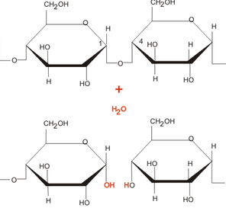

**Study Design Reference**

Condensation and polymerisation reactions that produce large biomolecules including

carbohydrates, proteins and DNA

**Web Link**

<http://www.elmhurst.edu/~chm/vchembook/547glycogen.html>

### Question 24 ANS D

Phenylalanine is an amino acid. See Page 9 of the Data Book. The functional groups are NH2 and COOH. These functional groups enable phenylalanine to form polypeptides and proteins. This is shown below. The phenyl grouping is C6H5 but this aromatic ring is not a functional group.

**A** and **C** are incorrect. CH2 is not a functional group. **B** is incorrect.

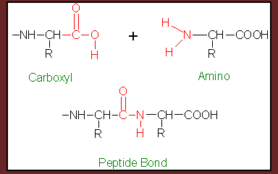

**Study Design Reference**

Primary, secondary and tertiary structures of proteins

**Web Link**

<http://www.chembio.uoguelph.ca/chemzine/v1i1feb02/page6.shtml>

### Question 25 ANS B

Use the electrochemical series on Page 4 of the Data Book. The oxidants are on the left hand side of the half-equations. The reductants are on the right hand side. An oxidant will react with a reductant if the E0 value of the oxidant is greater than (more positive than) the E0 value of the reductant. The oxidant Cu2+(aq) has a more positive E0 value (+0.34V) than the reductant H2(g).

(0.00V or -0.83V). Hence, a spontaneous reaction is predicted. O2(g) and Cu2+(aq) are both oxidants and, therefore, no reaction is predicted between O2(g) and Cu2+(aq). Pb(s) is predicted to react with O2(g) only. **A is incorrect.** Ag(s) is predicted to react with O2(g) only. **C is incorrect.**

Al3+(aq) is predicted to react with neither O2(g) nor H2(g). **D is incorrect.**

**Study Design Reference**

Use of the electrochemical series in predicting the products of redox reactions and deducing overall

equations from redox half equations.

**Web Link**

<http://www.chemguide.co.uk/physical/redoxeqia/ecs.html>

### Question 26 ANS D

The external power supply provides electrons directly to the graphite electrode (negative electrode) so that the reduction reaction Cu2+(aq) + 2e-  Cu(s) can occur to deposit copper metal on the graphite. Charge is carried through the electrolyte as positive and negative ions **not** as electrons. This is illustrated below. The electrode labeled Me is graphite in this case.

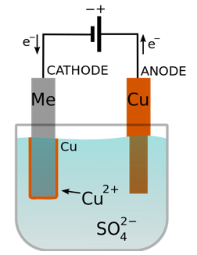

**Study Design Reference**

The chemical principles, half-equations and overall equations of simple electrolytic cells;

**Web Link**

<http://www.genericmaker.com/2012_04_01_archive.html>

### Question 27 ANS B

### Use Page 10 in the Data Book. Linolenic acid has the formula C17H29COOH. This is an unsaturated acid. A saturated acid would be C17H35. For each C=C double bond formed, 2 hydrogen atoms are lost. Therefore, in linolenic acid there are three C=C double bonds. There is also one C=O double bond in the functional group –COOH. The total number of double covalent bonds in linolenic acid is four (4). The structure is shown below.

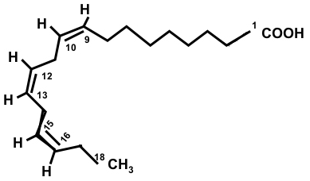

**Study Design Reference**

Condensation reactions that produce lipids (limited to triglycerides)

**Web Link**

<http://en.wikipedia.org/wiki/Alpha-Linolenic_acid>

### Question 28 ANS D

DNA has a backbone of alternating sugar and phosphate units with the nitrogen bases (Adenine, Thymine, Cytosine and Guanine) attached only to the sugar units. This is shown below. The phosphate groups are not joined directly. Only **D** shows this backbone correctly.

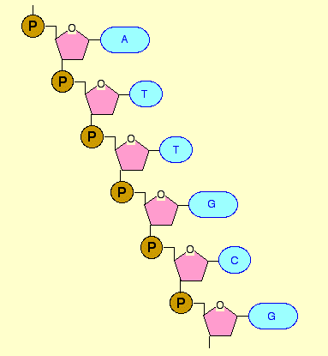

**Study Design Reference**

Primary and secondary structure of DNA.

**Web Link**

### <http://www.chemguide.co.uk/organicprops/aminoacids/dna1.html>

### Question 29 ANS C

There are 5 carbon atoms in the molecule. The longest possible carbon chain here contains 4 carbon atoms. Hence, the name is derived from butane. **B** and **D** are incorrect. Place the OH on the lowest possible number for the chain. With some exceptions (outside the VCE syllabus), the alcohol or hydroxyl group gets first priority for naming. **A** is incorrect. Therefore, numbering from the left of the chain, 3-methylbutan-2-ol.

**Study Design Reference**

Nomenclature of alkanols (CnH2n+1OH) up to C10

**Web Links**

### <http://en.wikipedia.org/wiki/IUPAC_nomenclature_of_organic_chemistry#Alcohols>

<http://chemwiki.ucdavis.edu/Organic_Chemistry/Alcohols/Naming_Alcohols>

### Question 30 ANS A

Use Page 7 of the Data Book. Butanoic acid contains the bond C=O with a wave number of

1670 – 1750 cm-1. There is no significant absorption in this region. **B** is incorrect. Butene contains the bond C=C with a wave number of 1610 – 1680 cm-1. There is no significant absorption in this region. **C** is incorrect. 2-chlorobutane contains the bond C-Cl with a wave number of 700 – 800 cm-1. There is no significant absorption in this region. **D** is incorrect. There is a large absorption band at 3350 cm-1. This is indicative of the bond O-H in an alcohol with a wave number of 3200 – 3550 cm-1.

**A** is the most likely.

**Study Design Reference**

Infrared spectroscopy (IR) including use of characteristic absorption bands to identify bonds

**Web Link**

### <http://www.chemguide.co.uk/analysis/ir/fingerprint.html#top>

**Question 1**

**a.** When the copper is heated, the energy is absorbed by the electrons in the copper atoms and the electrons move to excited states. (1 mark) When these electrons release their energy by moving to lower energy levels, (1 mark) the **difference in the energy levels** (1 mark) is seen as green light. This is shown in the diagram below.

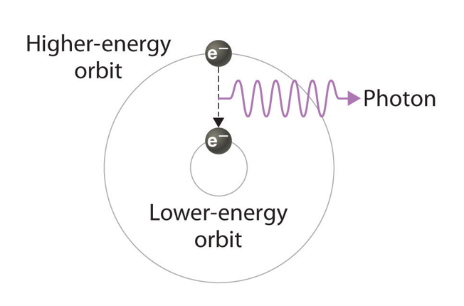

**Study Design Reference**

Visible and ultraviolet spectroscopy (visible-UV) including electron transitions.

**Web Link**

<http://www.chemguide.co.uk/analysis/uvvisible/radiation.html#top>

(1 mark)

Relative isotopic mass

62

63

64

65

Relative abundance

20

40

60

80

100

**b.**

(1 mark)

75

25

(1 mark)

The relative atomic mass is the weighted average of the relative isotopic masses of the naturally occurring isotopes. RAM = (75% of 63) + (25% of 65) = 63.5

**Study Design Reference**

Mass spectroscopy

**Web Link**

<http://www.chemguide.co.uk/analysis/masspec/howitworks.html>

**Question 1 (continued)**

**c.** From the balanced equation:

*n*(NO) produced =  × *n*(Cu) used up (1 mark) =  × 0.6 = 0.4 mol (1 mark)

**Study Design Reference**

Calculations including amount of solids, liquids and gases;

volume, pressure and temperature of gases.

**Web Link**

[www.educationscotland.gov.uk/images/chemmolecalcsunitlabel_tcm4-148466.pdf](http://www.educationscotland.gov.uk/images/chemmolecalcsunitlabel_tcm4-148466.pdf)

**d.** 

(Consequential on the answer to **1 c)**

              

P = 337 kPa

**Study Design Reference**

Calculations including amount of solids, liquids and gases;

volume, pressure and temperature of gases.

**Web Link**

<http://www.chemguide.co.uk/physical/kt/idealgases.html#top>

**Question 2**

**a.** As the carrier gas sweeps the sample through the glass column, the components move in and out of solution in the liquid stationary phase. (1 mark) The least soluble components move through the column most quickly. (1 mark)

**b.** HPLC is a very sensitive technique because the components in the sample continually pass into and out of solution in the liquid stationary phase. (1 mark) Very small differences in the adsorption and desorption of different components are amplified (1 mark) and even 10-12 g of a compound can be detected.

**Study Design Reference**

High performance liquid chromatography (HPLC)

**Web Link**

## <http://www.chemguide.co.uk/analysis/chromatography/hplc.html>

**Question 3**

**a.** *n*(H2O2) initially = *c* × *V* = 0.15 × 0.2 = 0.03mol(1 mark)

**b.** *n*(H2O2) not reacting = (5/2) × *n*(MnO4-) (1 mark)

= (5/2) × 0.01 × 0.025

= 0.000625

= 6.25 × 10-4 mol (1 mark)

**c.** *n*(H2O2) reacting = 0.03 - 0.000625 (1 mark)

= 0.029375 = 2.94 × 10-2 mol (1 mark)

**d.** *n*(SO2) = *n*(H2O2) reacting = 0.029375 (1 mark)

Hence, *m*(SO2) = 0.029375 × 64 = 1.88 g (1 mark)

**e.** [SO2] = 1.88/20 (1 mark)

= 0.094

= 9.40 × 10-2 g m-3(1 mark)

**Study Design Reference**

Volumetric analysis including determination of excess and limiting reagents and titration curves:

simple and back titrations, acid-base and redox titrations.

**Web Link**

<http://www.bbc.co.uk/bitesize/higher/chemistry/calculations_3/redox_titr/revision/1/>

**Question 4**

**a.** An unsaturated compound is one that contains at least one carbon to carbon multiple covalent bond (double bond or triple bond). (1 mark)

**b.**

|  |  |  |  |
| --- | --- | --- | --- |
| Reagent | Name | Chemical Formula |  |
| **A** | chlorine gas | Cl2 | (1 mark) |
| **B** | aqueous sodium hydroxide | NaOH(aq) | (1 mark) |
| **E** | hydrogen chloride gas | HCl(g) | (1 mark) |
| **F** | steam (water) | H2O(g) | (1 mark) |
| **G** | phosphoric acid | H3PO4 | (1 mark) |

**c.**

|  |  |
| --- | --- |
| C ethanoic acid (1 mark)  **Macintosh HD:Users:billhealy:Desktop:Screen Shot 2013-08-07 at 10.20.43 AM.png**  (1 mark) | D propyl ethanoate (1 mark)  **Macintosh HD:Users:billhealy:Desktop:Screen Shot 2013-08-07 at 10.22.25 AM.png**  (1 mark) |

**Study Design Reference**

Organic reaction pathways including appropriate equations and reagents - production of esters from alkenes

**Web Link**

<http://en.wikipedia.org/wiki/Ethylene>

**Question 5**

**a.** The calibration constant of the calorimeter:



**b.** The next experimental steps and the calculations required are:

* Determine the initial temperature of the calorimeter with 100 mL of de-ionised water ().
* Slowly add, while stirring, a known mass of concentrated sulfuric acid to the calorimeter (*m*).
* Determine the maximum temperature reached after all of the sulfuric acid has been added ().
* Calculate the change in temperature ().
* Calculate the number of mol of sulfuric acid added .
* Use the formula:

(1 mark for each dot point to a maximum of 4 marks)

**c.**  Possible sources of error in this experiment are:

* The addition of sulfuric acid may change the volume of liquid in the calorimeter and, hence, the calibration constant may not be the same.
* Heat energy may escape from the calorimeter during the addition of the sulfuric acid.
* Insufficient stirring may cause the energy in the calorimeter to be not distributed evenly and, hence, the temperature measurements may not be accurate.

(1 mark for each dot point to a maximum of 2 marks)

**Study Design Reference**

Application of calorimetry to measure energy changes in chemical reactions in solution calorimetry

and bomb calorimetry, including calibration of a calorimeter and the effects of heat loss.

**Web Link**

<http://bit.ly/WYNVr5>

**Question 6**

**a.**



From the balanced equations,

890 kJ is released for 1 mol of CH4(g) and 1560 mol is released for 2 mol of C2H6 (g).

**Important note: The *H* values are per mole of equation as written.**



**b.** Coal is produced from organic material under heat and pressure over a very long time frame. Once it is consumed it is gone and, therefore, non-renewable. (1 mark)

Natural gas is also produced over a long time deep within the Earth (non-renewable) but it also produced from the rapid decay of organic material on the surface of the Earth.

Natural gas, as a biofuel, is renewable. (1 mark)

**Study Design Reference**

Deduction of Δ*H* for an overall reaction given energy profiles or Δ*H* of two related reactions. Comparison of the renewability of energy sources including coal, petroleum, natural gas, nuclear

fuels and biochemical fuels.

**Web Links**

<http://bit.ly/1aiFW2R>

<http://science.howstuffworks.com/environmental/energy/natural-gas-renewable3.htm>

**Question 7**

**a.** 2CrO4 2- (aq) + 2H+(aq)  Cr2O7 2-(aq) +H2O(l)

This is **not** a redox reaction. (1 mark)

The oxidation numbers in the equation do not change. Cr remains +6. (1 mark)

### b. Use the data book (page 4) for the Zn(s) half-equation.

### Zn(s)  Zn2+(aq) + 2e-

### Cr2O7 2-(aq) + 14H+(aq) + 6e-    2Cr 3+(aq) + 7H2O(l) (1 mark)

3Zn(s) + Cr2O7 2-(aq) + 14H+(aq)     Zn2+(aq) + 2Cr 3+(aq) + 7H2O(l) (1 mark)

**c.** Use the data book (page 8) to get the molecular formula for glycine.

The equation for the combination of 2 molecules of glycine to form a dipeptide is

2NH2CH2COOH **** NH2CH2CONHCH2COOH + H2O (1 mark)

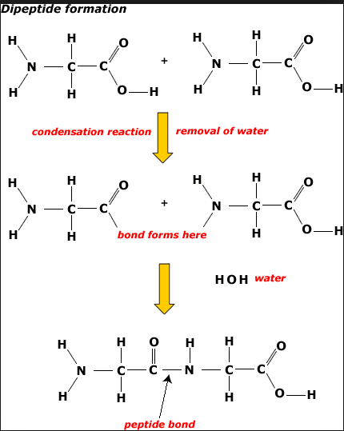

**Study Design Reference**

The writing of balanced chemical equations, including the use of oxidation numbers to write redox

equations. Condensation and polymerisation reactions that produce large biomolecules including

carbohydrates, proteins and DNA.

**Web Links**

<http://www.youtube.com/watch?v=yumnYB_iGfU>

### <http://www.youtube.com/watch?v=mfDApGo8PC0>

### <http://click4biology.info/c4b/3/images/3.2/dipeptide.gif>

### Question 8

**a.** B is the cathode since the electrons pushed here by the power supply will cause a reduction reaction. (The cathode is the electrode at which reduction takes place). (1 mark)

**b.** Use the Data Book Page 4. Ag+(aq) is the strongest oxidant (+0.80V) and so it will react first according to the equation:

Ag+(aq) + e- ** **Ag(s) (1 mark)

**c.** Use the Data Book Page 4. Cu2+(aq) is the next strongest oxidant (+0.34V) and so it will react next according to the equation:

Cu2+(aq) + 2e- ** **Cu(s) (1 mark)

**d.** Use the Data Book Page 4. H2O(l) is the weakest oxidant (-0.83V) and so it will react last according to the equation:

2H2O(l) + 2e- → H2 (g) + 2OH-(aq) (1 mark)

**e.** Use the Data Book Page 4. Water is oxidised at the anode to produce oxygen gas according to the equation:

2H2O(l) → O2(g) + 4H+(aq) + 4e-



**Study Design Reference**

The chemical principles, half-equations and overall equations of simple electrolytic cells; comparison of electrolytic cells using molten and aqueous electrolytes, and inert and non-inert electrodes. Application of Faraday’s laws in electrochemistry.

**Web Link**

### <http://firstyear.chem.usyd.edu.au/bridging_course/Questions/electrolysis.htm>

### Question 9

**a.**

|  |  |
| --- | --- |
| Name | pentan-1-ol (1 mark) |
| Semi-structural formula | CH3CH2CH2CH2CH2OH (1 mark) |
| Structural formula | Macintosh HD:Users:billhealy:Desktop:Screen Shot 2013-08-12 at 12.38.01 PM.png  (1 mark) |

**b.**

|  |  |
| --- | --- |
| Name | butanoic acid (1 mark) |
| Semi-structural formula | CH3CH2CH2COOH (1 mark) |
| Structural formula | Macintosh HD:Users:billhealy:Desktop:Screen Shot 2013-08-12 at 12.40.10 PM.png  (1 mark) |

### Question 9 (continued)

**c.** Structure of **pentyl butanoate**.

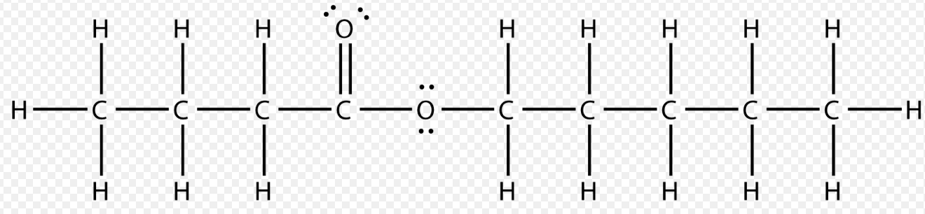

For overall structure (1 mark)

For showing all bonds (1 mark)

### d. Circle around ester functional group shown above. (1 mark)

### 

**Study Design Reference**

Structure including molecular, structural and semi-structural formulae, and International Union

of Pure and Applied Chemistry (IUPAC) nomenclature of alkanes, alkenes, amines, haloalkanes,

alkanols (C*n*H2*n*+1OH), alkanoic acids (C*n*H2*n*+1COOH) and esters up to C10

**Web Link**

### <http://www.chemguide.co.uk/physical/catalysis/esterify.html>

### Question 10

**a.** A peptide link between two alpha amino acids. Circle shows the peptide link.

**Z1** and **Z2** represent the side branches on the alpha amino acids.

The elements in the peptide link are carbon, oxygen, nitrogen and hydrogen (1 mark)

N

H

C

O

NH2 – CH**Z1** – CONH – CH**Z2** – COOH

(1 mark)

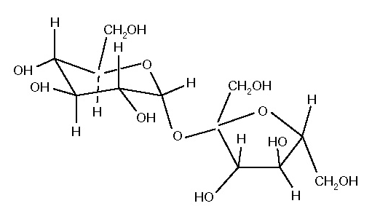**b.** When the two monosaccharides glucose and fructose combine to form sucrose, the link between the two ring structures is a **carbon – oxygen – carbon** link as shown below.

The bond is called a glycosidic or ether linkage. (1 mark)

(1 mark)

### Question 10 (continued)

**c.** A disulfide link (-S–S-) in a protein molecule occurs between two amino acids each containing a sulfur atom as shown below. The link contributes to the tertiary structure of the protein by getting the amino acid sequence to fold in a particular way.

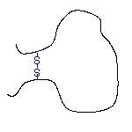 (1 mark)

(1 mark)

**Study Design Reference**

Chemical bonding - primary, secondary and tertiary structures of proteins.

Condensation and polymerisation reactions that produce large biomolecules including carbohydrates, proteins and DNA.

**Web Links**

<http://www.chemguide.co.uk/organicprops/aminoacids/proteinstruct.html>

<http://chemed.chem.wisc.edu/chempaths/GenChem-Textbook/Disaccharides-1022.html>

**Question 11**

**a.** 

At equilibrium, [HCOOH] = 0.01M and [H3O+] = [HCOO-]

From the Data Book page 11, *Ka* for methanoic acid at 25oC = 1.8 × 10-4

Therefore,



**b.** Sodium methanoate is HCOONa which produces sodium ions and methanoate ions in aqueous solution. According to Le Chatelier’s principle, the addition of HCOO- will shift the position of equilibrium to the left.

(1 mark)

More HCOOH will be produced and H3O+ will be used up. Hence, acidity will decrease.

Hence, pH will increase.

(1 mark)

**Question 11 (continued)**

**c.** (full marks to be allocated only for a correct description **and** a correctly drawn graph)

**1.** When the HCl is added, the reaction shifts to the left to produce more HCOOH and less HCOO-.

(1 mark)

The amount of H3O+ is greater than the original amount so that, at the new equilibrium position 2, (EQ2), the value of *Ka* is unchanged (temperature is constant). (1 mark)

**2.** When the temperature is increased, the reaction shifts to the left to favour the endothermic reaction and produce more HCOOH, less HCOO- and less H3O+. (1 mark)

A new equilibrium position is reached (EQ3) and the value of *Ka* has decreased. (1 mark)

HCOOH

H3O+

HCOO-

0.00134 M

0.01 M

0.00134 M

**Concentration**

**(not to scale)**

**Reaction**

EQ1

EQ2

EQ3

**Study Design Reference**

Homogeneous equilibria and the equilibrium law. Le Chatelier’s Principle and factors which affect the position of equilibrium. pH as a measure of strength of acids and bases; *Kw*, *Ka* for weak acids.

**Web Link**

<http://www.chemguide.co.uk/physical/acidbaseeqia/acids.html>

**Question 12**

You can also use the 1H NMR information on Pages 5 and 6 of the Data Book.

**a.** There are 5 different hydrogen environments. (1 mark)

There are 5 sets of peaks. (1 mark)

**b.** The triplet shows that there are 2 hydrogen atoms on the neighbouring carbon atom. (1 mark)

**c.**

|  |  |
| --- | --- |
| Macintosh HD:Users:billhealy:Desktop:Screen Shot 2013-08-17 at 11.46.37 AM.png  (1 mark) | butan-1-ol (1 mark) |

**A more detailed explanation of the 1H NMR spectrum of butan-1-ol**

There are five types of H in compound **X**, three different CH2 units, a CH3 unit, and the -OH unit. There are five sets of peaks. The first CH2 unit has 2 H neighbours, so the *n* + 1 rule means we see the 3 lines of a triplet. The second CH2 unit has a total of 4 H neighbours (2 × CH2) so the *n* +1 rule means that we see the 5 lines of a quintet. The third CH2 unit has a total of 5 H neighbours

(1 × CH2 + 1 × CH3) so the *n* + 1 rule means that we see the 6 lines of a sextet. The CH3 unit has

2 H neighbours, so the *n* + 1 rule means we see the 3 lines of a triplet. The proton in the –OH

appears here as a singlet. The heights of the peaks are in a 2 : 1 : 2 : 2 : 3 ratio.

**Question 12 (continued)**

**d.** There are 5 different hydrogen environments. (1 mark)

There are 5 sets of peaks. (1 mark)

**e.** The sextet shows that there are 5 hydrogen atoms on the neighbouring carbon atom. (1 mark)

**f.**

|  |  |
| --- | --- |
| **Macintosh HD:Users:billhealy:Desktop:Screen Shot 2013-08-17 at 12.00.36 PM.png**  (1 mark) | butan-2-ol (1 mark) |

**A more detailed explanation of the 1H NMR spectrum of butan-2-ol**

There are five types of H here, a CH unit, a CH2 unit, two different CH3 units, and the -OH unit.

There are five sets of peaks. The CH unit has 5 H neighbours (1 × CH2 + 1 × CH3), so the *n* + 1 rule means we see the 6 lines of a sextet. The CH2 unit has 4 H neighbours (1 × CH + 1 × CH3), so the

*n* + 1 rule means that we see the 5 lines of a quintet. The CH3 nearest the oxygen has 1 H neighbour, so the *n* + 1 rule means we see the 2 lines of a doublet. The CH3 unit furthest from the oxygen has 2 H neighbours, so the *n* + 1 rule means we see the 3 lines of a triplet.   
The proton in the –OH appears here as a singlet.

The heights of the peaks are in a 1 : 1 : 2 : 3 : 3 ratio.

**Question 12 (continued)**

**g.** Compound Z has the structure

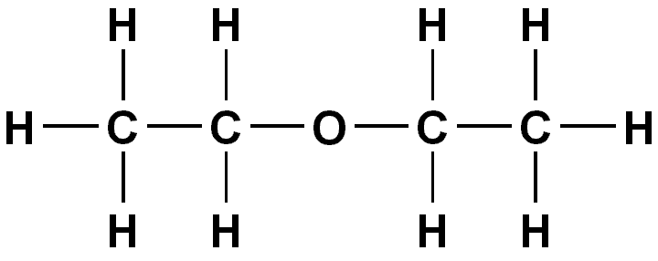 (1 mark)

**A more detailed explanation of the 1H NMR spectrum of compound Z (diethyl ether)**

The two ethyl groups in diethyl ether are equivalent to each other so we have two types of H, the CH2 units and the CH3 units. These are seen as two sets of peaks. The CH2 unit has 3 H neighbours, so the *n* + 1 rule means that we see the 4 lines of a quartet. The CH3 unit has 2 H neighbours, so the *n* + 1 rule means we see the 3 lines of a triplet. The peak heights of CH2 to CH3 give a 2 : 3 ratio. This is the "classic" spectrum of an ethyl group, -CH2CH3

##### h.

|  |  |  |
| --- | --- | --- |
| Compound | Number of carbon atoms | Number of different carbon environments |
| Z | 4 | 2 (1 mark) |

**Study Design Reference**

Proton nuclear magnetic resonance spectroscopy (NMR) including spin. The application of

carbon-13 to determine number of equivalent carbon environments and application of proton NMR to determine structure: chemical shift, areas under peak and peak splitting patterns and application of *n* + 1 rule to simple compounds.

**Web Link**

<http://www2.chemistry.msu.edu/faculty/reusch/VirtTxtJml/Spectrpy/nmr/nmr1.htm>

**End of 2013 Kilbaha VCE Chemistry Trial Examination**

**Detailed Answers**

|  |  |
| --- | --- |
| **Kilbaha Multimedia Publishing**  **PO Box 2227**  **Kew Vic 3101**  **Australia** | **Tel: (03) 9018 5376**  **Fax: (03) 9817 4334**  [**kilbaha@gmail.com**](mailto:kilbaha@gmail.com)  [**http://kilbaha.com.au**](http://kilbaha.com.au) |