**THELSON**

TRIAL EXAMINATION 2011

**CHEMISTRY**

WRITTEN EXAMINATION 2

QUESTION AND ANSWER BOOKLET

READING TIME: 15 minutes

WRITING TIME: 1 hour 30 minutes

STUDENT NAME: ______________________

TEACHER’S NAME:_______________________

STRUCTURE OF BOOKLET:

|  |  |  |  |
| --- | --- | --- | --- |
| SECTION | NUMBER OF QUESTIONS | NUMBER OF QUESTIONS TO BE ANSWERED | MARKS |
| A | 20 | 20 | 20 |
| B | 7 | 7 | 70 |
|  |  |  | Total 90 marks |

|  |
| --- |
| * Students are permitted to bring into the examination room: pens, pencils, highlighters, erasers, sharpeners, rulers and one scientific calculator. * Students are NOT permitted to bring into the examination room: blank sheets of paper and/or white out liquid/tape.   **Materials Supplied**   * Question and answer booklet of 25 pages * Data Booklet of 11 pages; use VCAA data book   **Instructions**   * Please ensure that you write **your name** and your **teacher’s name** in the space provided on this booklet. * All written responses must be in English. |

|  |
| --- |
| **Students are NOT permitted to bring mobile phones and/or any other unauthorised electronic devices into the examination room.** |

SECTION A: MULTIPLE-CHOICE QUESTIONS

|  |
| --- |
| **Instructions for Section A**  Answer **all** questions in pencil on the answer sheet provided for multiple-choice questions.  Choose the response that is **correct** or that **best answers** the question.  A correct answer scores 1, an incorrect answer scores 0.  Marks will **not** be deducted for incorrect answers.  No mark will be given if more than one answer is completed for any question. |

**Question 1**

Which of the following statements is TRUE in regards to activation energy?

1. In an exothermic reaction, the activation energy is more than the energy released when the new bonds form.
2. Activation energy is the amount of energy released when new bonds form.
3. The fraction of molecules able to overcome the activation barrier changes with the temperature.
4. The activation energy for an endothermic reaction will be the same as the activation energy of the reversed reaction.

**Question 2**

The value of an equilibrium constant, K, for a particular reaction is found to 4.6. Which of the following is the most likely scenario of the reaction?

1. The solution is primarily made up of reactants.
2. The solution is primarily made up of products.
3. The solution is made up of a significant number of both reactants and products.
4. The scenario cannot be determined without further information.

**Question 3**

For the reaction given below, the value of the equilibrium constant, K, is 8.

$$\text{2A + 3B }\text{ 2C + 4D}$$

Assuming the same conditions are kept, another reaction is run:

$$\text{4C + 8D }\text{ 4A + 6B}$$

The value of K for this new reaction would be:

1. 16
2. 64
3. 0.125
4. 0.0156

*Questions 4 and 5 refer to the following information.*

Also known as the Haber Process, a common equilibrium reaction is shown:

$${N_{2}}_{(g)} + 3{H_{2}}_{(g)} ↔ {2NH_{3}}_{(g)} ΔH = -92.22 kJ {mol}^{-1}$$

**Question 4**

Assuming equilibrium, which of the following scenarios **WOULD NOT** result in a net **forward** reaction?

1. addition of H2 reactant
2. decrease in volume
3. decrease in temperature
4. addition of Ar(g)

**Question 5**

In a separate reaction, 3 mol of N2 and 3 mol of H2 is added to a 2L vessel and is sealed. After a period of time, in which it is deemed to be at equilibrium, the concentration of NH3 is 0.5mol L-1.

The equilibrium constant for this particular reaction is closest to:

1. 0.05
2. 0.50
3. 5.00
4. 50.0

**Question 6**

Nuclear Fission is an alternative method to produce energy. Its advantages include (but are not limited to) being able to produce large amounts of energy that is stored within the nucleus of an atom, and having an environmental impact less than that of burning fossil fuels.

Which of the following correctly describes the process of nuclear fission?

1. measuring the half-life of certain elements to determine their radioactive decay.
2. bombarding large atoms with neutrons in order to break apart their nuclear force.
3. reacting two lighter nuclei in order to form a single, heavier nucleus.
4. exciting nuclei to higher energy levels in order to gather the heat produced when photons are emitted.

**Question 7**

Biochemical Fuels are one of the many renewable energy sources that are becoming increasingly popular as a possible source of energy for the future.

Which of the following is not a type of biochemical fuel?

1. methane
2. ethanol
3. octane
4. methyl stearate

*Questions 8 and 9 refer to the following information.*

The ***hydrogen-oxygen fuel cell*** is becoming an attractive option for portable energy generation in the near distant future.

**Question 8**

Which of the following is the correct combination of the characteristics of the hydrogen-oxygen fuel cell?

|  |  |  |  |
| --- | --- | --- | --- |
|  | Fuel | Oxidant | Which is more efficient?  (fuel cell/coal power stations) |
| **A.** | hydrogen | oxygen | coal |
| **B.** | hydrogen | oxygen | fuel cell |
| **C.** | oxygen | hydrogen | coal |
| **D.** | oxygen | hydrogen | fuel cell |

**Question 9**

Which of the following is **NOT** true for ordinary fuel cells?

1. All fuel cells use hydrogen as a fuel.
2. All fuel cells consist of an electrolyte material that is “sandwiched” between two electrodes.
3. All fuel cells have an input fuel that passes over the anode where it splits into ions and electrons.
4. All fuel cells will run continuously as long as fuel is supplied.

**Question 10**

For the following reaction;

$${{2H}_{2}O}_{(l)} ↔{{H_{3}O}^{+}}_{(aq)}+{{OH}^{-}}_{(aq)}; ∆H=+57 kJ {mol}^{-1}$$

Which of the following alternatives is correct when the temperature increases above 25°C?

|  |  |  |
| --- | --- | --- |
|  | pOH (of pure water) | Ionisation Constant of Water (Kw) |
| **A.** | Increases | Increases |
| **B.** | Increases | Decreases |
| **C.** | Decreases | Increases |
| **D.** | Decreases | Decreases |

*Questions 11 refers to the following information.*

A reaction between hydrochloric acid and barium hydroxide is shown below.

$${2HCl}_{(aq)} + Ba{{\left(OH\right)}_{2}}_{(aq)} → Ba{{Cl}_{2}}_{(aq)} + 2H_{2}O$$

**Question 11**

The resultant pH when 50.0mL of 1.00M HCl is added to 50.0mL of 0.500M Ba(OH)2 is?

1. 0.6
2. 1.7
3. 7.0
4. 12.7

**Question 12**

In another reaction, a 100mL solution of the above mixture is found to have a pH of 4. What volume of water must be added to raise the pH to 6?

1. 0.9L
2. 2.0L
3. 9.9L
4. 10.0L

**Question 13**

Electrorefining of Copper is a common industrial practice to remove impurities from what is known as “Blister Copper”.

Which of the following substances in blister copper is **NOT** oxidised at the anode, given that the potential difference exerted across the two half cells is just enough to cause oxidation of copper?

1. silver
2. copper
3. zinc
4. nickel

**Question 14**

The deposition of a layer of metal on the surface of another metal by electrolysis is known as electroplating.

Which of the following is the correct statement regarding the **object being plated** in this process?

1. It is acting as the negative electrode, and is the cathode.
2. It is acting as the negative electrode, and is the anode.
3. It is acting as the positive electrode, and is the cathode.
4. It is acting as the positive electrode, and is the anode.

*Questions 15 and 16 refer to the following information.*

An electrolytic cell was constructed, and at the cathode the following half equation for the deposition of aluminium atoms is shown:

$${{Al}^{3+}}_{(aq)} + 3e^{-}→ {Al}_{(s)}$$

After 10 seconds, a mass gain by the deposition of aluminium on the electrode was 0.81g.

**Question 15**

Assuming no mass is lost during this reaction, the charge passed through the cell over the 10 seconds is closest to

1. 2.5 C
2. 87 C
3. 2900 C
4. 8700 C

**Question 16**

A second cell is constructed using the same apparatus, however this time the **current** is halved.

What mass would be deposited if the same reaction occurred for 5 minutes?

1. 0.405g
2. 4.050g
3. 12.15g
4. 24.30g

**Question 17**

Phosphoric Acid (H3PO4) is a common catalyst and dehydrating agent. Since it is a triprotic acid, the following reactions occur;

$$Reaction 1: H_{3}P{O_{4}}_{\left(s\right)} + H_{2}O_{(l)} ↔ H_{3}O_{(aq)}^{+} + H_{2}P{O_{4}^{-}}_{(aq)}$$

$$Reaction 2: H_{2}P{O_{4}^{-}}_{(aq)} + H_{2}O_{(l)} ↔ H_{3}O_{(aq)}^{+} + HP{O_{4}^{2-}}_{(aq)}$$

$$Reaction 3: HP{O_{4}^{2-}}_{(aq)} + H_{2}O_{(l)} ↔ H_{3}O_{(aq)}^{+} + P{O_{4}^{3-}}_{(aq)}$$

Out of these reactions, which would possess the highest Ka value?

1. Reaction 1
2. Reaction 2
3. Reaction 3
4. Unable to be determined without further information

**Question 18**

According to the following reaction;

$$N{H_{3}}_{(g)} + HCl_{(g)} → NH_{4}Cl_{\left(s\right)}; ∆H= \text{-176kJ mo}{\text{l}}^{\text{-1}}$$

The amount of energy that would be produced if 30.0g of NH3 is reacted completely with excess HCl would be closest to

1. 176 J
2. 176,000 J
3. 311,000 J
4. 0.311 J

*Questions 19 and 20 refer to the following galvanic cells.*

A student is given two galvanic cells by his teacher, as shown below. The student’s task is to correctly determine the identity of the 3 elements X, Y and Z – which represent real elements - used in the construction of these two galvanic cells.

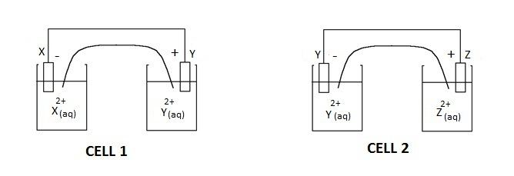

**Question 19**

On the basis of the polarity of the electrodes shown above, which one of the following reactions would **not** be expected to occur spontaneously?

$Y_{(aq)}^{2+} + X_{(s)} → Y_{(s)} + X_{(aq)}^{2+}$

$Z_{(aq)}^{2+} + Y_{(s)} → Z_{(s)} + Y_{(aq)}^{2+}$

$Z_{(aq)}^{2+} + X_{(s)} → Z_{(s)} + X_{(aq)}^{2+}$

$X_{(aq)}^{2+} + Y_{(s)} → X_{(s)} + Y_{(aq)}^{2+}$

**Question 20**

In order to determine what each of the elements were, the student set up another set of galvanic cells (at 298K, 1.0 mol-1 solutions and 1atm). He thought that if he could determine the standard cell potential differences, he could determine the identity of his unknown metals. Unfortunately, his voltmeter could only give approximate readings. These readings are as shown:

* X & Z = 0.50 – 0.70V
* Y & Z = 0.05 – 0.25V

Which of the following could be the identity of X and Y respectively?

1. zinc, nickel
2. tin, iron
3. manganese, magnesium
4. magnesium, calcium

**Instructions for Section B**

Answer **all** questions in the spaces provided.

To obtain full marks for your responses you should

* + give simplified answers with an appropriate number of significant figures to all numerical questions;

unsimplified answers will not be given full marks.

* show all working in your answers to numerical questions. No credit will be given for an incorrect answer unless it is accompanied by details of the working.
* make sure chemical equations are balanced and that the formulas for individual substances include an indication of state; for example, H2(g); NaCl(s)

**Question 1**

On the planet Ecorus, ammonia (NH3) is present as a liquid, and in this planet the role of ammonia is analogous to that of water on Earth. Like water, ammonia can undergo autodissociation as per the following equation:

2 NH3 (l) 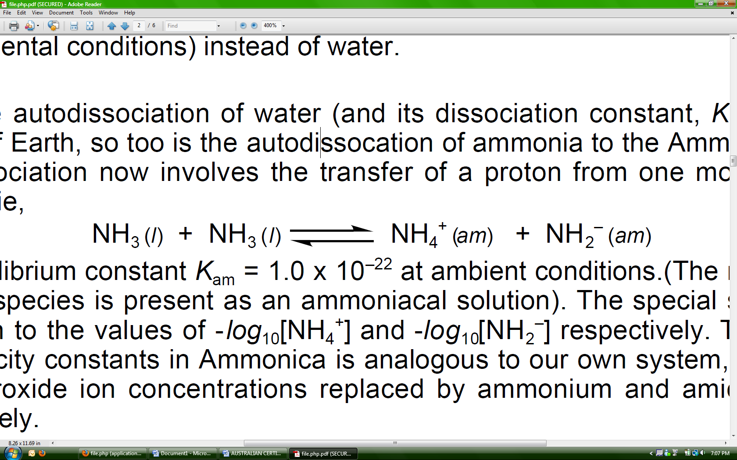NH4+ (am) + NH2- (am)

Kam = [NH4+][NH2-] = 1.0 x 10-22 (at ambient temperature)

The (am) state refers to a substance dissolved in ammonia, analogous to (aq) for water.

In this planet, pH and pNH2 are defined as –log10[NH4+] and –log10[NH2-] respectively. Assume that the species are present at ambient temperature.

1. What is the relationship between [NH4+] and [NH2-] in neutral ammonia?

1 mark

1. Therefore, state the pH of neutral ammonia.

1 mark

Suppose we dissolve water (**which exists as a solid in this planet**) into ammonia to form a solution.

1. Explain why water acts as an acid when dissolved in ammonia by referring the behaviour of ammonia when dissolved into water on Earth.

1 mark

Water acts as a weak acid in ammonia. Ignore any possibility of OH- acting as an acid.

1. Write a balanced equation for the reaction between water and ammonia in Ecorus. Include states in your answer.

2 marks

1. Write an expression for the Ka of water in ammonia in terms of the concentrations of the appropriate species. **Do not use the symbol [H+].**

1 mark

The Ka of water in ammonia is 1.8 x 10-5 at ambient temperature.

1. Determine the pH of the solution if 4.25 g of pure solid water is dissolved in 475.0 mL of pure ammonia, with both the solution and the water at ambient temperature.

3 marks

1. Write **three assumptions** that you made in the calculation performed in part **f**, and justify why these assumptions are valid.

3 marks

Total 12 marks

**Question 2**

When 0.01 g of the sparingly soluble salt silver chloride is inserted into 100.0 mL water to form a saturated solution, its aqueous phase establishes equilibrium with its solid phase as per the following equation:

AgCl (s) Ag+ (aq) + Cl- (aq) ΔH = +82 kJ/mol at 298 K

Ksp is an equilibrium constant. The following relation holds for a saturated solution of silver chloride:

Ksp = [Ag+ ] [Cl-] = 1.6 x 10-10 M2.

The **solubility** of AgCl is the concentration of AgCl (aq) - in mol L-1 - when an excess of solid silver chloride is mixed with pure water to form a saturated solution of AgCl, where the aqueous and the solid phases are in equilibrium.

1. What is the solubility of AgCl in mol L-1?

2 marks

1. A 0.20 g block of sodium chloride is dissolved into this 100.0 mL mixture of AgCl and water. The mass of the solid is observed to increase. Explain this observation.

2 marks

A 1.00 x 10-5 g sample of pure AgCl was added to 50.0 mL of water, then a 50.0 mL aliquot of 2.00 x 10-2 M sodium chloride was added to this mixture, and equilibrium was established.

1. Calculate the final mass of the AgCl precipitate. State any reasonable assumptions that you make.

4 marks

1. Would an increase in temperature from 298 K increase or decrease the solubility of AgCl? Explain your answer using equilibrium principles.

2 marks

Total 10 marks

**Question 3**

At 698 K hydrogen and iodine gas establishes equilibrium with hydrogen iodide as per the following equation:

H2(g) + I2(g)2HI(g)

A closed container contains a mixture of H2, I2 and HI (all in the gaseous phase at 698 K), which is initially at equilibrium. The following changes are made in the following order:

* a decrease in volume at constant temperature at **2 minutes**
* injection of a sample of HI (g) into the reaction mixture at **10 minutes** at constant volume

The system re-establishes equilibrium before the second change is made.

1. On the axes below, the reaction rate - time and concentration - time graphs**. Label** the axes and lines drawn.Include:

* the rate of the forward and back reactions in the rate-time graph
* the concentrations of each species in the concentration-time graph

**Rate – time graph Concentration – time graph**

4 marks

1. Explain the change in the **rate-time** graph at **10 minutes** using collision theory.

2 marks

Total 6 marks

**Question 4**

Circle the chemical that you have studied this year.

ammonia ethene sulfuric acid nitric acid

Below is a table of the reaction conditions of the reversible reactions:

|  |  |  |
| --- | --- | --- |
| Chemical | ammonia | ethene |
| Reversible Reaction(s) | N2 (g) + 3H2 (g)  2NH3 (g)  ΔH = - 92 kJ/mol | C2H6 (g)  C2H4 (g) + H2 (g)  ΔH = +138 kJ/mol  C3H8 (g)  C2H4 (g) + CH4 (g)  ΔH = +81 kJ/mol |
| Conditions | T = 773 K  P = 250 atm  excess reactant is not used (for economic reasons)  removal of product  catalyst is ferric oxide, aluminium oxide and potassium oxide | T = 1023 – 1173 K  P ~ 1 atm  product is constantly removed |

|  |  |  |
| --- | --- | --- |
| Chemical | sulfuric acid | nitric acid |
| Reversible Reaction(s) | 2SO2 (g) + O2 (g)  2SO3 (g)  ΔH = - 198 kJ/mol | Reaction 1 🡪  4NH3 (g) + 5O2 (g)  4NO (g) + 6H2O(g)  ΔH = -907 kJ/mol  Reaction 2 🡪  2 NO (g) + O2 (g)  2NO2 (g)  ΔH = -114 kJ/mol  **Note: rate of reaction 2 increases with a decrease in temperature.** |
| Conditions | T = 723 K  P ~ 1 atm  excess oxygen is used  removal of product  catalyst is vanadium (V) oxide | Reaction 1 🡪  T = 1093 – 1203 K  P > 1 atm  excess oxygen is used  product is constantly removed  catalyst 🡪 Pt/Rh  Reaction 2 🡪  T = 303 K  P > 1 atm  product is constantly removed |

* 1. In a short paragraph, describe the reasons for why the **reversible reaction(s)** that occur(s) during the production of your chemical is generally done under the specific conditions outlined above. Refer to both the rate of reaction and the position of equilibrium in your answer.

6 marks

* 1. Name two uses of your selected chemical, and outline how its chemical properties make it suitable for these uses.

4 marks

Total 10 marks

**Question 5**

Ammonium nitrate (NH4NO3) is a chemical with many uses. It is an explosive, but it can also be used in ice packs. Dissolution of ammonium nitrate in water results in a decrease in the temperature of the water.

1. Explain whether the dissolution of ammonium nitrate in water is endothermic or exothermic, **based on the information given above.**

1 mark

A 0.243 g sample of ammonium nitrate was dissolved in 200.0 g of water in a solution calorimeter. The temperature of the water decreased from 296.41 K to 296.14 K.

1. Determine the heat of dissolution per mole of ammonium nitrate using the specific heat capacity of water only (4.18 J g-1 K-1).

2 marks

Another way to determine the heat of dissolution of ammonium nitrate in water is by calibrating the solution calorimeter. A current of 3.10 A was passed through a second **identical** calorimeter (also containing 200.0 g of water) for 30.0 seconds at a voltage of 6.00 V. The temperature of the calorimeter and its contents increased from 294.32 K to 296.41 K. Another 0.243 g sample of ammonium nitrate was dissolved in the water in the calorimeter, and the temperature of the contents again decreased from 296.41 K to 296.14 K.

* 1. Determine the calibration factor of this calorimeter and use this to re-calculate the molar heat of dissolution of ammonium nitrate.

3 marks

1. Which of the calculated values for the heat of dissolution is more accurate? Explain your answer.

1 mark

Consider the reaction NH4NO3 (aq) 🡪 NH4NO3 (s).

1. Determine the heat of the above reaction per mole of ammonium nitrate based on your calculations performed in this question. Use the more accurate value that you calculated.

1 mark

Total 8 marks

**Question 6**

Consider a galvanic cell with the following specifications:

Half-cell 1:

* Pb electrode
* 1.00 M Pb2+ solution

Half-cell 2:

* Ni electrode
* 1.00 M Ni2+ solution
* Salt bridge is made out of aqueous potassium nitrate.
* The half-cells are connected to a voltmeter.
* The temperature of the cell is 298 K.

1. Sketch a diagram of the above galvanic cell. Indicate:

* the species present in each half-cell and the composition of each electrode
* the cathode and the anode, and their polarities
* the direction of the electron flow
* the direction of the flow of the ions in the salt bridge

4 marks

1. Write down:
   1. a balanced overall equation for the redox reaction
   2. the standard electrode potential of the cell (E°CELL)

1 + 1 = 2 marks

The standard potential difference (E°CELL) between two half-cells is the potential difference between the two half-cells under standard conditions. The actual potential difference between the two half-cells (ECELL) varies according to temperature of the half-cells and the concentration of the ionic species; it may or may not be equal to E°CELL.

1. Is the standard potential difference (E°CELL) equal to the actual potential difference (ECELL1) between the above two half-cells with the above specifications? Explain.

1 mark

Now consider this galvanic cell (Cell 2).

Half-cell 1:

* Pb electrode
* 0.100 M Pb2+ solution

Half-cell 2:

* Ni electrode
* 2.00 M Ni2+ solution
* Salt bridge is made out of aqueous potassium nitrate.
* The half-cells are connected to a voltmeter.
* The temperature of the cell is 304 K.

1. Is the standard potential difference (E°CELL) is equal to the actual potential difference (ECELL2) between the two new half-cells with the above specifications? Explain.

1 mark

The potential difference of the new half-cell can be calculated using the Nernst equation:

ECELL = E°CELL –

where R is the universal gas constant, T is the temperature in Kelvin, F is Faraday’s constant.

1. Determine the potential difference (ECELL) between the two half-cells in the second galvanic cell.

2 marks

A solution of 0.100 M Pb2+ and 2.000 M Ni2+ was made up, and an adequate number of nickel and copper granules added to this mixture. The mixture is at a temperature of 304 K. This solution can be viewed as having a potential difference between the reactants and the products which is initially equal to the potential difference calculated in part **e**. As the redox reaction proceeds, the potential difference between the reactants and the products decreases to 0 V and then the concentrations of the ionic species remain constant.

At ECELL = 0 V, the reaction mixture of Ni2+ and Pb2+ is in equilibrium.

1. Using the Nernst equation, determine the equilibrium constant of the reaction written in part **bi** at 304 K.

2 marks

1. Hence, calculate the final concentrations of Ni2+ and Pb2+ in the mixture.

2 marks

Total 14 marks

**Question 7**

Electrorefining is a technique to purify solid metals via electrolysis. One electrode is comprised of a thin sheet of pure copper, whilst the other electrode is comprised of the impure copper sample. After electrolysis occurs, the copper from the impure copper sample is deposited onto the pure sheet.

Below is an incomplete diagram of the apparatus used for electrorefining. **Note that the direction of electron flow is given.**

1. Complete the diagram of the apparatus used for electrorefining. Label:

* the anode and cathode, and their polarities.
* the electode with the pure copper sample, and the electrode with the impure copper sample
* the cations present in solution

direction of electron flow

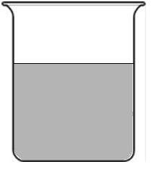

4 marks

There are other metals present in the impure copper sample that behave upon electrolysis according to their reactivity.

1. **Circle** the metals that are **more** reactive than copper under standard conditions.

Ni Fe Pb Co Au Sn Zn Ag

1 mark

1. What happens to the metals you have circled during electrolysis?

1 mark

1. What happens to the **uncircled** metals during electrolysis (i.e. metals less reactive than copper)?

1 mark

The initial mass of the impure copper sample acting as an electode is 1.00 g. The technician performing the electrorefining made a mistake in switching the terminals, so that copper from the pure sheet was being deposited onto the impure copper sample. The 3.00 A current was run for 2.00 minutes. After the 2 minutes, there is still copper remaining on the thin sheet.

1. What is the final mass of the impure sample of copper?

3 marks

Total 10 marks

**END OF QUESTION AND ANSWER BOOK**