Balance of Payments – Check for Understanding

**Using the data in the chart to answer questions 1 – 4.**

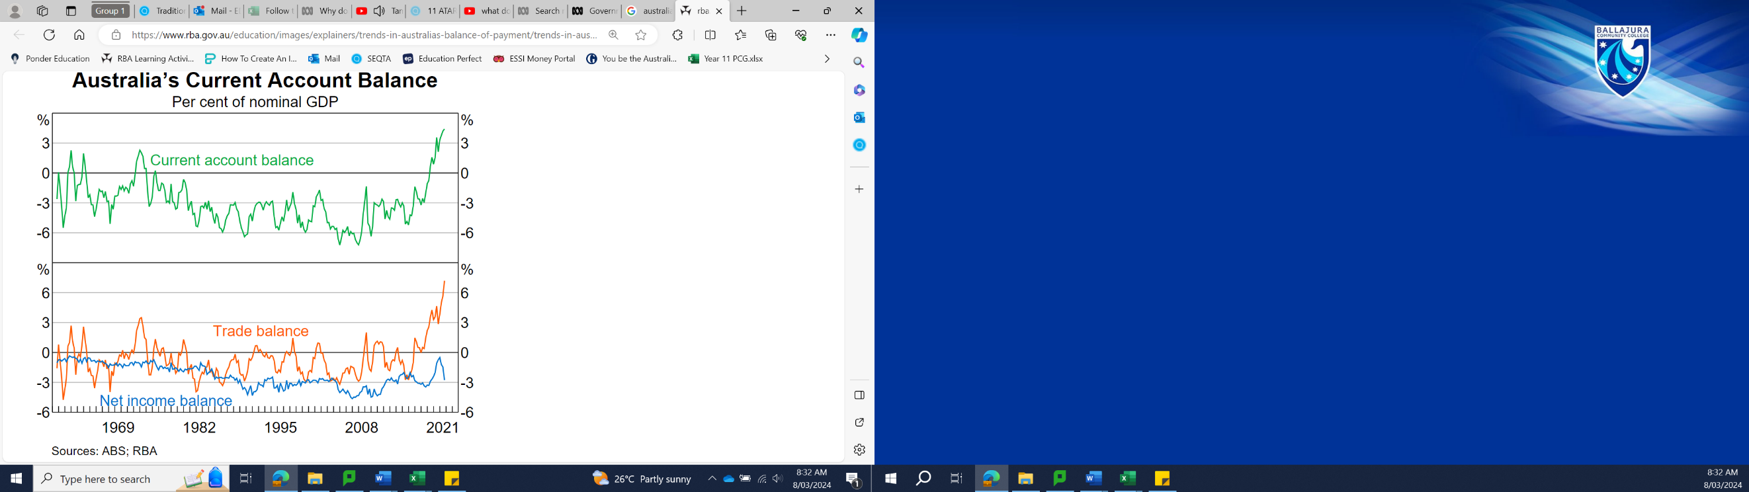

1. **Which of the following statements is false?**
2. The CAD widened during the mining boom
3. Australia recorded a CAS in 2021
4. Net income balance has been in defict since the 1960s
5. The Trade balance has trended constant from 2010-2020
6. **At the end of the mining boom (2015 – 2020), the net income balance …**
7. Narrowed from the decrease in foreign investment
8. Widened from the increase in foreign investment
9. Widened from the decrease in foreign investment
10. Narrowed from the increase in foreign investment
11. **The fluctations in the Current Account are primarily caused by …**
12. flucations in income outflows.
13. fluctuations in the balance of goods and services.
14. fluctuations in income outflows
15. fluctuations in foreign investments
16. **If the Capital Account was balanced in 2010, then …**
17. there must be a surplus in Errors and Omissions equal to 5% of GDP.
18. the Current Account must also be balanced.
19. the Financial Account must have recorded a surplus of 3% of GDP.
20. the Reserve Bank must be buying foreign assets.
21. **Calculate the balance on the capital and financial account during 2020. (1)**

___________________________________________________________________

1. **Explain why Australia’s balance of payments account must always balance. (2)**

_______________________________________________________________________________________________________________________________________________________________________________________________________________________________________________________________________________________________________________________________________________

1. **Explain two reasons why Australia recorded a Current Account Surplus. (4)**

__________________________________________________________________________________________________________________________________________________________________________________________________________________________________________________________________________________________________________________________________________________________________________________________________________________

______________________________________________________________________________________________________________________________________

___________________________________________________________________

___________________________________________________________________

1. **Discuss what this CAS means for Australia’s national savings. (3)**

_______________________________________________________________________________________________________________________________________________________________________________________________________________________________________________________________________________________________________________________________________________

______________________________________________________________________________________________________________________________________

1. **Explain how the business cycle has impacted Australia’s trade balance from 2015 - 2020. (3)**

_______________________________________________________________________________________________________________________________________________________________________________________________________________________________________________________________________________________________________________________________________________

______________________________________________________________________________________________________________________________________

**ANSWERS**

1. **D –** the other answers are all true, but the trade balance has not trended constant from 2010-2020, it has increased significantly (-3% in 2010 and +3% 2020).
2. **A -** The end of the mining boom meant less foreign investment was entering Australia, so it must be A or C. And the deficit in net income balance narrowed (got smaller) from 2015-2020, so the answer is A.
3. **B –** The graph shows that the fluctuations in the Current Account mirrors the fluctuations in the trade balance. Balance of Goods and Services is another name for the trade balance.
4. **C –** The Current Account recorded a -3% deficit in 2010, so if the Capital Account is balanced (=0%) then the Financial Account must be in surplus of 3%, so that the Balance of Payments is equal to zero.
5. KAFA = -3% (deficit) of Nominal GDP
6. Australia’s Balance of Payments must always balance, or equal zero, because it uses the double entry accounting system to record our international transactions. Double entry recording means that for every credit or debit in the accounts, there must be an equal and opposite entry, thus meaning that the balance is always equal to zero across all accounts.
7. *[Explain question, your answer must explain why we have a CAS, what caused it]*

*Example:*1) Australia’s trade balance increased significantly, which leads to an increase in the Current Account. Our exports increased significantly over this period as there was high global demand for our commodities (especially China as they experienced strong economic growth). Our exports also increased because global commodity prices remained high over this period, leading to greater export profits for Australia.  
2) Australia’s high levels of foreign investment over the mining boom, used to generate large income outflows (dividends and interest paid to foreign investors) recorded in the Current Account. The mining boom ending means there is less foreign investment, therefore less income outflows which will increase the Current Account.

1. *[Discuss question, your answer must outline the relationship between CAB and Savings/Investment, then explain a positive and a negative side to S > I ]*

*Example:*  
Current Account Balance is equal to the difference between national savings and national investment **(CAB = S – I)**. A CAS, means that national savings is greater than national investment (S > I), meaning that there is no Savings-Investment gap, and our surplus savings is being invested overseas. This could be a sign of strength for the economy because it shows that we have enough savings to fund all our investment opportunities, and we don’t need to borrow money from other countries. On the other hand, this could be a sign of weakness for the economy because it could mean our economy has less investment opportunities, which will mean slower economic growth in the future.

1. Between 2015 – 2020, Australia’s trade balance grew significantly, which was primarily the result of increased exports. This was in part caused by the global business cycle because as our trade partners all went through the expansion phase of the business cycle during this period, they experienced high levels of employment and economic growth. This increased income for our trade partners led to high levels of demand for our exports (particularly our commodities), which partly explains the large increase in our trade balance.