Multiple-choice section

|  |  |  |  |  |  |  |  |  |  |
| --- | --- | --- | --- | --- | --- | --- | --- | --- | --- |
| Question | 1 | 2 | 3 | 4 | 5 | 6 | 7 | 8 | 9 |
| Answer | C | B | B | D | A | C | B | C | D |

|  |  |  |  |  |  |  |  |  |  |
| --- | --- | --- | --- | --- | --- | --- | --- | --- | --- |
| Question | 10 | 11 | 12 | 13 | 14 | 15 | 16 | 17 | 18 |
| Answer | C | B | C | B | D | C | D | B | A |

Question 1 [1.4]

C

3y = x + 2: y = ; m = 

The perpendicular line has a gradient of -3.

Question 2 [2.3]

B

IQR of Fertiliser A: 20 – 10 = 10

IQR of Fertiliser B: 20 – 5 = 15

So, the IQR of Fertiliser A is not greater than the IQR of Fertiliser B.

Question 3 [2.6] [10A]

B

w = -2.96 × 25 + 14.23

= -74 + 14.23

= -59.77

Question 4 [3.4]

D

The negative in front of the bracket causes a reflection in the x-axis.

The -3 inside the bracket causes a translation of 3 units to the right.

Question 5 [3.6]

A



= 

= 

Question 6 [4.2]

C

3(m2 − 4m + 1)

= 3[(m − 2)2 − 3]

= 3(m − 2 − )(m − 2 + )

Question 7 [5.2]

B

SA = 2 × πr2 + 2πr × 20

= 2πr(r + 20)

= 2 × π × 7(7 + 20)

= 1187.522

Question 8 [6.3]

C

Using a calculator, cos-1(0.2917) = 73°2'25''.

Question 9 [7.3] [10A]

D

3 = 4cos(x)

cos(x) = 0.75

x = 41.409°

Also need the 4th quadrant angle:   
(360 − 41.4)° = 318.6°

Question 10 [9.6] [10A]

C

The top-left angle is 55° as it is on the same arc as the other 55° angle.

α is the third angle in the triangle:   
180 − 42 − 55 = 83

Question 11 [8.3] [10A]

B

(2x3 − 3x + 5) × (3x3 − 2x)  
= 6x6 − 4x4 − 9x4 + 6x2 + 15x3 − 10x

= 6x6 − 13x4 + 15x3 − 6x2 − 10x 

Question 12 [10.4]

C



Question 13 [11.4] [10A]

B

 = 

Question 14 [12.5] [10A]

D

Use the rule to change format.

Question 15 [9.1]

C

AB connects 39° and 78°.

Question 16 [10.1]

D

|  |  |  |  |  |  |  |
| --- | --- | --- | --- | --- | --- | --- |
|  | 1 | 2 | 3 | 4 | 5 | 6 |
| 1 | 2 | 3 | 4 | 5 | 6 | 7 |
| 2 | 3 | 4 | 5 | 6 | 7 | 8 |
| 3 | 4 | 5 | 6 | 7 | 8 | 9 |
| 4 | 5 | 6 | 7 | 8 | 9 | 10 |
| 5 | 6 | 7 | 8 | 9 | 10 | 11 |



Question 17 [13.2]

B

Quarterly interest means rate is 

5 years = 20 quarterly periods

Question 18 [13.5]

A

$(2500 − 250) = $2250

 = 0.4090, so $0.41

Multiple-choice total marks: 18

Short answer section

Question 19 12 marks [1.3]

|  |  |
| --- | --- |
| (a) x − y = 2  PM10_PR_ES01 | (b) 5x + 3y = 6  PM10_PR_ES02 |
| (c) y = -3x  PM10_PR_ES03 | (d) y = 5  PM10_PR_ES04_RR |
| (e) x = -2 PM10_PR_ES05 | (f) 3x + 2y = -10  PM10_PR_ES06_RR |

Question 20 6 marks [1.6]

(a) Let a = number of 3-mark questions  
b = number of 2-mark questions  
 a + b = 37 [1]  
 3a + 2b = 100 [2]  
 2a + 2b = 74 [1] × 2: (3)  
 3a + 2b = 100 [2]  
 a = 26 [2] − (3)  
Substitute for a = 26 in [1]  
 26 + b = 37  
 b = 11  
There are 26 3-mark questions and 11 2-mark questions.

(b) Let h = number of herbs  
 s = number of seedlings  
 h + s = 13 [1]  
 4.95h + 3.95s = 58.35 [2]  
 395h + 395s = 5135 [1] × 395: (3)  
 495h + 395s = 5835 [2] × 100: (4)  
 100h = 700 (4) − (3)  
 h = 7  
Substitute for h = 7 in [1]  
 7 + s = 13  
 s = 6  
Rhonda purchased 7 pots of herbs and 6 punnets of seedlings.

Question 21 10 marks [3.7]

|  |  |
| --- | --- |
| (a)  = | (b)  =  = |
| (c)  = | (d)  =  = |

Question 22 6 marks [5.1, 5.7]

(a) Area of rectangle: 20 × 30 = 600 cm2  
Area of circles = 6 × π × 52 = 471.238 898  
Area not used = 128.761 102  
= 128.76 cm2

(b) Area of rectangle: 15 × 7.5 = 112.5 cm2  
Area of circle = π × 2.52 = 19.634 954 08  
Area of shape = 92.865 045 92  
= 92.87 cm2

[10A] (c)  so   
 volume =  = 22.1 cm3

[10A] (d) 

= 

= 50 mL/L

Question 23 2 marks [6.3]

|  |  |
| --- | --- |
| (a) tan(θ) =  θ = 29°44'42'' | (b) cos(θ) =  θ = 66°25'19'' |

Question 24 6 marks [6.5]

(a)

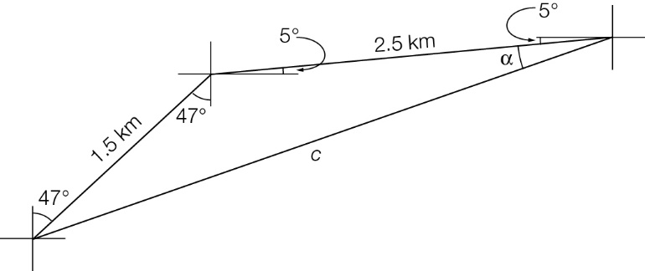  
c2 = 1.52 + 2.52 − 2 × 1.5 × 2.5 × cos(142°)  
 = 14.410...  
 c = 3.796...  
So, the distance back to camp is 3.80 km

(b)

  
α = 14.08... °

270 − α − 5 = 270 – 14.08... – 5 = 250.92...

The scout needs to follow a bearing of 251°T.

Question 25 3 marks [7.5] [10A]





θ = 43.47° or 43°28'

Question 26 7 marks [2.2]

(a) Using technology  
min: 149  
Q1: 160  
median: 168  
Q3: 173  
max: 181

(b) 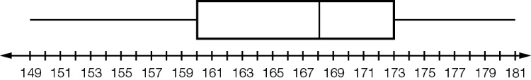

(c) IQR = 173 − 160 = 13  
1.5 × IQR = 19.5  
Q1 − 19.5 = 140.5  
Q3 + 19.5 = 192.5  
There are no outliers

Question 27 6 marks [2.3]

(a) Class A has the highest median but the biggest range and the second biggest IQR. The students who did not do well did relatively poorly. Class B has the highest mean and the lowest IQR and second lowest range. It is certainly a very consistent class. Class C is very bunched with almost no students in the whisker parts.

(b) Sample answer: 47 50 52 52 66 67 68 74 76 77 81 82 93 95 99

Question 28 4 marks [9.1]

|  |  |
| --- | --- |
| (a)   = 3.75 | (b)   = 6.6 |

Question 29 5 marks [9.5]

(a) (i) two pairs of opposite sides parallel

(ii) parallelogram

(b) (i) two pairs of adjacent sides equal and one pair of opposite angles equal

(ii) kite

Question 30 3 marks [9.7] [10A]

ΔJGB ≡ ΔMGE (RHS)

So, AJ = JB = FM = ME

So, BC = ED

So, KC = LD (K is midpoint as KH is perpendicular bisector)

ΔKHC ≡ ΔLHD (RHS)

So, KH = LH

Question 31 6 marks [4.1]

|  |  |  |
| --- | --- | --- |
| (a) 3x2 − 30x + 75 = 0 3(x2 − 10x + 25) = 0 3(x − 5)2 = 0 x = 5 | (b) x2 + 5x − 14 = 0 (x + 7)(x − 2) = 0 x = −7 or 2 | (c) x2 + 12 = 7x x2 − 7x + 12 = 0 (x − 4)(x − 3) = 0 x = 4 or 3 |

Question 32 4 marks [8.5] [10A]

|  |  |
| --- | --- |
| (a) P(x) = (x − 3)(x − 2)(x + 1) PM10_PR_ESA02 | (b) P(x) = (x − 1)2(x + 2)2  PM10_PR_ESA03 |

Question 33 5 marks [10.5]

(a)  
 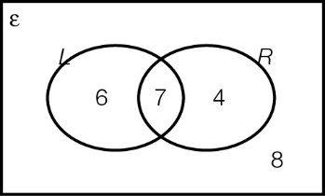  
(b) 7 students (c) (i)  (ii)  (iii) 

Question 34 5 marks [11.3] [10A]

(a)  =   
=   
= 

(b)  =   
= 

(c)  = 3a − 2a = a

(d)  =   
=   
= 

Question 35 8 marks [12.3]

|  |  |
| --- | --- |
| (a)  =  =  = | (b)  =  =  = |
| (c)  =  =  = | (d)  =  =  = |

Question 36 4 marks [13.3]

(a) 10 000(1 + 0.0106 25)8   
= 10 882.29  
10 882.29(1 + 0.011 875)8 = 11 960.111...  
The investment will be worth $11 960.11 after the 4 years.

(b) 11 960.11 = 10 000(1 + r)16  
 = 1 + r  
= 1.011 249 799  
So, r = 0.011 249 799  
Multiply by 4 to find the annual rate  
r = 4.4999%  
The single rate would be 4.5% p.a. for 4 years.

Short answer total marks: 102

Extended answer section

Question 37 12 marks [2.2, 10.1, 10.5]

(a) 41.52

(b) min: 13.3; Q1: 39.7; median: 42.85; Q3: 48.8; max: 53.5

(c) IQR = 9.1 so 1.5 × IQR = 13.65  
Q1 − 13.65 = 26.05  
Q3 + 13.65 = 62.45  
So, 13.3, 15.6 and 19.9 are all outliers as they are more than 1.5 × IQR below Q1.

(d)

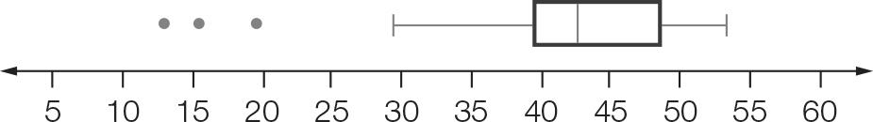

(e) 

(f) 

Question 38 6 marks [9.3]

(a) ∠ADB = ∠CDB (straight angles)  
DB = DB (common side)  
AD = DC (given)  
ΔADB ≡ ΔCDB (SAS)  
So, ∠ABD = ∠CBD (third angle in triangle)  
So, EB bisects ∠ABC

(b) ∠EAD + ∠DAC = ∠DAC + ∠CAB  
So, ∠EAC = ∠DAB  
∠AED = ∠ADF (given)  
AE = AD (given)  
So, ΔEAC ≡ ΔDAB (ASA)

Question 39 12 marks [4.4]

(a)

|  |  |  |  |  |  |  |
| --- | --- | --- | --- | --- | --- | --- |
| Width (w) | 20 | 40 | 60 | 80 | 100 | 120 |
| Length (l) | 100 | 80 | 60 | 40 | 20 | 0 |
| Area (A) | 2000 | 3200 | 3600 | 3200 | 2000 | 0 |

(b) A = w(120 − w)

(c)

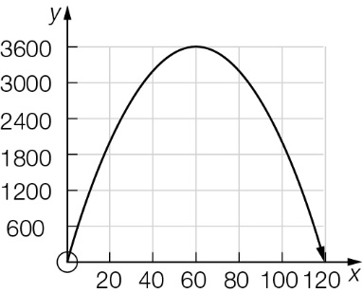

(d) 60 × 60 gives the largest area.

(e)

|  |  |  |  |  |  |  |  |  |  |  |
| --- | --- | --- | --- | --- | --- | --- | --- | --- | --- | --- |
| Width (w) | 20 | 40 | 60 | 80 | 100 | 120 | 140 | 160 | 180 | 200 |
| Length (l) | 180 | 160 | 140 | 120 | 100 | 80 | 60 | 40 | 20 | 0 |
| Area (A) | 3600 | 6400 | 8400 | 9600 | 10 000 | 9600 | 8400 | 6400 | 3600 | 0 |

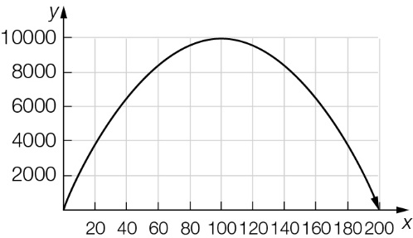  
A = w(200 − w)  
The greatest area is 100 × 100 m

(f) A square gives the greatest area.

Extended answer total marks: /30

TOTAL test marks: /150