Multiple-choice section – choose the correct answer

Question 1 [6.2]

The coordinates of a point that lies on the line *y* = 2*x* – 3 are:

A (0, 3) B (-1, -5) C (-2, -4) D (3, 5)

Question 2 [6.3]

(-2, -5), (-1, -1), (0, 3), (1, 7) are points that lie on the line with the rule:

A *y* = 4*x* – 3 B *y* = 2*x* + 3 C *y* = 4*x* + 1 D *y* = 4*x* + 3

Question 3 [7.1]

Which equation describes the sentence; six is added to four times a number to give thirty?

A 4*x* – 6 = 30 B 6*x* + 4 = 30 C 4*x* + 6 = 30 D 6 + 4*x* = 3

Question 4 [7.2]

Which of the following equations is equivalent to 9*a* + 12 = 84?

A 9*a* = 72 B 9*a* = 94 C *a* + 12 = 8 D *a* + 12 = 10

Question 5 [7.3]

To obtain *b* from  − 6 you would need to:

A add 6, then divide by 5 B subtract 6, then multiply by 5

C multiply by 5, then add 6 D add 6, then mulitply by 5

Question 6 [7.4]

Solve: 4*c* + 2 = 2*c* + 6

A *c =* 1 B *c =* 2 C *c =* 3 D *c = -*1

Question 7 [8.1]

In the diagram, the angle that is vertically opposite *w* is:

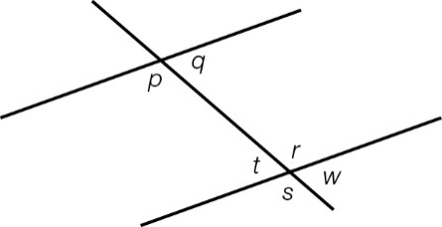

A *p* B *r* C *t* D *s*

Question 8 [8.2]

In the diagram, the value of *a* is:

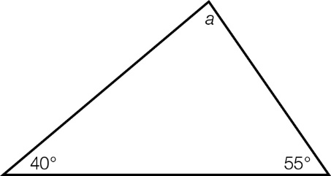

A 80° B 55° C 65° D 85°

Question 9 [8.4]

For the following pair of congruent triangles, state which congruence test is satisfied:

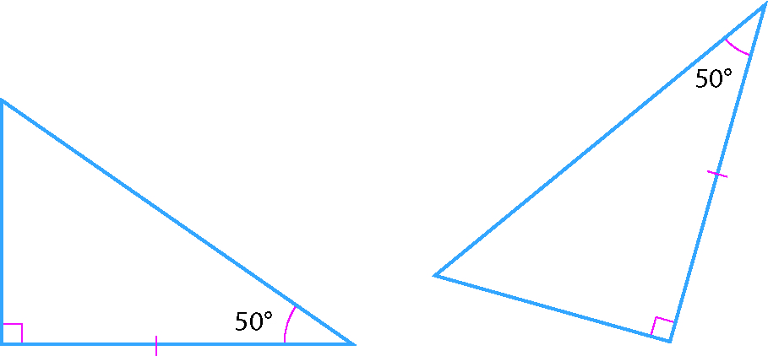

A SSS B RHS C SAS D ASA

Question 10 [9.2]

The mean of 23, 25 and an unknown number is 26. The unknown number is:

A 27 B 28 C 29 D 30

Question 11 [9.4]

For the tabulated data, the mean is:

|  |  |  |
| --- | --- | --- |
| *x* | *f* | *x* × *f* |
| 3  4  5 | 6  10  4 | 18  40  20 |
|  |  |  |

A $\frac{78}{20}$ B  C $\frac{68}{20}$ D $\frac{78}{3}$

Question 12 [9.6]

A card is drawn from a standard pack of 52 cards. What is the probability it is an Ace?

A $\frac{1}{4}$ B  C  D 

Multiple-choice results: \_\_\_ /12

Short answer section

Question 13 11 marks

Choose the correct word from the following list to fill each of the gaps in the following sentences.

*median origin vertex mean equation y-axis gradient  
x-intercept right-angled Cartesian x-axis pronumeral angle  
hypotenuse opposite zero*

(a) The \_\_\_\_\_\_\_\_\_\_\_\_\_\_\_\_\_\_\_\_of a line is a measure of its steepness.

(b) The *y*-intercept is where a line crosses the \_\_\_\_\_\_\_\_\_\_\_and the \_\_\_\_\_\_\_\_\_\_\_\_\_\_is where a line crosses the *x*-axis.

(c) The point (0, 0) is the \_\_\_\_\_\_\_\_\_\_\_\_\_\_\_\_of the \_\_\_\_\_\_\_\_\_\_\_\_\_\_\_\_\_\_plane.

(d) An \_\_\_\_\_\_\_\_\_\_\_\_\_\_is an algebraic statement with an equals symbol.

(e) In algebraic equations or equation the unknown value is represent by a \_\_\_\_\_\_\_\_\_\_\_\_\_\_\_\_ which is generally a letter of the alphabet.

(f) An \_\_\_\_\_\_\_\_\_\_\_\_\_\_ is formed when two lines (or rays) intersect at a point called the \_\_\_\_\_\_\_\_\_\_\_\_.

(g) In a \_\_\_\_\_\_\_\_\_\_\_\_\_\_\_\_\_\_\_\_\_ triangle the \_\_\_\_\_\_\_\_\_\_\_\_\_\_\_\_\_\_\_\_ is opposite the 90°, or right angle.

Question 14 2 marks [9.4]

Discuss whether the mean or the median is a better measure of centre. Give an example where one would be preferred.

Question 15 4 marks [6.2]

(a) Use the table of values to create a list of points for the equation *y* = 2*x* + 1.

|  |  |  |  |  |  |
| --- | --- | --- | --- | --- | --- |
| *x* | -2 | -1 | 0 | 1 | 2 |
| *y* |  |  |  |  |  |

(b) Plot the points on Cartesian axes to draw the graph of the relationship.

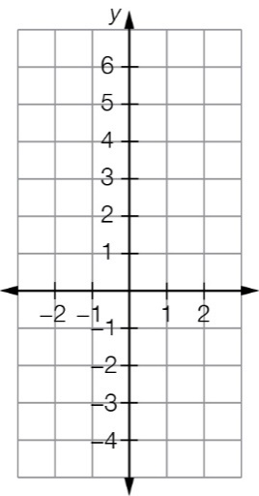

Question 16 4 marks [6.3]

Find the rule for each of the following sets of points.

(a) (-3, -2), (-2, 0), (-1, 2), (0, 4)  
  
*y =* \_\_\_\_\_\_\_\_\_\_\_\_\_\_\_\_\_\_\_\_\_\_\_\_

(b)

|  |  |  |  |  |  |  |
| --- | --- | --- | --- | --- | --- | --- |
| *x* | -3 | -2 | -1 | 0 | 1 | 2 |
| *y* |  |  | 6 | 3 | 0 |  |

*y* = \_\_\_\_\_\_\_\_\_\_\_\_\_\_\_\_\_\_\_\_\_\_\_\_

Question 17 2 marks [6.3]

Determine the equation for the following graph.

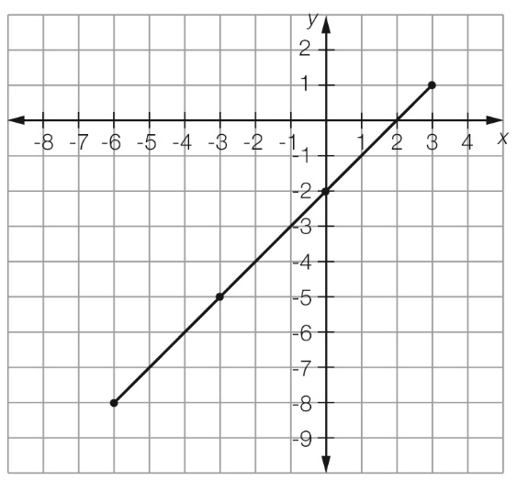

Question 18 4 marks [7.2]

Find the value of the pronumeral in each of the following equations.

(a) 2*a* – 5 = 17 (b) -5*b* + 9 = 29

Question 19 6 marks [7.3]

Find the value of the pronumeral in each of the following equations.

(a)  − 4 = 8 (b) 8(2*r* – 5) = 72

Question 20 6 marks [7.4]

Find the value of the pronumeral in each of the following equations.

(a) 3*a* – 5 = *a* + 7 (b)  = $\frac{4x+7}{2}=\frac{x+10}{6}$

Question 21 3 marks [7.5]

The total distance around this rectangular field is 480 m. Find the value of *x* and use this result to find the length and width of the field.

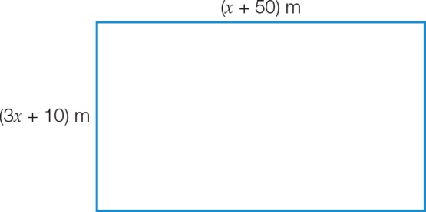

Question 22 7 marks [8.2]

Find the value of the pronumerals in each diagram. Give reasons for your answer.

|  |  |
| --- | --- |
| (a)  PM8_SmB_SemT2_07_RR | (b)  PM8_SmB_SemT2_08_RR |

Question 23 5 marks [8.2]

Find the value of the pronumerals in each diagram. Give reasons for your answer.

|  |  |
| --- | --- |
| (a)  PM8_SmB_SemT2_09_RR | (b)  PM8_SmB_SemT2_10_RR |

Question 24 4 marks [8.3]

(a) Plot the points *A*(2, 2), *B*(8, 2) and *C*(2, 6) on the Cartesian plane provided below. Join the points to form a triangle *ABC* and label the points.

(b) Perform the translation of [-3, 4] on the triangle.

(c) Using the shape you created in (b), perform a clockwise rotation of 90° about the point *C'*.

(d) Using the shape you created in (c), perform a reflection in the *x*-axis. What are the coordinates of the transformed triangle?   
*A*"' \_\_\_\_\_\_\_\_\_\_\_\_ *B*"' \_\_\_\_\_\_\_\_\_\_\_\_ *C*"' \_\_\_\_\_\_\_\_\_\_\_\_

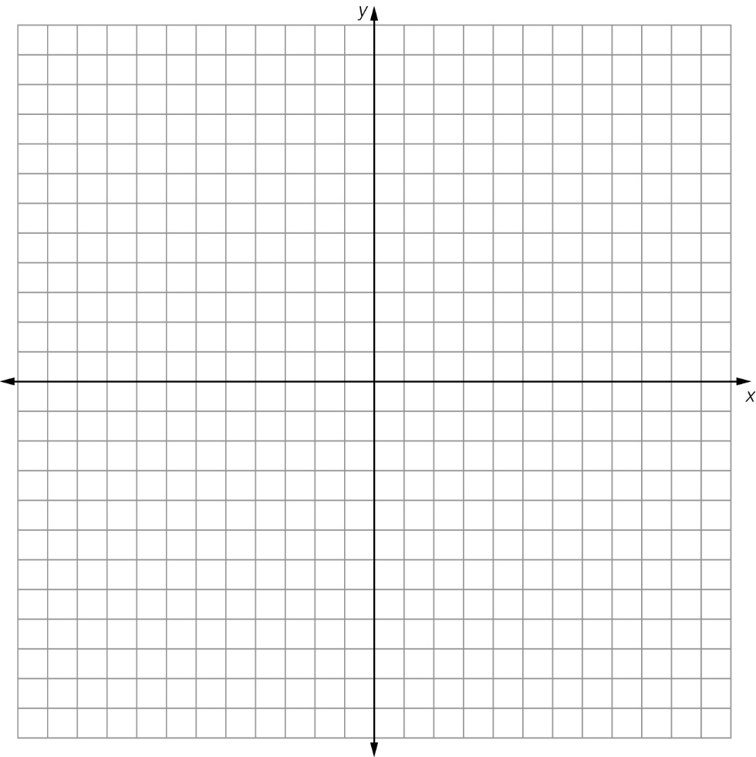

Question 25 4 marks [9.2]

The runs of each member of a cricket team in one innings of a cricket match are given below.

20, 0, 12, 0, 140, 0, 8, 14, 18, 22, 18

(a) Calculate the mean (correct to 2 decimal places).

(b) Identify the median.

(c) Identify the mode.

(d) Comment on which measure best reflects the ‘typical’ amount of runs of this cricket team?

Question 26 3 marks [9.3]

The time taken to complete a maths crossword was recorded for each student in a group. The results are shown in a frequency column graph. Re-construct the frequency table that was used to collect and organise the data.

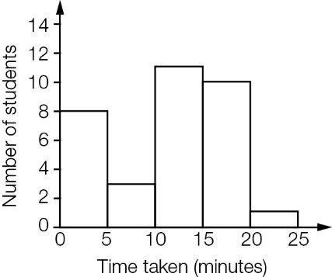

Question 27 2 marks [9.5]

The Budgerigars can either win, lose or draw their next dodgeball game. The probability that they win is and the probability of a draw is . What is the probability that they lose?

Short answer results: \_\_\_ / 67

Extended answer section

Question 28 3 marks [7.5]

The shape below has a perimeter of 174 cm. Use the information provided in the diagram to write an algebraic equation and then find the value of *x* in cm.

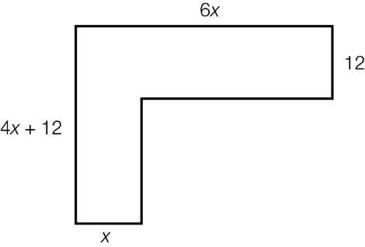

Question 29 4 marks [8.2]

Below is the triangle *ABC* (not drawn to scale). Along the side *BC*, there is the point *D* from which the line is drawn to *A* (creating the line *AD*). Given that *AD* = *BD* = *CD*, what is the size of ∠*BAC*?

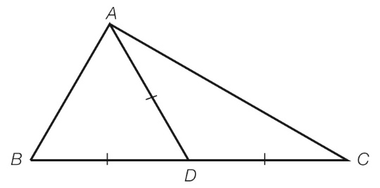

Question 30 4 marks [9.2]

Tom played five games of basketball one season. In the first three games he scored 17 points, 35 points and 24 points. In his fourth game he scored less than 10 points and in his fifth game he scored at least 50 points.

If Tom’s average (mean) number of points per game for the five matches was 27, what possible combination of points could he have scored in the last two games? Give four combinations and show all working.

|  |  |  |  |  |
| --- | --- | --- | --- | --- |
| Game | Combination 1 | Combination 2 | Combination 3 | Combination 4 |
| 1 | 17 | 17 | 17 | 17 |
| 2 | 35 | 35 | 35 | 35 |
| 3 | 24 | 24 | 24 | 24 |
| 4 |  |  |  |  |
| 5 |  |  |  |  |

Question 31 4 marks [9.7]

When you throw a pair of standard six-sided dice and add their scores together, you get a total ranging from 2 to 12.

(a) Construct a table to show the outcomes of the totals of the two dice.

(b) One of the dice is changed by replacing the 2 with an 8. Can you change the second die so that they still produce the same totals with exactly the same probability when thrown as a pair?   
For example, when thrown the probability of a total of 10 remains  = as before, and this similarly occurs for all the other totals from 2 to 12.

Extended answer results: \_\_\_ / 15

TOTAL test results: \_\_\_ / 94