|  |  |  |  |  |  |  |  |  |  |  |  |  |
| --- | --- | --- | --- | --- | --- | --- | --- | --- | --- | --- | --- | --- |
| Question | 1 | 2 | 3 | 4 | 5 | 6 | 7 | 8 | 9 | 10 | 11 | 12 |
| Answer | B | D | C | A | D | B | C | D | D | D | A | C |

Question 1 [6.2]

B

(-1, -5)

*y* = 2*x* – 3

= 2 × (-1) – 3

= -5

Question 2 [6.3]

D

*y* increases by 4 as *x* increases by 1, so there is 4*x* in the rule.

Where *x* = 0, *y* = 3 so need to add 3.

So, *y* = 4*x* + 3.

Question 3 [7.1]

C

‘six is added’: + 6

‘four times a number’: 4*x*

‘to give thirty’: = 30

So, 4*x* + 6 = 30.

Question 4 [7.2]

A

9*a* + 12 = 84

9*a* = 84 – 12

9*a* = 72

Question 5 [7.3]

D

add 6, then mulitply by 5

Question 6 [7.4]

B

4*c* + 2 = 2*c* + 6

2*c* = 4

*c* = 2

Question 7 [8.1]

C

*t*

Question 8 [8.2]

D

40 + 55 + *a* = 180

*a* = 85°

Question 9 [8.4]

D

corresponding: right angle; side; 50°

ASA

Question 10 [9.2]

D

(23 + 25 + *x*) ÷ 3 = 26

48 + *x* = 78

*x* = 30

Question 11 [9.4]

A

|  |  |  |
| --- | --- | --- |
| *x* | *f* | *x* × *f* |
| 3  4  5 | 6  10  4 | 18  40  20 |
|  | 20 | 78 |

mean = = 

Question 12 [9.6]

C

There are 4 Aces in a pack of 52 cards.

=

Multiple-choice total marks: 12

Short answer section

Question 13 11 marks

(a) *The gradient* of a line is a measure of its steepness.

(b) The *y*-intercept is where a line crosses the *y-axis* and the *x-intercept* is where   
a line crosses the *x*-axis.

(c) The point (0, 0) is the *origin* of the *Cartesian* plane.

(d) An *equation* is an algebraic statement with an equals symbol.

(e) In algebraic equations the unknown value is represent by a *pronumeral* which is generally   
a letter of the alphabet.

(f) An *angle* is formed when two lines (or rays) intersect at a point called the *vertex*.

(g) In a *right-angled* triangle the *hypotenuse* is opposite the 90°, or right angle.

Question 14 2 marks [9.4]

The strength of the mean as a measure of centre is that all data values are used when it is calculated. However, its weakness is that it is affected by outliers, which have an effect on the sum of all data values.

Median is a good measure of centre when the data is normally distributed and there is an   
outlier present.

Question 15 4 marks [6.2]

(a)

|  |  |  |  |  |  |
| --- | --- | --- | --- | --- | --- |
| *x* | -2 | -1 | 0 | 1 | 2 |
| *y* | -3 | -1 | 1 | 3 | 5 |

(b)

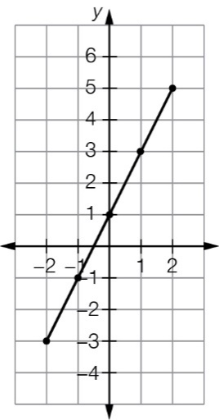

Question 16 4 marks [6.3]

(a) The *y*-value rises 2 for every 1 unit of the *x*-value, so the rule must have a (× 2) multiplier.

Looking at the pattern, can see 4 is then added. So the rule is *y* = 2*x* + 4

(b) Complete the table first:

|  |  |  |  |  |  |  |
| --- | --- | --- | --- | --- | --- | --- |
| *x* | -3 | -2 | -1 | 0 | 1 | 2 |
| *y* | 12 | 9 | 6 | 3 | 0 | -3 |

Can see the *y*-values decrease by 3 as the *x*-values increase by 1. Therefore, the rule must have a multiplier of (-3), then looking at the table, can deduce 3 is then added.   
The rule is *y* = -3*x* + 3

Question 17 2 marks [6.3]

As *x* increases by 1, *y* increases by 1, so there is no multiplier of *x*.

Where *x* = 0, *y* = -2, so 2 is subtracted from *x*.

Therefore, the equation is *y* = *x* – 2.

Question 18 4 marks [7.2]

|  |  |
| --- | --- |
| (a) 2*a* – 5 = 17  2*a* = 17 + 5  2*a* = 22  *a* =   *a* = 11 | (b) -5*b* + 9 = 29  -5*b* = 29 – 9  -5*b* = 20  *b* = $∴\frac{-5b}{-5}=\frac{20}{-5}$  *b* = -4 |

Question 19 *6 marks* [7.3]

|  |  |
| --- | --- |
| (a)  − 4 = 8  = 8 + 4   = 12  2*a* = 12 × 3  2*a* = 36  *a* =   *a* = 18 | (b) 8(2*r* – 5) = 72  2*r* – 5 =   2*r* – 5 = 9  2*r* = 9 + 5  2*r =* 14  *r* *=*   *r* = 7 |

Question 20 6 marks [7.4]

|  |  |
| --- | --- |
| (a) 3*a* – 5 = *a* + 7 3*a* – *a* = 7 + 5  2*a* = 12  *a =*   *a* = 6 | (b)  =  = *x* + 10  12*x* + 21 = *x* + 10  12*x* − *x* = 10 – 21  11*x* = -11  *x* =  *x* = -1 |

Question 21 3 marks [7.5]

2 × (3*x* + 10) + 2 × (*x* + 50) = 480

6*x* + 20 + 2*x* + 100 = 480

8*x* = 480 – 120

8*x* = 360

*x* = 45

length= 3 × 45 + 10 = 145 m

width = 45 + 50 = 95 m

Question 22 7 marks [8.2]

|  |  |
| --- | --- |
| (a) *a* = 70° (corresponding angles on parallel lines) *b* = 110° (alternate angles on parallel lines) *c* = 70° (supplementary angles) *d* = 110° (supplementary angles) | (b) *a* = 50° (co-interior angles on parallel lines)  *b* = 50° (supplementary angles)  *c* = 90° (angle sum of a triangle is 180°) |

Question 23 5 marks [8.2]

(a) *x +* 27 + *x* + 27 + 38 = 180 (angle sum of a triangle is 180°)  
2*x* + 92 = 180  
 2*x* = 88  
 *x* = 44°

(b) *y* = 140° (co-interior angles on parallel lines)

*z* + 3 + 40 = 180 (co-interior angles on parallel lines)  
*z*  = 137°

2*x* – 6 = 40 (opposite angles of a parallelogram are equal)  
*x* = 23°

Question 24 4 marks [8.3]

(a)–(d) *A*"' (-5, -10), *B*"' (-5, -4), *C*"' (-1, -10)

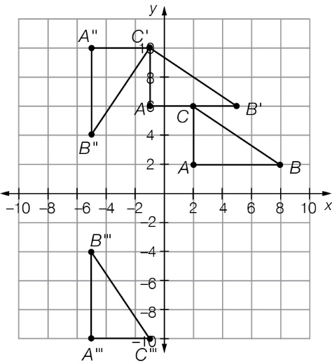

Question 25 4 marks [9.2]

(a) mean =  =   
= 22.91

(b) Place the values in ascending order first: 0, 0, 0, 8, 12, 14, 18, 18, 20, 22, 140  
median = 6th value = 14

(c) mode = 0

(d) Because of the outlier (140 runs) the mean is greater than all but one data value. The presence of this outlier makes the median the best measure of centre because it represents the typical amount of runs of this cricket team.

Question 26 3 marks [9.3]

|  |  |
| --- | --- |
| Time taken (minutes) | Number of students |
| 0–<5 | 8 |
| 5–<10 | 3 |
| 10–<15 | 11 |
| 15–<20 | 10 |
| 20–<25 | 1 |

Question 27 2 marks [9.5]

Pr(lose) = 1 – (Pr(win) + Pr(draw))

= 1 − 

= 

Short answer total marks: 67

Extended answer section

Question 28 3 marks [7.5]

*P* = 6*x* + 12 + 5*x* + 4*x* + *x* + 4*x* + 12

20*x* + 24 = 174

20*x* = 150

*x* = 7.5 cm

Question 29 4 marks [8.2]

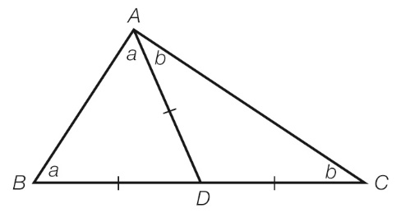

2*a* + 2*b* = 180°

*a* + *b* = 90°

∠*BAC* = 90°

Question 30 4 marks [9.2]

To have an average (mean) of 27 points over the five games, the total points Tom scored is:   
5 × 27 = 135 points

Then subtracting the points Tom scored in games 1, 2 and 3 will leave:

135 – (17 + 35 + 24) = 59 points

This means that in the last two games the combined total is 59 points. Using the given information (at least 50 points in the fourth game and less than 10 points in the fifth game) gives the following possible combinations:

Combination 1: 50 points and 9 points

Combination 2: 51 points and 8 points

Combination 3: 52 points and 7 points

Combination 4: 53 points and 6 points

Combination 5: 54 points and 5 points

Combination 6: 55 points and 4 points

Combination 7: 56 points and 3 points

Combination 8: 57 points and 2 points

Combination 9: 58 points and 1 point

(Only 4 of these are needed for the answer.)

Question 31 4 marks [9.7]

(a)

|  |  |  |  |  |  |  |
| --- | --- | --- | --- | --- | --- | --- |
|  | 1 | 2 | 3 | 4 | 5 | 6 |
| 1 | 2 | 3 | 4 | 5 | 6 | 7 |
| 2 | 3 | 4 | 5 | 6 | 7 | 8 |
| 3 | 4 | 5 | 6 | 7 | 8 | 9 |
| 4 | 5 | 6 | 7 | 8 | 9 | 10 |
| 5 | 6 | 7 | 8 | 9 | 10 | 11 |
| 6 | 7 | 8 | 9 | 10 | 11 | 12 |

(b) Still need a 1 on the second dice in order to be able to make the smallest total of 2. This then gives us the first row of the ‘possibility space’ table. There is no total of 3 as yet, and the only way to get a total of 3 *twice* is to have the number 2 *twice* on the second dice. We continue in this way, row by row, until the table is complete.

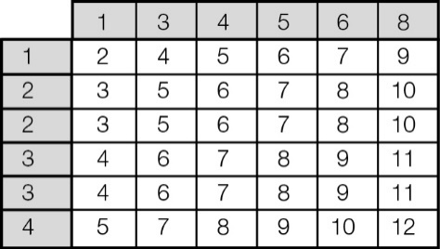

Extended answer total marks: 15

TOTAL test results: 94