Multiple-choice section – choose the correct answer

Question 1 [6.1]

In the diagram, the value of *x* is:

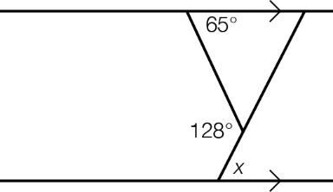

A 52° B 63° C 65° D 128°

Question 2 [6.2]

The test used to prove that the triangles shown are congruent is:

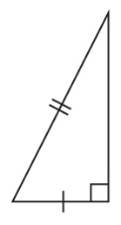 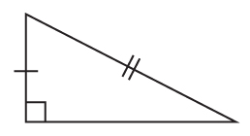

A SSS B SAS C RHS D ASA

Question 3 [6.5]

Given that triangle *ABC* is similar to triangle *DEF*, the corresponding side to *AC* is:

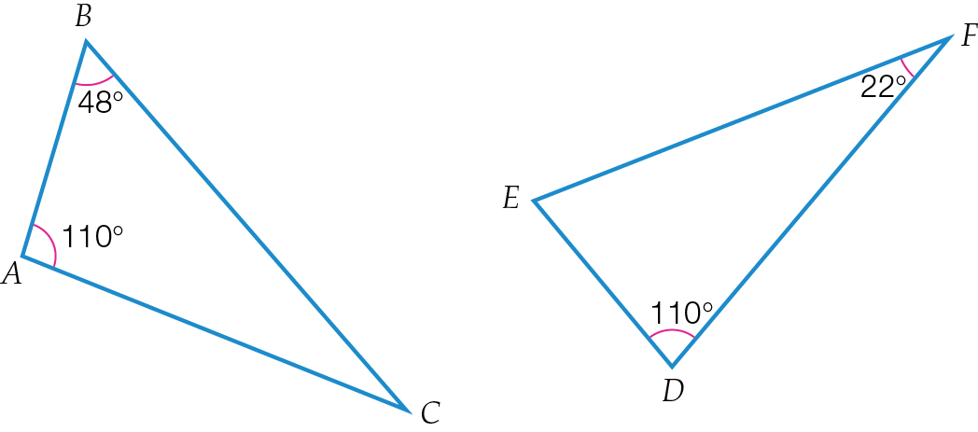

A *FD* B *EF* C *ED*  D *BC*

Question 4 [6.4]

A scale factor of 0.5 has been applied to a rectangle 12 cm long and 7 cm wide. The new dimensions would be:

A 24 cm × 14 cm B 6 cm × 7 cm C 12 cm × 3.5 cm D 6 cm × 3.5 cm

Question 5 [7.1]

Which of the following statements is incorrect?

A The hypotenuse is the longest side in a right-angled triangle.

B The hypotenuse is opposite the right angle.

C The shorter side next to the reference angle is called the opposite side.  
D The shorter side next to the reference angle is called the adjacent side.

Question 6 [7.2]

In this triangle, tan(*x*) is:

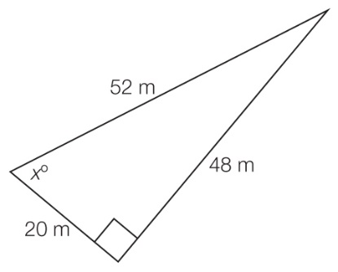

A  B  C  D 

Question 7 [7.4]

The value of θin this diagramcould be found by using the equation:

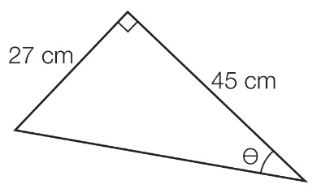

A θ =tan-1 B θ =cos-1 C θ =tan-1 D θ = cos1

Question 8 [7.5]

From the rooftop garden of a multi-storey building, the angle of depression to a parked car on the road beneath is 75°. If the rooftop garden is 123 m above the ground, the horizontal distance from the base of the building to the car, to the nearest metre, is:

A 32 m B 33 m C 127 m D 459 m

Question 9 [8.1]

The speed of cars recorded by a police radar is an example of:

A continuous data B discrete data C categorical data D ordinal data

Question 10 [8.3]

The class centre for a class interval of 0–20 is:

A 9 B 9.5 C 10 D 10.5

Question 11 [8.5]

In a drawer there are 5 identical pairs of white socks and 15 pairs of other colours.

A white sock is selected from the drawer.

The probability of randomly selecting another white sock from the drawer is:

A  B  C  D 

Question 12 [8.7]

Lisa has 5 different tops and 6 different skirts. One top will only match with 2 of the skirts. What is the probability that she randomly selects this top and a matching skirt?

A  B  C  D 

Question 13 [9.2]

The solution/s to *x*2 = 14*x* – 49 is/are:

A *x* = 1, *x* = 7 B *x* = -7, *x* = 7 C *x* = -7 D *x* = 7

Question 14 [9.3]

To obtain the graph of *y* = (*x* – 4)2 – 5, the graph of *y* = *x*2 is moved:

A 4 units to the right and 5 units down

B 5 units to the right and 4 down

C 4 units to the left and 5 units down

D 4 units to the left and 5 up

Question 15 [9.4]

Which of the following equations shows a circle relationship?

A *y* = *x*2 – 3*x* + 5 B *y* = C *y2 = x*2 + 3 D *y*2 *=* 5 – *x*2

Multiple-choice results: ___ / 15

Short answer section

Question 16 4 marks [6.1]

Find the value of *x*.

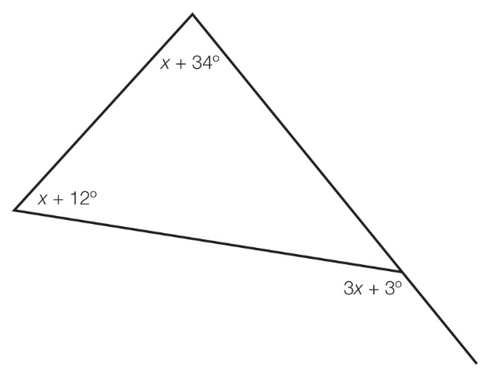

Question 17 5 marks [6.2]

**(a)** Show that triangle *ABC* is congruent to triangle *DCB* in the figure below.

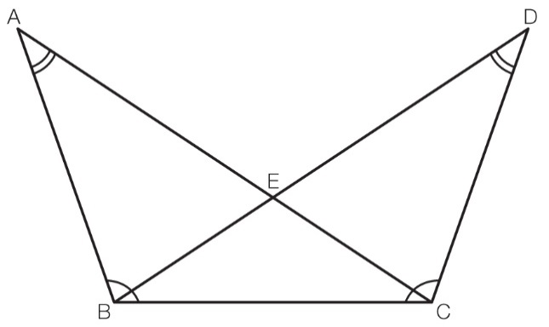

**(b)** Name another pair of congruent triangles. Give the name of the congruency test you have used.

Question 18 3 marks [6.3]

Find the value of the variable in the following figure.

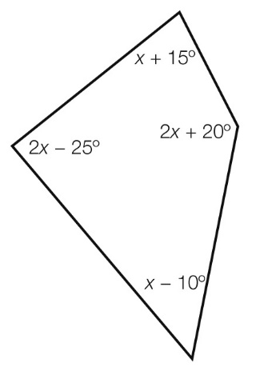

Question 19 3 marks [6.4]

Enlarge this figure by a scale factor of 2.

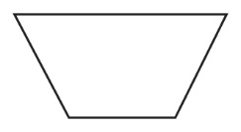

Question 20 5 marks [6.5]

(a) Use a similarity test to show that Δ*ABC* is similar to Δ*XYZ*.

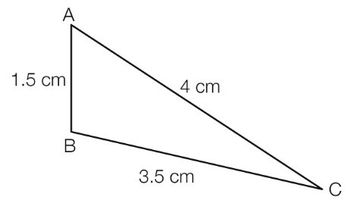 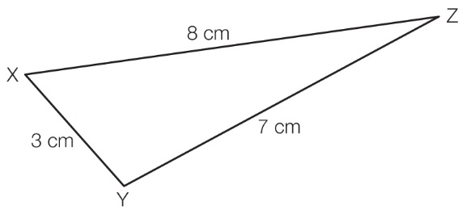

(b) Find the scale factor used to enlarge Δ*ABC* to Δ*XYZ*.

Question 21 3 marks [6.7]

Draw a net for a triangular prism.

Question 22 3 marks [7.1]

For the following triangle, state the length of the:

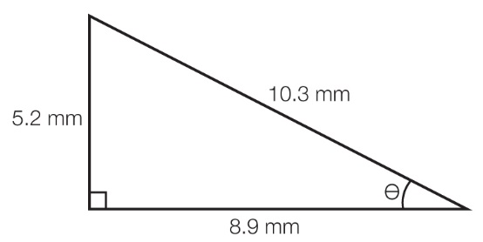

(a) hypotenuse

(b) opposite side

(c) adjacent side.

Question 23 3 marks [7.2]

In the given triangle, find the exact value of:

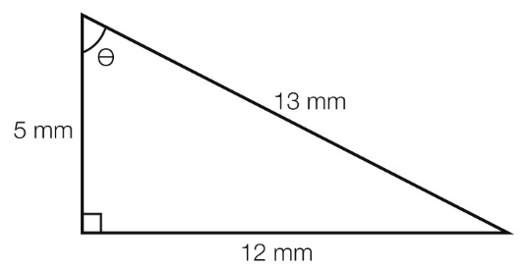

(a) sin(θ)

(b) cos(θ)

(c) tan(θ).

Question 24 3 marks [7.3]

Find the value of the variable, to 2 decimal places.

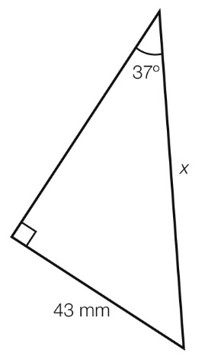

Question 25 3 marks [7.5]

Hannah hikes for 15.5 km on a bearing of 294°T. How far north is Hannah from her base camp? Give your answer correct to 1 decimal place.

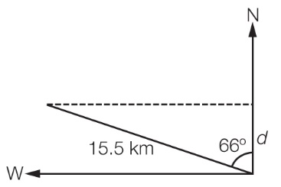

Question 26 3 marks [8.1]

Fill in the missing words in the following sentences.

**(a)** Data that is measured, such as the weight of a bag of apples, is called _____________ data.

**(b)** Data that is counted, such as the number of people attending a concert, is called ____________ data.

**(c)** Data that in not numerical and has no sense of order, such as the country you were born in, is called _____________________ data.

Question 27 3 marks [8.2]

A packet of 100 jelly beans made by a company contains 25 red ones.

(a) If this packet is representative of the packets of jelly beans made by this company, what is the mean number of packets needed if 400 red jelly beans are required to decorate a cake?

(b) The packet is opened and 40 jelly beans spill accidentally. 14 of the spilled jelly beans are red. Is this unexpected? Explain your answer.

Question 28 3 marks [8.5]

In a pack of 30 jelly beans, there are 8 black, 6 red, 9 green and 7 yellow jelly beans. Liam loves red jelly beans and dislikes black ones. If Liam chooses a jelly bean at random, what is the probability that he:

(a) picks a black jelly bean

(b) picks a green jelly bean

(c) does not pick a red jelly bean.

Question 29 3 marks [8.7]

At a school camp, students can choose from five different arts and crafts activities in the morning and six different sporting activities in the afternoon.

(a) If ‘origami’ is a morning activity and ‘rock climbing’ is an afternoon activity, what is the probability that a student chooses these two activities at random?

(b) If ‘bushwalking’ is another afternoon activity, what is the probability that a student chooses either this activity or ‘rock climbing’, and any morning activity except ‘origami’?

Question 30 5 marks [9.1]

For the parabola shown, write:

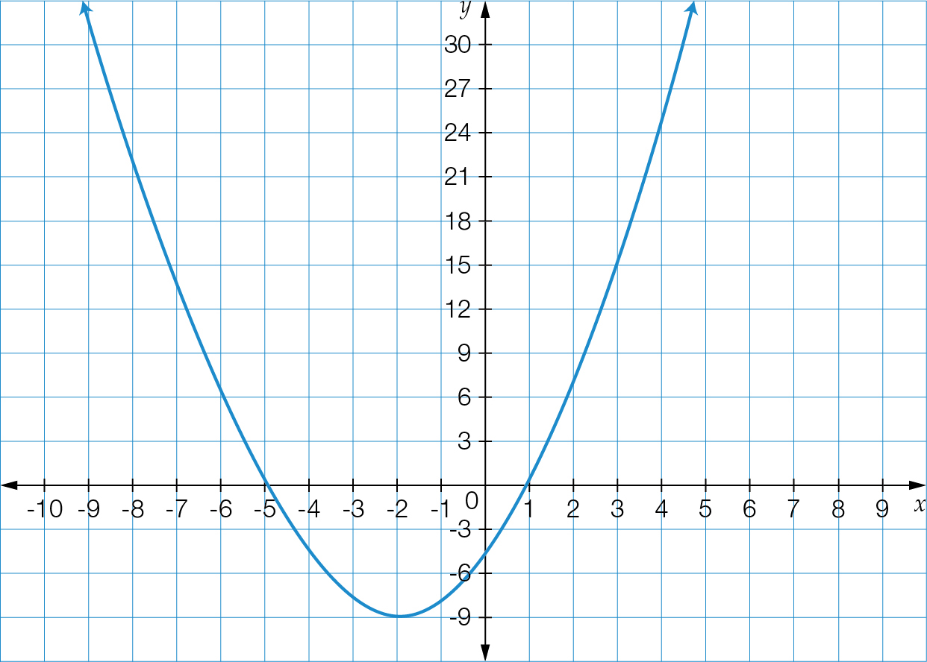

(a) the coordinates of the turning point

(b) the type of turning point

(c) the equation of the axis of symmetry

(d) the *y*-intercept

(e) the *x*-intercepts.

Question 31 4 marks [9.2]

Solve the following quadratic equations using the null factor law.

(a) *x*(*x* + 4) = 0

(b) *x*2 – 10*x* + 25 =0

Question 32 4 marks [9.3]

For the quadratic relationship *y* = *-*(*x* + 5)2 + 6:

(a) state the transformations of *y = x*2 that have taken place

(b) find the turning point.

Question 33 3 marks [9.3]

Determine the centre and radius of the following circle relationships and hence the equation of the circle.

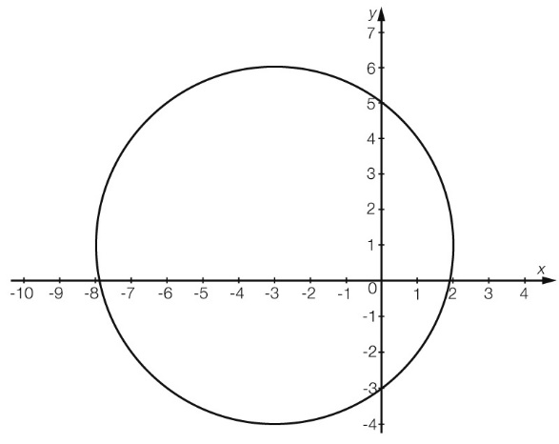

Question 34 3 marks [9.6]

For the following table of values, find the constant of proportionality and hence find the missing values in the table.

|  |  |  |  |  |
| --- | --- | --- | --- | --- |
| *x* | 3 | 5 |  | 8 |
| *y* | 21 |  | 49 | 56 |

Question 35 2 marks [9.7]

Find the equation of the relationship between the variables in the following table.

|  |  |  |  |  |
| --- | --- | --- | --- | --- |
| *x* | 1 | 2 | 4 | 8 |
| *y* | 16 | 8 | 4 | 2 |

Short answer results: ___ / 68

Extended answer section

Question 36 8 marks [6.6]

In the diagram, show that the two triangles are similar and then find the value of the variable.

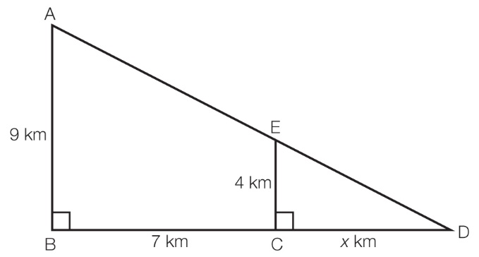

Question 37 10 marks [8.3]

The number of people who buy an item from a particular store each day is monitored over a 30-day period and the results are tabulated below.

|  |  |
| --- | --- |
| Number of people | Frequency (*f*) |
| 0–9 | 1 |
| 10–19 | 5 |
| 20–29 | 10 |
| 30–39 | 7 |
| 40–49 | 4 |
| 50–59 | 2 |
| 60–69 | 1 |

(a) Use the grouped data to find the mean number of customers per day, correct to 2 decimal places.

(b) Find the median class interval for the number of customers each day.

(c) Draw a bar chart of the sales.

(d) Describe the spread of the data.

Question 38 6 marks [9.3]

(a) Show that (*x* – 3)2 + 1 = (*x* – 4)(*x* – 2).

(b) Sketch the graph of *y* = (*x* – 3)2 + 1 by transforming the graph of *y* = *x*2. Clearlylabel both graphs and show *x*- and *y*-intercepts and the turning point.

Use the information in **(a)** to find the *x*-intercepts.

Extended answer results: ___ / 24

TOTAL test results: ___ / 107