**Insert School Logo**

**Semester One Examination 2018**

**Question/Answer Booklet**

**PHYSICS**

**UNIT 1**

**Name: \_\_\_\_\_\_\_\_\_\_\_\_\_\_\_\_\_\_\_\_\_\_\_\_\_\_\_\_\_\_\_\_\_\_\_\_\_\_\_\_\_\_\_\_\_\_\_\_\_\_\_\_\_\_\_\_\_\_\_\_\_\_\_\_\_\_\_\_\_\_\_\_\_\_\_\_\_\_\_\_\_\_\_\_\_\_\_\_\_**

**Teacher: \_\_\_\_\_\_\_\_\_\_\_\_\_\_\_\_\_\_\_\_\_\_\_\_\_\_\_\_\_\_\_\_\_\_\_\_\_\_\_\_\_\_\_\_\_\_\_\_\_\_\_\_\_\_\_\_\_\_\_\_\_\_\_\_\_\_\_\_\_\_\_\_\_\_\_\_\_\_\_\_\_\_\_\_\_\_\_\_**

**Time allowed for this paper**:

Reading time before commencing work: 10 minutes

Working time for paper: 3 hours

**Materials required/recommended for this paper**

***To be provides by the supervisor***

This Question/Answer Booklet

Formulae and Data Booklet

***To be provided by the candidate***

Standard items: pens, pencils (including coloured), sharpener, correction fluid, eraser, ruler, highlighters.

Special items: up to three non-programmable calculators approved for use in the WACE examinations, drawing templates, drawing compass and a protractor.

**STRUCTURE OF THIS PAPER**



|  |  |  |  |  |  |  |
| --- | --- | --- | --- | --- | --- | --- |
| **Section** | **No. of**  **Questions** | **No. of questions**  **to be attempted** | **Suggested working time**  **(minutes)** | | **Marks available** | **Percentage of**  **exam** |
| Section one  Short Response | 11 | ALL | 55 | | 54 | 30 |
| Section two  Problem Solving | 6 | ALL | 95 | | 90 | 50 |
| Section three  Comprehension | 2 | ALL | 30 | | 36 | 20 |
| Total | **180** | **100** |

**INSTRUCTIONS TO CANDIDATES**



Write your answers in the spaces provided beneath each question. The value of each question (out of 180) is shown following each question.

Answers to questions involving calculations should be evaluated and given in decimal form. Final answers should be given up to three significant figures and include appropriate units.

Questions containing the instruction "**ESTIMATE**" may give insufficient numerical data for their solution. Give final answers to a maximum of two significant figures and include appropriate units.

Despite an incorrect final result, credit may be obtained for method and working providing these are clearly and legibly set out.

Questions containing specific instructions to **show working** should be answered with a complete, logical, clear sequence of reasoning showing how the final answer was arrived at; correct answers which do not show working will not be awarded full marks.



**Section One: Short Response 30% (54 marks)**

This section has 11 questions. Answer **all** questions. Answer the questions in the spaces provided.

Suggested working time: 50 minutes.

**Question 1 (5 marks)**

Two substances with the same mass are made up of pure metals. One is pure gold and another one is pure copper. The specific heat capacities of gold and copper are 130 J kg-1 K-1 and 390 J kg-1 K-1, respectively.

1. Explain what it is meant by 130 J kg-1 K-1.

(2 marks)

1. With the same amount of energy being transferred to each metal, which metal will have the greatest change in temperature? Use appropriate formulae to support your answer.

(3 marks)

**Question 2 (4 marks)**

Complete the following nuclear equations and name the particle / radiation types.

(4 marks)

1. \_\_\_\_\_\_\_\_\_\_\_\_\_\_\_\_\_\_\_\_\_\_\_\_\_\_ Name of the particle: \_\_\_\_\_\_\_\_\_\_\_\_\_\_\_\_\_\_
2. \_\_\_\_\_\_\_\_\_\_\_\_\_\_\_\_\_\_\_\_\_\_\_\_\_\_\_ Name of the particle: \_\_\_\_\_\_\_\_\_\_\_\_\_\_\_\_\_\_

**Question 3 (5 marks)**

Sue wants to lower the temperature of her stainless-steel barbecue plate from 400 oC to 180 oC by spraying water directly onto the 25.0 kg plate.

Calculate the mass of water, initially at 20.0 oC, required to cool the barbecue plate. Assume all water completely evaporates to steam at 100 oC and that there is no energy lost to the environment. The specific heat capacity of the stainless-steel is 450 J kg-1 K-1.

**Question 4 (4 marks)**

“The Fremantle Doctor” is the local term for the cooling afternoon sea breeze which occurs during summer time around the south west area of Western Australia. This sea breeze occurs because of the major temperature difference between the land and sea.

Explain this phenomenon using physics concepts and include a diagram to assist your answer.

**Question 5 (5 marks)**

1. Many multi-outlet power boards have a fuse with a maximum current rating of 7.50 A. Explain how this fuse works as a circuit safety feature.

(3 marks)

1. Outline a difference between a fuse differ and an RCD (residual-current device).

(2 marks)

**Question 6 (3 marks)**

Strontium-90 emits beta particles which are used for thickness control of paper and plastic film in manufacturing industry. Explain why alpha particles and gamma rays are not able to do the same job as beta particles.

(3 marks)

**Question 7 (9 marks)**

A voltage source is connected across a light bulb and the current is recorded for different voltages. The graph is shown below.

1. Draw a line of best fit for the data shown in the graph above.



(1 mark)



1. State the range of voltages where the light bulb is ohmic.



(1 mark)

Range:

1. Use the graph above to calculate the resistance of the light bulb when it is ohmic.

(3 marks)

1. Calculate the resistance of the light bulb when the voltage is at 8.00 V.

(2 marks)

**(Question 7 continued)**



1. Explain the difference in values for part c) and d).

(2 marks)

**Question 8 (6 marks)**

The initial activity of a radioactive source an isotope of Radon is 180 Bq. The half-life of Radon is 4.00 days.

1. Calculate the activity of Radon after one day.

(3 marks)

1. Plot the time variation of activity of the source from 0 to 12.0 days. [An additional graph is available on page 34 if required.]

(3 marks)

|  |  |  |  |  |  |  |  |  |  |  |  |  |  |  |  |
| --- | --- | --- | --- | --- | --- | --- | --- | --- | --- | --- | --- | --- | --- | --- | --- |
|  |  |  |  |  |  |  |  |  |  |  |  |  |  |  |  |
|  |  |  |  |  |  |  |  |  |  |  |  |  |  |  |  |
|  |  |  |  |  |  |  |  |  |  |  |  |  |  |  |  |
|  |  |  |  |  |  |  |  |  |  |  |  |  |  |  |  |
|  |  |  |  |  |  |  |  |  |  |  |  |  |  |  |  |
|  |  |  |  |  |  |  |  |  |  |  |  |  |  |  |  |
|  |  |  |  |  |  |  |  |  |  |  |  |  |  |  |  |
|  |  |  |  |  |  |  |  |  |  |  |  |  |  |  |  |
|  |  |  |  |  |  |  |  |  |  |  |  |  |  |  |  |
|  |  |  |  |  |  |  |  |  |  |  |  |  |  |  |  |

**Question 9 (5 marks)**

Amy is measuring the following shaded rectangle and she puts two rulers next to the rectangle, as shown below.

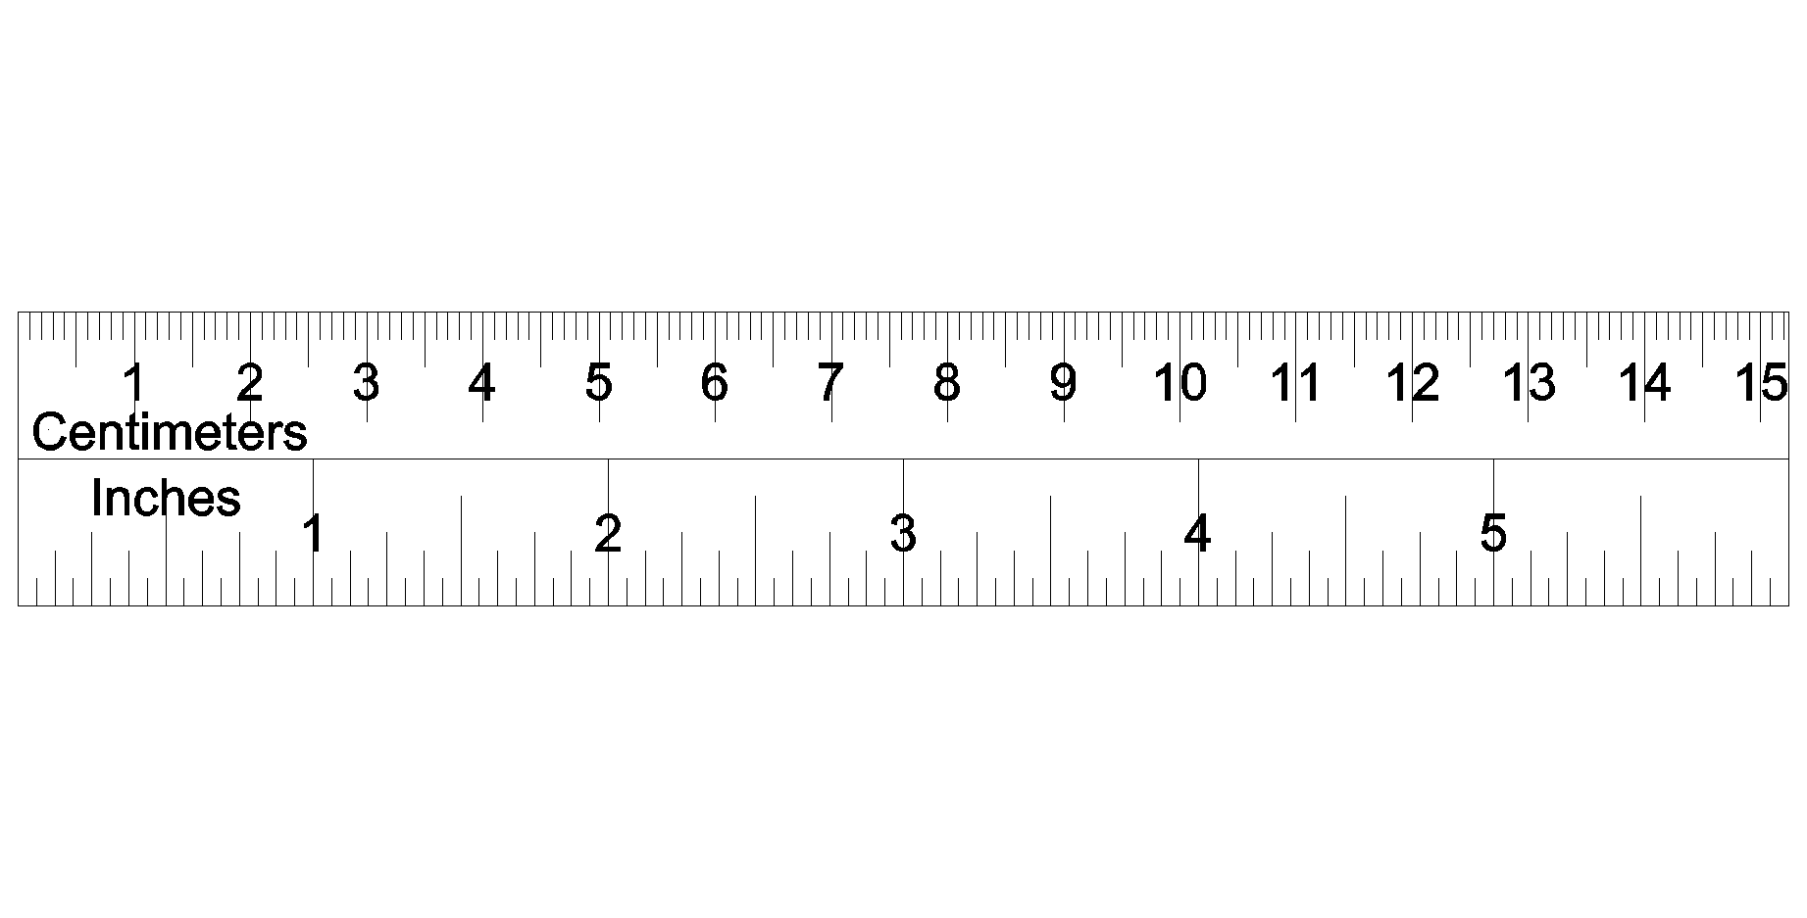

1. Write the width and length of the rectangle including absolute uncertainties.

(2 marks)

Length: \_\_\_\_\_\_\_\_\_\_\_\_\_\_\_\_\_ ± \_\_\_\_\_\_\_\_\_\_\_\_\_\_\_\_\_\_

Width: \_\_\_\_\_\_\_\_\_\_\_\_\_\_\_\_\_ ± \_\_\_\_\_\_\_\_\_\_\_\_\_\_\_\_\_\_

1. Calculate the relative uncertainty of the area of the shaded rectangle. Show ALL working for full marks.

(3 marks)

**Question 10 (4 marks)**

A rating of a battery is “1.20 V, 1600 mA”. The battery is used for 1.00 hour.

1. Calculate the total charge passing through the battery.

(2 marks)

1. Calculate the total useful energy released by the battery, if the battery is 80.0% efficiency.

(2 marks)

**Question 11 (4 marks)**

**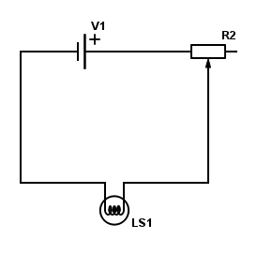**The diagram on the right shows a light bulb and a rheostat that are being connected with a 12.0 V battery.

1. On the diagram, draw an arrow showing the electron current.

(1 mark)

1. Explain how the rheostat could affect the brightest of the light bulb. Use some equations to assist your answer.

(2 marks)

1. If the rheostat is set to the maximum, the light bulb will be: (circle the answer)

(1 mark)

**The Brightest The dimmest No effect to the brightness**

**END OF SECTION ONE**

**Section Two: Problem-solving 50% (90 marks)**

This section contains 6 questions. Answer **all** questions. Answer the questions in the spaces provided.

Suggested working time 90 minutes.

**Question 12 (16 marks)**

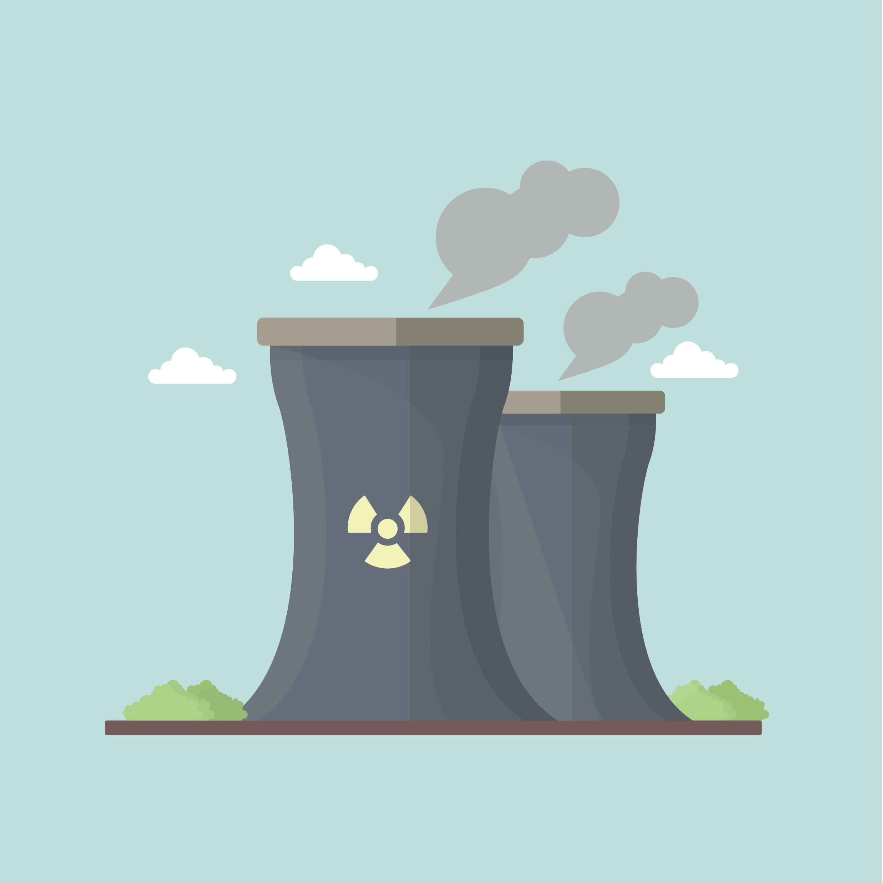In a fast breeder reactor, a neutron, mass 1.00867 u, causes fission of Pu-239 (239.05216 u). One of the two fission fragments is Tc-104 (103.91145 u) and three neutrons are released. The atomic mass of the other fragment is 132.91525 u.

.

1. State what it is meant by a fast breeder reactor.

(1 mark)

1. Outline two main differences between a fast breeder reactor and an ordinary nuclear reactor. Describe the components which are different and also their purpose.

(4 marks)

1. Construct the decay equation as outlined in the text.

(2 marks)

**(Question 12 continued)**



1. Calculate how much energy, in MeV, is produced by this nuclear reaction. Show all working clearly.

(5 marks)

1. If the average power consumption for Perth city is 600 MW daily, calculate the mass of Pu-239 (in kg) required to provide Perth city with enough energy for 30 days.

(4 marks)

**Question 13 (16 marks)**

The follow graph shows the cooling curve of 1.00 kg of naphthalene from liquid to solid over 18.0 minutes. The naphthalene releases energy at a rate of 350 W as it cools from 90.0 oC.



1. On the graph above, label the time when the naphthalene is in liquid state.

(1 mark)

1. Use kinetic theory to explain why the curve stays flat between 3.00 minutes and 11.0 minutes.

(3 marks)

1. A value for the latent heat of fusion can be found using the curve.
2. Calculate the total energy released between 3.00 minutes and 11.0 minutes.

(2 marks)

**(Question 13 continued)**



1. Hence, determine a value for the latent heat of fusion. Write the correct unit.

(3 marks)

1. Use the graph to **estimate** the specific heat capacity of the solid naphthalene.

(4 marks)

1. On the graph below, redraw new cooling curves when the following conditions have changed: the mass of the naphthalene is doubled; the rate of energy lost is the same as before and the initial temperature stays at 90.0 oC. [An additional graph is available on page 34.]

(3 marks)

**Question 14 (18 marks)**

A quality-control officer tests a strand of nylon cord by subjecting it to various loads (force) and recording the subsequent extensions. The diagram shows on the right. The original length of the nylon string is 100 mm.

**load**

Nylon cord

length

1. Complete the following:

(2 marks)

Independent variable: \_\_\_\_\_\_\_\_\_\_\_\_\_\_\_\_\_\_\_\_\_\_\_\_\_\_

Dependent variable: \_\_\_\_\_\_\_\_\_\_\_\_\_\_\_\_\_\_\_\_\_\_\_\_\_\_\_



1. Complete the table.

(1 mark)

|  |  |  |  |  |  |  |
| --- | --- | --- | --- | --- | --- | --- |
| **F** (N) | 0 | 10 | 20 | 30 | 40 | 50 |
| **L** (mm) | 100 | 108 | 117 | 124 | 132 | 139 |
| **ΔX** (mm) |  |  |  |  |  |  |

**F**: Load, in Newtons

**L**: Length, in millimetres

**ΔX**: Extension or change of length **to 100 mm (initial length).**

1. Calculate the relative uncertainty for the **length of the nylon** string if the load is 20 N.

(2 marks)

1. Plot the graph using **ΔX** and **load** (See the next page). Label all axes with appropriate units. [An additional graph is available in page 35.]

(4 marks)

1. Calculate the gradient of the graph. Show all working out clearly. Include all units.

(4 marks)

**(Question 14 continued)**

Macintosh HD:Users:wijaya.joni:Desktop:Metric_20mm&2mm_Linear_LightGray&Watermark_MC-Port_Letter.pdf

1. What does the gradient tell you about the string?

(1 mark)

**(Question 14 continued)**

1. Write the equation for the relationship between extension and load.

(1 mark)

1. **Estimate** the length of the nylon when 60 N of load is used. Show clear working.

(3 marks)

**This page is intentionally left blank.**

**Question 15 (18 marks)**

As shown below, six resistors are connected in a network to a 12.0 V battery (V1). The values of the resistors are also shows below:

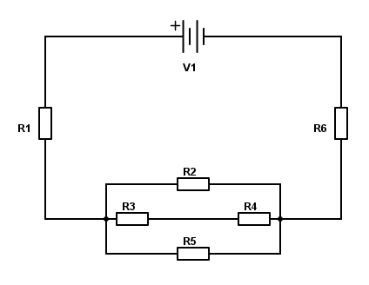

R1 = 10.0 Ω

R2 = 12.0 Ω

R3 = 4.00 Ω

R4 = unknown

R5 = 6.00 Ω



R6 = 20.0 Ω

1. On the diagram above, draw an arrow to show the direction of conventional current through resistor R1.

(1 mark)

1. On the diagram above, show how you would connect a voltmeter to measure the voltage of R2.

(1 mark)

1. Outline what the voltmeter in part ii) is effectively measuring, in terms of the charge flowing through R2.

(2 marks)

It is found that the circuit current measured in the main circuit is 0.371 A.

1. Calculate the voltage across resistor R1 and R6. Show all working below.

(2 marks)

**(Question 15 continued)**

1. Hence, determine the voltage across R2.

(2 marks)

1. Show that the current flowing through R4 is 0.153 A. Show all clear working.

(5 marks)

1. Hence determine the resistance of R4.

(3 marks)

1. If resistor R4 burns out, would the circuit current increase or decrease? Explain your answer. No calculations are required.

(2 marks)

**Question 16 (11 marks)**

A catering food warmer consists of two compartments: a stainless steel food tray which holds the food and a hot water bath tray beneath it.

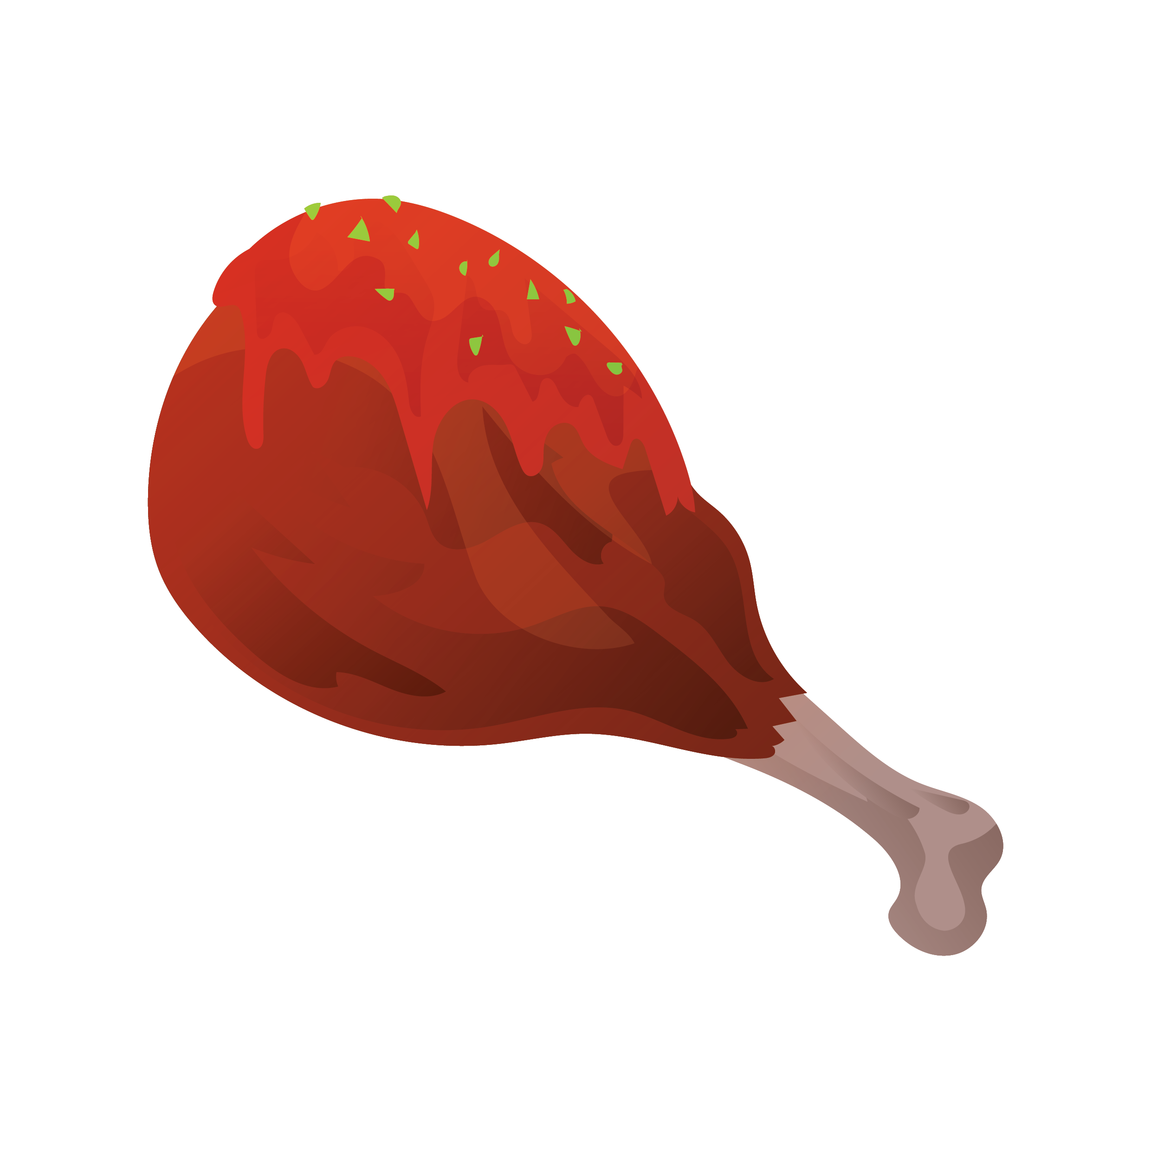



Food Tray



Hot Water Tray



1. Use appropriate physics concepts and the diagram above to explain how hot water bath is able to reheat the food.

(3 marks)

1. The 2.50 kg of food in the food tray has dropped to 40.0 oC. Calculate the volume (in L) of 100 oC water required to warm the food back to 60.0 oC. The mass of the food tray is 2.00 kg. The specific heat capacity of food is 6000 J kg-1 K-1 and the specific heat capacity of the stainless-steel is 450 J kg-1 K-1. Assume 20.0% heat lost to other areas and the density of water as 1.00 kg L-1.

(5 marks)

**(Question 16 continued)**

1. Use your understanding of heating and cooling methods to explain the benefits of using a lid on the food warmer.

(3 marks)



**Question 17 (11 marks)**

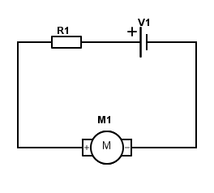On the right is a schematic diagram showing the connection of a battery to a motor (M1). R1 is the internal resistance of the battery and has a value of 5.00 Ω. When no current is being drawn, the voltage across the battery is 12.0 V. This is known as the EMF of the battery. The motor has a resistance of 40.0 Ω.



1. When the circuit is working would the motor (M1) has a voltage drop of 12.0 V? Give a reason for your answer.

(2 marks)

1. Show that:

(4 marks)

Where VM = voltage drop of the motor

RM = resistance of the motor

V = emf of the battery

**(Question 17 continued)**

1. Hence, calculate the voltage drop of the motor using the formula in part b).

(2 marks)



1. Larger motors used in mechanical workshops use thicker cables and a higher voltage. Explain why thicker cables are used.

(3 marks)

**END OF SECTION TWO**

**Section Three: Comprehension 15% (36 marks)**

This section has two questions. Answer **both** questions. Answer the questions in the spaces provided.

Suggested working time: 40 minutes.

**Question 18 (18 marks)**

**When the weather warms up, pop on cooling clothes**

*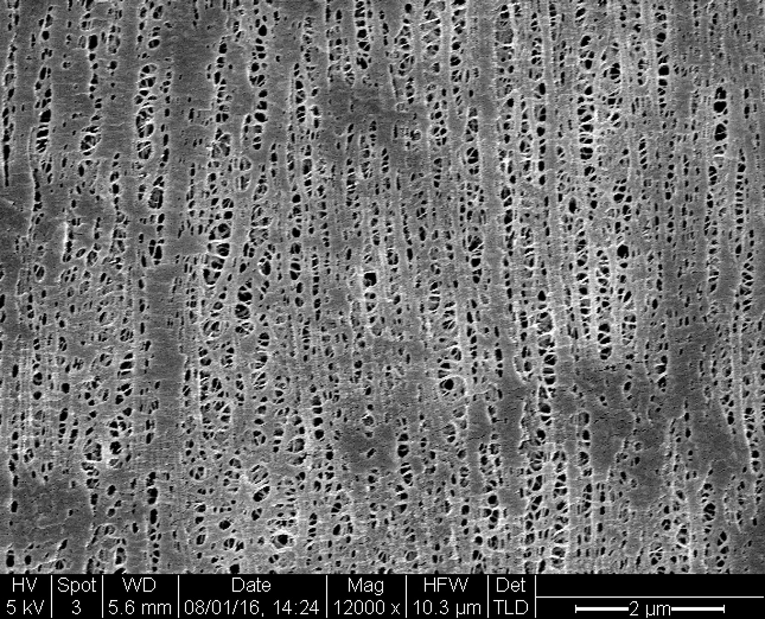*

*You might add layers when the thermostat drops, but could clothing actually help you cool off too? Stanford University researchers have found a way. Anthea Batsakis reports.*

In hot weather, we can only shed so many layers of clothes before it starts to get rude – but now a low-cost material has been invented that cools you down when you start heating up.Developed by researchers at Stanford University, the material reflects sunlight from the body while providing an escape route for heat radiating from our skin.

The fabric is a creative substitute for air conditioning or other indoor cooling devices, Po-Chun Hsu, Yi Cui and colleagues write in Science. They hope the material can be developed on a commercial scale and have a global impact by reducing greenhouse gas emissions.

**Figure 1 An electron microscope image of the cooling material. The tiny pores let sweat evaporate.**

The human body emits mid-infrared radiation. But this is the core of the cooling problem – wavelengths of our infrared emissions sit so close to visible light on the electromagnetic spectrum, the two overlap a little. This means regular clothes that block visible light from entering also trap body heat. The cool fabric from Stanford, though, lets infrared through, lowering temperatures between 2 °C and 3 °C. It also facilitates air and water vapour flow, making things more manageable when we sweat. It’s made of a flexible and durable version of the thin plastic film you might use in the kitchen to cover food called polyethylene. But unlike cling film, the new material is treated with safe chemicals to create nanoporous polyethylene, which lets water evaporate through tiny pores.

Compared to pure cotton, though, the material is far more “breathable”: cotton only allows 1.5% of infrared waves to pass, while the porous polyethylene clears the way for 96% of infrared waves radiated from our skin. [The remaining heat stays in the human body.] Peter Musk, who also seeks to find sustainable clothing alternatives at the State Library of Queensland in Australia, says it’s important to consider the costs developing this material would have. “This new polyethylene product may well reduce the need for energy use by the end user, but analysis of the total cost to the environment, and greenhouse gas emissions involved in mining, transporting, refining and manufacturing the product might produce a different conclusion about its contribution to sustainability,” Musk says.

In any case, instead of cranking up the air conditioning, you might one day change your clothes instead. The scientists are working on adding more colours and textures to their range over the next few months.

1. Explain how the cool fabric from Stanford University might contribute to reduced greenhouse gas emissions.



(3 marks)

1. Outline three differences between pure cotton and the cool fabric in terms of cooling the body.

(3 marks)

|  |  |
| --- | --- |
| **Pure cotton** | **Cool fabric** |
|  |  |
|  |  |
|  | . |

1. Use kinetic theory to explain how evaporation of water from the human body can cause cooling.

(2 marks)

1. John, a 75.0 kg runner, generates 8.00 MJ of energy while training for a marathon.
2. Calculate the temperature rise of John’s body if he is wearing the cool fabric. Assume the specific heat capacity of an average human body is 3500 J kg-1 K-1. Use data in paragraph four to assist your calculation.

(4 marks)

1. **Estimate** the mass of water needed to evaporate from John’s body to maintain a constant body temperature during this run. (If you could not calculate part i) use a value of 2.00 oC). Assume evaporation is occurs at the same temperature as John’s body)

(4 marks)

1. Describe the difference it would make to John’s body if he were to wear cotton clothes instead. No calculations required.

(2 marks)

**Question 19 (18 marks)**

**Are Canadian fish being poisoned by radiation from Japan?**

*In 2015, a single salmon caught in Osoyoos Lake in British Columbia was found to contain very low levels of a radioactive isotope called caesium-134.*

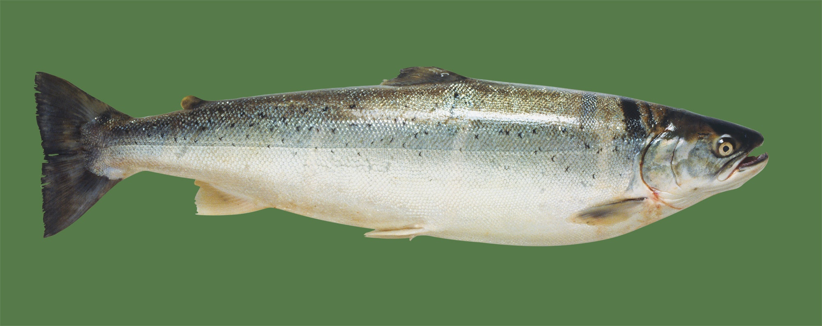

**Figure 2 Were salmon in Canada really contaminated with radioactive isotopes from the damaged nuclear power plant at Fukushima in Japan?**

A news story has done the rounds on social media this year claiming that salmon in Canada had been found contaminated with radioactive isotopes from the damaged nuclear power plant at Fukushima in Japan.

Is it true? And, if so, is there anything to worry about? The answer to the first question is “yes, sort of”, but the answer to the second is “definitely not”!

The story grew from the fact that, in 2015, a single salmon caught in Osoyoos Lake in British Columbia was found to contain very low levels of a radioactive isotope called caesium-134. The isotope is produced during nuclear fission – the process that drives both atomic power stations and atomic bombs. Because it has a half-life of 2.04 years, any caesium-134 that was released into the atmosphere by previous bomb tests or reactor disasters (such as Chernobyl) has long since decayed away. Therefore, any caesium-134 found in anything at the moment can only have come from Fukushima.

So, yes, a radioactive nasty from Japan did end up in a fish in Canada. However, there is much more to the story than that.

First off, scientists have always predicted that radioactive stuff from the damaged reactor would spread around the world, through the oceans and the air. This is simply what happens. Between 1955 and 1963, for instance, there were a whole bunch of atmospheric nuclear bomb tests, which collectively pumped out a huge amount of an isotope called carbon-14. All over the world, people who were children during that time have higher-than-average levels of it in their muscle tissues.

In 2016, caesium-134 from Fukushima was detected in the waters off the coast of north-western US state of Oregon for the first time. This did not surprise environmental scientists and oceanographers, who had long predicted its eventual arrival. The isotopes detected in the sea were at very low levels and didn’t pose any threat to human health. The same goes for the single Canadian salmon. In fact, the radiation levels detected in the fish were actually lower than the levels found in most other fish around the globe. This is because, every day, every living thing absorbs radiation produced naturally by cosmic rays, some kinds of rocks and minerals, and even the air itself. It’s called “background radiation” and it has been around since the Big Bang.

The suspect salmon wasn’t eaten, because it was used for testing. But if it had been, would it have made the person who ate it ill? Not at all. The standard measurement for radiation in food is a unit called the becquerel. It is always expressed in terms of becquerels per kilogram. The Canadian salmon contained 0.7 becquerels per kilogram. The World Health Organisation’s recommended safe maximum limit for radioisotopes in food is 1,000 becquerels per kilogram. So, should you ever be lucky enough to find yourself hooking a sockeye salmon in Osoyoos Lake, have no fear. Wrap it in foil with a few slices of lemon and some thyme, chuck it on the camp fire, and enjoy!

1. Explain why it is important to measure the level of radiation in fish.

(3 marks)

1. Fukushima Daiichi reactors exploded in 2011. Now the radiation “stuff” is said to be spread around the word due to water current. Outline why the author does not believe this radiation to be harmful.

(2 marks)

1. According to the articles, there are many sources of radiation which could affect our lives. Apart from the nuclear reactor plants, state two more.

(2 marks)

1. Calculate the binding energy per nucleon of caesium-134. Express your answer in MeV and show clear working.

Use the following data:

Mass of proton = 1.00727 u

Mass of neutron = 1.00867 u

Mass of Caesium-134 = 133.907 u

(4 marks)

1. The caesium-134 undergoes alpha decay followed by a beta positive decay. Write down the two equations of this decay series.

(3 marks)

1. A 6.00 kg salmon has eaten food that contains caesium-134 with a radiation level of 400,000 becquerel. **Estimate**, how long it will take for the salmon to be safe according to the World Health Organisation’s recommended maximum limit.

(4 marks)

**END OF SECTION THREE**

**Extra Space**

**Extra Space**

**Extra Space**

**Extra Graph for question 8**

|  |  |  |  |  |  |  |  |  |  |  |  |  |  |  |  |
| --- | --- | --- | --- | --- | --- | --- | --- | --- | --- | --- | --- | --- | --- | --- | --- |
|  |  |  |  |  |  |  |  |  |  |  |  |  |  |  |  |
|  |  |  |  |  |  |  |  |  |  |  |  |  |  |  |  |
|  |  |  |  |  |  |  |  |  |  |  |  |  |  |  |  |
|  |  |  |  |  |  |  |  |  |  |  |  |  |  |  |  |
|  |  |  |  |  |  |  |  |  |  |  |  |  |  |  |  |
|  |  |  |  |  |  |  |  |  |  |  |  |  |  |  |  |
|  |  |  |  |  |  |  |  |  |  |  |  |  |  |  |  |
|  |  |  |  |  |  |  |  |  |  |  |  |  |  |  |  |
|  |  |  |  |  |  |  |  |  |  |  |  |  |  |  |  |
|  |  |  |  |  |  |  |  |  |  |  |  |  |  |  |  |

**Extra graph for question 13**

**Extra Graph for question 14**

Macintosh HD:Users:wijaya.joni:Desktop:Metric_20mm&2mm_Linear_LightGray&Watermark_MC-Port_Letter.pdf

**Acknowledgements**

**Question 18** Adapted from: Batsakis, A. (2016). Cosmos. *When the weather warms up, pop on cooling clothes*. Retrieve November 30, 2017, from https://cosmosmagazine.com/chemistry/when-the-weather-warms-up-pop-on-cooling-clothes

**Question 19** Adapted from: Masterson, A. (2017). Cosmos. *Are Canadian fish being poisoned by radiation from Japan?*. Retrieve November 30, 2017, from https://cosmosmagazine.com/chemistry/are-canadian-fish-being-poisoned-by-radiation-from-japan

**WATP acknowledges the permission of School Curriculum and Assessment Authority in**

**providing instructions to students.**