* Copyright for test papers and marking guides remains with *West Australian Test Papers*.
* The papers may only be reproduced within the purchasing school according to the advertised conditions of sale.
* Test papers must be withdrawn after use and stored securely in the school until Friday 30th November 2018.

**PHYSICS**

**UNITS 1 & 2**

**2018**

**Insert School Logo**

Name: _______________________________________________________

Teacher: ___________________________________________________

***TIME ALLOWED FOR THIS PAPER***

Reading time before commencing work: Ten minutes

Working time for the paper: Three hours

***MATERIALS REQUIRED/RECOMMENDED FOR THIS PAPER***

**To be provided by the supervisor:**

* This Question/Answer Booklet; Formula and Constants sheet

**To be provided by the candidate:**

* Standard items: pens, pencils, eraser or correction fluid, ruler, highlighter.
* Special items: Calculators satisfying the conditions set by the SCSA for this subject.

***IMPORTANT NOTE TO CANDIDATES***

No other items may be taken into the examination room. It is **your** responsibility to ensure that you do not have any unauthorised notes or other items of a non-personal nature in the examination room. If you have any unauthorised material with you, hand it to the supervisor **before** reading any further.

**Structure of this paper**

|  |  |  |  |  |  |
| --- | --- | --- | --- | --- | --- |
| Section | Number of questions available | Number of questions to be answered | Suggested working time  (minutes) | Marks available | Percentage of exam |
| Section One:  Short answer | 13 | 13 | 50 | 54 | 30 |
| Section Two:  Extended answer | 7 | 7 | 90 | 90 | 50 |
| Section Three:  Comprehension  and data analysis | 2 | 2 | 40 | 36 | 20 |
|  |  |  | **Total** | 180 | 100 |

**Instructions to candidates**

1. The rules for the conduct of Western Australian external examinations are detailed in the *Year 11 Information Handbook 2017.* Sitting this examination implies that you agree to abide by these rules.
2. Write your answers in this Question/Answer Booklet.
3. When calculating numerical answers, show your working or reasoning clearly. Give final answers to **three** significant figures and include appropriate units where applicable.

When estimating numerical answers, show your working or reasoning clearly. Give final answers to a maximum of **two** significant figures and include appropriate units where applicable.

1. You must be careful to confine your responses to the specific questions asked and follow any instructions that are specific to a particular question.
2. Spare pages are included at the end of this booklet. They can be used for planning your responses and/or as additional space if required to continue an answer.
   * Planning: If you use the spare pages for planning, indicate this clearly.
   * Continuing an answer: If you need to use the space to continue an answer, indicate in the original answer space where the answer is continued, i.e. give the page number. Refer to the question(s) where you are continuing your work.

**Section One: Short response 30% (54 Marks)**

This section has **thirteen** **(13)** questions. Answer **all** questions. Write your answers in the space

provided. Suggested working time for this section is 50 minutes.

**Question 1 (4 marks)**

Fill in the table to show the relative magnitude of various properties of the radioactive particles.

|  |  |  |  |
| --- | --- | --- | --- |
| **Particle** | **Alpha** | **Beta** | **Gamma** |
| **Mass**  **(Zero, Small, Medium, Large)** |  |  |  |
| **Electric Charge**  **(Zero, Small, Medium, Large)** |  |  |  |
| **Ionising Ability**  **(Zero, Small, Medium, Large)** |  |  |  |
| **Penetrating Ability**  **(Zero, Small, Medium, Large)** |  |  |  |

**Question 2 (4 marks)**

A resistor has a voltage that has twice the magnitude of the current through it when measured in volts and amperes respectively. The resistor converts 380 J of electrical energy into heat energy over 40.0 s of operation. Find the voltage and current of the resistor.

Voltage is _________________ V Current is _________________ A

**Question 3 (5 marks)**

A firework is launched straight up at 26.0 m s-1 from a 6.00 m high platform. It malfunctions and, after failing to explode, falls back down to the ground at the base of the platform. Calculate the height the firework achieved above the ground and the speed it hits the ground with.

Height is _________________ m Speed is _________________ m s-1

**Question 4 (4 marks)**

A speaker is producing a 450 Hz sound which has an intensity of 1.50 W m-2 when 3.20 m directly in front of the speaker (Point X). What is the intensity of the sound at point Y in the diagram?

X

Y

1.50 m

Speaker

Answer _________________ W m-2

**Question 5 (4 marks)**

Consider these three containers, each holding a sample of gas. The number of particles in each container as well as the relative mass and average velocity has also been listed.

|  |  |  |
| --- | --- | --- |
| Number of particles: 10  **1**  Mass of each particle: 1  Average velocity of particles: 2 | Number of particles: 30  **2**  Mass of each particle: 2  Average velocity of particles: 1 | Number of particles: 50  **3**  Mass of each particle: 1  Average velocity of particles: 1 |

(a) Which container of gas (1, 2 or 3) has the highest temperature? Justify your choice.

(2 marks)

(b) Which container of gas (1, 2 or 3) has the highest internal energy? Justify your choice.

(2 marks)

**Question 6 (4 marks)**

An 85.0 kg rugby player collides with a 76.0 kg rugby player. Both players were moving towards each other at 2.60 m s-1. The players bounce off each other such that the heavy player moves at 2.31 m s-1 and the lighter player moves at 2.89 m s-1. Use suitable calculations to explain whether the collision was elastic or not.

**Question 7 (4 marks)**

Miners in a uranium mine are regularly checked for radiation exposure. Concerns are raised if the miners are exposed to more than 100 mSv a month. The primary mode of decay in the mine is through alpha emission. Estimate how much radiation energy a miner can safely absorb in a month. Give your answer to a suitable number of significant figures.

Answer _________________

**Question 8 (3 marks)**

The P wave produced by an earthquake moves faster in lower density layers of the Earth. Show the behaviour of the P wave moving between layers of the Earth by completing the wave diagram below.

Earth's Surface

Higher Density Layer

Lower Density Layer

**Question 9 (4 marks)**

A 125 kg wind surfer takes advantage of a sudden increase in the wind speed, accelerating from 4.85 m s-1 to 7.40 m s-1 in 3.30 s. Calculate the force and power of the wind, applied to the wind surfer.

Force is _________________ N Power is _________________ W

**Question 10 (4 marks)**

A fridge uses an evaporator, located in the inside the fridge, to remove heat from the interior. The condenser on the outside of the fridge deposits this heat to the exterior air.

(a) Describe how the evaporator is able to extract heat. (2 marks)

(b) Describe how the condenser is able to deposit heat. (2 marks)

**Question 11 (4 marks)**

The radiator used in a car cooling system is constructed from many narrow passageways which the coolant (liquid for capturing heat from the engine) passes through. A fan is used to force air through the radiator. Describe the reason for having such narrow passageways and why air is forced through the radiator.

**Question 12 (4 marks)**

Calculate the voltage, current and power of the 60.0 Ω resistor in the circuit below.

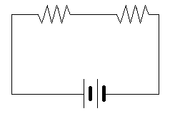

12.0 V

40.0 Ω

60.0 Ω

Voltage is ______________ V Current is ______________ A Power is ______________ W

**Question 13 (6 marks)**

A toddler places a metal toy train into a toaster which provides an electrical contact between the interior electrical components and the exterior metal case of the toaster. The train has a very high resistance such that when the toaster is turned on, a **small** current flows through the train into exterior case and then into the person who was holding the toaster.

(a) Name two safety devices that would help prevent this particular electrocution and describe why this device would be useful. (4 marks)

(b) Name one safety device that would **not** be useful for this particular electrocution and describe why. (2 marks)

**End of Section One**

**Section Two: Problem-solving 50% (90 Marks)**

This section has **seven (7)** questions. You must answer **all** questions. Write your answers in the

space provided. Suggested working time for this section is 90 minutes.

**Question 14 (12 marks)**

A 600 g substance, beginning in its liquid phase, was heated using a 300 W source. The substance produced the following heating curve:

(a) State the boiling point of the substance. (1 mark)

(b) State the range(s) of time that the kinetic energy of the substance was increasing.

(2 marks)

(c) State a time where the substance would be a mixture of both liquid and gas phases.

(1 mark)

(d) Calculate the latent heat of vaporisation from the data available on the graph. (3 marks)

Answer _________________ J kg-1

(e) Calculate the specific heat capacity of the gas phase of the substance from the data available on the graph. (3 marks)

Answer _________________ Units _________________

(f) Is the specific heat capacity of the liquid phase of this substance higher or lower than when in its gas phase? No calculation is required but you must refer to elements of the graph to justify your choice. (2 marks)

**Question 15 (14 marks)**

Radio carbon dating is a useful technique for establishing the date of death of organic matter. Two pieces of information are required; the half-life of carbon-14 and the ratio of carbon-14 to non-radioactive forms of carbon the organic matter contained while it was alive. The fraction of carbon-14 compared to total carbon for a sample as a function of time is shown below.

(a) What percentage of carbon in this organic matter was **not** radioactive while the organism was alive? (2 marks)

(b) What is the half-life of carbon-14 as indicated by the graph? Show evidence of how you determined your answer on the graph to help support your answer. (2 marks)

(c) The graph scale reveals the percentage of carbon-14 becomes negligible at 40 thousand years since time of death. Determine, by use of a calculation, what the likely percentage of carbon-14 is after 40 thousand years has passed. (3 marks)

Answer _________________ %

(d) Explain why your calculation in the previous answer will only be the “likely” percentage, no matter how accurate the half-life used in the calculation is. (2 marks)

(e) Each radioisotope has a different half-life. This is due to differences in the stability of forces acting within the nuclei. Explain why some nuclei are more unstable than others. (3 marks)

(f) On the graph, sketch the curve showing the percentage of carbon-14 for a sample that had 20% carbon-14 prior to its death. (2 marks)

**Question 16 (15 marks)**

Students were asked to find and then analyse the voltage-current profile of a circuit element. The students were required to measure current through the element for a variety potential differences. The equipment available to them was the circuit element, a 24.0 V battery, variable resistor (rheostat), voltmeter, ammeter and a collection of wires.

(a) Draw a circuit diagram of the circuit the students could use to vary the potential difference applied to the circuit element and to measure this potential difference and the current through the element. (4 marks)

(b) Use the record of the student's results in the following table to produce a voltage-current graph. Place the voltage along the horizontal axis. A grid is available on the next page. If you require, a spare grid is found at the back of the exam paper. (4 marks)

|  |  |  |  |  |  |
| --- | --- | --- | --- | --- | --- |
| **Voltage (V)** | 3.00 | 6.00 | 10.0 | 13.0 | 16.0 |
| **Current (A)** | 0.30 | 0.65 | 1.20 | 1.20 | 1.70 |

(c) Is this circuit element ohmic or non-ohmic? Justify your choice by referring to the graph.

(2 marks)

prac exam youngs mod 10 by 10

(d) Calculate the gradient of the line of best fit. (2 marks)

Answer _________________ Ω-1

**Question 16 (continued)**

(e) Using the gradient, determine the resistance of the circuit element. (2 marks)

Answer _________________ Ω

(f) On to your graph, sketch the voltage-current curve for another circuit element that has twice the resistance of the element investigated by the students. (1 mark)

**Question 17 (15 marks)**

In the 1950s, it was common practice for elevators to be operated by a bell hop; a person who would manipulate hand controls to determine both the speed and direction of the elevator. A 60.0 kg bell hop is bored and decides to play around with the elevator controls.

(a) Draw a free body diagram showing a labelled weight force and normal force that would be acting on the bell hop for each scenario the elevator is found in below. For clarity, draw the forces in the white space next to each bell hop, not over the bell hop. (3 marks)

Scenario 1:

Stationary

Scenario 2:

Slowing down while moving up

Scenario 3:

Moving down at a steady speed



(b) Calculate the weight of the bell hop. (1 mark)

Answer _________________ N

(c) Calculate the magnitude of the normal force acting on the bell hop in scenario 2 if the acceleration of the elevator is 3.20 m s-2. (3 marks)

Answer _________________ N

(d) The elevator itself has a 180 kg mass. Calculate the tension in the cable supporting the elevator with the bell hop inside if the elevator was stationary. (2 marks)

Answer _________________ N

**Question 17 (continued)**

(e) Explain whether the tension in the cable would increase, decrease or remain the same as the elevator begins to move up, compared to when it was stationary. State and refer to one of Newton's laws of motion in your answer. (3 marks)

(f) Describe why the bell hop would feel weightless if the cable supporting the elevator breaks.

(3 marks)

**Question 18 (13 marks)**

An organ is a musical instrument that operates on the resonance of both open and closed pipes of varying length. A keyboard of white and black keys, similar in appearance to those on a piano, are used to activate wind that passes through the pipes, causing them to vibrate at their natural frequencies. A full-size organ spans 5 octaves from the lowest note to the highest note across the keyboard. In music, an octave is the separation between two notes if one note has either double or half the frequency of the other.

(a) Explain why pipes of varying length and type (open/closed) are required to produce different notes. (3 marks)

(b) A full-sized organ can produce notes as low as 8.00 Hz.

(i) Calculate the shortest length of pipe able to produce this note. (3 marks)

Answer _________________ m

(ii) Draw the standing wave pattern inside this pipe when producing this note. (1 mark)

(iii) Calculate the highest frequency this full-sized organ will produce when activating a key on the other end of the keyboard. (1 mark)

Answer _________________ Hz

**Question 18 (continued)**

(c) Show that the wavelength of **any** harmonic of an open pipe can also be produced by a closed pipe of equal length resonating at twice the harmonic of the open pipe. (3 marks)

(d) On hot days, the organ can sound slightly out of tune. Suggest a reason for this. (2 marks)

**Question 19 (11 marks)**

The nuclear fission of uranium-235 within nuclear fuel rods has a range of possible products. While the average mass of a fission fragment is 118, it is unlikely to find fragments of this mass since the uranium nucleus usually splits unevenly. The most common fission result is barium-137 and krypton-95 in addition to some neutrons. The mass of reactants and products of this common reaction are found in the table below.

|  |  |
| --- | --- |
| **Particle** | **Mass (u)** |
| Uranium-235 | 235.043930 |
| Barium-137 | 136.905827 |
| Krypton-95 | 94.939844 |
| Neutron | 1.000866 |

(a) Write the nuclear reaction showing the most commonly occurring fission of uranium-235.

(3 marks)

(b) Calculate the mass defect of this fission reaction. (2 marks)

Answer _________________ u

(c) Calculate the energy released by a single fission event in joules. (3 marks)

Answer _________________ J

**Question 19 (continued)**

(d) In what form does this released energy exist? (1 mark)

(e) State two safety mechanisms employed at nuclear power plants to minimise the chance of nuclear accidents. (2 marks)

**Question 20 (10 marks)**

A 0.850 kg remote-controlled car is powered by a 2.00 W electric motor. Its operator, standing next to the car, pushes the control stick forward to its maximum position, causing the car to accelerate along the flat path away from the operator. The car’s velocity for the first 6.00 s of its journey is shown below.

(a) Calculate the acceleration of the car by analysing the graph. (2 marks)

Answer _________________ m s-2

(b) Calculate the distance covered by the car in the 6.00 s by analysing the graph. (2 marks)

Answer _________________ m

**Question 20 (continued)**

(c) Calculate the efficiency of the car’s motor. (3 marks)

Answer _________________ %

(d) At the 6.00 s mark, the operator released the control stick and the car slowed down, coming to a complete stop 4.40 m from the operator. Calculate the average frictional force acting on the car during its deceleration. (3 marks)

Answer _________________ N

**End of Section 2**

**This page has been left blank intentionally**

**Section Three: Comprehension 20% (36 Marks)**

This section contains **two (2)** questions. You must answer both questions. Write your answers in

the spaces provided. Suggested working time for this section is 40 minutes.

**Question 21 (18 marks)**

**The Medical Use of Ultrasound**

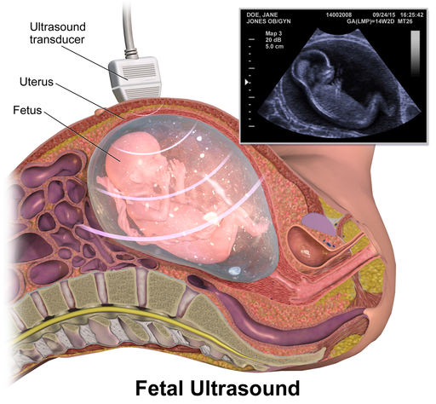

The term ultrasound refers to sound vibrations with a frequency higher than is perceptible by humans; in the range of 20.0 kHz or more. As with all sound, ultrasound waves will undergo reflection and refraction at boundaries between mediums as well as undergoing interference. Ultrasound’s wave behaviours allow for it to be used as a non-invasive, safe imaging technique for medical diagnosis; The most common being to monitor fetal development.

An ultrasound wave is produced within a device called a transducer which houses a piezoelectric material that vibrates in response to an electric current. The wave is directed into the body where it reflects or refracts at the boundary between different tissue layers (e.g. between fat and muscle or blood and arterial walls). Reflected waves are detected by the piezoelectric material in the transducer, converted into a current and interpreted by software to form an image.

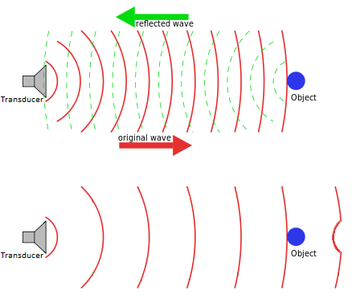

When using a wave to form an image it is important that the wavelength is similar or smaller than the size of the features that need to be distinguished. If the wavelength is larger than the feature, the wave tends to bend around the feature instead of being reflected (see image on left). Monitoring fetal development requires observation of features as small as one millimetre wide. This is why the ‘ultra’ part of ultrasound is required – it has a small enough wavelength to reveal the necessary details.

Can we keep increasing the frequency to obtain clearer images? Unfortunately, the energy of the wave is absorbed easily by body tissues at higher frequencies. This limits how deep a high frequency wave can penetrate into the body before it must reflect, otherwise it will be absorbed before returning to the transducer. Thus higher frequencies have low penetration but clearer images while low frequencies have higher penetration but lower clarity. The right frequency to use will be one that maximises clarity while still being able to reach deep enough into the part of the body needing to be imaged.

As stated earlier, the ultrasound will reflect and refract at the boundary between tissue layers. How much of the wave reflects and how much refracts depends on the difference between the acoustic impedance of each layer. The acoustic impedance ($Z$) is the resistance the ultrasound wave encounters moving through tissue. As the difference in acoustic impedance between the layers increases, the fraction of the wave that reflects also increases. The fraction of the amount reflected can be calculated using:

$$reflection fraction={\left(\frac{Z_{2}-Z_{1}}{Z_{1}+Z_{2}}\right)}^{2}$$

Where $Z_{1}$ and $Z_{2}$ are the acoustic impedance of tissue layer 1 and tissue layer 2 respectively.

A similar observation can be made with audible sounds. An echo heard from a canyon wall occurs because the difference in acoustic impedance between the air and the dense rock is large, causing the sound to be reflected back. However, sound waves moving through different density layers of air mostly refracts because the layers have similar impedances.

**Questions:**

(a) What is the maximum wavelength of an ultrasound passing through air at 25.0 0C? Give your answer to a suitable number of significant figures. (3 marks)

Answer _________________ m

(b) Describe the role of a transducer in a medical ultrasound. (2 marks)

**Question 21 (continued)**

(c) In the diagram below, is it possible for the incident wave to reflect off the object that is in the path of the wave? Justify your answer by referring to information available in the diagram and article. (2 marks)

(d) Typically, a 2.50 MHz wave is used for a medical ultrasound of a fetus.

(i) What is the size of the smallest feature required to be distinguished when monitoring a fetus? (1 mark)

(ii) Via a suitable calculation, estimate the speed of sound inside the womb where the fetus is located. (3 marks)

Answer _________________ m s-1

(e) Describe why increasing the frequency of the ultrasound waves is not always the best option to produce useful medical images. (2 marks)

(f) The table below shows the acoustic impedance of mediums relevant to ultrasound medical imaging.

|  |  |
| --- | --- |
| **Medium** | **Impedance (× 106 kg m-2 s-1)** |
| Air | 0.0004 |
| Skin | 1.99 |
| Fat | 1.38 |
| Kidney | 1.65 |

(i) Calculate the fraction of an ultrasound wave that is reflected at the boundary of fat and kidney tissue. (3 marks)

Answer _________________

(ii) A special gel is placed on the transducer so that when it is placed on the skin of the patient there is no air between the transducer and the skin. Suggest a reason why this is important. (2 marks)

**Question 22 (18 marks)**

**Colder than Absolute Zero**

While studying Physics Unit 1, you were likely exposed to the concept of absolute zero; the lowest possible temperature, occurring when particles have zero kinetic energy. However, experiments conducted within the last 5 years have produced negative temperatures. That is, temperatures below absolute zero. In a bizarre twist, it’s also possible to view a substance at a negative temperature as also being hotter than infinity.

For a substance at any positive temperature, the particles of the substance have a range of kinetic energies. The higher the temperature, the higher the average kinetic energy. However, regardless of how high the temperature is, it is more likely to find a particle at lower kinetic energies than higher kinetic energies. The number of particles across the range of all kinetic energy values is described by the Maxwell-Boltzmann distribution (see below).

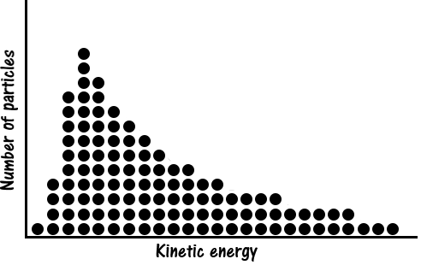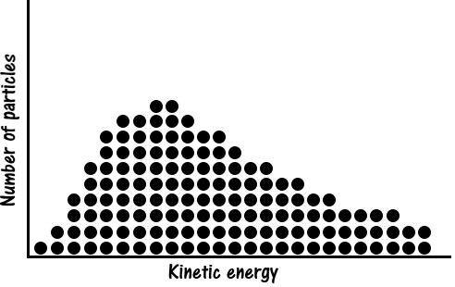

Maxwell-Boltzmann particle distributions:

High positive temperature

Low positive temperature

Approaching 0 K, the particles all bunch up on the left side of the horizontal axis as no particles have any kinetic energy. As the temperature increases more and more particles move towards higher kinetic energies but there are always some particles with very little, or no kinetic energy. Even at a theoretical infinite temperature the particles would **not** all bunch up on the right side of the horizontal axis. There will always be particles with zero, or low, kinetic energy; this is how a chaotic system of particles naturally organises itself.

For negative temperatures to be achieved, the particles must exist in an unnatural state. If you take a collection of particles and make sure they all have around the same (non-zero) kinetic energy, then you have achieved a negative temperature. What makes this a negative temperature you ask? After all, the particles still have a positive average kinetic energy and temperature is simply average kinetic energy, right? Well that depends on who you ask. There are several definitions of temperature, including:

1. the measurement of warmth or coolness (non-scientist)
2. the average kinetic energy of the particles (large objects)
3. the amount of entropy compared to the energy of the particles (small clusters of particles)

It’s that last definition that has allowed for negative temperatures to be achieved. Entropy is the amount of randomness within a system. High positive temperatures have high entropy because of the large spread (randomness) of the particle kinetic energies. Negative temperatures have low entropy because the particle kinetic energies are not spread out (low randomness). Scientists have trapped collections of potassium atoms using lasers and magnetics such that they all have the same kinetic energy and cannot collide with each other. This is how the negative temperature was achieved.

It’s worthwhile noting that negative temperatures are actually warmer than positive temperatures. If a collection of particles at a negative temperature was brought into contact with a collection of particles at (any) positive temperature then heat would flow from the negative temperature region to the positive temperature region. As heat flows from hot to cold, negative temperatures are warmer. So negative temperatures are hotter than infinity!

**Questions:**

(a) The lowest temperatures in Western Australian occur at night in the desert and are as low as -4.50 0C. Explain why this article is so impressed with the concept of negative temperatures when even a warm country like Australia experiences them. (3 marks)

(b) For the Maxwell-Boltzmann distribution below, place an arrow on the horizontal axis indicating the approximate value of the average kinetic energy of all the particles. Label this arrow clearly. (1 mark)



(c) Explain why negative temperatures do not occur naturally. (2 marks)

**Question 22 (continued)**

(d) On the set of axes provided, draw the distribution of particle kinetic energies expected for the following conditions:

(i) Absolute zero (2 marks)

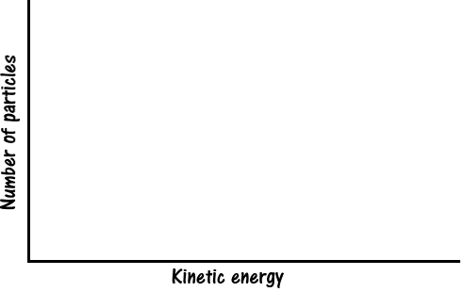

(ii) Negative temperature (2 marks)



(e) Describe one similarity and one difference between a substance at a positive temperature and a substance at a negative temperature. (3 marks)

(f) What equipment was used to create negative temperatures in the lab? (1 mark)

(g) Why do you suppose it was important that the potassium atoms were stuck in place and not able to collide with each other? (2 marks)

(h) Explain why negative temperatures are hotter than positive temperatures. (2 marks)

**End of Questions**

**Additional working space**

**Spare grid for graph**

prac exam youngs mod 10 by 10

**End of examination**

**Acknowledgements**

**Question 20**

Fetal Ultrasound

https://commons.wikimedia.org/wiki/File:Fetal_Ultrasound.png

By BruceBlaus (Own work) [CC BY-SA 4.0 (http://creativecommons.org/licenses/by-sa/4.0)], via Wikimedia Commons

Wave Reflection

Adapted from https://commons.wikimedia.org/wiki/File%3ASonar_Principle_EN.svg

By Georg Wiora (Dr. Schorsch) (Self drawn with Inkscape) [GFDL (http://www.gnu.org/copyleft/fdl.html), CC-BY-SA-3.0 (http://creativecommons.org/licenses/by-sa/3.0/) or CC BY-SA 2.5 (http://creativecommons.org/licenses/by-sa/2.5)], via Wikimedia Commons