|  |  |
| --- | --- |
|  | **VICTORIAN CERTIFICATE OF EDUCATION**  **Year 2014** |

###### **STUDENT NUMBER Letter**

|  |  |  |  |  |  |  |  |  |  |  |  |
| --- | --- | --- | --- | --- | --- | --- | --- | --- | --- | --- | --- |
| **Figures** |  |  |  |  |  |  |  |  |  |  |  |
| **Words** |  |  |  |  |  |  |  |  |  |  |  | |

###### **PHYSICS**

**Trial Written Examination**

Reading time: 15 minutes

Writing time: 2 hours 30 minutes

**QUESTION AND ANSWER BOOK**

## Structure of book

|  |  |  |  |
| --- | --- | --- | --- |
| *Section* | *Number of*  *questions* | *Number of questions*  *to be answered* | *Number of*  *marks* |
| A – Core studies | 21 | 21 | 128 |
|  | *Number of*  *detailed studies* | *Number of detailed*  *studies to be answered* | *Number of*  *marks* |
| B – Detailed studies | 6 | 1 | 22 |
|  |  |  | Total 150 |

* Students are permitted to bring into the examination room: pens, pencils, highlighters, erasers,

sharpeners, rulers, up to two pages (one A4 sheet) of pre-written notes (typed or handwritten) and one scientific

calculator.

* Students are NOT permitted to bring into the examination room: blank sheets of paper and/or

white out liquid/tape.

**Materials supplied**

* Question and answer book of 94 pages. A formula sheet.
* Answer sheet for multiple-choice questions.

**Instructions**

* Write your **student number** in the space provided above on this page.
* Check that your **name** and **student number** as printed on your answer sheet for multiple-choice questions are correct, **and** sign your name in the space provided to verify this.
* Unless otherwise indicated, the diagrams in this book are **not** drawn to scale.
* All written responses must be in English.

**At the end of the examination**

* Place the answer sheet for multiple-choice questions inside the front cover of this book.

**Students are NOT permitted to bring mobile phones and/or any other unauthorised electronic devices**

**into the examination room.**

** Kilbaha Pty Ltd 2014**

|  |  |
| --- | --- |
|  |  |

**SECTION A**

**Area of study Page**

Motion in one and two dimensions …………………………………………………………………….2

Electronics and photonics …………………………………………………………………………….15

Electric power ………………………………………………………………………………………...29

Interactions of light and matter ……………………………………………………………………….42

**SECTION B**

**Detailed Studies**

Einstein’s special relativity …………………………………………………………………………..51

Materials and their use in structures …………………………………………………………………58

Further electronics ………………………………………………………………………………....…66

Synchrotron and its applications ……………………………………………………………………..73

Photonics ……………………………………………………………………………………………..80

Sound ………………………………………………………………………………………………...87

**SECTION A – Core studies**

**Instructions for Section A**

Answer **all** questions in this section in the spaces provided. Write using black or blue pen.

Where an answer box has a unit printed in it, give your answer in that unit.

You should take the value of *g* to be 10 m s-2.

Where answer boxes are provided write your final answer in the box.

In questions worth more than 1 mark, appropriate working should be shown.

Unless otherwise indicated, diagrams are not to scale.

**Area of Study - Motion in one and two dimensions**

**Question 1**  (7 marks)

In an experiment, a physics trolley rolls down a slope dropping 1.50 m in height.

The trolley has a mass of 1.40 kg.

On the slope the surface can be regarded as frictionless.

The trolley smoothly reaches the floor and then rolls horizontally, against a friction force of 1.5 N.

After rolling 8.0 m, it reaches a spring barrier. The spring constant is 100 Nm-1. See **Figure 1a**.

(Ignore any friction during the compression of the spring.)

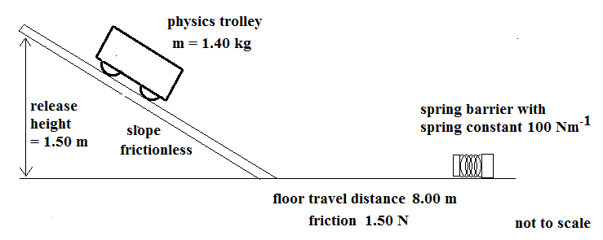

**Figure 1a**

**a.** What is the speed of the trolley when it reaches the end of the slope? 2 marks

|  |  |
| --- | --- |
|  | ms-1 |

**Area of Study - Motion in one and two dimensions**

**b.** What is the compression of the spring, when the trolley has been brought to a stop?

(Ignore any friction during the compression of the spring.)

2 marks

|  |  |
| --- | --- |
|  | m |

**c.** While coming to rest against the spring, which graph would best represent velocity- displacement?

Choose the best example. 3 marks

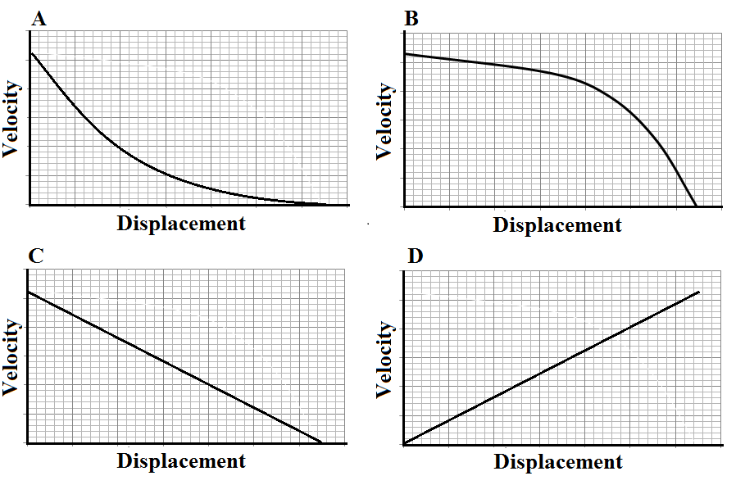

**Figure 1b**

|  |  |
| --- | --- |
|  |  |

**Area of Study - Motion in one and two dimensions**

**d.** The trolley rebounds from the spring with a speed of 2.1 ms-1. At that moment the student carrying out the experiment was walking towards the spring from the ramp with a speed of 1.2 ms-1.

What is the velocity of the student relative to the trolley at that instant?

|  |  |
| --- | --- |
| magnitude  ms-1 | direction |

**Area of Study - Motion in one and two dimensions**

**Question 2** (5 marks)

A netballer makes a shot at the goal.

She is 3.42 m horizontally away from the ring when she releases the ball from a height of 1.90 m towards the 3.05m high hoop.

The ball was shot with a velocity of 7.00 ms-1 at an angle of 60° to the horizontal as shown in **Figure 2** below.

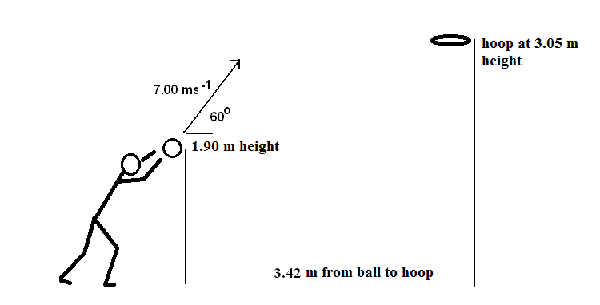

**Figure 2**

**a.** What is the maximum height reached by the ball, above the court floor? 2 marks

|  |  |
| --- | --- |
|  | m |

**b.** Use calculations to show that the ball can be expected to pass through the hoop.

3 marks

**Area of Study - Motion in one and two dimensions**

**Question 3**  (9 marks)

A coin donation bin has been designed as a horizontal cone with a hole in the centre. A coin can be rolled around the conical surface, but will slow and eventually drop through the hole in the centre.

The surface of the cone is very smooth. The conical path and coin are shown in **Figure 3a**.

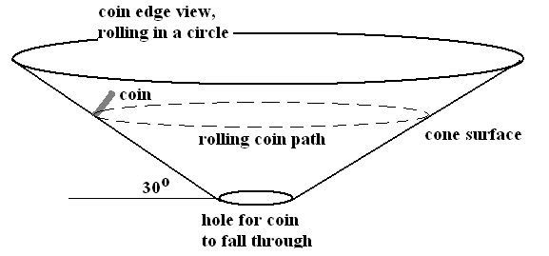

**Figure 3a**

**a.** On the diagram below (**Figure 3b**) indicate the applied forces which act on a coin rolling smoothly in a circle around this conical surface.

Use correctly drawn vectors. (Names of the forces are not needed) 2 marks

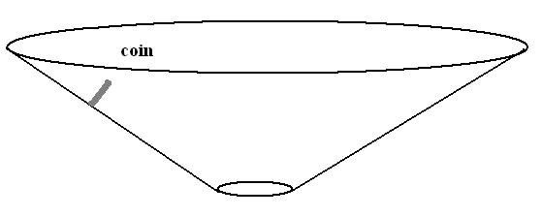

**Figure 3b**

**Area of Study - Motion in one and two dimensions**

**b.** From the selection in **Figure 3c** choose an arrow which shows the direction of the **net** force.

1 mark

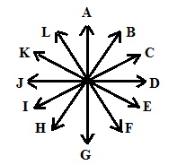

**Figure 3c**

**c.** Explain your choice.

2 marks

**d.**  The cone makes an angle of 30° to the horizontal.

The coin is rolling in a circle with a radius of 0.25 m.

What speed will it need, to continue in its circular path?2 marks

|  |  |
| --- | --- |
|  | ms-1 |

**Area of Study - Motion in one and two dimensions**

**Question 4**  (10 marks)

In an ambitious project to take a human crew to Mars, an artificial gravity section will be used for the crew on the long journey.

The spacecraft, the Ares Voyager (**Figure 4a**) will have an artificial gravity section in the form of a spinning ring. The artificial gravity is planned to be only a small fraction of the Earth’s strength,

0.90 N kg-1. Scientists/engineers decided that the ring should spin at 2 turns per minute.

This is the highest possible while maintaining the crew’s comfort.

This data will determine some of the structure of the Ares Voyager.

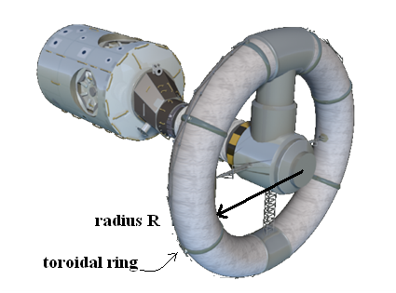

**Figure. 4a**

<http://en.wikipedia.org/wiki/File:Nautilus-X_ISS_demo_1.png>

**a.** What radius *R*, to the floor surface in the toroidal ring is needed for the ring to generate this artificial gravity? 2 marks

m

**Area of Study - Motion in one and two dimensions**

**b.** There is a discussion about which direction in the spinning ring will be understood as down by the crew. Some suggest that the outer wall will be the floor, others suggest the inner wall. **Figure 4b.**

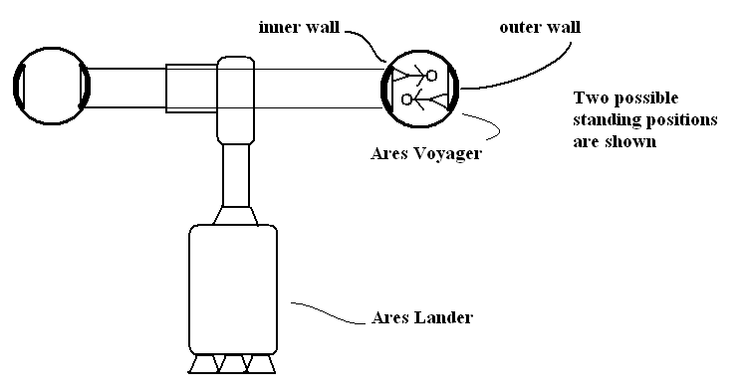

**Figure 4b**

Which is to be the floor? Select which is the floor. 2 marks

inner outer

Explain your choice.

**c.** When the Ares Voyager reaches Mars, the craft will be put in a circular orbit, where the orbit will be completed in 1.61 × 104 s. This orbit is at a radius of 6.50 × 106 m.

Determine the mass of Mars from this data. 2 marks

kg

**Area of Study - Motion in one and two dimensions**

**d.** While in this orbit, the crew of the Ares Voyager will leavethe ring of the space ship and enter the non-rotating Ares Lander craft at its centre. The crew will now experience an apparent weightlessness although the gravitational strength of Mars is quite measureable.

Why will they experience apparent weightlessness now, although subject to a gravitational field? 2 marks

**e.** The Lander section, mass 220 tonnes (1 tonne = 1000 kg) is detached from the craft and descends to the surface of Mars. The change in gravitational field approaching Mars is shown in **Figure 4c**.

Mars has a radius of 3.50 × 106 m.

What is the change in potential energy for the Ares Lander? 2 marks

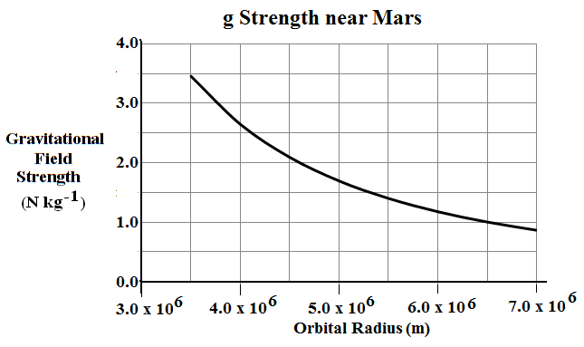

**Figure 4c**

J

**Area of Study - Motion in one and two dimensions**

**Question 5** (7 marks)

A train of ore trucks moves slowly under a hopper, (**Figure 5a**) which drops 120 tonnes of ore into each truck. Each rail truck moves slowly, taking 40 s to fill and then and the next truck to be filled moves into its place.

The rail trucks have a constant speed of 0.25 ms-1. They are each 10 m long and have an empty mass of 9.0 tonnes. When the ore reaches the truck, it has a speed of 4.0 ms-1 vertically.

**a.** What magnitude of impulse is applied vertically to the ore in being loaded during 1 second? 2 marks



**Figure 5a**

<http://www.abc.net.au/news/stories/2011/05/21/3223114.htm?site=perth>

Ns

**Area of Study - Motion in one and two dimensions**

**b.** What force must be provided by the train to maintain its constant speed,

against the increasing mass of its load, while the ore is loading? 2 marks

N

**c.** A particular train has 8 identical trucks, each fully loaded. The engine has a mass of 250 tonnes.

See **Figure 5b**.

The friction on the trucks and the engine is 1.0 × 104 N in each case.

What is the magnitude and direction of the force which the last truck exerts on the second last truck, on a track sloping downhill at 1.0° if the speed is constant at 20 ms-1? 3 marks

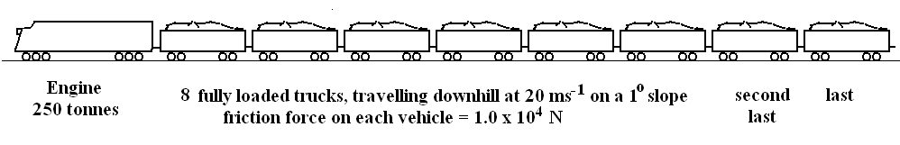

**Figure 5b**

|  |  |
| --- | --- |
| ………… kkN |  |

**Area of Study - Motion in one and two dimensions**

**Question 6** (4 marks)

An overshot water wheel, with water flowing over the top of the wheel, was designed with a **diameter** of 4.5 m and completes 10 turns in a minute. Water flows over the top of the wheel and none is held by the blades at the bottom.

The overshot water wheel is seen in **Figure 6**.

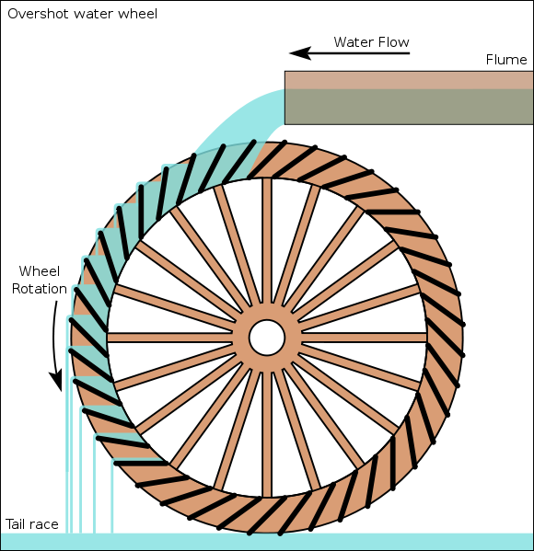

‘

**Figure 6**

<http://en.wikipedia.org/wiki/Water_wheel>

**a.** What is the centripetal acceleration at the rim of the wheel, where the paddles, which are driven by the water, are located? 2 marks

ms-2

**Area of Study - Motion in one and two dimensions**

**b.** A paddle has a mass of 5.0 kg. What magnitude is the force exerted on the paddle when it is at the bottom of the vertical motion? 2 marks

N

**Area of study – Electronics and Photonics**

**Question 7** (6 marks)

A network of resistors is designed with two series branches placed in parallel.

**a.** In branch A of the resistor network in **Figure 7a**, *R1* = 1.8 k Ω and *R2* = 2.2 k Ω.

The battery is 6.0 V 2 marks

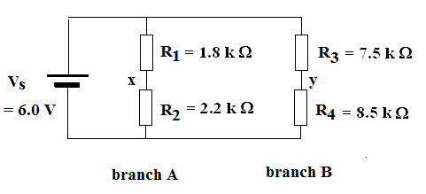

Fig. 7a

**Figure 7a**

Find the voltage at the point labelled “x”.

V

**b.**  In branch B, *R3* = 7.5 kΩ and *R4* = 8.5 kΩ. What is the effective resistance of the whole circuit?

2 marks

kΩ

**Area of study – Electronics and Photonics**

**c.** An ammeter is now added to the circuit (Fig. 7b) between points “x” and “y”.

Under what conditions will the ammeter read zero current? 2 marks

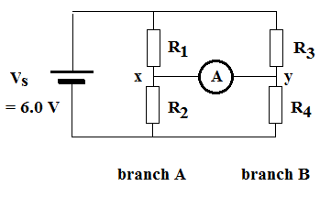

**Figure 7b**

Select the best answer.

**A.** The ammeter will always detect a current while the battery is connected.

**B.** The ammeter will read zero if *R1/R2 = R3/R4.*

**C.** The ammeter will read zero if *R1/R4 = R3/R2.*

**D.** The ammeter will read zero if *R1/R2 = R4/R3.*

**Area of study – Electronics and Photonics**

**Question 8** (7 marks)

A control circuit, seen in **Figure 8a**, using a resistor and a thermistor is designed to operate a switch and turn on a refrigerator when the output switching voltage drops below 4.0 V. The supply voltage is 6.0 V

It uses thermistor **A**, with characteristics seen in **Figure 8b**.

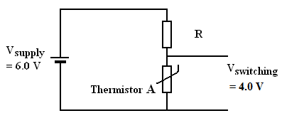

**Figure 8a**

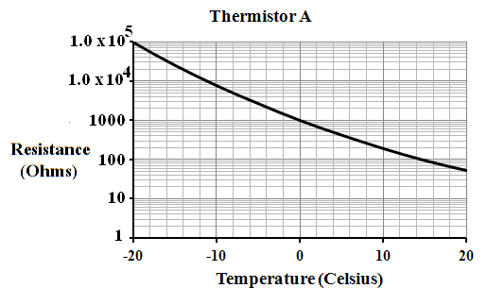

**Figure 8b**

**a.**  What is the resistance of the thermistor **A,** when the temperature is – 4.0° C.

The characteristics of this thermistor are shown in Fig. 8b, above. 1 mark

Ω

**Area of study – Electronics and Photonics**

**b.**  What value is needed for the resistor R, if the refrigerator is to switch on at – 4.0° C?

2 marks

Ω

**c.**  The circuit is changed to use thermistor **B**. Which circuit would be the most appropriate use of this thermistor to turn on a refrigerator? The characteristic graph for thermistor **B** is shown in

**Figure 8c**.

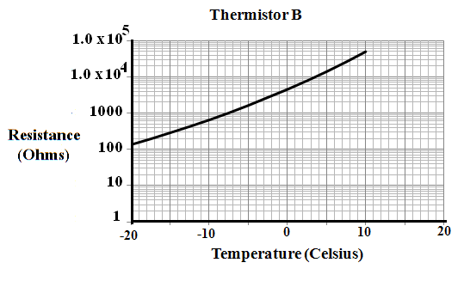

**Figure 8c**

**Area of study – Electronics and Photonics**

Choose the most appropriate design from the options below in **Figure 8d**. 2 marks

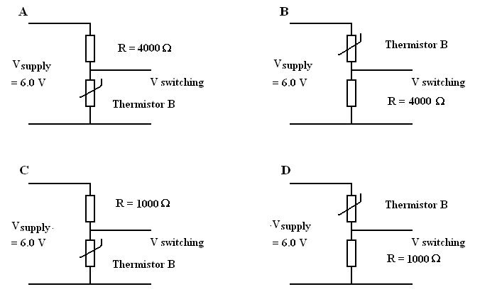

Fig. 8b

**Figure 8d**

**Area of study – Electronics and Photonics**

**d.**  Using a relevant **calculation and explanation** show why this is the most appropriate circuit.

2 marks

**Area of study – Electronics and Photonics**

**Question 9** (7 marks)

An LED (light emitting diode) and a resistor R1 are in the circuit shown in **Figure 9a**. The LED is to operate at 18 mA, supplied by a voltage of 22 V.

The LED has the characteristic curve shown in **Figure 9b**.

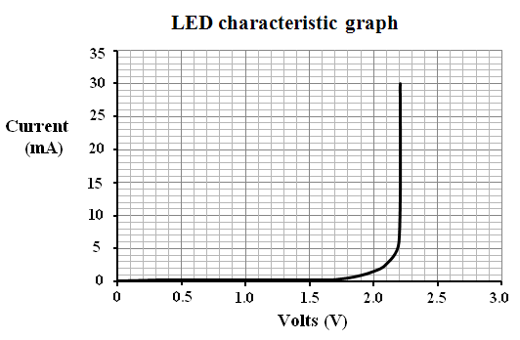

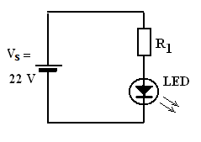

**Figure 9a Figure 9b**

**a.** What value is needed for the resistor *R1*. (2 marks)

k Ω

**Area of study – Electronics and Photonics**

**b.** The light from the LED is shone onto a photo-diode.

The photo-diode has the characteristic graph shown in **Figure 9c**.

The light intensity on the photo diode is 1.5 Wm-2.

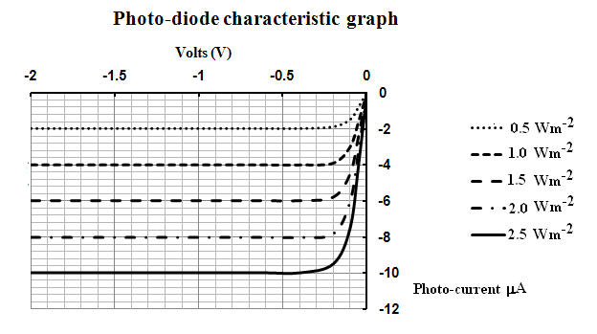

**Figure 9c**

In the optically linked circuit shown in **Figure 9d**, resistor R2 is 1.2 MΩ. The supply voltage in the photo-diode section of the circuit is 9.0 V

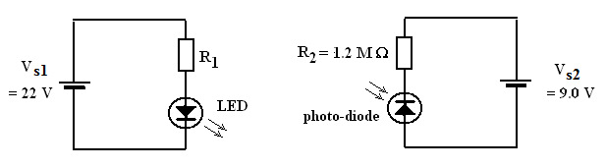

**Figure 9d**

What is the voltage across resistor R2? (2 marks)

V

**Area of study – Electronics and Photonics**

**c.**  The two circuits are now combined so that an audio data signal controls the current through the

LED. These two waves are shown in **Figure 9e**.

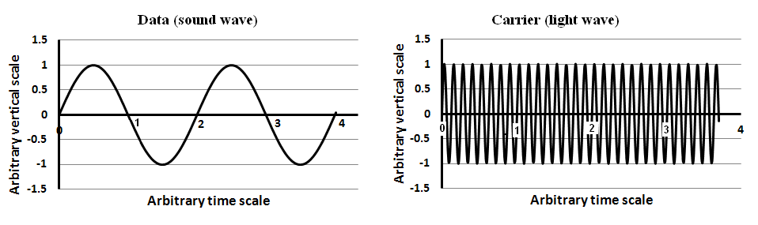

**Figure 9e**

**Area of study – Electronics and Photonics**

Which graphs would best represent the modulated light wave (I) and the brightness of the modulated light (II) Select from the waveforms below, in **Figure 9f**. (2 marks)

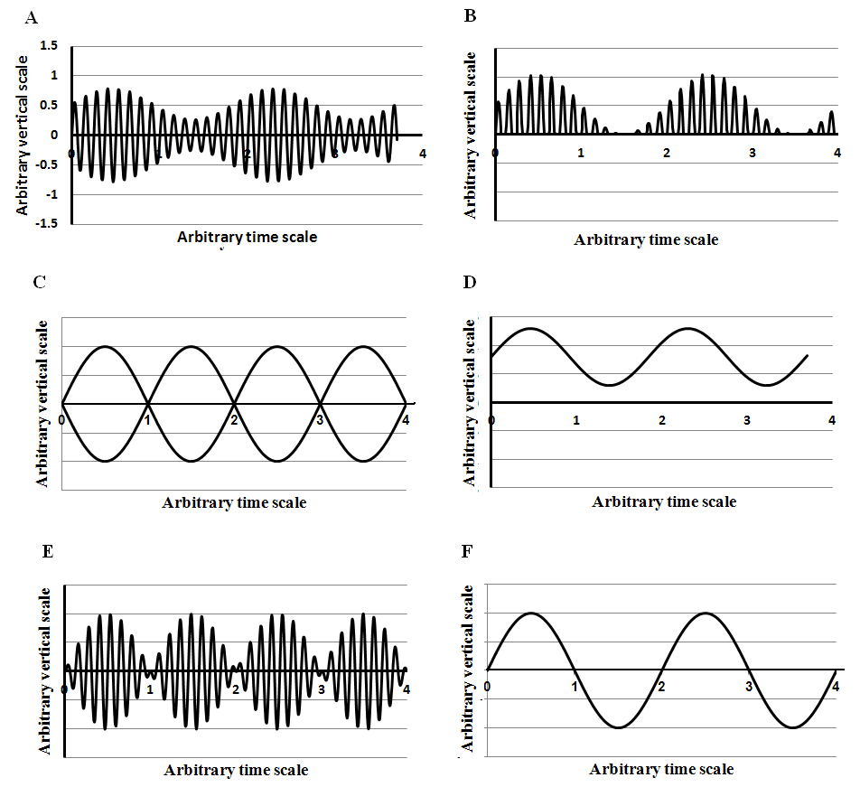

**Figure 9f**

|  |  |
| --- | --- |
| Modulated  light waveform  (I) | Brightness  of the modulated light (II) |
|  |  |

**Area of study – Electronics and Photonics**

**d.** Which waveform from above in **Figure 9f**, could represent the electrical current flowing in the

photo-diode of the receiver circuit? (1 mark)

**Area of study – Electronics and Photonics**

**Question 10**  (6 marks)

An amplifier is driven by the input audio signal as shown in **Figure 10a**.

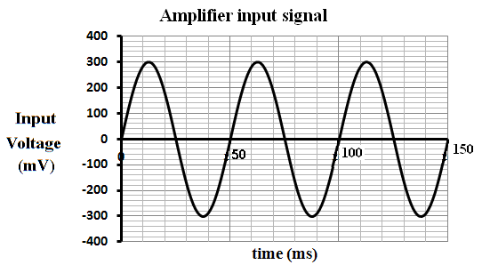

**Figure 10a**

**a.** What is the frequency of this signal? (1 mark)

Hz

**Area of study – Electronics and Photonics**

**b.** The amplifier has the characteristic curve shown in **Figure 10b**.

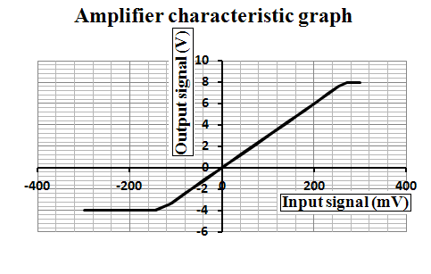

**Figure 10b**

What is the linear gain of the amplifier? 2 marks

**Area of study – Electronics and Photonics**

**c.** On the graph below (**Figure 10c**) sketch the output signal showing voltages and any relevant information. Include voltages on the vertical axis. 3 marks

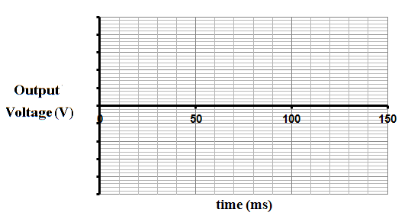

**Figure 10c**

**Area of study - Electric power**

**Question 11** (4 marks)

The Earth’s magnetic field is not horizontal but inclined upwards in Victoria with a strength of 60 μT directed at an angle of 70° up from the Earth’s surface. (**Figure 11**)

At a point where a measurement is taken, a bar magnet, held vertically, cancels the vertical component of this field.

**a.** What is the strength of the bar magnet at the point X, directly below the bar magnet, where the

measurement is taken? This is shown in **Figure 11**. 2 marks

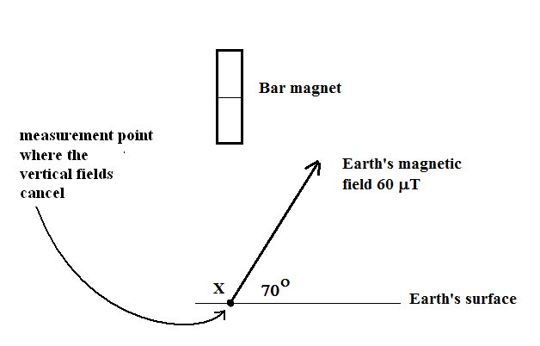

**Figure 11**

μT

**b.** Label the NORTH pole of the magnet with an “N”

Explain how you know that this pole is the north end. 2 marks

**Area of study - Electric power**

**Question 12** (4 marks)

During a “brown out” power failure, the mains voltage was substantially reduced but not turned off.

The voltage was measured with a suitable voltmeter and found to be 85 VRMS instead of its usual 230 VRMS.

**a.** If this could have been measured with a cathode ray oscilloscope (CRO) what **peak-to-peak** voltage would have been measured? (Assume the waveform remained sinusoidal). 2 marks

V

**b.** An electric jug with a rating of 1500 W at 230 VRMS was turned on. What power would it consume under these “brown out” conditions? 2 marks

W

**Area of study -Electric power**

**Question 13** (6 marks)

An experimental motor was made with two bar magnets and a coil wound on an axle with 150 turns of wire. The magnetic field is uniform with strength of 0.060 T. The coil has a width (side WZ) of 7.0 cm and a length (side WX) of 6.5 cm. It has a split ring commutator.

Initially the commutator side P has a positive voltage compared to commutator side Q.

The motor is turned on with a current of 0.50 A in the position shown in **Figure 13a**.

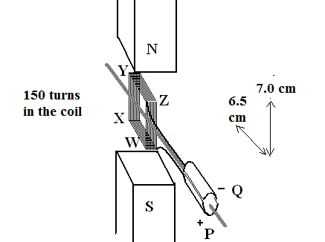

**Figure 13a**

**Area of study -Electric power**

**a.** The commutator is split as shown in **Figure 13a**. At which position in the rotation in **Figure 13b**, should the commutator switch the current to maintain a constant rotation? 1 mark

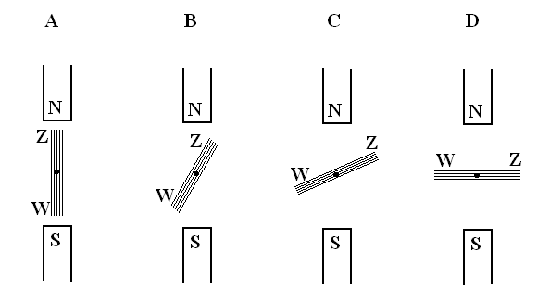

Fig. 13b

**Figure 13b**

**b.** Why is this, the best position to switch the current? 2 marks

**c.** In this starting position shown in **Figure 13a**, what is the magnitude of the force on side YZ?

2 marks

N

**Area of study -Electric power**

**Question 14** (8 marks)

The motor from Question 13 is now disconnected from the power supply and driven as a generator.

In the generator, the magnetic field is uniform with strength of 0.060 T. There are 150 turns in the coil.

The coil has a width (side WZ) of 7.0 cm and a length (side WX) of 6.5 cm.

**a.** Firstly the output voltage was investigated, connecting an oscilloscope to the split ring commutator.

The split ring commutator is removed and a slip ring system used instead. The output is again measured on the oscilloscope.

Four possible views of the voltage output seen on the oscilloscope are shown in **Figure 14a**.

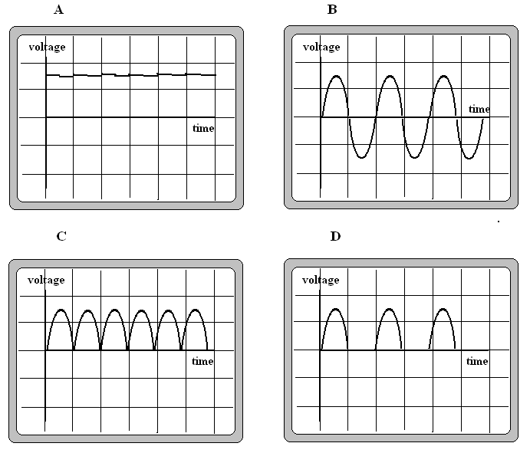

**Figure 14a**

**Area of study -Electric power**

Which is the most accurate oscilloscope view of the voltage output (**Figure 14a**) using the split ring commutator and which using with the slip rings? 2 marks

|  |  |
| --- | --- |
| split ring  commutator |  |
| slip  rings |  |

**b.** The alternator, using its slip rings, rotates 90° from the start position to place the coil perpendicular to the magnetic field. What flux passes through the coil at this rotated position? 2 marks

Wb

**c.** While operating the alternator rotates at 25 Hz. What average emf is generated during

this 90° turn? 2 marks

V

**Area of study -Electric power**

**d.** The driving force is removed and the alternator slows to a stop. On the oscilloscope view in **Figure 14b**, below, show the view of the voltage while the motor is stopping. 2 marks

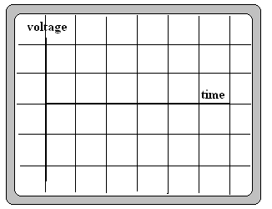

The oscilloscope settings are unchanged from the view in Question 14a.

**Figure 14b**

**Area of study -Electric power**

**Question 15** (6 marks)

A circuit with a battery, globe, switch and an ideal transformer are connected as shown in **Figure 15**.

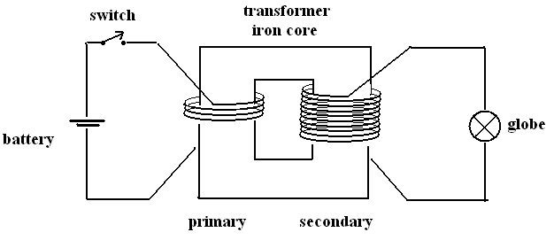

Fig 15a

**Figure 15**

**a.** The switch is closed allowing current to flow in the primary side of the circuit.

The globe glows for a moment.

The switch is opened, stopping the flow of current in the primary circuit.

Again the globe glows for a moment.

Explain why the globe operates briefly at these stages of the experiment, when normally a transformer will not operate from DC voltages. 2 marks

**Area of study -Electric power**

**b.** The battery is now replaced with a 12 VRMS AC voltage source.

The primary has 200 turns.

The output voltage is 27 VRMS.

The circuit is switched on.

What is the ratio of secondary to primary turns? 2 marks

**c.** Why does this turns ratio give a higher secondary voltage than the primary voltage? 2 marks

**Area of study -Electric power**

**Question 16** (6 marks)

There is a proposal to build a 30 MW power station (**Figure 16**), which is powered by the Earth’s geothermal heat at Paralana, 600 km north of Adelaide.

A power line would deliver the energy to Adelaide on a 275 kV transmission line, while the generator would produce 20 kV.

The transmission lines would have a resistance of 1.05 × 10-4 Ω m-1 over its 1200 km length. (2 wires).

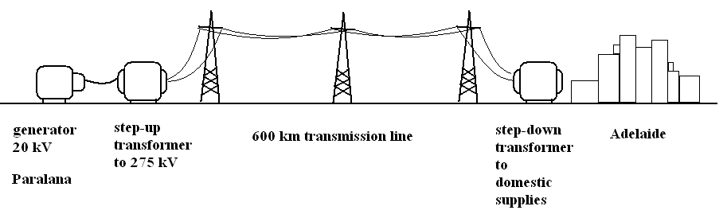

Fig. 16a

**Figure 16**

**a.** What would the voltage drop be in the high voltage line when operating at its highest current?

2 marks

V

**b.** What is the fraction of power transmitted to Adelaide compared to total power generated?

2 marks

**Area of study -Electric power**

**c.** If the power was transmitted without any transformers by the 20 kV generator, to a resistive load of 57 Ω in Adelaide, what power would be supplied?

W

**Area of study -Electric power**

**Question 17** (3 marks)

A conducting ring is held on the end of a pendulum. It is swinging between the poles

of a magnet as shown in **Figure 17a**.

It begins its swing at (I), swings through the gap between the poles (II) and then out to the left at (III)

before returning.

It moves to the **left initially.**

**The ring can be regarded as perpendicular to the field at all times.**

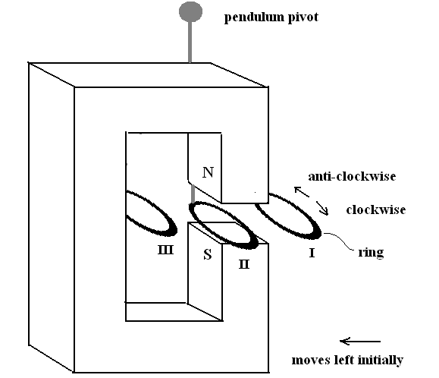

**Figure 17a**

The possible directions of current flow are marked on the ring, viewed from above.

**Area of study -Electric power**

**Question 17 (continued)**

**a.** Which graph, in **Figure 17b** below, best shows the current in the ring during **one** complete swing of the pendulum, starting from the right and returning there? 1 mark

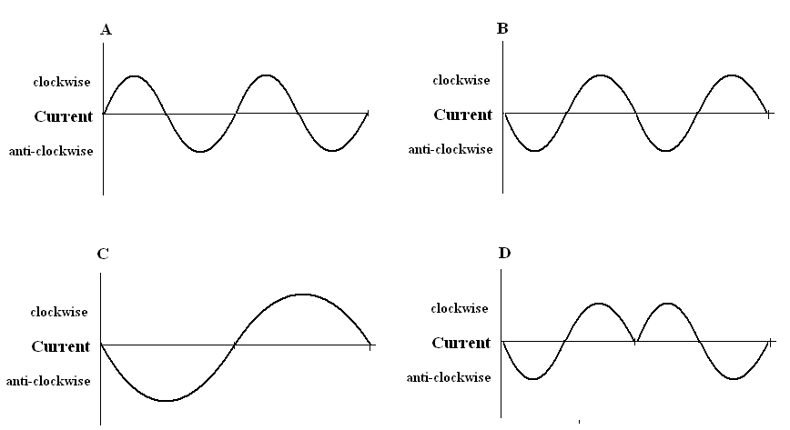

**Figure 17b**

**b.** Explain your selection by stating an appropriate physical law which refers to the direction of current flow. 2 marks

**Area of study – Interactions of light and matter**

**Question 18** (7 marks)

Young’s two slit experiment is a strong foundation for the wave model of light. Light is shone through two narrow slits and the pattern of light produced is observed on a screen.

**a.** If the particle model had been valid under these conditions, what sort of light pattern would have been seen on the screen? Choose the best selection from **Figure 18a** below. 1 mark

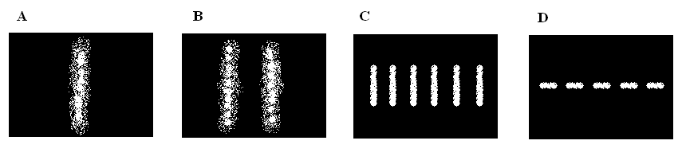

Fig. 17a

**Figure 18a**

**b.** The light used in a particular investigation has an energy of 1.97 eV. What is its wavelength?

2 marks

nm

**c.** How many photons of the 1.97 eV light would be needed to transfer 1.0 J of energy?

2 marks

**Area of study – Interactions of light and matter**

**d.** In a investigation of Young’s experiment, two wavelengths of light were used. The first was at 630 nm and the second was an unknown wavelength.

It was found that using the same set of slits and screen distance, that the third node for the 630 nm light was in the same position as the third anti-node using the second light

This is shown in **Figure 18b** below.

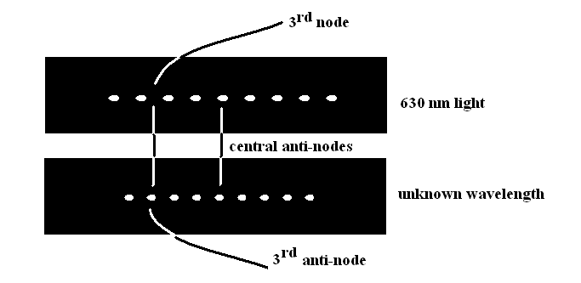

**Figure 18b**

What is the wavelength of the second light? 2 marks

nm

**Area of study – Interactions of light and matter**

**Question 19** (7 marks)

A simple observation of the photo-electric effect can be made using an electroscope with a magnesium plate.

If charged negatively, and sunlight is shone onto the charging plate, the separated leaves close

together, indicating that the charge is lost.

The electroscope does not discharge if the charging plate is positive or if incandescent light is used.

(**Figure 19a**)

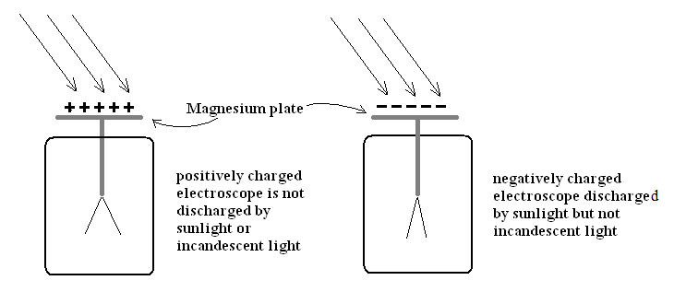

Fig 18a

**Figure 19a**

**a.** How does this observation support a particle model of light? 2 marks

**Area of study – Interactions of light and matter**

**b.** Using the photo-electric apparatus shown in **Figure 19b** and a series of light filters, data was obtained and is shown in the table in **Figure 19c**.

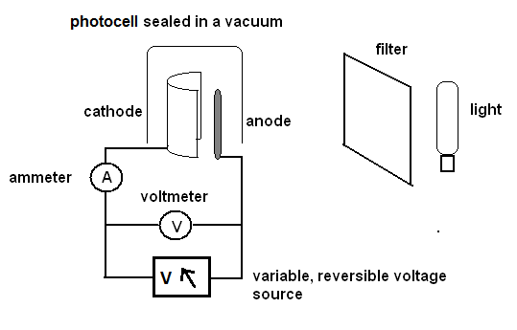

**Figure 19b**

|  |  |
| --- | --- |
| Stopping  Voltage (V) | Frequency  (Hz × 1014) |
| 0.2 | 9 |
| 1.6 | 12 |
| 2.7 | 15 |
| 4.1 | 18 |

**Figure 19c**

**Area of study – Interactions of light and matter**

Plot the data on the graph in **Figure 19d**. Show values on the axes.

Using the plot or otherwise determine the value of Planck’s constant from **this data**. 3 marks

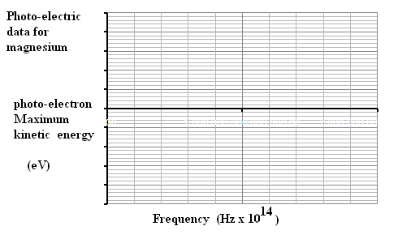

**Figure 19d**

eV s

**Area of study – Interactions of light and matter**

**c.** Determine the work function of magnesium from this data. 1 mark

eV

**d.** Using this data, if light with frequency 1.4 × 1015 Hz strikes the magnesium plate, what is the maximum energy which these electrons could have? 2 marks

eV

**Area of study – Interactions of light and matter**

**Question 20** 6 marks

A crystal was investigated using electron beam diffraction, and a strong diffraction pattern was

produced using electrons which had been accelerated by 18 V.

a What is the speed of these electrons? 2 marks

ms-1

b What is the wavelength of these electrons? 2 marks

m

c The experiment is repeated with X-rays. What energy X-rays would be needed to achieve a similar result? 2 marks

eV

**Area of study – Interactions of light and matter**

**Question 21** 6 marks

Mercury is energised in a vapour lamp. The light emitted by the gas shows a series of specific bands of

light, rather than a full spectrum. The energy transitions involved in this process are shown in

**Figure 21a**, for some lower level transitions.

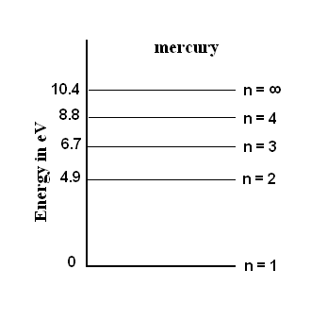

**Figure 21a**

**a.** The mercury vapour is struck by photons with wavelength 141 nm and they are absorbed by the mercury.

At which energy level are the excited electrons after this collision? 2 marks

**b.** Bound electrons can only exist with measured quanta of energy. Why can’t they accept values in between? 2 marks

**Area of study – Interactions of light and matter**

**c.** When the electrons return to their lower states or the unexcited state, a number of different frequencies of light are emitted, as shown in the emission spectra diagram in **Figure 21b**.

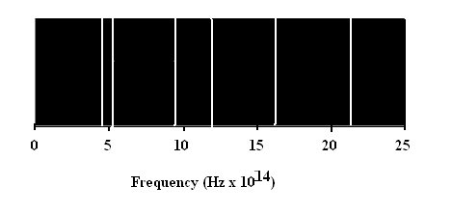

**Figure 21b**

Which transition could produce the spectral band at approximately 5.1 × 1014 Hz? 2 marks

Transition from level ….. to level ……..

**End of Section A**

**Core Studies**

**SECTION B – Detailed Studies**

**Instructions for Section B**

Select **one** Detailed Study and answer all questions within that Detailed Study in pencil on the answer sheet provided for multiple-choice questions.

Show the Detailed Study you are answering by shading the matching box on your multiple-choice answer sheet and writing the name of the Detailed Study in the space provided.

Choose the response that is correct for each question.

A correct answer scores 2, an incorrect answer scores 0.

Marks will not be deducted for incorrect answers.

No marks will be given if more than one answer is completed for any one question.

**Detailed Study 1 - Einstein’s Relativity**

**Question 1**

A high speed tram is travelling at 0.80 c towards an observer waiting at a tram stop.

Its lights are on and the siren is sounding. This is seen in **Figure 1**.

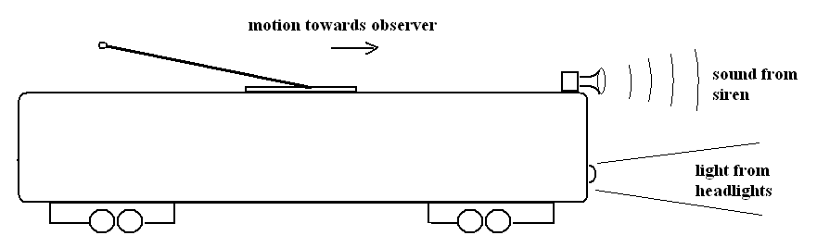

**Figure 1**

Select the most accurate statement

**A.** The speed of sound is increased by the tram’s motion, but the speed of the light is unchanged.

**B.** The speed of sound depends on any air movement. The speed of light is constant.

**C.** The speed of sound and the speed of the light are both increased by the tram’s movement.

**D.** The speed of sound and the speed of the light are both constants.

**Detailed Study 1 - Einstein’s Relativity**

**Question 2**

The tram is seen by its passengers as being 25 m long. How long does it appear to an observer waiting at

the tram stop?

**A.** 41.7 m

**B.** 25 m

**C.** 15 m

**D.** 9.0 m

**Question 3**

The Michelson Morley experiment failed to demonstrate its hypothesis that

**A.** The ether had a constant speed, maintaining a constant light speed, relative to the Earth.

**B.** The ether varied in speed, relative to the Earth. over time, changing the speed of light.

**C.** The lengths of the arms of the interferometer were constant in all frames of reference.

**D.** The lengths of the arms of the interferometer changed for different observers.

**Question 4**

Einstein’s First Postulate of Special Relativity is “The laws of physics are the same in all inertial frames

of reference.” The inertial frame of reference means a situation in which

**A.** there is either gravity or other forces causing acceleration.

**B.** there is gravity but no other force to cause acceleration.

**C.** there is no gravity, but other forces can cause acceleration.

**D.** acceleration is zero, whether produced by gravity or other forces.

**Detailed Study 1 - Einstein’s Relativity**

**Question 5**

A relativistic railway station has a light at the forward end which will flash when the front of the train reaches it.

There is a second light which will flash when the rear of the train passes that end.

The lights are separated by the rest length of the 400 m platform. The train approaching the station is an express and will not stop. It is travelling at 0.6c.

The train has a rest length of 500 m.

There are two observers, Michael waiting in the middle of the platform and Nina, a passenger in the middle of the train. This is shown in **Figure 2**.

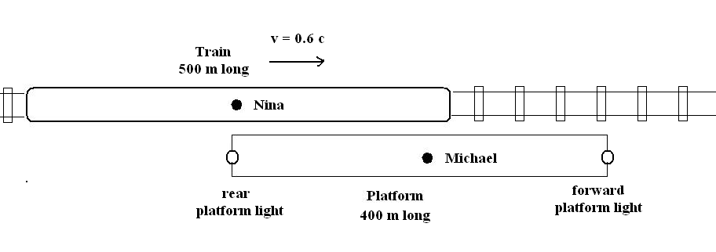

**Figure 2**

What will be observed by each observer?

**A.** Michael observes that the flashes are simultaneous, while Nina says the rear flash came first

**B.** Michael observes that the flashes are simultaneous, while Nina says the forward flash came first.

**C.** Michael and Nina agree that each sees their own flashes simultaneously, and Michael’s flashes came first.

**D.** Michael and Nina agree that the forward flash is first, the rear is second, and that they did not see these events simultaneously.

**Detailed Study 1 - Einstein’s Relativity**

**Question 6**

A muon is a short lived sub-atomic particle, created by cosmic ray collisions in the upper atmosphere. It

has a half-life of 2.2 μs and is travelling at 0.85 c

On its downward journey through the atmosphere, the muon observes a helium atom, which is

effectively motionless in the Earth’s atmosphere.

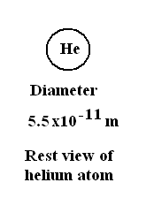

Helium atoms have a diameter in the laboratory of

5.5 × 10-11 m. See **Figure 3**.

Which is the best representation of the helium atom observed

by the muon? Chose from the representations in **Figure 4**.

**Figure 3**

**(right)**

**Figure 4 (below)**

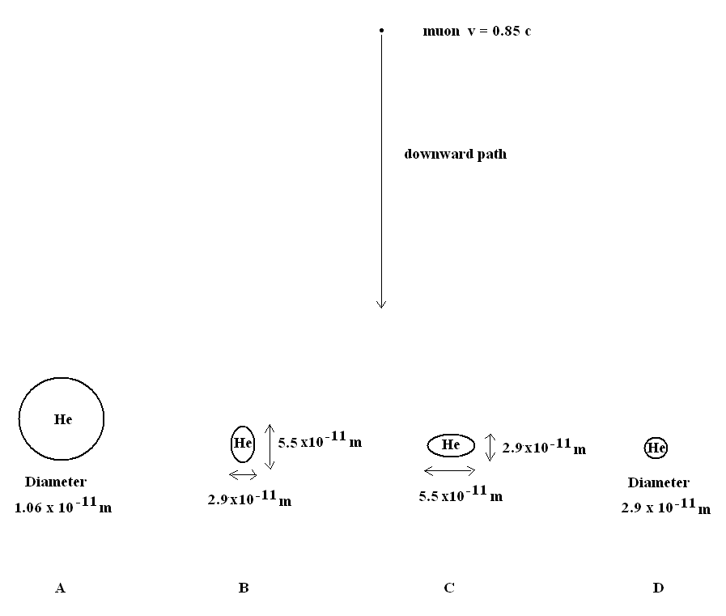

**Detailed Study 1 - Einstein’s Relativity**

**Detailed Study 1 - Einstein’s Relativity**

**Question 7**

How far will the muon travel in the ground frame of reference, during its lifetime which was 2.2 μs?

**A.** 1060 m

**B.** 660 m

**C.** 560 m

**D.** 350 m

**Question 8**

At rest a muon has a mass of 1.9 × 10-28 kg. How much energy did the muon gain, from rest conditions, in the collision in the upper atmosphere, which gave it the speed of 0.85c?

**A.** 4.9 × 10-11 J

**B.** 3.2 × 10-11 J

**C.** 1.5 × 10-11 J

**D.** 8.9 × 10-12 J

**Question 9**

A muon cannot travel at the speed of light. This is because

**A.** Its mass would become infinite.

**B.** Even photons can only travel near to the speed of light.

**C.** It would decrease its life greatly and so it would decay before it could be observed.

**D.** It would need to have gained infinite energy to travel at the speed of light.

**Detailed Study 1 - Einstein’s Relativity**

**Question 10**

There are two observers, each with a light clock. The light clock times its ticks by the time taken for

light to travel vertically 3.0 m. At the speed of light, this pulse takes 1.0 × 10 -8 s.

The first observer (Anna) is stationary, but observes the second light clock with observer (Bertram) as

moving on a trolley at 0.3 c. Anna notes that her “stationary” clock completes a pulse in 1.0 × 10-8 s.

Bertram makes the same observation of his clock’s tick which is on his horizontally moving trolley.

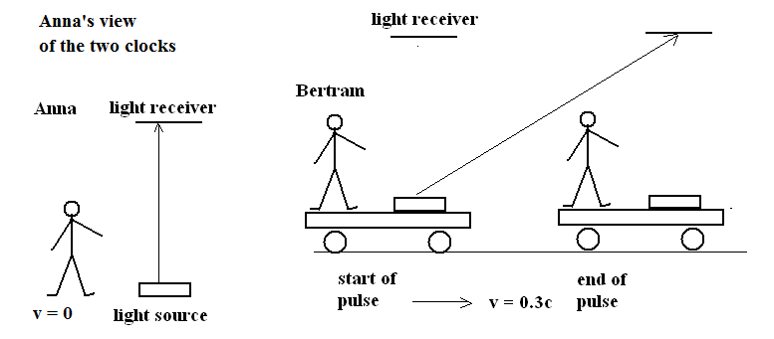

**Figure 5**

What will Anna see Bertram’s moving clock doing, where the light’s path now appears to be lengthened

because the receiver moves while the light crosses the gap? (Not to scale, in **Figure 5**).

**A.** Anna will see events slowed for the moving clock, the light will travel at c but take longer to complete the path.

**B.** For Anna, the moving trolley light now travels faster than for the stationary clock light.

**C.** Anna will record that the light path in the moving clock will be shortened, so that light can cross the gap in the correct time.

**D.** Anna will actually see the light path shortened and light will still complete the path in 1.0 × 10-8 s.

**Detailed Study 1 - Einstein’s Relativity**

**Question 11**

A spaceship travelling with a speed corresponding to γ = 1.1, accelerates to twice the speed.

What is the new value of γ?

**A.** 1.2

**B.** 1.4

**C.** 1.6

**D.** 1.8

**End of Detailed Study 1**

**Einstein’s Relativity**

**Detailed study 2 – Materials and their use in structures**

**Question 1**

A sample of a material is tested by loading forces applied three different ways, as shown in **Figure 1**.

The loading forces’ directions are shown with arrows.

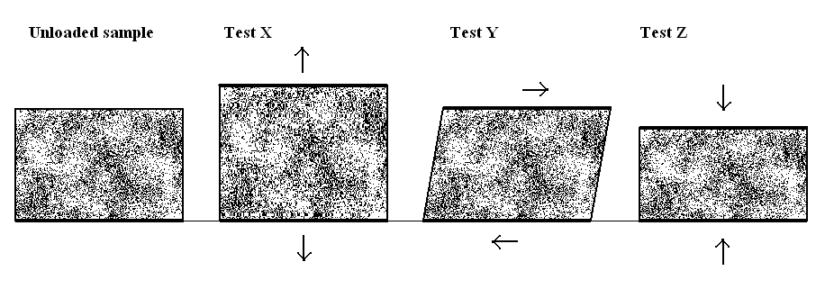

Fig.1

**Figure 1**

What are the loading conditions in each of the test situations?

|  |  |  |  |
| --- | --- | --- | --- |
|  | Test X . | Test Y . | Test Z . |
| **A.** | compressive | tensile | shear |
| **B.** | shear | tensile | compressive |
| **C.** | tensile | compressive | tensile |
| **D.** | tensile | shear | compressive |

**Detailed study 2 – Materials and their use in structures**

**Question 2**

A number of steel samples were tested and the stress-strain results are shown in **Figure 2**.

The “x” marks denote fracture points.

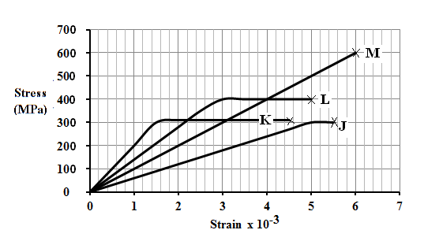

**Figure 2**

What is the Young’s Modulus of the stiffest steel?

**A.** 2.0 × 105 MPa

**B.** 6.0 ×104 MPa

**C.** 550 MPa

**D.** 320 MPa

**Question 3**

Sample M has a round cross-section and the **diameter** is 1.20 cm.

What force would be carried at a strain of 5.0 × 10-3?

**A.** 2.26 × 105 N

**B.** 5.65 × 104 N

**C.** 2.26 × 104 N

**D.** 5.65 × 103 N

**Detailed study 2 – Materials and their use in structures**

**Question 4**

What is the toughness of Sample L?

**A.** 2.0 × 106 J m-3

**B.** 1.4 × 106 J m-3

**C.** 8.0 × 105 J m-3

**D.** 6.0 × 105 J m-3

**Question 5**

A steel type needs to be selected which will have some inelastic region, but have a large elastic region.

The steel must also have a high elastic limit. A high Young’s Modulus is not so essential. Which is the

best steel to choose?

**A.** J

**B.** K

**C.** L

**D.** M

**Detailed study 2 – Materials and their use in structures**

**Question 6**

The photo (**Figure 3**) shows the Malmsbury railway bridge. It is constructed with a series of pillars, linked by arches.

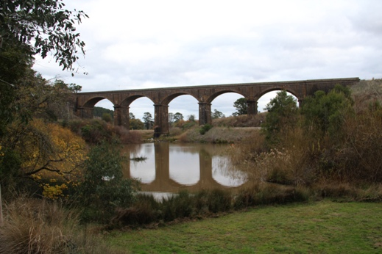

**Figure 3** (Author’s photo)

The design uses arches because

**A.** they stop the bridge from rocking sideways when the train passes over.

**B.** they demonstrate the skill of the designers and labourers who built the bridge.

**C.** they distribute the load to each of the pillars, when the train passes over.

**D.** they keep all material in the bridge in compression, when the train passes over.

**Detailed study 2 – Materials and their use in structures**

**Question 7**

In **Figure 4**, the photo shows the Clifton Bridge, Bristol.

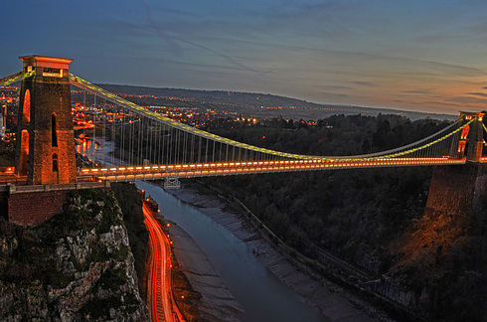

**Figure 4**

<http://www.sooziq.com/6833/33-awe-inspiring-bridges-you-need-to-cross-in-your-lifetime/>

The Clifton Bridge structure differs from the Malmsbury railway bridge, because in the Clifton Bridge

**A.** all the main components are modern and so are in tension.

**B.** the pillars and roadway are in compression, the stays from the pylon is in tension.

**C.** the pillars and upper roadway are in compression, the remainder of the design is in tension

**D.** this is in inverted arch structure which puts all the main components back in compression.

**Detailed study 2 – Materials and their use in structures**

**Question 8**

A cantilevered car-park surface, shown in **Figure 5**, has been built over a shopping centre. The car-park span and cantilever has a mass of 22 tonnes (1 tonne = 1.0 × 103 kg) and the cars are 1.0 tonne each and can be regarded as placed together 20 m from the adjacent support Y.

The supports are separated by 30 m and the cantilever is 25 m long.

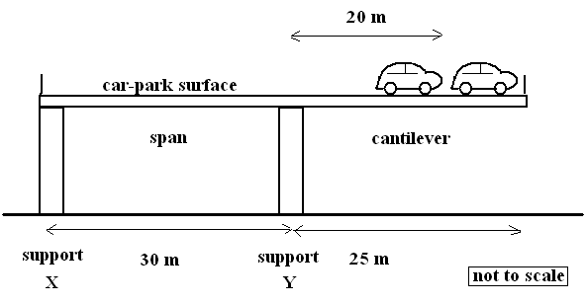

**Figure 5**

What is the total torque produced by the cars and the car-park surface about support X in this structure?

**A.** 7.05 × 106 Nm

**B.** 1.00 × 106 Nm

**C.** 7.05 × 105 Nm

**D.** 2.35 × 105 Nm

**Question 9**

What force does the structure impose on the support X?

**A.** 2.35 × 105 N

**B.** 1.10 × 105 N

**C.** 2.35 × 104 N

**D.** 5.00 × 103 N

**Detailed study 2 – Materials and their use in structures**

**Question 10**

A parachutist, in **Figure 6** is using a circular

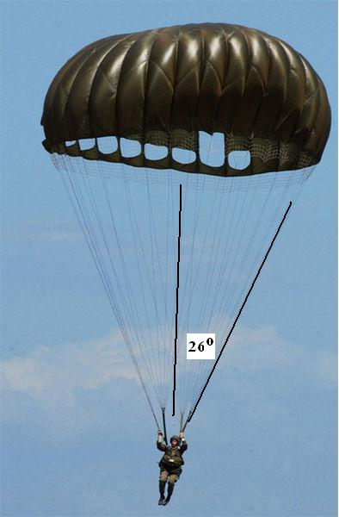

domed shaped parachute, falling at a constant

speed of 6.4 ms-1.

The parachute has 14 lines evenly attached to

the parachutist**’**s harness, and they spread at an

angle of 26° from the vertical.

The parachutist has a mass of 92 kg.

The lines have a **diameter** of 3.5 mm

**Figure 6**

<http://en.wikipedia.org/wiki/Parachute>

What is the stress in these parachute lines?

**A.** 7.6 × 106 Pa

**B.** 6.8 × 106 Pa

**C.** 1.9 × 106 Pa

**D.** 7.6 × 105 Pa

**Detailed study 2 – Materials and their use in structures**

**Question 11**

Carbon fibre is well known as a material of exceptional properties. A stress – strain curve for pure carbon

fibre is shown in **Figure 7**.

The fracture points are marked with a “+”

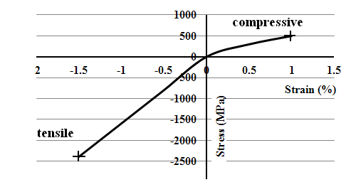

**Figure 7**

As a material, carbon fibre is shown on this curve to be a material

**A.** with unreliable stiffness its Young’s Modulus is not constant.

**B.** which is stronger in tension than compression.

**C.** which is stronger in compression than tension and brittle.

**D.** with significant inelastic properties.

**End of Detailed Study 2**

**Materials and their use in structures**

**Detailed Study 3 - Further Electronics**

**Question 1**

A transformer is supplied with an **input** of 120 VRMS. The **output** is measured on an oscilloscope and

is shown in **Figure 1**.

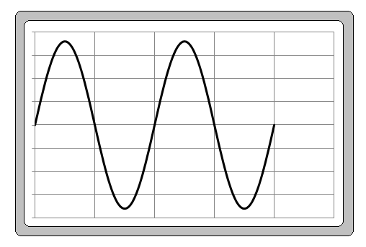

**Figure 1**

The vertical scale is 5 V per division and the horizontal is 0.002 s per division.

What is the VRMS output of the voltage shown on the display?

**A.** 36.0 V

**B.** 25.4 V

**C.** 18.0 V

**D.** 12.7 V

**Question 2**

What is the ratio of primary to secondary turns in the transformer?

**A.** 9.43

**B.** 6.67

**C.** 4.72

**D.** 3.33

**Detailed Study 3 - Further Electronics**

**Question 3**

In designing a power supply, seen in **Figure 2**, a transformer with an output of 12 VRMS was selected.

The voltage is rectified with a full wave bridge rectifier.

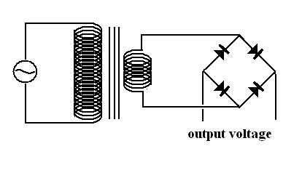

**Figure 2**

What is the peak voltage produced with these components?

**A.** 17.0 V

**B.** 16.3 V

**C.** 15.6 V

**D.** 12.0 V

**Question 4**

An AC voltmeter is placed across the terminals of the diode output.

What will be the reading on the meter?

**A.** 17.0 V

**B.** 15.6 V

**C.** 12.0 V

**D.** 11.0 V

**Detailed Study 3 - Further Electronics**

**Question 5**

A capacitor is added and a resistive load is driven from the supply.

The capacitor is 100 μF and the resistor is 1000 Ω.

The output is measured with an oscilloscope.

Which is the best indication of the display? Select from **Figure 3**.

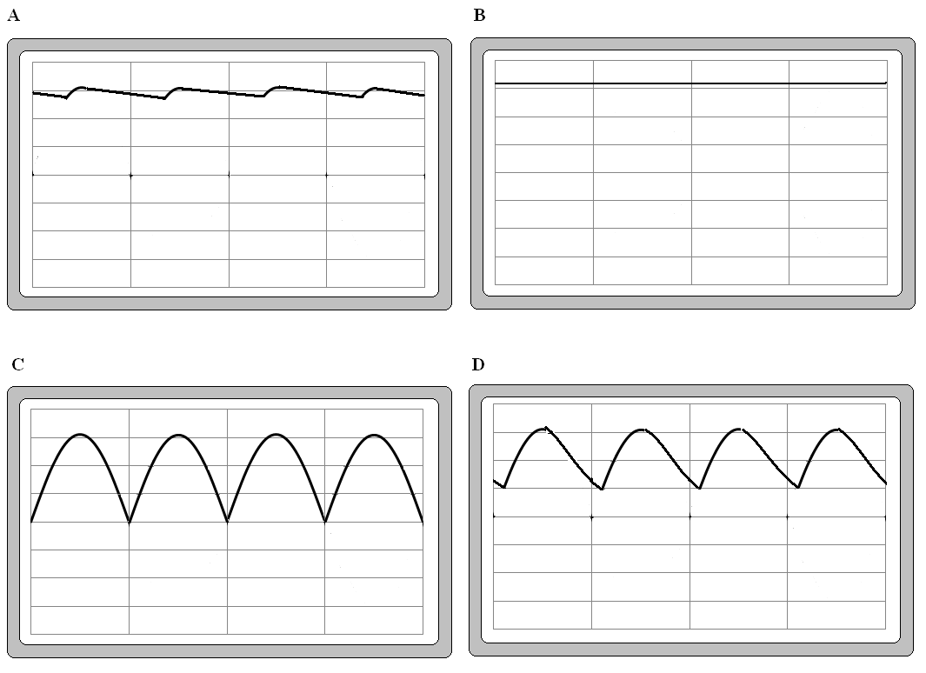

**Figure 3**

**Detailed Study 3 - Further Electronics**

**Question 6**

The power supply then shows a fault. The voltage display appears as in **Figure 4**.

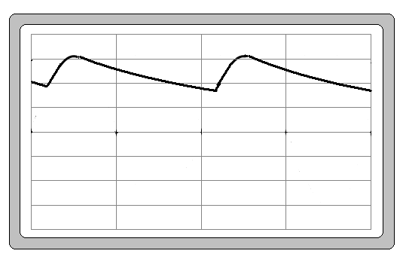

**Figure 4**

This could be caused by

**A.** The capacitor is not functioning, it is open circuit.

**B.** There is a short circuit across the load resistor.

**C.** A diode has short circuited.

**D.** A diode has gone open circuit.

**Question 7**

In this (repaired) filtered power supply, an improvement can be made to improve the voltage smoothing

by making a simple change to the circuit.

Which change should be made to best operate the 1000 Ω load?

**A.** Use a heat sink on the diode bridge.

**B.** Increase the capacitor to 1000 μF.

**C.** Decrease the capacitor to 10 μF.

**D.** Use a single diode rectifier.

**Detailed Study 3 - Further Electronics**

**Question 8**

A choice has to be made about a further improvement to the power supply. Regulation will be added.

This can be done using a zener diode circuit or by using a three pin regulator (perhaps the 78xx series).

Possible circuits are shown in **Figure 5**.

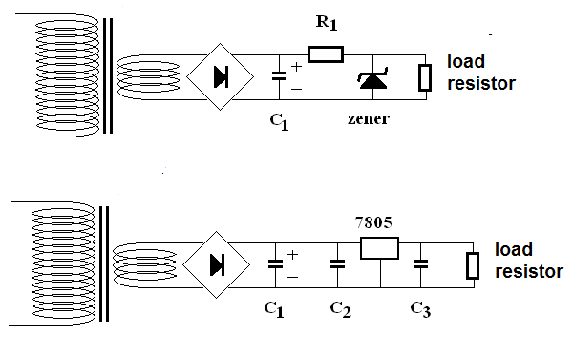

**Figure 5**

Which statement best describes the better selection?

**A.** The 78xx regulator is better because it uses minimal extra power to regulate the voltage and only

draws current when needed.

**B.** The 78xx regulator is better because it has three capacitors.

**C.** The zener circuit is better because the voltage output from the zener can be controlled by just selecting the correct value for resistor R1.

**D.** The zener circuit is better because it only needs an additional regulating resistor in the circuit.

**Detailed Study 3 - Further Electronics**

**Question 9**

With a 15 V DC supply from the 2000 μF capacitor, a different circuit, using a zener based regulator will be built using the layout shown in **Figure 6**.

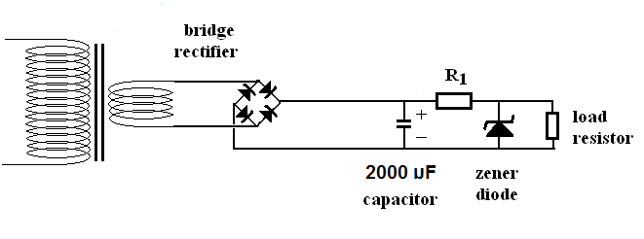

**Figure 6**

The zener diode is designed to give a 12 V output and is rated at 400 mW.

What is the largest current which this circuit will be able to supply, given that the zener needs protection from overload even if the load is removed?

**A.** 133 mA

**B.** 127 mA

**C.** 33 mA

**D.** 27 mA

**Question 10**

The load resistor is to be 500 Ω.

What is the best value for R1, to give the required 12 V? Even if the load is removed, the zener must not be overloaded and the design must minimise wasted energy?

**A.** 500 Ω

**B.** 125 Ω

**C.** 113 Ω

**D.** 90 Ω

**Detailed Study 3 - Further Electronics**

**Question 11**

A capacitor with a resistor in a series circuit, shown in **Figure 7**, was charged from a 12.0 V power supply. The voltage across the capacitor was measured with an oscilloscope.

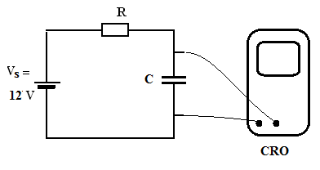

**Figure 7**

The data was recorded and is shown in **Figure 8**.

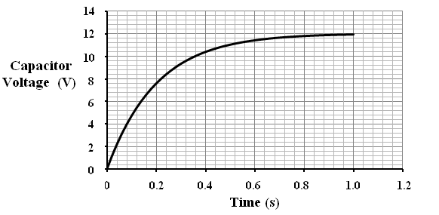

**Figure 8**

The time constant for the resistor and capacitor combination was

**A.** 0.090 s

**B.** 0.14 s

**C.** 0.20 s

**D.** 1.00 s

**End of Detailed Study 3**

**Further Electronics**

**Detailed Study 4 – Synchrotron and its applications**

**Question 1**

The light in a synchrotron and that of other sources like x-rays and lasers can be similar in some ways, and differ in others. Which statement is correct?

**A.** The synchrotron light has much greater brightness than x-ray sou­rces.

**B.** Synchrotron light can be polarised and is collimated, unlike laser light.

**C.** Synchrotron light and x-rays are produced on similar wavelengths.

**D.** Unlike the synchrotron, lasers cannot operate down to infra-red wavelengths.

**Question 2**

The diagram in **Figure 1** shows the location of a number of sections of the Australian Synchrotron.

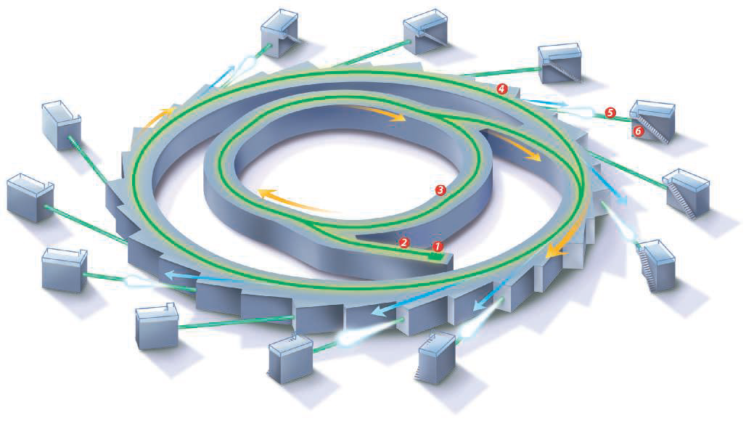

<http://en.wikipedia.org/wiki/Australian_Synchrotron>

**Figure 1**

There are two rings, the booster and the storage ring.

The difference between these rings is that

**A.** the storage ring has no process for accelerating electrons, unlike the booster ring.

**B.** the booster ring is used to provide lower energy beamlines than the storage ring.

**C.** in the booster ring electron energy is increased, while in the storage ring it is maintained.

**D.** in the storage ring electron energy is increased, while in the booster ring it is maintained.

**Detailed Study 4 – Synchrotron and its applications**

**Question 3**

The undulators produce coherent light by the magnetic acceleration of electrons. White incandescent light is incoherent and is produced by the thermal acceleration of electrons.

These lights differ because

**A.** Thermal acceleration of electrons stops the white wavelength superimposing in the same way the light produced in the undulator.

**B.** Thermal acceleration is random and so are the wavelengths of white light. Undulator light is of a single wavelength and the wave-fronts superimpose constructively.

**C.** The white light is a mixture of colours and is coherent, but the undulator light is a single wavelength and coherent.

**D.** White light is incoherent because of the random heat processes, while magnets attract the electrons precisely, forcing the ongoing emission of a single wavelength of light

**Question 4**

The monochromator is used to ensure that only a single wavelength of light is sent to a particular

beamline. The monochromator works by

**A.** changing the light of an inappropriate wavelength into the specified value.

**B.** transmitting the correct wavelength light and reflecting the rest back into the storage ring.

**C.** polarising the inappropriate wavelength light and having it absorbed in a filter.

**D.** transmitting the correct wavelength light by Bragg reflection and absorbing the rest.

**Detailed Study 4 – Synchrotron and its applications**

**Question 5**

Synchrotron radiation using a range of wavelengths can be used in Bragg scattering experiments.

Bragg’s Law identifies the angles of peak intensity produced when this radiation strikes a crystal.

The diagram in **Figure 2** shows this.

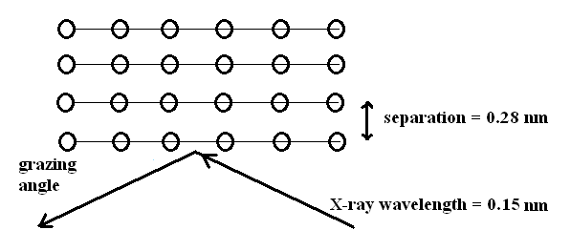

**Figure 2**

X-rays of wavelength 0.15 nm are fired at a crystal with a plane spacing of 0.28 nm.

At what grazing angle will the first reflected X-rays be detected?

**A.** 15.5 °

**B.** 32,4 °

**C.** 53.4 °

**D.** 69.0 °

**Detailed Study 4 – Synchrotron and its applications**

**Question 6**

In another experiment measuring Bragg angles, the data shown in **Figure 3** was collected.

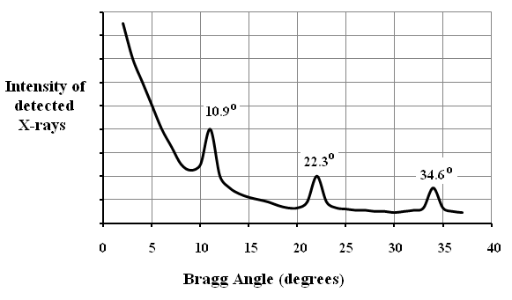

**Figure 3**

The wavelength of the x-rays was 0.20 nm.

What is the approximate value of the crystal planes separation measured from this data?

**A.** 1.76 nm

**B.** 1.06 nm

**C.** 0.53 nm

**D.** 0.26 nm

**Detailed Study 4 – Synchrotron and its applications**

**Question 7**

Synchrotron light has many similarities to that of lasers and X-rays, however, the synchrotron light is sometimes preferred.

Which statement is the best description of research using synchrotron light

**A.** Synchrotron radiation is important for research which needs its low spectral range and wide divergence. The brightness of the light does not improve the imaging.

**B.** The tuneable wavelength of light and high intensity light which can be pulsed enables testing of processes as they occur. There is strong beam divergence because of the processes used in the light production.

**C.** The tuneable wavelength of light and high intensity light which can be pulsed enables testing of processes as they occur. Low divergence of the beam is essential in this.

**D.** Synchrotron radiation is important for research which needs its wide spectral range and low divergence. The brightness of the light does not improve the imaging.

**Question 8**

An electron is moving in the storage ring with a relativistic momentum of 1.4 × 10-18 kg ms-1.

It is forced into a curved path with radius 36 m, by a magnetic field.

What is the strength of the magnetic field?

**A.** 4.11 T

**B.** 0.24 T

**C.** 0.059 T

**D.** 0.028 T

**Question 9**

In a synchrotron the electrons are freed by a heated element and then accelerated by a large voltage.

In this case the accelerating voltage of 80 kV accelerates the electrons over a distance of 0.15 m.

What is the force on the electrons?

**A.** 6.25 × 1018 N

**B.** 5.3 × 105 N

**C.** 8.5 × 10-14 N

**D.** 1.6 × 10-19 N

**Detailed Study 4 – Synchrotron and its applications**

**Question 10**

In Compton scattering, an inelastic collision occurs between a photon and an electron.

In the case in **Figure 4**, an incident X-ray with 200 keV of energy strikes a stationary electron.

Afterwards, the electron moves off with 65 keV of energy.

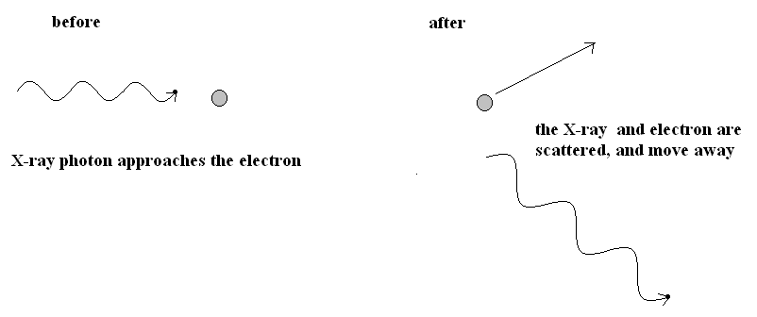

**Figure 4**

What is the wavelength of the X-ray photon after the collision?

**A.** 1.9 × 10-11 m

**B.** 9.2 × 10-12 m

**C.** 6.2 × 10-12 m

**D.** 1.5 × 10-30 m

**Detailed Study 4 – Synchrotron and its applications**

**Question 11**

Thomson scattering is a different type of collision between a photon and electron.

In Thomson scattering

**A.** the photon has the same wavelength after the collision, that it had before.

**B.** the photon has a shorter wavelength than it had before.

**C.** the photon has a longer wavelength than it had before.

**D.** the photon has the same wavelength but a changed momentum after the collision.

**End of Detailed Study 4**

**Synchrotron and its applications**

**Detailed Study 5 - Photonics**

**Question 1**

Unlike ordinary silicon diodes, a light emitting diode (LED) produces light at its junction. This is produced by the

**A.** transition of electrons from the valence to the conduction band in the semiconductor.

**B.** transition of electrons from the conduction to the valence band in the semiconductor.

**C.** acceleration of electrons as they are drawn into the semiconductor.

**D.** transition of electrons dropping down through their excitation levels, after energisation by the diode voltage drop.

**Question 2**

An endoscope needs a coherent bundle of fibres to carry an image.

This bundle of fibres needs to be coherent so that

**A.** the light carried is produced by an LED which is incoherent. The coherent fibres correct for the errors produced in the variation of the source’s wavelength.

**B.** the light carried is laser light, which is coherent and so coherent optic-fibres are needed.

**C.** the organisation of the bundle of optic-fibres is known so that each can carry a pixel of the image to a precise point for developing as an image.

**D.** there are up to 100000 optic fibres in a coherent bundle. This has the same optical structure as a single stepped optic fibre.

**Question 3**

A laser produces coherent light because it is

**A.** using electrons which do not drift as current usually does, but all are driven at exactly the same rate so that they energise the gas atoms in exactly the same way. The light pulse is then triggered releasing a coherent beam.

**B.** constantly producing incoherent light and changing it to a coherent form as it passes through the stimulated gas.

**C.** making precisely quantised energy flow into the optical resonator , which is then emitted as coherent photons.

**D.** using a single photon to trigger the energised atoms to emit identical photons with the same phase and energy.

**Detailed Study 5 - Photonics**

**Question 4**

Light passes along a fibre-optic cable by total internal reflection. In a step-index fibre there are two materials, an inner transmitting core and an outer protecting and reflecting cladding. In a particular cable (**Figure 1**), the index of refraction in the core was 1.42 and in the cladding it was 1.38.

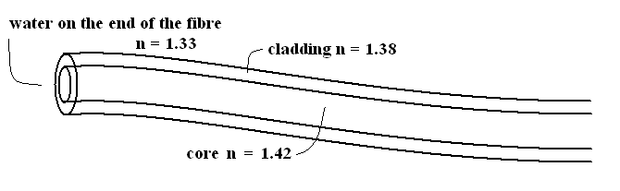

**Figure 1**

What is the critical angle for this fibre-optic cable?

**A.** 44.8 °

**B.** 46.4 °

**C.** 59.0°

**D.** 76.4°

**Question 5**

The process of transmitting light through a fibre, when the light is locked in by total internal reflection is very effective, however the light must get into the fibre initially.

This is measured by its acceptance angle.

What is the acceptance angle for this fibre if the end is in water, with index n = 1.33?

**A.** 14.6°

**B.** 33.1°

**C.** 46.5°

**D.** 48.3°

**Detailed Study 5 - Photonics**

**Question 6**

Light from an unknown source is investigated. The researcher wishes to determine whether the light is produced by random thermal motion of colliding valence electrons.

In the answers below are some observations which could be made of this light.

Which observations correctly indicate (firstly) incandescent light and (secondly) laser light?

|  |  |  |
| --- | --- | --- |
|  | **Evidence for incandescent light** | **Evidence for laser light** |
| **A.** | the light is white | when dispersed by a prism two colours are seen |
| **B.** | when dispersed by a prism only a single colour is seen | the light is very intense |
| **C.** | the light delivers energy as well | the light is incoherent |
| **D.** | the light has a broad continuous spectrum | the light is in phase |

**Detailed Study 5 - Photonics**

**Question 7**

A particular fibre-optic cable was tested with light of different wavelengths, and the transmitted signal’s

brightness was measured. The graph shown in **Figure 2** shows the results.

How can the features and trends in this graph be explained/

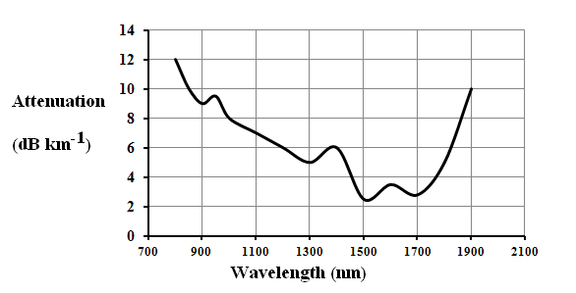

**Figure 2**

**A.** The downward trend towards long wavelengths shows the Rayleigh reduction in transmission quality at these wavelengths. The peaks show some windows of good wavelengths where the material selected is better for transmission and long wavelengths.

**B.** The downward trend towards long wavelengths shows the Rayleigh scattering improvement in transmission quality at these wavelengths. The peaks show some regions which have poor transmission due to impurities in the cable. Transmission is best as long wavelengths avoiding these peaks.

**C.** The peaks show the Rayleigh scattering caused by impurities in the material, while the downward trend towards long wavelengths shows the improvement in transmission quality which occurs if the cable is manufactured without any small mechanical imperfections.

**D.** The Rayleigh peaks on the graph show windows of good transmission. At these wavelengths there are less impurities reducing the quality of the signal. The trend to poorer transmission at long wavelengths is a feature of the wavelength of the light approaching the molecular diameters.

**Detailed Study 5 - Photonics**

**Question 8**

For the cable above, the optimum transmission would use an LED with a band gap of

**A.** 1.31 eV

**B.** 0.95 eV

**C.** 0.83 eV

**D.** 0.73 eV

**Question 9**

Two factors in the cable are related to the index of refraction and they both change the quality of the signal which is transmitted. The material and modal dispersion must both be managed to maximise the distance a signal can be transmitted.

**A.** Material dispersion occurs when light of a specific wavelength follows a single path at different speeds, but modal dispersion occurs when a specific wavelength light follows different paths and so takes different times.

**B.** Modal dispersion occurs when light of a specific wavelength follows a single path at different speeds, but material dispersion occurs when light of that wavelength follows different paths and take different times.

**C.** Material dispersion occurs when two different wavelengths of light follow a single path at different speeds, but modal dispersion occurs when any specific wavelength light follows different paths and takes different times.

**D.** Modal dispersion occurs when two different wavelengths of light follow a single path at different speeds, but material dispersion occurs when any specific wavelength light follows different paths and takes different times.

**Detailed Study 5 - Photonics**

**Question 10**

In a practical investigation students were measuring light attenuation in a fibre-optic cable.

They wound a specific length of cable into a curve of a measured radius and their results are shown in a graph in **Figure 3**.

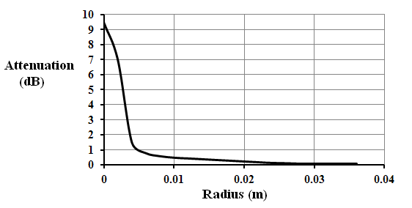

**Figure 3**

There is a sharp loss of signal when the radius is less than 0.005 m. Explain this loss of transmission.

**A.** At this curvature, there are mechanical changes in the index of the cladding and TIR is lost.

**B.** At this curvature TIR is lost because the angle at which light strikes the two-step interface is less than the critical angle.

**C.** At this curvature, there are mechanical changes in the index of the core and TIR is lost.

**D.** At this curvature mechanical changes have been forced at the cable ends and the angle of acceptance has been reduced, so less light is transmitted.

**Detailed Study 5 - Photonics**

**Question 11**

Different transmission systems will require different components, and deal with separate problems

Which combination has the optimum selection of light sources and cable designs?

|  |  |  |
| --- | --- | --- |
| Application | light source | cable |
| Home or work  computer network | LED | step-index |
| Short distance  fibre-optic (2 km) | LED | multi-mode |
| Moderate distance  fibre-optic (15 km) | Laser-diode | multi-mode |
| Long distance  fibre-optic (100 km) | Laser-diode | single mode |

|  |  |  |
| --- | --- | --- |
| application | light source | cable |
| Home or work  computer network | laser-diode | step-index |
| Short distance  fibre-optic (2 km) | LED | multi-mode |
| Moderate distance  fibre-optic (15 km) | Laser-diode | multi-mode |
| Long distance  fibre-optic (100 km) | Laser-diode | single mode |

|  |  |  |
| --- | --- | --- |
| application | light source | cable |
| Home or work  computer network | LED | step-index |
| Short distance  fibre-optic (2 km) | LED | step-index |
| Moderate distance  fibre-optic (15 km) | Laser-diode | multi-mode |
| Long distance  fibre-optic (100 km) | Laser-diode | single mode |
|  |  |  |
| application | light source | cable |
| Home or work  computer network | LED | step-index |
| Short distance  fibre-optic (2 km) | Laser-diode | step-index |
| Moderate distance  fibre-optic (15 km) | Laser-diode | multi-mode |
| Long distance  fibre-optic (100 km) | LED | single mode |

**A.**

**B.**

**C.**

**D.**

**End of Detailed Study 5**

**Photonics**

**Detailed study 6 – Sound**

**Question 1**

A set of speakers has been built into the rear parcel shelf of a car. The speakers face upwards and one of them is shown in **Figure 1**. A dust particle is in the air above the operating speaker.

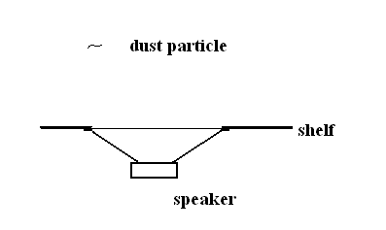

**Figure 1**

What is the best description of the path of the dust particle, shown in **Figure 2**?

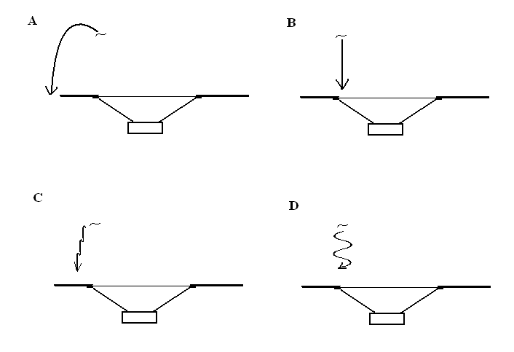

**Figure 2**

**Detailed study 6 – Sound**

**Question 2**

Sound at 1000 Hz is produced from a siren at a sound intensity level of 54dB, measured 2.0 m from the siren.

What intensity is this sound at that point?

**A.** 2.5 × 10 -7 W m-2

**B.** 2.5 × 10 -8 W m-2

**C.** 5.4 × 10 -11 W m-2

**D.** 5.4 × 10 -12 W m-2

**Question 3**

How far would you need to move for the sound from the siren to drop to the level of the threshold of hearing at 1.0 × 10-12 Wm-2?

**A.** 2000 m

**B.** 1000 m

**C.** 700 m

**D.** 500 m

**Question 4**

A string, length 0.96 m, fixed at both ends, is resonating with a third harmonic wave. The string is shown in **Figure 2**.

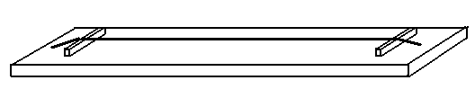

**Figure 2**

What is the distance between the nodal points on the string?

**A.** 0.96 m

**B.** 0.64 m

**C.** 0.48 m

**D.** 0.32 m

**Detailed study 6 – Sound**

**Question 5**

The wave in the string is a standing wave, which has nodes which do not move, unlike those in travelling waves.

How does such a different wave form, with stationary nodes?

**A.** An initial travelling wave is generated, which reaches the fixed ends holding the string and reflects back. The returning wave superimposes on the initial wave and the resultant waveform has stationary nodes.

**B.** An initial travelling wave is generated, which reaches the fixed ends holding the string and reflects back. The returning wave only interferes constructively with the initial wave and the resultant waveform has stationary nodes.

**C.** An initial travelling wave is generated, which reaches the fixed ends holding the string and reflects back. The returning wave is now fully restricted by the fixed ends and cannot travel. It is forced into a stationary mode.

**D.** An initial travelling wave is generated, which reaches the fixed ends holding the string and reflects back. The returning wave destructively interferes with the initial wave and forces it to cease its movement, leaving stationary nodes.

**Question 6**

A sound generator, it is used with a small speaker to produce resonant sound in a tube. The 1.12 m tube is closed at one end. (Fig. 3)

A small microphone is passed into the tube and the first quiet point inside the tube is found 0.32 m from the opening.

The speed of sound is 343 ms-1.

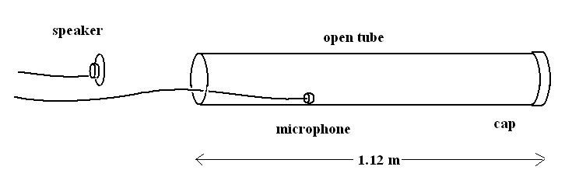

**Figure 3**

What is the frequency of the sound generated in the tube?

**A.** 1.07 kHz

**B.** 613 Hz

**C.** 536 Hz

**D.** 429 Hz

**Detailed study 6 – Sound**

**Question 7**

In further investigating the pressure node conditions inside the tube with the microphone, it was found that

**A.** both ends of the tube had pressure anti-nodes.

**B.** the closed end had a pressure anti-node, while the open end was nodal.

**C.** both ends of the tube had pressure nodes.

**D.** the closed end had a pressure node, while the open end was anti-nodal.

**Question 8**

The ribbon and dynamic microphone and the dynamic speaker are all electromagnetic devices.

It is suggested that this means they all work the same way.

**A.** The statement is correct because all three operate on the same electro-magnetic processes.

**B.** The dynamic microphone uses electromagnetic induction to generate a signal from sound, while the speaker uses forces based on electro-magnetism. The ribbon microphone has no coil or diaphragm. It has no obvious structural similarity to the other two.

**C.** The two microphones both use electromagnetic forces to generate a signal from sound, while the speaker uses electro-magnetic induction.

**D.** The two microphones both use electromagnetic induction to generate a signal from sound, while the speaker uses forces based on electro-magnetism.

**Detailed study 6 – Sound**

**Question 9**

After conducting an extensive hearing test, an audiologist produced a chart recording a person’s hearing.

The audiologist notes that this person’s hearing is unusual at high frequencies as shown in the chart in **Figure 4**.

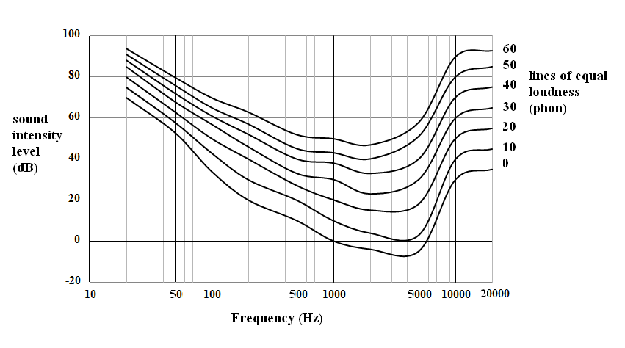

**Figure 4**

The patient would hear a sound at 10000 Hz at 40 dB as loud as

**A.** 5000 Hz at 40 dB

**B.** 500 Hz at 40 dB

**C.** 500 Hz at 20 dB

**D.** 500 Hz at 10 dB

**Detailed study 6 – Sound**

**Question 10**

Unlike emergency sirens, foghorns operate at low frequencies. The eastward horn on the Golden Gate bridge San Francisco, shown in **Figure 5**, in fog, sounds at about 100 Hz.

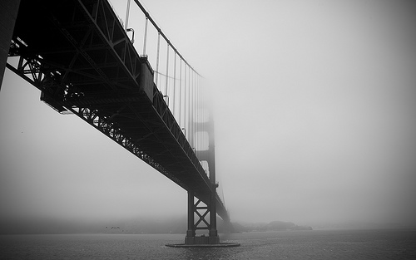

**Figure 5**

<http://www.photoree.com/photos/permalink/1051374-83646108@N00>

Why would foghorns use low frequencies?

**A.** This differentiates fog warnings from other emergency sirens.

**B.** The low frequency has a long wave which will penetrate into ships, through windows and doors, around corners, alerting people inside the ship, where high frequencies could not diffract.

**C.** The low frequencies of foghorns travel greater distances through damp air, diffracting around the tiny water droplets.

**D.** The low frequencies of foghorns travel greater distances, because they diffract over the wave peaks, which are usually shorter than the wavelength of the foghorn.

**Detailed study 6 – Sound**

**Question 11**

A high quality speaker capable of a broad frequency response was placed in a speaker baffle. It was placed in a room, against a wall and its frequency response was tested at point T, off centre from the speaker.

The speaker had a diameter of 0.17 m and the baffle was 0.40 m wide, as seen in **Figure 6**.

The speed of sound is 340 ms-1.

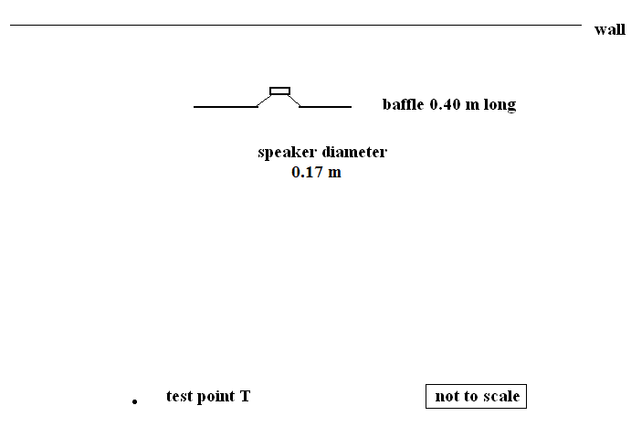

**Figure 6**

**Detailed study 6 – Sound**

**Question 11 (continued)**

Which is the most likely frequency response of the speaker under these conditions, from the graphs in **Figure 7**, below?

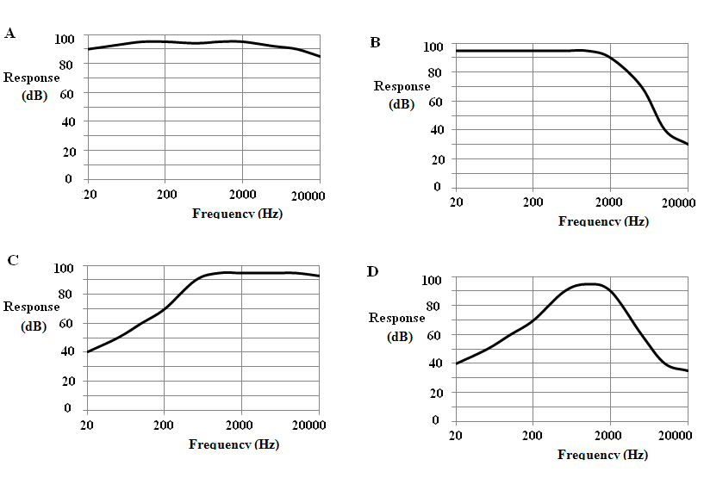

**Figure 7**

**End of Detailed Study 6**

**Sound**

##### **End of questions for the 2014 Kilbaha VCE Physics Trial Examination**

|  |  |
| --- | --- |
| **Kilbaha Multimedia Publishing**  **PO Box 2227**  **Kew Vic 3101**  **Australia** | **Tel: (03) 9018 5376**  **Fax: (03) 9817 4334**  [**kilbaha@gmail.com**](mailto:kilbaha@gmail.com)  [**http://kilbaha.com.au**](http://kilbaha.com.au) |

|  |  |  |
| --- | --- | --- |
| 1 | velocity, acceleration |  |
| 2 | equations for constant acceleration |  |
| 3 | Newton’s second law |  |
| 4 | circular motion |  |
| 5 | Hooke’s Law |  |
| 6 | elastic potential energy |  |
| 7 | gravitational potential energy near the Earth’s surface |  |
| 8 | kinetic energy |  |
| 9 | Newton’s law of universal gravitation |  |
| 10 | gravitational field |  |
| 11 | acceleration due to gravity at Earth’s surface |  |
| 12 | voltage: power |  |
| 13 | resistors in series |  |
| 14 | resistors in parallel |  |
| 15 | transformer action |  |
| 16 | AC voltage and current |  |
| 17 | magnetic force |  |
| 18 | electromagnetic induction |  |
| 19 | transmission losses |  |
| 20 | mass of the electron |  |
| 21 | charge of the electron |  |
| 22 | Planck’s constant |  |
| 23 | speed of light |  |
| 24 | photoelectric effect |  |
| 25 | photon energy |  |
| 26 | photon momentum |  |
| 27 | de Broglie wavelength |  |
| 28 | speed, frequency and wavelength |  |
| 29 | energy transformations for electrons in an electron gun (< 100 keV) |  |
| 30 | radius of electron path |  |
| 31 | magnetic force on a moving electron |  |
| 32 | Bragg’s law |  |
| 33 | electric field between two charged plates |  |
| 34 | band gap energy |  |
| 35 | Snell’s law |  |
| 36 | intensity and level | sound intensity level (in dB)  where |
| 37 | Lorentz factor |  |
| 38 | time dilation |  |
| 39 | length contraction |  |
| 40 | relativistic mass |  |
| 41 | total energy |  |
| 42 | stress |  |
| 43 | strain |  |
| 44 | Young’s modulus |  |
| 45 | capacitors |  |
| 46 | universal gravitational constant |  |
| 47 | mass of Earth |  |
| 48 | radius of the Earth |  |
| 49 | mass of the electron |  |
| 50 | charge on the electron |  |
| 51 | speed of light |  |

|  |  |
| --- | --- |
| **Prefixes/Units** | p = pico = 10-12 |
| n = nano = 10-9 | μ = micro = 10-6 |
| k = kilo = 103 | M = mega = 106 |
| G = giga = 10 9 | t = tonne = 103 kg |

##### **End of formula sheet for the 2014 Kilbaha VCE Physics Trial Examination**