Melbourne High School



VCE Physics Units 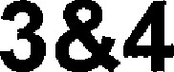

Trial Exam 2020

PHYSICS 

Written examination

Worked solutions

This book contains:

 worked solutions

 mark allocations

explanatory notes



 tips

**SECTION A**

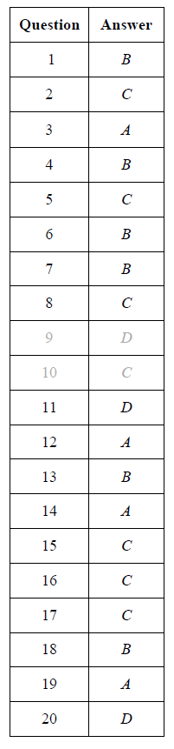

A

C

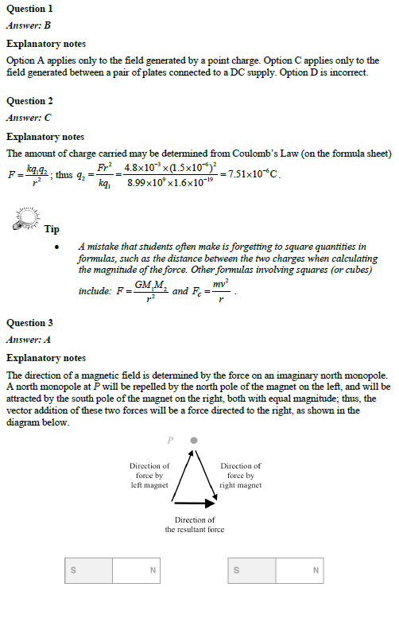

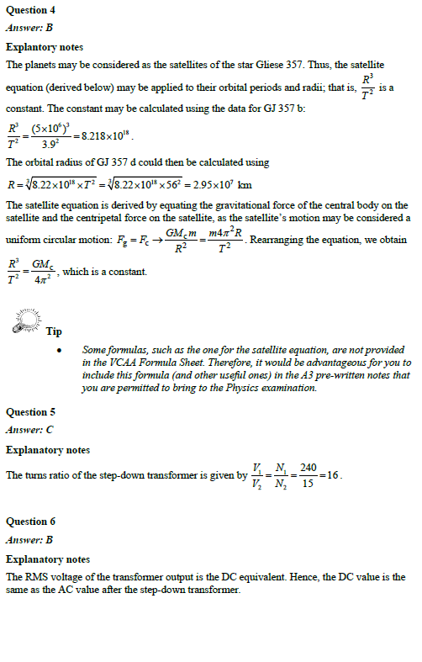

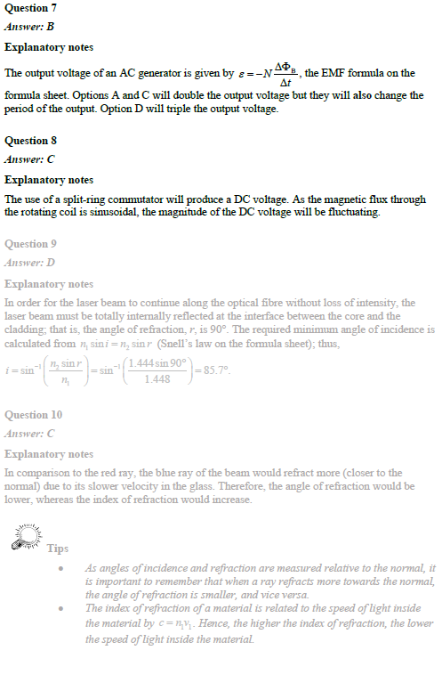

***Answer: A***

Experiments conducted in inertial (nonaccelerating) frames will be identical. Experiments conducted in accelerating frames will differ from experiments conducted in inertial frames.

***Answer: C***

Need to calculate  from v = 0.98c, which gives an approximate answer of 5.

The measured half life will be five times longer, so C.

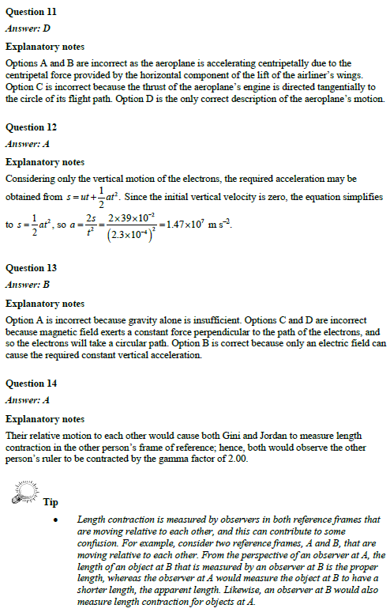

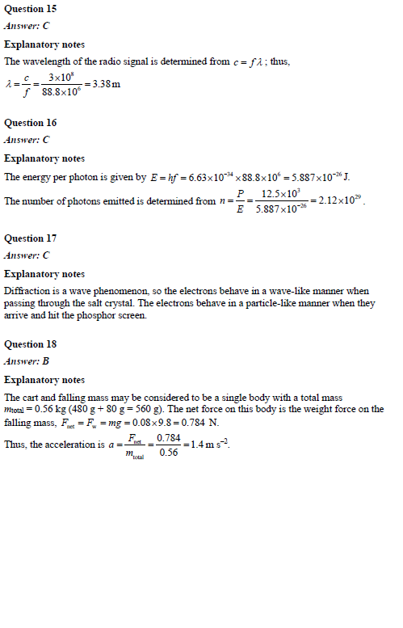

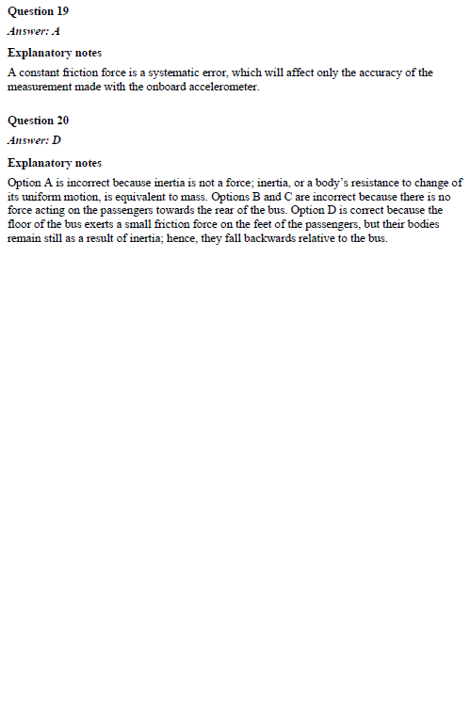

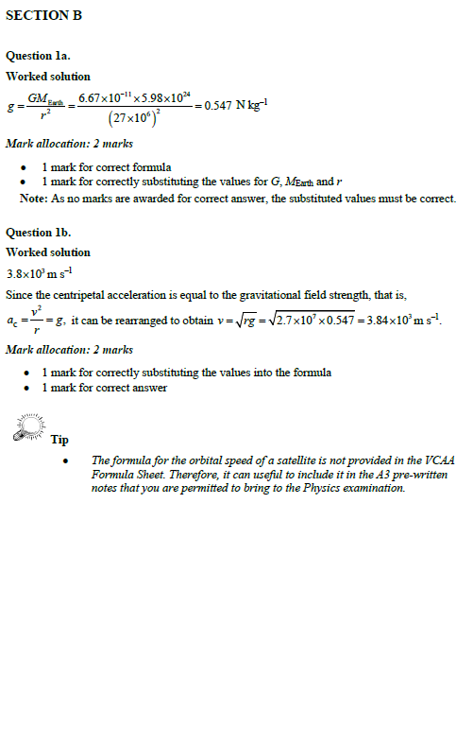

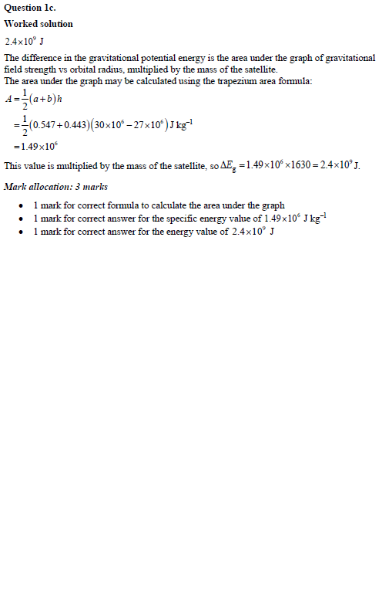

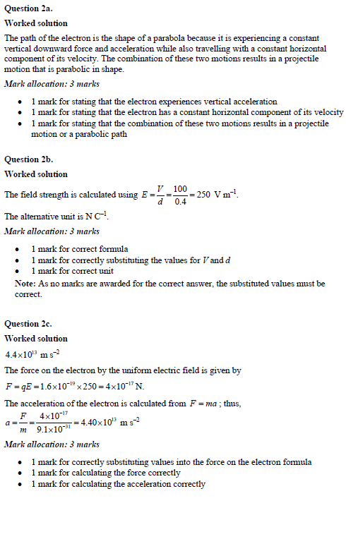

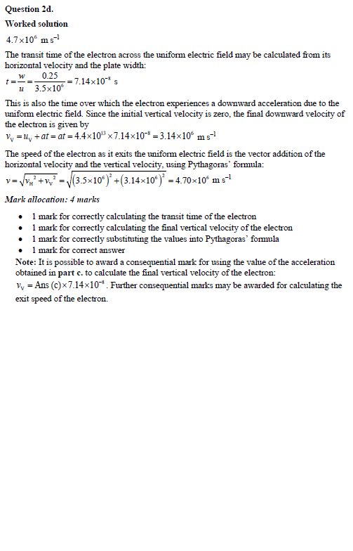

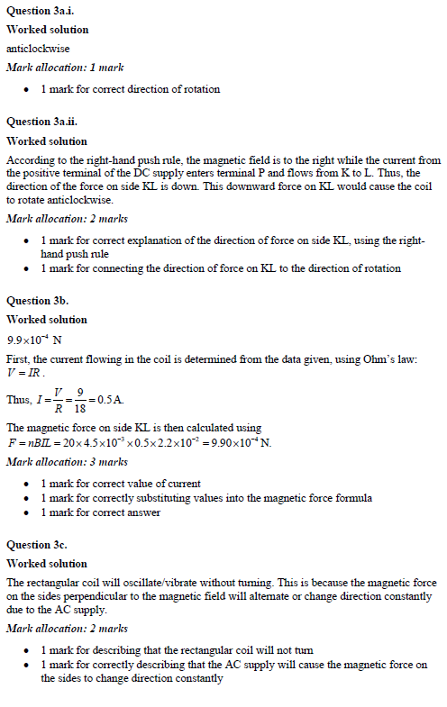

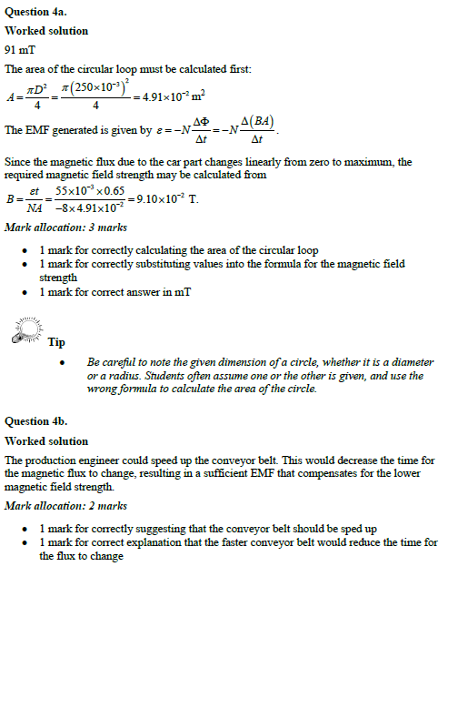

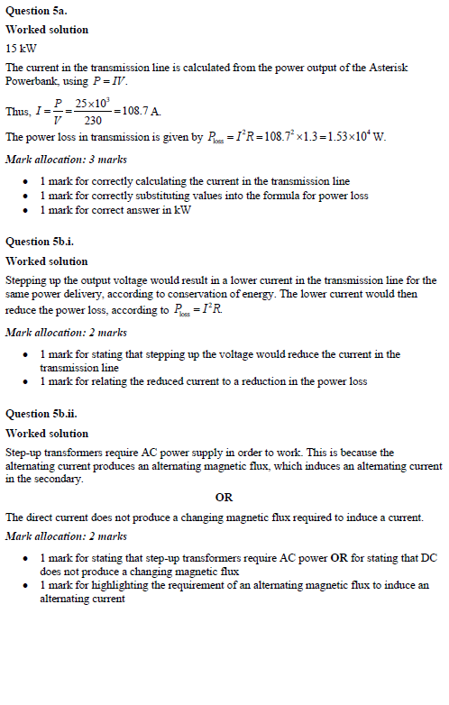

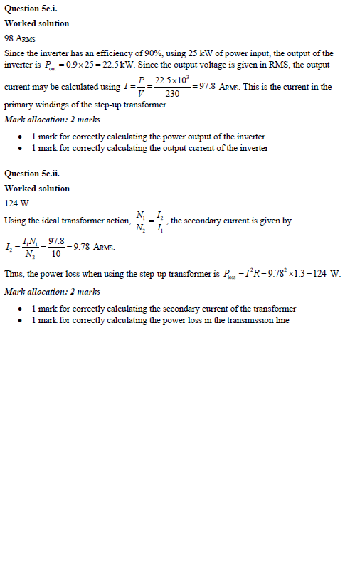

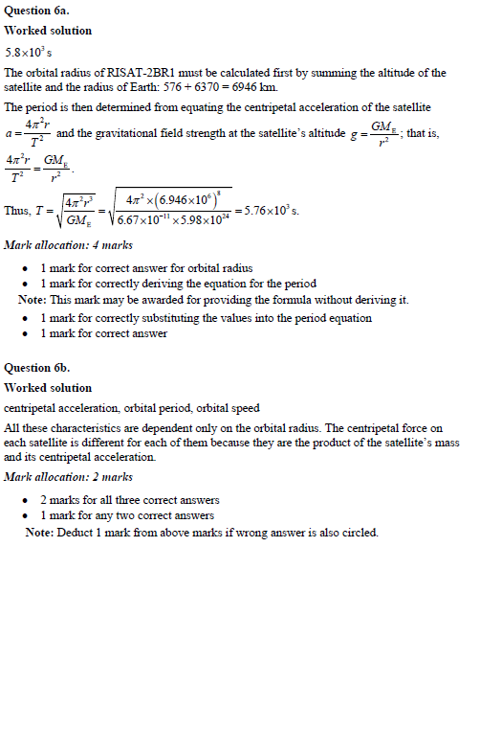

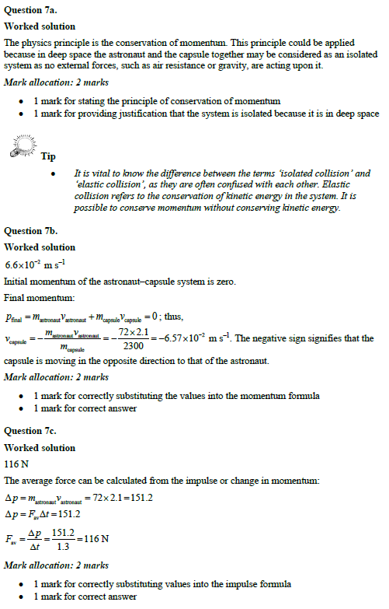

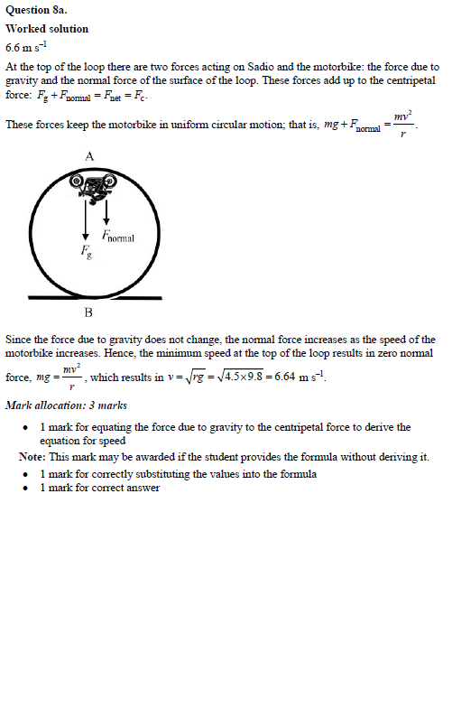

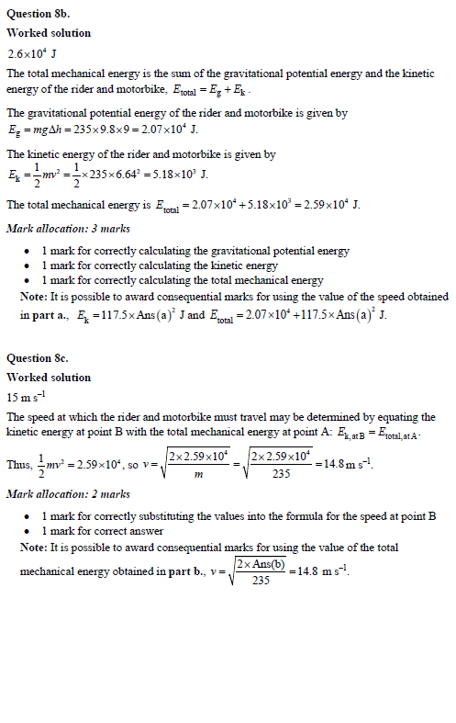

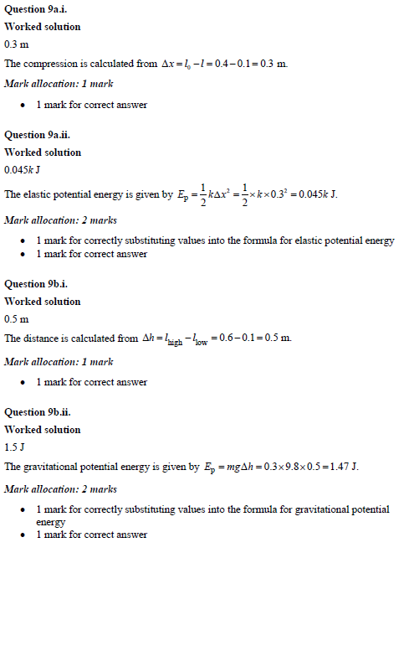

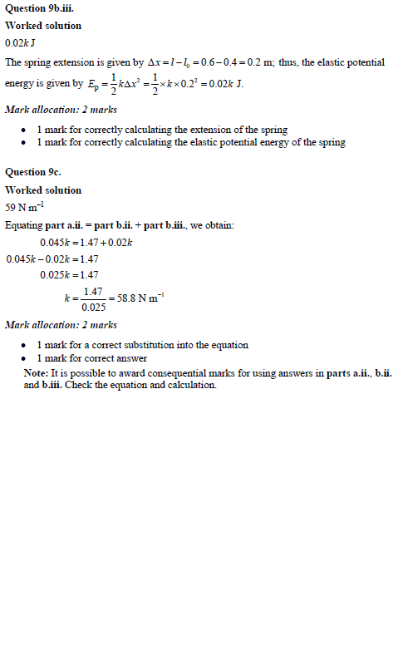

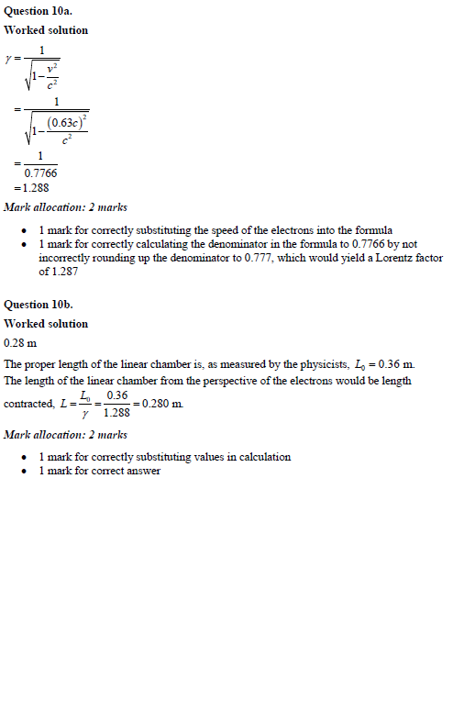

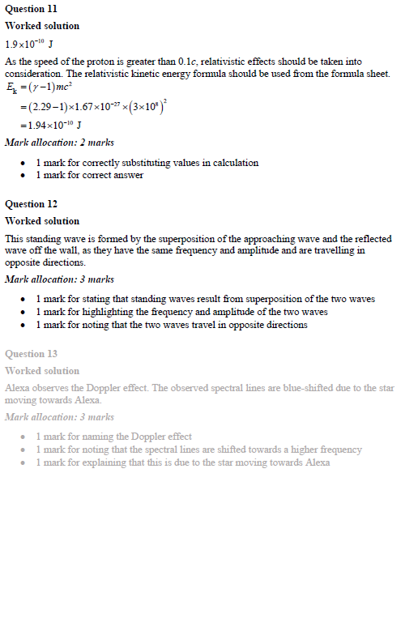

Muons decay with a very short half-life, so few would reach the Earth’s surface after being created high in the atmosphere if Newton’s physics is applied.

Einstein’s special relativity explains that, according to the muon, the distance it has to travel is contracted.

Also, according to observers on the surface of the Earth, time is dilated for the muon, so it takes longer to decay. More muons would reach the surface of the Earth as detected.

* 1 mark for each statement

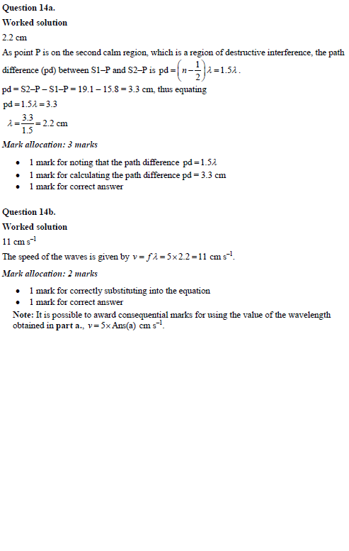

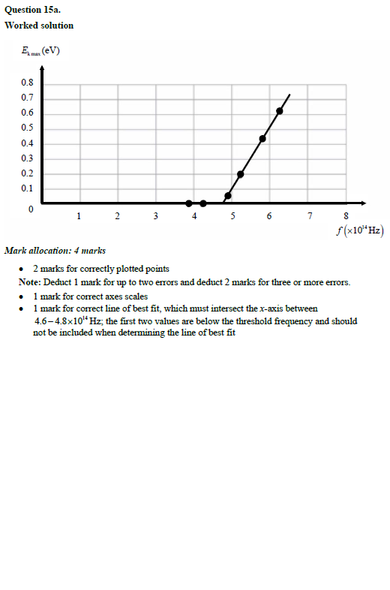

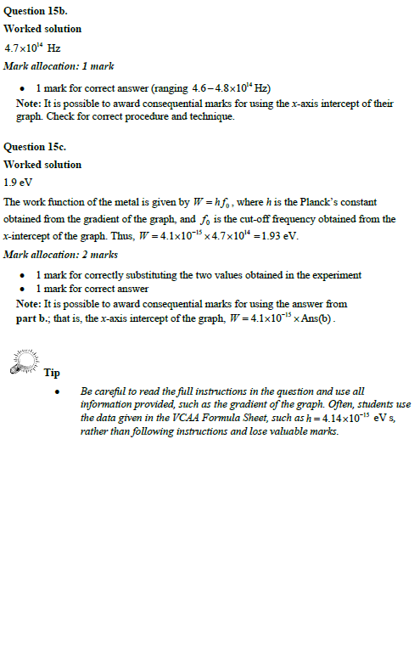

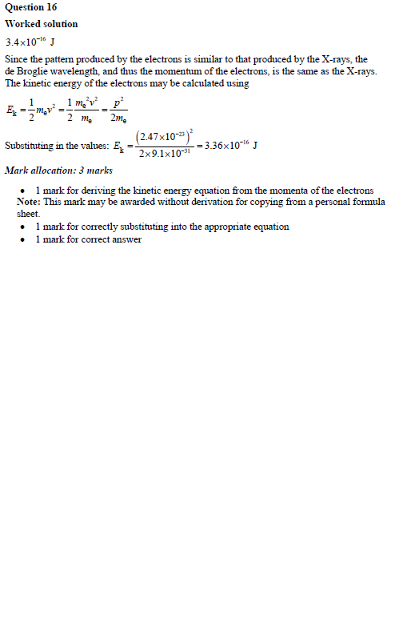

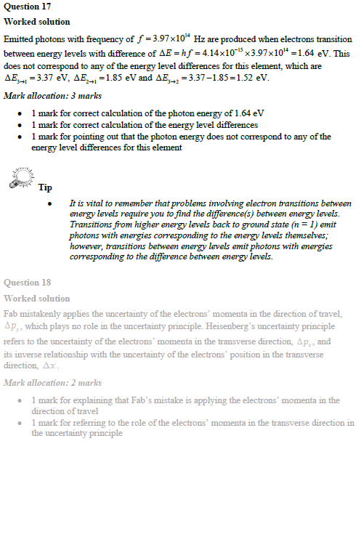

The increase in mass would be given by  .

The denominator is 9 × 1016, so you would have to do 9 × 1016 J of work on the object to see its mass rise only 1 kg.

In everyday life, the work done on objects is generally a tiny fraction of this and, therefore, there is no noticeable increase in mass.

* 1 mark for each statement

