**VCE Physics Units 3 & 4**

**Trial examination 2020**

|  |  |
| --- | --- |
| **STUDENT:** | **TEACHER:** |

**Reading time: 15 minutes**

**Writing time: 2 hours 30 minutes**

**Structure of book**

|  |  |  |  |
| --- | --- | --- | --- |
| *Section* | *Number of questions* | *Number of questions to be answered* | *Number of marks* |
| A | 20 | 20 | 20 |
| B | 20 | 20 | 110  Total 130 |
| * Students are permitted to bring into the examination room: pens, pencils, highlighters, erasers, sharpeners, rulers, two double-sided A4 sheets of notes, and a **scientific** calculator. * Students are **not** permitted to bring into the examination room: blank paper and/or white out liquid/tape. * Students are **not** permitted to bring into the examination room: blank paper and/or white out liquid/tape.   **Materials**   * This **question and answer book** of 43 pages * An **answer sheet** for multiple-choice questions * VCE Physics formula sheet   **Instructions**   * Write using blue or black pen, except on the multiple-choice answer sheet. * Write your name in the space provided above, and on the multiple-choice answer sheet. * Answer Section A (multiple-choice questions) on the separate answer sheet. Answer Section B in the spaces provided in this book. * Where answer boxes are provided, write your final answer in the box. * Where an answer box has units printed in it, give your answer in those units. If no units are printed in the answer box, you mustchoose **appropriate units.** * Set out your solutions clearly and logically. * Unless otherwise indicated, diagrams are not to scale.   Write in comprehensible and unambiguous English. | | | | | |

*Students are not permitted to bring mobile phones and/or any other unauthorised electronic communication devices into the examination room.*

# SECTION A – Multiple-choice questions Instructions for Section A

Answer **all** questions in pencil on the answer sheet provided for multiple-choice questions.

Choose the response that is **correct** or that **best answers** the question.

A correct answer scores 1; an incorrect answer scores 0.

Marks will **not** be deducted for incorrect answers.

No marks will be given if more than one answer is completed for any question.

Unless otherwise indicated, the diagrams in this book are **not** drawn to scale. Take the value of *g* to be 9.8 m s–2.

## Question 1

An electrical field is generated in the space around a point electric charge or between a pair of plates connected to a DC supply.

Which one of the following statements describes both types of electric field?

**A.** Their field strength follows the inverse-square law.

1. Their field lines point away from the positive charge or plate.
2. Their field strength is uniform.
3. Their field lines point towards the positive charge or plate.

## Question 2

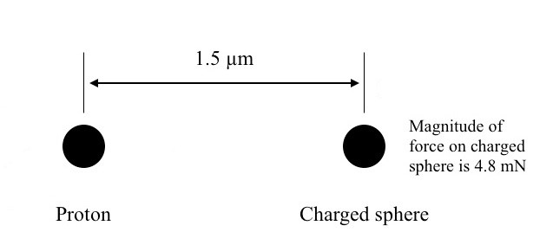

A tiny charged sphere is experiencing a force of 4.8 mN when placed at a distance of

1.5 *µ*m from a proton (*q*proton = 1.6 × 10-19 C).

What is the amount of charge carried by the tiny sphere?

1. 7.5 10× −4 C
2. 7.5 × 10-5 C
3. 7.5 × 10-6 C
4. 7.5 × 10-7 C

## Question 3

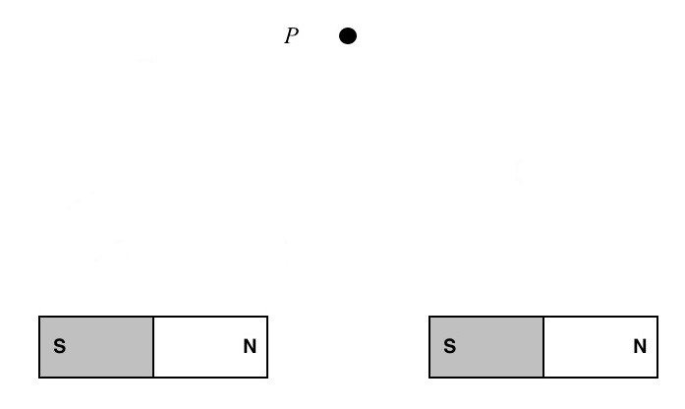

Two identical bar magnets are placed in line with each other. Point *P* is equidistant from the north pole of the magnet on the left, and from the south pole of the magnet on the right.

Which one of the following arrows best represents the direction of the magnetic field at point *P*?

**A.**  **B.**

**C. D.**

## Question 4

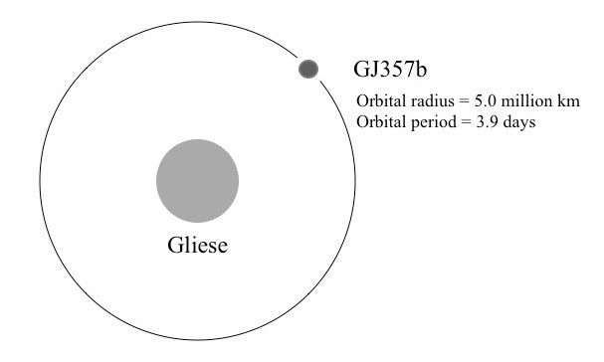

Gliese 357 is a star in the Hydra constellation. It has been confirmed that there are three planets orbiting Gliese. One planet, known as GJ 357 b, orbits at a radius of 5.0 million km with a period of 3.9 days. Another planet, which is known as GJ 357 d, orbits with a period of 56 days.

Which one of the following is closest to the orbital radius of GJ 357 d?

1. 27 million km
2. 30 million km
3. 44 million km
4. 72 million km

*Use the following information to answer Questions 5 and 6.*

A mobile phone charger comprises a step-down transformer and a rectifier (which converts the AC output of the transformer to DC). The charger is connected to a 240 VRMS AC power outlet, and the output of the transformer is 15.0 VRMS AC.

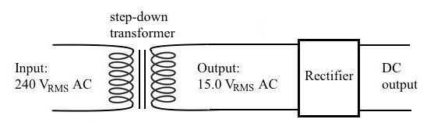

## Question 5

What is the turns ratio of the step-down transformer?

1. 1:16
2. 15:1
3. 16:1
4. 24:1

## Question 6

Assuming that the transformer and the rectifier are ideal, the DC output of the mobile phone charger is expected to be

1. 10.6 V DC
2. 15.0 V DC
3. 21.2 V DC
4. 30.0 V DC

## Question 7

An AC generator uses a coil of 50 turns to produce 110 VRMS AC at a frequency of 60 Hz.

Which one of the following actions will double the magnitude of the output voltage, yet has no other effect on the output voltage wave?

1. rotating the coil twice as fast
2. increasing the number of turns to 100
3. halving the period of rotation
4. increasing the magnetic field strength by 200%

## Question 8

A group of students is generating electricity using a model generator shown in the diagram on the left. The model generator uses a rotating rectangular coil that is connected to a pair of slip rings. The output voltage between the terminals labelled X and Y is shown on the graph.

The slip rings are now replaced with a split-ring commutator.

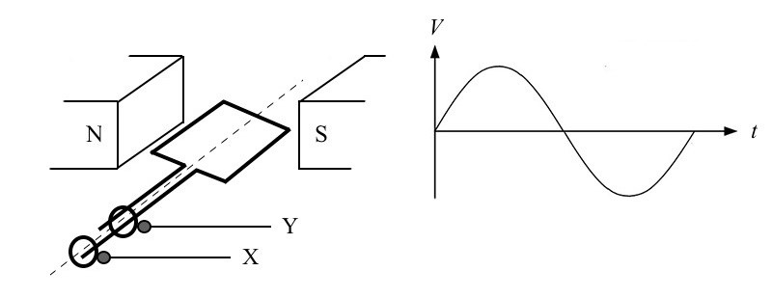

Which one of the following types of electrical output is most likely to be observed between the terminals labelled X and Y?

1. constant magnitude DC voltage
2. sinusoidal magnitude AC voltage
3. fluctuating magnitude DC voltage
4. constant magnitude AC voltage

**Question 9**

Pions are particles that are present in cosmic rays striking Earth. Pions decay, with a half-life of 26  ns. The half-life is the time taken for half of a large number of pions to decay.

 Consider one pion approaching Earth at a speed of 0.98*c*. It decays 26  ns in its own frame of reference after it is formed.

 How long did the pion exist as observed in Earth's frame of reference?

1. 5.2 ns
2. 26 ns
3. 130 ns
4. 650 ns

**Question 10**

A student sits inside a windowless box that has been placed on a smooth-riding train carriage. He conducts a series of motion experiments to investigate frames of reference.

Which one of the following observations is correct?

**A.** The results when the train accelerates differ from the results when the train is in uniform motion in a straight line.

**B.** The results when the train accelerates are identical to the results when the train is in uniform motion in a straight line.

**C.** The results when the train accelerates are identical to the results when the train is at rest.

**D.** The results when the train is at rest differ from the results when the train is in uniform motion in a straight line.

## Question 11

An aeroplane is flying at a constant speed in a horizontal circle.

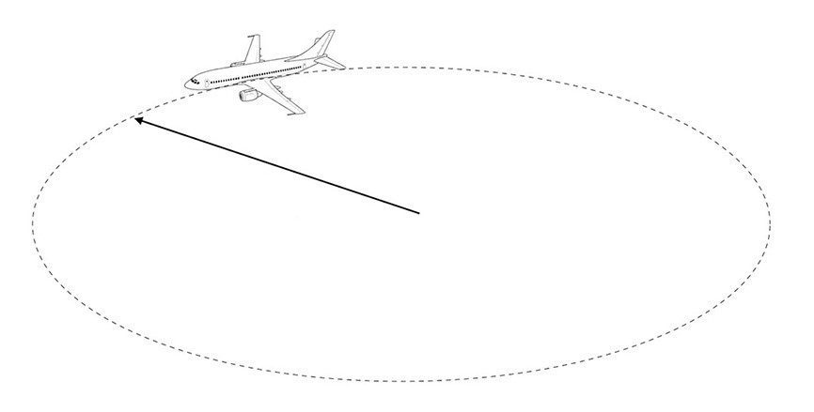

Which one of the following statements best describes the motion of the aeroplane?

1. The net force on the aeroplane is zero because it is moving at a constant speed.
2. The velocity of the aeroplane is constant because it is flying in a horizontal circle.
3. The thrust of the aeroplane’s engines is greater than the air resistance, to provide centripetal acceleration.
4. The upward lift of the aeroplane’s wings is equal to the force due to gravity on the aeroplane.

*Use the following information to answer Questions 12 and 13.*

An electron gun ejects electrons horizontally at a constant velocity into a vacuum chamber. The electrons are deflected with a constant vertical force downwards, so that they hit a target that is 39 cm below the horizontal path of the electrons. The flight time of the electrons is 2.3 ×10 −4s.

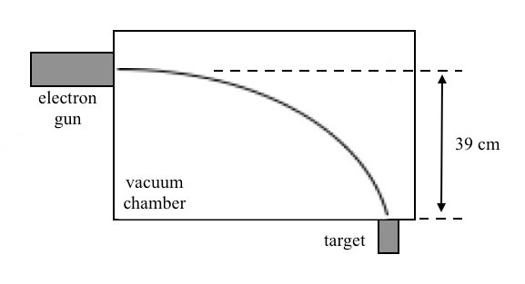

## Question 12

Which one of the following is the closest value of the downward acceleration of the electrons?

1. 1.5×10 7 m s−2
2. 1.5×10 8 m s−2
3. 1.5×10 9 m s−2
4. 1.5×10 10 m s−2

**Question 13**

The constant vertical acceleration of the electrons may be caused by

**A.** gravity only.

1. an electric field only.
2. a magnetic field only.
3. either an electric field or a magnetic field.

**Question 14**

Gini is a mission controller at a space station. She observes Jordan in a spaceship travelling past her observation post on the space station at a relative speed of 0.866*c* (γ= 2.00) . Both

Gini and Jordan each hold up a metre ruler parallel to the direction of their travel past each other. Due to relativistic effects, Gini measures Jordan’s ruler as 0.5 m, a phenomenon known as length contraction.

What will be the measurement that Jordan makes of Gini’s ruler?

1. 0.5 m
2. 1.0 m
3. 1.5 m
4. 2.0 m

*Use the following information to answer Questions 15 and 16.*

The Beet FM radio station broadcasts at a frequency of 88.8 MHz. The Beet FM transmitter at the top of Mount Dandenong in Victoria, Australia, has an output power of 12.5 kW.

## Question 15

Which one of the following is closest to the wavelength of the radio signal from Beets FM?

1. 1.7 m
2. 2.5 m
3. 3.4 m
4. 6.8 m

## Question 16

Assuming that the transmitter is ideal, the number of photons emitted per second is closest to

1. 3.4×10 10
2. 3.0×10 18
3. 2.1×10 29
4. 1.9×10 37

## Question 17

A cathode ray tube is used to accelerate electrons to a constant speed. These electrons pass through a thin slice of a salt crystal and form a diffraction pattern on a phosphor screen on the wall of the cathode ray tube.

Which one of the following best relates the behaviour of the electrons and the observations made in the cathode ray tube?

|  |  |
| --- | --- |
| **Electrons diffracting through the salt crystal** | **Electrons arriving at the phosphor screen** |
| electrons behave in a wave-like manner | electrons behave in a wave-like manner |
| electrons behave in a particle-like manner | electrons behave in a particle-like manner |
| electrons behave in a wave-like manner | electrons behave in a particle-like manner |
| electrons behave in a particle-like manner | electrons behave in a wave-like manner |

**A.**

**B.**

**C.**

**D.**

*Use the following information to answer Questions 18 and 19.*

Taku and Mina are experimenting with a frictionless air track. A cart (mass *M* = 480 g) is attached to a falling mass (mass *m* = 80 g), using a massless cable. The falling mass is allowed to free fall under the influence of gravity. The cable runs over a frictionless pulley and air resistance is negligible.

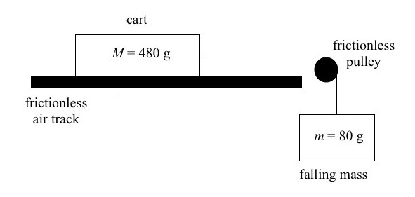

Taku and Mina measure the acceleration of the cart with an onboard accelerometer, which is included as part of the mass of the cart.

## Question 18

Which one of the following is closest to the expected magnitude of the acceleration of the cart?

1. 1.2 m s–2
2. 1.4 m s–2
3. 1.6 m s–2
4. 1.8 m s–2

## Question 19

After two runs with the apparatus, the frictionless pulley becomes twisted. It now exerts a constant friction force of 0.15 N on the motion of the cable.

Which one of the following best explains how this constant friction force will affect the measurement of the acceleration of the cart, in terms of accuracy and precision?

**A.** The constant friction force will affect the accuracy only.

1. The constant friction force will affect the precision only.
2. The constant friction force will affect both the accuracy and the precision.
3. The constant friction force will affect neither the accuracy nor the precision.

## Question 20

A group of Physics students, Ali, Bobbi, Curtis and Daria, are waiting at the bus stop. They observe a group of passengers boarding a bus that is heading to a different destination. As the bus accelerates away from the bus stop, the Physics students notice a few standing passengers appearing to fall towards the rear of the bus. They discuss their observations.

|  |  |
| --- | --- |
| Ali | ‘The force of inertia on these passengers caused them to fall towards the rear of the bus.’ |
| Bobbi | ‘There is an imaginary force acting on these passengers, making them fall towards the rear of the bus.’ |
| Curtis | ‘The bus exerts a backward force on the passengers to make them fall towards the rear of the bus.’ |
| Daria | ‘Friction force on the passengers’ feet pulls their legs forward, but their bodies fall towards the rear of the bus.’ |

Which one of the students best describes the physics of the motion of the standing passengers?

**A.**

**B.**

**C.**

**D.**

**SECTION B**

# Instructions for Section B

Answer **all** questions in the spaces provided. Write using blue or black pen.

Where an answer box is provided, write your final answer in the box.

If an answer box has a unit printed in it, give your answer in that unit.

In questions where more than one mark is available, appropriate working **must** be shown.

Unless otherwise indicated, the diagrams in this book are **not** drawn to scale.

Take the value of *g* to be 9.8 m s–2.

## Question 1 (7 marks)

A GPS satellite orbits Earth at an orbital radius of 27 ×10 6 m, as shown in Figure 1.

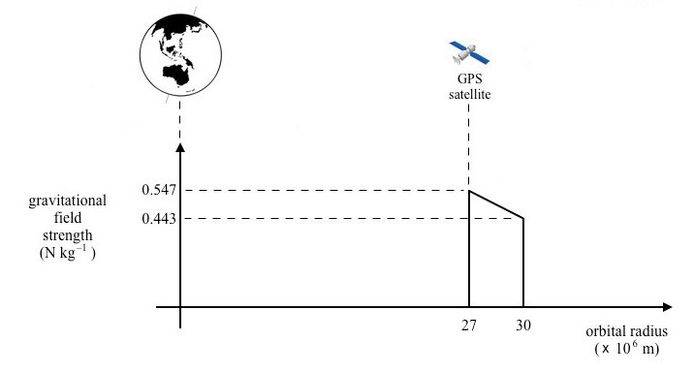

## Figure 1

**a.** Show that the gravitational field strength of Earth is 0.547 N kg–1 at this orbital radius.

2 marks

______________________________________________________________________

______________________________________________________________________

______________________________________________________________________

______________________________________________________________________

1. Calculate the orbital speed of the GPS satellite at this orbital radius.

2 marks

______________________________________________________________________

______________________________________________________________________

______________________________________________________________________

______________________________________________________________________

m s–1

The GPS satellite is boosted to a higher altitude, to an orbital radius of 30 ×10 6 m. At this new position, the gravitational field strength of Earth is 0.443 N kg–1. The variation in the gravitational field strength may be assumed to be linear, as shown in Figure 1. The mass of the GPS satellite is 1630 kg.

1. Calculate the difference in the gravitational potential energy of the satellite between these two positions.

3 marks

______________________________________________________________________

______________________________________________________________________

______________________________________________________________________

______________________________________________________________________

______________________________________________________________________

______________________________________________________________________

J

## Question 2 (13 marks)

An electron travels horizontally at a constant velocity of 3.5 ×10 6 m s–1 into a uniform electric field between two parallel plates that are connected to a 100 V DC supply. The distance between the two plates is *d* = 40 cm. Plate A is connected to the negative terminal of the DC supply, and Plate B is connected to the positive terminal of the DC supply. The motion of the electron as it enters and travels through the uniform electric field is shown in Figure 2. Ignore the effects of gravity, air resistance or special relativity.

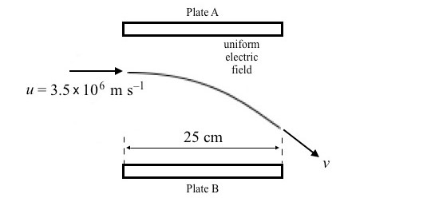

Distance between

plates

*d*

=

40 cm

Voltage between plates

*V*

=

100 V

## Figure 2

1. Explain why the path of the electron is the shape of a parabola while the electron is inside the uniform electric field.
   1. marks

______________________________________________________________________

______________________________________________________________________

______________________________________________________________________

______________________________________________________________________

______________________________________________________________________

______________________________________________________________________

1. Show that the field strength of the uniform electric field between the plates is 250 V m–1. Identify an alternative unit to V m–1.
   1. marks

______________________________________________________________________

______________________________________________________________________

______________________________________________________________________

______________________________________________________________________

Alternative unit =

1. Calculate the acceleration of the electron while it is inside the uniform electric field.
   1. marks

______________________________________________________________________

______________________________________________________________________

______________________________________________________________________

______________________________________________________________________

______________________________________________________________________

______________________________________________________________________

m s–2

1. Calculate the speed of the electron, *v*, as it exits the uniform electric field.
   1. marks

______________________________________________________________________

______________________________________________________________________

______________________________________________________________________

______________________________________________________________________

______________________________________________________________________

______________________________________________________________________

______________________________________________________________________

______________________________________________________________________

m s–1

## Question 3 (8 marks)

A model electric motor is composed of a rectangular coil, with 20 loops of copper wire, of side length KL = 2.2 cm. The loop is entirely within a magnetic field of 4.5 mT, and connected to a split-ring commutator with terminals labelled P and Q. P is connected to the positive terminal of a 9 V DC supply, and Q is connected to the negative terminal.

A student measures the resistance of the circuit *R* = 18 Ω.

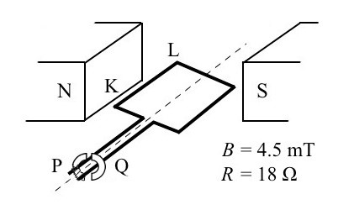

## Figure 3

1. **i.** Circle the direction the motor will turn when viewed from the commutator side.

1 mark clockwise anticlockwise the motor will not turn

**ii.** Explain your answer to **part a.i.**

2 marks

_________________________________________________________________

_________________________________________________________________

_________________________________________________________________

_________________________________________________________________

1. Calculate the magnitude of the magnetic force on side KL.

3 marks

______________________________________________________________________

______________________________________________________________________

______________________________________________________________________

______________________________________________________________________

______________________________________________________________________

______________________________________________________________________

N

N

**c.** A student decides to switch the power supply to 9 V AC while the rectangular coil is in the position shown in Figure 3.

Explain what would happen to the motion of the rectangular coil of the model electric motor.

2 marks

______________________________________________________________________

______________________________________________________________________

______________________________________________________________________

______________________________________________________________________

## Question 4 (5 marks)

The production line of a car parts factory uses a conveyor belt to transport parts from one section of the factory to another. The car parts are magnetic and could be detected using a detector system that comprises a conductor coil of wire and a voltage detector located overhead, as shown in Figure 4. The conductor coil fits within the magnetic field of each car part.

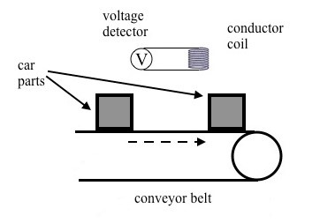

## Figure 4

The conductor coil comprises eight circular loops of copper wire with a diameter of 250 mm. The conveyor belt moves at a constant speed, and the time for the magnetic flux from the car parts to change from zero to maximum flux is *t* = 0.65 s. The conveyor belt speed can be varied from half to double the initial set speed.

**a.** The average EMF (ɛ) generated in the conductor coil must be at least 55 mV in order to detect a car part moving under the detector system.

Determine the minimum magnetic field strength at the location of the coil that would cause a car part to be detected by the detector system.



3 marks

______________________________________________________________________

______________________________________________________________________

______________________________________________________________________

______________________________________________________________________

______________________________________________________________________

______________________________________________________________________

mT

A production engineer measures the magnetic field strength of the car part and finds that the magnetic field strength is approximately 10% lower than the required field strength in **part a.**

**b.** Using the same equipment, suggest one way for the production engineer to enable the car parts to be detected. Explain why your suggestion would work.

2 marks

______________________________________________________________________

______________________________________________________________________

______________________________________________________________________

______________________________________________________________________

## Question 5 (11 marks)

The Asterisk Powerbank is a battery power storage system designed to provide backup power for small communities, as shown in Figure 5. The battery provides 25 kW of power at the output voltage of 230 V DC, and it lasts for 1 hour.

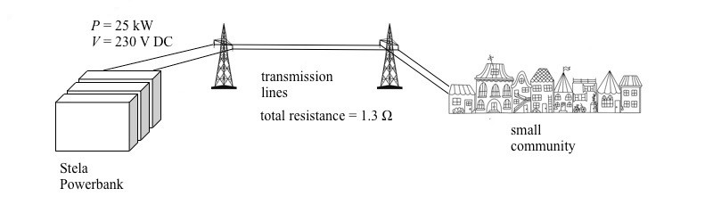

## Figure 5

The planned installation for one small community involves transmitting the power via transmission lines that have a total resistance of 1.3 Ω.

**a.** Calculate the amount of power that may be lost during transmission.

3 marks

______________________________________________________________________

______________________________________________________________________

______________________________________________________________________

______________________________________________________________________

______________________________________________________________________

______________________________________________________________________

kW

**b.** It is decided to step up the voltage before transmission in order to reduce the power loss during transmission; however, stepping up the voltage of the Asterisk Powerbank can not be achieved using a step-up transformer.

1. If stepping up the voltage before transmission were possible, explain how this would reduce power loss.
   1. marks

_________________________________________________________________

_________________________________________________________________

_________________________________________________________________

_________________________________________________________________

1. Explain why this cannot be achieved with DC output of the battery.
   1. marks

_________________________________________________________________

_________________________________________________________________

_________________________________________________________________

_________________________________________________________________

### 

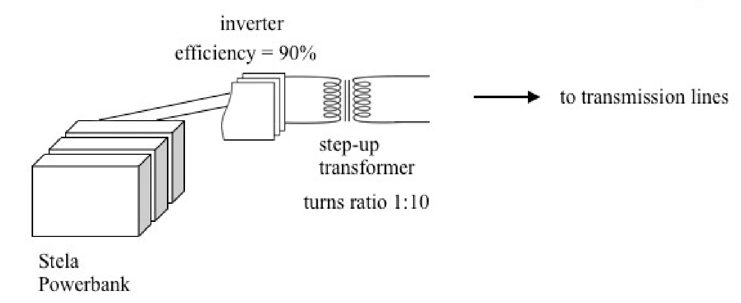

inverter

-

## Figure 6

**c.** A power inverter is a device that converts DC to AC. It converts the 230 V DC output of the battery to 230 VRMS AC at an efficiency rating of 90%. The AC output of the inverter is then stepped up with a step-up transformer that has a turns ratio of 1:10. Assume that the transformer is ideal.

1. Calculate the expected current in the primary windings of the step-up transformer.
   1. marks

_________________________________________________________________

_________________________________________________________________

_________________________________________________________________

_________________________________________________________________

ARMS

1. With the same transmission lines (total resistance = 1.3 Ω), what is the power loss in the transmission lines with the set-up shown in Figure 6?
   1. marks

_________________________________________________________________

_________________________________________________________________

_________________________________________________________________

_________________________________________________________________

W

## Question 6 (6 marks)

India is among the most active nations in launching satellites to fulfil tasks such as telecommunications, navigation and meteorology. One recent launch transported RISAT2BR1 to an altitude of 576 km above Earth’s surface.

1. Determine the orbital period for RISAT-2BR1.

4 marks

______________________________________________________________________

______________________________________________________________________

______________________________________________________________________

______________________________________________________________________

______________________________________________________________________

______________________________________________________________________

______________________________________________________________________

______________________________________________________________________

s

1. India plans to launch a new series of satellites to the same altitude as RISAT-2BR1. The mass of each of these satellites will be approximately 25% larger than that of RISAT2BR1.

Circle all of the characteristics of the new satellites that will be the same as those of

RISAT-2BR1.

2 marks

centripetal acceleration centripetal force orbital period orbital speed

## Question 7 (6 marks)

An astronaut and her colleague (labelled ‘observer’) are outside their space capsule in deep space, as shown in Figure 7. Initially, the astronaut, the observer and the capsule are at rest together at a point in space. The mass of the astronaut is 72 kg and the mass of the capsule is 2300 kg.

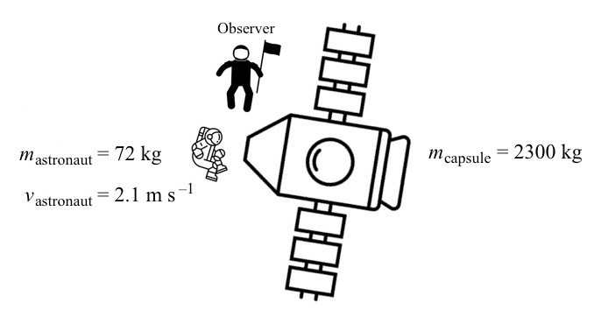

–

## Figure 7

The astronaut pushes against the capsule and moves in a straight line away from the capsule at a velocity of 2.1 m s–1, while the observer remains at the initial position. The capsule also moves in a straight line away from the astronaut.

1. Without performing any calculations, state the physics principle that could be applied to determine the speed at which the capsule is moving. Justify your answer.

2 marks

______________________________________________________________________

______________________________________________________________________

______________________________________________________________________

______________________________________________________________________

1. Calculate the speed at which the capsule is moving away from the initial position.

2 marks

______________________________________________________________________

______________________________________________________________________

______________________________________________________________________

______________________________________________________________________

m s–1

**c.** The contact time between the astronaut and the capsule is 1.3 s when the astronaut is pushing against the capsule.

Determine the magnitude of the average force that the astronaut was exerting against the capsule.

2 marks

______________________________________________________________________

______________________________________________________________________

______________________________________________________________________

______________________________________________________________________

N

## Question 8 (8 marks)

Sadio is attempting to ride a motorbike around a vertical loop that is 9.0 m in diameter, as seen in Figure 8. The total mass of Sadio and the motorbike is 235 kg, and may be considered to be concentrated at a point.

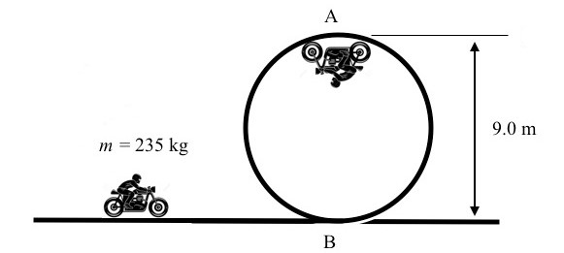

## Figure 8

1. Determine the minimum speed that Sadio and the motorbike must be travelling at the top of the loop (point A in Figure 8) in order for the wheels of the motorbike to maintain contact with the track at all times.

3 marks

______________________________________________________________________

______________________________________________________________________

______________________________________________________________________

______________________________________________________________________

______________________________________________________________________

______________________________________________________________________

m s–1

1. Calculate the total energy, relative to the ground, of Sadio and the motorbike at the top of the loop.

3 marks

______________________________________________________________________

______________________________________________________________________

______________________________________________________________________

______________________________________________________________________

______________________________________________________________________

J

**c.** What is the minimum speed that Sadio and the motorbike must travel at the bottom of the loop (point B in Figure 8) in order to go around the loop?

2 marks

______________________________________________________________________

______________________________________________________________________

______________________________________________________________________

______________________________________________________________________

m s–1

## Question 9 (10 marks)

Gomez and Matip are designing a jack-in-the-box toy. They choose a spring with a natural length, *l*0 = 0.4 m. The jack has a mass of 0.3 kg and is fixed to the top of the spring, as shown in Figure 9.

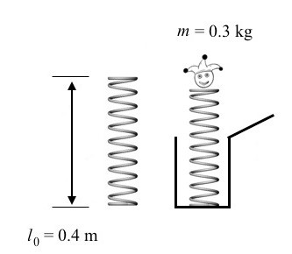

## Figure 9

When the jack and spring are compressed inside the box, the length of the spring is *l* = 0.1 m. After the box is opened, the jack will spring out of the box and extend to a full height, having a spring length of *l* = 0.6 m.

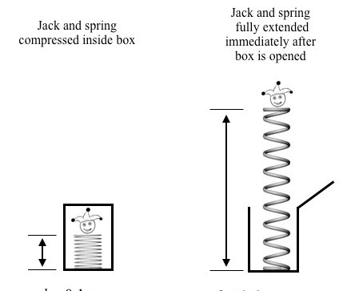

*l* = 0.1 m *l* = 0.6 m

## Figure 10

Gomez and Matip wish to determine the spring constant, *k*, for the jack-in-the-box toy.

Assume that the spring has a negligible mass.

1. **i.** Calculate the amount of compression of the spring, ∆*x*.

1 mark

_________________________________________________________________

_________________________________________________________________

m

**ii.** Calculate the elastic potential energy stored in the spring as a decimal multiple of the spring constant, *k*.

2 marks

_________________________________________________________________

_________________________________________________________________

_________________________________________________________________

_________________________________________________________________

k J

When the spring is fully extended after the box is opened, the stored elastic potential energy of the compressed spring is converted into the gravitational potential energy of the jack, plus the stored potential energy of the extended spring.

1. **i.** Calculate the distance between the two positions of the jack, where the spring is fully compressed to where the spring is fully extended.

1 mark

_________________________________________________________________

_________________________________________________________________

m

1. Determine the change in gravitational potential energy of the jack as it rises from the lowest position (spring fully compressed) to the highest position (spring fully extended).
   1. marks

_________________________________________________________________

_________________________________________________________________

_________________________________________________________________

_________________________________________________________________

J

1. Determine the elastic potential energy stored in the spring, in terms of the spring constant, *k*.
   1. marks

_________________________________________________________________

_________________________________________________________________

_________________________________________________________________

_________________________________________________________________

k J

**c.** By equating the elastic potential energy of the compressed spring in **part a.ii.** with the sum of the gravitational potential energy and elastic potential energy of the stretched spring (**part b.ii.** + **part b.iii.**), determine the value for the spring constant, *k*.

2 marks

______________________________________________________________________

______________________________________________________________________

______________________________________________________________________

______________________________________________________________________

N m–1

## Question 10 (4 marks)

At the Australian Synchrotron located in the southeast of Melbourne, electrons are first accelerated to about 0.63*c* or 63% of the speed of light.

1. Show that the Lorentz factor at this speed is γ=1.288.
   1. marks

______________________________________________________________________

______________________________________________________________________

______________________________________________________________________

______________________________________________________________________

1. After accelerating, the electrons travel at a constant speed along a linear chamber before insertion into the booster ring. The length of the linear chamber, as measured by the physicists at the Australian Synchrotron, is 36 cm.

What is the length of the linear chamber when measured from the frame of reference of the electrons?

* 1. marks

______________________________________________________________________

______________________________________________________________________

______________________________________________________________________

______________________________________________________________________

m

## Question 11 (2 marks)

A high-energy proton travels directly towards Earth from interstellar space at a speed of *v* = 2.70 10× 8 m s–1 (equivalent to *v* = 0.900*c* and γ= 2.29), as measured by an observer on Earth. The mass of a proton is *m*p =1.67 10× −27 kg.

Determine the kinetic energy of the proton, as measured by the observer on Earth.

___________________________________________________________________________

___________________________________________________________________________

___________________________________________________________________________ ___________________________________________________________________________

J

## Question 12 (3 marks)

A sinusoidal wave on the surface of the ocean approaches a wall at speed *v*, as shown in Figure 11. The wall is a perfect reflector, and reflects the waves back in the direction they came from.

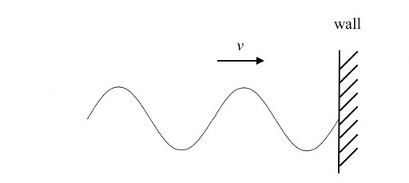

## Figure 11

Soon after the initial arrival of the wave at the wall, a standing wave could be observed at the region near the wall, as shown in Figure 12.

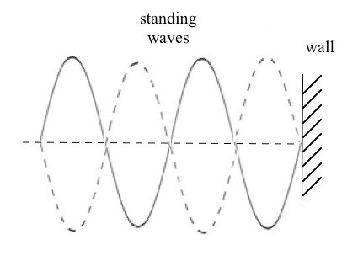

## Figure 12

Explain how this standing wave is formed at the region near the wall.

___________________________________________________________________________

___________________________________________________________________________

___________________________________________________________________________ ___________________________________________________________________________

**Question 13** (3 marks)

An example of a practical application of Einstein’s theory is muons reaching the Earth’s surface. Explain how his theory supports the high number of muons reaching the surface while Newtonian physics does not.

___________________________________________________________________________

___________________________________________________________________________

___________________________________________________________________________

___________________________________________________________________________

___________________________________________________________________________ ___________________________________________________________________________

## Question 14 (5 marks)

A ripple tank that has a pair of vibrating dippers is used to study the wave phenomenon of interference, as shown in Figure 13.

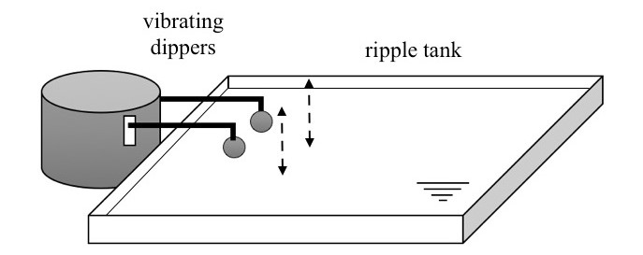

## Figure 13

With the frequency of the dippers set at *f* = 5 Hz, the interference pattern shown in Figure 14 is observed.

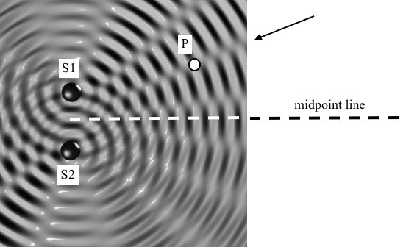

## Figure 14

The two dippers are labelled S1 and S2, and the midpoint line indicates the regions where the distance to S1 is equal to the distance to S2. The region along the midpoint line is where the waves are observed to have the highest amplitude. There are also calm regions, along which only small wave activities are observed, as indicated by the arrow. The point P is located along the second calm region, away from the midpoint line.

1. The distance from S1 to P is 15.8 cm, whereas the distance from S2 to P is 19.1 cm.

What is the wavelength of the waves generated by the dippers?

3 marks

______________________________________________________________________

______________________________________________________________________

______________________________________________________________________

______________________________________________________________________

______________________________________________________________________

cm

1. Determine the speed of the waves generated by the dippers.

2 marks

______________________________________________________________________

______________________________________________________________________

______________________________________________________________________

______________________________________________________________________

cm s–1

## Question 15 (7 marks)

Moh and Div are experimenting with different coloured filters as they investigate the photoelectric effect, using the apparatus shown in Figure 15.

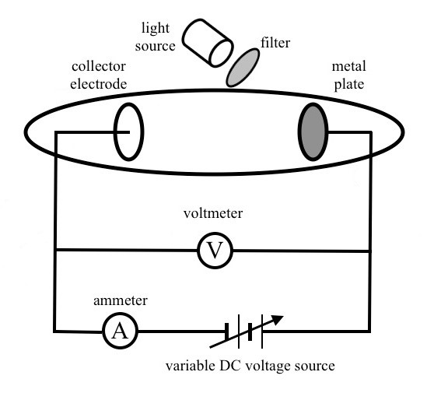

## Figure 15

The aim of the practical is to determine the cut-off frequency of the metal plate and the work function of the metal. Moh and Div obtain the following results for the maximum kinetic energy ( Ekmax ) of the emitted photoelectrons versus the frequency of the light incident on the metal plate.

The results of their investigation are shown in Table 1 below.

## Table 1

|  |  |
| --- | --- |
| *f* (×1014Hz) | *Ek*max (eV) |
| 3.90 | 0.00 |
| 4.15 | 0.00 |
| 4.89 | 0.05 |
| 5.15 | 0.19 |
| 5.75 | 0.42 |
| 6.25 | 0.62 |

1. On the axes provided below:
   * plot the data presented in Table 1
   * include appropriate scales on each axis
   * draw a line of best fit that is suitable for determining the cut-off frequency of the metal plate.

*E*kmax(eV) 4 marks

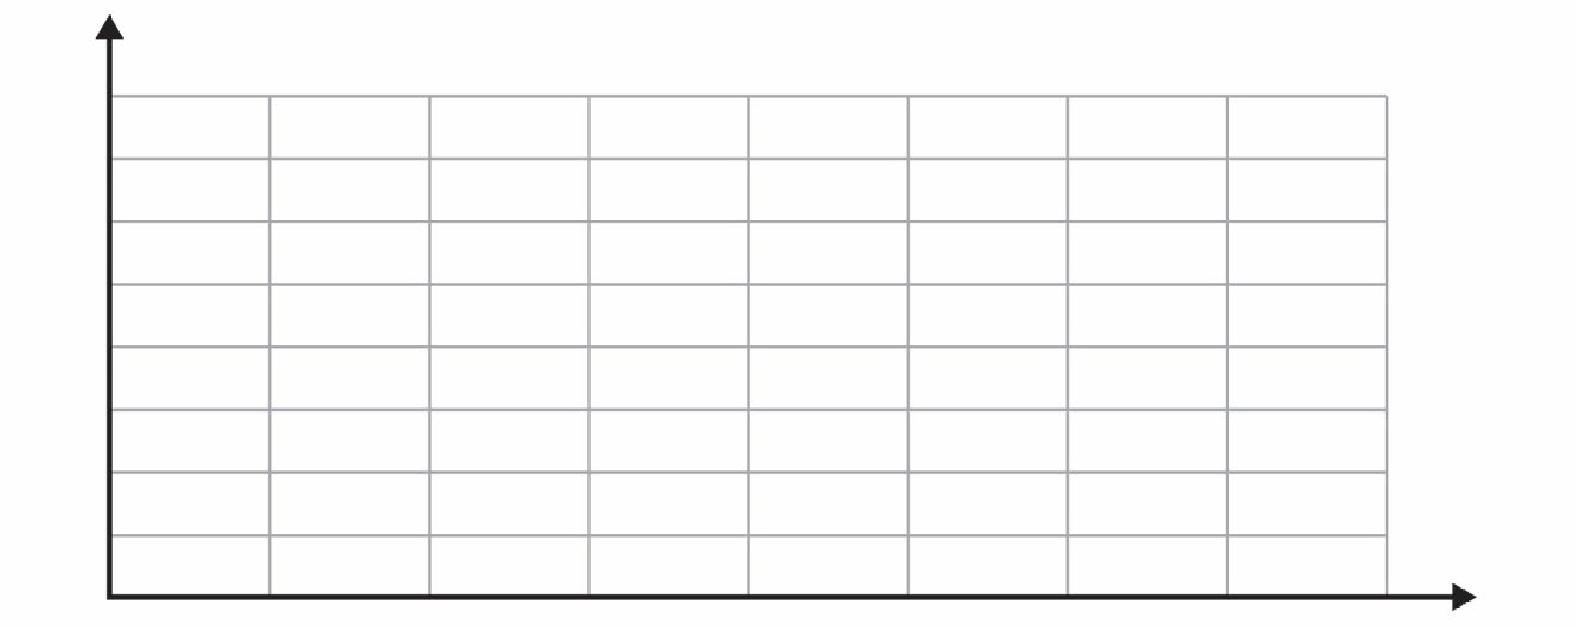

*f* (×1014 Hz)

1. State the cut-off frequency that is observed from the results of the experiment.

1 mark

______________________________________________________________________

______________________________________________________________________

Hz

Moh and Div calculate the gradient of their graph to be 4.1 ×10 −15 eV s.

1. Using this value and the information on your graph, determine the work function, *W*, of the metal used in this photoelectric experiment.

2 marks

______________________________________________________________________

______________________________________________________________________

______________________________________________________________________

______________________________________________________________________

eV

## Question 16 (3 marks)

A teacher is demonstrating how diffraction patterns from X-rays and electrons through thin metal foils might appear similar to each other, even though the means of producing them are different. The pattern from an electron experiment is combined with one from an X-ray experiment shown in Figure 16. Note that both patterns shown are to the same scale.

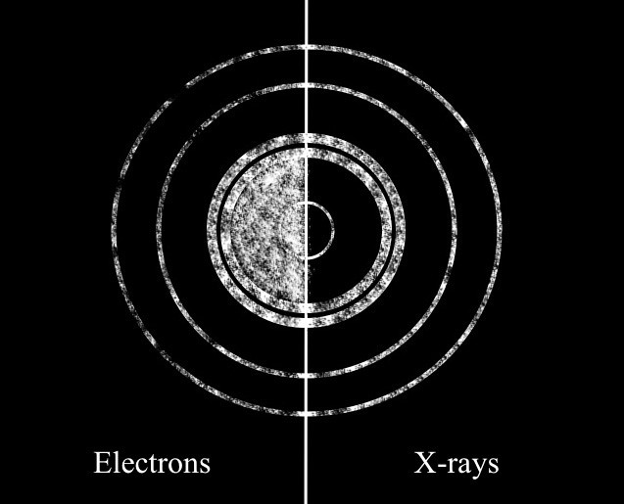

## Figure 16

The X-rays that produce the pattern have momenta of 2.47× 10 −23 N s.

Calculate the kinetic energy of the electrons for this experiment.

___________________________________________________________________________

___________________________________________________________________________

___________________________________________________________________________ ___________________________________________________________________________

J

## Question 17 (3 marks)

The emission spectrum of an element shows discrete lines corresponding to the different light frequencies emitted by electrons as they transition between energy levels.

In one experiment involving a particular element, electrons transitioned from level *n* = 3 back to ground state (*n* = 1).

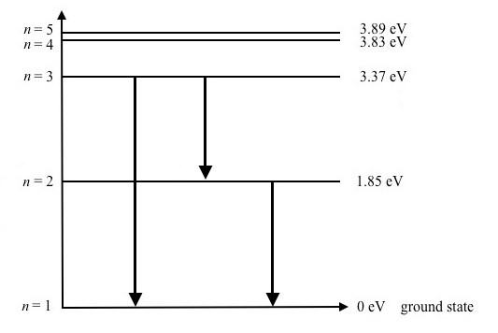

## Figure 17

The observed emission spectrum that was produced displayed spectral lines at the frequencies indicated in Figure 18.

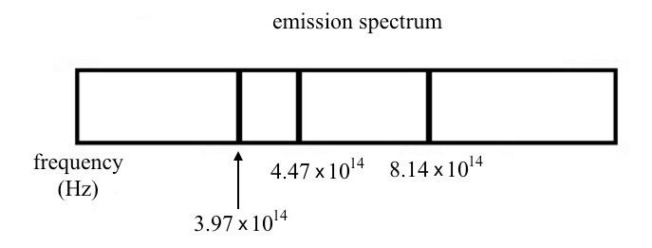

## Figure 18

Elliot, a Physics student, notes that the first reported spectral line with frequency

*f* = 3.97 10× 14 Hz must be a mistake.

Explain why this frequency could not be observed when the electrons of this element transitioned from level *n* = 3 back to ground state and support your answer with calculations.

___________________________________________________________________________

___________________________________________________________________________

___________________________________________________________________________

**Question 18** (2 marks)

Einstein’s famous equation *E* = *m*c2 implies that if we do work on an object, its mass increases.

Explain why, in everyday life, we do not measure an increase in the mass of an object when we do work on it.

___________________________________________________________________________

___________________________________________________________________________

___________________________________________________________________________

___________________________________________________________________________

**Question 19** (4 marks)

In preparation for a physics experiment, Adrienne uses a mass balance to weigh five 50 g slotted masses to ensure that they are suitable for the experiment. She finds that the average mass is 54.88 g.

Later, she finds that the balance is poorly calibrated, resulting in all objects measuring

4.52 g more.

1. Identify the type of error that is caused by the poor calibration of the balance.

1 mark

______________________________________________________________________

______________________________________________________________________

1. **i.** Circle the aspect of Adrienne’s measurements of the masses that will be affected by this type of error.

1 mark accuracy only precision only both accuracy and precision

**ii.** Explain your choice in **part b.i.**

2 marks

_________________________________________________________________

_________________________________________________________________

_________________________________________________________________

_________________________________________________________________

**END OF QUESTION AND ANSWER BOOK**