**PHYSICS**

**UNIT 3**

**2021**



**MARKING GUIDE**

**Name ____________________________________________________**

**Teacher ____________________________________________________**

**Time allowed for this paper**

Reading time before commencing work: ten minutes

Working time: three hours

**Materials required/recommended for this paper**

***To be provides by the supervisor***

This Question/Answer booklet

Formulae and Data booklet

***To be provided by the candidate***

Standard items: pens (blue/black preferred), pencils (including coloured), sharpener,

correction fluid, eraser, ruler, highlighters.

Special items: up to three non-programmable calculators approved for use in the WACE examinations, drawing templates, drawing compass and a protractor.

**Important note to candidates**

No other items may be taken into the examination room. It is **your** responsibility to ensure that you do not have any unauthorised material. If you have any unauthorised material with you, hand it to the supervisor **before** reading any further.

**Question 1 (4 marks)**

1. (i) Draw an arrow showing the direction of the magnetic field.

|  |  |
| --- | --- |
| **Description** | **Marks** |
| Draws an arrow from left to right, from North (N) to South (S) | 1 |
| **Total** | 1 |

(ii) Draw an arrow on the wire to show the direction of the force acting on it.

|  |  |
| --- | --- |
| **Description** | **Marks** |
| Draws an arrow upwards from the wire. | 1 |
| **Total** | 1 |

1. Calculate the magnitude of the magnetic field (B) if the wire experiences a force of 2.7 mN.

|  |  |
| --- | --- |
| **Description** | **Marks** |
|  |  |
|  | 1 |
|  | 1 |
| **Total** | 2 |

**Question 2 (5 marks)**

|  |  |
| --- | --- |
| **Description** | **Marks** |
|  | 1 |
|  | 1 |
|  | 1 |
|  | 1 |
| Unknown moon (from table) is Proteus | 1 |
| **Total** | 5 |

**Question 3 (6 marks)**

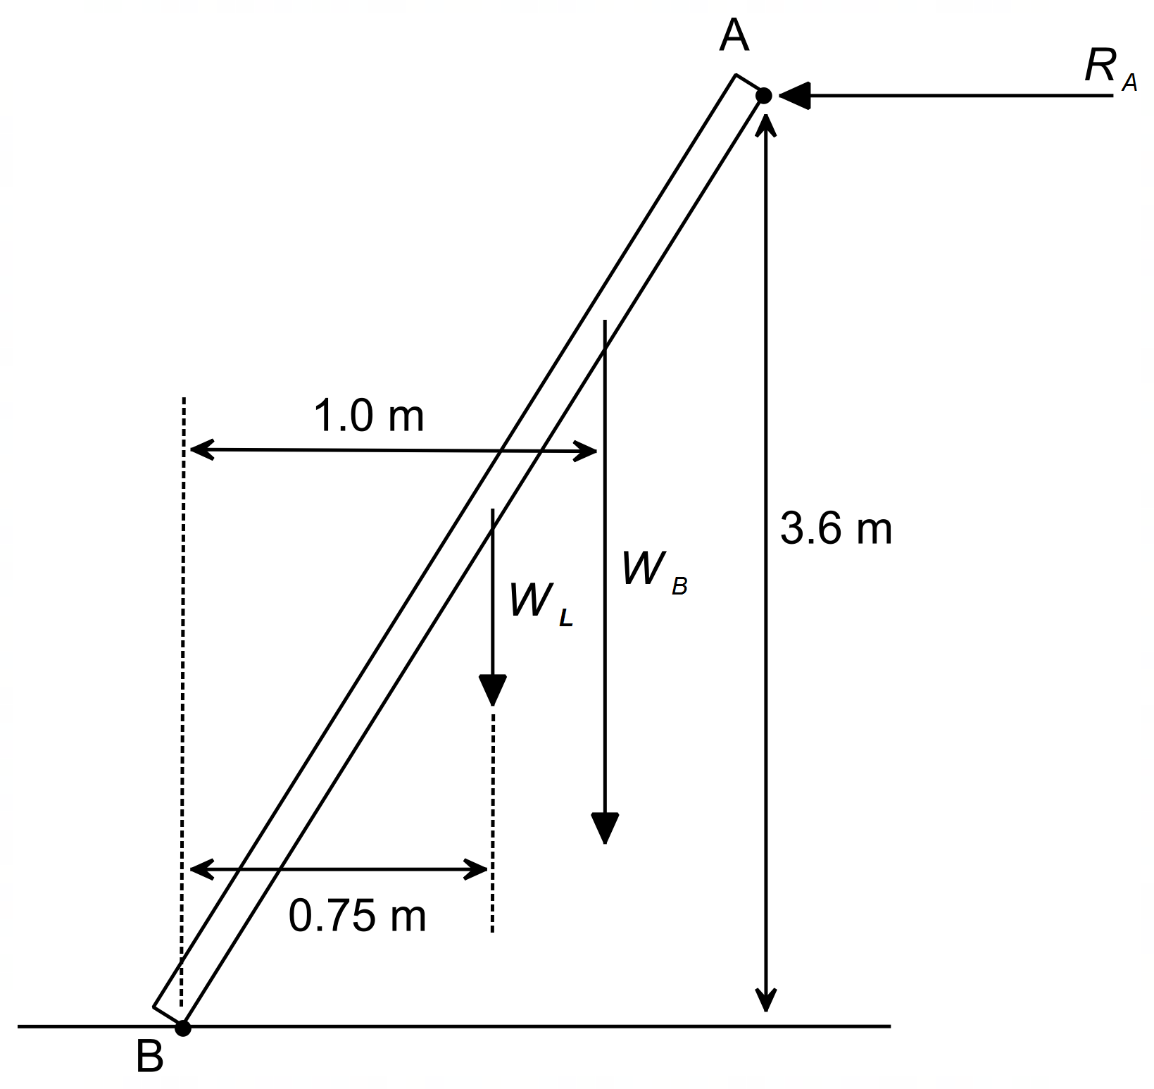

1. Evaluate with calculations whether this situation is safe when the bricklayer is in the position described.

|  |  |
| --- | --- |
| **Description** | **Marks** |
|  | 1 |
| Summing torques about point B | 1 |
|  | 1 |
| Since the reaction force is less than 300 N, the situation is safe. | 1 |
| **Total** | 4 |

1. The bricklayer now moves to a position three-quarters up the length of the ladder. Explain how this makes the situation less safe.

|  |  |
| --- | --- |
| **Description** | **Marks** |
| Moving 75% up ladder increases the CW torque from *WB* about point B, thus also increasing the CCW torque required. | 1 |
| Thus, reaction force *RA* will increase closer to 300 N, causing the situation to be less safe. | 1 |
| **Total** | 2 |

**Question 4 (6 marks)**

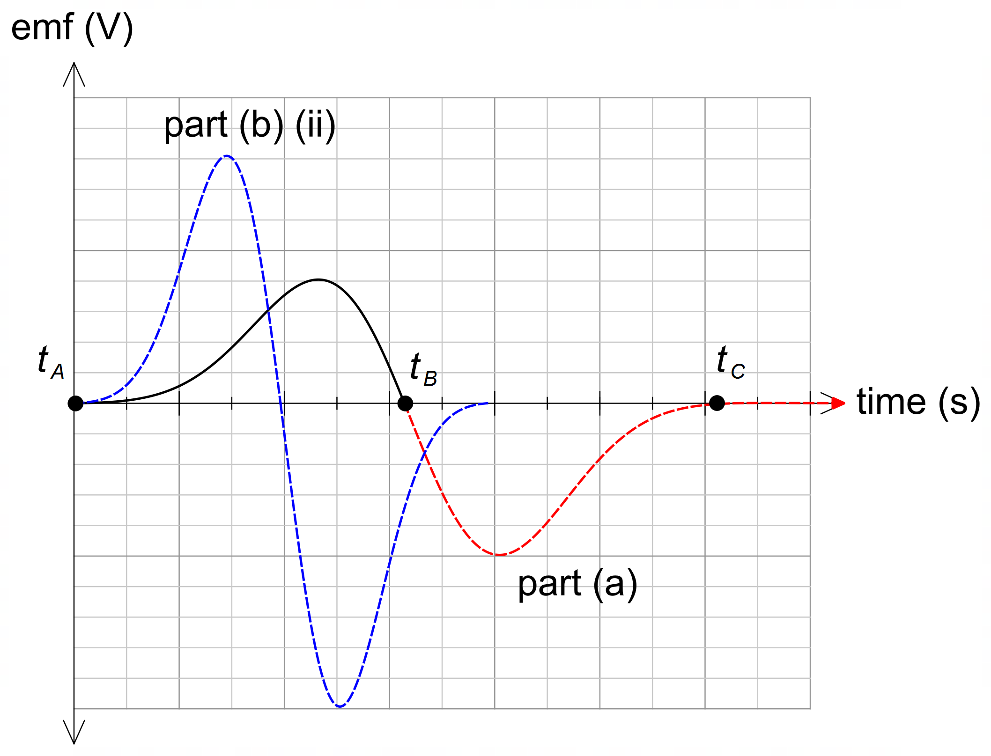

1. Complete the plot of the induced emf in the coil for the period the magnet moves between B and C. This will require you to mark and label *t C* on the graph. Ignore any effects of the Earth’s magnetic field.

|  |  |
| --- | --- |
| **Description** | **Marks** |
| Larger maximum voltage for second half between B and C compared to between A and B. | 1 |
| Time between B and C slightly shorter (due to increased velocity) than between A and B. | 1 |
| **Total** | 2 |

1. The following changes are then made to this experiment:
   1. This equipment is now placed in an external vertical magnetic field. The external magnetic field is twice the strength of the magnetic field of the magnet. With reference to relevant Physics concepts, explain the effect on the output emf.

|  |  |
| --- | --- |
| **Description** | **Marks** |
| The induced emf is proportional to the rate of change of flux due to the movement of the magnet through the coil (Faraday’s law) | 1 |
| Since the field due to the external magnetic field is constant, the output emf will be unaffected. | 1 |
| **Total** | 2 |

1. This experiment is now performed on a planet where the acceleration due to gravity is 19.6 m s–2. Draw the resulting emf output on the graph above for this location. (2 marks)

|  |  |
| --- | --- |
| **Description** | **Marks** |
| On graph in blue – twice magnitude, second half larger than first half | 1 |
| On graph in blue – reduced time in the coil | 1 |
| **Total** | 2 |

**Question 5 (3 marks)**

|  |  |
| --- | --- |
| **Description** | **Marks** |
| Polarity of both charges is positive | 1 |
|  | 1 |
| Vector drawn horizontal to the left, equal in size to *FB* | 1 |
| **Total** | 3 |

**Question 6 (6 marks)**

|  |  |
| --- | --- |
| **Description** | **Marks** |
|  | 1 |
|  | 1 |
|  | 1 |
|  | 1 – 2 |
|  | 1 |
| **Total** | 6 |

**Question 7 (3 marks)**

|  |  |
| --- | --- |
| **Description** | **Marks** |
|  | 1 |
|  | 1 |
|  | 1 |
| **Total** | 3 |

**Question 8 (4 marks)**

|  |  |
| --- | --- |
| **Description** | **Marks** |
|  | 1 |
|  | 1 |
|  | 1 |
|  | 1 |
| **Total** | 4 |

**Question 9 (7 marks)**

1. Show that the trolley accelerates up the slope at exactly 1.00 m s–2.

|  |  |
| --- | --- |
| **Description** | **Marks** |
|  | 1 – 2 |
|  | 1 – 2 |
|  | 1 – 2 |
| **Total** | 6 |

1. Unfortunately, two of the bags of cement were not attached securely and dropped off the counterweight shortly after the trolley began moving. Which of the following graphs best describes the entire journey of the trolley on the slope? Circle your answer.

|  |  |
| --- | --- |
| **Description** | **Marks** |
| Graph A | 1 |
| **Total** | 1 |

**Question 10 (7 marks)**

1. Indicate on the diagram above the direction of the current flowing in the coil.

|  |  |
| --- | --- |
| **Description** | **Marks** |
| Current is anticlockwise (D-C-B-A) | 1 |
| **Total** | 1 |

1. Calculate the magnitude of the torque on the coil when it is in the position shown.

|  |  |
| --- | --- |
| **Description** | **Marks** |
|  | 1 |
|  | 1 |
|  | 1 |
| **Total** | 3 |

1. The student notices that once the motor is turned on for a short period, it quickly maintains a constant rotational speed. Explain this observation, using relevant Physics concepts. Ignore mechanical friction.

|  |  |
| --- | --- |
| **Description** | **Marks** |
| As the speed of the coil increases, there is an induced emf (“back emf”) in the opposite direction to the coil voltage, proportional to the speed of the coil (Faraday’s law) | 1 |
| As the coil speeds up, the “back emf” increases and the net coil voltage decreases, thus decreasing the current drawn. | 1 |
| When the torque produced by the coil current is sufficient to overcome the frictional forces and drag forces, the coil will stop accelerating and rotate at a constant speed. | 1 |
| **Total** | 3 |

**Question 11 (3 marks)**

|  |  |
| --- | --- |
| **Description** | **Marks** |
|  | 1 |
|  | 1 |
| Number of turns is 1400 (max 2 sf) | 1 |
| **Total** | 3 |

**Question 12 (14 marks)**

1. Calculate the orbital speed that the spacecraft should have at the location indicated by X for it to maintain a stable orbit at an altitude of 4000 km.

|  |  |
| --- | --- |
| **Description** | **Marks** |
|  | 1 |
| Uses distance of 4000 km + 3390 km = 7390 km | 1 |
|  | 1 |
|  | 1 |
| **Total** | 4 |

1. Using your answer to part (a), given data and relevant physics concepts, explain why the Mars2021 will continue to descend from an altitude of 4000 km.

|  |  |
| --- | --- |
| **Description** | **Marks** |
|  | 1 |
| A satellite travelling slower than the stable orbital speed will fall to a lower orbit. | 1 |
| The actual speed of the spacecraft (1.95 km/s) is slower than the stable orbital speed (2.40 km/s), thus it will “fall”. | 1 |
| **Total** | 3 |

1. Use the area under the graph to estimate the change in potential energy of the spacecraft as it descends from an altitude of 4000 km to an altitude of 500 km. Show working.

|  |  |
| --- | --- |
| **Description** | **Marks** |
|  | 1 |
|  | 1 |
|  | 1 |
| **Total** | 3 |

1. Using your answer to part (c), determine the final speed of the spacecraft as it reaches an altitude of 500 km altitude. [Note: if you did not get an answer to part (c) use 5 GJ for the change in potential energy]

|  |  |
| --- | --- |
| **Description** | **Marks** |
|  | 1 |
|  | 1 |
|  | 1 |
|  | 1 |
| **Total** | 4 |

**Question 13 (15 marks)**

1. Determine the ratio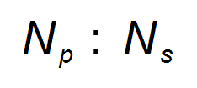in its simplest form.

|  |  |
| --- | --- |
| **Description** | **Marks** |
|  | 1 |
|  | 1 |
|  | 1 |
| **Total** | 3 |

1. Determine the number of turns of wire in the primary coil.

|  |  |
| --- | --- |
| **Description** | **Marks** |
|  | 1 |
| **Total** | 1 |

1. Determine the RMS current on the secondary side of the transformer.

|  |  |
| --- | --- |
| **Description** | **Marks** |
|  | 1 |
|  | 1 |
|  | 1 |
| **Total** | 3 |

1. State and explain one (1) possible source of power loss within non-ideal transformers.

|  |  |
| --- | --- |
| **Description** | **Marks** |
| Either  Eddy currents in the iron core OR Resistive heat loss in wires of secondary coil | 1 |
| Eddy currents in the iron core  The alternating magnetic field experienced by the iron core results in the formation of eddy currents.  These eddy currents create heat losses due to the resistance in the iron core. | 1 – 2 |
| Resistive heat-loss in wires of secondary coil  Wires, no matter which property or dimension all have some sort of resistance. Effectively they act as a resistor and therefore have some amount of power loss (voltage drop) across them. | 1 – 2 |
| **Total** | 3 |

1. With reference to the principles of electromagnetic induction and/or Faraday’s Law, explain how the voltage in the primary coil of this transformer is transformed to the stated voltage in the secondary coil.

|  |  |
| --- | --- |
| **Description** | **Marks** |
| Transformers use AC current. | 1 |
| AC implies that the associated magnetic field/flux is also continually changing (alternating) | 1 |
| This alternating magnetic field (or changing flux) occurs in both coils (since they are both connected by the iron core) | 1 |
| According to Faraday’s Law, the emf is proportional to the number of turns (N): | 1 |
| Therefore, increasing N on the secondary side will increase the induced emf (voltage) in the secondary coil. | 1 |
| **Total** | 5 |

**Question 14 (18 marks)**

1. Calculate the vertical and horizontal components of the initial speed of the water as it exits the hose. (2 marks)

|  |  |
| --- | --- |
| **Description** | **Marks** |
|  | 1 |
|  | 1 |
| **Total** | 2 |

1. Determine the height above the ground the water is being released from if the water travels a horizontal distance of 16.0 m to the far edge of the lawn.

|  |  |
| --- | --- |
| **Description** | **Marks** |
|  | 1 – 2 |
|  | 1 – 2 |
| **Total** | 4 |

1. Determine the maximum height the water reaches above the end of the hose.

|  |  |
| --- | --- |
| **Description** | **Marks** |
|  | 1 |
|  | 1 |
|  | 1 |
| **Total** | 3 |

1. Using the information in the question, draw a velocity-time graph and an acceleration-time graph for the water droplet for the period between leaving the hose and hitting the grass. Assume that upwards is a positive frame of reference. Indicate and label all key features of each graph. Ignore the effects of air resistance for this question.

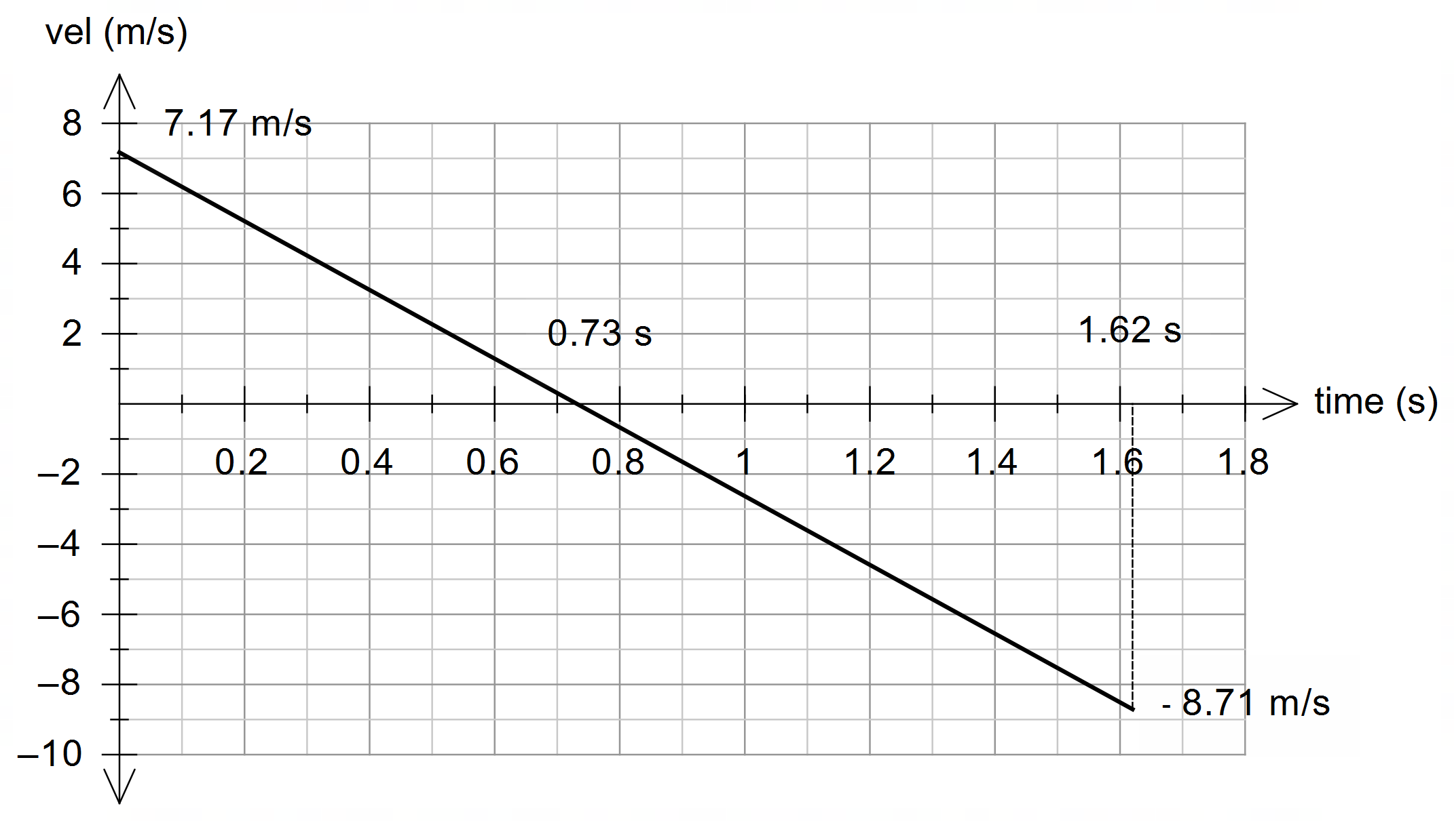

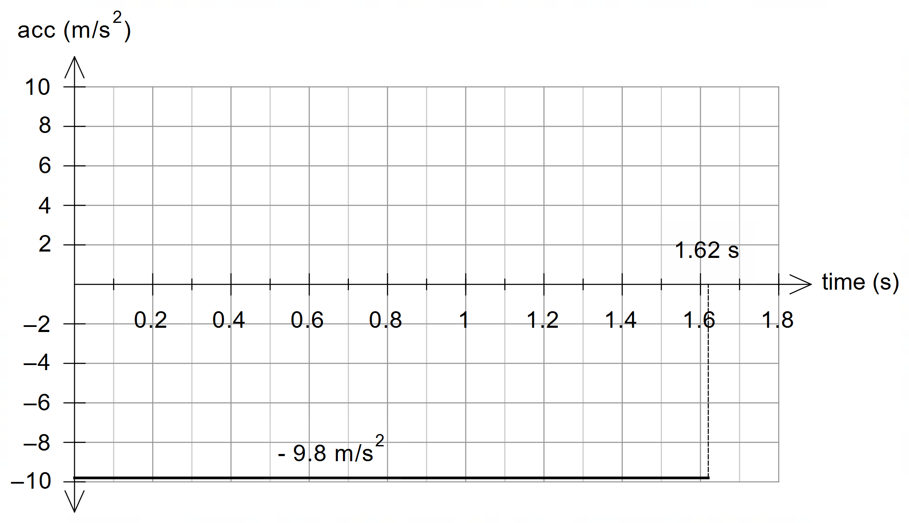

|  |  |
| --- | --- |
| **Description** | **Marks** |
| Inidcates correct initial velocity on graph (~7.2 m/s) | 1 |
| Indicates correct final velocity on graph (~8.7 m/s) | 1 |
| Indicates correct final time on graph (1.62 s) | 1 |
| Indicates correct time at which *v =* 0, 0.73 s (i.e. time of max height) | 1 |
| Velocity-time graph is linear with gradient of –9.8 m/s2 | 1 |
| Acceleration-time graph is constant at –9.8 m/s2 | 1 |
| **Total** | 6 |

1. State three (3) ways in which the motion of a water droplet exiting the hose is affected by drag force due to air resistance.

|  |  |
| --- | --- |
| **Description** | **Marks** |
| **Three of the following:** |  |
| Reduced range | 1 |
| Reduced maximum height | 1 |
| Decreased time of flight | 1 |
| Asymmetrical nature of motion (i.e. – no longer a perfectly parabolic path) | 1 |
| The horizontal velocity component decreases – no longer constant – hence reduced range | 1 |
| The vertical velocity component decreases at a greater rate – hence reduced height | 1 |
| The vertical velocity component downwards still increases but at a slower rate | 1 |
| **Total** | 3 |

**Question 15 (15 marks)**

1. On the diagram above, draw and label the electric field *E* in the region between the two plates. Draw at least four (4) field lines.

|  |  |
| --- | --- |
| **Description** | **Marks** |
| Electric field lines directed from bottom plate to top plate | 1 |
| Electric field lines should be uniform (4 or more lines shown) | 1 |
| **Total** | 2 |

1. Using convention for the direction shown in the diagram above, indicate the direction of the forces acting on the proton, due to the magnetic and electric field when the proton is first released. The first one has been done for you.

|  |  |
| --- | --- |
| **Description** | **Marks** |
| Magnetic force = INTO PAGE | 1 |
| Electric force = UP | 1 |
| **Total** | 2 |

1. Determine the magnitude and direction of the net force on the proton when it is released in the region. You may ignore gravity.

|  |  |
| --- | --- |
| **Description** | **Marks** |
|  | 1 |
|  | 1 |
|  | 1 |
|  | 1 |
|  | 1 |
| **Total** | 5 |

1. Calculate the work done by the electric field as it moves through the entire region.

|  |  |
| --- | --- |
| **Description** | **Marks** |
|  | 1 |
|  | 1 |
|  | 2 |
| **Total** | 2 |

1. An observer watching the proton being released notices that the proton begins to move upward in a spiral. It is observed that the spiral has a constant radius but an ever-increasing distance vertically between rotations. Account for this motion.

|  |  |
| --- | --- |
| **Description** | **Marks** |
|  | 1 |
|  | 1 |
|  | 1 |
|  | 1 |
| **Total** | 4 |

**Question 16 (12 marks)**

1. As the centre of the coil moves from point A to B, it experiences an average induced EMF equal to 2.50 × 10–6 V. Determine the speed of the coil.

|  |  |
| --- | --- |
| **Description** | **Marks** |
|  | 1 |
|  | 1 |
|  | 1 |
|  | 1 |
|  | 1 |
|  | 1 |
| **Total** | 6 |

1. Will the induced EMF in the coil be greater at point A or point B? Justify your choice. No calculations are needed.

|  |  |
| --- | --- |
| **Description** | **Marks** |
|  | 1 |
|  | 1 |
|  | 1 |
| **Total** | 3 |

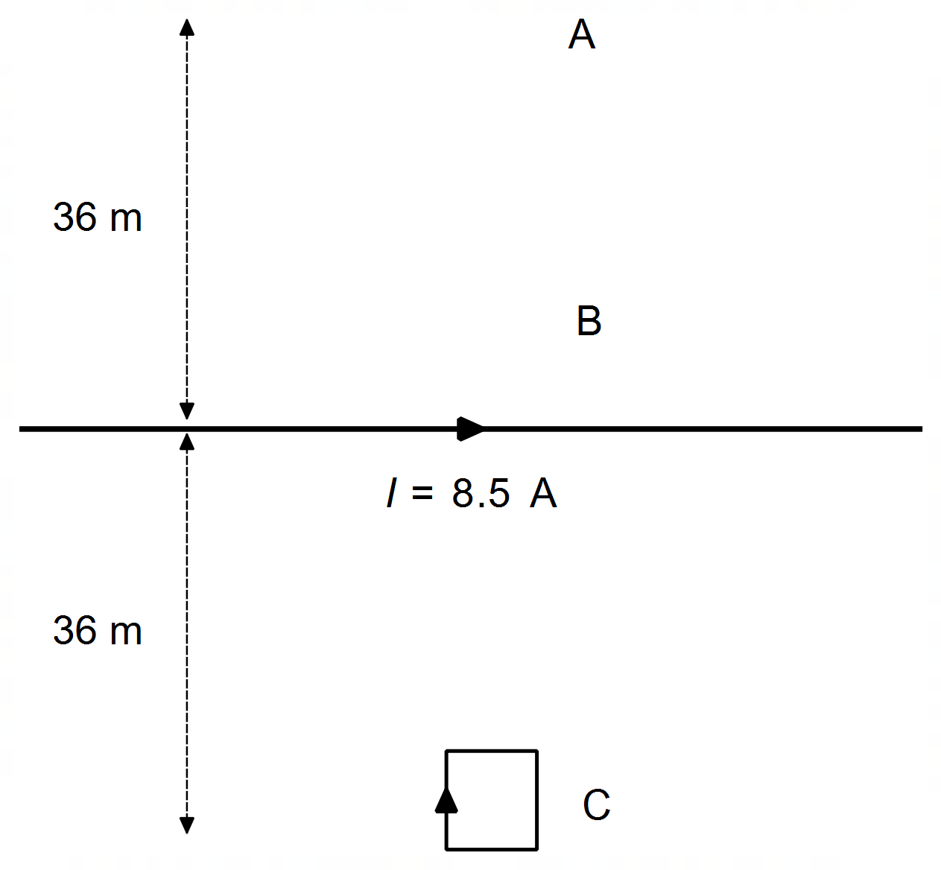

1. On the diagram above, draw the coil at point C and indicate the direction of the induced current in the coil at this location. With reference to a relevant physics concept, explain the reason you drew the current in the direction you did.

|  |  |
| --- | --- |
| **Description** | **Marks** |
|  | 1 |
|  | 1 |
|  | 1 |
| **Total** | 3 |

**Question 17 (7 marks)**

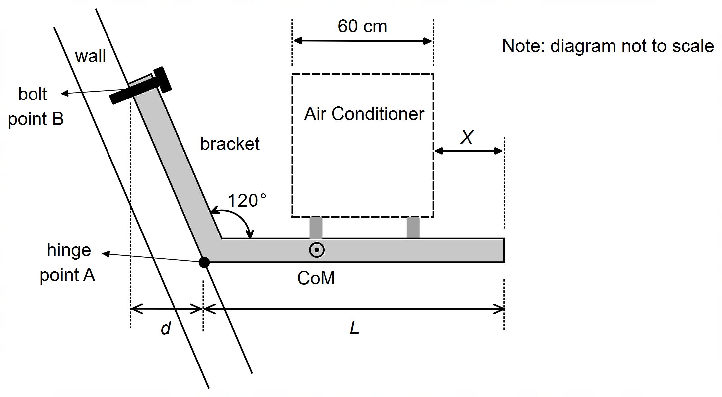

|  |  |
| --- | --- |
| **Description** | **Marks** |
|  | 1 |
|  | 1 |
|  | 1 – 2 |
|  | 1 – 2 |
|  | 1 |
| **Total** | 7 |

**Question 18 (9 marks)**

1. With reference to specific forces, explain why the string always makes an angle dipped below the horizontal when the ball is twirling horizontally?

|  |  |
| --- | --- |
| **Description** | **Marks** |
| For the net force to be exactly horizontal the vertical weight force needs to be balanced by another force – in this case the vertical component of the tension. | 1 |
| The tension force obviously also needs to provide a horizontal force, in this case, the centripetal force, causing circular motion. | 1 |
| Since both components are non-zero, the string will always be at some angle below horizontal | 1 |
| **Total** | 3 |

**Alternate Solution**

|  |  |
| --- | --- |
| **Description** | **Marks** |
| For perfect horizontal motion, there would be no vertical component of the tension | 1 |
| However, there must be a vertical weight force, which is therefore unbalanced | 1 |
| So perfect horizontal motion is not possible, and the string will always be dipped | 1 |
| **Total** | 3 |

1. Calculate θ if the mass of the ball is 1.00 × 102 grams, the ball traces a circle of 1.0 m radius and the ball passes around the teacher’s head once every second.

|  |  |
| --- | --- |
| **Description** | **Marks** |
|  | 1 |
|  | 1 |
|  | 1 |
| **Total** | 3 |

1. How would the tension in the string change if the ball were made to move faster? No calculations are necessary. Use a relevant formula to justify your response.

|  |  |
| --- | --- |
| **Description** | **Marks** |
| If the velocity increases, centripetal force will increase, | 1 |
| Thus, the horizontal component of the tension also increases | 1 |
| Since the vertical component of the tension remains unchanged (weight force), the tension will increase. | 1 |
| **Total** | 3 |

**Question 19 (18 marks)**

1. Briefly explain why a “crown elevation” road profile is not suitable for the design of a road surface where cars are travelling around a corner.

|  |  |
| --- | --- |
| **Description** | **Marks** |
|  | 1 |
|  | 1 |
| **Total** | 2 |

1. Determine the angle  for a “super elevated” road with a slope of 2.5%.

|  |  |
| --- | --- |
| **Description** | **Marks** |
|  | 1 |
| **Total** | 1 |

1. Without using equation 2, show that the maximum speed of a car navigating a corner on flat ground, with friction, is given by the expression:

|  |  |
| --- | --- |
| **Description** | **Marks** |
|  | 1 |
|  | 1 |
|  | 1 |
| **Total** | 3 |

1. Calculate the three (3) possible maximum speeds that a car could navigate a bend on a road with a radius 46 m on a normal, dry day under the three following conditions (note: if you could not determine  for part (b) then use  = 2.0°):

|  |  |
| --- | --- |
| **Description** | **Marks** |
|  | 1 |
|  | 1 |
|  | 1 |
|  | 1 |
| **Total** | 4 |

1. A sports car is navigating a racecourse with seven bends which are all on flat ground. The driver of the sports car drives as fast as possible without their car skidding around each corner. For each bend, the radius; the maximum velocity; and the square root of radius are listed in the table below.

|  |  |  |  |
| --- | --- | --- | --- |
| **Corner** | **Radius *r* (m)** | **Velocity *v* (m s-1)** |  |
| 1 | 19.1 | 12.5 | 4.37 |
| 2 | 8.30 | 8.90 | 2.88 |
| 3 | 41.5 | 18.0 | 6.44 |
| 4 | 68.0 | 23.4 | 8.25 |
| 5 | 31.5 | 16.7 | 5.61 |
| 6 | 114 | 31.0 | 10.7 |
| 7 | 54.0 | 20.7 | 7.35 |

1. Use the information in the table to graph the velocity v versus the square root of radius on the set of axes provided below. Draw a line of best fit.

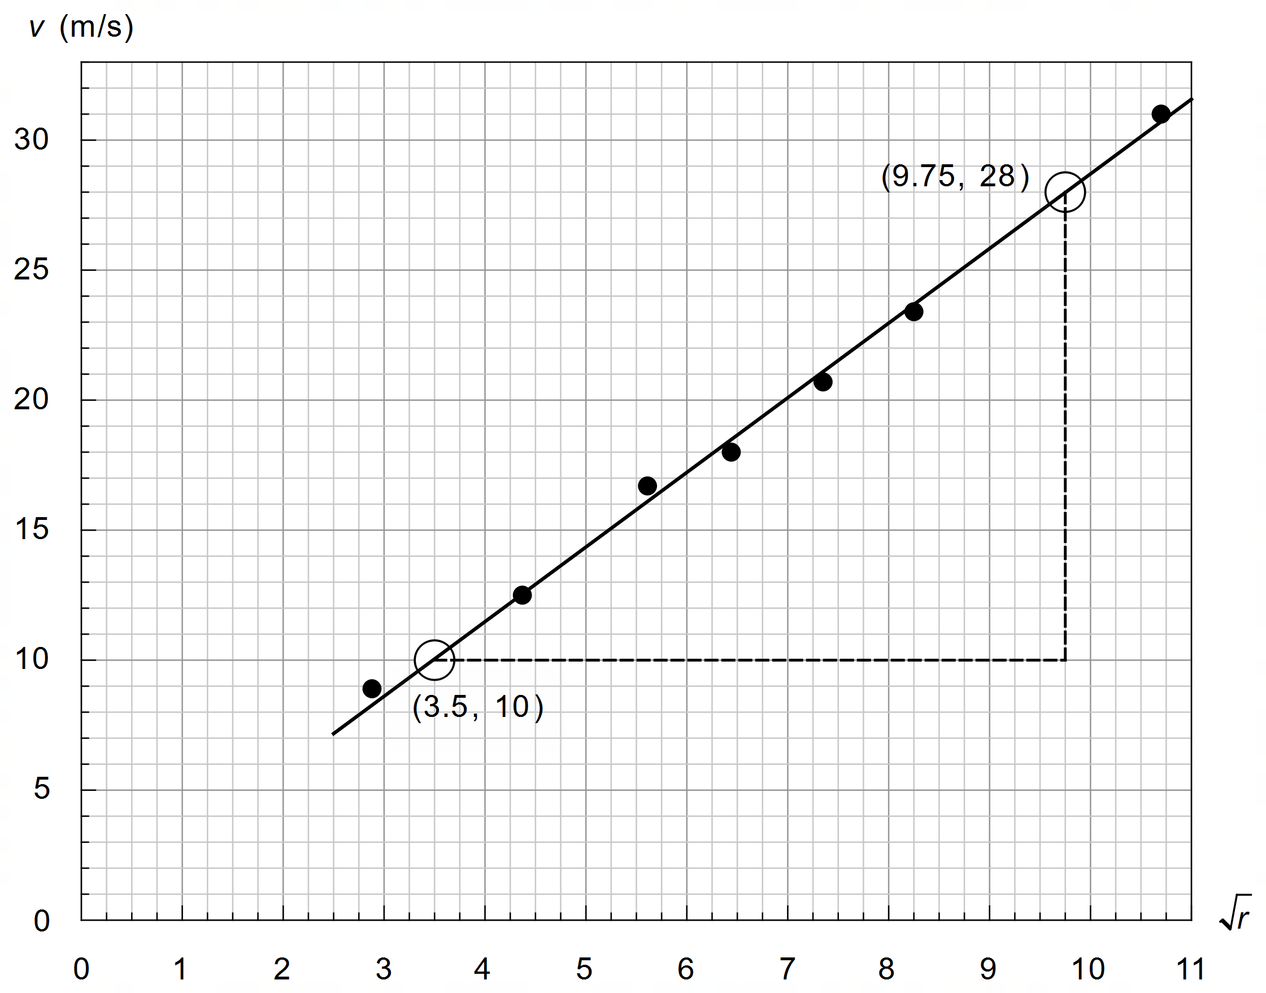

|  |  |
| --- | --- |
| **Description** | **Marks** |
|  | 1 |
|  | 1 |
|  | 1 |
| **Total** | 3 |

1. Determine the gradient for your line of best fit and use it to estimate a value for the coefficient of friction µ on the racecourse. Indicate clearly how you used your graph to calculate the gradient. Give your answer to an appropriate number of significant figures. Based on your result, explain the likely conditions of the road that day.

|  |  |
| --- | --- |
| **Description** | **Marks** |
|  | 1 |
|  | 1 |
|  | 1 |
|  | 1 |
|  | 1 |
| **Total** | 5 |

**Question 20 (18 marks)**

**Galvanometers**

1. On Figure 4 indicate the direction of the torque provided by the coil.

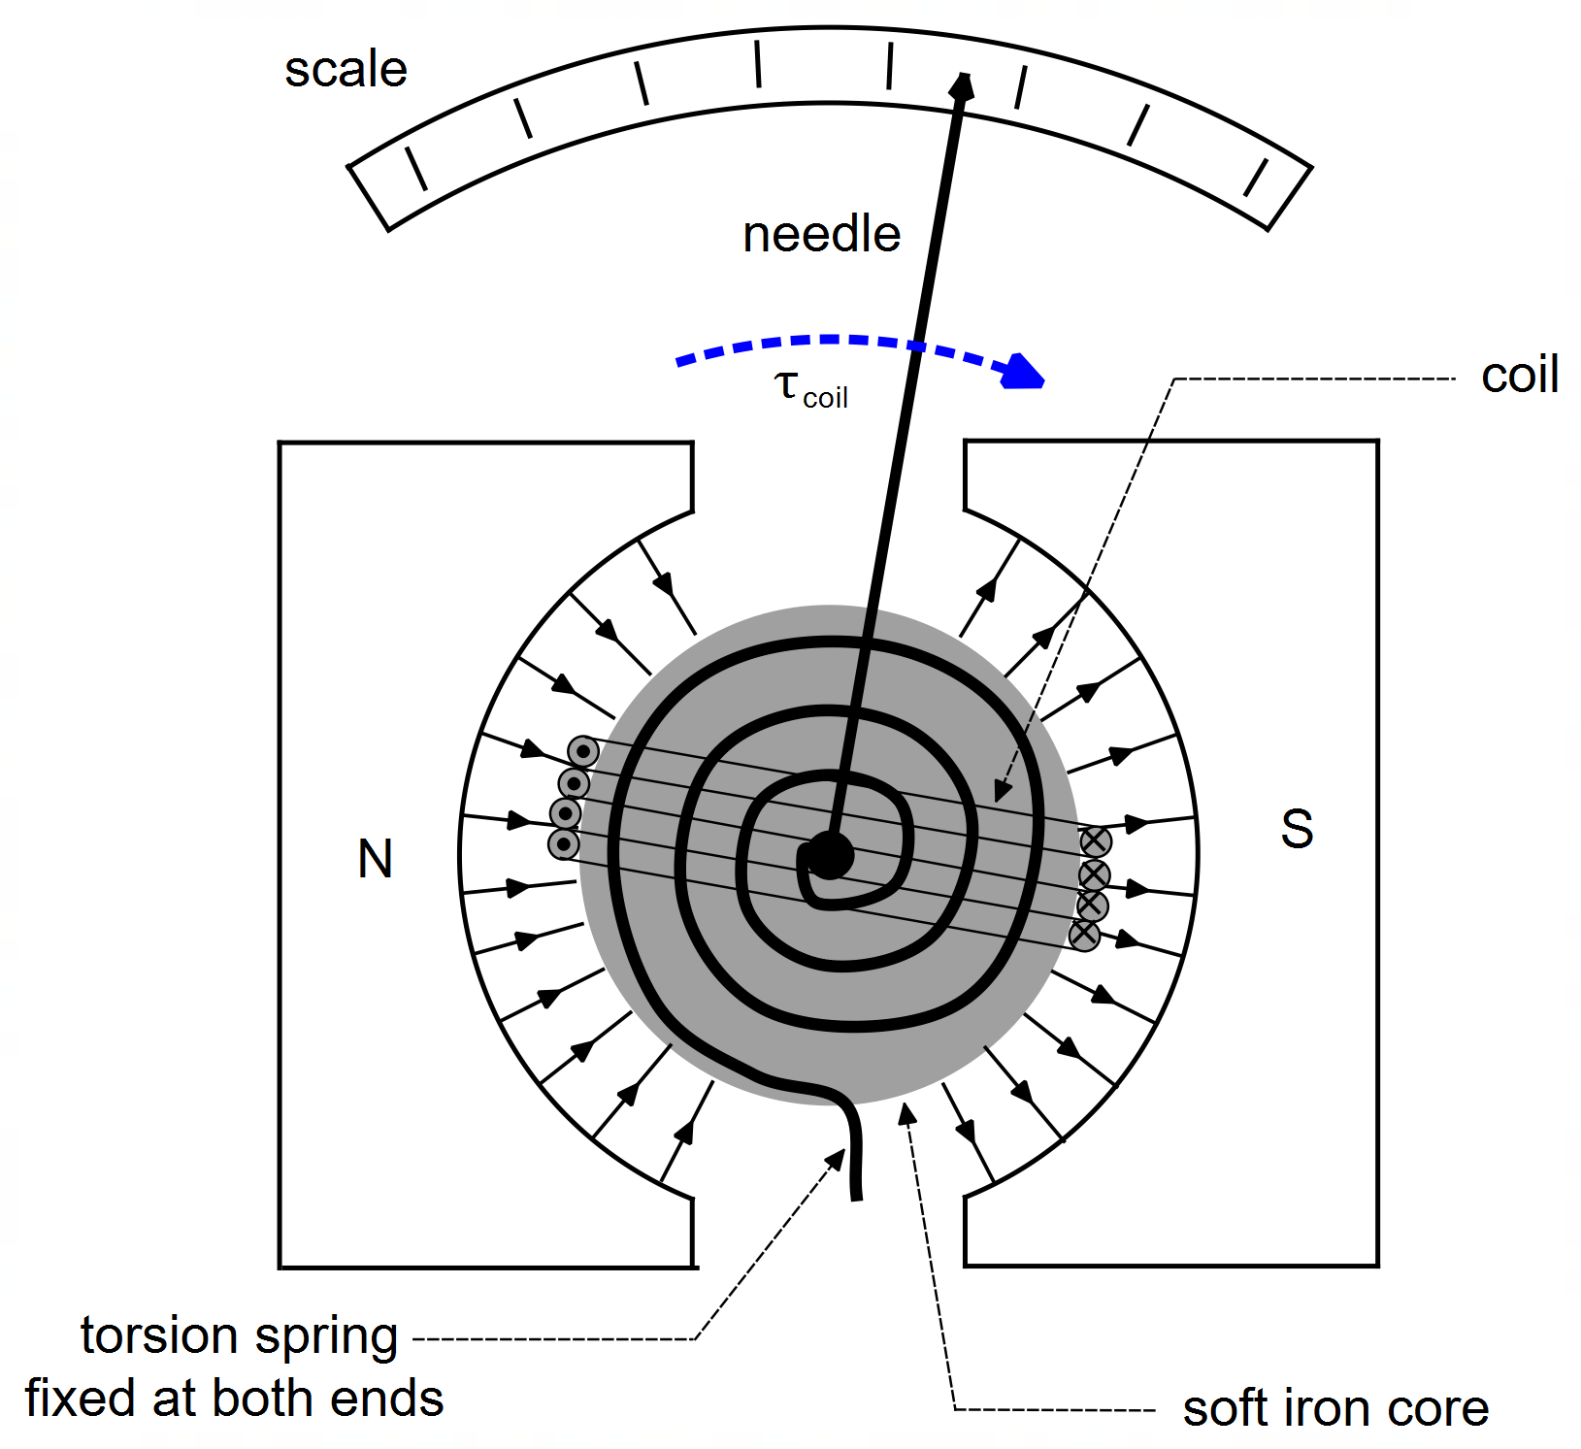

|  |  |
| --- | --- |
| **Description** | **Marks** |
| Torque acting in a clockwise direction on diagram. | 1 |
| **Total** | 1 |

1. Explain the importance of the circular shape of the permanent magnets.

|  |  |
| --- | --- |
| **Description** | **Marks** |
|  | 1 |
|  | 1 |
|  | 1 |
| **Total** | 3 |

1. State two (2) likely sources of an inaccurate reading when using a galvanometer.

|  |  |
| --- | --- |
| **Description** | **Marks** |
| Stiffness of the spring is not constant | 1 |
| The magnetic field between the poles and core is not uniform (or not circular in shape) | 1 |
| **Total** | 2 |

1. With reference to relevant physics concepts, explain how eddy currents in the metal core help the needle of DC galvanometer to quickly come to a reading without vibrating back and forth?

|  |  |
| --- | --- |
| **Description** | **Marks** |
|  | 1 |
|  | 1 |
|  | 1 |
|  | 1 |
| **Total** | 4 |

1. Ideally, the angle of deviation of the needle of a galvanometer should be directly proportional to the current in the coil. In other words: Use equation 3 to determine an expression for the constant *C*.

|  |  |
| --- | --- |
| **Description** | **Marks** |
|  | 1 |
|  | 1 |
| **Total** | 2 |

1. A certain galvanometer has a rectangular 3.0 cm by 4.0 cm coil wrapped around a soft iron metal core. The core is attached to a torsion spring with stiffness *k* = 3.50 × 10-3 Nm per °. The coil and core arrangement sit in the region between two circular magnetic poles with a magnetic field strength of 550 mT. The coil has 38 turns of wire.
2. Determine the angle the needle deviates when a known current of 1.76 A passes through the coil.

|  |  |
| --- | --- |
| **Description** | **Marks** |
|  | 1 |
|  | 1 |
|  | 1 |
| **Total** | 3 |

1. Unfortunately, the scale on the galvanometer is no longer legible. An unknown current is passed through the device such that the needle deviates exactly three divisions, through an angle of 21.5°. How much current (A) is represented by each division on the scale?

|  |  |
| --- | --- |
| **Description** | **Marks** |
|  | 1 |
|  | 1 |
|  | 1 |
| **Total** | 3 |

Alternatively:

|  |  |
| --- | --- |
| **Description** | **Marks** |
|  | 1 |
|  | 1 |
|  | 1 |
| **Total** | 3 |

**END OF EXAMINATION**