Letter

STUDENT

NUMBER

|  |  |  |  |  |  |  |  |
| --- | --- | --- | --- | --- | --- | --- | --- |
|  |  |  |  |  |  |  |  |

|  |
| --- |
|  |

**ACCOUNTING UNITS 3 & 4**

2020

**TRIAL EXAM B**

Reading time: 15 minutes

Writing time: 2 hours

**QUESTION BOOK**

Structure of book

**Students are NOT permitted to bring mobile phones and/or any other unauthorised electronic devices into the examination room**

• Students are permitted to bring into the examination room: pens, pencils, highlighters, erasers, sharpeners, rulers and one scientific calculator.

• Students are NOT permitted to bring into the examination room: blank sheets of paper and/or correction fluid/tape

**Materials supplied**

• Question book of 11 pages

• Answer book of 14 pages

**Instructions**

• Write your student number in the space provided on the front cover of the answer book.

• Answer all questions in the answer book.

• All written responses must be in English.

At the end of the examination

* • You may keep this question book.

|  |  |  |
| --- | --- | --- |
| *Number of questions* | *Number of questions to be answered* | *Number of marks* |
| 9 | 10 | 100 |

**Question 1** (12 marks)

Georgie’s Music sells musical instruments to customers from their Smith St shop front. Sales are on both cash and credit. The following information relates to Accounts Receivable for December 2020.

* The opening balance on 1 December 2020 was $17 000
* The closing balance on 31 December 2020 was $17 300
* Receipts from Accounts Receivable during July 2019 were $21 540
* Discount Revenue was $540
* Discount Expense was $380
* Sales returns during July were $1 300 excluding GST.
* $550 was written off as a Bad Debt on 19 December 2020

**a.** Using the information provided, reconstruct the Accounts Receivable ledger account to determine the Credit Sales for December 2020. 7 marks

**b.** With reference to one accounting assumption, explain the effect of the Bad Debt being written on the net profit for the period ended 31 December 2020.

3 marks

**c.** Describe a strategy that Georgie’s Music could adopt to decrease the amount of Bad Debts written off.

2 marks

**Question 2** (11 marks)

Snowy’s Skiwear prepared a Trial Balance at the end of June 2020. However the accountant noticed an entry of $1 500 in the Drawings account that should have been recorded as Advertising (Memo 41)

**a.** Prepare the General Journal entry to correct this error. A narration is required.

3 marks

**b.** Describe the effects this entry would have on Owners Equity

2 marks

Snowy’s Skiwear’s debt ratio for 2019 and 2020 can be determined from the graphs below.

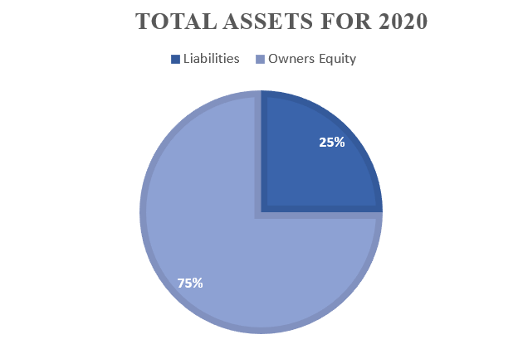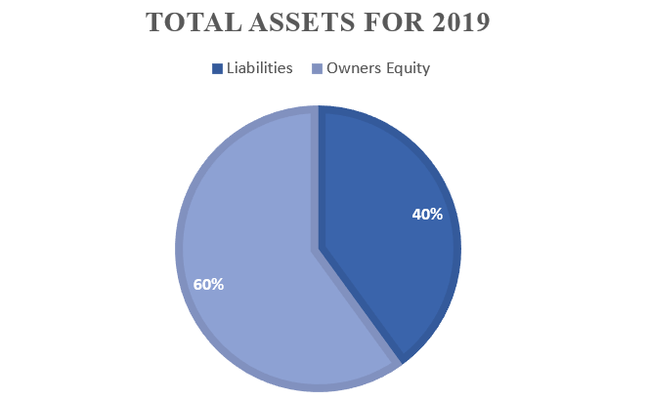

**c.** Referring the change in debt ratio, **explain** the implications for Snowy’s Skiwear’s profitability and liquidity.

4 marks

**d.** State **two** items of non-financial information that Snowy’s Skiwear could use to evaluate performance.

2 marks

**Question 3** (11 marks)

Lisa’s Carpets sells and installs carpet on credit to its customers. They require the deposit to be paid at time of ordering. The remaining amount is invoiced once the carpet is installed.

The following transactions relate to an order received from Rising Sun Pty Ltd. The order was for 75 square metres of plush carpet. Lisa’s Carpets charges $100 (plus GST) per square metre including installation. The per unit cost price of a square metre of plush carpet in the inventory card is $30. Lisa’s Carpets offers its customers credit terms of 4/10 n/30.

* 11 October 2020 – Deposit paid by Rising Sun Pty Ltd of $2 000 (EFT Receipt 123)
* 22 October 2020 – Carpet installed to Rising Sun Pty Ltd (Invoice OO311)
* 31 October 2020 – Rising Sun Pty Ltd paid the account in full taking advantage of the discount offered (Rec 75)

**a.** Prepare the journal entries required to record the transactions above. Narrations are **not** required.

6 marks

**b.** Explain why discount expense is reported as an expense.

2 marks

**c.** Explain the effects on the accounting equation if the transaction on 11 October was not recorded.

3 marks

**Question 4** (11 marks)

Draper’s Boutique sells high end menswear. The following is an extract of the Trial Balance as at 31 December 2020:

|  |  |  |
| --- | --- | --- |
|  | **Debit** | **Credit** |
| Accounts Payable – Stirling |  | 23 000 |
| Accounts Receivable – Cooper | 28 000 |  |
| Interest Expense | 500 |  |
| Cost of Sales | 123 000 |  |
| Customs Duty | 300 |  |
| Wages | 12 000 |  |
| GST Clearing |  | 6 700 |
| Loss on Disposal of Vehicle | 8 000 |  |
| Inventory Gain |  | 600 |
| Sales |  | 320 000 |
| Sales Returns | 1 500 |  |
| Bad Debts | 400 |  |

**a.** Using the information provided, use the General Journal to;

* close all the revenue and expense accounts
* close the Profit and Loss Summary account
* transfer drawings to the Capital accounts

Narrations are **not** required.

8 marks

**b.** With reference to an Accounting Assumption, explain why revenue and expense accounts are closed.

3 marks

**Question 5** (12 marks)

Evans Bikes sells bicycles and cycling accessories. The Downhill Racer is sold for $460 plus GST

|  |  |  |  |  |  |  |  |  |  |  |
| --- | --- | --- | --- | --- | --- | --- | --- | --- | --- | --- |
| **Product: Downhill Racer**  **Cost Assignment Method: Identified Cost** | | | | | | | | | | |
| **Date** | **Details** | **IN** | | | **OUT** | | | **BALANCE** | | |
| **Qty** | **Cost** | **Total** | **Qty** | **Cost** | **Total** | **Qty** | **Cost** | **Total** |
| **1 Apr** | **Balance** |  |  |  |  |  |  | **3** | **220** | **660** |
| **6 Apr** | **Inv 45** |  |  |  | **1** | **220** | **220** | **2** | **220** | **440** |
|  |  |  |  |  |  |  |  |  |  |  |

|  |  |  |  |
| --- | --- | --- | --- |
| **Perry Bike Distributors**  22 Yarra St, Heidelberg VIC 3085  ABN: 33 041 413 066 | | | |
| Evans Bikes  220 Princes Highway, Dandenong, 3175  ABN: 22 626 971 023 | | **Tax invoice 270**  9 April 2020  Terms: n/30 | |
| **Item** | **Quantity** | **Unit Price** | **Total** |
| Downhill Racer | 2 | 215 | 430 |
| Elite Racer | 5 | 300 | 1 500 |
| Assembly of bike | 7 | 10 | 70 |
| Freight |  |  | 50 |
| GST (10%) |  |  | 205 |
| **Total** | | | **2 255** |

**Additional information:**

* 8 April, a customer M Snowball returned one Downhill Racer (CN 12)
* On 15 May, due to the onset of winter and the end of the cycling season, it was decided to reduce the selling price of the Downhill Racer to $250. As a promotion, every Downhill Racer will come with a free helmet valued at $35 (Memo 8)

**a.** Complete the inventory card using the information provided. 3 marks

**b.** Justify your treatment of the Assembly of bike cost from 9 April.

2 marks

**c.** Calculate the Net Realisable Value of one Downhill Racer Bike on the 15 May 2020.

1 mark

**d.** Record the transaction from 15 May 2020 in the General Journal of Evans Bikes. A narration **is** required.

3 marks

**e.** With reference to one qualitative characteristic, explain your treatment of the transaction on 15 May 2020.

3 marks

**Question 6** (8 marks)

Bella’s Music has provided the following information relating to the years ending 31 December.

|  |  |  |
| --- | --- | --- |
|  | **2019** | **2020** |
| Inventory Turnover | 87 days | 75 days |
| Accounts Payable Turnover | 25 days | 38 days |

**a.** Describe the change/trend in Accounts Payable Turnover from 2019 to 2020.

2 marks

**b.** Provide **one** possible reason for this change in Accounts Payable Turnover.

1 mark

**c.** Identify **one** positive and **one** negative effect that the change in Accounts Payable Turnover could have on Bella’s Music.

2 marks

**d.** The owner believes that the change in Inventory Turnover should lead to an increase in gross profit.

Do you agree with the owner? Explain.

3 marks

**Question 7** (17 marks)

Perry Plumbing is a sole trading plumbing enterprise who report on 31 December each year. Recently, Perry Plumbing decided to upgrade so they purchased a new vehicle. Details of the purchase are below. To fund the purchase, Perry Plumbing took out a loan of $30 400 from Eastpac Bank. These proceeds were received on 26 December 2019.

|  |  |  |
| --- | --- | --- |
| **Truckin’ Good Autos**  22 Grace St, Carlton VIC 3053  ABN: 11 049 411 049 | | |
| Perry Plumbing  15 Edgar Street, Essendon, 3041  ABN: 22 654 885 001 | | **Tax invoice 107**  1 January 2020  Terms: Cash |
| **Item** | **Quantity** | **Unit Price**  **Total** |
| Steward Utility Vehicle | 1 | 42,000 |
| Roof Rack | 1 | 1 400 |
| 12 months registration | 1 | 600 |
| GST (10%) |  | 4 400 |
| Invoice Price |  | 48 400 |
| Less: Trade In |  | 18 000 |
| **Balance Paid: 30 400** | | |
|  | | |

Additional Information

|  |  |  |
| --- | --- | --- |
| **Balance Sheet as at 31 December 2019 (extract)** | | |
| Vehicle | 36 000 |  |
| Less Accumulated Depreciation – Vehicle | 18 500 |  |
|  |  | 17 500 |

* The $30 400 paid on 1 January 2020 was paid with cheque 142
* The new vehicle will be depreciated at 15% per annum using the reducing balance method of depreciation

Required

**a.** Prepare the General Journal entries to record the purchase of the van financed by the loan. A narration **is** required for the purchase of the van entry.

7 marks

**b.** Show how the Gain or Loss on Disposal of Vehicle would appear in the Income Statement of Perry’s Plumbing for the year ended 31 December 2020.

2 marks

**c.** Explain how the Gain or Loss on Disposal of Vehicle occurred.

3 marks

**d.** Justify the decision to use the reducing balance method of depreciation for the vehicle instead of the straight-line method of depreciation.

2 marks

**e.** Model the effect on Net Profit for the year ended 31 December 2020 if Perry’s Plumbing had depreciated the vehicle at 15% using the straight-line method.

3 marks

**Question 8** (9 marks)

Armstrong Pty Ltd imports and sells electronic goods. They have provided you with the following information.

**Income Statement (extract) for the month ended 30 November 2020**

|  |  |  |
| --- | --- | --- |
|  | **$** | **$** |
| **Gross Profit** |  | **10 000** |
| add Inventory gain | 500 |  |
| **Adjusted Gross Profit** |  | **10 500** |
| **add Other revenues** |  |  |
| Interest Revenue | 1 000 |  |

**Balance Sheet (extract) as at 30 November 2020**

|  |  |  |
| --- | --- | --- |
| **Current Assets** | **31 Oct 2020** | **30 Nov 2020** |
| Cash at Bank | 4 500 | 3 000 |
| Inventory | 12 000 | 13 000 |
| Accrued Interest | 11 500 | 500 |
| **Non-current Assets** |  |  |
| Term Deposit | 120 000 | 120 000 |

**Additional Information**

* The term deposit was taken out on 15 November 2017. The agreement with the bank states that interest will be paid annually on 15 November for the life of the term deposit.

**a.** Show how the Accrued Interest Revenue account would appear in the General Ledger at 30 November 2020 after the above information has been recorded and prepare the account for the next period.

4 marks

**b.** Calculate the annual rate of interest earned on the term deposit.

2 marks

**c.** Explain the treatment of Accrued Interest at 30 November 2020.

3 marks

**Question 9** (9 marks)

Margie’s Machinery sells mining equipment. Sales are on cash and credit. The nature of the industry is low sales volumes but high dollar value. They have provided the following General Ledger account for January 2020.

|  |  |  |  |  |  |
| --- | --- | --- | --- | --- | --- |
| **Bank** | | | | | |
| **Date** | **Cross Reference** | **Amount** | **Date** | **Cross Reference** | **Amount** |
|  |  |  |  |  |  |
| 1-Jan | Balance | 12 000 | 15-Jan | Inventory / GST Clearing | 165 000 |
| 8 Jan | Loan – Eastpac | 150 000 |  | Electricity / GST Clearing | 1 100 |
| 21 Jan | Sales / GST Clearing | 275 000 |  | Rent | 3 000 |
|  |  |  |  | Wages | 67 900 |
|  |  |  | 31 Jan | Drawings | 185 000 |
|  |  |  |  | Balance | 15 000 |
|  |  | **437 000** |  |  | **437 000** |
| 1 Feb | Balance | 15 000 |  |  |  |

**a.** Prepare the Cash Flow Statement for January 2020

6 marks

**b.** Discuss whether Margie’s Machinery should be concerned with their cash position at 31 January 2020.

3 marks

**END OF QUESTION BOOK**