**Student Name:**

**PES**

**2021 ACCOUNTING UNIT 4**

## Outcome 1

## EXTENSION OF RECORDING AND REPORTING

**QUESTION BOOK**

**Structure of book**

|  |  |  |
| --- | --- | --- |
| *Number of*  *Questions* | *Number of questions*  *to be answered* | *Number of*  *marks* |
| 5 | 5 | 50 |

* Students are permitted to bring into the SAC room: pens, pencils, highlighters, erasers, sharpeners, rulers and one scientific calculator.
* Students are NOT permitted to bring into the SAC room: blank sheets of paper and/or white out liquid/tape.

**Materials supplied**

* Question Book of 5 pages.
* Answer Book of 9 pages.

**Instructions**

* Write your name and your teacher’s name in the space provided on the front page of both this Question Book and the Answer Book.
* Answer all questions in the Answer Book.

**At the end of the task**

* Place this Question Book on top of the Answer Book and wait for both to be collected.

**Students are not permitted to bring mobile phones and/or any other unauthorised electronic devices into the SAC room.**

**Question 1 (8 marks)**

Monique owns and operates Mon’s Mats, a business that sells assorted mats to the public.

The business prepares monthly reports. Wages are paid on the first Friday of the month at $450 per day, from Monday to Friday. Next payment is due on Friday 2 July 2021. A pay rise of 10% per day applies from 1 July 2021.

|  |
| --- |
| **Memo: 0084** |
| **To:** *Accounts Dept* |
| **From:** *Monique* |
| **Date:** *30 June 2021* |
| **Re:** *BDAs* |
| *Record the necessary adjustment for Wages.* |

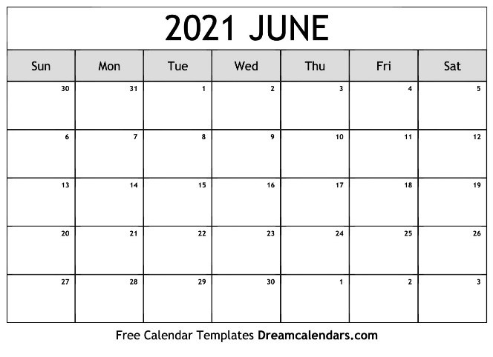

1. Using the information provided calculate the following Wages values.
2. Accrued Wages at 30 June 2021 1 mark
3. Wages expense as at 30 June 2021 1 mark
4. Wages paid on 2 July 2021 1 mark
5. Record the relevant information for the month ended 30 June 2021 in the Wages account.

You are required to complete this account.

3 marks

1. With reference to an accounting assumption explain the purpose of preparing the adjusting entry for Wages on 30 June 2021

2 marks

**Question 2 (8 marks)**

Econoworld purchased a Motor Vehicle for $27 500 including GST in 2015. On 30 June 2021 the business traded in the Motor Vehicle for $3 000 on a new Motor Vehicle which cost $32 000 plus GST. At the time of the trade-in the carrying value of the Motor Vehicle was $3 700. The business financed the purchase of the new Motor Vehicle with a Loan from WC Bank.

Prepare the General Journal entries required to record the Disposal and purchase of the Motor Vehicle on 30 June 2021.

**Question 3 (13 marks)**

At 1st January 2021 Linda’s Lamps had a balance in the Allowance for Doubtful Debts account of $550. At 31st May 2021 the business was notified that A. Akroyd was declared bankrupt and would only be able to pay 10% of his outstanding debt of $4 950. A cheque for the amount paid was received at this date.

1. Record the necessary General Journal entries required at 31st May 2021.

4 marks

During the period the business generated $120 000 sales of which 60% were on credit, sales returns for the period were $3 600. The business calculates their allowance for doubtful debts at 2% of net credit sales. The Accounts Receivable balance at the 30 June 2021 was $67 050

1. Show the Allowance for Doubtful Debts Account in the General Ledger at 30 June 2021.

3 marks

1. Show how the Accounts Receivable would be reported in the Balance Sheet as at 30 June 2021. 2 marks

The owner is wanting to apply for a loan to undertake some business expansion during July and is concerned that the bank will not look favorably on the Allowance provided for Doubtful Debts.

1. Explain the ethical implications if the owner were to remove the Allowance for Doubtful Debts from the accounting reports.

4 marks

**Question 4 (16 marks)**

Courtney Colt owns and operates Courtney’s Vintage Clothing, a small business selling retro clothing. The business applies a 100% mark-up on inventory.

The accountant provided the following Pre-Adjustment Trial Balance (extract) as at 31 March 2021.

**Courtney’s Vintage Clothing**

**Pre-Adjustment Trial Balance (extract) as at 31 March 2021**

|  |  |  |
| --- | --- | --- |
| **Account** | **Debit** | **Credit** |
| Prepaid Rent Expense | 9 600 |  |
| Inventory | 24 900 |  |
| Wages | 8 900 |  |
| Unearned Sales Revenue |  | 1 000 |
| Term Deposit | 24 000 |  |

The accountant also noted the following.

* Reports are prepared on a quarterly basis.
* The unearned sales revenue relates to a deposit received from Olden Days. On 10 March 2021 the business delivered and invoiced Olden Days with the balance owing on their order for retro clothing for $3 200 plus GST on the full value of the sale.
* The business invested cash in a 24-month term deposit on 1 February 2021, which is earning 3% per annum. The interest is payable annually on 30th June.
* On 16 March 2021 Courtney took three t-shirts from the store as a gift for her son’s teacher’s birthday. These t-shirts cost the business $30 plus GST each and were to sell for $60 plus GST each. This transaction has not yet been recorded.
* Rent is paid six months in advance on 1 February and 1 August each year. The payment made on 1 February 2021 was $8 400 plus GST.
* The stocktake determined $25 580 worth of inventory on hand as at 31 March 2021.

1. Reconstruct the Prepaid Rent Expense account to determine the Rent Expense incurred for the period. 3 marks
2. Prepare the General Journal entries required as at 31 March 2021. 10 marks

On 30 June 2021 the business received the interest on their Term Deposit.

1. Explain the impact of the receipt of the interest on the financial reports.

3 marks

**Question 5 (4 marks)**

|  |  |  |
| --- | --- | --- |
| **Depreciation of Equipment** | **Straight Line** | **Reducing Balance** |
| Year 1 | 500 | 750 |
| Year 2 | 500 | 600 |
| Year 3 | 500 | 450 |
| Year 4 | 500 | 300 |

Based on the information provided by the accountant the owner has decided to proceed with the reducing balance method for depreciating the Equipment as the expense decreases over time so Net Profit will be higher.

Evaluate the owner’s decision to use the reducing balance method to depreciate the Equipment.

**END OF QUESTION BOOK**