

**VCE Unit 1** **Business Management**

**Semester 1 2018**

**Question and Answer Booklet**

**STUDENT NAME: _________________________________________________**

**TEACHER(S):** Mrs. Monique McCorry Ms Emerson-Drake

**TIME ALLOWED: Reading time**  **minutes**

**Writing time**  **minutes**

**INSTRUCTIONS**

|  |
| --- |
| **You are not permitted to use notes, texts or a dictionary.**  **You are to answer each question in space provided.**  **Do not write in pencil.** |

**STRUCTURE OF BOOKLET / MARKING SCHEME**

|  |  |  |
| --- | --- | --- |
| Section Number of questions | Number of questions to be answered | Number of marks |
| A 2  B 1 | 2  1 | 38  17  Total 55 |

**SECTION A**

**Instructions for Section A**

Answer **all** questions in the spaces provided.

**Question 1 (27 marks)**

Rose recently moved into her inner-city Melbourne apartment and was shopping for furniture to fit the small space. She spent many weekends going to homemaker centres and shopping outlets looking for suitable, stylish furniture but could not find anything. Rose decided that she had identified a ‘gap in the market’ so began ‘Small Spaces’ – a business specialising in interior design concepts for apartments.

1. Outline the personal motivation behind Rose wanting to start ‘Small Spaces’ 2 marks

|  |
| --- |
|  |
|  |
|  |
|  |
|  |
|  |
|  |

1. Describe why it is important for Rose to set goals before starting her new business. 1 mark

|  |
| --- |
|  |
|  |
|  |

1. Once the business becomes established, Rose plans to employ two full-time staff members. Explain how Rose’s business contributes to the economy through employment and taxation revenue. 2 marks

|  |
| --- |
|  |
|  |
|  |
|  |
|  |
|  |
|  |

1. Explain how societal attitudes and behaviour will affect the business planning that Rose will need to undertake. 2 marks

|  |
| --- |
|  |
|  |
|  |
|  |
|  |
|  |
|  |

1. Describe what decisions Rose will need to make when organising the supply chain for this business. 3 marks

|  |
| --- |
|  |
|  |
|  |
|  |
|  |
|  |
|  |
|  |
|  |
|  |
|  |

1. Whilst there is a limited range of small furniture stores in Melbourne, Rose will still need to compete with overseas competitors. Explain why overseas competitors need to be considered by business owners during the planning stage. 2 marks

|  |
| --- |
|  |
|  |
|  |
|  |
|  |
|  |
|  |

1. The location of ‘Small Spaces’ will determine whether or not the business is known and accessible to potential customers. Recommend one suitable location for ‘Small Spaces’.   
   In your answer, explain two factors that will affect the choice of location. 5 marks

|  |
| --- |
|  |
|  |
|  |
|  |
|  |
|  |
|  |
|  |
|  |
|  |
|  |
|  |
|  |
|  |
|  |
|  |
|  |
|  |

1. Rose has decided to establish her own business. Discuss this possible business venture. 4 marks

|  |
| --- |
|  |
|  |
|  |
|  |
|  |
|  |
|  |
|  |
|  |
|  |
|  |
|  |
|  |
|  |

1. Rose needs to determine her sources of finance. Describe one short-term and one long-term finance option. Explain one item that Rose would buy with each of these options. 4 marks

|  |
| --- |
|  |
|  |
|  |
|  |
|  |
|  |
|  |
|  |
|  |
|  |
|  |
|  |
|  |
|  |

1. Outline one entrepreneurial characteristic and one managerial characteristic that would contribute to Rose’s success. 2 marks

|  |
| --- |
|  |
|  |
|  |
|  |
|  |
|  |
|  |

**Question 2 (11 marks)**

IKEA is an international retailer in home furnishings, recognised for its Scandinavian style. It is now the world’s largest furniture retailer. The majority of IKEA’s furniture is sold as a flat-pack, which is then assembled by the consumer. This allows for reduced costs of assembling the furniture, storage and packing. IKEA sells stock through its 373 stores in 47 countries plus online stores.

1. Describe each of the following types of business models: 2 marks
   * 1. online business

|  |
| --- |
|  |
|  |
|  |

ii. bricks and mortar business

|  |
| --- |
|  |
|  |
|  |

1. Explain the purpose of a SWOT analysis, outlining how IKEA would use this planning tool. 3 marks

|  |
| --- |
|  |
|  |
|  |
|  |
|  |
|  |
|  |
|  |
|  |
|  |
|  |

1. Evaluate each type of business model stated in part a. and recommend the best option for future IKEA trading. 6 marks

|  |
| --- |
|  |
|  |
|  |
|  |
|  |
|  |
|  |
|  |
|  |
|  |
|  |
|  |
|  |
|  |
|  |
|  |
|  |
|  |
|  |
|  |
|  |
|  |

**SECTION B**

**Instructions for Section B**

Use the case study provided to answer the questions in this section. Answers must apply to the case study.

Answer **all** questions in the spaces provided.

**Question 3 (17 marks)**

Small cocoa farmers in West Africa grow 90% of the world’s cocoa. Many of the farmers are illiterate, the cocoa trees are ageing and provide fewer cocoa pods. The children of the cocoa farmers are moving to the cities in search of better pay and work conditions. However, the wholesale traders, branded businesses and retailers continue to increase their profits.

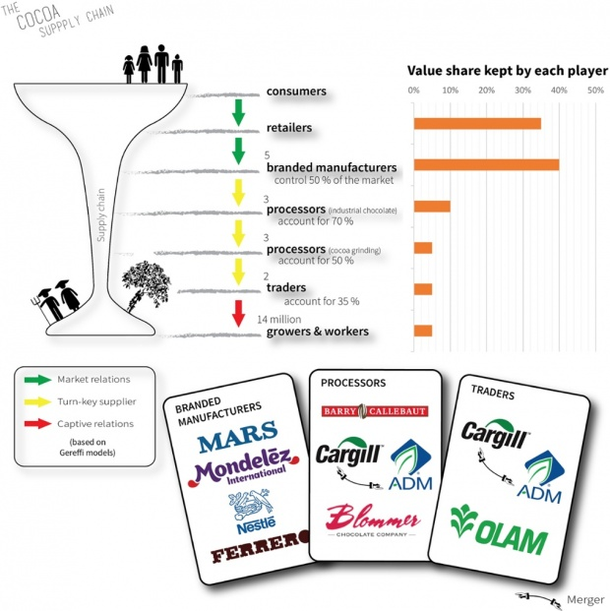

Retailers and branded manufacturers each take 35-40% of the chocolate’s value, leaving the cocoa farmers themselves with just 5%.

Photograph: Fair Trade Advocacy Office

1. Define each of the following resources and provide an example for each in the chocolate industry: 6 marks
   * 1. Natural

|  |
| --- |
|  |
|  |
|  |

* + 1. labour

|  |
| --- |
|  |
|  |
|  |

* + 1. capital

|  |
| --- |
|  |
|  |
|  |

1. Describe two special interest groups and explain how they could be interested in the chocolate industry. 4 marks

|  |
| --- |
|  |
|  |
|  |
|  |
|  |
|  |
|  |
|  |
|  |
|  |
|  |
|  |
|  |
|  |

1. Define corporate social responsibility and suggest two ways that it would affect business planning in the chocolate industry. 3 marks

|  |
| --- |
|  |
|  |
|  |
|  |
|  |
|  |
|  |
|  |
|  |
|  |
|  |

1. Identify and justify one method by which a culture of business innovation and entrepreneurship may be fostered in nations that provide chocolate. 4 marks

|  |
| --- |
|  |
|  |
|  |
|  |
|  |
|  |
|  |
|  |
|  |
|  |
|  |
|  |
|  |

EXTRA SPACE FOR ANSWERS

|  |
| --- |
|  |
|  |
|  |
|  |
|  |
|  |
|  |
|  |
|  |
|  |
|  |
|  |
|  |
|  |
|  |
|  |
|  |
|  |
|  |
|  |
|  |
|  |
|  |
|  |
|  |
|  |
|  |
|  |