

**VCE Unit 3 Business Management**

**EXAMINATION**

**Practice Exam 2021**

**Question Booklet**

**STUDENT NAME:**

**TEACHER(S):** Ms Emerson-Drake Mr Harris

**TIME ALLOWED: Reading time: 15 minutes**

**Writing time: 90 minutes**

**INSTRUCTIONS**

You are not permitted to use notes, texts or a dictionary.  
You are to answer each question in space provided.  
Do not write in pencil.

**STRUCTURE OF BOOKLET / MARKING SCHEME**

|  |  |  |
| --- | --- | --- |
| Exam Section | Number of questions to be answered | Total marks |
| A  B | 6  5 | 35  20  **Total 55** |

**SECTION A**

**Instructions for Section A**

Answer **all** questions in the spaces provided.

**Question 1** (2 marks)

Define the term ‘public company’.

|  |
| --- |
|  |
|  |
|  |
|  |
|  |
|  |
|  |

**Question 2 (9 marks)**

1. Explain onetraining option that would be suitable for a business wanting to multiskill its employees. 2 marks

|  |
| --- |
|  |
|  |
|  |
|  |
|  |
|  |
|  |

b.Employee observation is one type of performance management strategy.

Propose a different performance management strategy that you believe would be effective in improving employee performance. Justify your choice. 4 marks

|  |
| --- |
|  |
|  |
|  |
|  |
|  |
|  |
|  |
|  |
|  |
|  |
|  |
|  |
|  |
|  |

c.Describe a management style and in your answer explain **one** benefit of using this style. 3 marks

|  |
| --- |
|  |
|  |
|  |
|  |
|  |
|  |
|  |
|  |
|  |
|  |
|  |

**Question 3** (4 marks)In the last few years McDonnell’s has seen a steady increase in staff turnover across its five offices in Melbourne. Departing staff complain of a disconnection between management and staff and limited opportunities for them to grow at the business.

Explain two strategies that the business could implement to develop a positive corporate culture.

|  |
| --- |
|  |
|  |
|  |
|  |
|  |
|  |
|  |
|  |
|  |
|  |
|  |
|  |
|  |
|  |
|  |

**Question 4** (4 marks)

Read the information in the table below relating to a Victorian business.

Prime Meats Pty Ltd is a manufacturer of various types of processed meats, including ham, salami and sausages. The Operations Manager, Hali, is concerned about the increasing level of wastage and decline in net profit as a result. She has set an objective to reduce wastage from the production process by 90% over the next two years.

|  |  |  |
| --- | --- | --- |
| **Key performance indicator** | **2019** | **2020** |
| level of wastage | ↑ 2% | ↑ 5% |
| net profit | $520 000 | $145 000 |

Explain how the principles of lean management could assist this business with improving its performance. In your response, refer to the data provided.

|  |
| --- |
|  |
|  |
|  |
|  |
|  |
|  |
|  |
|  |
|  |
|  |
|  |
|  |
|  |
|  |
|  |

**Question 5** (6 marks)

Some employees reach their targets and pursue excellence while others just show up to work each day and count the hours until the end of their shift.

Compare two theories of motivation. In your response, refer to the statement above.

|  |
| --- |
|  |
|  |
|  |
|  |
|  |
|  |
|  |
|  |
|  |
|  |
|  |
|  |
|  |
|  |
|  |
|  |
|  |
|  |
|  |
|  |
|  |
|  |
|  |

**Question 6** (10 marks)

Using a business case study from the past four years, illustrate how corporate social responsibility considerations can influence the decisions taken by management in relation to an operations system. Evaluate the potential effects that these decisions may have on **one** stakeholder of the business.

|  |
| --- |
|  |
|  |
|  |
|  |
|  |
|  |
|  |
|  |
|  |
|  |
|  |
|  |
|  |
|  |
|  |
|  |
|  |
|  |
|  |
|  |
|  |
|  |
|  |
|  |
|  |
|  |
|  |
|  |
|  |
|  |
|  |
|  |
|  |
|  |
|  |
|  |
|  |

|  |
| --- |
|  |
|  |
|  |
|  |
|  |
|  |
|  |
|  |
|  |
|  |
|  |
|  |

**SECTION B**

**Instructions for Section B**

Use the case study provided to answer the questions in this section. Answers must apply to the case study. Answer **all** questions in the spaces provided.

Compucinch Pty Ltd is an IT consultancy business established 15 years ago by its CEO, David Myles. The company specialises in the provision of expert advice, assistance and support to clients making IT software and hardware purchases. Step-by-step instructions and advice are provided to clients while they are making these purchases.

Compucinch has grown to employ 30 full-time employees since the establishment of the business. All of Compucinch’s employees are currently working under award pay and conditions.

Digipurchase Pty Ltd is a competitor of Compucinch and offers a similar product range. Over the past six months, three of Compucinch’s employees have resigned to take up positions with Digipurchase. Exit interviews have shown that the departing employees have been attracted by the more generous pay and conditions offered in the Digipurchase enterprise agreement.

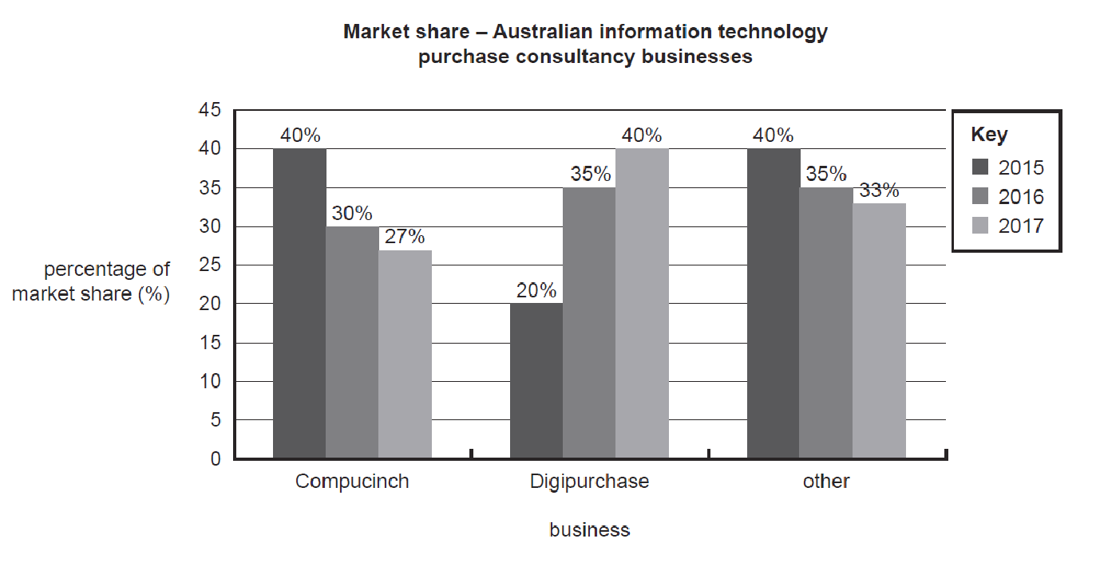

**Question 1** (2 marks)

Outline an entitlement issue Compucinch would need to consider when managing resigning employees.

|  |
| --- |
|  |
|  |
|  |
|  |
|  |

**Question 2** (2 marks)

As the CEO of Compucinch, David will need to possess and apply many management skills.

Explain how David might utilise planning and interpersonal skills in order to manage Compucinch effectively.

|  |
| --- |
|  |
|  |
|  |
|  |
|  |

**Question 3** (4 marks)

Manufacturing and service businesses are identified by a number of characteristics. With reference to Compucinch and a manufacturing business of your choice, distinguish between the characteristics of the output elements of each type of business.

|  |
| --- |
|  |
|  |
|  |
|  |
|  |
|  |
|  |
|  |
|  |
|  |
|  |
|  |
|  |
|  |
|  |
|  |

**Question 4** (8 marks)

1. Define the key performance indicator ‘percentage of market share’. 1 mark

|  |
| --- |
|  |
|  |
|  |

1. Interpret the market share data and propose how Compucinch could use one motivational strategy to increase employee job satisfaction in the short or long-term and reduce staff turnover. 3 marks

|  |
| --- |
|  |
|  |
|  |
|  |
|  |
|  |
|  |
|  |
|  |
|  |

1. Discuss how Compucinch could use Total Quality Management to improve its market share. 4 marks

|  |
| --- |
|  |
|  |
|  |
|  |
|  |

|  |
| --- |
|  |
|  |
|  |
|  |
|  |
|  |
|  |
|  |
|  |
|  |
|  |
|  |
|  |
|  |

**Question 5** (4 marks)

Justify the benefits of choosing an agreement instead of an award for Compucinch.

|  |
| --- |
|  |
|  |
|  |
|  |
|  |
|  |
|  |
|  |
|  |
|  |
|  |
|  |
|  |
|  |

**END OF EXAMINATION**

**Extra space for writing**

|  |
| --- |
|  |
|  |
|  |
|  |
|  |
|  |
|  |
|  |
|  |
|  |
|  |
|  |
|  |
|  |
|  |
|  |
|  |
|  |
|  |
|  |
|  |
|  |
|  |
|  |
|  |
|  |
|  |
|  |
|  |
|  |

|  |
| --- |
|  |
|  |
|  |
|  |
|  |
|  |
|  |
|  |
|  |
|  |
|  |
|  |
|  |
|  |
|  |
|  |
|  |