**ECONOMICS Unit 1**

**Written examination 2019**

**Reading time: 15 minutes**

**Writing time: 90 minutes (1 hour and 30 minutes)**

**Name: _______________________**

**QUESTION AND ANSWER BOOK**

|  |  |  |  |
| --- | --- | --- | --- |
| ***Section*** | ***Number of Questions*** | ***Number of questions to be answered*** | ***Number of marks*** |
| A | 15 | 15 | 15 |
| B | 6 | 6 | 50 |
|  | | | **Total: 65** |

**Structure of book**

|  |
| --- |
| * Students are permitted to bring into the examination room: pens, pencils, highlighters, erasers, sharpeners and rulers. * Students are NOT permitted to bring into the examination room: blank sheets of paper and/or correction fluid/tape. * No calculator is allowed in this examination.   **Materials supplied**   * Question and answer book of 21 pages * Answer sheet for multiple-choice questions   **At the end of the examination**   * Place the answer sheet for multiple-choice questions inside the front cover of this book. |

|  |
| --- |
| **Students are NOT permitted to bring mobile phones and/or any other unauthorised electronic devices into the examination room.** |

**Section A: Multiple Choice Questions**

**Instructions for Section A**

Answer **all** questions in **pencil** on the answer sheet provided for multiple choice questions.

Choose the response that is **correct** or the **best answers** the question.

**Question 1**

Refer to the output combinations for Europe when answering **question 2.**

|  |  |  |  |  |
| --- | --- | --- | --- | --- |
|  | **A** | **B** | **C** | **D** |
| **Cheese** | 100 | 90 | 60 | 0 |
| **Beer** | 0 | 30 | 65 | 110 |

Based on the output combinations, the opportunity cost of moving from output combination B to output combination C is:

**A.** 35 units of beer

**B.** 60 units of cheese

**C.** 30 units of cheese

**D.** 65 units of beer

**Question 2**

An increase in the price of butter is likely to have what effect on the market for margarine?

**A.** Shift the supply curve to the right leading to a decrease in equilibrium price and increase in equilibrium quantity

**B.** Shift the demand curve to the right leading to an increase in equilibrium price and increase in equilibrium quantity

**C.** Shift the supply curve to the left leading to an increase in equilibrium price and decrease in equilibrium quantity

**D.** Shift the demand curve to the left leading to a decrease in equilibrium price and decrease in equilibrium quantity

**Question 3**

Refer to the production possibilities curve.

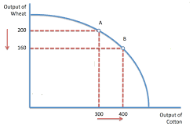

Which of the following statement is **incorrect**?

**A.** The opportunity cost of moving from point A to point B is 40 units of wheat.

**B.** Due to scarcity, an economy cannot produce outside of the production possibilities curve.

**C.** The production possibilities curve can shift outward if there is a decrease in the quantity and quality of labour.

**D.** An economy that produces inside the production possibilities curve is inefficient and results in underemployed factors of production such as labour and capital.

**Question 4**

Status Quo bias exists when:

1. Consumers place too much weight on a small number of more ‘standout’ observations.
2. confronted by decisions where the outcomes are highly unpredictable, people often ‘follow the herd’.
3. Consumers tend to stick to a particular choice even though that choice is no longer in their self-interest.
4. Consumers’ judgements are affected by some arbitrary starting value or reference point (or price).

**Question 5**

Which of the following statements about the circular flow model is **incorrect?**

**A.** An increase in factors of production should lead to a decrease cost of production to firms.

**B.** Higher levels of household disposable income should lead to an increase in economic activity.

**C.** Increased tax rates imposed by the government should lead to firms decreasing their demand for factors of production which should lead to a decrease in goods and services produced, leading to a decrease in economic activity.

**D.** An increase in economic activity can result in a decrease in non-material living standards due to increased work hours which may result in increased stress and a decrease in work-life balance.

**Question 6**

Which of the following is **not** a basic economic question?

**A.** What and how much to produce?

**B.** For whom to produce?

**C.** When to produce?

**D.** How to produce?

**Question 7**

Which of the following factors is **not** likely to be a factor that shifts the demand curve for product A?

**A.** an improvement in climatic conditions

**B.** a decrease in the price of a complement

**C.** lower income tax rates

**D.** higher consumer confidence

**Question 8**

Which market structure achieves allocative efficiency, higher quantities and lower prices?

**A.** Oligopoly

**B.** Monopoly

**C.** Perfect competition

**D.** Monopolistically competitive

**Question 9**

Which of the following is not considered to be a traditional view of business behaviour?

1. Businesses seek to maximise community and environmental goals at the expense of shareholder wealth and profit.
2. Businesses seek to maximise shareholder wealth and utilise strategies such as multi-branding and price discrimination to do so.
3. Businesses achieve community and environmental goals to maximise business reputation which result in profit maximisation.
4. Businesses attempt to engage in anti-competitive behavioural strategies to maximise their profit even though it is illegal.

**Question 10**

A consumer has decided to trade-off future and increase current expenditure. What impact would this have on living standards?

1. Increase current living standards and increase future living standards
2. Increase current living standards and decrease future living standards
3. Decrease current living standards and increase future living standards
4. Decrease current living standards and decrease future living standards

**Question 11**

What impact has technological change had on consumer behaviour in recent years?

1. Improved access to assets via peer-to-peer rental schemes
2. Increased use of self-service technology in the retail environment
3. Increase in online retail and sales from international markets
4. All of the above

**Question 12**

Which of the following **is not** a characteristic of the traditional view of consumer behaviour?

**A.** Ordered preferences

**B.** Utility maximisation

**C.** Uninformed decision making

**D.** Rational decision making

**Question 13**

Which of the following factors is **not** likely to be a factor that shifts the supply curve to the left?

**A.** an increase in productivity

**B.** an decrease in the quantity (or availability) of factors of production

**C.** a increase in labour costs at the firm producing the good

**D.** a cyclone that destroyed land used in production

**Question 14**

Refer to the demand and supply schedule below

Demand and supply schedule for avocados

|  |  |  |
| --- | --- | --- |
| **$Price** | **Quantity demanded (000’s)** | **Quantity supplied (000’s)** |
| 1 | 200 | 25 |
| 2 | 150 | 60 |
| 3 | 120 | 120 |
| 4 | 30 | 170 |

Based on the demand and supply schedule for avocados above, which of the following statement is incorrect?

**A.** The equilibrium price is $3 and the equilibrium quantity is $120

**B.** At a price of $2 there is an excess supply

**C.** At a price of $4 there is an excess supply

**D.** At a price of $2 price will rise causing an expansion in quantity supplied and contraction in quantity demanded

**Question 15**

Which of the following is **not** a feature of a perfectly competitive market

**A.** Low barriers to entry and exit

**B.** Heterogenous goods and services

**C.** Suppliers are price takers

**D.** Resources are efficiently allocated and there is no loss of social welfare

**SECTION B: WRITTEN RESPONSES**

**Question 1 (13 marks)**

*Analyse the demand and supply schedule for the market for passion fruit*

|  |  |  |
| --- | --- | --- |
| **Price ($)** | **Demand (000’s)** | **Supply (000’s)** |
| 6 | 20 | 200 |
| 5 | 80 | 170 |
| 4 | 100 | 150 |
| 3 | 140 | 140 |
| 2 | 180 | 80 |
| 1 | 200 | 30 |

**a. Construct** a suitably labelled demand and supply diagram for the market for passion fruit using the data above.

(4 marks)

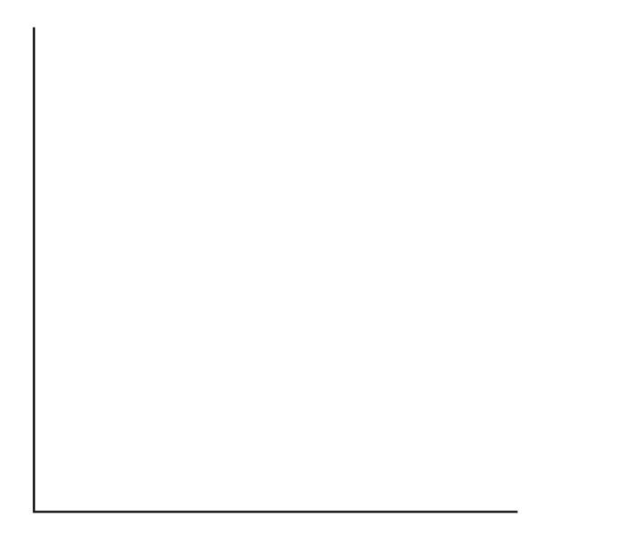

**b. Explain** the term ‘equilibrium’ using the diagram to support your answer.

(2 marks)

|  |
| --- |
|  |
|  |
|  |
|  |
|  |

**c. Describe** one demand-side factor that is likely to cause a decrease in demand for passion fruit.

(2 marks)

|  |
| --- |
|  |
|  |
|  |
|  |
|  |
|  |
|  |
|  |
|  |
|  |
|  |

**d. Show** the change in demand on the demand and supply diagram above in **part a.**

(1 mark)

**e. Explain** how the role of relative prices will cause the equilibrium price and equilibrium quantity to adjust as a result of the demand-side factor in **part d.**

(4 marks)

|  |
| --- |
|  |
|  |
|  |
|  |
|  |
|  |
|  |
|  |
|  |
|  |
|  |
|  |
|  |
|  |
|  |

**Question 2 (8 marks)**

**a.** Usingmarket diagrams, **explain** the difference between a shift of the demand curve and a movement along the demand curve.

(4 marks)

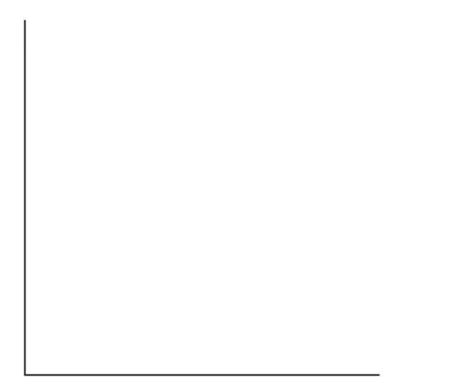

|  |
| --- |
|  |
|  |
|  |
|  |
|  |
|  |
|  |
|  |
|  |
|  |

**b. Explain** how a decrease in the price for almond milk is likely to affect the demand for diary milk. Construct fully labelled demand and supply curves to illustrate your explanation.

(4 marks)



|  |
| --- |
|  |
|  |
|  |
|  |
|  |
|  |
|  |
|  |
|  |
|  |

**Question 3 (4 marks)**

There are different market structures that exists in Australia’s capitalist economic system. **Identify** and **describe** one market structure and using an example **analyse** the effect of this market structure of resource allocation and living standards.

|  |
| --- |
|  |
|  |
|  |
|  |
|  |
|  |
|  |
|  |
|  |
|  |
|  |
|  |
|  |
|  |
|  |
|  |
|  |
|  |

**Question 4 (10 marks)**

**a. Explain** the traditional economic viewpoints of consumer behaviour and business behaviour.

(2 marks)

|  |
| --- |
|  |
|  |
|  |
|  |
|  |
|  |
|  |
|  |
|  |

In recent years there has been a focus on understanding why consumers fail to act like ‘homo-economicus’ and make decisions that are not able to be answered using the traditional economic viewpoint of consumer behaviour.

**b. Explain** how one aspect of behavioural economics can assist to understand why consumers are not always able to act like ‘homo-economicus’.

(3 marks)

|  |
| --- |
|  |
|  |
|  |
|  |
|  |
|  |
|  |
|  |
|  |
|  |
|  |
|  |
|  |
|  |
|  |
|  |
|  |

**c. Identify** and **explain** how a positive incentive may influence the decision making of a consumer **or** a business.

(2 marks)

|  |
| --- |
|  |
|  |
|  |
|  |
|  |
|  |
|  |
|  |
|  |

**d.** Not all business strategies to maximise profit are illegal.

**Explain**, referring to an example,one business strategy that can be used to maximise profitability of the business.

(3 marks)

|  |
| --- |
|  |
|  |
|  |
|  |
|  |
|  |
|  |
|  |
|  |
|  |
|  |
|  |
|  |
|  |
|  |
|  |
|  |

**Question 5 (8 marks)**

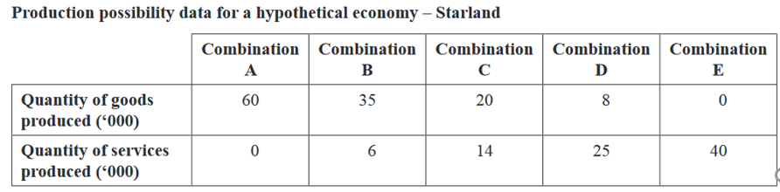

**a. Construct** and the production possibility curve on the axis below for the ‘Starland’ economy. Make sure you fully label this model.

(3 marks)



b. Referring to points on the production possibilities curve, **explain** what is meant by scarcity and opportunity cost.

(3 marks)

|  |
| --- |
|  |
|  |
|  |
|  |
|  |
|  |
|  |
|  |
|  |
|  |
|  |
|  |
|  |

c. Referring to the production possibilities curve, **explain** one type of economic efficiency.

(2 marks)

|  |
| --- |
|  |
|  |
|  |
|  |
|  |
|  |
|  |
|  |
|  |

**Question 6 (7 marks)**

‘Triple bottom line reporting assists businesses to meet their evolved goals and obligations to consider both the environment and the community in which they operate in. Although, it can be argued that this is just another way for businesses to maximise their profit and therefore shareholder wealth’.

**Discuss**, with reference to a business example (Coca Cola or Yakult), one advantage and one disadvantage of triple bottom line reporting and how your chosen business has achieved the evolved business goals of community and environment. **Justify** whether your chosen business will be able to maximise profit despite their increased obligations to more than just shareholders.

|  |
| --- |
|  |
|  |
|  |
|  |
|  |
|  |
|  |
|  |
|  |
|  |
|  |
|  |
|  |
|  |
|  |
|  |
|  |
|  |
|  |
|  |
|  |
|  |
|  |
|  |
|  |
|  |
|  |
|  |
|  |
|  |
|  |

**END OF EXAMINATION**

**Extra writing space**

**(Please label all responses clearly)**

|  |
| --- |
|  |
|  |
|  |
|  |
|  |
|  |
|  |
|  |
|  |
|  |
|  |
|  |
|  |
|  |
|  |
|  |
|  |
|  |
|  |
|  |
|  |
|  |
|  |
|  |
|  |
|  |
|  |
|  |
|  |
|  |
|  |
|  |
|  |
|  |
|  |
|  |
|  |
|  |
|  |
|  |
|  |
|  |
|  |
|  |
|  |
|  |
|  |
|  |
|  |
|  |
|  |
|  |
|  |
|  |
|  |
|  |
|  |
|  |
|  |
|  |
|  |
|  |