

**LEGAL STUDIES**

**UNITS 3 & 4**

2020

**TRIAL EXAM A**

**SUGGESTED SOLUTIONS/RESPONSES**

**SECTION A**

**Instructions for Section A**

Answer **all** questions in the spaces provided

**Question 1 (2 marks)**

1. Explain one purpose of committal proceedings. (2 marks)

Suggested Solution

*One key reason for committal proceedings is to determine whether there is sufficient evidence to support a conviction at trial. Individuals charged with an indictable offence will have an opportunity at the committal hearing to test the strength of the prosecutions case and in the process allow the Magistrate to deliberate based on the prima facie evidence whether the case should proceed to trial.*

Other possible purposes that could be mentioned:

* Determine whether the indictable offence is appropriate to be heard summarily
* Allow the accused to properly prepare and present a case
* Provides for a fair trial because the accused has an opportunity to read the evidence and cross-examine the witnesses

**Marking Guide**

**1 mark** for correctly identifying a reason for committal proceedings

**1 mark** for the detail explaining the reason identified

**Question 2 (6 marks)**

John is Suing

John is suing his employer for defamation. He is seeking $500,000 in compensation and the trial is set to be heard in the Magistrates Court on the 30th of November. The prosecution said, “John’s case is not strong”. Lawyers representing John are confident they will prove loss of reputation beyond reasonable doubt.

1. There are errors in the case “John is Suing”. Identify three errors and state what the correct legal principle, process or procedure should be applied. (2 + 2 + 2 = 6 marks)

**Suggested solution**

***The first error*** *is that the Magistrates Court cannot hear civil cases for $500,000. The County or Supreme Court have an unlimited jurisdiction for civil claims. Therefore, the case could only be heard in the County or Supreme Court.*

***The second error*** *is the prosecution are said to be representing John, but the prosecution does not litigate civil disputes, it prosecutes criminal cases. John as the plaintiff in this case could self-represent or have a lawyer represent him in pre-trial and trial proceedings.*

***The final error*** *is the claim the case needs to be proven ‘beyond reasonable doubt’. This is not the standard of proof for a civil case, in a civil case the standard of proof is ‘on the balance of probabilities’ the defendant can be found liable.*

**Marking Guide**

**1 mark** for each error identified

**1 mark** for an explanation of what is the correct process, procedure or outcome

**Question 3 (4 marks)**

In reference to one right of the accused, discuss to what extent the accused achieves access before the Victorian Criminal Justice System. (4 marks)

*The accused is entitled to be tried without an unreasonable delay meaning the accused is to have their charges heard in a timely manner, while if there is a delay it may be only considered reasonable given the complexity and circumstances of the case. The Charter of Human Rights and responsibilities Act of 2006 Section 25 refers to this right being owed ‘without discrimination’, thus ensures all accused persons regardless of prior offending, ethnicity or socio-economic status are to have access to a hearing before the Courts that is timely and avoids delays to justice where possible.*

*However, a structural restraint (backlogs) cause some delays to court hearings and trials taking place in what would be deemed a ‘timely manner’. The limited number of Magistrates and County Courts available to hear criminal matters causes delays in cases reaching court. Particularly a backlog of cases in the County and Supreme Court mean accused persons may be held in remand for several months denying them access to a means of resolving their charges within a reasonable period of time.*

**Marking Guide**

**1 mark** for correctly referring to one right of the accused (tried without an unreasonable delay, open and fair hearing or trial by jury)

**1.5 marks** for explaining how the principle of access is upheld

**1.5 marks** for explaining how the principle of access might be undermined

**Question 4 (9 marks)**

Chief Justice Faye Dean recently said,

“Section 109 of the Australian constitution places a restriction on the Commonwealth Governments law-making authority”

1. Do you agree with Chief Justice Dean? Justify your answer. (3 marks)

Suggested Solution

*I disagree with Judge Dean because S.109 does not restrict Commonwealth governments law making authority. S.109 relates to areas of concurrent law-making where there is an inconsistency between Commonwealth and State parliaments laws, the former laws will prevail, and the latter’s laws will be invalid to the extent the State laws are inconsistent with the Commonwealth laws. In fact, S.109 is a restriction on the State governments law making powers not the Commonwealth.*

**Marking Guide**

**1 mark** for stating Justice Dean is incorrect

**2 marks** for explain that S.109 is a restriction on the States not the Commonwealth

1. Examine to what extent the role of the High Court interpreting the Australian Constitution limits parliaments law-making powers. (6 marks)

*To a small extent the role of the High Court interpreting the words enumerated in the constitution limits parliaments law-making powers. Although the High Court in its guardian role protecting the integrity of the Constitution, has at times made significant decisions that have limited the law-making powers of parliament. The High Court by virtue of S.76 is empowered to give meaning to the words in the constitution and thus confirms or checks parliaments authority when test cases are before the High Court. For instance when the “freedom of political communication” case was contested before the High Court, the judiciary decided the parliament had made laws beyond its powers given the intention of S.7 and S.24 stating the people elected to parliament are to be chosen by the people.*

*Although, one significant reason the High Court is not a significant check on law-making is the infrequency in which laws made by parliament are contested before the High Court. One impediment is the expense of litigation and another deterrent being the time taken to challenge a State or Commonwealth law before the High Court. Over the years, very few cases effectively limit parliament law making powers and comparatively the bicameral parliament operates to more frequently and more effectively check parliaments law making powers.*

**Marking Guide**

**3 marks** for examining the reasons why the High Court can be effective at checking parliaments law-making powers

**3 marks** for examining why the High Court has a limited role in checking the law-making powers of parliament

**## In a ‘to what extent’ question the response must take a position and not sit on the fence##**

**Question 5 (15 marks)**

Helen bought a second-hand car from Cars R US for $5,000. Gerry the salesman, said the car is in good working order and is one of the best buys they have on display.

After 10 days driving the car, it breaks down. Helen after having her car inspected by a mechanic, is told it needs a new engine and it will cost $6,000 in parts and labour to repair.

Helen calls Cars R US and asks for a full refund. Gerry advises Helen there will be no refund and that in her contract it stated ‘buyer beware’ as no refunds or returns will be accepted.

Helen has spoken to a legal adviser at a Community Legal Centre and is considering suing Cars R US.

1. Justify whether the car dispute is a criminal or civil dispute. (2 marks)

*Helen’s car dispute is a civil case. A commercial dispute between an individual and a business like Cars R US, relates to a contractual issue, in the sale of a good or service and is resolved through the civil justice system.*

**Marking Guide**

**1 mark** for stating it is a civil dispute

**1 mark** for using evidence from the case regarding a commercial contract being a civil dispute

1. Explain the role of Victorian community legal centres in relation to accused persons in a criminal case. (3 marks)

*Community legal centres (CLCs) provide free and independent advice to accused persons. Guidance regarding what rights they have as the accused and can help with completing preliminary letters and forms prior to going to Court. It is possible CLCs Duty Lawyers provide advice for urgent matters, but CLC Duty Lawyers rarely take on criminal matters. CLC preferring to assist accused persons who are eligible for Victorian Legal Aid to apply for and gain legal aid representation for their case, if the accused is unable to afford a lawyer.*

**Marking Guide**

**1 mark** for a brief description of community legal centres

**2 marks** for a detailed description of the services that the CLC offers the accused

After consulting with the Victorian Community legal centre Helen decides to take Cars R US to Court.

1. Identify who will have the burden of proof and explain the meaning of standard of proof that will be required in Court (4 marks)

*Helen as the plaintiff in this case has the burden of proof to prove in this case Cars R US are liable. In Court Helen would need to prove ‘on the balance of probabilities’ (Standard of proof) that Cars R US knowingly sold Helen a defective car and owe her a refund or compensation for the civil wrong that has been done.*

**Marking Guide**

**2 marks** for correctly detailing the burden of proof in a civil case

**2 marks** for correctly detailing the standard of proof in a civil case

1. Identify and examine in detail two purposes of civil pre-trial procedures. (6 marks)

*Civil pre-trial procedures provide both parties the opportunity to clarify the issue in dispute, narrowing the scope of the claim until it is very clear what will be contested should the dispute make it to court. Pleadings involves the disputing parties filing and exchanging documents prior to the matter heading to Court. A statement of claim is filed by the plaintiff against the defendant, it sets out the claims against the defendant and the remedy sought by the plaintiff. In response the defendant files a defence, which responds to each of the claims made by the plaintiff. This initial filing of documents limits the scope of the dispute to any claims raised in these preliminary documents.*

*Another purpose of pre-trial procedures such as pleadings and discovery of documents is to assist in reaching an out-of-court-settlement. Through discovery the parties are required to list all the documents relevant to the claims and the other side is entitled to inspect these documents. For example, copies of contracts or medical records could be exchanged. In many cases, once either the plaintiff or the defendant has determined the strength of their case it prompts one party to seek an out-of-court settlement to avoid the expense of proceeding with the dispute before the courts.*

**Marking Guide X 2**

**1 mark** for outlining one purpose of a civil pre-trial procedure.

(**Alternative purposes**: clarify/narrow the issue/s in dispute, procedural fairness, avoids the other party being ambushed at trial, reach an out-of-court settlement)

**2 marks** for examining how pleadings, discovery of documents and exchange of evidence operate to achieve the purposes of pre-trial procedures.

**Question 6 (4 marks)**

A law expert said,

“It would improve the efficiency of the legal system if judges could make changes to statute law when the need arises”

Identify which principle entrenched in the Australian Constitution needs to be considered here. Explain the principle and its purpose within the Australian legal system.

*Established within the constitution is the principle of separation of powers. The separation of powers refers to the bodies of the legislature, the judiciary and executive having separate and different roles to perform within the Australian legal system. The legislature role is to make law, the judiciary role is to apply law, while the executive role is to administer law within Australia. The purpose of the separation of powers is to ensure that no one body has absolute power or control the functions of making law, applying law and administering law. It provides a ‘checks and balances’ on the power of the Commonwealth Parliament, the Judiciaries conduct and the executive administration of governing the nation.*

**Marking Guide**

**1 mark** for identifying the principle of separation of powers.

**3 marks** for explaining the separation of powers and how it operates to provides a system of ‘check and balances’

**END OF SECTION A**

**SECTION B**

|  |
| --- |
| **Instructions for Section B**  **Use stimulus material, where provided, to answer the questions in this section. It is not intended that this material will provide you with all the information to fully answer the questions.**  **Answer all questions in the spaces provided.** |

**Question 1** (17 marks)

**Source 1: COVID-19 Omnibus (Emergency measures) Act 2020 (Vic)**

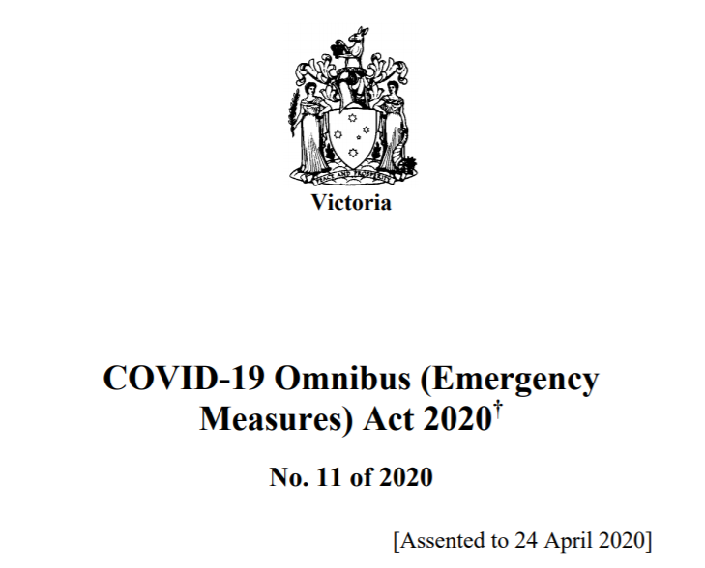

**Source 2**: **Residential Tenancies Act 1974 (Vic) - Amendment Sub Sections 562**

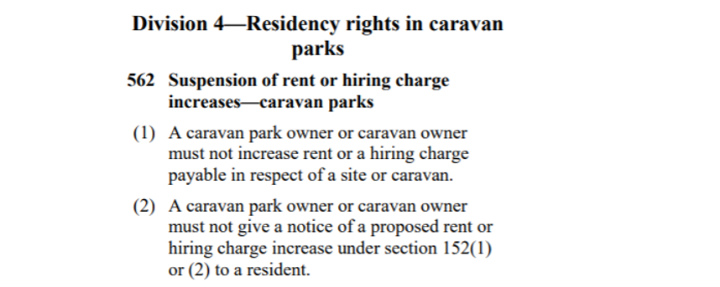

**Source 3: First Reading of the Bill COVID-19 Omnibus (Emergency measures) Act 2020**

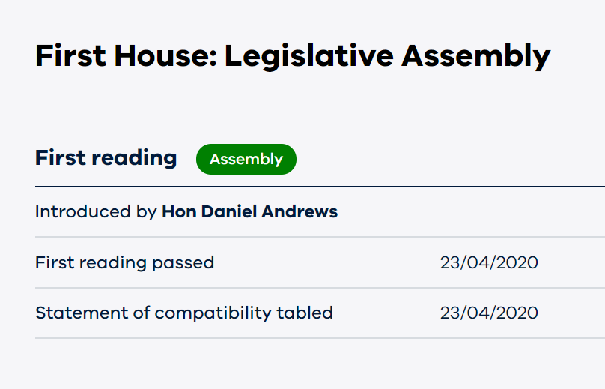

1. Explain one reason for the COVID-19 Omnibus (Emergency measures) Act 2020 law reform. (2 marks)

*The introduction of the COVID-19 Omnibus reform was for the protection of society. Within the reform it provided Emergency Powers under the Public Health Act of Victoria, that gave the Department of Health the authority to legally enforce restrictions on ‘freedom of movement’ and making it mandatory to wear a mask in public. In effect, these measures limiting the spread of COVID-19 and protecting the health and safety of the community.*

**Alternative Solution**: Changes in social, economic and political conditions.

**Marking Guide**

**1 mark** for outlining an appropriate reason in relation to the COVID-19 Omnibus legislation

**1 mark** justifying why this legislation provided protection to society

1. With reference to the roles of the Legislative Assembly, discuss two factors that may have impacted the parliament’s ability to pass this law. (8 marks)

*Representative government is one of the roles performed by the Legislative Assembly, with the party holding the majority in the lower house forming government. Government has a mandate to pass laws that best reflect the views and values of the constituents that voted them into power. In passing the COVID-19 Omnibus it is important the protections and precautions to be made law are supported by the voters in Victoria, confirming their role of representative government. Although, internal pressures may have interfered with the smooth passage of this Bill. Some government members of parliament (in this case the Andrews government) may have disagreed with the measures introduced in the COVID-19 Omnibus, yet felt compelled to vote along ‘party lines’ instead of following their own moral conscience when offering support for the Bill in the lower house.*

*The Legislative Assembly initiate bills, thereby introducing new Bills or Bills that amend existing law before the parliament. The COVID-19 Omnibus included a range of measures designed to protect the health, safety and economic security of all Victorians. The introduction of a Bill usually will come from the Premier or the cabinet. Bills introduced to the Legislative Assembly by a cabinet minister generally are successful in passing the lower house, with the support of the members of the government party. Although, if these measures had been introduced to the house as a ‘private member’s bill’ it would be unlikely the bill would successfully pass the lower house. A ‘private members bill’ is introduced by a non-government member of parliament, and therefore often fail but can raise some publicity and awareness amongst the members of parliament.*

**Marking Guide X 2**

**1 mark** for stating a role of the Legislative Assembly (determines government, initiate bills, representative government, debate and discuss proposed laws and bills for supply)

**3 marks** for discussing how the factor could support the legislation being passed and how it may inhibit the laws being passed

In reference to Source 2: ‘Residency Rights in Caravan Parks’

1. Explain one reason why a judge may need to interpret the words ‘Caravan Parks’ and outline the effect of a judge giving meaning to these words. (4 marks)

*The exact meaning of the words ‘Caravan Parks’ may be ambiguous. The words used in Section 562 is attempting to cover cases where a caravan park owner attempts to raise the rent whilst these emergency measures are in place. However, in some instances it may be unclear what is a ‘Caravan Park’ and what may be described as a ‘Camping Ground’ or even a ‘half-way house’, to this extent it may be necessary for the courts to decide on the meaning according to the intention of the statute.*

*The effect of the judge determining the meaning of ‘Caravan Parks’ is it sets precedent for future cases that follow. The reasons used by the judge to form the meaning of the words ‘Caravan Park’ form the ratio decidendi to be followed by subsequent cases where the Statute is read in conjunction with a similar dispute before the Courts.*

**Marking Guide**

**2 marks** for describing a valid reason why ‘Caravan Parks’ may need to be interpreted (ambiguity of meaning, statute written in general terms, problems drafting the legislation)

**2 marks** for describing the effect of the statutory interpretation (develops precedent for future cases, narrow the application of the statute, broaden the application of the legislation)

Stuart a Victorian Caravan Park owner said…

“It’s Okay for him to increase rent because Tenancies laws is an exclusive power and the Victorian government have no authority making laws like these…”

1. Do you agree with Stuart? Justify your answer. (3 marks)

*Stuart is incorrect in the assertion he has a lawful right to increase the rent. The Residential Tenancies Act 1974 (Vic) is legislation that applies to tenancy laws within the jurisdiction of Victoria. In this case, this area of law making which is not written into the constitution makes it an area of residual law-making, not exclusive. Hence, Stuart is wrong to say the Victorian government have no authority to make these laws and if he were to defy the law, he could be subjected to a penalty such as a large fine for breaking the law.*

**Marking Guide**

**1 mark** for stating Stuart’s claim is incorrect

**2 marks** for justifying that his claim is incorrect because the area of law making in question is a residual power

**Question 2** (10 marks)

Olivia and Ted are olive farmers from Swan Hill. During growing season, on a windy day, their neighbour John sprayed his wheat crop for weeds. The chemicals drifted onto Olivia and Ted’s farm killing one half of their olive trees. It is estimated the financial loss for the current year will be $450 000 and it will cost $500 000 to replace the dead trees. Olivia and Ted are considering taking legal action against their neighbour.

1. Explain why enforcement issues should be considered before Olivia and Ted take legal action. (2 marks)

*Olivia and Ted will need to consider whether John if found liable for negligence is able to pay the amount of compensation that they are seeking in this dispute. Before Olivia and Ted initiate civil legal action for close to $1 million it is advisable they establish to the best of their abilities, the capability of John to pay the compensation should they be successful in their claim. If prior to the case, Ted and Olivia find out John is bankrupt it would be pointless to proceed with their legal claim against John.*

**Marking Guide**

**2 marks** for outlining that enforcement issues relate to the ability of the defendant to pay damages dependent on the circumstances

1. Advise Olivia and Ted on whether they should mediate or take their case to court. (6 marks)

*Prior to going to court it is advisable that Olivia and Ted attempt to resolve the dispute through mediation. This could be arranged by Olivia and Ted and John through a private mediator or the parties may be referred by a judicial officer to mediation. At mediation, the disputing parties sit down and discuss the issue of the damage to the Olive Trees, the belief John’s spraying caused this damage and the restitution Olivia and Ted would be seeking to resolve the dispute. At mediation, the mediator facilitates discussion but does not offer any suggestions to how the dispute could be resolved. Mediation is suitable if Olivia, Ted and John are willing to meet to negotiate “in good faith” to reach an agreement. But would be inappropriate if there is a history of broken promises or animosity that would make the mediation unworkable.*

*If John is unwilling to mediate and insists, his spraying of his crop did not cause his neighbour’s trees to perish, there may be no choice but to take the dispute to Court. The advantage of taking the case to court is that procedural fairness is achieved, with a judge who is an expert in law and legal processes adjudicating over proceedings. Another benefit of taking it to Court is finality, that is a legally binding decision will be made that will bring closure to the dispute. Although, in advising Olivia and Ted they should be cautious in proceeding to court if they consider their case to be relatively weak, as it is a very expensive exercise taking a civil matter before the County or Supreme court.*

**Marking Guide**

**1 mark** for correctly describing the process of mediation

**2.5 marks** for applying how mediation could be used in this case under certain circumstances

**2.5 marks** for applying how a court-based solution could be appropriate under different circumstances

1. Describe the remedy Olivia and Ted would be seeking. (2 marks)

*Olivia and Ted are seeking compensatory damages that would provide a form of restitution for the loss they have suffered. They are seeking specific damages that have been calculated to be $450,000 in lost income for the current financial year and another $500,000 to replace the trees that have been destroyed.*

**Marking Guide**

**2 marks** for identifying compensatory damages (and describing specific damages where the dollar amount can be calculated)

**Question 3 (13 marks)**

**SOURCE 1: Royal Commission Summary Report 2016 & Recommendation 76**

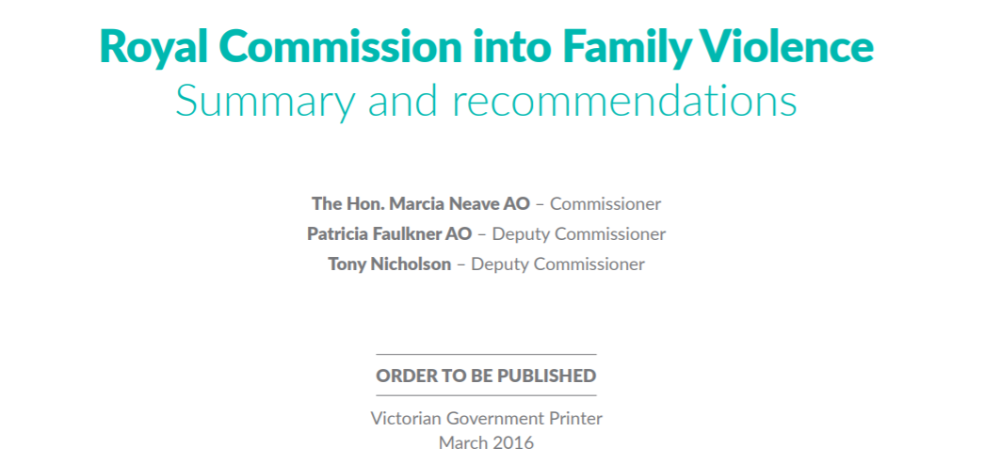

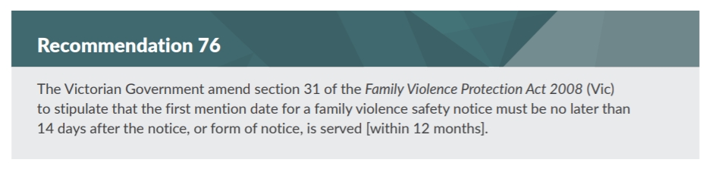

**Source 2: Parliamentary Committee Final Report – Inquiry into end of life choices.**

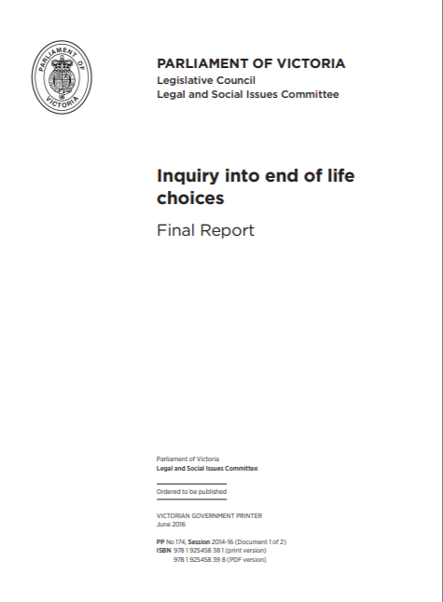

1. Explain the role of one parliamentary committee or one Royal Commission. (3 marks)

*A parliamentary committee is a group of government and non-government members of parliament who undertake work to investigate policy reform and the administration of government. Parliamentary committee’s review a specific area of law and make suggestions to amendments to the law as is required. A standing committee or select committee can give voice to the community through public consultations and reviewing submissions from the public.*

Alternatively

*A Royal Commission is an independent inquiry established by the Governor General or state Governor to inquire into a specific issue through consultation with experts and the community by seeking submissions and holding public hearings. At the conclusion of the Royal Commission a final report is published making recommendations on law reform that will be tabled before parliament.*

**Marking Guide**

**1 mark** for describing who is involved and the context

**2 marks** for providing detail regarding the role of a parliamentary committee or Royal Commission

1. Discuss the ability of either one parliamentary committee or one Royal Commission to influence law reform. (6 marks)

*Parliamentary Committees can be more efficient in the investigation of law reform as the process will not require the entire parliament to be involved, thus ensuring that the law reform process does not impede the parliament from performing its key role of making laws. However, the Parliamentary Committees can be very costly and experience long delays in delivering their recommendations before parliament. In 2014, the Legal and Social Issues Standing Committee began its investigation in to the ‘end of life choices’, but it was not until 2018 that these findings were put before the parliament.*

*Parliamentary Committees seek community input community at community hearings where experiences and opinions are considered or through seeking written submissions from the public. Although Parliamentary Committees composition can be dominated by the governing party of the day and therefore controversial issues such as the Voluntary Assisted Dying Bill may be ignored for the fear of it jeopardising the party’s re-election.*

*Parliamentary committees when investigating law reform in areas like the ‘end of life choices’, have access to expert opinions and it is more likely that the recommendations made by the committee will be adopted by parliament, which was the case when responding by passing the Voluntary Assisted Dying Act of 2018. In addition, the Terms of Reference to investigate areas needing reform being set by the Attorney General means the VLRC is very successful in achieving law reform, with 70% of recommendations being taken up by parliament.*

**Marking Guide**

**2 marks** for discussing strengths of the parliamentary committee or Royal Commission

**2 marks** for discussing weaknesses of the parliamentary committee or Royal Commission

**2 marks** for providing details and application of one recent inquiry by the parliamentary committee or Royal Commission

1. Analyse whether parliament or the courts are best placed to respond to a recommendation made by a parliamentary committee or Royal Commission (4 marks)

*In reference to Parliamentary Committee reports provided to parliament or a final report from a Royal Commission tabled before parliament, the parliament is best placed (not the courts) to respond to any recommendations that are made to reform the area of law. For example, the parliament were best placed to introduce laws legalising euthanasia in Victoria. Parliament is the supreme law-making body with the ability to make and change any law within its constitutional power. The responsiveness of parliament is enhanced when the reform before parliament has bi-partisan support and both parties agree on the urgency of passing the reform. In contrast, Courts are limited in their ability to respond because they must wait for a specific case testing the area to be reformed, which is too arbitrary to be a reliable method of approaching law reform. One strength of courts is the ability of common law to ‘fill the gaps’ in law making in areas not already covered by legislation. However, the Parliament as the supreme law maker is best placed to respond to any official recommendation for reform from a parliamentary committee or Royal Commission.*

**Marking Guide**

**3 marks** for discussing the relative strengths and weaknesses of parliament and courts

**1 mark** for making a decisive judgement about which is best placed to respond to the recommendations (based on the discussion)

The material is the property of prime.edu © and is subject to the copyright laws of Australia. **Disclaimer:** This resource has been written by the author for use with students of VCE Legal Studies. This does not imply that it has been endorsed by the Victorian Curriculum and Assessment Authority (VCAA). The current [VCE Legal Studies Study Design](http://www.vcaa.vic.edu.au/Pages/vce/studies/legalstudies/legalindex.aspx) (2018–2022) can be accessed directly via the VCAA website. VCE is a registered trademark of VCAA. While every care is taken, PRIME.EDU accepts no responsibility for the accuracy of information or advice contained in the exam*.* Teachers are advised to preview and evaluate all PRIME.EDUresources before using them or distributing them to students.