**SACRED HEART GIRLS’COLLEGE**

**MATHEMATICAL METHODS CAS UNIT 3**

**Test SAC 1**

Name:___________________________

**PART 1: NO Calculators and NO Notes are permitted.**

**Time allowed: 20 minutes**

**Total Marks = 16**

**SHORT ANSWER QUESTIONS**

**Instructions:**

Answer **all** questions in the spaces provided.

In all questions where a numerical answer is required an exact value must be given unless otherwise specified.

In questions where more than one mark is available, appropriate working **must** be shown..

Unless otherwise indicated, the diagrams in this test are **not** drawn to scale.

**Question1**

The transformation $T:R^{2}→R^{2}$ is defined by

$$T\left(\left[\begin{matrix}x \\ y\end{matrix}\right]\right)=\left[\begin{matrix}0.5 & 0 \\ 0 & -3\end{matrix}\right]\left[\begin{matrix}x \\ y\end{matrix}\right]+\left[\begin{matrix}0 \\ 1\end{matrix}\right]$$

The image of the curve $y=2x^{2}+1$ under the transformation *T* has equation $y=ax^{2}+c.$

Find the values of *a* and *c*.

3 marks

**Question2**

Let $f:D→R, f\left(x\right)=-3\sqrt{4-2x}+4$

1. State the transformations that would have to be applied to $g\left(x\right)=\sqrt{x}$ to form $f\left(x\right).$

3 marks

1. State the maximal domain, *D*.

1 mark

1. Sketch the graph of $f(x)$ on the axes provided. Label axes intercepts with their co-ordinates.

|  |
| --- |
|  |

3 marks

1. Hence, sketch the graph of the inverse function, $f^{-1}(x)$. Label axes intercepts with their co-ordinates.

1 mark

1. Find the inverse function, $f^{-1}(x)$.

3 marks

1. Find the co-ordinates of the point of intersection of and .

2 marks

**PART 2: CAS Calculator and two double sided A4 pages of notes are permitted.**

**Time allowed: 25 minutes**

**Total Marks = 16**

**Multiple Choice Section**

**Instructions:**

Answer **all** questions on the separate answer sheet provided.

Question 1

For $f:\left(-1,6\right)→R, f\left(x\right)=x^{2}+3$, the range is:

1. [3,39]
2. [3, $∞$)
3. [3,39)
4. [4,39]
5. (4,39]

Question 2

State the maximal domain of the function with the rule $f\left(x\right)=\frac{5}{\sqrt{x-10}}$

$R\backslash \{10\}$

$R\{-10\}$

$R^{+}$

$[10,∞)$

$(10,∞)$

Question 3

If $f\left(m\right)=m^{2}+1$ and $g\left(m\right)=1-2m$ then $f\left(g\left(m\right)\right)=$

$4m^{2}-8m+1$

$4m$

$4m^{2}-4m+2$

$4m^{2}-1$

$2m^{2}-1$

Question 4

For $f:\left[a,b\right)→R, g\left(x\right)=15-x$ where $a<b$ the range is:

$(15-a, 15-b)$

$(15-a, 15-b]$

$(15-b, 15-a)$

$(15-b, 15-a]$

$[15-b, 15-a)$

Question 5

Which of the following functions is not one-to-one?

$g\left(x\right)=49-x^{2}, x<0$

$h\left(x\right)=\frac{1}{x^{2}}+16$

$f\left(x\right)=1-10x$

$m\left(x\right)=4\sqrt{x}$

$n\left(x\right)=-\frac{5}{x}$

Question 6

For $f:R→R, f\left(x\right)=x+4$ and $g:\left[0,∞\right)→R, g\left(x\right)=x^{2}-1$ a restriction of $f(x)$ such that $g(f\left(x\right))$ is defined is

$[0,∞)$

$[-1,∞)$

$[-4,∞)$

$[4,∞)$

$(-∞,-4]$

**EXTENDED RESPONSE QUESTION**

**Instructions:**

Answer **all** questions in the spaces provided.

In all questions where a numerical answer is required an exact value must be given unless otherwise specified.

In questions where more than one mark is available, appropriate working **must** be shown..

Unless otherwise indicated, the diagrams in this test are **not** drawn to scale.

Hamish is planning on riding his bike from his house to the shops. His farm is a rectangle with width 5 km and length 20 km. His house is located at point A diagonally opposite the shops at point B as shown below.

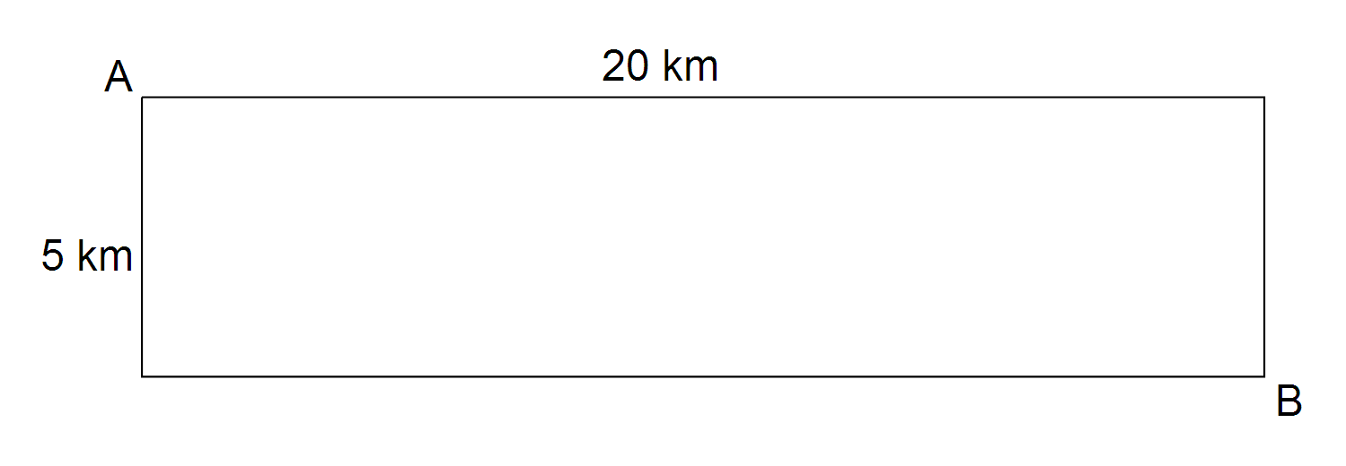

1. Find the distance Hamish rides if he goes directly from home to the shops.

1 mark

Suppose Hamish cannot go directly from home to the shops so he decides to ride in a straight line from home to a point C on the road and then ride the remaining d km along the road as shown below.

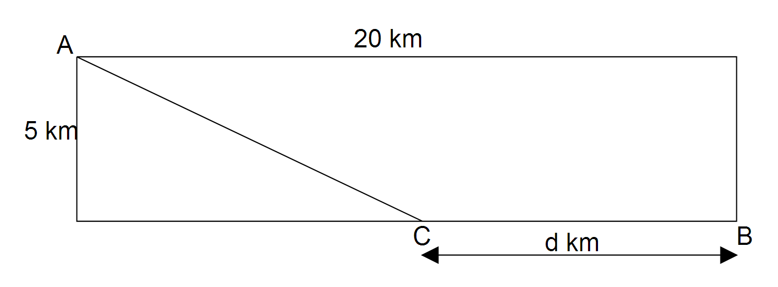

1. (i) Show that the distance Hamish rides, L, in terms of d, is $\sqrt{d^{2}-40d+425}+d$

1 mark

(ii) State the domain of L.

1 mark

1. Sketch the graph of L on the axes below. Clearly label endpoints with co-ordinates.

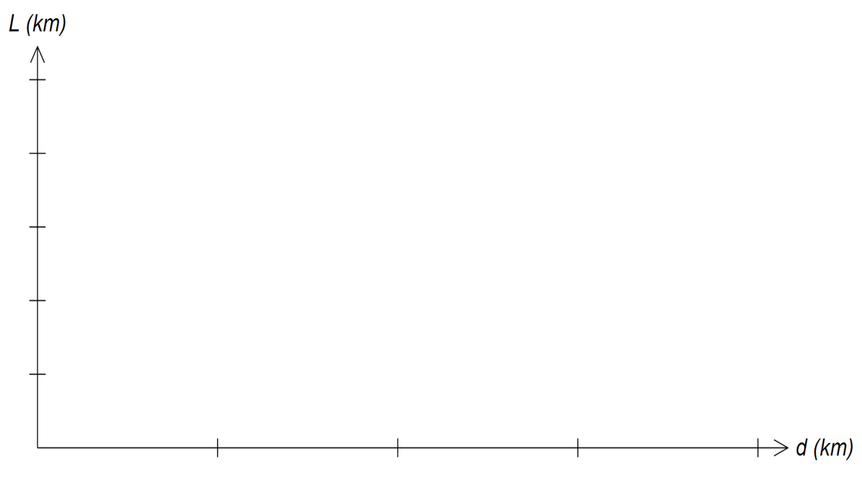

2 marks

1. Hamish’s front tyre has a slow leak and he needs to limit his ride to less than 48 km per trip. If Hamish wants to have the longest ride possible following the same path to the shops and back, how far, correct to two decimal places, should he ride along the road on each trip?

2 marks

1. Hamish can ride at 10 km/hr across his property and at 30 km/hr along the road. If he needs to get to the shops as quickly as possible should he go directly from home to the shops or should he ride across his property to a point half way along the road and finish his journey along the road?

3 marks

END OF SAC