**SACRED HEART GIRLS’ COLLEGE**

**OAKLEIGH**



**Mathematical Methods CAS 2012**

**Unit 3 SAC 2: TEST**

**Name: ________________________________**

**Teacher (please circle)**: Ms Gates Mr Smith

**Part 1: 5 short answer questions.**

**No CAS and no summary notes permitted**

**Reading: 5 minutes**

**Writing: 30 minutes**

**SHORT ANSWER QUESTIONS**

**Instructions:**

Answer **all** questions in the spaces provided.

In all questions where a numerical answer is required an exact value must be given unless otherwise specified.

In questions where more than one mark is available, appropriate working **must** be shown.

Unless otherwise indicated, the diagrams in this test are **not** drawn to scale.

**Question 1**

1. Describe the transformations required to transform the graph of $y=sin\left(x\right)$ to the graph of $y=4sin2\left(x-\frac{2π}{3}\right)+5.$

2 marks

1. State the range and period of the function $f:\left[0,π\right]→R, f\left(x\right)=4sin2\left(x-\frac{2π}{3}\right)+5.$

2 marks

1. Find the exact solutions of $4sin2\left(x-\frac{2π}{3}\right)+5=7$ over the domain $\left[0,π\right].$

2 marks

**Question 2**

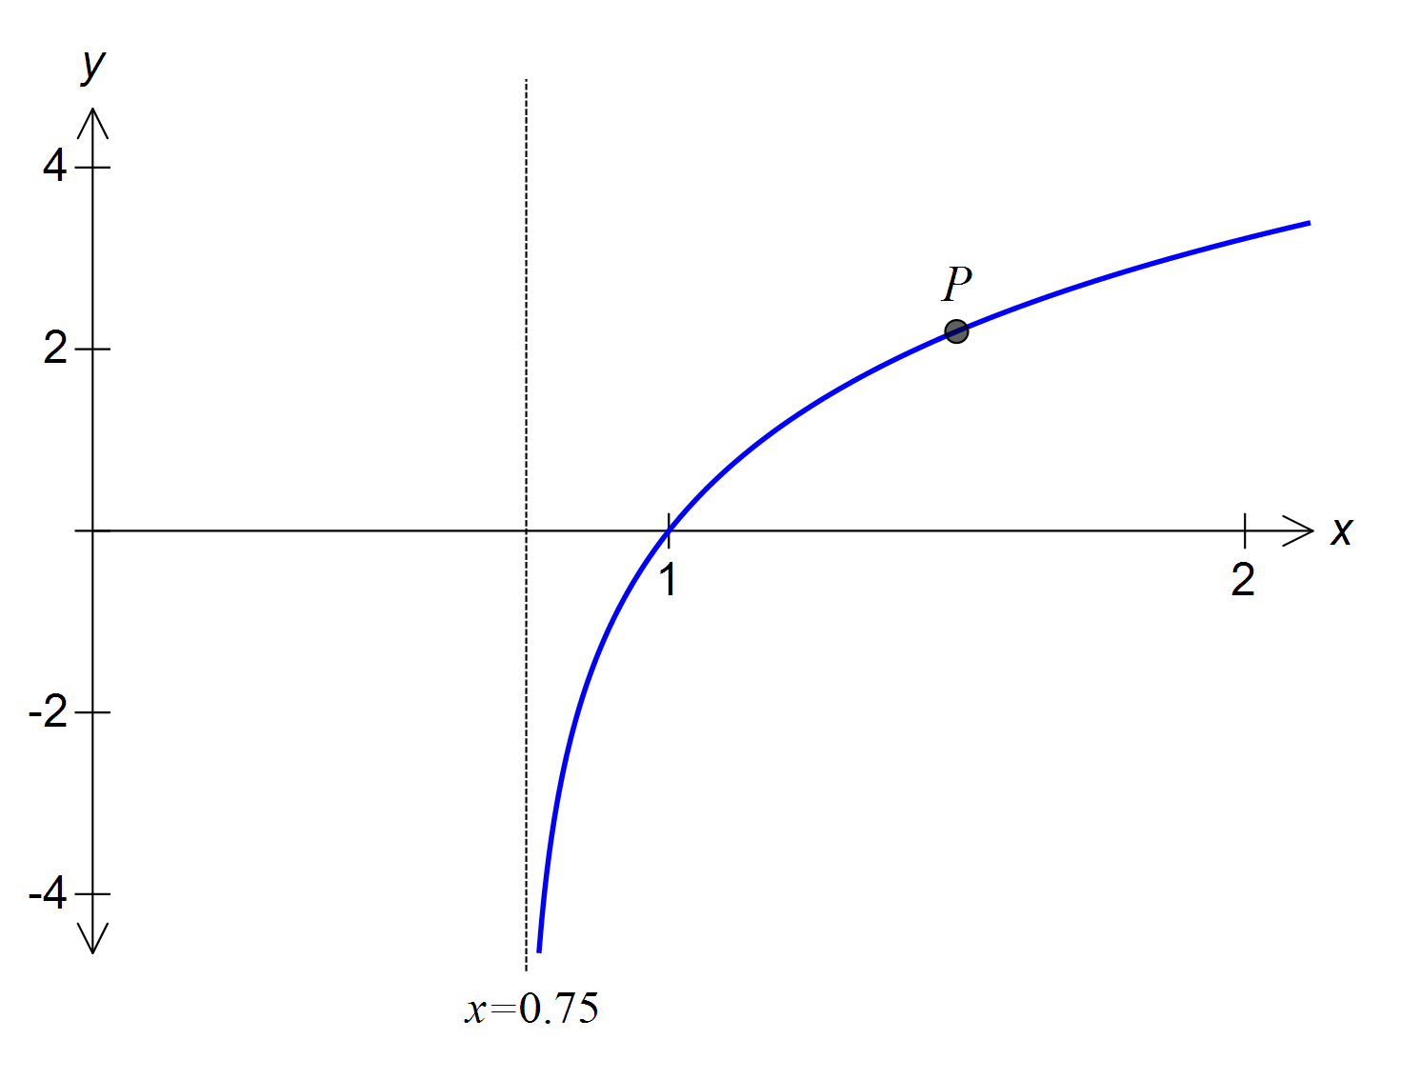

A graph of a function of the form $f\left(x\right)=a\log_{e}(bx+c)$ is shown above.

The graph has a vertical asymptote at $x=0.75$ and an *x*-intercept at (1, 0)

1. Find the values of b and c.

3 marks

The graph passes through the point, *P*, with co-ordinates (1.5, $\log_{e}9$).

1. Find the value of a.

1 mark

**Question 3**

Sketch the graph of the function $y=\log_{e}(2\left|x\right|-4)$ on the axes below. Label any axis intercepts with coordinates and any asymptotes with equations.

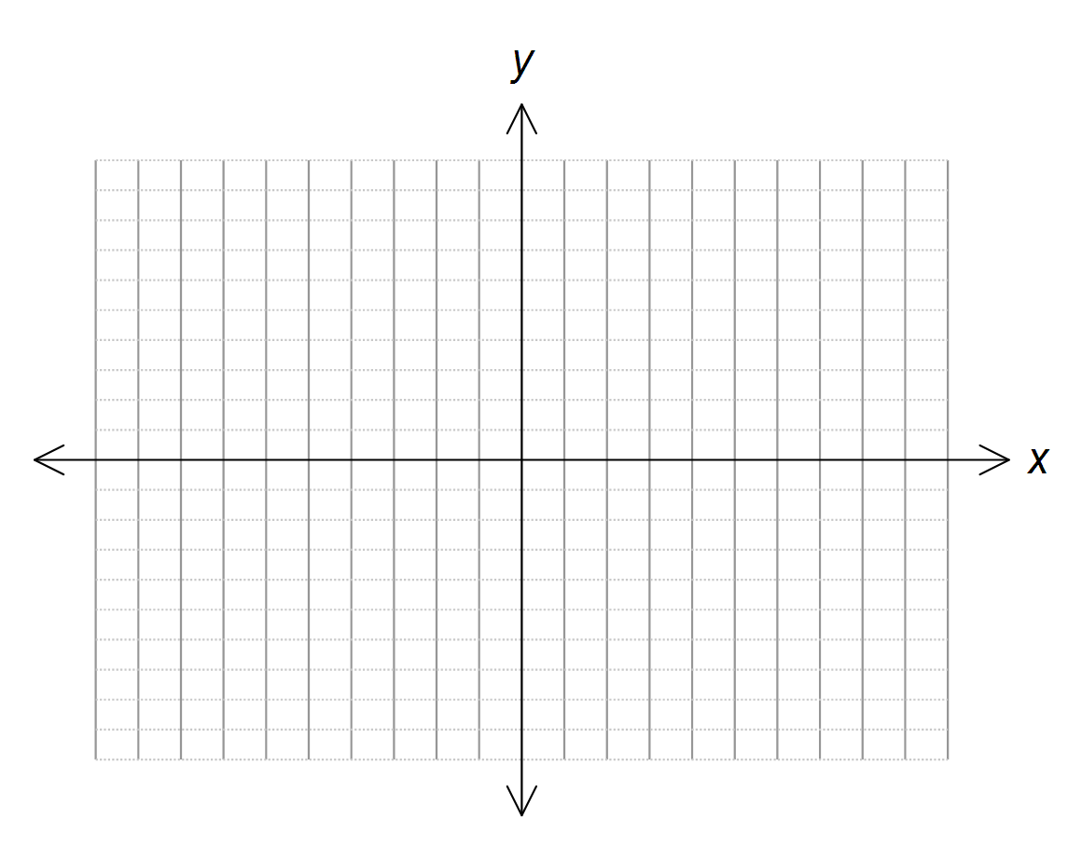

3 marks

**Question 4**

Solve the equation $2×2^{x}-5=\frac{12}{2^{x}}$ for *x*.

3 marks

**Question 5**

If the function *f* has the rule $f\left(x\right)=sinx$ and the function *g* has the rule $g\left(x\right)=\log_{e}x$ state the maximal domain for which $f(g\left(x\right))$ is defined.

2 marks

END OF SAC PART 1

**SACRED HEART GIRLS’ COLLEGE**

**OAKLEIGH**



**Mathematical Methods CAS 2012**

**Unit 3 SAC 2: TEST**

**Name: ________________________________**

**Teacher (please circle)**: Ms Gates Mr Smith

**Part 2: 12 multiple choice questions and 2 extended response questions. 18 Marks**

**CAS and 2 A4 pages of summary notes permitted**

**Reading: 5 minutes**

**Writing: 35 minutes**

**Multiple Choice Section**

**Instructions:**

Answer questions on the Multiple Choice answer sheet provided.

**Question 1**

The equation of the following graph could be

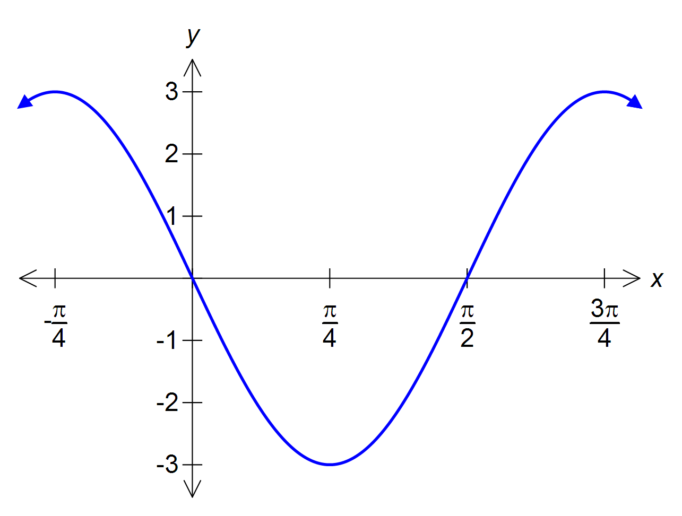

$y=-3sinx$

$y=-\frac{π}{2}sin3x$

$y=3sin2\left(x-\frac{π}{2}\right)$

$y=3cos2\left(x+\frac{π}{4}\right)$

$y=3cos2\left(x-\frac{π}{4}\right)$

**Question 2**

Which of the following does not have an inverse function?

$f\left(x\right)=3x-4, x∈R$

$f\left(x\right)={(x+1)}^{2}-2, x≤0$

$f\left(x\right)=cos\left(\frac{x}{2}\right), 0≤x≤2π$

$f\left(x\right)=2e^{-3x}, x≥0$

$f\left(x\right)=x^{3}, x∈R$

**Question 3**

The *x*-intercept of $y=\frac{1}{2}\log_{e}\left(x-1\right)+3$ is

$\frac{1}{e^{6}}+1$

$e^{-\frac{3}{2}}+1$

$1$

$2e^{-\frac{1}{3}}$

$2e^{-3}+1$

**Question 4**

If the function $f\left(x\right)=\log_{e}(x+3)$ is dilated away from the *x*-axis, which of the following would remain unchanged?

1. The *x*-intercept only
2. The *y*-intercept only
3. The asymptote only
4. The *x*-intercept and the *y*-intercept
5. The *x*-intercept and the asymptote

**Question 5**

If the graph of $y=\log_{e}(x)+3$ is

* translated 2 units in the negative *x* direction
* translated 1 unit in the positive *y* direction
* reflected in the *x*-axis

in that order, the equation of the resulting graph would be

$y=\log_{e}\left(-\left(x+2\right)\right)+2$

$y={-log}_{e}\left(x+2\right)+2$

$y=-\log_{e}(x-2)+2$

$y=-\log_{e}(x+2)-4$

$y=-\log_{e}\left(x+2\right)-2$

**Question 6**

The period of the function with the rule $y=-3tan\left(\frac{2π}{5}(x-2)\right)$ is

$\frac{2π}{5}$

$2$

$\frac{5}{2}$

$5$

$\frac{5π}{2}$

**Question 7**

The transformation T: *R*2 *R*2 is defined by

$$T\left(\left[\begin{matrix}x \\ y\end{matrix}\right]\right)=\left[\begin{matrix}-1 & 0 \\ 0 & 2\end{matrix}\right]\left[\begin{matrix}x \\ y\end{matrix}\right]+\left[\begin{matrix}-2 \\ 2\end{matrix}\right]$$

The equation of the image of the curve with equation ${y=e}^{x}$, under the transformation is given by:

$y=2e^{-(x+2)}-2$

$y=2e^{-(x-2)}-2$

$y=2e^{-x-2}+2$

$y=\frac{1}{2}e^{-x-2}-2$

$y=-2e^{-x+2}+2$

**Question 8**

The sum of the solutions to the equation $10\cos\left(3x\right)=5$ for $x∈[0,π]$ is

$\frac{π}{9}$

$\frac{π}{3}$

$\frac{13π}{18}$

$\frac{13π}{9}$

$\frac{2π}{3}$

**Question 9**

The function $g:\left(-2,∞\right)→R, where g\left(x\right)=2\log_{e}\left(x+2\right)-1$ has an inverse function $g^{-1}.$ The function $g^{-1}(x)$ is given by

$g^{-1}:\left(-2,∞\right)→R, where g^{-1}\left(x\right)=e^{2x+1}+2$

$g^{-1}:\left(-2,∞\right)→R, where g^{-1}\left(x\right)=e^{\frac{x+1}{2}}-2$

$g^{-1}:\left(0,∞\right)→R, where g^{-1}\left(x\right)=e^{\frac{1}{2x+1}}+2$

$g^{-1}:R→R, where g^{-1}\left(x\right)=e^{\frac{x+1}{2}}-2$

$g^{-1}:R→R, where g^{-1}\left(x\right)=e^{2x+1}+2$

**Question 10**

The general solution to the equation $\sin\left(2x\right)=-1$ is

$x=nπ-\frac{π}{4}, n∈Z$

$x=2nπ+\frac{π}{4} or x=2nπ-\frac{π}{4}, n∈Z$

$x=\frac{nπ}{2}+{(-1)}^{n}\frac{π}{2}, n∈Z$

$x=\frac{nπ}{2}+{(-1)}^{n}\frac{π}{4}, n∈Z$

$x=nπ+\frac{π}{4} or x=2nπ+\frac{π}{4}, n∈Z$

**Question 11**

The number of solutions for *x* of the equation $\left|acos⁡(2x)\right|=\left|a\right|,$ where $x∈[-2π,2π]$ and a is a non-zero constant, is

1. 3
2. 4
3. 5
4. 7
5. 9

**Question 12**

The maximal domain, D, of the function $f:D→R$ with rule $f\left(x\right)=\log_{e}\left(\left|x-2\right|\right)+3$ is

$R$

$R\backslash \{-2\}$

$R\backslash \{2\}$

$(2,∞)$

$(-∞,2)$

**EXTENDED RESPONSE**

**Instructions:**

Answer **all** questions in the spaces provided.

In all questions where a numerical answer is required an exact value must be given unless otherwise specified.

In questions where more than one mark is available, appropriate working **must** be shown.

Unless otherwise indicated, the diagrams in this test are **not** drawn to scale.

**Question 1**

The graphs of the functions $f$ and $g$ are shown below. Sketch the graph of $f+g$ on the same set of axes.

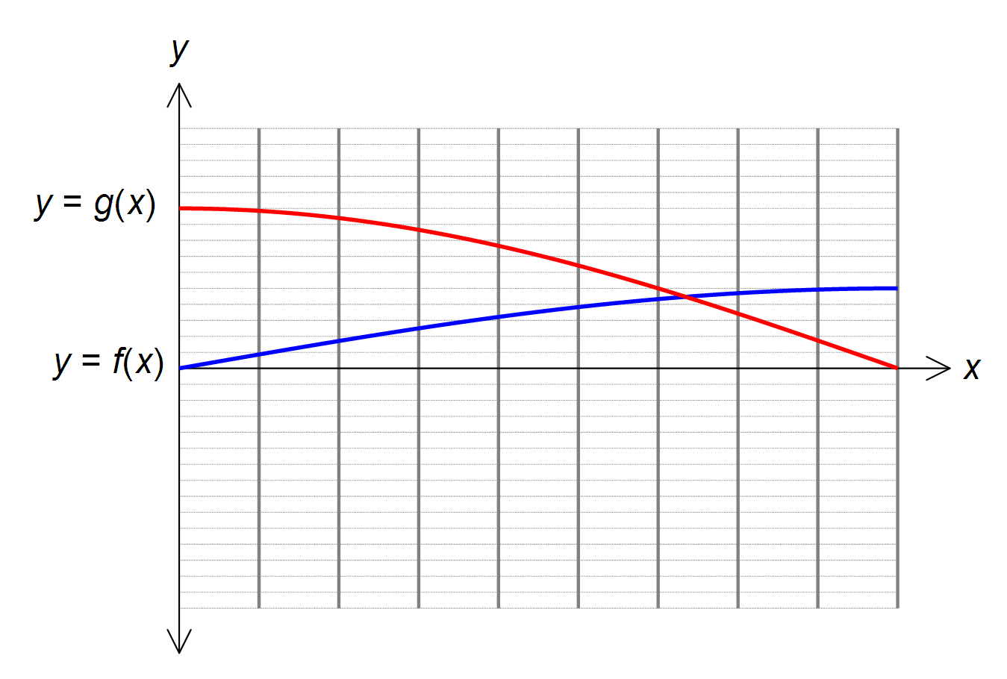

2 marks

**Question 2**

Dorothy Smart the trampolinist trains on a trampoline that is level with the ground and has a pit dug under it. Her height in metres (where 0 metres is level with the ground) as a function of time in seconds can be modelled by

$$h\left(t\right)=-0.5+e^{0.07t}\sin\left(\frac{πt-554}{2}\right)+0.11t, where 0≤t≤27$$

,

1. Correct to one decimal place, what is her initial height?

1 mark

1. Correct to one decimal place, what is the maximum height Dorothy reaches and when does she first reach it?

2 marks

1. Dorothy needs to reach a height of 4 metres above the ground before she can successfully perform a somersault. Correct to one decimal place, when can she first perform a somersault?

1 mark

END OF PART 2