**SACRED HEART GIRLS’ COLLEGE**

**OAKLEIGH**



**Mathematical Methods CAS 2012**

**Unit 3 SAC 3: APPLICATION TASK**

**PART A**

**Name: ________________________________**

**Teacher (please circle)**: Ms Gates Mr Smith

**Part A: 5 extended response questions.**

**Open book, CAS and discussion permitted**

**EXTENDED RESPONSE**

**Instructions:**

Answer **all** questions in the spaces provided.

In all questions where a numerical answer is required an exact value must be given unless otherwise specified.

In questions where more than one mark is available, appropriate working **must** be shown.

Unless otherwise indicated, the diagrams in this test are **not** drawn to scale.

**The Calculator Company: Part 1**

**Question 1 (13 marks)**

After years of using CAS, Alan and Sue, in the twilight of their teaching careers, decide to take some long service leave and travel to the factory where CAS calculators are produced. While in the aeroplane on the way they hear there is a tsunami warning right where the factory is situated. They fear that the waves will reach the factory and decide not to visit, but they listen carefully to the news.

After some measurements by a special tsunami monitoring camera they hear that the distance from the factory’s front door to the water is generally modelled by the function

$D\left(t\right)=asin\left(\frac{πt}{6}\right)+b$ for $0≤t≤12,$

where $D$ is the distance, in metres, from the factory’s front door to the edge of the water, and *t* is the time, in hours after **7am** on **12th March 2011**. *a* and *b* are positive real constants.

1. If two measurements are taken and it is found that *D*(1) = 35 and *D*(12) = 25, show that

*a* = 20 and *b* = 25

2 marks

1. At what distance from the factory’s front door does the water reach at 12 noon and at 5pm.

2 marks

1. There is a monitoring camera fixed at a distance of 10 metres from the factory’s front door. On a particular day, between what times is this monitoring camera covered by water, from 7am to 7pm? Give your answer as times of day, correct to the nearest minute.

2 marks

1. If coordinates of the turning points of the graph of *y* = *D*(*t*) are at (3, *c*) and (9, *d* ) , state the values of *c* and *d*, and hence state the times of day when the water is furthest away from, and is closest to, the factory’s front door.

4 marks

The graph of $y = D(t)$ is dilated by a factor from the *x*-axis to form another function $g(t)$ so that the **vertical** distance between the maximum and minimum distances from the factory’s front door is reduced by a factor of $\frac{1}{2}$.

1. Hence, or otherwise, write down the coordinates of the turning points of the graph with equation $y = g(t)$ and therefore state how long, over the 12 hour period from 7am, the monitoring camera will be covered by water. Give your answer correct to the nearest hour.

3 marks

**Question 2 (15 marks)**

A graph of the form $g\left(x\right)=-ae^{ax}\sin\left(ax\right)+b$ is used to model the fortunes, or otherwise, of the calculator company that sells CAS calculator for students of mathematics in Australia, where $g(x)$ describes the profit that the company makes (in $1,000) for *x* boxes of CAS calculator sales in a given calendar year. *a* and *b* are real constants.

It is found that $g(0) = -1$.

1. Show that $g(0) = b$, and hence that $b = -1$

1 mark

It is also found that $g(10π) = -1$.

1. By substituting $a=\frac{1}{10} ,$ verify that a solution for *a* is $a=\frac{1}{10}$

2 marks

1. Using the values of $b=-1$ and $a=\frac{1}{10}$  , sketch the graph of $g\left(x\right)=-ae^{ax}\sin\left(ax\right)+b$ for the domain 0, 94, clearly labelling the coordinates of the endpoints and axial intercepts, correct to 1 decimal place.

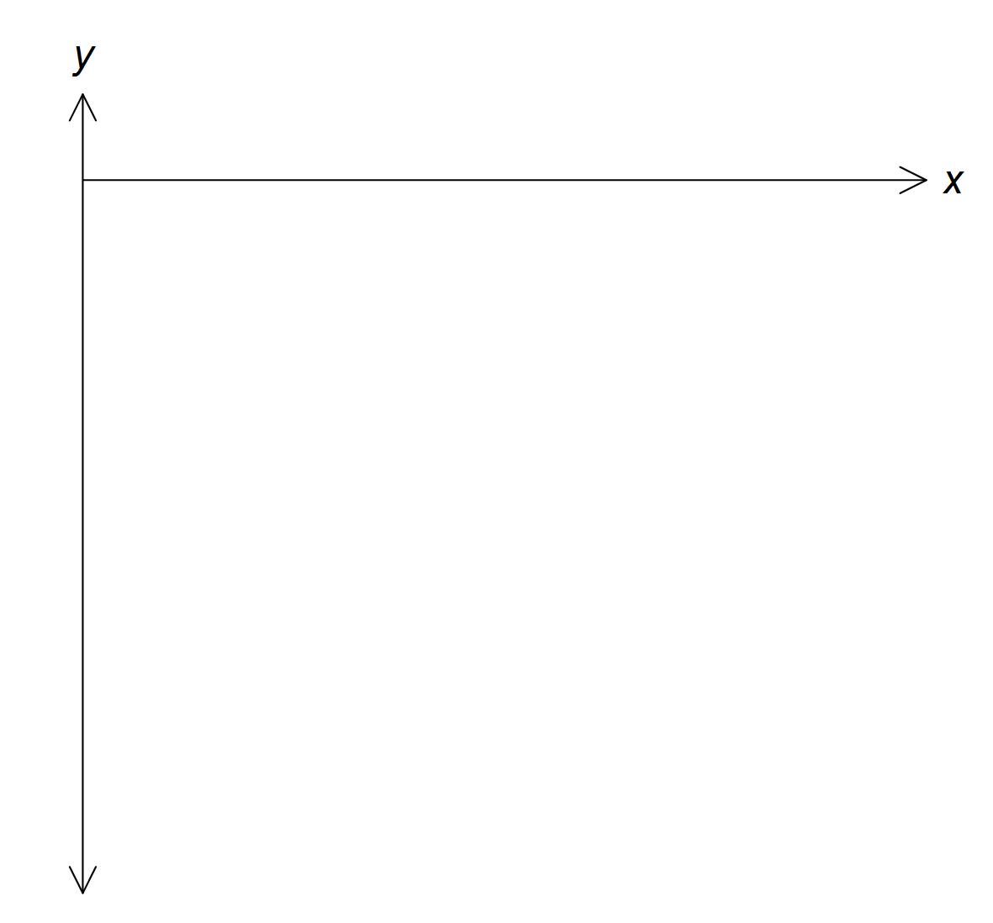

4marks

1. How many boxes of CAS calculators (rounded down to the nearest whole number) do the company sell in a calendar year when they make a loss?

2 marks

1. For the domain $x∈[0,94]$ find the coordinates of the first minimum and maximum point, correct to 1 decimal place, for the function $g\left(x\right)=-\frac{1}{10}e^{\frac{1}{10}x}\sin\left(\frac{1}{10}x\right)-1$

2 marks

1. State the maximum profit that the company can achieve to the nearest dollar, for *x*0, 94.

1 mark

1. Hence state the number of boxes of CAS calculator sales that the company should aim for in a given calendar year in order to achieve a maximum profit.

1 mark

1. The company is struggling to survive and decides to only operate when there is a profit. State, to the nearest number of boxes of CAS calculators when this will happen.

2 marks

**Question 3 (14 marks)**

Alan and Sue hear there is a nuclear power plant that has been damaged by the earthquake.

Although devastated by the news, they are also fascinated by the mathematics involved.

They make up a mathematical model that they think will approximate the progress of the radiation in the soil surrounding the nuclear power plant.

They decide on the function, $N\left(t\right)=c\log_{e}\left(dt+20\right)+100$ where $N(t)$ is the unit measure of radiation in the soil at time *t* days. *c* and *d* are real constants.

1. Sketch a general graph of the function $N(t) = c log (20)+100$, if it is known that *c* is a negative real number. Label the equation of any asymptote and any label any axial intercepts with coordinates.

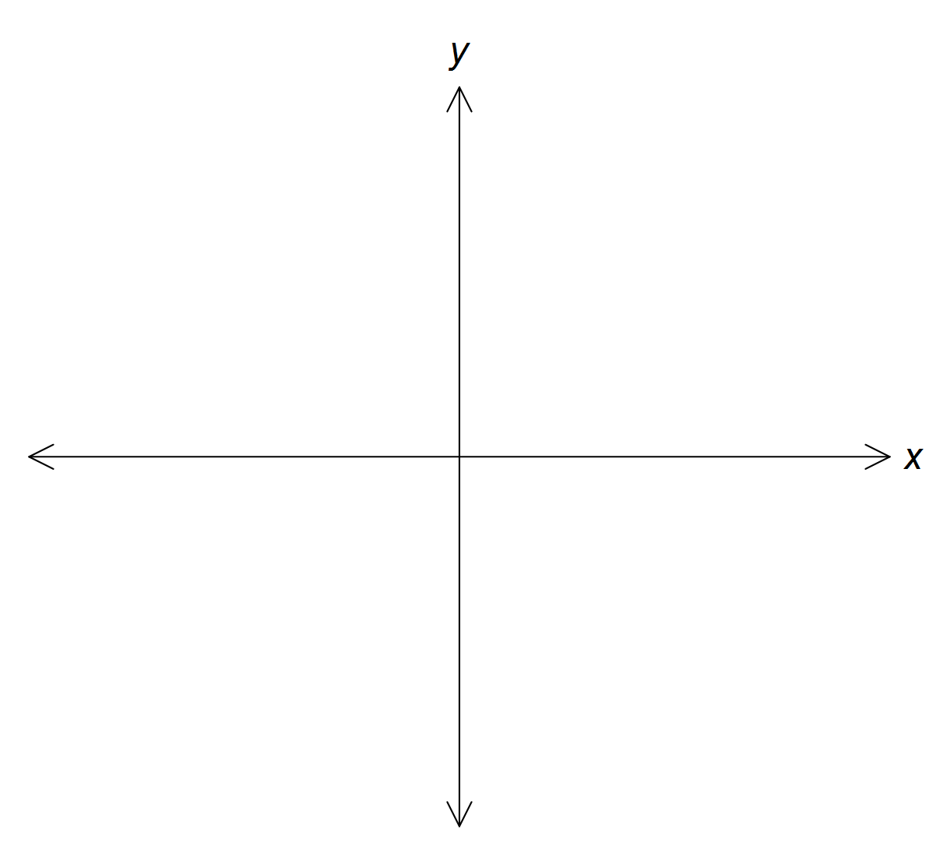

3 marks

Alan and Sue use their marvellous mathematical powers and decide that $c=-13$ and $d=7.$ Also, *t* exists for $t ≥0$, *t* days after the explosion on **12th March, 2011.**

1. Using $c=-13$ and $d=7$, sketch the graph of the function $N\left(t\right)=c\log_{e}\left(dt+20\right)+100$ for $t∈\left[0,100\right].$ Show the equation of any asymptote and the co-ordinates of any exact endpoints that **may** exist within the given domain.

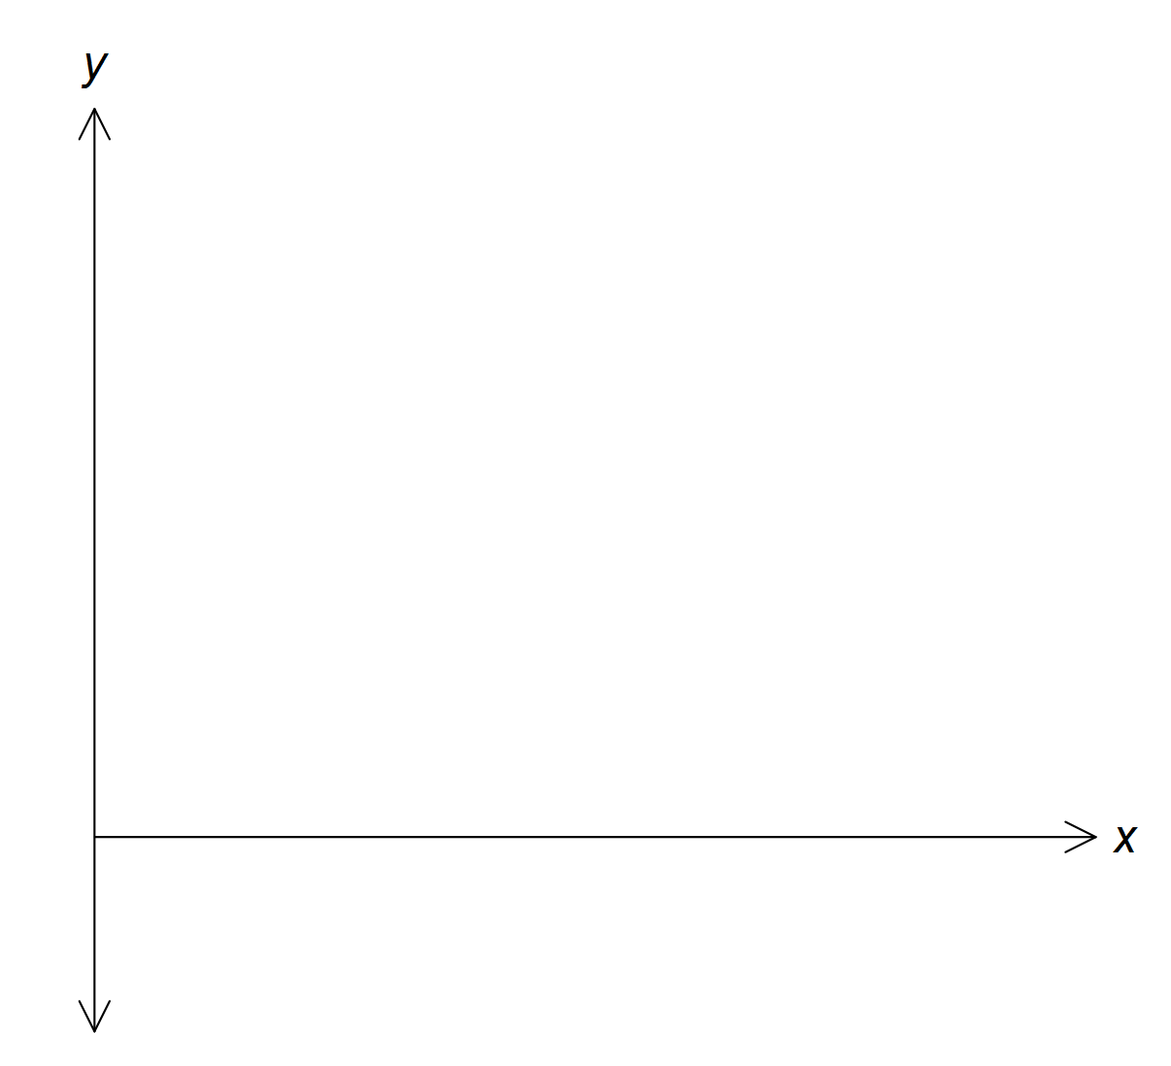

3 marks

1. Government officials are concerned about the level of radiation in the soil and estimate that it is safe to live in the surrounding area when the radiation level is below 16 units. After how many days after the explosion will it be safe to live near the power plant? Express your answer as a whole number.

2 marks

1. Within the domain for $N(t)$ of $t∈\left[0,100\right],$ find the rule and domain for the inverse function $y=N^{-1}\left(t\right).$ Give the domain of the inverse correct to one decimal place.

3 marks

A sketch graph is given of the graphs of $N\left(t\right)=-13\log_{e}\left(7t+20\right)+100$ and the graph of $y={-N}^{-1}\left(t\right)+40$

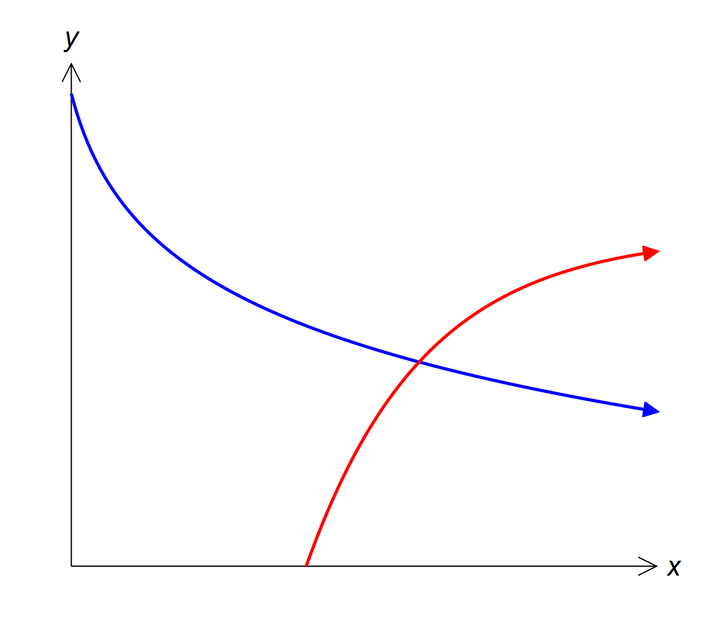

1. A crisis occurs when engineers fail to cool the reactors and another massive explosion occurs. The crisis occurs when $N(t)$ intersects with $y={-N}^{-1}\left(t\right)+40$. Find, correct to one decimal place, the level of radiation at this crisis point and the value of t when this occurs.

2 marks

The situation deteriorates rapidly and Government officials estimate that it is no longer safe to remain in the area when radiation levels reach 30 units.

1. Alan and Sue decide to immediately fly home to Australia when radiation levels reach 29 units. On which day do they fly home?

1 mark

**Question 4 (17 marks)**

While Sue has been home she has decided on a different function to model radioactive decay in the soil surrounding the power plant.

Consider the function $g:\left[0,100\right]→R,g\left(t\right)=60e^{-0.05t}+20.$ where $g(t)$ is the unit measure of radiation in the soil at time *t* days after the explosion on **12th March, 2011.**

1. Find $g(0)$

1 mark

1. Find $g(100)$

1 mark

1. Find the gradient of the straight line that joins the points $(0, 80)$ and $(50, e^{-\frac{5}{2}}+20)$ in the graph of $g\left(t\right).$ Express you answer correct to three decimal places.

2 marks

1. Hence find the point $(a, g(a))$  , where the tangent to the graph of $g(t)$ at $t=a$ is parallel to the line found in part **c).** Give both values correct to 2 decimal places.

3 marks

Alan disagrees with Sue and still likes the model for radiation in the soil, from **Part One,** that is

$N\left(t\right)=-13\log_{e}\left(7x+20\right)+100$, where $N(t)$ is the unit measure of radiation in the soil at time *t* days after the explosion on **12th March, 2011.**

1. Find *N*(0)

1 mark

1. Find $N(100)$

1 mark

1. Find the approximate gradient of the straight line that joins the points $(0, 61.055)$ and $(50, 23.124)$ in the graph of $(t)$. Give your answer correct to 3 decimal places.

2 marks

1. Hence find the point $(a, N(a))$, where the tangent to the graph of $N(t)$ at $t = a$ is parallel to the line found in part **g).** Give both values correct to 2 decimal places.

3 marks

1. State the average rate of change from $t = 0$ to $t = 50$ for both functions, $g(t)$ and $N(t)$.

2 marks

1. Using this information in part **i)** show that Alan’s model has a slower reduction in radiation than Sue’s new model.

1 mark

Question 5

A water pipe to cool the reactor is modelled by a quadratic in the form $f\left(x\right)=A{(x-30)}^{2}+10$.

1. If the pipe starts 35 metres above the ground find the value of A.

2 marks

1. Express $f\left(x\right)$ in the form $ax^{2}+bx+c.$

1 mark

1. What is the initial gradient of the pipe?

1 mark

The engineers at the plant decide to increase the initial gradient of the pipe to $-2.$

1. For the function $g\left(x\right)=ax^{2}+bx+c$ find the value of b required to obtain this initial gradient.

1 mark

1. Find the values of *a* and *c,* so that this function also has a minimum at the same point as the original track and hence write the rule for $g\left(x\right).$

3 marks

1. The first section of the track is to finish at the point B where the gradient is 1. Find the

coordinates of B and hence write down the domain of $g\left(x\right).$

3 marks

A second section of the track is modelled by the function: $g(x) = ax^{2} + bx + c$ and must join smoothly with the first section at B and pass through the point C with coordinates $\left(75, 25\right).$

1. Find the exact values of the coefficients and hence the rule for *g*(*x*) which fulfils these requirements.

3 marks