**SACRED HEART GIRLS’ COLLEGE**

**OAKLEIGH**



**Mathematical Methods CAS 2012**

**Unit 4 SAC 4: ANALYSIS TASK**

**PART A**

**Name: ________________________________**

**Teacher (please circle)**: Ms Gates Mr Smith

**Part A:**

**Section 1: 4 short answer questions**

**(no notes, no calculator)**

**Section 2: 1 extended response question.**

**(notes and calculator permitted)**

**Reading: 5 minutes**

**Writing: Section 1: 20 minutes Section 2: 20 minutes**

**Marks: 30**

**SECTION 1: SHORT ANSWER QUESTIONS**

**Instructions:**

Answer **all** questions in the spaces provided.

In all questions where a numerical answer is required an exact value must be given unless otherwise specified.

In questions where more than one mark is available, appropriate working **must** be shown.

Unless otherwise indicated, the diagrams in this test are **not** drawn to scale.

Question 1

1. Differentiate $x^{3}e^{2x}$ with respect to $x.$

2 marks

1. For $f\left(x\right)=\log_{e}(x^{2}+1)$ find $f^{'}\left(2\right).$

2 marks

Question 2

For the graph of $y=xe^{-2x}$ find:

1. The gradient at $x=1.$

2 marks

1. The equation of the normal to the graph at $x=1.$

2 marks

Question 3

1. Use the relationship $f\left(x+h\right)≈f\left(x\right)+hf'(x)$ for a small positive value of *h*, to find an approximate value for $\sqrt[3]{8.06}.$

3 marks

1. Explain why this approximation value is greater than the exact value for $\sqrt[3]{8.06}$.

1 mark

Question 4

A wine glass is being filled with wine at a rate of 8 cm3/s. The volume, *V* cm3, of wine in the glass when the depth of wine in the glass is *x* cm is given by $V=4\sqrt{x^{3}}$. Find the rate at which the depth of wine in the glass is increasing when the depth is 4 cm.

3 marks

**Name: ________________________________**

**Teacher (please circle)**: Ms Gates Mr Smith

**SECTION 2: EXTENDED RESPONSE**

**Instructions:**

Answer **all** questions in the spaces provided.

In all questions where a numerical answer is required an exact value must be given unless otherwise specified.

In questions where more than one mark is available, appropriate working **must** be shown.

Unless otherwise indicated, the diagrams in this test are **not** drawn to scale.

Question 1

The graph of $f:\left(-π,π\right)∪\left(π,3π\right)→R, f\left(x\right)=tan\left(\frac{x}{2}\right)$ is shown below.

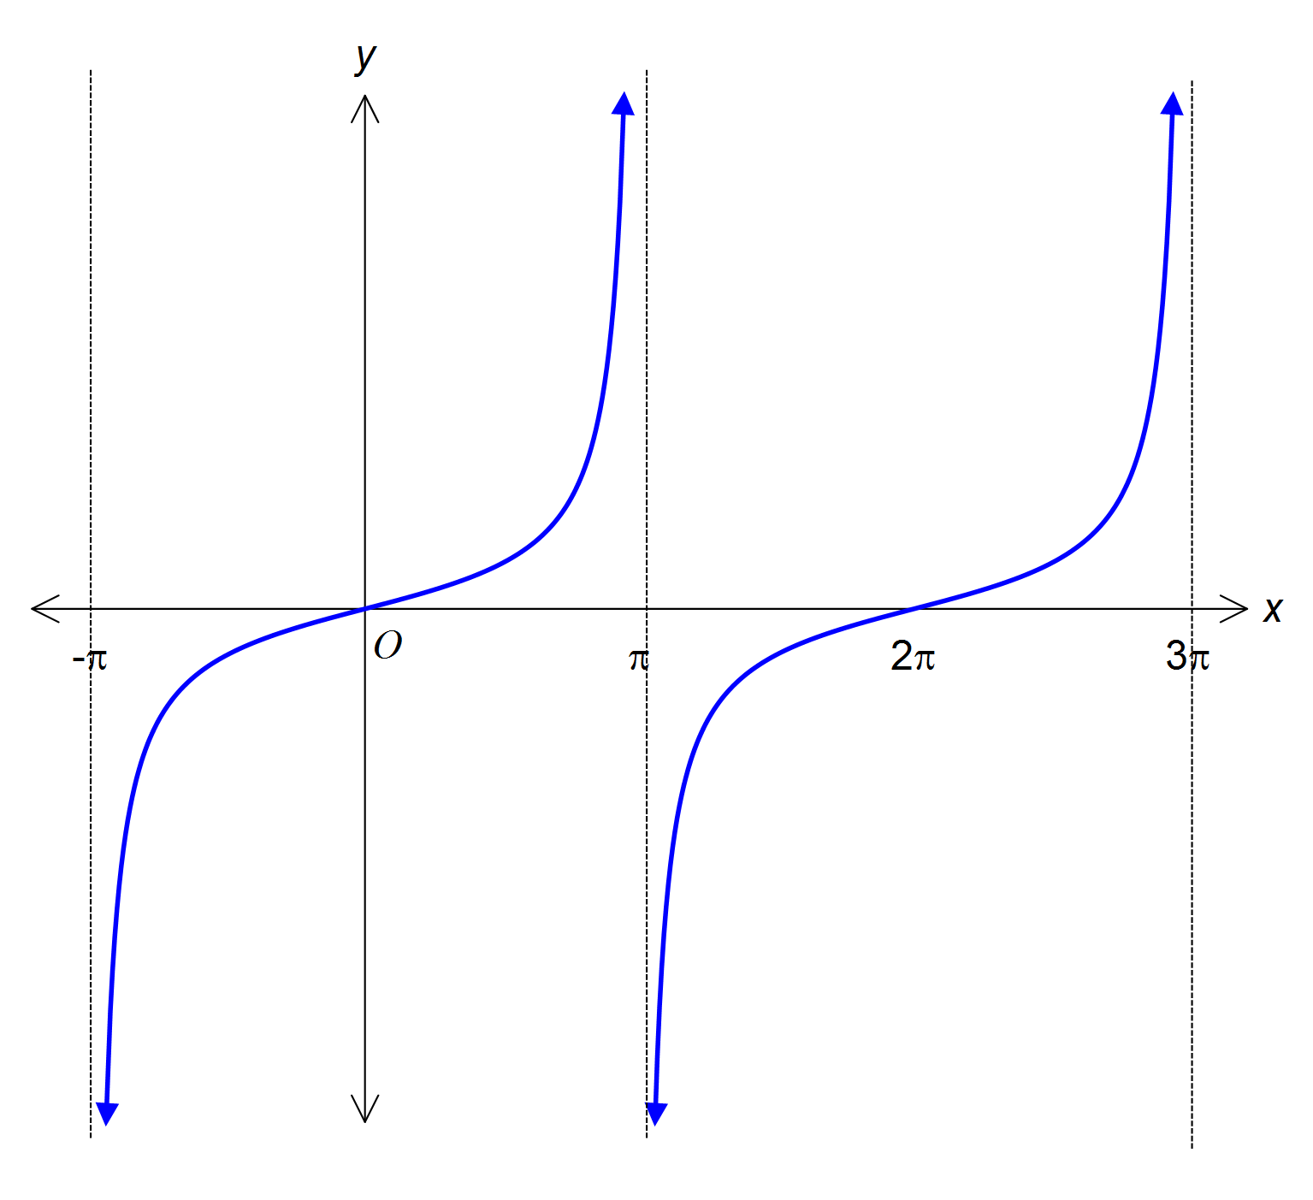

1. Find $f'\left(\frac{π}{2}\right)$.

1 mark

1. Find the equation of the normal to the graph of $y=f(x)$ at the point where $x=\frac{π}{2}$.

2 marks

1. Sketch the graph of this normal on the axes above. Give the exact axis intercepts.

2 marks

1. Find the exact values of $x∈(-π,π)∪(π,3π)$ such that $f^{'}\left(x\right)=f\left(\frac{π}{2}\right)$.

2 marks

Question 2

An open water trough is in the shape of a semi-cylinder with length, *l*, and radius, *r*, as shown below.

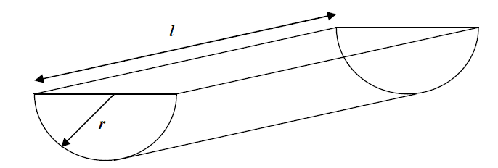

1. If the volume of the trough is 62500 cm3,
2. Show that the length of the trough, *l*, in terms of *r* is $l=\frac{125000}{r^{2}}$

1 mark

1. Show that the external surface area of the trough in terms of *r* is

$A=πr^{2}+\frac{125000π}{r}$

1 mark

1. Find the exact value of *r* for which the external surface area is a minimum.

2 marks

1. Find the minimum external surface area correct to the nearest cm2.

1 mark

1. If the length is 75 cm, find *r*, correct to two decimal places.

1 mark

1. Find the rate of change of the external surface area with respect to the radius when *l*=75 cm, correct to two decimal places.

2 marks

END OF PART A