

**SACRED HEART GIRLS’ COLLEGE**

**OAKLEIGH**



**Mathematical Methods CAS 2013**

**Unit 3 SAC 2: TEST**

**Part A**

**Name: ________________________________**

**Teacher (please circle)**: Ms Gates Mr Smith Mrs Mak

**No CAS and no summary notes permitted**

**Part A: 5 short answer questions**

**Writing Time: 20 minutes**

**Marks: 14**

**SHORT ANSWER QUESTIONS**

**Instructions:**

Answer **all** questions in the spaces provided.

In all questions where a numerical answer is required an exact value must be given unless otherwise specified.

In questions where more than one mark is available, appropriate working **must** be shown.

Unless otherwise indicated, the diagrams in this test are **not** drawn to scale.

**Question 1**

Solve the equation  for all *x*.

*_______________________________________*_______________________________________________________________________________________________________________________________________________________________________________________________________________________________________________________________________________________________________________________________________________________________________________________________________________________________________________________________________________________________________________________________________________________________________________________________________________

______________________________________________________________________

3 marks

**Question 2**

Solve the equation 

______________________________________________________________________________________________________________________________________________________________________________________________________________________________________________________________________________________________________________________________________________________________________________________________________

2 marks

**Question 3**

The unhealed area,  cm, of a particular wound, days after it was sustained, is given by the function 

According to this model, what is the time required for the area of unhealed wound to be halved?

____________________________________________________________________________________________________________________________________________________________________________________________________________________________________________________________________________________________________________________________________________________________________________________________________________________________________________________________________________________________________________________________________________________________________________________________________________________________________________________________________________________________________________________________________________________________________________________________________________

3 marks

**Question 4**

Show that 

____________________________________________________________________________________________________________________________________________________________________________________________________________________________________________________________________________________________________________________________________________________________________________________________________________________________________________________________________________________________________________________________________________________________________________________________________________________________________________________________________________________________________________________________

2 marks

**Question 5**

For the function 

Sketch the graph of the function *f* on the set of axes below. Find the amplitude and period and label axes intercepts as well as endpoints with their coordinates

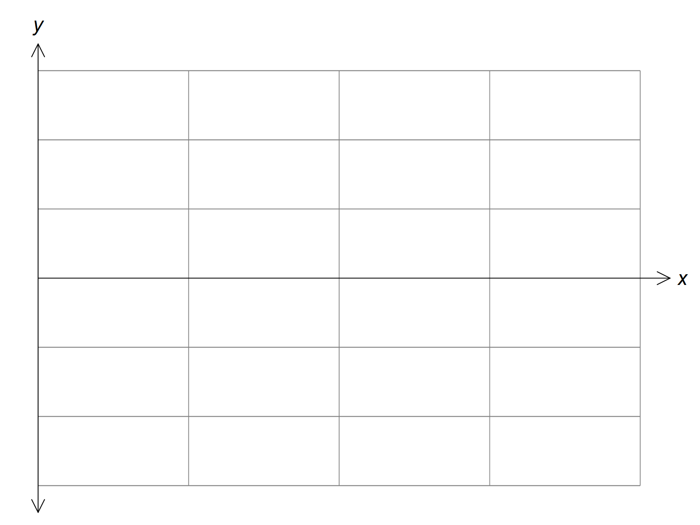

____________________________________________________________________________________________________________________________________________________________________________________________________________________________________________________________________________________________________________________________________________________________________________________________________________________________________

4 marks

**END PART A**