**SACRED HEART GIRLS’ COLLEGE**

**OAKLEIGH**



**Mathematical Methods CAS 2014**

**Unit 3 SAC 2: TEST**

**Part B**

**Name: ________________________________**

**Teacher (please circle)**: Ms Gates Mr Smith Ms Garkel

**Part B: 4 multiple choice questions and 2 extended response questions.**

**CAS and a bound reference of summary notes permitted**

**Writing Time: 25 minutes**

**Marks: 14**

**MULTIPLE CHOICE**

**Instructions:**

Answer **all** questions in pencil on the answer sheet provided for multiple-choice questions.

Choose the response that is **correct** for that question.

A correct answer scores 1, an incorrect answer scores 0.

Marks will **not** be deducted for incorrect answers.

No marks will be given if more than one answer is completed for any question.

**Only the answers on the Answer Sheet will be marked.**

**Question 1**

If $y=\log_{m}\left(6x-n\right)+5$, then $x$ is equal to



$\frac{1}{6}m^{y-5}+n$

$\frac{1}{6}\left(m^{y}-5\right)+n$

$\frac{1}{6}{(m}^{y-5}+n)$

$m^{y-5}-\frac{n}{6}$

$\frac{y-5}{\log_{m}(6-n)}$

**Question 2**

The range of the function $f:\left[0,π\right]→R,f\left(x\right)=-3\sin\left(2\left(x-\frac{π}{6}\right)\right)+1$ is

$\left[1,∞)\right.$

$\left[-3,1\right]$

$R$

$\left[-∞,1)\right.$

$\left[-2,4\right]$

**Question 3**

The temperature, in degrees Celsius, of a public swimming pool is given by the equation

$T=21-4\cos\left(\frac{πt}{12}\right)$, where $t$ is the number of hours after midnight. The time(s) during the day when the temperature would be $25℃$ are

1. midnight and noon
2. midnight only
3. noon only
4. 8 a.m. and 4 p.m.
5. 6 a.m. and 6 p.m.

**Question 4**

Let $f:\left(-\frac{π}{2},\frac{π}{2}\right)→R,f\left(x\right)=\sin{(2x)}$

The graph of $y=f(x)$ is transformed by a dilation of factor 2 from the $x$-axis, followed by a dilation of factor 2 from the $y$-axis, then a translation of $π$ units in the positive $x$ direction.

The resulting function $g$, is given by

$g:\left(-\frac{π}{2},\frac{π}{2}\right)→R, g\left(x\right)=\sin\left(\frac{x-π}{2}\right)$

$g:\left(0,π\right)→R, g\left(x\right)=\sin\left(\frac{x-π}{2}\right)$

$g:\left(0,2π\right)→R, g\left(x\right)=2\sin{(x-π)}$

$g:\left(0,2π\right)→R, g\left(x\right)=\sin\left(\frac{x-π}{2}\right)$

$g:\left(0,π\right)→R, g\left(x\right)=2\sin{(x+π})$

**Question 5**

The following graph could have an equation of

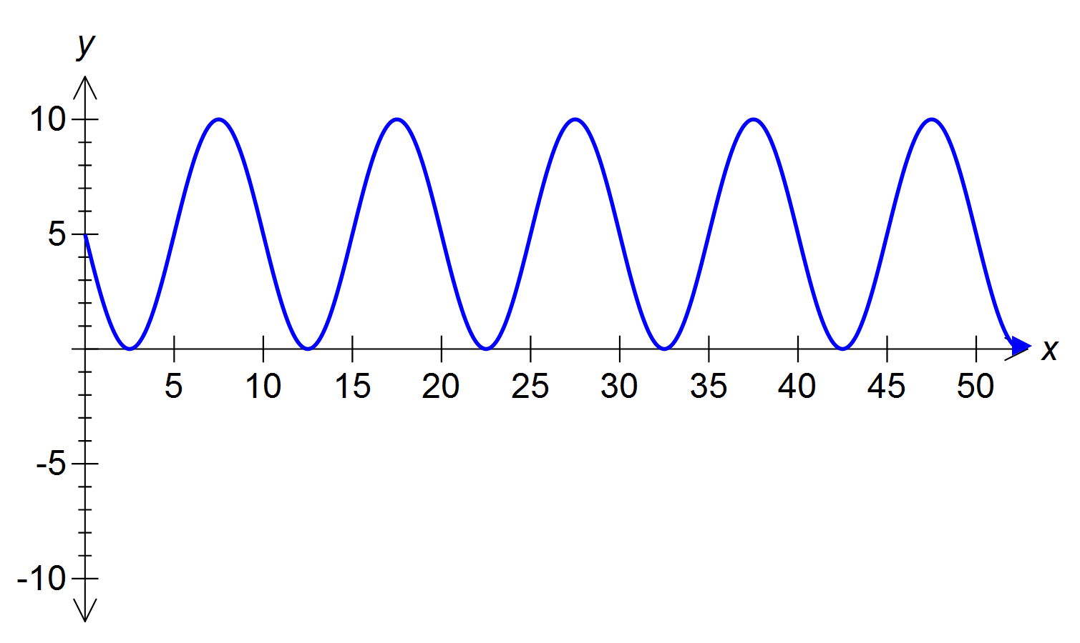

$y=10\sin\left(x\right)$

$y=5-5\sin{(\frac{πx}{5}})$

$y=\cos{5πx}$

$y=5+\cos{(\frac{-x}{5}})$

$y=10-\sin{5x}$

**EXTENDED RESPONSE**

**Instructions:**

Answer **all** questions in the spaces provided.

In all questions where a numerical answer is required an exact value must be given unless otherwise specified.

In questions where more than one mark is available, appropriate working **must** be shown.

Unless otherwise indicated, the diagrams in this test are **not** drawn to scale.

(9 marks)

There are two different species of shark, Gummy shark and White Pointer shark, in the ocean near Tweed Heads, being monitored by marine biologists. The population of these sharks is modelled by the equations:

Gummy shark, $G\left(t\right)=400+100\sin\left(\frac{πt}{2}\right)$

White Pointer shark, $W\left(t\right)=500+200\cos{(πt)}$

where $t$ is the time in years from when the biologists started on the project.

1. State the period of $G(t)$ 1 mark
2. What is the maximum number of White Pointer sharks that would be recorded at any time according to this model? 1 mark
3. How many months does it take for the population of Gummy sharks to first reach 450?

2 marks

1. Find the period of time, during the first two years of the project, for which the number of White Pointer sharks exceeds the number of Gummy sharks. Give your answer in years, correct to two decimal places. 2 marks
2. The marine biologists are concerned that the White Pointer sharks will become too dominant at times. They wish to establish what percentage of the time in the first four years that the White Pointer sharks would be at least 200 more in number than the Gummy sharks. Calculate this percentage correct to the nearest whole number. 3 marks

**END OF QUESTION AND ANSWER BOOKLET**