

2017 TRIAL EXAMINATION 2

UNITS 3&4

**STUDENT NAME**

|  |  |  |  |  |  |  |  |  |  |  |  |  |  |  |  |  |  |  |  |  |
| --- | --- | --- | --- | --- | --- | --- | --- | --- | --- | --- | --- | --- | --- | --- | --- | --- | --- | --- | --- | --- |
| First Name |  |  |  |  |  |  |  |  |  |  |  |  |  |  |  |  |  |  |  |  |
| Last Name |  |  |  |  |  |  |  |  |  |  |  |  |  |  |  |  |  |  |  |  |

**MATHEMATICAL METHODS**

**Written examination 2**

**2017**

**Reading time: 15 minutes**

**Writing time: 2 hours**

**QUESTION AND ANSWER BOOK**

**Structure of book**

|  |  |  |  |  |
| --- | --- | --- | --- | --- |
| *Section* | *Number of*  *questions* | *Number of questions*  *to be answered* |  | *Number of*  *marks* |
| A | 20 | 20 |  | 20 |
| B | 6 | 6 |  | 60 |
|  |  |  | Total | 80 |

* Students are permitted to bring into the examination room: pens, pencils, highlighters, erasers, sharpeners, rulers, a protractor, set squares, aids for curve sketching, one bound reference, one approved technology (calculator or software) and, if desired, one scientific calculator. Calculator memory DOES NOT need to be cleared. For approved computer-based CAS, full functionality may be used.
* Students are NOT permitted to bring into the examination room: blank sheets of paper and/or

correction fluid/tape.

**Materials supplied**

* Question and answer book of 26 pages.
* Working space is provided throughout the book.

**Instructions**

* Write your **name** in the space provided above on this page.
* Unless otherwise indicated, the diagrams in this book are **not** drawn to scale.
* All written responses must be in English.

**Students are NOT permitted to bring mobile phones and/or any other unauthorised electronic devices into the examination room.**

**THIS PAGE IS BLANK**

VCE Examination cover content © VCAA; used with permission. The VCAA does not endorse this publication and makes no warranties regarding the correctness or accuracy of its content. Current and past VCAA exams and related content can be accessed directly at www.vcaa.vic.edu.au

**SECTION A**

**Instructions for Section A**

Answer **all** questions on the answer sheet provided for multiple-choice questions.

Choose the response that is **correct** for the question.

A correct answer scores 1, an incorrect answer scores 0.

Marks will **not** be deducted for incorrect answers.

No marks will be given if more than one answer is completed for any question.

Unless otherwise indicated, the diagrams in this book are **not** drawn to scale.

**Question 1**

The period of the function is

**A.** 

**B.** 

**C.** 

**D.** 

**E.** 

**Question 2**

The range of the linear function *f* : *D* → *R* with rule *f* (*x*) = *x* – 5 is [−8, 3).

The domain, *D*, of *f* (*x*) is

**A.** (3, 8]

**B.** (−8, 3]

**C.** [−8, 3)

**D.** [−3, 8)

**E.** (−3, 8]

**Question 3**

Consider the function *f* (*x*), where *f* (−*f* (*x*)) = −*x* for all *x* ∈*R*.

How many of the following functions satisfy the functional equation above.

*f* (*x*) = *x* + 1,  *f* (*x*) = *x*, *f* (*x*) = *x*3, *f* (*x*) = *e*− *x*, *f* (*x*) = *x* − 1

**A.** 1

**B.** 2

**C.** 3

**D.** 4

**E.** 5

**SECTION A** –continued

**TURN OVER**

**Question 4**

Consider the transformation  with rule .

The transformation *T* maps the line with equation  to the line with equation

**A.** 4*x* + *y* = 8

**B.** 4*x* – *y* = − 6

**C.** − 4*x* – *y* = − 8

**D.** − 2*x* – *y* = 8

**E.** 2*x* + *y* = − 6

**Question 5**

A point *P*(2, −7) is translated three units to the left and dilated by a factor of five from the *y* – axis.

The coordinates of the image point of *P* after the two transformations have been applied to point *P* are

**A.** (−5, −7)

**B.** (−1, −7)

**C.** (−1, −35)

**D.** (5, −7)

**E.** (5, −35)

**Question 6**

Consider two independent events, *A* and *B*.

If Pr(*B*) = *k* and Pr(*A*') = 0.4, then the probability Pr(*A* ∪ *B*), in terms of *k* is

**A.** 0.4 + 0.6*k*

**B.** 0.6 + *k*

**C.** 1.2*k*

**D.** *k*

**E.** 0.6 + 0.4*k*

**Question 7**

Consider that .

The value of  is

**A.** −7

**B.** 12

**C.** 13

**D.** 14

**E.** 25

**SECTION A** –continued

**Question 8**

One of the factors of the polynomial *P*(*x*) = (3*p* + 1)*x*3 – 31*x*2 + *x* + 2*p* is (*x* – *p*), where *p* is a real positive integer.

The value(s) of *p* is (are)

**A.** 

**B.** 

**C.** 

**D.** 

**E.** 

**Question 9**

Consider the system of simultaneous linear equations given below.



The value of *k* for which the system of simultaneous linear equations has **infinitely many solutions** is

**A.** *k* = −3

**B.** *k* = −2

**C.** *k* = 1

**D.** *k* = 3

**E.** *k* = 4

**Question 10**

Two students have to be chosen at random from a group of seven students. The seven students have been allocated a unique number from 1 to 7. Two numbers are drawn without replacement.

The probability that the two numbers are either both odd or both even is

**A.** 

**B.** 

**C.** 

**D.** 

**E.** 

**SECTION A** –continued

**TURN OVER**

**Question 11**

From a random sample of 148 year 12 students from the whole cohort of year 12 students, 31% have expressed their intention of taking a year off when they finish year 12.

A 95% confidence interval for the proportion of the whole cohort of students who intend to take a year off when they finish year 12, is given by

**A.** 

**B.** 

**C.** 

**D.** 

**E.** 

**Question 12**

A tangent to the graph of the function *f* (*x*) = log*e*(*kx*), where *x* > 0, is drawn at *x* = *p*.

If the tangent at *x* = *p* has a gradient of  and passes through the point (0, −1), then the values of *p* and *k* are

**A.** 

**B.** 

**C.** 

**D.** 

**E.** 

**SECTION A** –continued

**Question 13**

Consider the function *f* : [*a*, *b*] → *R* with rule . The range of *f* (*x*) is [−3, 3].

The minimum positive value of *a* and the maximum positive value of *b* for which *f* (*x*) has an inverse function are respectively

**A.** 

**B.** 

**C.** 

**D.** 

**E.** 

**Question 14**

Bern is a tennis player and he is practising for an upcoming tennis tournament. From past records, his serve is a fault 3 times in 25 serves.

If he practises his serving skills 75 times, the expected number of correct serves is

**A.** 9

**B.** 11

**C.** 22

**D.** 66

**E.** 88

**Question 15**

The probability density function for the continuous random variable *X* is given by



where *a* is a real positive integer.

The value(s) of *a* is/are

**A.** −

**B.** {−1, −}

**C.** {1, }

**D.** 

**E.** 1

**SECTION A** –continued

**TURN OVER**

**Question 16**

Julia is in year 12 and drives to school only when it rains. When it rains, Julia arrives at school on time 80% of the time while when it does not rain she arrives late at school 24% of the time.

* Let *D* be the event Julia drives to school
* Let *L* be the event Julia arrives at school late

If Pr(*D*) = 0.35, then which one of the following is **not** true?

**A.** Pr(*D* ∩ *L*′) = 0.44

**B.** Pr(*L*) = 0.226

**C.** Pr(*D*′) = 0.65

**D.** Pr(*L* | *D*′) = 0.24

**E.** Pr(*D*′ ∩ *L*′) = 0.494

**Question 17**

The parallelogram *ABCD* shown below has side lengths *a* and *b*. The size of the obtuse angle *BCD* is *x* radians.

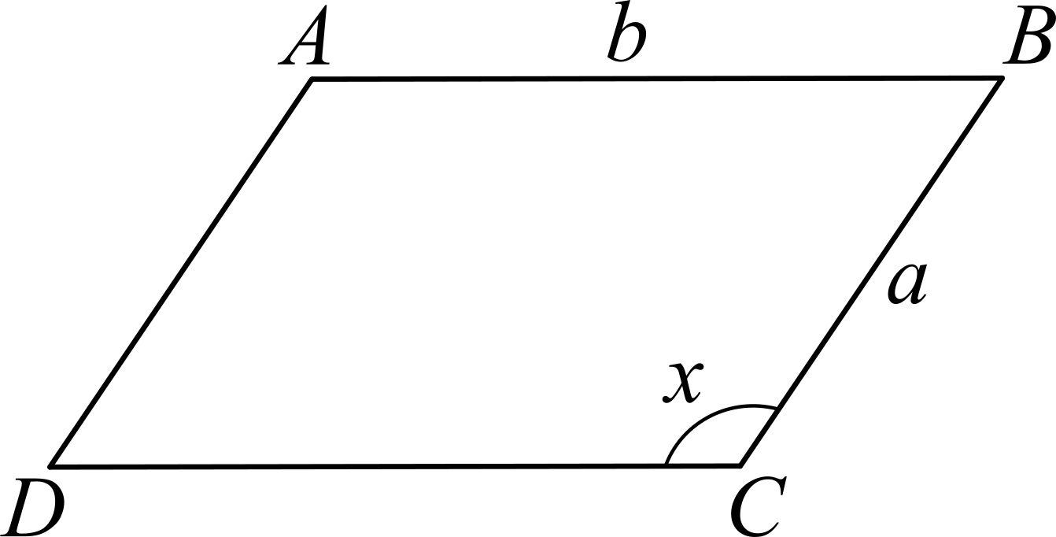

The value of *x* for which the area of the parallelogram is a maximum is

**A.** 

**B.** 

**C.** 

**D.** 

**E.** 

**Question 18**

A songwriter has written a number of songs. The length, in minutes, of each song may be modelled by a normal distribution of mean 5.2 and standard deviation of 1.2. The length of one song is independent of the lengths of all the other songs.

The probability that a song has length between 3.7 minutes and 6.4 minutes is

**A.** 0.1522

**B.** 0.2016

**C.** 0.2643

**D.** 0.6987

**E.** 0.7357

**SECTION A** –continued

**Question 19**

Part of the graph with rule  is shown in the diagrams below.

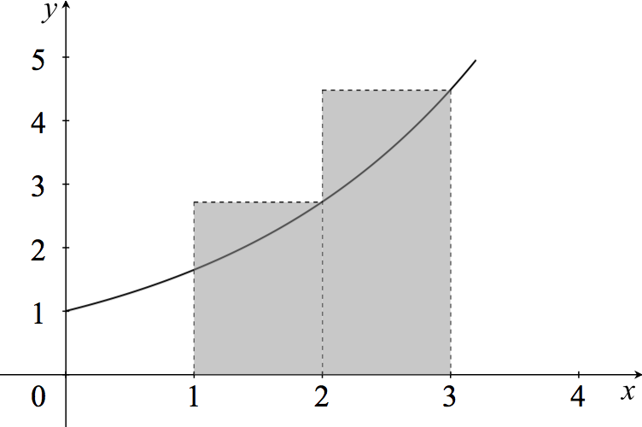 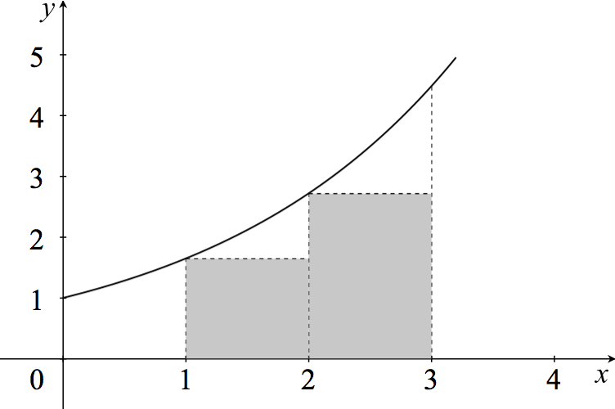

Area 1 Area 2

The difference between the two areas, Area 1 – Area 2, is

**A.** 

**B.** 

**C.** 

**D.** 

**E.** 

**Question 20**

Let *f* : *R* → *R* be a differentiable function with a gradient function as shown in the graph below.

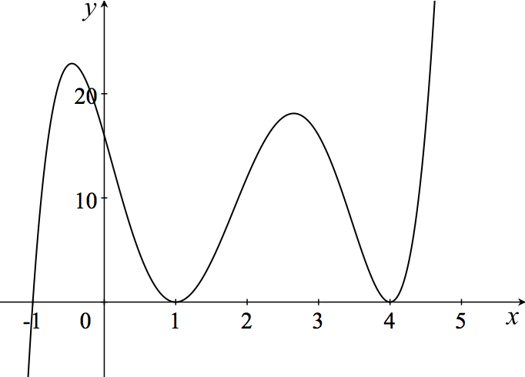

*f* (*x*) is strictly increasing for

**A.** *x* ∈(−1, ∞)\{1, 4}

**B.** *x* > 0

**C.** *x* = {−1, 1, 4}

**D.** *x* > 3

**E.** *x* ∈[−1, 4]

**END OF SECTION A**

**TURN OVER**

**THIS PAGE IS BLANK**

**SECTION B**

**Instructions for Section B**

Answer **all** questions in the spaces provided.

In all questions where a numerical answer is required, an exact value must be given unless otherwise specified.

In questions where more than one mark is available, appropriate working **must** be shown.

Unless otherwise indicated, the diagrams in this book are **not** drawn to scale.

**Question 1** (8 marks)

A gift box is made out of cardboard in the shape of a hexagonal prism. The shape of the hexagonal base is shown in the diagram below. All measurements are in centimetres.

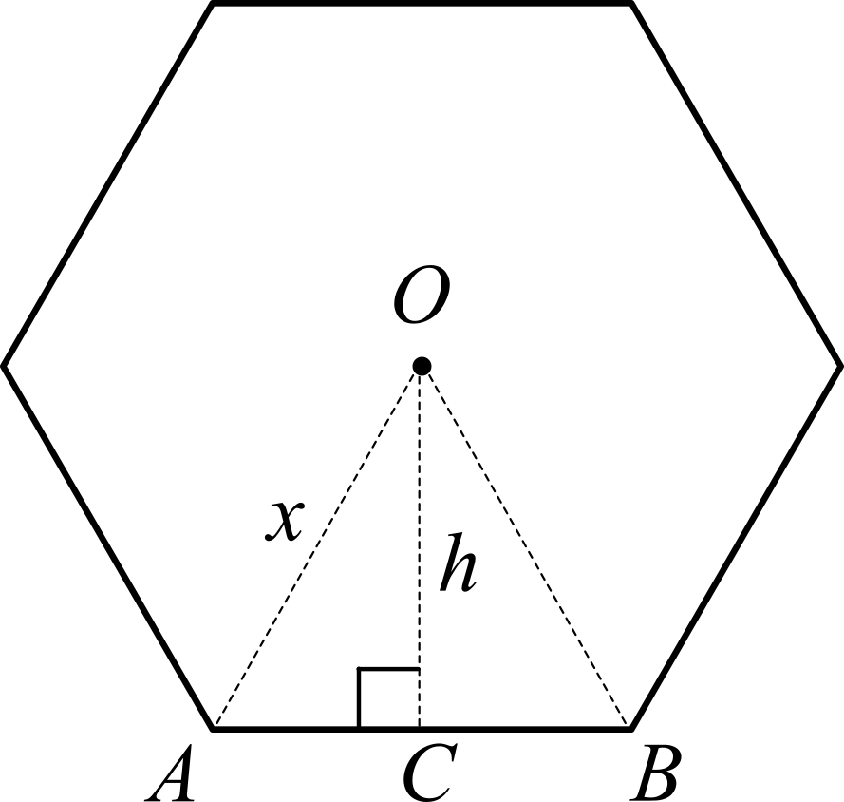

**a.** Show that the height of Δ*OAB*, in terms of *x*, is equal to . 1 mark

____________________________________________________________________________

____________________________________________________________________________

____________________________________________________________________________

____________________________________________________________________________

____________________________________________________________________________

____________________________________________________________________________

____________________________________________________________________________

____________________________________________________________________________

**SECTION B** – **Question 1** – continued

**TURN OVER**

**b.** Show that the area of the hexagon, in terms of *x*, is . 2 marks

____________________________________________________________________________

____________________________________________________________________________

____________________________________________________________________________

____________________________________________________________________________

____________________________________________________________________________

____________________________________________________________________________

____________________________________________________________________________

____________________________________________________________________________

The gift box is shown in the diagram below, where the height of the hexagonal prism is *H*.

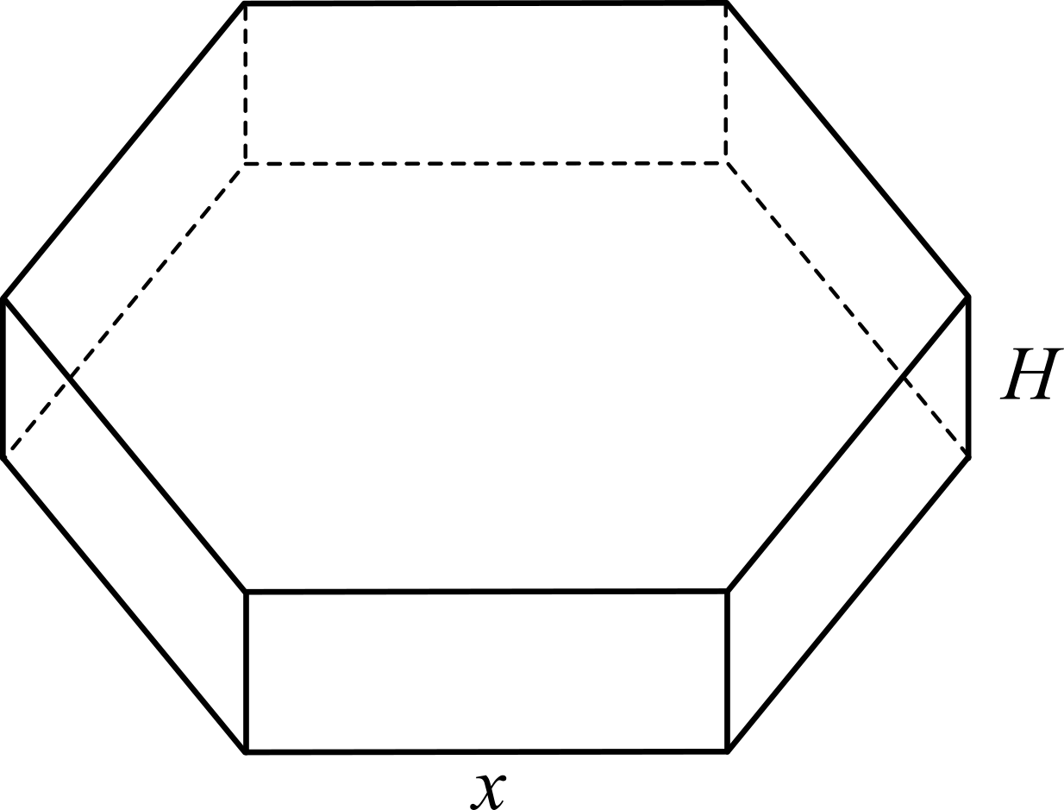

**c.** If the volume of the box, , determine an expression for the height, *H*, of the box. 1 mark

____________________________________________________________________________

____________________________________________________________________________

____________________________________________________________________________

____________________________________________________________________________

____________________________________________________________________________

**SECTION B** – **Question 1** – continued

**d.** Determine all possible values of *x*. 1 mark

____________________________________________________________________________

____________________________________________________________________________

____________________________________________________________________________

____________________________________________________________________________

____________________________________________________________________________

**e.** Calculate the value of *x* for which the volume of the box, *V*(*x*), is a maximum.

Give your answer in exact form. 2 marks

____________________________________________________________________________

____________________________________________________________________________

____________________________________________________________________________

____________________________________________________________________________

____________________________________________________________________________

____________________________________________________________________________

____________________________________________________________________________

____________________________________________________________________________

____________________________________________________________________________

**f.** What is the value of *H* for a gift box of maximum volume? 1 mark

____________________________________________________________________________

____________________________________________________________________________

____________________________________________________________________________

____________________________________________________________________________

____________________________________________________________________________

**SECTION B** – continued

**TURN OVER**

Working space

**Question 2** (10 marks)

A chocolate factory uses two types of hexagonal gift boxes: medium and large. Assume the weight of the gift boxes is normally distributed.

The medium boxes have a mean weight of 285 g and a standard deviation of 9 g.

The large boxes have a mean weight of 405 g and a standard deviation of 15 g.

**a.** Calculate the probability that a randomly chosen medium gift box has a weight of at least 274 g.

Give your answer correct to four decimal places. 2 marks

____________________________________________________________________________

____________________________________________________________________________

____________________________________________________________________________

____________________________________________________________________________

____________________________________________________________________________

**b.** Calculate the probability that a randomly chosen large gift box has a weight between 393 g and 426 g.

Give your answer correct to four decimal places. 2 marks

____________________________________________________________________________

____________________________________________________________________________

____________________________________________________________________________

____________________________________________________________________________

____________________________________________________________________________

**SECTION B** – **Question 2** – continued

**TURN OVER**

A supermarket buys a large number of both medium and large gift boxes from the chocolate factory.

60% of all the gift boxes purchased are medium gift boxes.

When the gift boxes arrive at the supermarket, a random sample of 30 gift boxes is randomly selected from this population.

**c. i.** Calculate the number of medium gift boxes expected to be in this sample if the sample proportion

is the same as the population proportion. 1 mark

__________________________________________________________________________

__________________________________________________________________________

__________________________________________________________________________

**ii.** What is the probability that in a sample of 30 gift boxes there will be exactly 12 large gift boxes?

Give your answer correct to four decimal places. 2 marks

__________________________________________________________________________

__________________________________________________________________________

__________________________________________________________________________

__________________________________________________________________________

__________________________________________________________________________

__________________________________________________________________________

**iii.** Calculate the probability that the sample proportion of large gift boxes lies within two standard

deviations of the population proportion. Give your answer correct to four decimal places. 3 marks

__________________________________________________________________________

__________________________________________________________________________

__________________________________________________________________________

__________________________________________________________________________

__________________________________________________________________________

__________________________________________________________________________

__________________________________________________________________________

__________________________________________________________________________

__________________________________________________________________________

**SECTION B** – continued

**Question 3** (10 marks)

The large gift boxes contain 25 chocolates of which *d* are dark chocolates and *w* are white chocolates.

Riley works at the chocolate factory as a researcher. She randomly selects 2 chocolates from a box.

The probability that she selects two dark chocolates is 0.07.

**a.** Calculate the number of dark chocolates, *d*, and the number of white chocolates, *w*, in the box. 3 marks

____________________________________________________________________________

____________________________________________________________________________

____________________________________________________________________________

____________________________________________________________________________

____________________________________________________________________________

____________________________________________________________________________

____________________________________________________________________________

____________________________________________________________________________

____________________________________________________________________________

____________________________________________________________________________

____________________________________________________________________________

**b.** Calculate the probability that the two chocolates randomly selected are either both dark chocolates or

both white chocolates. 2 marks

____________________________________________________________________________

____________________________________________________________________________

____________________________________________________________________________

____________________________________________________________________________

____________________________________________________________________________

**SECTION B** – **Question 3** – continued

**TURN OVER**

**c.** The weight of individual chocolates, *W*, is a continuous random variable with a probability density

function *g*, as defined below.



**i.** Calculate the value of *b*. 3 marks

__________________________________________________________________________

__________________________________________________________________________

__________________________________________________________________________

__________________________________________________________________________

__________________________________________________________________________

__________________________________________________________________________

__________________________________________________________________________

__________________________________________________________________________

__________________________________________________________________________

__________________________________________________________________________

**ii.** If Riley randomly selects 100 chocolates, how many chocolates can she expect to weigh more

than 17 grams? 2 marks

__________________________________________________________________________

__________________________________________________________________________

__________________________________________________________________________

__________________________________________________________________________

__________________________________________________________________________

__________________________________________________________________________

__________________________________________________________________________

**SECTION B** – continued

**Question 4** (8 marks)

Consider the two polynomial functions given below.

*f* : [0, 9] → *R*, with rule *f* (*x*) = *x*2 (9 – *x*)

*g* : [0, 9] → *R*, with rule *g* (*x*) = 

**a.** Determine the coordinates of the points of intersection between *f* (*x*) and *g* (*x*). 2 marks

____________________________________________________________________________

____________________________________________________________________________

____________________________________________________________________________

____________________________________________________________________________

____________________________________________________________________________

____________________________________________________________________________

____________________________________________________________________________

**b.** Show that the points of intersection between *f* (*x*) and *g* (*x*) occur at the stationary points of *f* (*x*). 2 marks

____________________________________________________________________________

____________________________________________________________________________

____________________________________________________________________________

____________________________________________________________________________

____________________________________________________________________________

____________________________________________________________________________

____________________________________________________________________________

____________________________________________________________________________

**SECTION B – Question 4 –** continued

**TURN OVER**

**c.** On the set of axes below plot the two functions *f* (*x*) and *g* (*x*). Label all key points including all axes

intercepts. 2 marks

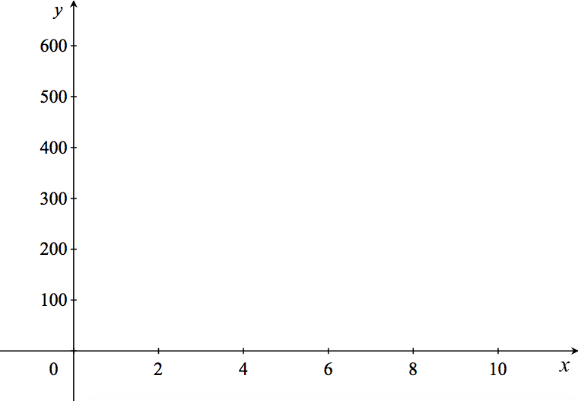

____________________________________________________________________________

____________________________________________________________________________

____________________________________________________________________________

**d.** Calculate the average value of *f* (*x*) over its domain. 2 marks

____________________________________________________________________________

____________________________________________________________________________

____________________________________________________________________________

____________________________________________________________________________

____________________________________________________________________________

____________________________________________________________________________

____________________________________________________________________________

**SECTION B** – continued

**Question 5** (13 marks)

The graph of the function *h* : *R* → *R* with rule *h*(*x*) = (*ex* – 3)2 – 4 is shown below.

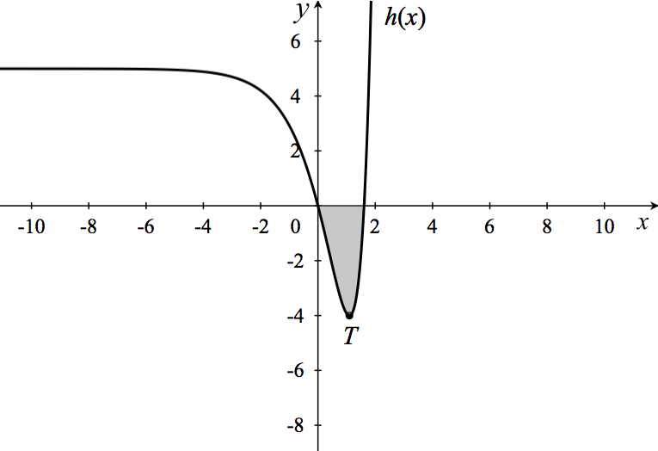

**a.** Show that the coordinates of the turning point, *T*, are (log*e*(3), – 4). 3 marks

____________________________________________________________________________

____________________________________________________________________________

____________________________________________________________________________

____________________________________________________________________________

____________________________________________________________________________

____________________________________________________________________________

____________________________________________________________________________

____________________________________________________________________________

____________________________________________________________________________

____________________________________________________________________________

____________________________________________________________________________

**SECTION B – Question 5 –** continued

**TURN OVER**

**b.** **i.** Determine the*x* – intercept(s) of the function *h*(*x*). 2 marks

__________________________________________________________________________

__________________________________________________________________________

__________________________________________________________________________

__________________________________________________________________________

__________________________________________________________________________

**ii.** **Hence**, calculate the area of the shaded region enclosed by the function *h*(*x*) and the *x* – axis between

the two *x* – intercepts. Give your answer in exact form. 2 marks

__________________________________________________________________________

__________________________________________________________________________

__________________________________________________________________________

__________________________________________________________________________

__________________________________________________________________________

**c.** The function *h*(*x*) has an inverse for *x* ∈ [*a*, ∞). Determine the minimum value of *a* for which *h*(*x*)

has an inverse function over this domain. 1 mark

____________________________________________________________________________

____________________________________________________________________________

____________________________________________________________________________

**d.** Determine the rule of the inverse function, *h*−1(*x*). 2 marks

____________________________________________________________________________

____________________________________________________________________________

____________________________________________________________________________

____________________________________________________________________________

____________________________________________________________________________

____________________________________________________________________________

____________________________________________________________________________

**SECTION B – Question 5 –** continued

**e.** State the domain and range of the inverse function, *h*−1(*x*). 1 mark

____________________________________________________________________________

____________________________________________________________________________

____________________________________________________________________________

____________________________________________________________________________

**f.** Plot the graph of the inverse function, *h*−1(*x*), on the same set of axes as *h*(*x*).

Label all key points including axes intercepts and the intercept between *h*(*x*) and *h*−1(*x*) over the restricted

domain [*a*, ∞). 2 marks

____________________________________________________________________________

**SECTION B –** continued

**TURN OVER**

**Question 6** (11 marks)

Aiden is a graphic designer. His latest design is a stylised fish as shown on the graph below.

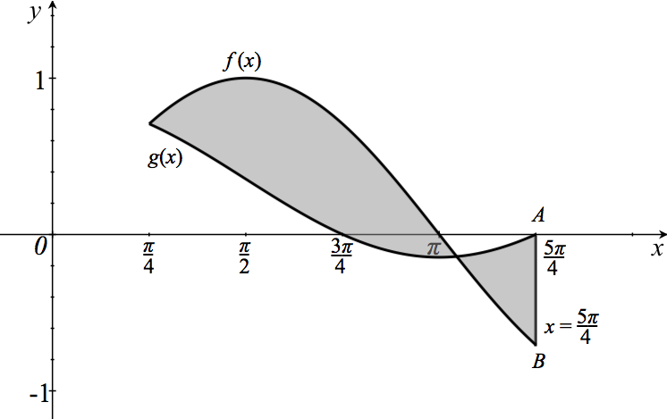

The two functions that define the shape of the stylised fish are given below.

*f* :  → *R*, with rule *f* (*x*) = 

*g* :  → *R*, with rule *g* (*x*) = 

The line with equation  encloses the tail of the stylised fish.

**a.** State the transformation that maps the function *h*(*x*) = cos(*x*) to the function *f* (*x*) = . 1 mark

____________________________________________________________________________

____________________________________________________________________________

**b.** State the transformations that map the function *h*(*x*) = cos(*x*) to the function *g*(*x*) = . 1 mark

____________________________________________________________________________

____________________________________________________________________________

____________________________________________________________________________

____________________________________________________________________________

**SECTION B – Question 6 –** continued

**c.** Compare the amplitudes and the periods of the two functions, *f* (*x*) and *g* (*x*). 2 marks

____________________________________________________________________________

____________________________________________________________________________

____________________________________________________________________________

____________________________________________________________________________

____________________________________________________________________________

____________________________________________________________________________

**d.** Calculate the length of the line segment *AB*. Give your answer in exact form. 1 mark

____________________________________________________________________________

____________________________________________________________________________

____________________________________________________________________________

____________________________________________________________________________

____________________________________________________________________________

____________________________________________________________________________

____________________________________________________________________________

**SECTION B – Question 6 –** continued

**TURN OVER**

**e.** Determine the coordinates of the points of intersection between the two functions, *f* (*x*) and *g* (*x*).

Give your answers correct to two decimal places. 2 marks

____________________________________________________________________________

____________________________________________________________________________

____________________________________________________________________________

____________________________________________________________________________

____________________________________________________________________________

____________________________________________________________________________

**f.** Calculate the value of the shaded area enclosed by the functions *f* (*x*) and *g* (*x*).

Give your answers correct to one decimal place. 2 marks

____________________________________________________________________________

____________________________________________________________________________

____________________________________________________________________________

____________________________________________________________________________

____________________________________________________________________________

____________________________________________________________________________

Let *m*1 be the slope of the tangent to the graph of *f* (*x*) at .

Let *m*2 be the slope of the tangent to the graph of *g* (*x*) at .

**g.** Show that*m*1 = −2*m*2 2 marks

____________________________________________________________________________

____________________________________________________________________________

____________________________________________________________________________

____________________________________________________________________________

____________________________________________________________________________

____________________________________________________________________________

____________________________________________________________________________

**END OF QUESTION AND ANSWER BOOK**

