**2020**

**VCE**

**Mathematical Methods**

**Trial Examination 2**

**Detailed Answers**



|  |  |
| --- | --- |
| **Kilbaha Education Publishing**  **PO Box 2227**  **Kew Vic 3101**  **Australia** | **Tel: (03) 9018 5376**  **Fax: (03) 9817 4334**  [**kilbaha@gmail.com**](mailto:kilbaha@gmail.com)  [**https://kilbaha.com.au**](https://kilbaha.com.au) |

*All publications from Kilbaha Education are digital and are supplied to the purchasing school in both WORD and PDF formats with a school site licence to reproduce for students*

*in both print and electronic formats.*



|  |  |
| --- | --- |
| **Kilbaha Education (Est. 1978) (ABN 47 065 111 373)**  **PO Box 2227**  **Kew Vic 3101**  **Australia** | **Tel: +613 9018 5376**  **Fax: +613 9817 4334**  **Email:** [**kilbaha@gmail.com**](mailto:kilbaha@gmail.com)  **Web:** [**https://kilbaha.com.au**](https://kilbaha.com.au) |

**IMPORTANT COPYRIGHT NOTICE FOR KILBAHA PUBLICATIONS**

(1) The material is copyright. Subject to statutory exception and to the provisions of the relevant collective licensing agreements, no reproduction of any part may take place without the written permission of Kilbaha Pty Ltd.

(2) The contents of these works are copyrighted. Unauthorised copying of any part of these works is illegal and detrimental to the interests of the author(s).

(3) For authorised copying within Australia please check that your institution has a licence from <https://www.copyright.com.au> This permits the copying of small parts of the material, in limited quantities, within the conditions set out in the licence.

(4) All pages of Kilbaha files must be counted in Copyright Agency Limited (CAL) surveys.

(5) Kilbaha files must **not** be uploaded to the Internet.

(6) Kilbaha files may be placed on a password protected school Intranet.

**Kilbaha educational content has no official status and is not endorsed**

**by any State or Federal Government Education Authority.**

While every care has been taken, no guarantee is given that the content is free from error.

Please contact us if you believe you have found an error.

**CAUTION NEEDED!**

All Web Links when created linked to appropriate Web Sites. Teachers and parents must always check links before using them with students to ensure that students are protected from unsuitable Web Content. Kilbaha Education is not responsible for links that have been changed in its publications or links that have been redirected.

**SECTION A**

**ANSWERS**

|  |  |  |  |  |  |  |  |  |  |  |
| --- | --- | --- | --- | --- | --- | --- | --- | --- | --- | --- |
| **1** |  | **A** |  | **B** |  | **C** |  | **D** |  | **E** |
| **2** |  | **A** |  | **B** |  | **C** |  | **D** |  | **E** |
| **3** |  | **A** |  | **B** |  | **C** |  | **D** |  | **E** |
| **4** |  | **A** |  | **B** |  | **C** |  | **D** |  | **E** |
| **5** |  | **A** |  | **B** |  | **C** |  | **D** |  | **E** |
| **6** |  | **A** |  | **B** |  | **C** |  | **D** |  | **E** |
| **7** |  | **A** |  | **B** |  | **C** |  | **D** |  | **E** |
| **8** |  | **A** |  | **B** |  | **C** |  | **D** |  | **E** |
| **9** |  | **A** |  | **B** |  | **C** |  | **D** |  | **E** |
| **10** |  | **A** |  | **B** |  | **C** |  | **D** |  | **E** |
| **11** |  | **A** |  | **B** |  | **C** |  | **D** |  | **E** |
| **12** |  | **A** |  | **B** |  | **C** |  | **D** |  | **E** |
| **13** |  | **A** |  | **B** |  | **C** |  | **D** |  | **E** |
| **14** |  | **A** |  | **B** |  | **C** |  | **D** |  | **E** |
| **15** |  | **A** |  | **B** |  | **C** |  | **D** |  | **E** |
| **16** |  | **A** |  | **B** |  | **C** |  | **D** |  | **E** |
| **17** |  | **A** |  | **B** |  | **C** |  | **D** |  | **E** |
| **18** |  | **A** |  | **B** |  | **C** |  | **D** |  | **E** |
| **19** |  | **A** |  | **B** |  | **C** |  | **D** |  | **E** |
| **20** |  | **A** |  | **B** |  | **C** |  | **D** |  | **E** |

**SECTION A**

**Question 1 Answer E**

## The domain of is ,

## but for we require ,

## since , the domain of *f* is

## Question 2 Answer D



**A.** **B.** **C.** and **E.** are all true

## Question 3 Answer A

 reflect in the *y*-axis so replace  it becomes 

translate one unit to the right so replace  it becomes 

dilate by *a* away from the *y*-axis or parallel to the *x*-axis, so replace  , it becomes



## Question 4 Answer C

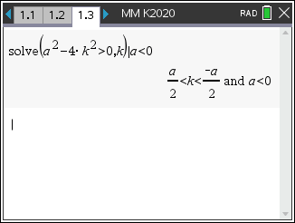

 , since 

**Question 5 Answer C**



 since 



**Question 6 Answer E**

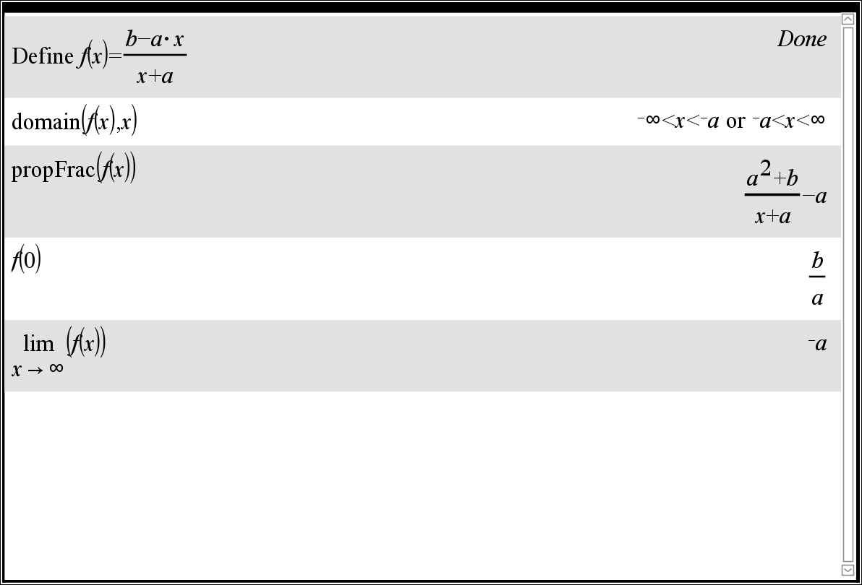

Allan stated that the maximal domain  and that the function has no turning points,

as it is a one-to-one function. Allan is correct.

Ben stated that the graph crosses the *x*-axis at  and the graph crosses the *y*-axis at . Ben is correct.

Colin stated that the graph has a vertical asymptote at  and a horizontal asymptote at.

Colin is correct.

**Question 7 Answer B**

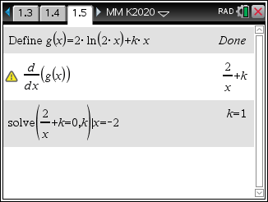

**Question 8 Answer B**



**Question 9 Answer C**

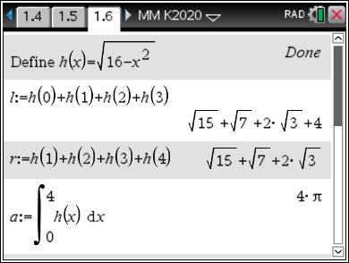









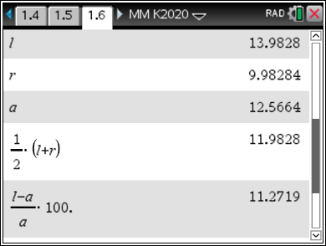

, **A.** is true

 , **D.** is true

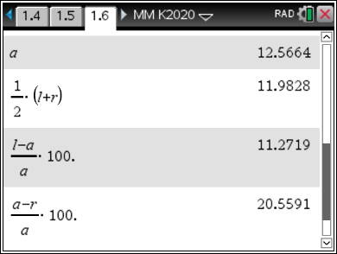 , **E.** is true , **B.** is true

 , **C.** **is false**

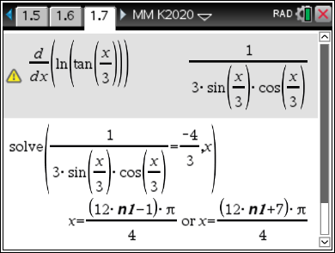**Question 10 Answer D**

**Question 11 Answer A**



## Question 12 Answer A

Given  and , where ,





## Question 13 Answer B

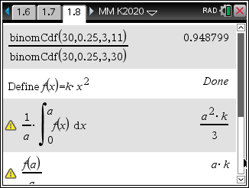40% of 30 is 12, 10% of 30 is 3, 



## Question 14 Answer C

 differentiating using product and chain rules



## Question 15 Answer E



**Question 16 Answer D**

 has period  and range 

## Question 17 Answer D



## Question 18 Answer B



**A.** 

**B.**  **B.** is not satisfied

**C.** 

**D.** 

**E.** 

## Question 19 Answer A

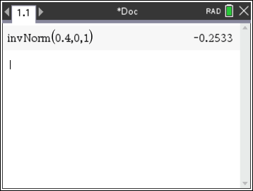The heights of the trees

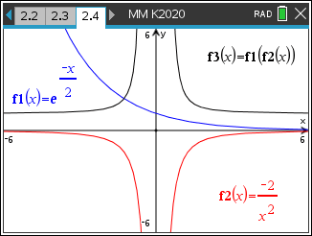

## Question 20 Answer E

Let 



**END OF SECTION A SUGGESTED ANSWERS**

**SECTION B**

**Question 1**

**a.** 





 A1

……



 A1

 A1

**b.** solving  gives  A1

 A1

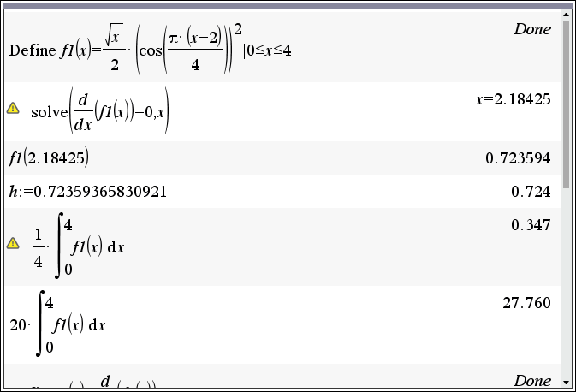

**c.**  A1

**d.**  A1



**e.** Let  solving  gives  A1

Now 

 A1

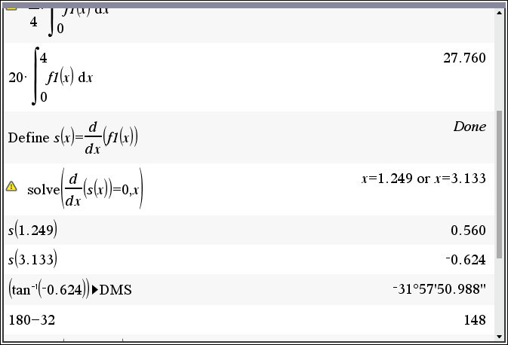

**f.** Solving  gives 

Solving  gives  M1

There are 19 beams of lengths  and

two end pieces the first of length 1.206, the last by symmetry has a length of 

Total length 

Alternatively  A1

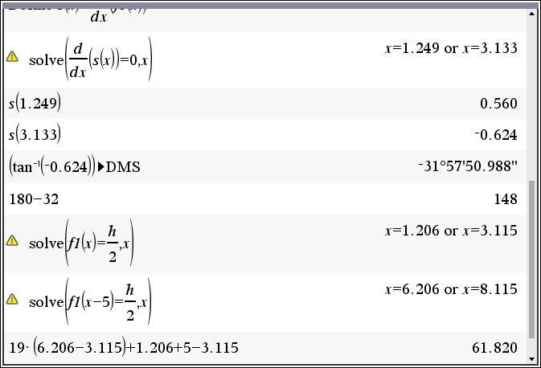

**Question 2**

**a.**  , ,   , 

Tangent 

 A1

**b.** crosses the *x*-axis at  ,  M1

crosses the *y*-axis at  , 

coordinates  A1

**c.** area of larger triangle, ORS minus area of rectangle OMQN

 M1

 and  M1

**d.** solving  with   M1

 A1 the minimum shaded region occurs  and is  A1

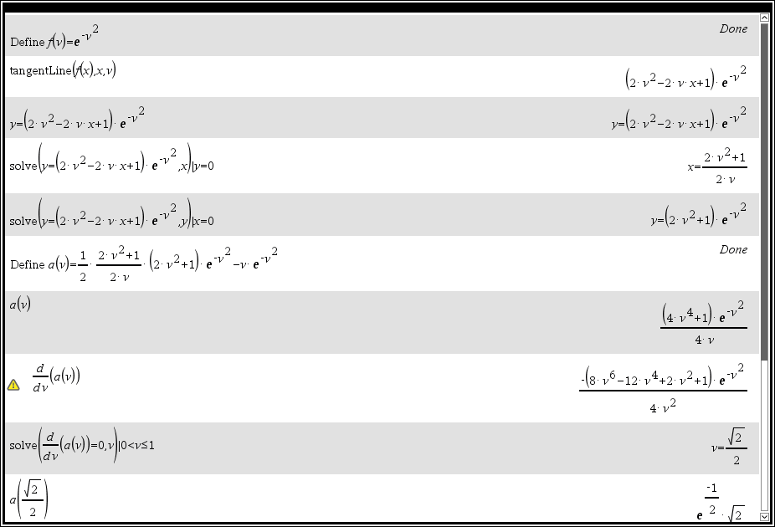

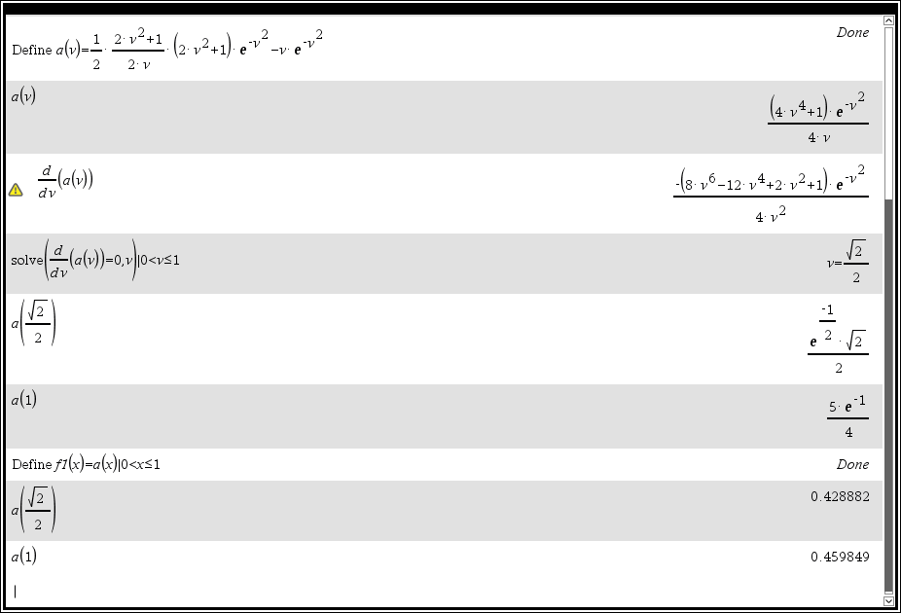

**Question 3**

**a.** 



 A1

**b.**  , 

 A1

**c.** 



 A1

 since also *P* lies on the circle A1

**d.** substitute  into 

 into 

 M1

 but 

 A1

**e.i.** the circle  top half of the circle

 A1

**ii.**  A1

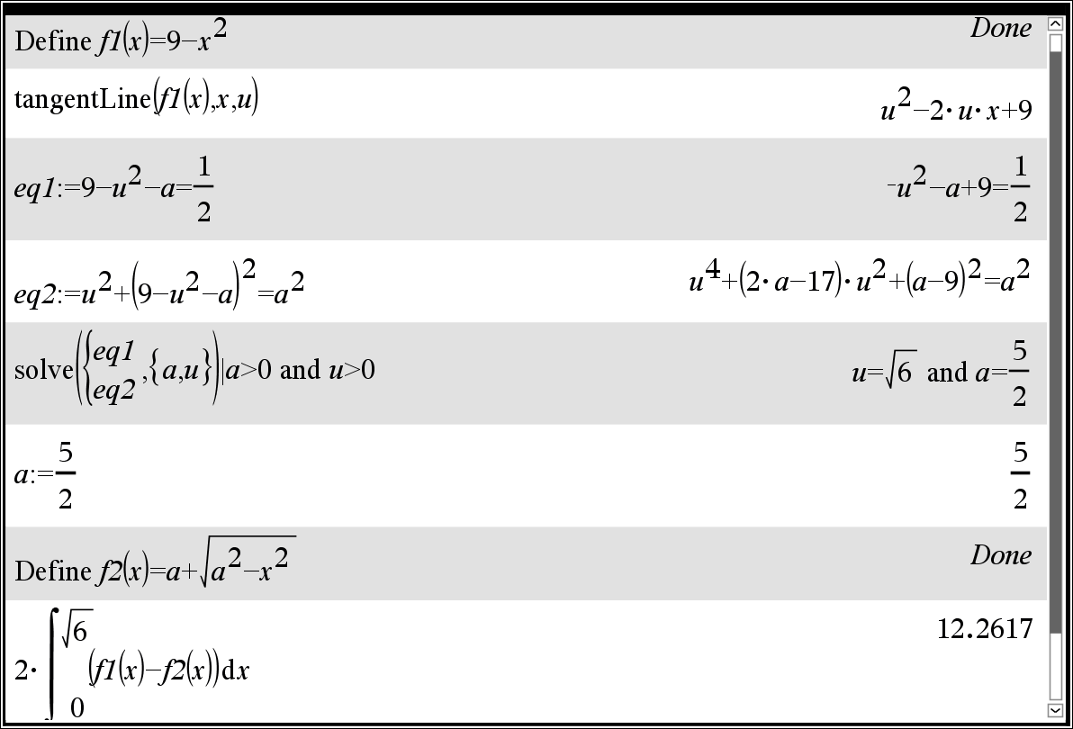

**f.**  , 

 , 

 A1

 since also *Q* lies on the circle

substitute  into 

 into 

 M1

since  ,  A1

the circle 

**g.i.**  A1

**ii.** when  A1

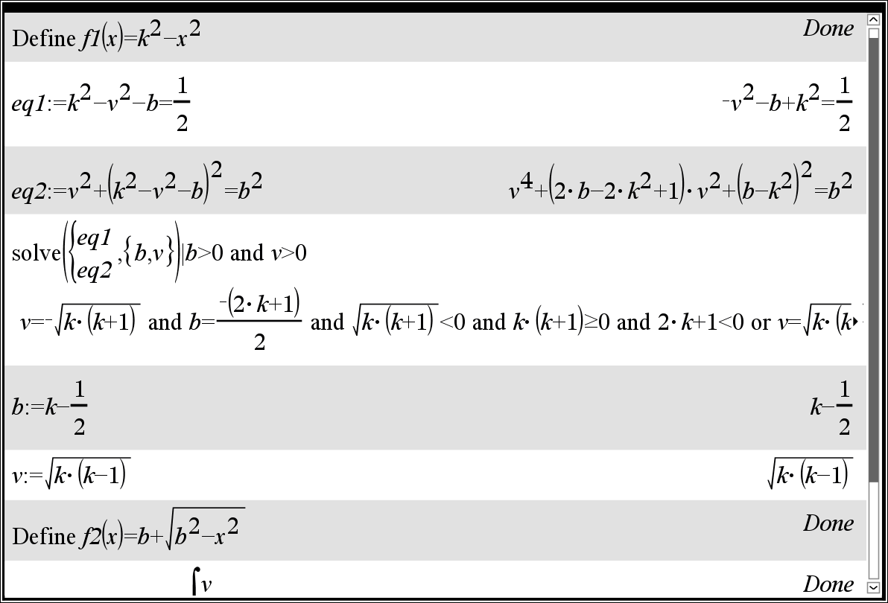

**Question 4**

**a.i.** *W***,** weights of basketballs 

 A1

**ii.** *X*, boxes of 10 basketballs 

 A1

**iii.** 

 A1

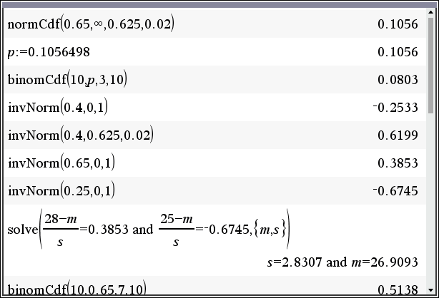

**b.** *B*, the distance Betty throws a basketball, 

 M1

 A1

solving  A1

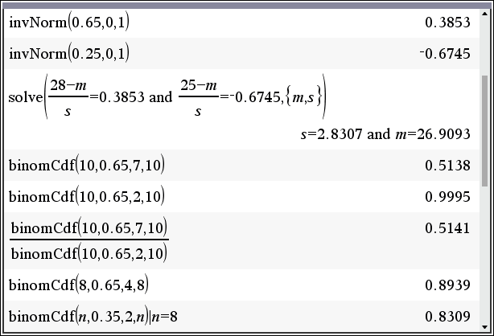

**c.** **i.** *C*, Colin shooting for a basket 

 M1

 A1

**ii.** the first two are baskets, we require more than 4 from the remaining 8

 M1

 A1

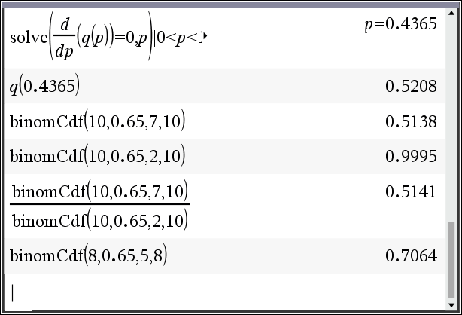

**d.** *D*, Dan shooting for a basket 



 A1

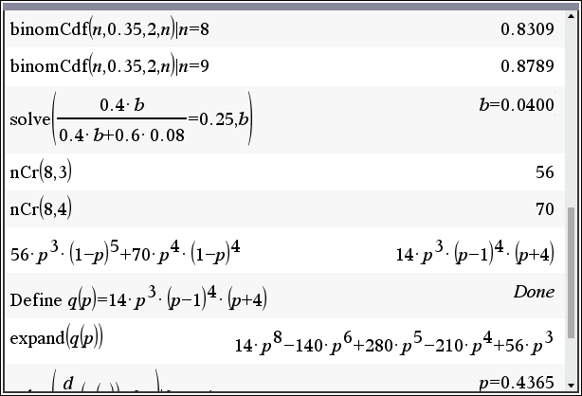

**e.** *A*, from machine *A*, *B*, from machine *B*, *D* defective basketball





B

A

*D*



*D*

0.6

0.4

0.08

0.92

*b*

M1

 A1

solving 

4% are defective from B. A1

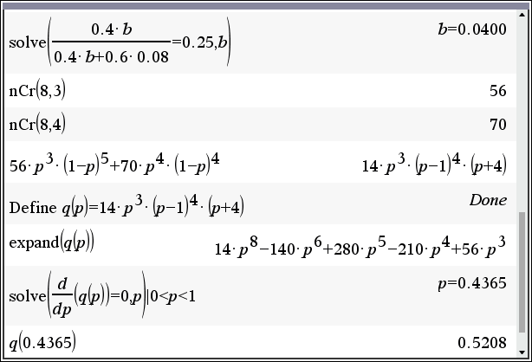

**f.i.** *F*, Fred shooting for a basket 

 M1

 A1

**ii.** since , solving  A1

 A1



**Question 5**

**a.** 

 M1

 A1

**b.** 

 M1

 A1

**c.**   or 

or  all give , solving M1

 both  are acceptable A1

since  ,  A1

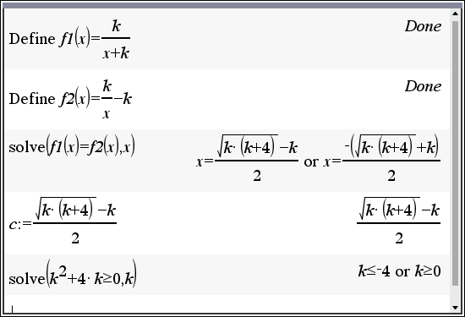

**d.** 

 M1

solving  A1

gives  both answers are acceptable. A1

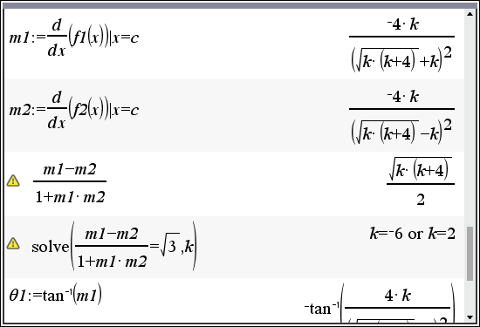

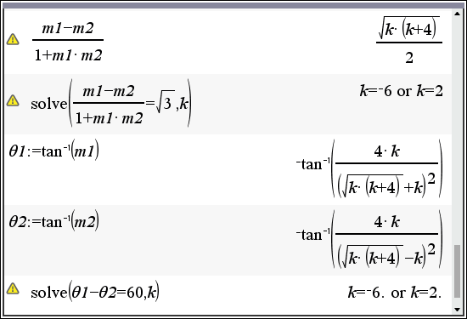

**END OF SECTION B SUGGESTED ANSWERS**

##### End of detailed answers for the

##### 2020 Kilbaha VCE Mathematical Methods Trial Examination 2

|  |  |
| --- | --- |
| **Kilbaha Education Publishing**  **PO Box 2227**  **Kew Vic 3101**  **Australia** | **Tel: (03) 9018 5376**  **Fax: (03) 9817 4334**  [**kilbaha@gmail.com**](mailto:kilbaha@gmail.com)  [**https://kilbaha.com.au**](https://kilbaha.com.au) |