Student Name………………………………….

Teacher’s Name ……………………………….

***MATHEMATICAL METHODS***

***UNIT 2***

***EXAMINATION***

***Paper 2: Technology Active***

**November 2016**

Reading Time: 5 minutes

Writing time 80 minutes

**Instructions to students**

This exam consists of 16 Multiple Choice questions and 4 Extender Response Questions.

The questions should be answered in the spaces provided.

All questions should be answered.

There is a total of 66 marks available.

**Calculators are permitted**

**One bound book is allowed.**

**SECTION 1**

**Question 1**

A Year 11 teacher must randomly choose 2 students from a group of 5 girls and 7 boys.

How many different selections can be made if the students must be the same gender?

1. 
2. 
3. 
4. 
5. 

**Question 2**

Paul has homework to do in five subjects and he randomly decides the order in which he will do them. The probability that Paul starts with his maths homework followed by his science homework is

1. 
2. 
3. 
4. 
5. 

**Question 3**

The maximal domain of the function  is

1. 
2. 
3. 
4. 
5. 

**Question 4**

The *x*-intercept of the graph of  occurs at the point

1. 
2. 
3. 
4. 
5. 

**Question 5**

The graph of the function *f* is shown below.



The rule of *f* could be

1. 
2. 
3. 
4. 
5. 

**Question 6**

If  then  is equal to

1. 
2. 1
3. 
4. 
5. 8

**Question 7**

Some leftover food is wrapped and placed in a freezer. The temperature *T*, in degrees Celsius, *t* minutes after it has been placed in the freezer is given by the function .

The rate at which the temperature of the food is changing 20 minutes after it is placed in the freezer, in degrees/minute is

1. 
2. 
3. 0
4. 0.4
5. 0.8

**Question 8**

The line  is tangent to the curve with equation  The value of *c* is

1. 1
2. 2
3. 4
4. 4.5
5. 5

**Question 9**

The function  is decreasing on the interval

1. 
2. 
3. 
4. 
5. 

**Question 10**

*X* and *Y* are two events such that  Given  and , then  is equal to

1. 0.25
2. 0.2592
3. 0.36
4. 0.2
5. 0.28

**Question 11**

The graph of the function  has *n* stationary points.

The value of *n* is:

1. 0
2. 1
3. 2
4. 3
5. 4

**Question 12**

 is equal to

1. 
2. 
3. 
4. 
5. 

**Question 13**

If  is equal to

1. 
2. 
3. 
4. 
5. 

**Question 14**

Rod buys an early morning coffee at a certain café 85% of the time. Kate does the same 60% of the time, independently of whether Rod does.

The probability that only one of them buys an early morning coffee on a particular morning is

1. 0.43
2. 0.51
3. 0.57
4. 0.62
5. 0.725

**Question 15**

 is equal to

1. 0
2. 1
3. 2
4. 3
5. 4

**Question 16**

The population of rabbits on farmer Brown’s property is growing. If the population, P, after t weeks is given by  , the average rate of growth of the population during the 4th week is closest to:

1. 5.45 rabbits/week
2. 4.9 rabbits/week
3. 4.36 rabbits/week
4. 6.1 rabbits/week
5. 3.6 rabbits/week

**SECTION 2**

**Question 1** (12 marks)

A particle moves in a straight line such that its velocity  cm per second at time  seconds is given by the equation  . If the particle starts from 34cm to the left of, find:

1. The initial velocity and acceleration.

____________________________________________________________________

2 marks

1. The displacement when .

3 marks

1. The distance travelled in the third second.

3 marks

1. The position and acceleration when the particle is momentarily at rest.

4 marks

**Question 2** (14 marks)

A group of students at Stanford College were surveyed. They were asked which of the following products: books (B), music (M) or films (F), they downloaded from the internet.

The following results were obtained:

100 students downloaded music;

95 students downloaded films;

68 students downloaded films and music;

52 students downloaded books and music;

50 students downloaded films and books;

40 students downloaded all three products;

8 students downloaded books **only**;

25 students downloaded none of the three products.

1. Use the above information to complete a Venn diagram.

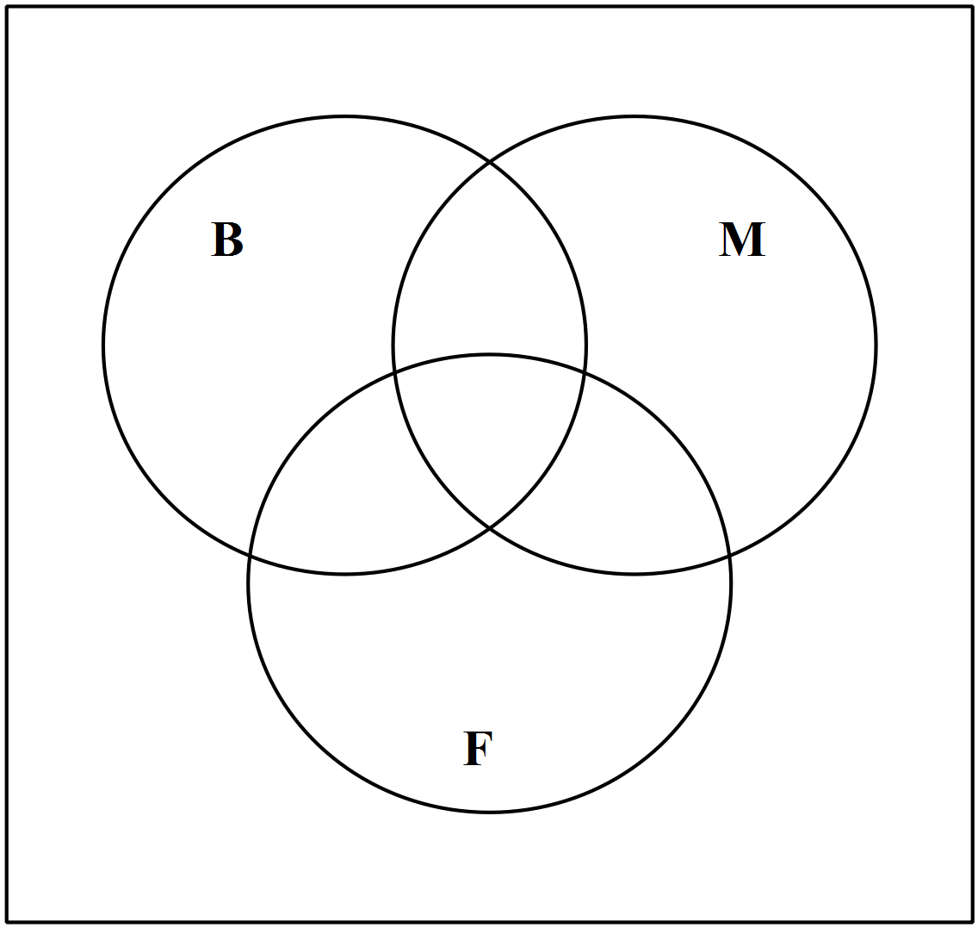

4 marks

1. Calculate the number of students who were surveyed.

2 marks

1. On your Venn diagram, shade the set 

1 mark

1. A student who was surveyed is chosen at random. Find the probability that
2. the student downloaded music;
3. the student downloaded books, given that they have not downloaded films;
4. the student downloaded at least two of the products.

5 marks

Stanford College has 850 students.

1. Find the expected number of students at Stanford College that downloaded music.

2 marks

**Question 3** (12 marks)

A Piper plane takes off from an airport at sea level and its altitude *h* (in metres) at time t (in minutes) is given by .

1. Sketch the graph of  for .

3 marks

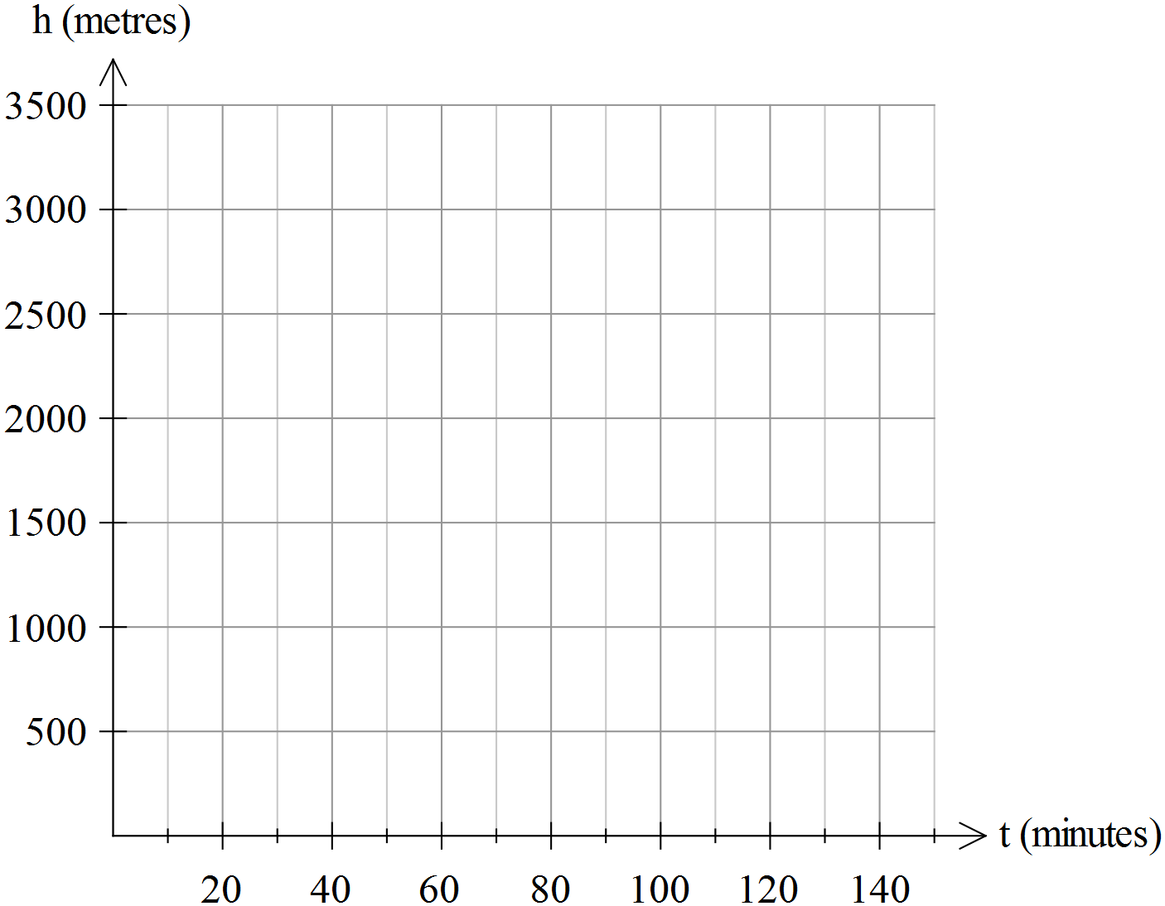

1. Find when the plane will reach the altitude of 3 km, to the nearest minute.

2 marks

1. Find the rate of climb at time t = 3 minutes.

2 marks

1. At what time the rate of climb will be equal to 50 m/min?

2 marks

1. Find such time *T* that the average rate of climb between  and  is equal to 50 m/min.

3 marks

**Question 4** (12 marks)

Consider the function  .

1. Sketch the graph of for  .

3 marks

1. Determine the range of the graph in part a.

2 marks

1. Solve the equation 

2 marks

1. Use your CAS calculator to find the area of the region bounded by the graph of  and the *x*-axis.

1 mark

The function  is the derivative function of 

1. Sketch the graph of on the same set of axes.

1 mark

1. Find the equation of the tangent to at 

2 marks

**END OF PAPER 2**