**Edwest Examination, 2015**

**Question/Answer Booklet**



BIOLOGY

**YEAR 11**

Student Name

#### Time allowed for this paper

Reading time before commencing work: ten minutes

Working time for paper: three hours

**Materials required/recommended for this paper**

To be provided by the supervisor

This Question/Answer Booklet

Multiple-choice Answer Sheet

***To be provided by the candidate***

Standard items: pens, pencils, eraser, correction fluid, ruler, highlighters

Special items:non-programmable calculators satisfying the conditions set by the Curriculum Council for this course

**Important note to candidates**

No other items may be taken into the examination room. It is your responsibility to ensure that you do not have any unauthorised notes or other items of a non‑personal nature in the examination room. If you have any unauthorised material with you, hand it to the supervisor before reading any further.

**Structure of this paper**

|  |  |  |  |  |  |
| --- | --- | --- | --- | --- | --- |
| Section | Number of questions available | Number of questions to be answered | Suggested working time  (minutes) | Marks available | Percentage of exam |
| Section One:  Multiple-choice | 30 | 30 | 40 | 60 | 30 |
| Section Two:  Short answer | 5 | 5 | 110 | 100 | 50 |
| Section Three:  Extended answer | 4 | 2 | 30 | 40 | 20 |
|  |  |  |  |  | 100 |

**Instructions to candidates**

1. Answer the questions according to the following instructions.

Section One: Answer all questions on the separate Multiple-choice Answer Sheet provided. For each question shade the box to indicate your answer. Use only a blue or black pen to shade the boxes. If you make a mistake, place a cross through that square, do not erase or use correction fluid, and shade your new answer. Marks will not be deducted for incorrect answers. No marks will be given if more than one answer is completed for any question.

Section Two: Write your answers in the space provided in this Question/Answer Booklet. Wherever possible, confine your answers to the line spaces provided. Use a blue or black pen (**not** pencil) for this section.

Spare answer pages are provided at the end of this booklet. If you need to use these, indicate in the original answer space where the answer is continued, e.g. write 'continued on page 38'. Fill in the number of the question that you are continuing at the top of that page.

The space provided for each question is an indication of the length of answer required.

Section Three: Write your answers in this Question/Answer Booklet. Use a blue or black pen (**not** pencil) for this section. Tick the box next to the question you are answering; write the number of each question in the margin. Do **not** copy the questions when answering.

If your answer exceeds the three pages provided for each question, continue writing on the spare pages at the end of the booklet. Indicate at the end of the page that the answer is continued. E.g. write 'continued on page 37'. Fill in the number of the question that you are continuing at the top of that page

**Section One: Multiple-choice 30% (30 Marks)**

This section has **30** questions. Answer **all** questions on the separate Multiple-choice Answer Sheet provided. For each question shade the box to indicate your answer. Use only a blue or black pen to shade the boxes. If you make a mistake, place a cross through that square, do not erase or use correction fluid, and shade your new answer. Marks will not be deducted for incorrect answers. No marks will be given if more than one answer is completed for any question.

Suggested working time for this section is 40 minutes.

**Questions 1 and 2 refer to the dichotomous key presented below. This key is used in the classification of annelids to the genus level of classification.**

|  |  |  |
| --- | --- | --- |
| 1a | No bristles on body | 2 |
| 1b | Bristles on body | Genus Septigi |
| 2a | Four mouth parts | Genus Listinia |
| 2b | Three mouth parts | 3 |
| 3a | Spotted segments towards the tail end | 4 |
| 3b | No spotted segments on body | Genus Portro |
| 4a | A thickened middle part of body | Genus Hutrus |
| 4b | Body has same thickness along entire length | 5 |
| 5a | Body has a dull grey colour | Genus Coptol |
| 5b | Body is white in colour | Genus Stulta |

1. Which of the following statements describes the genus Coptol most correctly?

(a) Bristles on body, spotted tail segments and a body of same thickness

(b) No bristles on body, three mouth parts and a spotted tail end

(c) Three mouth parts, no spotted segments and a body of same thickness

(d) Four mouth parts, spotted tail segments and a dull grey colour

2. Which of the following features are shared by both the genus Hutrus and the genus Stulta?

1. A white body colour

(b) Bristles on body

(c) Spotted segments towards the tail end

(d) Body of same thickness

3. Which of the following statements concerning the hierarchy of biological classification is correct?

(a) The species level of classification contains the greatest diversity of organisms.

(b) All organisms classified in the same genus must belong in the same phylum.

(c) There are a greater number of classes than there are orders.

(d) Organisms placed in the same kingdom have more in common than organisms placed in the same order.

4. A species is best defined as a group of individuals that

(a) occupy the same habitat.

(b) share many features in common.

(c) have a common ancestor.

(d) can reproduce fertile offspring.

**Questions 5 and 6 refer to the cell diagram presented below.**

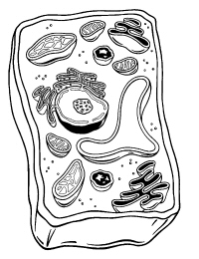

C

A

D

B

5. Which of the following correctly identifies the structures labelled A, B and C?

(a) A: nucleus B: vacuole C: chloroplast

(b) A: chloroplast B: ribosomes C: nucleus

(c) A: mitochondria B: chloroplast C: nucleus

(d) A: ribosomes B: nucleus C: mitochondria

6. The function of the organelle labelled D is best described as the

1. storage of materials that supply energy to the cell.
2. control of all cell activities.
3. transport of substances around the cytoplasm.
4. formation of vesicles that export material from the cell.

7. Which of the following statements best describes what occurs in the organelle

labelled C?

(a) The breakdown of organic substances to produce energy.

(b) The conversion of light energy into chemical energy.

(c) The formation of inorganic molecules from organic substances.

(d) The production of ATP as an energy storage molecule.

**Questions 8 and 9 refer to the food web presented below.**

Shark

Seagulls

Small Fish Coral

Prawns

# Algae Phytoplankton

8. Which organism occupies two different trophic levels?

(a) Coral

(b) Prawns

(c) Small fish

(d) Seagulls

9. Which of the following is a possible consequence if overfishing removed small fish from the food web?

(a) Coral would increase in population

(b) The population of sharks would rise

(c) The seagull population would remain unaffected

(d) The availability of prawns would decrease

10. Which of the following best describes the process of biomagnification?

(a) Higher order consumers will have the highest concentration of toxic pollutants in their body tissues.

(b) The amount of toxic pollutants in the environment increases as they are passed from one consumer to the next.

(c) Producers absorb toxic substances and use them to form new cells.

(d) Decomposers cannot breakdown some pollutants and the levels of these pollutants slowly increase in the environment.

**Questions 11 and 12 refer to the models presented below that represent the internal**

**transport system for some vertebrates**

Model A Model B

BODY

GAS EXCHANGE SURFACE

PUMP

BODY

GAS EXCHANGE SURFACE

PUMP

11. The internal transport system represented by model B would best be described as?

1. A double closed circulation.
2. A double open circulation.
3. An open circulation.
4. A single closed circulation.

12. The advantage that model A has over model B is that

1. gas exchange can occur over a greater surface area.
2. oxygen levels can be delivered to more cells at a higher level
3. the gas exchange surface remains separate from the vascular system.
4. oxygenated and deoxygenated blood are able to mix freely.

13. Land plants exchange gases with the atmosphere through the

1. epidermis
2. vascular bundles.
3. stomata.
4. cuticle.

14. Haemolymph is best described as the fluid that

1. flows in arteries and veins to provide oxygen to cells.
2. moves water from the root system to the leaves in plants.
3. surrounds all cells and provides for movement across membranes.
4. transports nutrients in the body cavity of an insect.

15. In multicellular organisms, the hierarchical structure of organisation from largest to smallest is

1. systems, tissues, organs, cells
2. organism, organs, cells, tissues.
3. systems, organs, tissues, cells.

(d) cells, organs, systems, tissues.

16. Organisms with a gastrovascular cavity

(a) have one body opening for the intake of food and elimination of wastes.

(b) have a vascular system that can obtain nutrients directly from the environment.

(c) absorb nutrients directly from the environment through their body covering. (d) possess a tube with two body openings through which they absorb nutrients.

17. Compared to a herbivore the alimentary canal in a carnivore

1. is more complex and requires a greater number of organs.
2. contains a greater number of enzymes.
3. requires a longer period of time to breakdown nutrients.

(d) is relatively shorter than the alimentary canal of a herbivore.

18. The infestation of the Prickly Pear was brought under control by the biological control agent; the Cactoblastis moth. The advantage of using a biological control agent is that

(a) they can respond to adaptive changes in the pest species.

(b) there is a great variety of potential control agents.

(c) that they are relatively inexpensive to develop.

(d) that they will completely eradicate the pest species.

19. Which of the following is NOT a possible consequence of climate change due to increasing levels of carbon dioxide in the atmosphere?

(a) An increase in the average atmospheric temperature.

(b) A rise in sea levels as the ice caps melt and the oceans expand.

(c) A change in the distribution of farmland as rainfall patterns change.

(d) A loss of ocean plant life as ultra-violet radiation levels rise.

Questions 20 and 21 refer to the table presented below. It represents the data collected by students conducting a fieldwork investigation on the population of crabs inhabiting a tidal reef obtained the following data:

|  |  |
| --- | --- |
| Population Density (High Tide)  (no./square metre) | Population Density (Low Tide)  (no./square metre) |
| 2 | 7 |

20. The best “abiotic” explanation to account for these results would be that

(a) Oxygen levels are lower at low tide.

(b) Crabs shelter from wave action and currents.

(c) Crabs are attracted by increased light levels.

(d) It is easier for crabs to locate prey at low tide.

21. When conducting this fieldwork, it is most likely that the students used

1. quadrat sampling.
2. the capture-recapture technique.
3. a transect line.
4. pit traps.

22. During the light phase of photosynthesis

(a) glucose molecules are produced in the stroma of the chloroplasts.

(b) carbon dioxide is absorbed into the chloroplast and stored for later use.

(c) energy is captured by chlorophyll and stored as ATP.

(d) water is split in the grana and energy is released.

23. During the dark phase of photosynthesis

(a) breakdown of ATP molecules in the stroma releases energy to split water.

(b) oxygen is produced from water molecules and given off as a waste product.

(c) carbon, oxygen and hydrogen are combined to produce glucose molecules.

(d) the grana captures carbon dioxide and combines it with water molecules.

**Questions 24 and 25 refer to the graph presented below. It represents data collected**

**from a small plant over a six hour period.**

CO2

Uptake

(mL/hr)

0

1 2 3 4 5 6

Time (hrs)

24. Which of the following statements is a possible explanation for the data collected between 2 and 5 hours?

(a) The levels of available light are decreasing.

(b) The stomates on this plant are slowly closing.

(c) The levels of oxygen available remains constant.

(d) There is maximum uptake of available water.

25. In the first hour of this experiment

(a) the plant is receiving a boost of soil nutrients.

(b) the rate of respiration exceeds the rate of photosynthesis.

(c) the rate of respiration slowly decreases.

(d) the air temperature increases rapidly.

26. Which of the following does NOT have a role in the cycling of nitrogen through the environment?

(a) Photosynthesis carried out in chloroplasts

(b) Lightning occurring in thunderstorms

(c) Nitrifying bacteria that live freely in the soil

(d) Waste products produced by animals

.

**Questions 27 and 28 refer to the diagram presented below. It represents a student drawing of a single cell organism.**

The drawing was made using a microscope set with a 10X ocular lens and a 20X objective lens. The field of view at this magnification was measured at 40 µm.

27. The approximate length of this single cell organism is

. (a) 10 µm

1. 20 µm
2. 40 µm
3. 80 µm

28. If the objective was changed to a magnification of 10X, which of the following is true?

(a) The organism would appear 2 times larger.

1. There will be fewer organisms in view.
2. The organism would appear in greater detail.
3. The field of view would be 20 µm.

**Questions 29 and 30 refer to the table presented below. It contains experimental data collected during an investigation on the effectiveness of a range of disinfectants.**

|  |  |
| --- | --- |
| Disinfectant | Population of Bacteria (x1000/mm2)  (after one month of use) |
| Brand A | 4.0 |
| Brand B | 3.3 |
| Brand C | 1.0 |

29. The best control procedure for this investigation would be to

1. allow only one type of bacteria to be present.
2. test for bacteria on surfaces that have had no disinfectant.
3. make sure that all surfaces received the same amount of disinfectant.
4. repeat this investigation in many locations.

30. This data is

1. discontinuous and best represented as a histogram.
2. discontinuous and best represented as a line graph.
3. continuous and best represented as a line graph.
4. continuous and best represented as a scatter diagram.

.

**End of Section One**

**Section Two: Short Answer 50% (100 Marks)**

Suggested working time for this section is 90 minutes.



This section has **five (5)** questions. Answer **all** questions. Write your answers in the space provided in this Question/Answer Booklet. Wherever possible, confine your answers to the line spaces provided. Use a blue or black pen (**not** pencil) for this section.

Spare pages are included at the end of this booklet. They can be used for planning your responses and/or as additional space if required to continue an answer.

* + Planning: If you use the spare pages for planning, indicate this clearly at the top of the page.
  + Continuing an answer: If you need to use the space to continue an answer, indicate in the original answer space where the answer is continued, i.e. give the page number. Fill in the number of the question(s) that you are continuing to answer at the top of the page.

**Question 31 (20 marks)**

An environmental scientist conducted a study on the forest ecosystems that surround farmland in the south-west of Western Australia. The scientist began with a survey of the biodiversity and community relationships within the forests. A sample of the data collected is shown in the table below.

|  |  |  |
| --- | --- | --- |
| Organism | Nutrient Source | Biomass  (kg/hectare) |
| Jarrah Trees |  | 20,000 |
| Wild Grass |  | 500 |
| Native Parrots | Jarrah Trees, Wild Grass | 150 |
| Blue Wrens | Predatory Spiders, Beetles | 100 |
| Predatory Spiders | Beetles | 200 |
| Mushroom Fungus | Jarrah Trees (Fallen) | 250 |
| Beetles | Wild Grass | 350 |

(a) (i) Use the information in the table above to construct a food web.

(2 marks)



(ii) List the organisms that occupy a consumer trophic level (1 mark)

(iii) List the organisms with which the Blue Wren competes. (1 mark)

(b) (i) Draw a diagram that illustrates the relative biomass of wild grass, beetles,

predatory spiders and blue wrens.

(2 marks)

(ii) Explain the shape of the diagram you have drawn. (2 marks)

(c) (i) In this community, describe the important role played by the Mushroom Fungus.

(2 marks)

(ii) In the table, no nutrient source is listed for the Jarrah Trees and Wild Grass.

Explain how these organisms are able to generate biomass.

(2 marks)

The environmental scientist noted that the ecosystem had been subject to repeated fire

“burn-offs” to clear forest litter as well as the introduction of invasive plant species.

Answer part (d) below by describing the effect of these two factors on the forest ecosystem.

(d) (i) Fire: (2 marks)

(ii) Introduction of invasive plant species: (2 marks)

(e) At the conclusion of the study there was a recommendation that efforts should be made to protect the forests surrounding the farmland.

Describe four environmental or management strategies that could be used to maintain this ecosystem. (4 marks)

**Question 32 (20 marks)**

Examine the diagram below which is an artist’s depiction of a cell.

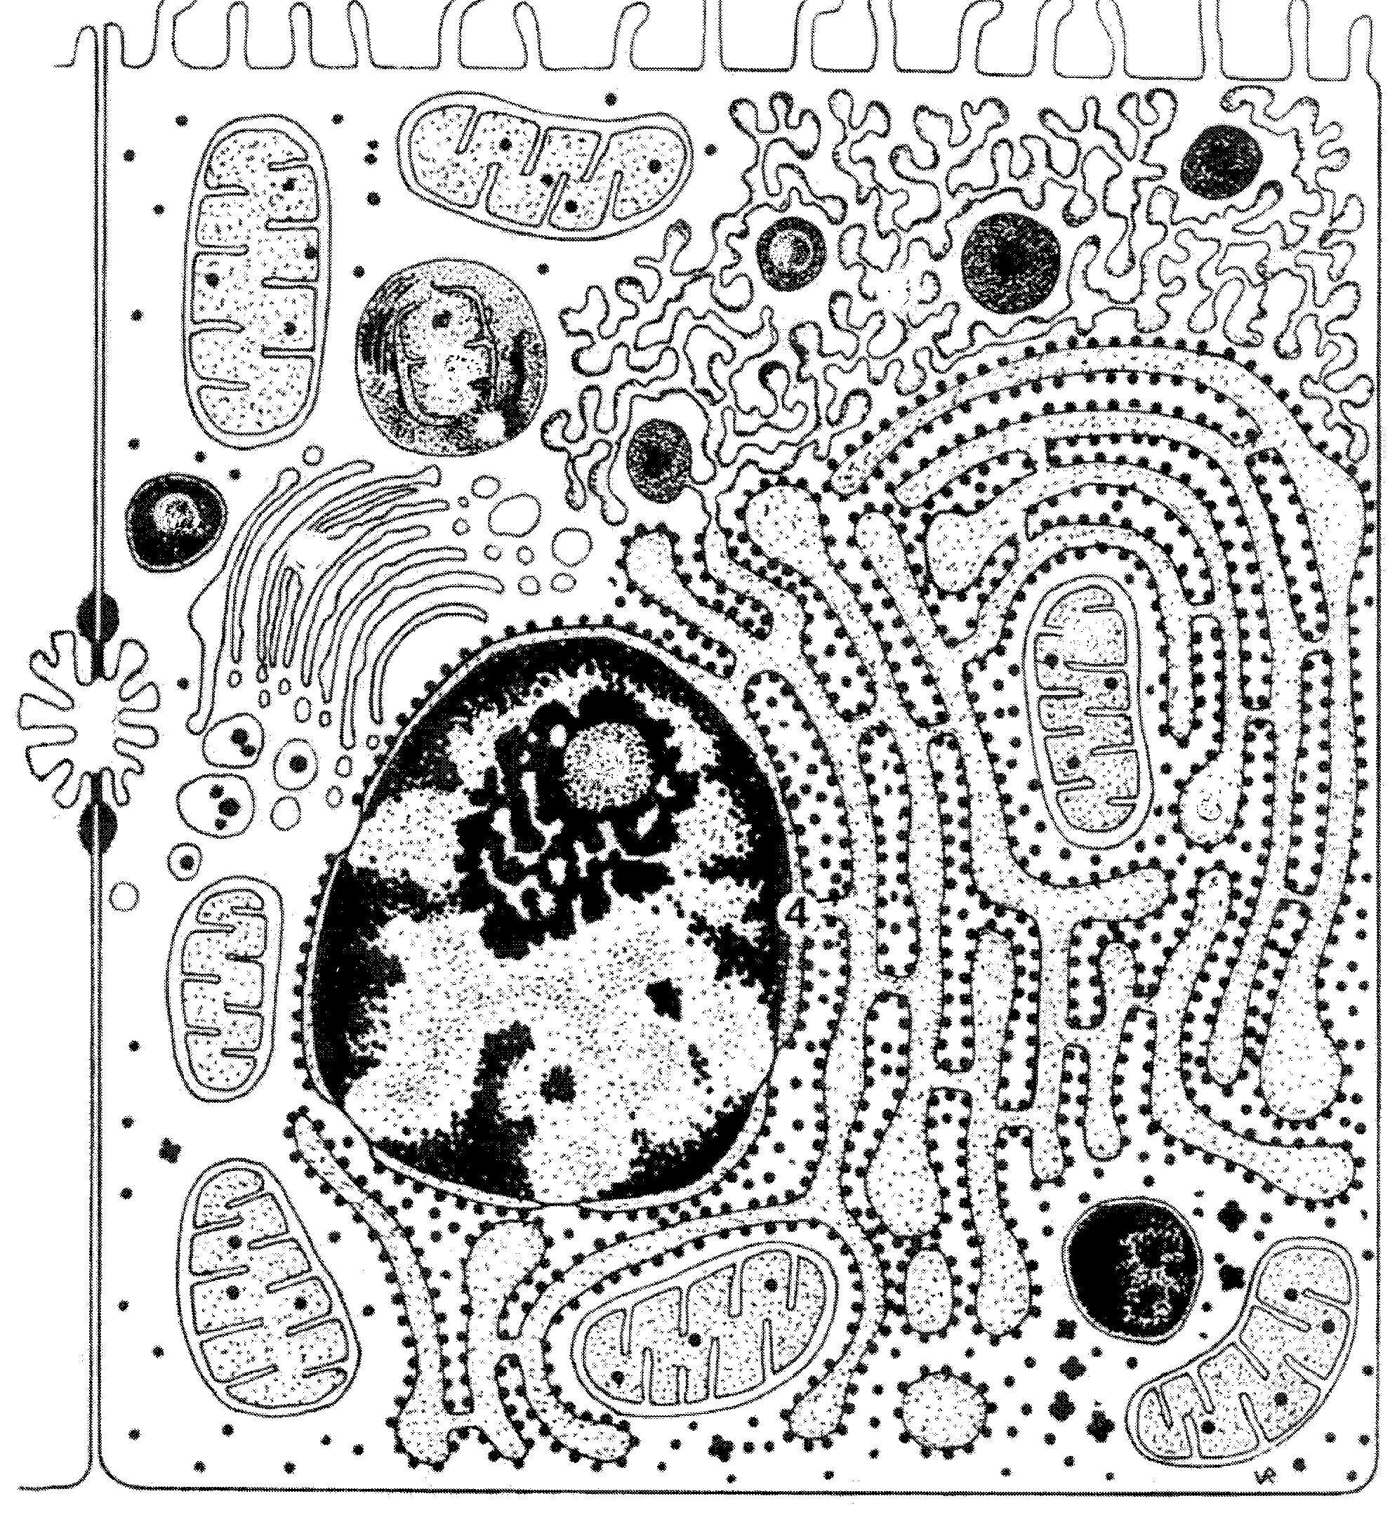

C

B

A

(a) (i) Classify this cell as a prokaryote or a eukaryote. Provide one reason for your

answer.

(2 marks)

(ii) Classify this cell as a plant or animal cell. Provide one reason for your

answer.

(2 marks)

(b) Cell respiration occurs in two forms and takes place in the areas labelled A and/or B.

State the type of respiration that occurs in each area and write a word equation to

describe what occurs.

A: ___________________________________________________________________

___________________________________________________________________

B: ___________________________________________________________________

___________________________________________________________________

(c) Identify the structure labelled C and provide a brief description of its structure.

(4 marks)

A number of these cells were obtained and placed in a nutrient medium to grow and divide. The table below shows the composition and concentration of both the nutrient solution and the cytoplasm of the cells.

|  |  |  |
| --- | --- | --- |
| **Substance** | **Cytoplasm**  **(g/L)** | **Nutrient Solution**  **(g/L)** |
| Chloride | 35.0 | 14.7 |
| Urea | 30.0 | 5.0 |
| Glucose | 0.5 | 25.0 |
| Sodium | 42.0 | 45.5 |
| Potassium | 29.8 | 2.0 |

Use the data in this table to answer part (d) below.

(d) (i) Which substance/s would have a net movement into the cell by diffusion?

________________________________________________________________

(ii) Potassium was noted to move the most rapidly. Explain why this is most likely.

(iii) Is this cell most likely to gain or lose water? Explain why this will occur.

(4 marks)

(e) As cells grow in size their ability to exchange materials with the environment decreases. Explain why this occurs and identify two ways in which cells address this issue.

(4 marks)

**Question 33 (20 marks)**

A class of biology students was given the task of investigating different approaches that could be used to maximise the production of carrots in a vegetable patch. They began by exploring different forms of fertilisers and their application.

Three garden beds were obtained and 100 carrot seeds were planted in each bed. The students purchased a granulated and liquid form of “Grow-Fast” fertiliser. The garden beds were treated with the fertilisers on a fortnightly basis and 50.0 g of the fertiliser was added each time. At 3, 6 and 12 months after planting, carrots were harvested and their biomass recorded.

A summary of the data obtained is presented below. **Examine the data presented and answer the questions that follow.**

**Biomass of Carrots (kg. / m2)**

|  |  |  |  |
| --- | --- | --- | --- |
| **Treatment** | **3 months** | **6 months** | **12 months** |
| **Granules** | **3.0** | **4.5** | **5.5** |
| **Liquid** | **4.0** | **4.2** | **3.5** |
| **No Fertiliser** | **2.8** | **3.0** | **2.7** |

(a) (i) State a hypothesis for this investigation. (2 marks) (1 mark)



1. For your hypothesis, state the independent variable. (1 mark)

(iii) For your hypothesis, state the dependent variable. (1 mark)

(b) On the grid provided, construct a graph that can be used to represent this data.

If you wish to have a second attempt at this graph, the grid is repeated at the end of the

examination booklet. Indicate clearly on this page if you have used the second

grid and cancel the working on the grid on this page.

(5 marks)

|  |  |  |  |  |  |  |  |  |  |  |  |  |
| --- | --- | --- | --- | --- | --- | --- | --- | --- | --- | --- | --- | --- |
|  |  |  |  |  |  |  |  |  |  |  |  |  |
|  |  |  |  |  |  |  |  |  |  |  |  |  |
|  |  |  |  |  |  |  |  |  |  |  |  |  |
|  |  |  |  |  |  |  |  |  |  |  |  |  |
|  |  |  |  |  |  |  |  |  |  |  |  |  |
|  |  |  |  |  |  |  |  |  |  |  |  |  |
|  |  |  |  |  |  |  |  |  |  |  |  |  |
|  |  |  |  |  |  |  |  |  |  |  |  |  |
|  |  |  |  |  |  |  |  |  |  |  |  |  |
|  |  |  |  |  |  |  |  |  |  |  |  |  |
|  |  |  |  |  |  |  |  |  |  |  |  |  |
|  |  |  |  |  |  |  |  |  |  |  |  |  |
|  |  |  |  |  |  |  |  |  |  |  |  |  |
|  |  |  |  |  |  |  |  |  |  |  |  |  |

(c) State **three** valid conclusions that can be drawn from this investigation

(3 marks)

(d) (i) Explain why it was necessary to repeat the investigation five times.

(2 marks)

.

(ii) Explain the purpose of the plot that contained “no fertiliser”. (2 marks)

.

(e) The class decided to perform the same procedure using a different brand of fertiliser. Describe and explain how they would go about ensuring that any new data collected could be added to the results already obtained. (4 marks)

**Question 34 (20 marks)**

Examine the microscope image showing a cross-section through a plant stem. Use this image to answer parts (a) and (b) below.

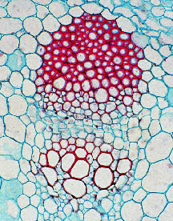

A

B

(a) Identify the structures labelled A and B and describe the role they play in normal plant function.

Structure A

Name: ________________________________________________________________

Function: _____________________________________________________________

_____________________________________________________________________

Structure B

Name: ________________________________________________________________

Function: _____________________________________________________________

_____________________________________________________________________

(4 marks)

(b) State two distinct structural features possessed by structure A and structure B.

(4 marks)

Structure A: ____________________________________________________________

Structure B:

(c) (i) Describe how materials are transported in structure A.

(2 marks)

(ii) List the forces required to move the materials transported in structure B.

. (2 marks)

The diagram presented below represents a cross section through a leaf. The leaf is from a plant that thrives in dry, arid coastal conditions. Use this diagram to answer parts (d) and (e).

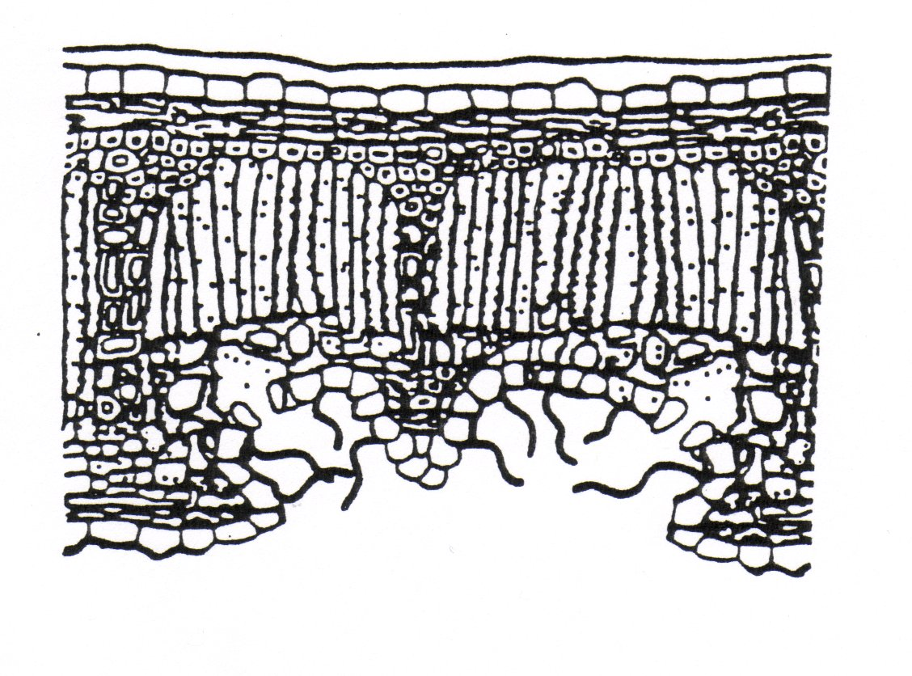

A

B

(d) (i) Identify the leaf structure labelled A and state its function. (2 marks)

(ii) Identify cell type labelled B and state its function. (2 marks)

(e) Identify **two** structural features, visible on this diagram that would serve as adaptations to dry, arid conditions. Explain how these adaptations improve plant survival

(4 marks)

**Question 35 (20 marks)**



In a small coastal town, falling rainfall lowered the water levels in the local river and several small sand islands appeared. Biology students in the town’s school began to study the islands and over a five year period collected data on a variety of plant and animal species.

Some of the data collected on plant species is shown below:

**Density of Plant Species on Small Sand Island**

|  |  |  |  |  |  |
| --- | --- | --- | --- | --- | --- |
| Years  (since appearance of island) | Density of Plant Species  (no./ hectare)  Year 1 Year 2 Year 3 Year 4 Year 5 | | | | |
| Spinifex | 7 | 15 | 30 | 35 | 35 |
| Pig-Face | _ | 4 | 15 | 15 | 16 |
| Beach Rosemary | _ | _ | 3 | 6 | 10 |
| Coastal Daisy Bush | _ | _ | 1 | 4 | 12 |
| Peppermint Tree | _ | _ | _ | _ | 2 |

(a) Explain how this data supports the concept of ecological succession.

(4 marks)

(b) Describe the likely survey technique that would have been used to estimate the density of these plant species. (4 marks)

The students obtained some data regarding the changing population of insects on the island

over the five year period. The shape of the data collected for beetles is presented in the

diagram below. Use this graph to answer parts (c) and (d) below.

C

B

A

Population of

Beetles

(c) (i) Explain the change in beetle population that occurs in the region labelled A.

(2 marks)

(ii). Explain the change in beetle population that occurs in the region labelled B

(2 marks)

(d) (i) What term is used to describe the dashed line labelled C? Define this term.

(2 marks)

(ii) List two environmental factors that influence its level in an environment.

(2 marks)

(e) In establishing the population of beetles on the islands the students used the Capture-Recapture technique. Describe how this technique is used to estimate animal populations.

(4 marks)

**End of Section Two**

**Section Three: Extended Answer 20% (40 Marks)**

Suggested working time for this section is 50 minutes.

This section contains **four (4)** questions. You must answer **two (2)** questions. Write your answers in the space provided. Each question carries ten (10) marks.

Section Three consists of four questions. Questions 36 and 37 are from Unit 1. Questions 38 and 39 are from Unit 2. Answer one question from Unit 2 and one question from Unit 4. Use black or blue pen or ballpoint for written answers and pencil for diagrams. Crossing out of incorrect material is acceptable and preferable to using correction fluid/tape. Spare pages are included at the end of this booklet. They can be used for planning your responses and/or as additional space if required to continue an answer.

Answers may be presented in different ways provided they communicate your ideas effectively. You may choose to:



* present a clearly labelled diagram
* write notes beside a clear diagram
* write lists of points, with sentences which link them
* write concisely worded sentences
* use some other appropriate way to present ideas.

Use blue or black pen for written answers and pencil for diagrams

Spare pages are included at the end of this booklet. They can be used for planning your responses and/or as additional space if required to continue an answer.

* + Planning: If you use the spare pages for planning, indicate this clearly at the top of the page.
  + Continuing an answer: If you need to use the space to continue an answer, indicate in the original answer space where the answer is continued, i.e. give the page number. Fill in the number of the question(s) that you are continuing to answer at the top of the page.

Unit 1: Choose either Question 36 or Question 37.

Indicate the question you will answer by ticking the box next to the question. Write your answers on pages 29–32. When you have answered your first question, turn to page 33 and indicate the second question you will answer on that page

**Question 36**

(a) The amount of matter within an ecosystem remains relatively stable despite

being transformed in a variety of living processes.

Discuss this statement using the carbon cycle as an example.

. (10 marks)

(b) Consider an ecosystem such as a coral reef or a jarrah forest.

Give an account of the flow of energy through such ecosystems.

(10 marks)

**Question 37**

(a) Discuss the ways in which human activities can act to decrease

biodiversity and how they can act to restore biodiversity.

(10 marks)

(b) A biologist writing an environmental impact report made the statement:

“This ecosystem is a web of interactions and relationships between

individuals within a species and between species”

Describe the relationships and interactions that can occur between individuals

that occupy the same ecosystem.

(10 marks)

**Unit 2: Choose either Question 38 or Question 39.**

Indicate the question you will answer by ticking the box next to the question. Write your

answers on pages 34 – 37.

**Question 38**

(a) Compare and contrast the process of gas exchange that occurs in an

arthropod such as a grasshopper with that of a mammal such as a

kangaroo.

(10 marks)

(b) In order to survive, all cells must exchange materials with their surrounding environment.

List the inputs and outputs shared by all cells and describe the factors that affect their ability to exchange these materials with their surrounding environment.

(10 marks)

**Question 39**

(a) Use the Lock and Key model of enzyme action to explain the action of

enzymes. Include in your answer, the factors that affect enzyme action.

(10 marks)

(b) Describe the variety of active processes that move substances into and out of a cell.

(10 marks)

**End of Questions**

**Additional working space:**

Question number:

**Additional working space:**

Question number:

|  |  |  |  |  |  |  |  |  |  |  |  |  |
| --- | --- | --- | --- | --- | --- | --- | --- | --- | --- | --- | --- | --- |
|  |  |  |  |  |  |  |  |  |  |  |  |  |
|  |  |  |  |  |  |  |  |  |  |  |  |  |
|  |  |  |  |  |  |  |  |  |  |  |  |  |
|  |  |  |  |  |  |  |  |  |  |  |  |  |
|  |  |  |  |  |  |  |  |  |  |  |  |  |
|  |  |  |  |  |  |  |  |  |  |  |  |  |
|  |  |  |  |  |  |  |  |  |  |  |  |  |
|  |  |  |  |  |  |  |  |  |  |  |  |  |
|  |  |  |  |  |  |  |  |  |  |  |  |  |
|  |  |  |  |  |  |  |  |  |  |  |  |  |
|  |  |  |  |  |  |  |  |  |  |  |  |  |
|  |  |  |  |  |  |  |  |  |  |  |  |  |
|  |  |  |  |  |  |  |  |  |  |  |  |  |
|  |  |  |  |  |  |  |  |  |  |  |  |  |

cas.bellarmine.educas.bellarmine.educas.bellarmine.edu