**BIOLOGY**

**Insert School Logo**

**Unit 3**

**2019**

Name

Teacher

**Time allowed for this paper**

Reading time before commencing work: ten minutes

Working time: three hours

**Materials required/recommended for this paper**

***To be provided by the supervisor***

This Question/Answer booklet

Multiple-choice answer sheet

***To be provided by the candidate***

Standard items: pens (blue/black preferred), pencils (including coloured), sharpener, correction fluid/tape, eraser, ruler, highlighters

Special items: non-programmable calculators approved for use in this examination

**Important note to candidates**

No other items may be taken into the examination room. It is **your** responsibility to ensure that

you do not have any unauthorised material. If you have any unauthorised material with you, hand it to the supervisor **before** reading any further.

**Structure of this paper**

|  |  |  |  |  |  |
| --- | --- | --- | --- | --- | --- |
| Section | Number of questions available | Number of questions to be answered | Suggested working time (minutes) | Marks available | Percentage of examination |
| Section One  Multiple-choice | 30 | 30 | 40 | 30 | 30 |
| Section Two  Short answer | 5 | 5 | 90 | 100 | 50 |
| Section Three  Extended answer  Part A | 2 | 1 | 50 | 40 | 20 |
| Part B | 2 | 1 |
|  |  |  |  | **Total** | 100 |

**Instructions to candidates**

1. The rules for the conduct of the Western Australian external examinations are detailed in the *Year 12 Information Handbook 2019*. Sitting this examination implies that you agree to abide by these rules.

2. Write your answers in this Question/Answer booklet preferably using a blue/black pen. Do not use erasable or gel pens.

3. Answer the questions according to the following instructions.

Section One: Answer all questions on the separate Multiple-choice answer sheet provided. For each question, shade the box to indicate your answer. Use only a blue or black pen to shade the boxes. Do not use erasable or gel pens. If you make a mistake, place a cross through that square, then shade your new answer. Do not erase or use correction fluid/tape. Marks will not be deducted for incorrect answers. No marks will be given if more than one answer is completed for any question.

Section Two: Write your answers in this Question/Answer booklet. Wherever possible, confine your answers to the line spaces provided.

Section Three: Consists of two parts each with two questions. You must answer one question from each part. Tick the box next to the question you are answering. Write your answers in this Question/Answer booklet.

4. You must be careful to confine your answers to the specific questions asked and to follow any instructions that are specific to a particular question.

5. Supplementary pages for planning/continuing your answers to questions are provided at the end of this Question/Answer booklet. If you use these pages to continue an answer, indicate at the original answer where the answer is continued, i.e. give the page number.

**Section One: Multiple-choice 30% (30 Marks)**

This section has **30** questions. Answer **all** questions on the separate Multiple-choice answer sheet provided. For each question, shade a box to indicate your answer. Use only a blue or black pen to shade the boxes. If you make a mistake, place a cross through that square, then shade your new answer. Do not erase or use correction fluid/tape. Marks will not be deducted for incorrect answers. No marks will be given if more than one answer is completed for any question.

Suggested working time: 40 minutes.

1. Which statement is true of the relationship between codons and amino acids?

(a) A single codon can code for many different amino acids.

(b) Each codon can only code for one specific amino acid.

(c) A number of different codons can code for the same amino acid.

(d) A codon is another term used to describe an amino acid.

2. Inbreeding is often associated with small, isolated populations. Inbreeding can cause a reduction in the genetic variation of a species because it can

(a) prevent genetic drift.

(b) lead to the creation of new alleles.

(c) increase the frequency of heterozygous alleles.

(d) increase the frequency of recessive alleles.

3. Sickle-cell anaemia is a genetic disorder that affects people of African, Asian and Mediterranean decent. Despite this disorder causing severe illness, it is still persistent in the gene pool. The most likely reason for this is

(a) sickle-cell anaemia is a dominant trait.

(b) a person can be a carrier of the disease without being affected.

(c) symptoms do not arise until later in life.

(d) sickle-cell anaemia is an X-linked trait.

4. A dihybrid cross is a useful tool to help geneticists analyse

(a) independent assortment in gametes.

(b) the frequency of heterozygotic inheritance.

(c) inheritance of unlinked autosomal genes.

(d) the occurrence of self-pollination in flowering plants.

5. Rare alleles are maintained in a gene pool as a result of

(a) conservation of heterozygotic alleles.

(b) large population sizes.

(c) genetic drift.

(d) natural selection.

6. A number of crop species have been genetically modified to resist damage from herbicide application or insects. Which of the following would NOT be a concern to conservation biologists regarding the large-scale growth of such genetically modified crops?

(a) Gene transfer could occur between plant species, creating feral plant species or 'super' weeds.

(b) Genetically modified crops could cause mutations in the native animals that may ingest them.

(c) The overuse of herbicides may result in an increase in pollution to the air, soil and water bodies.

(d) Biodiversity of neighbouring ecosystems may be negatively affected.

7. A dog breeder mates a white and black-haired male Jack Russell with a white and tan- haired female. The puppies produced from this cross had white hair with patches that containing both black and tan hairs, so that in the light they appeared dark brown. The likely pattern of inheritance for this trait is

(a) codominance.

(b) complete dominance.

(c) incomplete dominance.

(d) x-linked recessive.

8. A pharmaceutical company developed a new drug to modify the production of specific proteins in people suffering from a rare genetic disorder. The drug works by damaging the amino acid binding site on tRNA. In which part of a cell would this occur?

(a) Nucleus

(b) Ribosome

(c) Endoplasmic reticulum

(d) Cytoplasm

9. A team of geneticists were trying to clone an endangered species of frog for the purpose of conservation. They inserted the DNA from the frog's liver cells into the unfertilised eggs of a 'donor' frog with the nuclei removed. Approximately 60% of the eggs developed into tadpoles and then adult frogs. The results of this experiment suggest that

(a) any cell can be used to make a clone of an organism.

(b) every cell in the frog's body contains the same genetic information.

(c) liver cells are easily transformed into stem cells.

(d) the DNA of the liver cells is highly specialised.

10. Using cloning technology to conserve a threatened species is not a viable, long-term solution because

(a) the cloned individuals are sterile.

(b) cloned organisms cannot produce viable offspring.

(c) variation in the gene pool will be reduced.

(d) cloned organisms are more likely to carry disease.

11. DNA microarray analysis is one of the most useful techniques in genetic research. This technique is used to determine whether

(a) sequences of DNA are damaged or mutated.

(b) a cell is cancerous.

(c) genes are 'switched' on or off.

(d) a protein is faulty.

12. The term 'chiasmata' refers to the

(a) structures within the cytoplasm that produce spindle fibres during cell division.

(b) separation of homologous chromosomes.

(c) point of contact between sister chromatids of homologous chromosomes.

(d) structure on sister chromatids where spindle fibres attach.

13. Which of the following could prevent the occurrence of natural selection over time?

(a) Large population size.

(b) Variation is due to environmental factors only.

(c) No competition for resources in the environment.

(d) Changes to the natural environment are extremely slow.

*The diagram below relates to questions 14 and 15.*

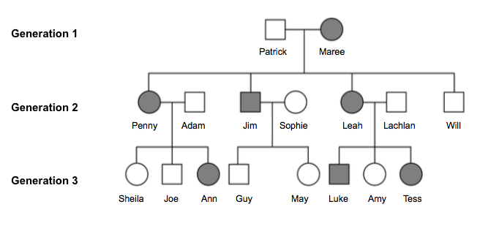

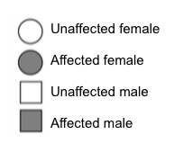

14. Which mode of inheritance best reflects the disease represented in the pedigree above?

(a) Autosomal dominant

(b) X-linked recessive

(c) Y-linked dominant

(d) Autosomal recessive

15. If Sheila were to have a daughter, what is the probability that the daughter will receive the disease trait?

(a) 0

(b) 1.0

(c) 0.5

(d) 0.25

16. Many people believe that evolution is a false theory, based on the idea that humans 'evolved from apes'. If humans have large brains, extensive problem-solving abilities and the power of speech, then why don't these primate 'ancestors'? Which of the following statements best supports the theory of evolution in response to this idea?

(a) Adaptations result in a compromise to another advantageous trait.

(b) Evolution is limited by phylogenetic constraints.

(c) The evolution of advantageous traits is dependent upon environmental factors.

(d) Advantageous traits do not appear within a population's gene pool on command.

*The diagram below relates to question 17.*

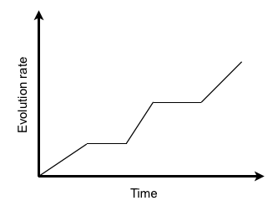

17. The pattern of evolution displayed in the graph above is known as

(a) adaptive radiation.

(b) gradualism.

(c) causal evolution.

(d) punctuated equilibrium.

18. Cytochrome *c* is a protein involved in the synthesis of ATP in the mitochondria. It is widely used in molecular genetics to determine phylogenetic relationships because

(a) its mutation rate is relatively constant over time.

(b) its sequence is highly variable between different organisms.

(c) mutations to the cytochrome *c* gene have occurred at the same time as major evolutionary events.

(d) the DNA sequence for cytochrome *c* has not changed over evolutionary time.

*The diagram below relates to questions 19 - 21*.

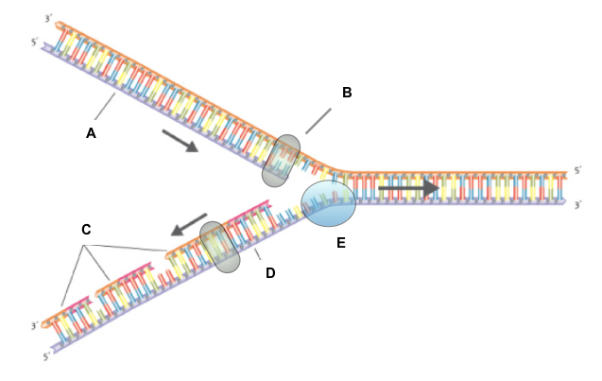

19. In the diagram above, what does structure E represent?

(a) DNA primase

(b) DNA helicase

(c) DNA polymerase

(d) RNA primer

20. The new strands of DNA are said to be semi-conservative because

(a) they are comprised of a leading strand and a lagging strand.

(b) the genetic information has not been conserved.

(c) they are comprised of a parent strand and a newly synthesised strand.

(d) they are made from bonded segments of Okazaki fragments.

21. If the lagging strand of this DNA molecule reads 3'-TAGAATCCTGAG-5', which of the following is the correct code for the complementary leading strand's DNA template?

(a) 3'-TAGAATCCTGAG-5'

(b) 5'-TAGAATCCTGAG-3'

(c) 3'-ATCTTAGGACAC-5'

(d) 5'-ATCTTAGGACAC-3'

22. The formation of a new species, through divergent evolution, can occur rapidly in the absence of natural selection if the new population is

(a) large and diverse.

(b) small and diverse.

(c) large with a high level of heterozygosity.

(d) small with advantageous mutations.

*The image below relates to question 23.*

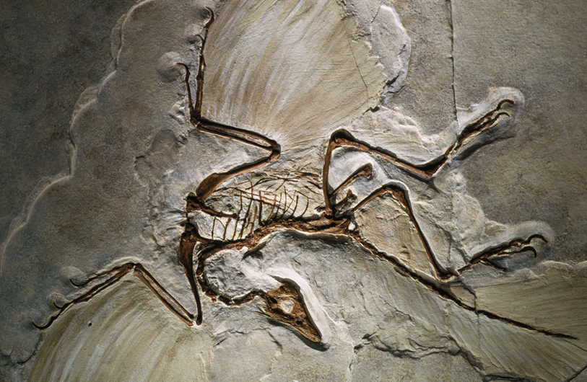

23. The fossilised remains of the extinct species shown above are comprised of morphological features resembling both reptiles and birds. For this reason, the fossilised species is said to be

(a) a hoax.

(b) successional.

(c) transient.

(d) transitional.

24. Fossil formation requires a series of very specific events. Which of the following is not a requirement for fossil formation?

(a) Rapid burial of the dead organism.

(b) The organism is decomposed prior to burial.

(c) The burial site is regularly deposited with sediments.

(d) The organism is comprised of a high percentage of hard tissue matter.

25. Genetic bottlenecks involve

(a) the sharing of genetic material between populations.

(b) an increased resistance to disease.

(c) substantial gene flow.

(d) a loss of genetic diversity in subsequent generations.

*The table below relates to question 26.*

Species

|  |  |  |  |  |  |  |
| --- | --- | --- | --- | --- | --- | --- |
|  | **A** | **B** | **C** | **D** | **E** | **F** |
| **A** |  | 8 | 1 | 3 | 8 | 9 |
| **B** |  |  | 8 | 5 | 1 | 9 |
| **C** |  |  |  | 4 | 8 | 9 |
| **D** |  |  |  |  | 5 | 9 |
| **E** |  |  |  |  |  | 9 |
| **F** |  |  |  |  |  |  |

Species

26. Which phylogenetic tree correctly represents the data in the table above?

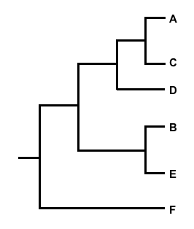

(b)

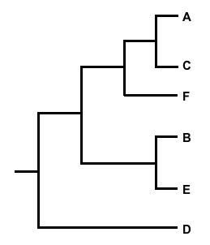

(a)

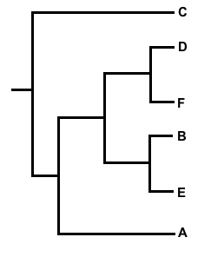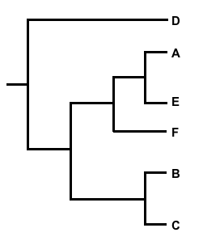

(c)

(d)

*The image below relates to question 27.*

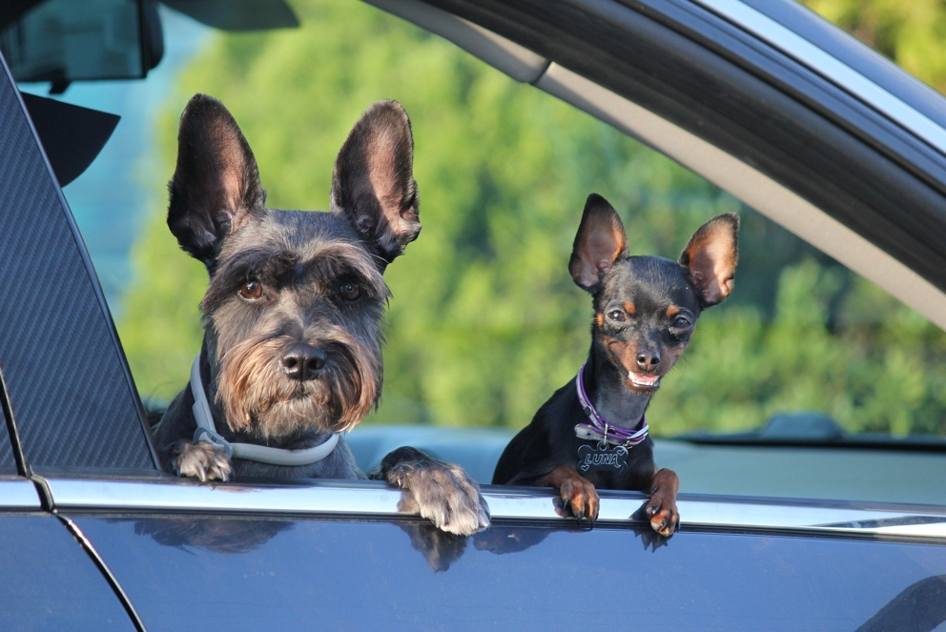

27. The animals in the image above belong to the same species, can interbreed and are descendants of the wolf. Which selection process is responsible for the high level of intraspecies variation, whilst avoiding speciation.

(a) Natural selection

(b) Directional selection

(c) Disruptive selection

(d) Artificial selection

*The information below relates to questions 28 and 29.*

Birds of Paradise have some amazing courtship rituals coupled with stunning plumage. The 'King of Saxony' Bird of Paradise (*Pteridophora alberti*) has exceptionally long, ornamental brow feathers that can reach up to 50 centimetres. During courtship, the male birds sing and flourish their brow feathers around in an elaborate performance.

A biologist wanted to investigate whether the length of the brow feathers influenced the female birds' choice of mate. To prove her theory, the biologist had to monitor the courtship rituals and mating success of several male King of Saxony birds, over a period of two months.

28. Which of the following hypotheses best reflects the aim of this investigation?

(a) Male birds with short brow feathers will be more reproductively successful.

(b) Female birds will prefer long brow feathers to short brow feathers.

(c) The longer the brow feathers, the greater the chance of mating success.

(d) Female birds will be less attracted to male birds with short brow feathers.

29. What is the dependent variable in this investigation?

(a) Mating success.

(b) Length of courtship ritual.

(c) Length of brow feathers.

(d) Degree of female attraction.

30. The brilliant plumage of Birds of Paradise is a display of sexual dimorphism. Sexual dimorphism can direct the evolution of a species by influencing

(a) gene flow.

(b) sexual selection.

(c) phenotypic frequencies.

(d) the inheritance of advantageous alleles.

**END OF SECTION ONE**

**Section Two: Short answer 50% (100 Marks)**

This section has **five (5)** questions. Answer **all** questions. Write your answers in the spaces provided in this Question/Answer booklet. Wherever possible, confine your answers to the line spaces provided. Use a blue or black pen for this section. Only graphs and diagrams may be drawn in pencil.

Additional working space pages at the end of this Question/Answer booklet are for planning or continuing an answer. If you use these pages, indicate at the original answer the page number it is planned/continued on and write the question number being planned/continued on the additional working space page.

Suggested working time: 90 minutes.

**Question 31 (20 marks)**

(a) Describe the components and structure of the following genetic material.

(i) Nucleotide (2 marks)

(ii) Codon (2 marks)

(iii) DNA (2 marks)

(iv) Chromatin (2 marks)

(b) Suggest why the information contained within genes is referred to as the 'universal genetic code'. (2 marks)

The following strand of DNA is part of a gene that codes for a structural protein.

**3' CAATTGATAAGTCAGTCAATGGAT 5'**

**5' GTTAACTATTCAGTCAGTTACCTA 3'**

(c) Determine the mRNA sequence that would be synthesised from the DNA strand shown above. (2 marks)

(d) Using the genetic code table below, identify the amino acids that would be translated from the transcribed mRNA strand. (4 marks)

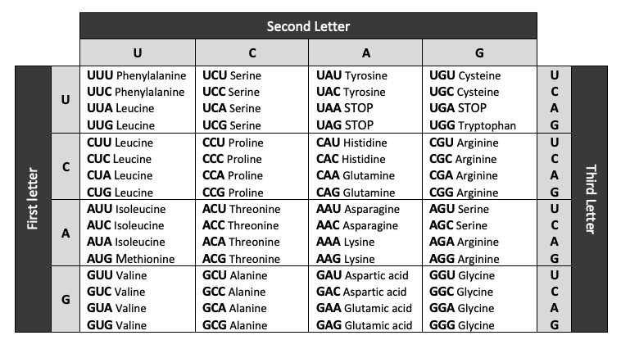The Genetic Code

There are 64 three-letter codes in the genetic code table but only 20 amino acids.

(e) Explain how having many more codes than amino acids could be of benefit to the process of protein synthesis. (2 marks)

Jessie and Rebecca are identical twins. Their parents, friends and teachers often find it difficult to tell them apart. However, Jessie was born with only four digits on her left hand.

(f) Explain how it is possible for Jessie to exhibit a difference in morphology to her identical twin. (2 marks)

**Question 32 (20 marks)**

(a) Define the term 'speciation'. (2 marks)

(b) Describe the **four (4)** main factors that influence the process of speciation. (8 marks)

1.

2.

3.

4.

(c) Using specific examples, explain how analysis of each of the following can provide evidence for the 'theory of evolution'. (6 marks)

(i) Fossils

(ii) Homologous structures

(iii) Analogous structures

(d) Explain how microevolution differs from macroevolution. (4 marks)

**Question 33 (20 marks)**

Spider silk is one of the strongest biopolymers on Earth. It is three times stronger than Kevlar, a material used in yacht sails, and 10 times stronger than steel. Its strength and elasticity can allow its use in airbags, artificial limbs, bulletproof vests and facial reconstructive surgery. However, producing spider silk in large quantities from spiders themselves is problematic. Farming spiders results in territorial disputes, generally ending in a fight to the death. In addition, millions of spiders are required to produce sufficient quantities of silk for use in commercial production. Molecular scientists from the U.S. and Canada have discovered a way to produce spider silk in goat's milk.

The gene for the production of dragline silk (used when spiders 'dangle') has been isolated from the genome of the golden orb-weaver spider, *Nephila clavipes*. Scientists then inserted the gene into the goat genome. The process is outlined below.

1. Silk gene isolated from spider and cloned.

2. Gene inserted into the genome of a goat's somatic cell (nucleus).

3. A donor ovum has its nucleus removed and is replaced with the modified nucleus.

4. The ovum is grown into an embryo and then implanted into a recipient goat.

5. The offspring of the modified embryo is born with the ability to produce spider silk in its milk.

(a) Explain why these genetically modified goats are considered 'transgenic' animals.

(2 marks)

To ensure the spider silk gene is only expressed in the cells of the goat's mammary glands, the gene is inserted within the milk producing genes.

(b) Suggest the importance of inserting the gene at this location. (3 marks)

(c) Construct an annotated diagram that reveals how a gene (segment of DNA) is inserted into a recipient genome. (6 marks)

When the genetically modified goats are of reproductive age, they are mated with unmodified males. Not all of the subsequent offspring contain the spider silk gene.

(d) Explain why scientists would breed modified goats with the unmodified male stock.

(3 marks)

Many news articles regarding the production of spider silk milk have referred to the genetically modified goats as 'spider goats'.

(e) Explain why the term 'spider goat' is scientifically incorrect. (3 marks)

(f) Suggest **three (3)** moral and/or ethical issues people may have with the use of mammals in genetic engineering. (3 marks)

**Question 34 (20 marks)**

(a) Identify **four (4)** main differences between mitosis and meiosis. (4 marks)

1.

2.

3.

4.

A tumour is a group of abnormal cells, with no useful function, that grow and reproduce in an unrestrained manner. They can be either benign (non-cancerous) or malignant (cancerous).

(b) Describe the change that occurs within a normal somatic cell to allow a tumour to form. (3 marks)

Meiosis plays an integral role in maintaining genetic diversity of a species' population.

(c) Explain what is meant by 'independent assortment of alleles'. (4 marks)

(d) Using a labelled diagram, describe the process of 'crossing over' that occurs during meiosis. (6 marks)

(e) Explain the role of fertilisation in fostering genetic variation. (2 marks)

(f) A fruit grower plants several different varieties of blueberry plants in close proximity to increase the likelihood of cross-pollination. Even though the flowers are fertilised with pollen from a different blueberry variety, they still produce fruit with the same genetic complement of the parent plant. Explain. (3 marks)

**Question 35 (20 marks)**

Molecular biologists were investigating the presence of a genetic mutation in two species of frog, *Limnodynastes dorsalis* (Pobblebonk frog) and *Crinia glauerti* (Glauert's froglet). This mutation is thought to provide natural resistance to a virus affecting frog populations worldwide. In 'normal' frogs, a protein found on the external surface of cell membranes allows the virus to attach to and enter the cell, resulting in infection and subsequent death. In frogs carrying the mutation, the virus is unable to enter their cells and cause illness.

40 individuals from each species were used in the investigation. Approximately half of the frogs showed symptoms of the virus (normal gene) and half were thought to be resistant (mutated gene). Genomic DNA was extracted from each frog and the region of DNA under investigation isolated.

(a) Identify the type of enzyme used to remove or 'cut' segments of DNA from a chromosome and explain how it works. (3 marks)

In a normal frog, the cell membrane protein is coded for by the gene VPCM. In frogs carrying the mutation, the end of this gene sequence has been deleted.

(b) Suggest why this mutation prevents the virus from entering the frog's cells. (2 marks)

Multiple copies of the frog's DNA, required to carry out further analysis, were synthesised using PCR (Polymerase Chain Reaction). Two different DNA primers were added to the PCR so the correct gene sequence would be copied from the mutated and non-mutated DNA.

(c) Explain the function of a DNA primer and their importance in the PCR process.

(3 marks)

Following the PCR process, the copied segments of DNA from each frog species were visualised via gel electrophoresis. The final 'gel' is shown below.

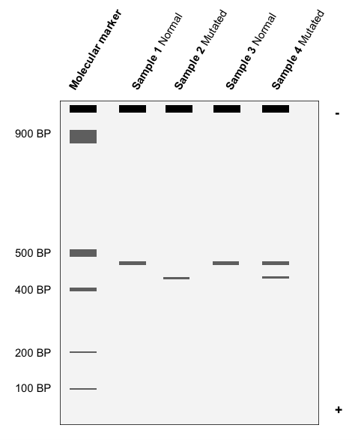

(d) Estimate the base-pair lengths for the gene segments of each test sample. (5 marks)

**Sample 1**

*L.* *dorsalis* (normal)

**Sample 2**

*L.* *dorsalis* (mutated)

**Sample 3**

*C. glauerti* (normal)

**Sample 4**

*C. glauerti* (mutated)

(e) Suggest a reason for the anomaly in the data for Sample 4. (1 mark)

The scientists repeated the experiment several times, only using the DNA from the frogs that were obviously healthy but had been exposed to the virus. To their surprise, they got the same results; two bands in Sample 4. After further analysis, a second mutation for the protein

was discovered in the gene from *C. glauerti*. It was later identified as a substitution mutation which did not change the length of the gene. While this mutation still allowed for protein production, the frogs carrying this gene were resistant to viral infection.

(f) Explain how this substitution mutation could allow the synthesis of the protein while offering resistance to the virus. (4 marks)

(g) Propose how these findings could be used in the future conservation of frogs.

(2 marks)

**END OF SECTION TWO**

**Section Three: Extended answer 20% (40 marks)**

This section contains **four (4)** questions. You must answer **two (2)** questions; **one (1)** from Part A and **one (1)** from Part B.

Use black or blue pen for this section. Only graphs and diagrams may be drawn in pencil. Responses can include: labelled diagrams with explanatory notes; lists of points with linking sentences; labelled tables and/or graphs; and/or annotated flow diagrams with introductory notes.

Additional working space pages at the end of this Question/Answer booklet are for planning or continuing an answer. If you use these pages, indicate at the original answer, the page number it is planned/continued on and write the question number being planned/continued on the additional working space page.

Suggested working time: 50 minutes

**Part A**

Choose **either** Question 36 **or** Question 37.

Indicate the question you will answer by ticking the box next to the question. Write your answer on pages 27 - 29. When you have answered your first question, turn to page 30 and indicate the second question you will answer on that page.

**Question 36 (20 marks)**

(a) Explain the concept of alleles in the inheritance and expression of genetic traits. (10 marks)

(b) Describe the type of mutations that result in a change in the structure of a chromosome. (10 marks)

OR

**Question 37 (20 marks)**

(a) Using specific examples, explain how environmental factors can influence phenotypic expression without causing change to the genotype. (10 marks)

(b) Outline the processes involved in the synthesis of proteins, from DNA to ribosome.

(10 marks)

**Question**

**Part B**

Choose **either** Question 38 **or** Question 39.

Indicate the question you will answer by ticking the box next to the question. Write your answer on the pages provided.

**Question 38 (20 marks)**

Analysing the similarities in homologous DNA sequences of organisms enables scientists to determine their relatedness.

(a) Describe the process of DNA (molecular) hybridisation and how it can reveal evolutionary relatedness and common ancestry. (10 marks)

(b) Explain how adaptive radiation gave rise to Darwin's Galapagos Island finches through allopatric speciation. (10 marks)

OR

**Question 39 (20 marks)**

The European rabbit (*Oryctolagus cuniculus*) was introduced into Australia in 1859 by a wealthy farmer keen on hunting. Within a few years, the rabbits had spread uncontrollably throughout Australia despite hunting, poisoning and trapping. The Australian landscape was devastated as the rabbits fed on native plants and domestic stock feed.

In 1950, a highly virulent strain of the Myxoma virus (causing Myxomatosis) was released. Within five years it had spread throughout Australia, reducing the rabbit population by 99%. However, the effectiveness of the virus gradually declined and by 1995, the rabbit population had reached an estimated 300 million.

(a) Discuss how the mechanisms of natural selection and the Founder Effect led to the development of a rabbit population in Australia, resistant to the Myxoma virus. (10 marks)

(b) Contrast the use of and processes involved in selective breeding and genetic modification in modern agricultural practice. (10 marks)

**END OF EXAM**

**Question**

**Acknowledgements**

**Question 14 and 15**

Author made

**Question 17**

Author made

**Question 19 - 21**

Diagram of DNA replication

http://www.publicdomainfiles.com/

**Question 23**

Fossil image

Wikimedia Commons

**Question 26**

Phylogenetic data table and trees

Author made

**Question 27**

Dogs in vehicle image

Pixabay - CC0 Creative Commons (free for commercial use)

**Question 31**

The Genetic Code table

Author made

**Question 33**

*https://phys.org/news/2010-05-scientists-goats-spider-silk.html*

*https://labiotech.eu/bioart/bulletproof-skin-goat-milk-spider-silk/*

*https://www.smithsonianmag.com/innovation/new-artificial-spider-silk-stronger-steel-and-98-percent-water-180964176/*

*http://www.takepart.com/article/2014/04/10/gmo-goats*

https://www.nature.com/articles/519S4a

Hinman, M. B. & Lewis, R. V. (1992). "Isolation of a clone encoding a second dragline silk fibroin. Nephila clavipes dragline silk is a two-protein fiber". J. Biol. Chem. **267** (27): 19320–19324.

Xu, M. & Lewis, R. V. (1990). [*"Structure of a Protein Superfiber - Spider Dragline Silk"*](https://www.ncbi.nlm.nih.gov/pmc/articles/PMC54695). Proceedings of the National Academy of Sciences of the United States of America. **87** (18): 7120–7124.

**Question 35**

Gel electrophoresis diagram

Author made

**Question 39**

Peter J. Kerr, Elodie Ghedin, Jay V. DePasse, Adam Fitch, Isabella M. Cattadori, Peter J. Hudson, David C. Tscharke, Andrew F. Read, Edward C. Holmes (2012).

[*Evolutionary History and Attenuation of Myxoma Virus on Two Continents*](https://www.ncbi.nlm.nih.gov/pmc/articles/PMC3464225/)*.* PLoS Pathog. 8(10): e1002950.