* Copyright for test papers and marking guides remains with *West Australian Test Papers*.
* The papers may only be reproduced within the purchasing school according to the advertised conditions of sale.
* Test papers must be withdrawn after use and stored securely in the school until Wednesday 1st July 2015.

**CHEMISTRY**

**UNIT 1**

**2015**



Name: _________________________________________________________________________________________

Teacher: ________________________________________________________________________________________

***TIME ALLOWED FOR THIS PAPER***

Reading time before commencing work: Ten minutes

Working time for the paper: Three hours

***MATERIALS REQUIRED/RECOMMENDED FOR THIS PAPER***

**To be provided by the supervisor:**

* This Question/Answer Booklet
* Multiple-choice Answer Sheet
* Chemistry Data Sheet

**To be provided by the candidate:**

Standard items: pens (blue/black preferred), pencils (including coloured), sharpener,

eraser, correction tape/fluid, ruler, highlighters

Special items: non-programmable calculators approved for use in the WACE

examinations

***IMPORTANT NOTE TO CANDIDATES***

No other items may be taken into the examination room. It is **your** responsibility to ensure that you do not have any unauthorised notes or other items of a non-personal nature in the examination room. If you have any unauthorised material with you, hand it to the supervisor **before** reading any further.

**Structure of this paper**

|  |  |  |  |  |  |
| --- | --- | --- | --- | --- | --- |
| Section | Number of questions available | Number of questions to be answered | Suggested working time  (minutes) | Marks available | Percentage of exam |
| Section One:  Multiple-choice | 25 | 25 | 50 | /50 | /25 |
| Section Two:  Short answer | 15 | 15 | 60 | /70 | /35 |
| Section Three:  Extended answer | 6 | 6 | 70 | /80 | /40 |
|  | | | | | /100 |

**Instructions to candidates**

1. Answer the questions according to the following instructions.

Section One: Answer all questions on the separate Multiple-choice Answer Sheet provided. For each questions shade the box to indicate your answer. Use only a blue or black pen to shade the boxes. If you make a mistake, place a cross through that square then shade your new answer. Do not erase or use correction fluid/tape. Marks will not be deducted for incorrect answers. No marks will be given if more than one answer is completed for any question.

Sections Two and Three: Write your answers in this Question/Answer Booklet.

2. When calculating numerical answers, show your working or reasoning clearly. Express numerical answers to three significant figures and include appropriate units where applicable.

3. You must be careful to confine your responses to the specific questions asked and to follow any instructions that are specific to a particular question.

4. Spare pages are included at the end of this booklet. They can be used for planning your responses and/or as additional space if required to continue an answer.

* + Planning: If you use the spare pages for planning, indicate this clearly at the top of the page.
  + Continuing an answer: If you need to use the space to continue an answer, indicate in the original answer space where the answer is continued, i.e. give the page number. Fill in the number of the question(s) that you are continuing to answer at the top of the page.

5. The Chemistry Data Sheet is **not** handed in with your Question/Answer Booklet.

**Section One: Multiple-choice 25% (50 marks)**

This section has 25 questions. Answer all questions on the separate Multiple-choice Answer Sheet provided. For each question, shade the box to indicate your answer. Use only a blue or black pen to shade the boxes. If you make a mistake, place a cross through that square then shade your new answer. Do not erase or use correction fluid/tape. Marks will not be deducted for incorrect answers. No marks will be given if more than one answer is completed for any question.

Suggested working time: 50 minutes.

1. Which element does not form ions with the same electron configuration as Argon?

(a) S

(b) Ca

(c) Al

(d) Cl

2. Using the given coefficients, balance the unbalanced equation below:

...Na3P04 (aq) + ...CaCl2 (aq) 🡪....NaCl(aq) + ...Ca3(PO4)2(s)

(a) 1,3,3,1

(b) 2,3,3,2

(c) 2,3,6,1

(d) 2,3,3,1

3. A metal (X) ion combines with the oxide ion to form an ionic compound with the formula X2O3. Which of the following is the most likely formula when X combines with the nitride ion?

(a) X2N3

(b) XN

(c) X3N2

(d) XN3

4. Which of the following compounds has a bonding structure which differs from the other three?

(a) Na2SO4

(b) RbOH

(c) NH4Cl

(d) SiO2

5. In which of the following molecules would you find six electrons shared between two bonding atoms?

(a) oxygen gas.

(b) ethane gas.

(c) ammonia gas.

(d) nitrogen gas.

6. Electronegativity tends to increase as:

1. you go down a group of the periodic table.
2. you go from left to right across a period of the periodic table..

(c) the atomic number increases

(d) the valency of the common ion increases

7. Which of the following statements is the best definition of ionisation energy?

(a) It is the energy needed to change a mole of a substance from a liquid to a gas.

(b) It is the energy required to dissociate one mole of ions in the solid phase.

(c) It is the energy required to remove a mole of electrons from a mole of

atoms or ions of an element in the gaseous phase.

1. It is the energy required to form one mole of an ionic substance from its

constituent atoms.

8. Which one of the following substances can conduct electricity?

(a) NaF (s)

(b) NH4Cl (s)

(c) HCl (g)

(d) C (s) (graphite)

9. Which of the following substances have both covalent and ionic bonding within them?

(a) CsF (s)

(b) Ca3(PO4)2 (s)

(c) HF (g)

(d) C (s) (graphite)

10. Silicon dioxide has a much higher melting point than carbon dioxide. Which of the following best explains this difference?

(a) Silicon dioxide is a larger molecule than carbon dioxide, so the forces between its molecules are greater than those between carbon dioxide molecules.

(b) Carbon is a more electronegative atom than silicon, so it attracts oxygen

atoms with a stronger force than silicon can.

(c) The double bonds within silicon dioxide molecules are stronger than the

double bonds within carbon dioxide molecules.

(d) Silicon atoms form extended single covalent bonding in silicon dioxide,

so its structure is a network solid whereas carbon dioxide forms discrete molecules with intermolecular forces between the molecules.

11. Mass spectrometers separate isotopes of different elements based on their:

1. Mass only
2. electric charge only
3. mass and electric charge
4. emission of photons

12.The percentage by mass of carbon is 82.7% in

1. methane.
2. ethane.
3. propane.
4. butane.

13.Which of the following is always produced during combustion of fossil fuels?

1. Water
2. Carbon (soot)
3. Sulfur dioxide
4. Carbon monoxide

14. “Line spectra” are caused primarily by:

(a) The existence of multiple ground states in an atom

(b) The release of multiple photons from an atom

(c) The existence of multiple atoms in a typical sample

(d) The existence of multiple excited states in an atom

15.Which of the following ions could be easily distinguished from the others using a flame test?

1. Al3+
2. Cu2+
3. Mg2+
4. Zn2+

16. A student performed a sampling technique as part of an investigation and repeated the sampling technique several times. What aspect of the experiment was improved by repeating the procedure?

1. Accuracy
2. Reliability
3. Safety
4. Validity

17.Iodine readily sublimes from solid to gas following moderate heating. The nature of the particles in these two physical states of iodine can be best described as?

***Solid🡪 vapour***

(a) ionic🡪 atomic

(b)ionic🡪 molecular

(c) molecular🡪 atomic

(d) molecular🡪 molecular

18. What is the correct IUPAC name for the compound CH3(CH2)2CH(CH3)CH2Cl?

(a) 1-chloroethylbutane

(b) 3-methyl-5-chloropentane

(c) 1-chloro-2-methylpentane

(d) 1-chloro-3-ethylbutane

19. Which of the following compounds readily undergoes addition reactions?

(a) ethane

(b) benzene

(c) propene

(d) cyclohexane

20. When ethene gas is reacted with bromine water, which of the following gives the correct product or products?

(a) bromoethene and hydrogen bromide

(b) 1,1-dibromoethane

(c) 1,2- dibromoethane

(d) 1,1-dibromoethene

21. The enthalpy of combustion of methane (CH4) is -882 kJ mol-1.The mass of methane which has to be burned to produce 88.2 kJ is:

1. 1.6g
2. 16g
3. 88.2g
4. 882g

22. Which one of the following substances conducts electricity by the *movement of oppositely charged ions*?

(a) aluminium metal

(b) carbon

(c) solid zinc chloride

(d) molten sodium chloride

23. Propane is commonly used as a fuel for portable stoves. It combusts with oxygen to produce carbon dioxide and water. The reaction is commonly represented as:

C3H8(g) + 5O2(g) 🡪 3CO2(g) + 4H2O(g)

Which of the following alternative does not accurately represent a correct mole relationship for the above reaction?

1. n(CO2) = 3/5 x n(O2)
2. n(H2O) = 4/5 x n(O2)
3. n(CO2) = 5/3 x n(O2)
4. n(H2O) = 4/3 x n(CO2)

24. Which of the following has notbeen named correctly?

* 1. 3-ethylpentane
  2. 2-ethylbutane
  3. 2, 2-dimethylbutane
  4. 2, 3-dimethylbutane

25. Which of the following statements about graphite is correct?

1. Graphite has a melting point similar to diamond.
2. Graphite is very hard. This is due to the need to break very strong carbon-carbon bonds operating in 3-dimensions.
3. Graphite doesn't conduct electricity. All the electrons are held tightly between the atoms, and aren't free to move.
4. Graphite is insoluble in water and organic solvents.

END OF SECTION ONE

**Section Two: Short answer 35% (70 marks)**

This section has 13 questions. Answer all questions. Write your answers in the spaces provided.

When calculating numerical answers, show your working or reasoning clearly. Express numerical answers to three significant figures and include appropriate units where applicable.

Spare pages are included at the end of this booklet. They can be used for planning your responses and/or as additional space if required to continue an answer.

* Planning: If you use the spare pages for planning, indicate this clearly at the top of the page.
* Continuing an answer: If you need to use the space to continue an answer, indicate in the original answer space where the answer is continued, i.e. give the page number. Fill in the number of the question(s) that you are continuing to answer at the top of the page.

Suggested working time: 60 minutes.

26. Isotopes of carbon are used to determine the age of fossilised organic samples dug up by archaeologists.

1. Explain what is meant by the term isotope. (2 marks)

___________________________________________________________________________________________________________________________________________________________________________________________________________________________

1. Explain why isotopes of the same element have the same chemical properties.

(2 marks)

_____________________________________________________________________________________________________________________________________________________________________________________________________________________________________________________________________________________________________________________________________________________________________________

1. Calculate the mass, in grams, of a single atom of this isotope of carbon-12.

(2 marks)

______________________________________________________________________________________________________________________________________________________________________________________________________________________________________________________________________________________________________________________________________________________________________________________________________________________________________________________

27. Draw electron-dot diagrams showing the arrangement of valence electrons in the following chemical species. (4 marks)

Represent all valence shell electron pairs either as : or –

|  |  |
| --- | --- |
| Ethane C2H6 | Hydroxide ion OH- |
|  |  |

28. (a) Using labelled arrows, on the periodic table below clearly label the trends in electronegativity, first ionisation energy and atomic radius. (3 marks)

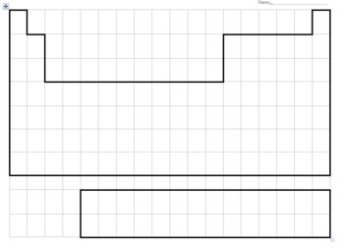

1. Describe and explain the trends for atomic radius. (4 marks)

_____________________________________________________________________________________________________________________________________________________________________________________________________________________________________________________________________________________________________________________________________________________________________________________________________________________________________________________________________________________________________________________________________________________________________________________________________________________________________________________________________________________________________________________________________________________________________________________________________________________________________________________________________________________________________________________________________________________________________________________

1. Explain, with the aid of a diagram, how movement of electrons within an atom produces the emission spectra responsible for observations in flame tests. (4 marks)

|  |
| --- |
|  |

_____________________________________________________________________________________________________________________________________________________________________________________________________________________________________________________________________________________________________________________________________________________________________________________________________________________________________________________________________________________

1. Complete the following table (4 marks)

|  |  |  |
| --- | --- | --- |
| **SUBSTANCE** | **NAME** | **TYPE(s) of BONDING** |
| Ti |  |  |
| CS2 |  |  |
| NH3 |  |  |
| NH4Cl |  |  |

1. Describe the differences in malleability and electrical conductivity for metals and ionic compounds. Explain these properties by referring to the bonding involved. (6 marks)

________________________________________________________________________________________________________________________________________________________________________________________________________________________________________________________________________________________________________________________________________________________________________________________________________________________________________________________________________________________________________________________________________________________________________________________________________________________________________________________________________________________________________________________________________________________________________________________________________________________________________________________________________________________________________________________________________________________________________________________________________________________________________________________________________________________________________________________________________________________________________________________________________________________________________________________________________________________________________________________________________________________________________________________________________________________________________________________________________________________________________________________________________________________________________________________________________________________________________________________________________________________________________________________________________________________________________________________________________________________

1. Compare the properties of hardness, melting point and electrical conductivity for a covalent molecular substance like water, and a covalent network substance like diamond. Explain the properties by referring to the bonding involved.

(6 marks)

________________________________________________________________________________________________________________________________________________________________________________________________________________________________________________________________________________________________________________________________________________________________________________________________________________________________________________________________________________________________________________________________________________________________________________________________________________________________________________________________________________________________________________________________________________________________________________________________________________________________________________________________________________________________________________________________________________________________________________________________________________________________________________________________________________________________________________________________________________________________________________________________________________________________________________________________________________________________________________________________________________________________________________________________________________________________________________________________________________________________________________________________________________________________________________________________________________________________________________________________________________________________________________________________________________________________________________________________________________________

1. The element gallium has the electron configuration 2,8,18,3. Using the same notation, give the electron configuration of: (2 marks)

(a) A chlorine atom, Cl   
  
(b) a calcium ion, Ca2+

1. Give IUPAC names for the following two organic compounds. (2 marks)

H H

* 1. \ /

C = C

/ \

H CH2 ─CH3 ______________________________________

CH2 ─ CH3

|

* 1. CH3─ CH ─CH2─CH ─ CH2 ─ CH3

| |

CH2 CH3 ________________________________________

|

CH3

1. Draw structural diagrams for the two organic compounds named here (2,2 marks)
2. 2-iodo-3-methyl-2-pentene b. 5,6-dimethyl-2-octene

1. Draw, and name using correct IUPAC nomenclature complete structural formulae for the isomers with molecular formula C6H14 (do not include hexane) (6 marks)

1. A sample of gaseous vanadium is analysed by mass spectrometry. The vanadium atoms are first ionised then accelerated before being deflected. (2,1,1 marks)

(a) Describe briefly how positive ions are formed from gaseous vanadium atoms in a mass

spectrometer.

___________________________________________________________________________________________________________________________________________________________________________________________________________________________

(b) What is used in a mass spectrometer to accelerate the positive ions?

__________________________________________________________________________________________________________________________________________________

(c) What is used in a mass spectrometer to deflect the positive ions?

________________________________________________________________________________________________________________________________________________

1. Diagram representing fractional distillation of crude oil.

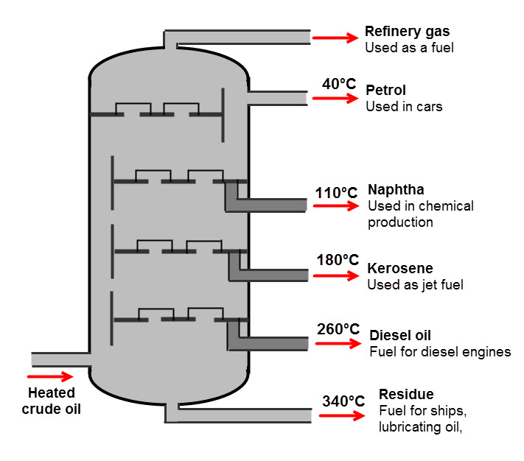

a) Give a brief description demonstrating your understanding of what is occurring in the diagram.

(2 marks)

___________________________________________________________________________________________________________________________________________________________________________________________________________________________________________________________________________________________________

b) Name the physical property that the process depends upon (1 mark)

__________________________________________________________________________________________________________________________________________________

c) What is the chemical property that underlies the physical property (1 mark)

__________________________________________________________________________________________________________________________________________________

d) Give the molecular formula for an alkane with seven carbon atoms. (1 mark)

__________________________________________________________________________________________________________________________________________________

e) Write an equation for the complete combustion of the alkane C8H18  (2 marks)

___________________________________________________________________________________________________________________________________________________________________________________________________________________________

39. Write a balanced equation for the following reactions. Give the name of any organic products.

1. methane and chlorine gases react to completion (4 marks)

___________________________________________________________________________________________________________________________________________________________________________________________________________________________

1. Bromine water is added to pent-2-ene

___________________________________________________________________________________________________________________________________________________________________________________________________________________________

40. Write **observations** for any reactions that occur in the following procedures. In each case describe in full what you would observe: (4 marks)

1. Methane gas and excess chlorine gases are mixed in the presence of UV light

___________________________________________________________________________________________________________________________________________________________________________________________________________________________

1. Bromine water is added to hex-1-ene

___________________________________________________________________________________________________________________________________________________________________________________________________________________________

END OF SECTION TWO

**Section Three: Extended answer 40% (80 marks)**

This section contains five (5) questions. You must answer all questions. Write your answers in the spaces provided below.

Where questions require an explanation and/or description, marks are awarded for the relevant chemical content and also for coherence and clarity of expression. Lists or dot points are unlikely to gain full marks.

Final answers to calculations should be expressed to three significant figures.

Spare pages are included at the end of this booklet. They can be used for planning your responses and/or as additional space if required to continue an answer.

* Planning: If you use the spare pages for planning, indicate this clearly at the top of the page.
* Continuing an answer: If you need to use the space to continue an answer, indicate in the original answer space where the answer is continued, i.e. give the page number. Fill in the number of the question(s) that you are continuing to answer at the top of the page.

Suggested working time: 70 minutes.

**Question 41 (11 marks)**

The annual contribution of Western Australia's mineral and petroleum industry to the Australian economy is well over $100 billion dollars. The industry employs approximately 100,000 people. Drug testing is an important process where Chemists are employed to ensure that the workplace remains safe. All employees are subjected to a stringent drug testing regime before they enter the workplace in addition to testing whilst they are on site.

Despite their best efforts, mining inspectors claim that synthetic drug use remains a major issue in the industry. It seems that synthetic versions of cannabis and ‘ice’ or crystal methamphetamine, in particular, are changing rapidly to avoid detection.

1. Using your knowledge of Chemistry, explain a technique of chemical analysis that could be used to identify a particular drug based on its chemical composition. (5 marks)

___________________________________________________________________________________________________________________________________________________________________________________________________________________________________________________________________________________________________________________________________________________________________________________________________________________________________________________________________________________________________________________________________________________________________________________________________________________________________________________________________________________________________________________________________________________________________________________________________________________________________________________________________________________________________________________________________________________________________________________________________________________________________________________________________________________________________________________________________________________________________________________

A sample of suspected crystal methamphetamine confiscated from one of the mine workers was submitted for analytical testing. The following data was obtained regarding the isotopic composition of elements present in the sample.

b) Identify the two elements present (2 marks)

______________________________________________________________________________________________________________________________________

c) Determine the relative atomic mass of each element. You must show your working to attain full marks. (4 marks)

_______________________________________________________________________________________________________________________________________________________________________________________________________________________________________________________________________________________________________________________________________________________________________________________________________________________________________________________________________________________________________________________________________________________

**Question 42 (10 marks)**

Saponification (the making of soap) is the hydrolysis of plant oil or an animal fat by treating it with a strong base. Below is a chemical reaction depicting the conversion of a fat molecule (triglyceride) into glycerol and the salt of a fatty acid (soap).

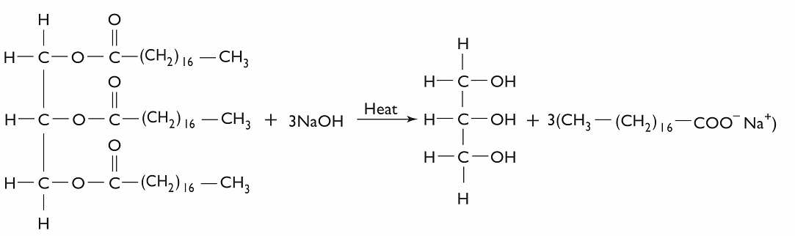

**Triglyceride** (fat) **🡪 glycerol + salt of fatty acid**

1. Determine the mass of one mole of the triglyceride molecule (2 marks)

_________________________________________________________________________

____________________________________________________________________________________________________________________________________________________________________________________________________________________________________________________________________________________________________

1. If 0.140 moles of triglyceride reacts, how many moles of the salt of a fatty acid are produced?

(1 mark)

_________________________________________________________________________

____________________________________________________________________________________________________________________________________________________________________________________________________________________________________________________________________________________________________

1. What is the mass of salt of fatty acid resulting from the breakdown of 0.140 moles triglyceride? (2 marks)

_________________________________________________________________________

____________________________________________________________________________________________________________________________________________________________________________________________________________________________________________________________________________________________________

1. Determine the percentage composition of each element in a triglyceride molecule.

(3 marks)

_________________________________________________________________________

____________________________________________________________________________________________________________________________________________________________________________________________________________________________________________________________________________________________________

_________________________________________________________________________

____________________________________________________________________________________________________________________________________________________________________________________________________________________________________________________________________________________________________

1. Why is heat required for the reaction to occur? (2 marks)

_________________________________________________________________________

__________________________________________________________________________________________________________________________________________________

**Question 43 (10 marks)**

The study and assembly of materials at the subatomic level is otherwise known as **Nanotechnology**. This emerging area of Science is aiming to provide solutions to some of the problems that humanity faces.

1. Describe two examples of nanotechnology potentially solving present day problems

(4 marks)

_________________________________________________________________________

____________________________________________________________________________________________________________________________________________________________________________________________________________________________________________________________________________________________________

__________________________________________________________________________________________________________________________________________________

____________________________________________________________________________________________________________________________________________________________________________________________________________________________________________________________________________________________________

1. Describe one potential risk arising from the use of nanotechnology. (2 marks)

_________________________________________________________________________

____________________________________________________________________________________________________________________________________________________________________________________________________________________________________________________________________________________________________

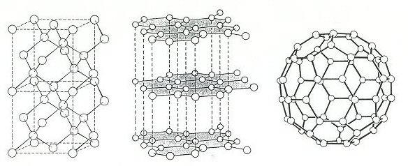

1. Three allotropes of carbon (diamond, graphite and a fullerene) are shown above.
2. What do you understand by the term ‘allotrope’ (1 mark)

______________________________________________________________________________________________________________________________________

1. Account for one physical property of each allotrope with reference to the bonding type present. Your answer must include a different property for each (3 marks)

_________________________________________________________________________

____________________________________________________________________________________________________________________________________________________________________________________________________________________________________________________________________________________________________

_________________________________________________________________________

__________________________________________________________________________________________________________________________________________________________________________________________________________________________________________________________________________________________________________________________________________________________________________________________________________________________________________________________________________________________________________________________________________________________________________________________________________________________________________________________________________________________________________________________________________________________

**Question 44 (22 marks)**

A typical petro diesel molecule has the molecular formula **C16H34**. It is produced by the fractional distillation of crude oil. Biodiesel, however, is derived from renewable sources such as vegetable oil or animal fat and has a typical molecular formula, **C17H34O2**.

1. Assuming complete combustion, write separate balanced equations for the combustion of petro diesel and biodiesel. (4 marks)

(i)__________________________________________________________________________________________________________________________(ii)__________________________________________________________________________________________________________________________

1. In order to determine the mass of Carbon Dioxide released from the combustion of one tonne of C16H34 and one tonne of C17H34O2, first determine the number of moles of each reactant in one tonne. (4 marks)

(i)__________________________________________________________________________________________________________________________

____________________________________________________________________________________________________________________________(ii)______________________________________________________________________________________________________________________________________________________________________________________________________________________________________________________

1. Determine the number of moles of carbon dioxide released from the combustion of one tonne of each diesel molecule. (2 marks)

(i)__________________________________________________________________________________________________________________________

____________________________________________________________________________________________________________________________

(ii)________________________________________________________________________________________________________________________________________________________________________________________

1. Assuming 3.5 tonnes of oxygen gas is available for each reaction determine whether there is sufficient oxygen for complete combustion. You must show all working for maximum marks

(4 marks)

(i)__________________________________________________________________________________________________________________________

____________________________________________________________________________________________________________________________________________________________________________________________________________________________________________________________________________________________________________________________________________________________________________________

(ii)____________________________________________________________________________________________________________________________________________________________________________________________________________________________________________________________________________________________________________________________________________________________________________________________________________________________________________________________________________________________________________________________________________________________________________

1. On the axes below draw an energy profile diagram for the enthalpy change in either reaction. Be sure to provide all the appropriate labels. (5 marks)

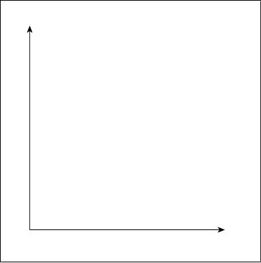

1. If the heat of reaction is (–10,700 kJ/mol) for the combustion of petro diesel, determine the amount of heat released from the combustion of one tonne of the substance.

(3 marks)

__________________________________________________________________________________________________________________________

______________________________________________________________________________________________________________________________________________________________________________________________________________________________________________________

**Question 45 (9 marks)**

Our current conception of the atomic model is due to a series of findings from key experiments in the past. Some involved newly developed devices of that time. Below are depictions of some of the devices or data obtained from the experiment. Outline how the principal findings of each contributed to our current understanding of atomic structure.

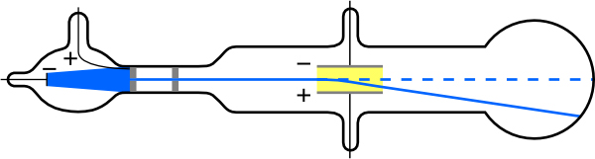

Cathode Ray Tube

____________________________________________________________________________________________________________________________

________________________________________________________________________________________________________________________________________________________________________________________________________________________________________________________

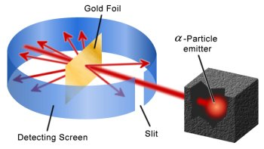

Rutherford’s Gold Foil Experiment

____________________________________________________________________________________________________________________________

________________________________________________________________________________________________________________________________________________________________________________________________________________________________________________________

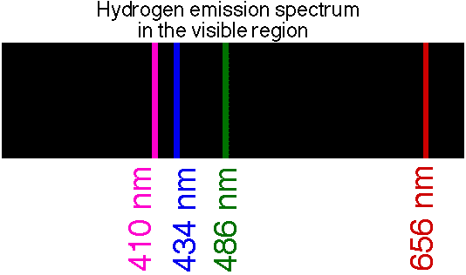

____________________________________________________________________________________________________________________________

________________________________________________________________________________________________________________________________________________________________________________________________________________________________________________________

**Question 46 (18 marks)**

When analysing combustion data from a range of fossil fuels and biofuels the following was claimed. “Different fuel types, combusted under identical conditions, produced significantly different amounts of important exhaust gases and different particle characteristics”. Carbon monoxide emissions have been a concern due to their toxicity. It is hypothesised that the combustion of biofuels produces significantly lower CO (g) emissions than the combustion of a similar mass of fossil fuel.

Answer the following questions based on the above information:

1. What is the independent variable? (1 mark)

____________________________________________________________________________________________________________________________

1. What is the dependent variable? (1 mark)

____________________________________________________________________________________________________________________________

1. What are three variables that you would **have** to control? (3 marks)

__________________________________________________________________________________________________________________________________________________________________________________________

______________________________________________________________

1. Design an investigation to verify the above claim. Include the procedure to be followed, the materials required, and the type and amount of primary and/or secondary data to be collected (4 marks)

______________________________________________________________________________________________________________________________________________________________________________________________________________________________________________________________________________________________________________________

______________________________________________________________

______________________________________________________________

______________________________________________________________

1. Conduct a risk assessment (2 marks)

__________________________________________________________________________________________________________________________________________________________________________________________

______________________________________________________________

1. identify sources of random and systematic error (2 marks)

__________________________________________________________________________________________________________________________________________________________________________________________

______________________________________________________________

1. estimate the effect of the errors on the measurement results (2 marks)

__________________________________________________________________________________________________________________________________________________________________________________________

_____________________________________________________________

1. Outline the evidence that you would require to make and justify conclusion (3 marks)

__________________________________________________________________________________________________________________________________________________________________________________________

______________________________________________________________

END OF EXAMINATION