

**Examination, 2023**

**Question/Answer Booklet**

ECONOMICS Unit 3 Semester 1, 2023

|  |  |  |  |  |  |  |  |  |  |
| --- | --- | --- | --- | --- | --- | --- | --- | --- | --- |
|  |  |  |  |  |  |  |  |  |  |

**Student Number: In figures**

**In words:**

|  |
| --- |
|  |
|  |

**Time allowed for this paper**

Reading time before commencing work: ten minutes

Working time for paper: three hours

**Materials required/recommended for this paper**

***To be provided by the supervisor***

This Question/Answer Booklet

Multiple-choice Answer Sheet

2 x Extended Response Answer Booklet

***To be provided by the candidate***

Standard items: pens (blue/black preferred), pencils (including coloured), sharpener,

correction fluid/tape, eraser, ruler, highlighters

Special items: non-programmable calculators approved for use in the ATAR examinations

**Important note to candidates**

No other items may be taken into the examination room. It is **your** responsibility to ensure that you do not have any unauthorised material. If you have any unauthorised material with you, hand it to the supervisor **before** reading any further.

**Structure of this paper**

|  |  |  |  |  |  |
| --- | --- | --- | --- | --- | --- |
| Section | Number of questions available | Number of questions to be answered | Suggested working time (minutes) | Marks available | Percentage of examination |
| Section One:  Multiple-choice | 24 | 24 | 30 | 24 | 24 |
| Section Two:  Data interpretation / Short response | 3 | 3 | 70 | 36 | 36 |
| Section Three  Extended answer | 2 | 2 | 80 | 40 | 40 |
|  |  |  |  | **Total:** | 100 |

**Instructions to candidates**

1. Answer the questions according to the following instructions.

**Section One**: Answer all questions on the separate Multiple-choice Answer Sheet provided. For each question shade the box to indicate your answer. Use only a blue or black pen to shade the boxes. If you make a mistake, place a cross through that square, then shade your new answer. Do not erase or use correction fluid/tape. Marks will not be deducted for incorrect answers. No marks will be given if more than one answer is completed for any question.

**Section Two:** Answer all questions. Write your answers in this Question/Answer booklet using a blue / black pen. Do not use erasable or gel pens.

**Section Three**: Consists of **two questions**. You must answer two (2) questions. Write your answers in this Question/Answer booklet using a blue / black pen. Do not use erasable or gel pens.

2. You must be careful to confine your responses to the specific questions asked and to follow any instructions that are specific to a particular question.

3. Supplementary pages for the use of planning/continuing your answer to a question have been provided at the end of this Question/Answer booklet. If you use these pages to continue an answer, indicate at the original answer where the answer is continued, i.e. give the page number.

**Section One: Multiple Choice (24 Marks)**

This section has **24** questions. Answer **all** questions on the separate Multiple-choice Answer Sheet.

For each question shade the box to indicate your answer. Use only a blue or black pen to shade the boxes. If you make a mistake, place a cross through that square, then shade your new answer. Do not erase or use correction fluid/tape. Marks will not be deducted for incorrect answers. No marks will be given if more than one answer is completed for any question.

Suggested working time: **30** minutes.

___________________________________________________________________

1. As a proportion of total world trade, manufactured goods account for approximately,

(a) 25 per cent

(b) 40 per cent

(c) 55 per cent

(d) 70 per cent

1. Australia’s top three two-way trading partners are

(a) China, India and Japan.

(b) China, Germany and U.S.A.

(c) China, Japan and South Korea.

(d) China, Japan and U.S.A.

1. A nation’s comparative advantage is determined **mostly** by

(a) bilateral and multilateral free trade agreements.

(b) its trading partners.

(c) its available resources and technology.

(d) transport costs and level of trade intensity.

1. When are countries most likely to specialise and trade with each other?

(a) When the cost of transport between them is high.

(b) When there are large differences in their resource allocations.

(c) When they have access to the same technology.

(d) When they have high tariffs and other protective measures.

1. Two countries, X and Y, produce cars and cameras. The table shows how many hours it takes them to produce one unit of each.



What will be the result if country Y doubles its productivity in the output of cameras and both countries produce only one good according to comparative advantage?

(a) Country X will continue to produce cameras.

(b) Country Y will produce cameras instead of cars.

(c) World camera production will rise.

(d) World car production will fall.

6. What would be the effect on the quantity consumed and the price in the domestic market

if this economy opened up to world trade?

Pw represents the world price. Pe represents the domestic price.



(a) Consumption would rise from Q1 to Q3 and the price would be constant at Pw.

(b) Consumption would fall from Q2 to Q1 and the price would rise from Pe to Pw.

(c) Consumption would fall from Q3 to Q2 and the price would fall from Pw to Pe.

(d) Consumption would not change from Q1 and the price would remain at Pe.

7. Restricting imports

(a) can protect Australian jobs in the protected industry, which increases economic welfare of the country as a whole.

(b) can protect Australian final goods and services in the protected industry and makes consumers better off.

(c) can protect Australian final goods and services in the protected industry and increase economic welfare of the country as a whole.

(d) can protect Australian jobs in the protected industry but will also lead to reductions in Australian output and income.

8. The diagram below shows the effects on a hypothetical market of a tariff on imports

Which combination of values is correct?

|  |  |  |
| --- | --- | --- |
|  | Consumer surplus under free trade | Consumer surplus after the tariff |
| (a) | $7200m | $5000m |
| (b) | $3200m | $2500m |
| (c) | $3600m | $2500m |
| (d) | $1600m | $1200m |

9. One advantage of the imposition of a subsidy is that it results in

(a) an increase in consumer surplus.

(b) an increase in producer surplus.

(c) an increase in total surplus for the economy.

(d) more efficient resource allocation in the economy.

10. An argument against regional trade agreements that underpin blocs such as the

European Union and the Association of Southeast Asian Nations is that they can

(a) be harder to negotiate compared with World Trade Organisation multilateral agreements.

(b) increase the trade intensity of member countries.

(c) divert trade from a low-cost producer outside the trade agreement to a higher-cost producer within the trade agreement.

(d) divert trade from high-cost producers within the trade agreement to lower-cost producers outside the trade agreement.

11. Which of the following is recorded as a debit item in the current account of the Australian Balance of Payments?

(a) Australian financial aid to developing countries.

(b) The purchase by Australians of equities in an overseas company.

(c) Dividend payments from an overseas company to Australian shareholders.

(d) The purchase of equities in an Australian company by an overseas company.

12. The most likely effect of a fall in commodity prices would be

(a) a favourable movement in Australia’s terms of trade and a depreciation of the Australian dollar.

(b) an unfavourable movement in Australia’s terms of trade and a depreciation of the Australian dollar.

(c) a favourable movement in Australia’s terms of trade and an appreciation of the Australian dollar.

(d) an unfavourable movement in Australia’s terms of trade and an appreciation of the Australian dollar.

13. The table shows components of the Balance of Payments for a hypothetical economy:

|  |  |
| --- | --- |
| *Balance of payments components* | *$ billion* |
| *Balance on goods and services* | *10* |
| *Net primary income* | *-20* |
| *Net secondary income* | *-5* |
| *Balance on capital account* | *1* |
| *Balance on financial account* | *?* |

What is the balance on the Financial Account?

(a) A deficit of $14 billion

(b) A deficit of $16 billion

(c) A surplus of $14 billion

(d) A surplus of $16 billion

14. If Australia records a financial account deficit, then

(a) Australia’s foreign assets will decrease.

(b) Australia’s foreign liabilities will increase.

(c) Australia’s trade balance will decrease.

(d) Australia’s net foreign liabilities will decrease.

15. If Australia recorded a current account surplus

(a) there would be a reduced need for foreign investment.

(b) net foreign liabilities would begin increasing rapidly.

(c) Australian residents would need to sell more assets to overseas residents.

(d) the capital account must record a deficit.

16. The purchasing of shares in an Australian company by an overseas resident would be recorded in Australia’s balance of payments as a

(a) credit in the financial account.

(b) credit in the net income account.

(c) debit in the transfers account.

(d) credit in the capital account.

17. If Australia’s Terms of Trade was 139.4 with the Export Price Index being 184.9 then the Import Price Index is

1. 127.5
2. 72.9
3. 75.4
4. 132.6

18. If Australia’s Terms of Trade were to move in an unfavorable direction, this could most likely be due to

1. An increase in commodity prices on world markets.
2. A decrease in inflationary pressures in Australia.
3. An increase in inflationary pressures in China.
4. A decrease in demand for manufactured goods in Australia.

19. Assume the following exchange rate: $1 AUD = $0.70 USD. What will be the cost in AUD of an imported American aircraft valued at $1.5 million USD? (Round your answer to the nearest $100 000.)

(a) $1.1 million

(b) $1.5 million

(c) $2.1 million

(d) $2.5 million

20. In May 2023, the United States official interest rate is 5.25% while Australia’s official interest rate is 3.85%. This would **most** likely cause

(a) an appreciation of the Australian dollar.

(b) a decline in the value of merchandise trade between the two nations.

(c) an increase in foreign investment into Australia.

(d) a depreciation of the Australian dollar.

21. Which of the following statements about Australia’s foreign debt are correct?

I. High foreign debt levels can cause a downgrade in Australia’s credit rating.

II. Government debt is the largest component of Australia’s foreign debt.

III. A depreciation of the Australian dollar has minimal effect on the servicing costs of Australia’s debt.

IV. High foreign debt can lead to higher per capita income in Australia.

(a) I, II, III and IV.

(b) I, III and IV.

(c) I and IV only.

(d) II, III and IV.

22. An appreciation of the Trade Weighted Index would most likely lead to

(a) a decrease in commodity prices.

(b) an increase in the trade balance.

(c) an increase in Australian exports.

(d) an increase in the demand for imports.

23. Foreign Liabilities refers to

(a) the level of foreign assets Australia has.

(b) the level of equity foreign nations have in Australia.

(c) The financial obligations that Australia has to the rest of the world.

(d) The transfer of interest and dividends between Australia and the rest of the world as recorded in the Income Account.

24. The largest component of Australia’s foreign debt is

(a) interest repayments to overseas lenders.

(b) borrowing by the private sector.

(c) borrowing by the government sector.

(d) payments for imported capital goods as a result of the high levels of investment in Australia.

***End of Section One***

**Section Two: Data interpretation/Short response (36 Marks)**

This section contains **three (3)** questions. Answer **all** questions. Write your answers in the spaces provided.

Supplementary pages for the use of planning/continuing your answer to a question have been provided at the end of this Question/Answer booklet. If you use these pages to continue an answer, indicate at the original answer where the answer is continued, i.e. give the page number.

Suggested working time: **70** minutes.

___________________________________________________________________

**Question 25 (12 marks)**

This question refers to the following edited extract from DFAT

***The Australia-India Economic Cooperation and Trade Agreement (ECTA)***

*This trade agreement will deliver new market access opportunities for Australian businesses and consumers from 29 December 2022. India has a population of over 1.4 billion people and is one of the world’s fastest growing major economies. India has now overtaken the United States to become Australia’s fourth-largest export market.*

*ECTA is a ground-breaking agreement that brings Australia and India's economies closer together. From 29 December, tariffs on 85 per cent of Australia's exports to India will be eliminated. The agreement will create enormous trade diversification opportunities for Australian producers and service providers. In addition, 96 per cent of imports from India will now be tariff free, rising to 100 per cent in four years. ECTA will save Australian exporters around $2 billion a year in tariffs, while consumers and business will save around $500 million in tariffs on imports of finished goods, and inputs to our manufacturing sector.*

|  |  |  |  |
| --- | --- | --- | --- |
| (a) | (i) | What percentage of Australia’s imports from India will now be tariff free? | |
|  |  | | (1 mark) |
|  |  | |  |

|  |  |  |
| --- | --- | --- |
|  | (ii) | What percentage of Australia’s exports to India will now be tariff free? |
|  |  | (1 mark) |
|  |  |  |

|  |  |
| --- | --- |
| (b) | Outline four (4) benefits to Australia of a Trade Agreement with India.  (4 marks) |
|  |  |
|  |  |
|  |  |
|  |  |
|  |  |
|  |  |
|  |  |
|  |  |
|  |  |
|  |  |
|  |  |
|  |  |
|  |  |
|  |  |
|  |  |
|  |  |

|  |  |  |
| --- | --- | --- |
| (c) | Using an appropriate model, explain the effect of removing a tariff on economic efficiency.  (6 marks) | |
|  |  | |
|  |  |  |
|  |  |  |
|  |  |  |
|  |  |  |
|  |  |  |
|  |  |  |
|  |  |  |
|  |  |  |
|  |  |  |
|  |  |  |
|  |  |  |
|  |  |  |
|  |  | |
|  |  | |
|  |  | |
|  |  | |
|  |  | |
|  |  | |
|  |  | |
|  |  | |
|  |  | |
|  |  | |
|  |  | |
|  |  | |
|  |  | |
|  |  | |
|  |  | |

**This page has been left blank intentionally**

**Question 26 (12 marks)**

This question refers to the graph below showing Australia’s Current Account Balance

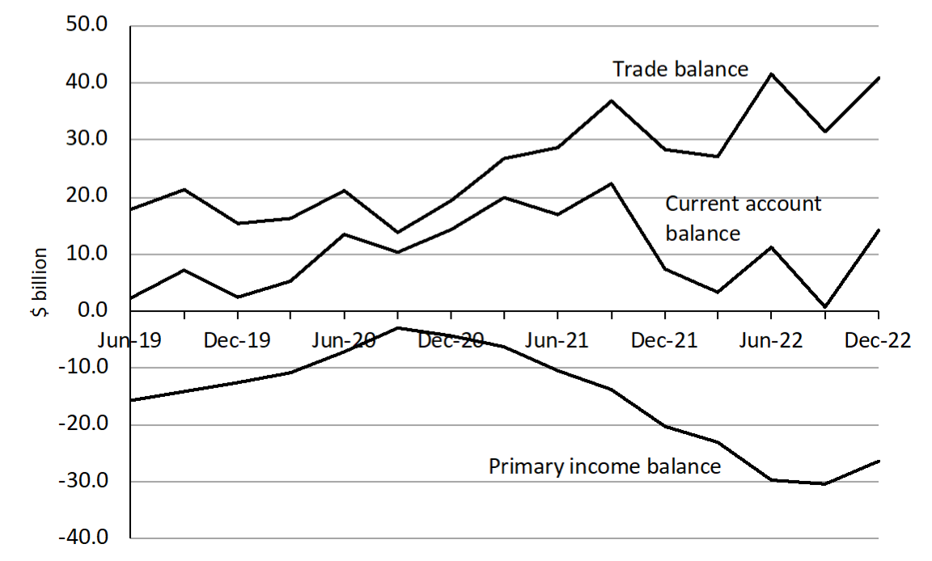

*Australia’s current account surplus increased by $13.4 billion to $14.1 billion (seasonally adjusted, current prices) in the December quarter 2022. Australia’s net foreign equity increased to $6.7 billion to an asset position of $306.1 billion. Australia’s net foreign debt increased by $3.6 billion to a liability position of $1,162.8 billion.*

|  |  |  |  |
| --- | --- | --- | --- |
| (a) | (i) | Identify the quarter which recorded the lowest trade balance. | |
|  |  | | (1 mark) |
|  |  | |  |

|  |  |  |  |
| --- | --- | --- | --- |
|  | (ii) | Calculate the value of Australia’s net foreign liabilities in Dec 2022. | |
|  |  | | (1 mark) |
|  |  | |  |
|  |  | |  |

|  |  |  |
| --- | --- | --- |
| (b) | Identify the trend in the trade balance between Dec 2020 and Dec 2022 and explain two reasons for this trend. | (5 marks) |
|  |  | |
|  |  | |
|  |  | |
|  |  | |
|  |  | |
|  |  | |
|  |  | |
|  |  | |
|  |  | |
|  |  | |
|  |  | |
|  |  | |
|  |  | |
|  |  | |
|  |  | |
|  |  | |
|  |  | |
|  |  | |
|  |  | |
|  |  | |

|  |  |  |
| --- | --- | --- |
| (c) | Explain the structural and cyclical reasons for the movement in the Current Account between Dec 2020 and Jun 2022. | |
|  |  | (5 marks) |
|  |  | |
|  |  | |
|  |  | |
|  |  | |
|  |  | |
|  |  | |
|  |  | |
|  |  | |
|  |  | |
|  |  | |
|  |  | |
|  |  | |
|  |  | |
|  |  | |
|  |  | |
|  |  | |
|  |  | |
|  |  | |
|  |  | |

**This page has been left blank intentionally**

**Question 27 (12 marks)**

This question refers to the graph below showing Australia’s exchange rate.

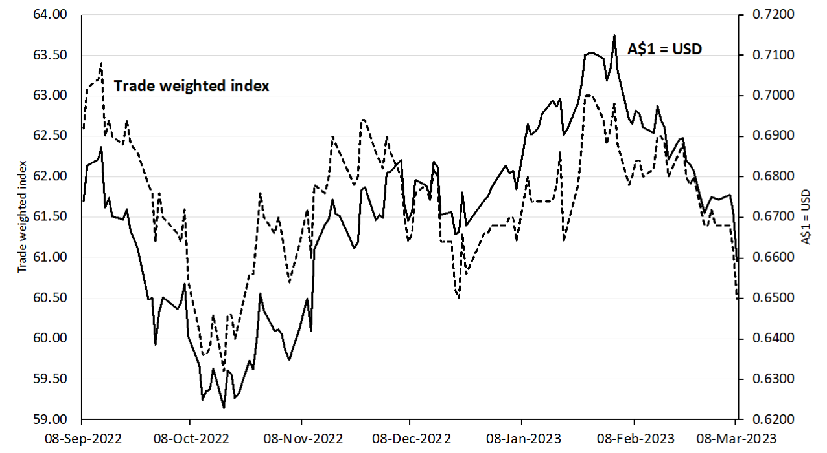

|  |  |  |
| --- | --- | --- |
| (a) | What is the value of the Trade Weighted Index on 8 March 2023? | (1 mark) |
|  |  | |

|  |  |  |
| --- | --- | --- |
| (b) | Explain why there could be a difference in the movement of the TWI and the AUD / USD exchange rate. | (2 marks) |
|  |  | |
|  |  | |
|  |  | |
|  |  | |
|  |  | |
|  |  | |
|  |  | |
|  |  | |
|  |  | |

|  |  |
| --- | --- |
| (c) | Identify the movement in the value of the Australian dollar from 8 Feb 2023 to 8 March 2023 and explain a possible cause for this change.  (3 marks) |
|  |  |
|  |  |
|  |  |
|  |  |
|  |  |
|  |  |
|  |  |
|  |  |
|  |  |
|  |  |
|  |  |
|  |  |
|  |  |
|  |  |
|  |  |
|  |  |

|  |  |
| --- | --- |
| (d) | Discuss the impact of the change in the value of the Australian dollar from 8 Oct 2022 to 8 Feb 2023 on three (3) sectors of the economy.  (6 marks) |
|  |  |
|  |  |
|  |  |
|  |  |
|  |  |
|  |  |
|  |  |
|  |  |
|  |  |
|  |  |
|  |  |
|  |  |
|  |  |
|  |  |
|  |  |
|  |  |
|  |  |
|  |  |
|  |  |
|  |  |
|  |  |
|  |  |
|  |  |
|  |  |
|  |  |
|  |  |
|  |  |

***End of Section Two***

**Section Three: Extended response 40% (40 Marks)**

Section Three consists of **two**questions, Question 28 and Question 29.

Answer **both**questions. Write your answers in the answer booklets provided.

Supplementary pages for planning/continuing your answers to questions are provided at the end of this Question/Answer booklet. If you use these pages to continue an answer, indicate at the original answer where the answer is continued, i.e. give the page number.

Suggested working time: 80 minutes.

_____________________________________________________________________________

**Question 28 (20 marks)**

1. Outline the concept of globalisation and the role of the WTO and discuss three (3) economic effects of globalisation.

(8 marks)

(b) Evaluate four (4) arguments for protection

(12 marks)

**AND**

**Question 29** **(20 marks)**

1. Distinguish between the two main types of foreign liability and explain why Australia has a net foreign liability position.

(8 marks)

(b) Discuss the costs and benefits of foreign investment into Australia. (12 marks)

***End of Questions***

|  |
| --- |
| Supplementary page  Question number: ______________ |
|  |
|  |
|  |
|  |
|  |
|  |
|  |
|  |
|  |
|  |
|  |
|  |
|  |
|  |
|  |
|  |
|  |
|  |
|  |
|  |
|  |
|  |
|  |
|  |
|  |
|  |
|  |
|  |
|  |
|  |
|  |
| Supplementary page  Question number: ______________ |
|  |
|  |
|  |
|  |
|  |
|  |
|  |
|  |
|  |
|  |
|  |
|  |
|  |
|  |
|  |
|  |
|  |
|  |
|  |
|  |
|  |
|  |
|  |
|  |
|  |
|  |
|  |
|  |
|  |
|  |
|  |
| Supplementary page  Question number: ______________ |
|  |
|  |
|  |
|  |
|  |
|  |
|  |
|  |
|  |
|  |
|  |
|  |
|  |
|  |
|  |
|  |
|  |
|  |
|  |
|  |
|  |
|  |
|  |
|  |
|  |
|  |
|  |
|  |
|  |
|  |

|  |
| --- |
| Supplementary page  Question number: ______________ |
|  |
|  |
|  |
|  |
|  |
|  |
|  |
|  |
|  |
|  |
|  |
|  |
|  |
|  |
|  |
|  |
|  |
|  |
|  |
|  |
|  |
|  |
|  |
|  |
|  |
|  |
|  |
|  |
|  |
|  |

|  |
| --- |
| Supplementary page  Question number: ______________ |
|  |
|  |
|  |
|  |
|  |
|  |
|  |
|  |
|  |
|  |
|  |
|  |
|  |
|  |
|  |
|  |
|  |
|  |
|  |
|  |
|  |
|  |
|  |
|  |
|  |
|  |
|  |
|  |
|  |
|  |
|  |
| Supplementary page  Question number: ______________ |
|  |
|  |
|  |
|  |
|  |
|  |
|  |
|  |
|  |
|  |
|  |
|  |
|  |
|  |
|  |
|  |
|  |
|  |
|  |
|  |
|  |
|  |
|  |
|  |
|  |
|  |
|  |
|  |
|  |
|  |
|  |
| Supplementary page  Question number: ______________ |
|  |
|  |
|  |
|  |
|  |
|  |
|  |
|  |
|  |
|  |
|  |
|  |
|  |
|  |
|  |
|  |
|  |
|  |
|  |
|  |
|  |
|  |
|  |
|  |
|  |
|  |
|  |
|  |
|  |
|  |

|  |
| --- |
| Supplementary page  Question number: ______________ |
|  |
|  |
|  |
|  |
|  |
|  |
|  |
|  |
|  |
|  |
|  |
|  |
|  |
|  |
|  |
|  |
|  |
|  |
|  |
|  |
|  |
|  |
|  |
|  |
|  |
|  |
|  |
|  |
|  |
|  |

|  |
| --- |
| Supplementary page  Question number: ______________ |
|  |
|  |
|  |
|  |
|  |
|  |
|  |
|  |
|  |
|  |
|  |
|  |
|  |
|  |
|  |
|  |
|  |
|  |
|  |
|  |
|  |
|  |
|  |
|  |
|  |
|  |
|  |
|  |
|  |
|  |