Multiple-choice section – choose the correct answer

Question 1 [1.3]

The equation of a line with a y-intercept of and a gradient of  is:

A 5x − 20y − 4 = 0 B 15x − 20y − 12 = 0 C 5x + 20y + 4 = 0 D 15x + 20y − 12 = 0

Question 2 [1.1]

The equation 5x − 3 = 4 − 2x has the solution:

A  B  C 1 D 

Question 3 [1.5]

This number line represents:

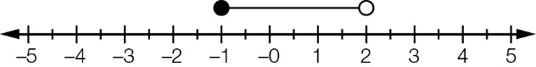

A -1 ≥ x > 2 B x ≥ -1 C x < 2 D -1 ≤ x < 2

Question 4 [2.2]

For the box plot shown the IQR is:

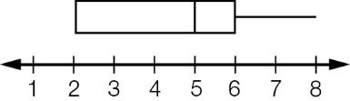

A 3 B 4 C 5 D 6

Question 5 [2.3]

The students in a class had their arm span (cm) recorded. The dot plot below shows the results.

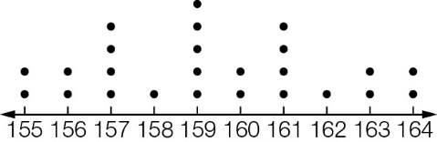

The five number summary for the data is:

A 155, 157.5, 159, 161.5, 164 B 0, 6.5, 13, 19.5, 25

C 1, 2, 2, 4, 5 D 155, 157, 159, 161, 164

Question 6 [2.8] [10A]

The recorded daily rainfall in a particular location (in mm) for a fortnight is as follows:

10.4, 0.8, 3.4, 0.2, 0, 0, 0.6, 0.2, 0.4, 0, 0, 7.8, 6.8, 0

When calculating the mean and standard deviation, the 0.4 result was incorrectly entered as 4.0.  
Which of the following is true of the calculated values, as compared to the correct values?

A Both the mean and standard deviation would be too high.

B The mean would be too high and standard deviation too low.

C The mean would be too low and standard deviation too high.

D Both mean and standard deviation would be too low.

Question 7 [3.1]

The expression (2x + 1)(3x − 1)(x + 2) is not the same as:

A (2x + 1)(x + 2)(3x − 1) B 6x3 + 13x2 + x − 2

C (2x + 1)(3x + 1)(x − 2) D (x + 2)(3x − 1)(2x + 1)

Question 8 [3.5]

If A = 3a2 + 7a − 12 and B = 2a2 + 12a + 2, then A − B, when factorised, becomes:

A (a − 2)(a + 7) B (2 − a)(a + 7) C (2 − a)(7 − a) D (a − 7)(a + 2)

Question 9 [4.1]

The solution to y = x2 − x − 6 is:

A x = 6 B x = 2, x = -3 C x = 1, x = 6 D x = -2, x = 3

Question 10 [4.4]

When expressed graphically, which of the following equations is most likely to be the equation of the parabola shown?

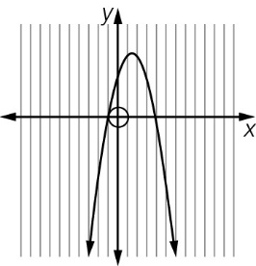

A y = -x2 − 3x − 4 B y = x2 − 3x − 4 C y = -x2 + 3x + 4 D y = x2 + 3x + 4

Question 11 [4.2]

To factorise 3m2 + 6m − 12 by completing the square, the value to be added and subtracted is:

A 1 B 2 C 6 D 9

Question 12 [4.5] [10A]

When factorised, 3x2 + x − 2 gives:

A (3x + 2)(x − 1) B (3x + 2)(x + 1) C (3x − 2)(x + 1) D (3x − 2)(x − 1)

Question 13 [5.1]

The area of this composite shape is:

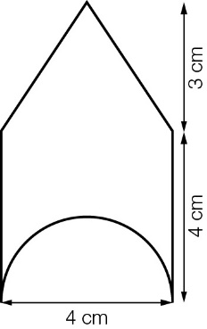

A (22 + 2π) cm2 B (22 − 2π) cm2 C (28 − 2π) cm2 D (22 − 8π) cm2

Question 14 [5.3]

The volume of this prism, in cm3, can be found by:

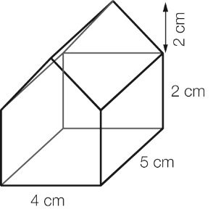

A  B 

C  D 

Question 15 [5.6]

Which of the following equations is equal to ?

A  B  C  D 

Question 16 [6.1]

Using a calculator, and evaluating the result to 4 decimal places, the value of tan(43°19') is:

A 0.7278 B 0.9387 C 0.9388 D 0.9429

Question 17 [6.3]

The value of θ in degrees, minutes and seconds in the equation tan(θ) = 0.7126 is:

A 35°28'25'' B 35°28'26'' C 35°47'36'' D 35°47'37''

Question 18 [6.5]

The compass bearing of point B as shown in the diagram is:

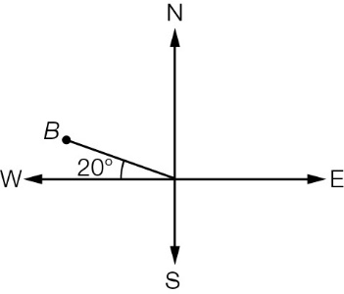

A S110°W B N20°W C N70°W D N290°E

Question 19 [6.5]

A bearing of 146°T is the same as:

A N140°E B S34°E C E56°S D S46°E

Question 20 [7.2] [10A]

An equivalent trigonometric ratio to cos(37°) is:

A cos(143°) B cos(217°) C -cos(323°) D cos(323°)

Multiple-choice results: ___ / 20

Short answer section

Question 21 4 marks [1.2]

Find an equation of a line with:

(a) a gradient of 3 that passes through (4, 1)

(b) a gradient of  that passes through (-3, 5).

Question 22 4 marks [1.4]

Find an equation of a line that is:

(a) parallel to y = 3x − 5 and passes through (-3, 5)

(b) perpendicular to y = -2x + 1 and passes through (-3, -4).

Question 23 4 marks [1.6]

(a) Solve the following simultaneous equations using the elimination method.

3x − 2y = -13

4x + 2y = 6

(b) Solve the following simultaneous equations using the substitution method.

3x − 4y = 10

y = 5x + 6

Question 24 3 marks [2.1]

Draw a cumulative frequency curve and use it to estimate for the median for the grouped data set.

|  |  |
| --- | --- |
| Height (cm) | Frequency |
| 140−<145 | 4 |
| 145−<150 | 5 |
| 150−<155 | 9 |
| 155−<160 | 8 |
| 160−<165 | 3 |



Question 25 4 marks [2.4]

The following table shows the kerb mass (tonnes) and fuel consumption (litres per 100 km) of a number of SUVs.

|  |  |  |  |  |  |  |  |  |  |  |
| --- | --- | --- | --- | --- | --- | --- | --- | --- | --- | --- |
| Kerb mass | 2.4 | 2.45 | 2.4 | 1.9 | 2.2 | 2.0 | 1.9 | 2.2 | 2.35 | 2.3 |
| Fuel consumption | 16.2 | 16.75 | 17.45 | 17.5 | 16.7 | 15.3 | 15 | 15.3 | 14.15 | 14.8 |

(a) Draw a scatter plot of the data with the kerb mass on the horizontal axis.



(b) Based on the scatter plot, comment on any relationship that may exist between the two variables.

Question 26 4 marks [2.5]

For the following pairs of variables, state the independent variable. Give a brief reason for your answer.

(a) Amount of water used per day in a household, and the number of people in the household.

(b) Head circumference, measured in cm, and age, measured in months, for children less than 2 years of age.

Question 27 2 marks [3.2]

Factorise each expression.

(a) 15a2 − 3a (b) 2x(a − 4) − 3(a − 4)

Question 28 3 marks [3.6]

Fully factorise each expression.

(a) 64p2 − 81q2 (b) (3x − 1)2 − 49

Question 29 6 marks [3.4]

State the transformations applied to y = x2 to give the following equations.

(a) y = (x − 4)2

(b) y = x2 + 4

(c) y = 

(d) y = 2(x − 3)2 + 5

Question 30 14 marks [3.7]

Simplify the following.

(a)  (b) 

(c)  (d) 

(e)  (f) 

Question 31 6 marks [4.3]

Solve the following quadratic equations by completing the square.

(a) 0 = x2 − 6x + 1

(b) 3 = 3x2 + 9x

(c) x2 = 5 − 2x

Question 32 6 marks [4.6] [10A]

Solve each of the following equations.

(a) 3x2 − 14x − 5 = 0 (b) 2x2 − 5x + 1 = 0

Question 33 4 marks [5.2]

(a) Find the surface area of a rectangular prism with side lengths 4 cm, 5 cm and 7 cm.

(b) Find the exact surface area of a closed cylinder with a radius of 6 cm and a height of 10 cm.

Question 34 4 marks [5.3]

Find the volume of each solid. Round to 2 decimal places, if necessary.

(a)

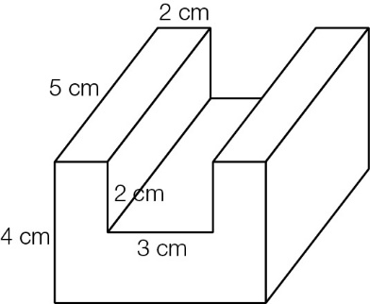

(b)

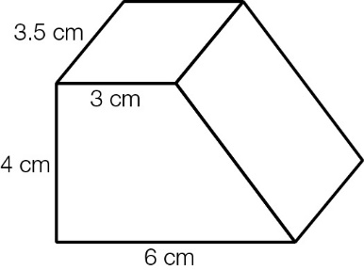

Question 35 6 marks [6.2]

Find the value of the unknown lengths in each of the following, correct to 2 decimal places.

(a)

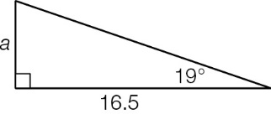

(b)

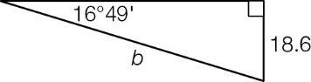

(c)

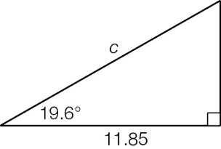

Question 36 3 marks [6.4]

A drainage pipe falls 15 cm over a horizontal distance of 15.6 m. Correct to 1 decimal place, what is the angle of depression that the pipe makes with the horizontal?

Question 37 6 marks [6.6]

A 6.8 m ladder, leaning against a wall, makes an angle of 70°20' with the horizontal.

(a) If the ladder is moved 0.5 m down the wall, find the new angle, correct to the nearest minute, made with the horizontal.

(b) What is the change in the horizontal distance from the wall produced by this move? Round your answer to 2 decimal places.

Question 38 4 marks [6.4]

Ed hits a golf ball which lands on the ground at some distance ahead. When Ed looks at the ball, the angle of depression from his eyes to the ball is 0.5°. Ed’s eyes are 170 cm from the ground. Round your answers to the following questions to 2 decimal places.

(a) How far away in metres is Ed’s ball from his eyes?

(b) When Ed has walked half-way towards his ball, he looks at it again. What will be the angle of depression now, assuming that all the land is flat?

Question 39 3 marks [6.6]

Find the unknown lengths, correct to 2 decimal places, in the following diagram.

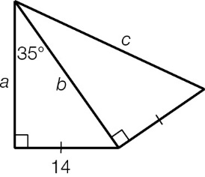

Question 40 5 marks [7.1] [10A]

A cube has a side length of 6 cm.

(a) Find the exact length of the base diagonal.

(b) Find the exact length of the body diagonal from the front left bottom corner to the back right top corner.

(c) Find the angle, correct to 2 decimal places, that this body diagonal makes with the base.

Question 41 6 marks [7.3] [10A]

Solve the following, rounding answers to 2 decimal places where appropriate.

(a) 3sin(x) + 2 = 0

(b) , 0° ≤ x ≤ 360°

(c) 2cos(x) = 1, 0° ≤ x ≤ 720°

Question 42 6 marks [7.4] [10A]

Find the unknown values in the following triangles. Where appropriate, round lengths to 2 decimal places and angles to 1 decimal place.

(a)

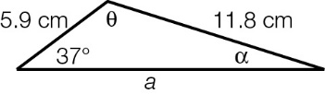

(b)

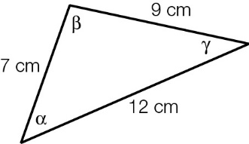

Question 43 3 marks [7.6] [10A]

Find the area enclosed by the following figure, correct to the nearest cm2.

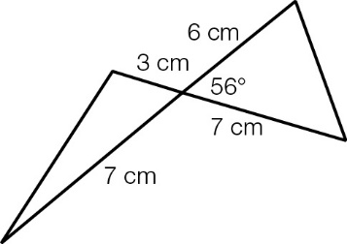

Short answer results: ___ / 110

Extended answer section

Question 44 3 marks [1.6]

To celebrate the Presidents Cup Golf Tournament, Australia Post issued a set of stamps. Some of the stamps had a face value of $0.60 and another had a face value of $1.65. Greg paid $53.25 for 45 stamps. How many of the two kinds of stamp did he purchase?

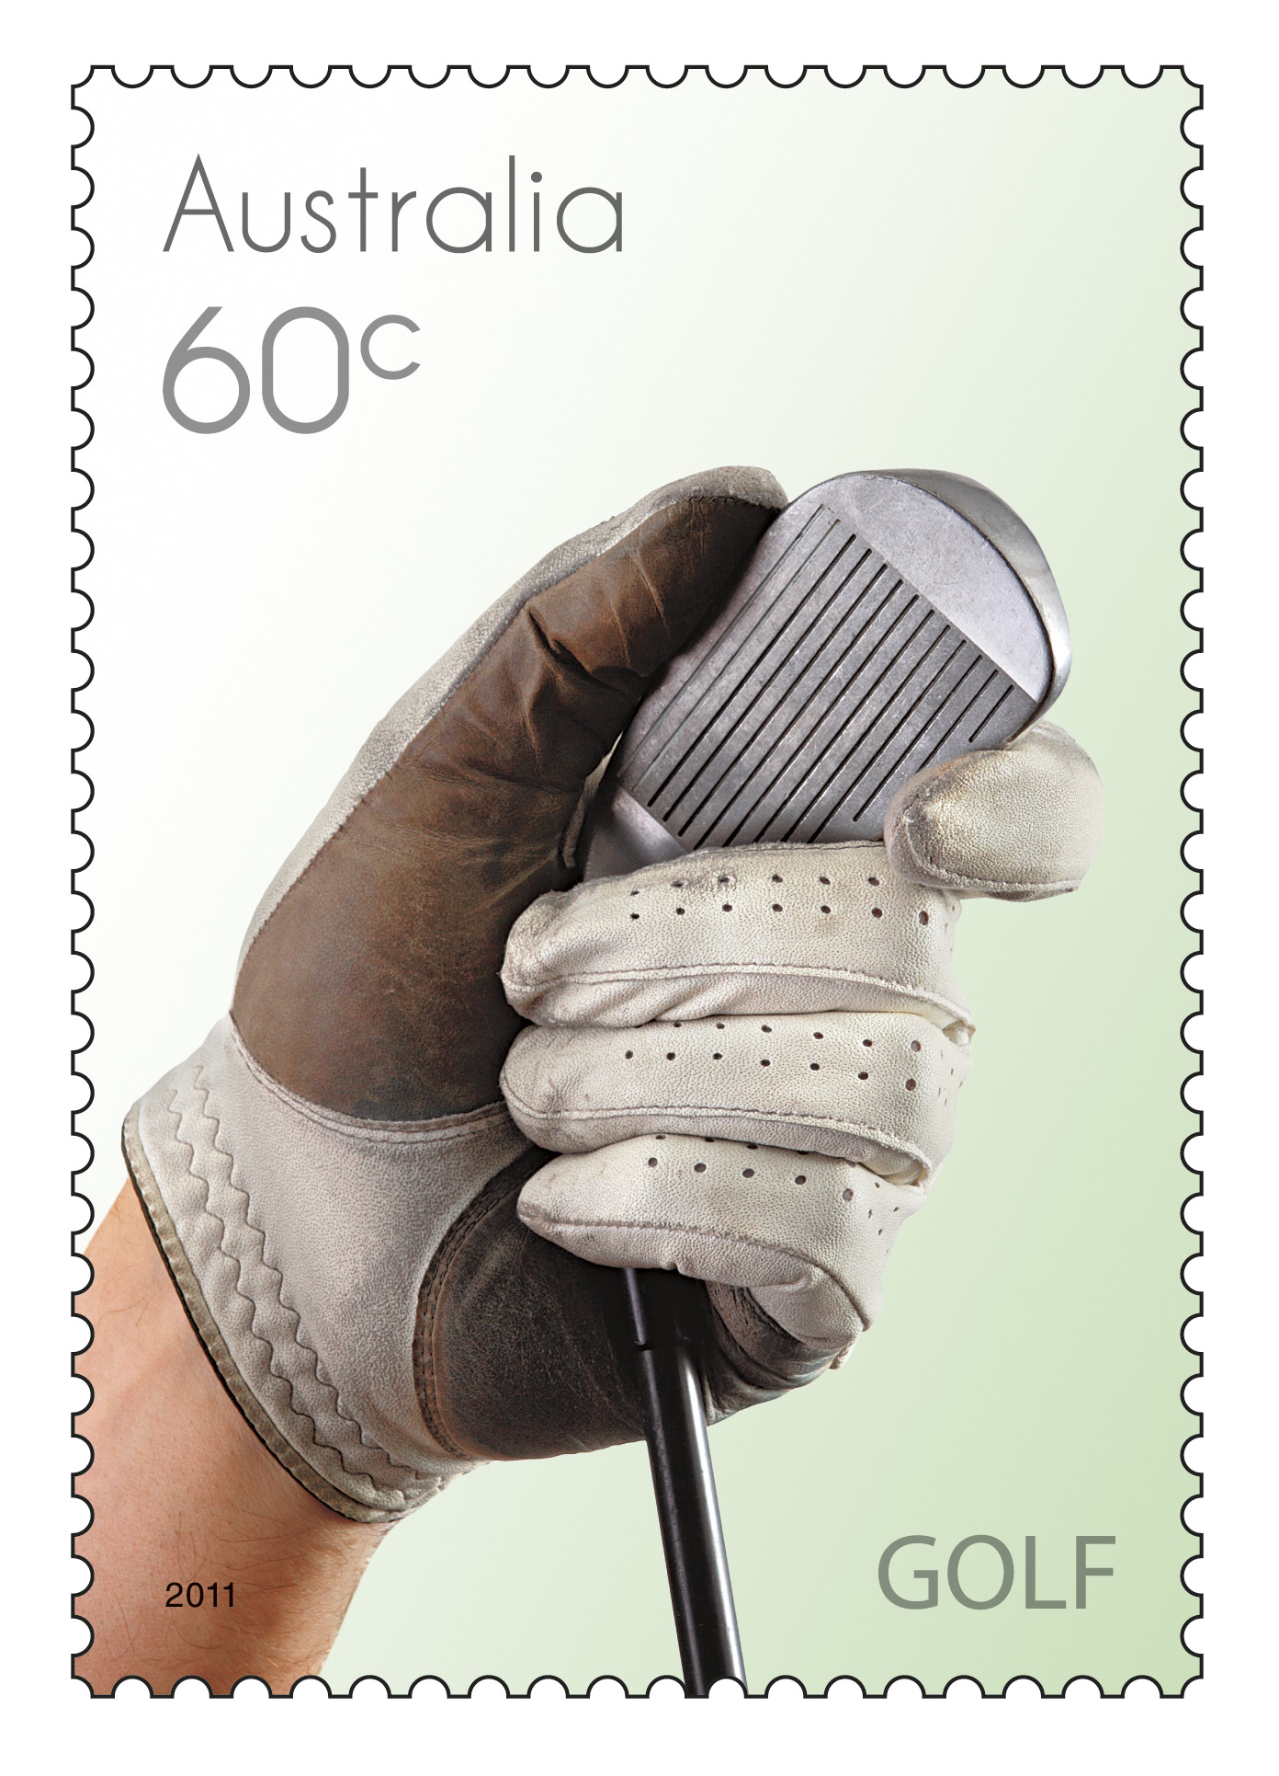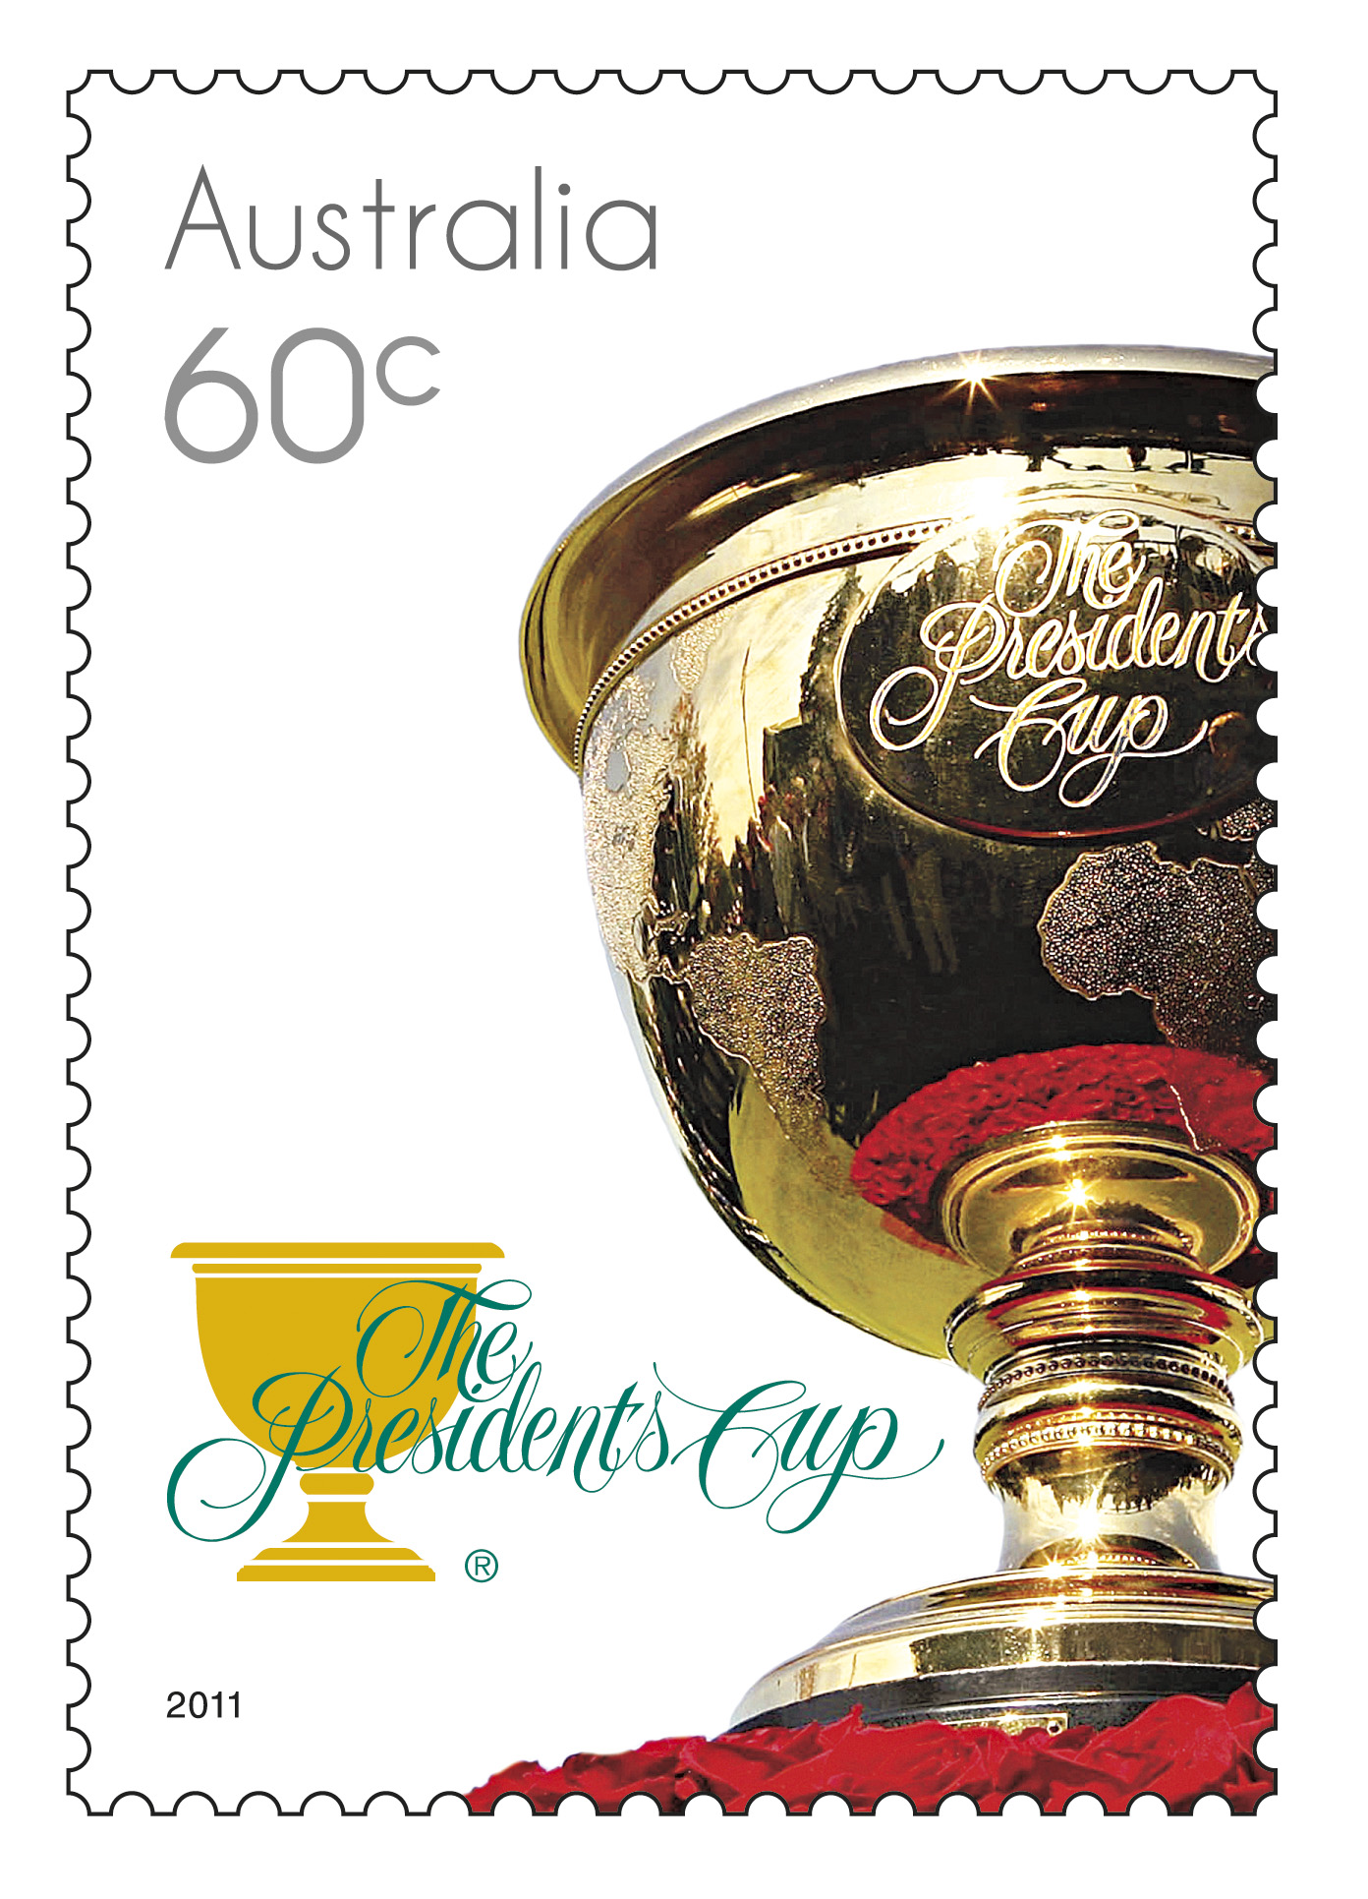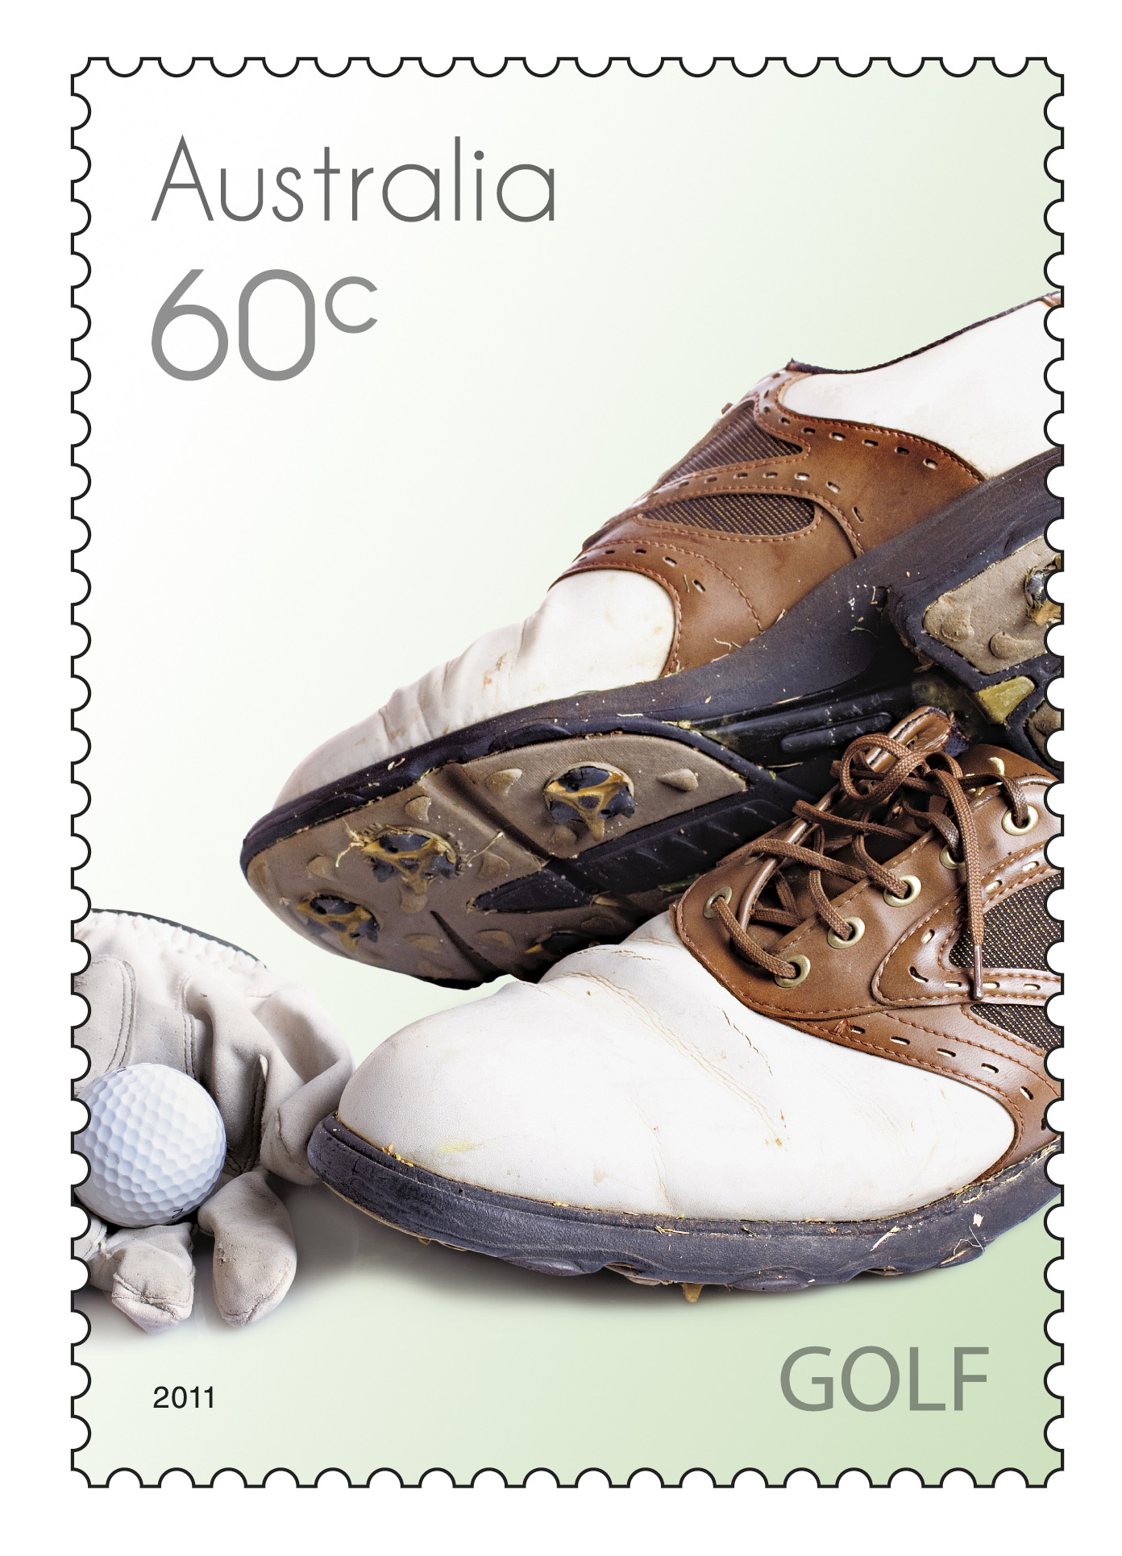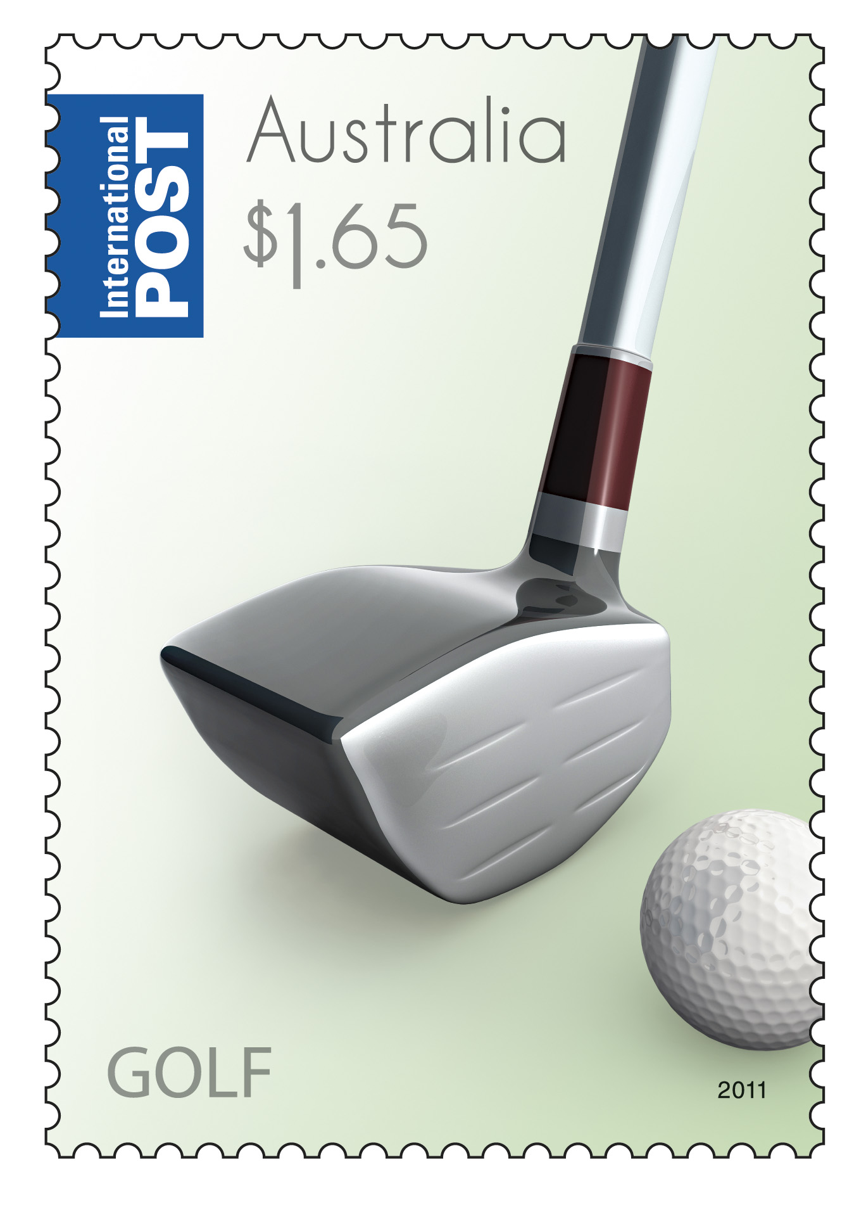

Question 45 9 marks [3.1, 5.3]

A rectangular prism has a length 7 cm greater than its height and a width 3 cm greater than  
its height.

(a) Draw a diagram showing this information. Use h to represent height.

(b) Write an expression in factorised form to represent the volume of the prism.

(c) Expand and simplify the expression for volume.

(d) Use your answer to part (b) to find the volume if the height is 15 cm.

(e) Use your answer to part (c) to find the volume if the height is 22 cm.

Question 46 10 marks [5.2, 5.3]

(a) Sketch a rectangular prism, with whole number side lengths, that has a volume of 24 cm3.

(b) How many different sets of three whole numbers are possible if the volume is 24 cm3? (Square faces are allowed.)

(c) Find the surface area of three of the prisms you identified in part (b).

Question 47 6 marks [7.1] [10A]

ABCDE is a rectangular-based pyramid with each of the sloping faces an isosceles triangle of side length 20 cm. EF is the altitude (height) of the pyramid.

(a) Find the length of EF, correct to 2 decimal places.

(b) Find the angle, correct to the nearest minute, that the face AED makes with the base ABCD.

(c) Find the angle, correct to the nearest minute, that EA makes with AC.

Question 48 8 marks [5.4, 5.5] [10A]

(a) Calculate the volume and surface area, correct to 2 decimal places, of the following square-based pyramid:

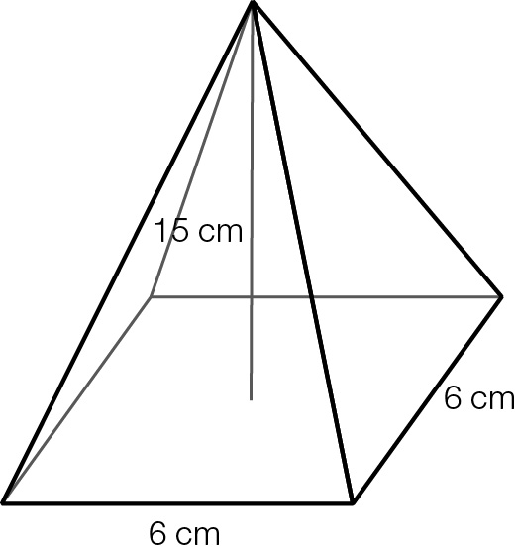

(b) Find the radius of a sphere, correct to 2 decimal places, that has the same volume as the pyramid in part (a).

(c) Find the radius of a sphere, correct to 2 decimal places, that has the same surface area as the pyramid in part (a).

(d) What can you conclude from your answers to part (a)−(c)?

Question 49 6 marks [2.6] [10A]

The Liquor Control Board of Canada checks the alcohol level of all wines sold. The following data shows the mean alcohol content (% volume) for wines that come from various countries.

|  |  |  |
| --- | --- | --- |
| Origin | Mean red (% vol) | Mean white (% vol) |
| France | 13.1 | 12.82 |
| Italy | 13.19 | 12.39 |
| Spain | 13.6 | 12.64 |
| Portugal | 13.19 | 12.33 |
| Argentina | 13.9 | 13.34 |
| Australia | 14 | 13.07 |
| Canada | 12.8 | 12.69 |
| Chile | 13.83 | 13.45 |
| New Zealand | 13.45 | 13.07 |
| South Africa | 13.77 | 13.03 |
| United States | 13.99 | 13.66 |

(a) Use technology to plot the data, putting red wines on the horizontal axis. Does there appear to be a linear relationship between the alcohol content for red and white wines from the same origin?

(b) Find the equation of the line of best fit (assuming it exists), correct to 3 decimal places.

(c) Use the equation to predict a country's white wine alcohol content, correct to 2 decimal places, if the red wine value is:

(i) 13.3 % vol (ii) 14.8 % vol

(d) In which of these estimates do you have more confidence? Explain your reasoning.

Extended answer results: ___ / 42

TOTAL test results: ___ / 172