Multiple-choice section

|  |  |  |  |  |  |  |  |  |  |  |
| --- | --- | --- | --- | --- | --- | --- | --- | --- | --- | --- |
| **Question** | 1 | 2 | 3 | 4 | 5 | 6 | 7 | 8 | 9 | 10 |
| **Answer** | B | C | D | B | D | B | C | D | D | C |

|  |  |  |  |  |  |  |  |  |  |  |
| --- | --- | --- | --- | --- | --- | --- | --- | --- | --- | --- |
| **Question** | 11 | 12 | 13 | 14 | 15 | 16 | 17 | 18 | 19 | 20 |
| **Answer** | A | C | B | C | B | D | A | C | B | D |

Question 1 [1.3]

B

y = mx + b where m is the gradient and b is the y-intercept:

y =

=

=

20y = 15x − 12

15x − 20y − 12 = 0

Question 2 [1.1]

C

5x − 3 = 4 − 2x  
5x + 2x − 3 = 4  
 7x − 3 = 4  
 7x = 7  
 x = 1

Question 3 [1.5]

D

A full circle means included, an open circle means not included.

Question 4 [2.2]

B

IQR = upper quartile − lower quartile (these are the values on the ends of the box)  
= 6 − 2  
= 4

Question 5 [2.3]

D

There are 25 dots; the median is the 13th dot. The lower quartile is between the 6th and 7th dots. These are both 157. This eliminates A.

Question 6 [2.8] [10A]

B

Using technology find

|  |  |  |
| --- | --- | --- |
|  | Actual | Calculated |
| Mean | 2.1857 | 2.4428 |
| Standard deviation | 3.3928 | 3.3841 |

Question 7 [3.1]

C

(2x + 1)(3x − 1)(x + 2)

= (2x + 1)(3x2 + 6x − x − 2)

= (2x + 1)(3x2 + 5x − 2)

= 6x3 + 10x2 − 4x + 3x2 + 5x − 2

= 6x3 + 13x2 + x − 2

Question 8 [3.5]

D

A − B = 3a2 + 7a − 12 − (2a2 + 12a + 2)

= 3a2 + 7a − 12 − 2a2 − 12a − 2

= a2 − 5a − 14

= (a − 7)(a + 2)

Question 9 [4.1]

D

x2 − x − 6 = (x − 3)(x + 2)

This has solutions 3 and -2.

Question 10 [4.4]

C

The coefficient of x2 is negative, so A or C. The y-intercept is positive, so the constant must be positive.

Question 11 [4.2]

A

3m2 + 6m − 12 = 3(m2 + 2m − 4)

The value required is = 1

Question 12 [4.5] [10A]

C

3x2 + x − 2  
= 3x2 + 3x − 2x − 2  
= 3x(x + 1) − 2(x + 1)  
= (3x − 2)(x + 1)

Question 13 [5.1]

B

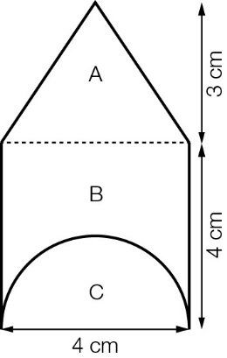

The required area is A + B − C (where B is the square)

Area =

= 6 + 16 − 2π

= (22 − 2π) cm2

Question 14 [5.3]

C

Volume = 4 × 3 × 5 +

= 

Question 15 [5.6]

B

The original equation is

So: 

Question 16 [6.1]

D

0.9429

Question 17 [6.3]

A

Use calculator, remembering to convert to degrees, minutes and seconds: 35°28'25''

Question 18 [6.5]

C

Go anticlockwise from north 70°, which is N70°W.

Question 19 [6.5]

B

146° is in the bottom right quadrant, 34° before 180°, which is south.

Question 20 [7.2] [10A]

D

This is positive, so the other positive quadrant is needed for cosine, which is the fourth quadrant.

Multiple-choice total marks: 20

Short answer section

Question 21 4 marks [1.2]

|  |  |
| --- | --- |
| (a) y − y1 = m(x − x1) y − 1 = 3(x − 4) y − 1 = 3x − 12 y = 3x − 11 | (b) y − y1 = m(x − x1) y − 5 =  5y − 25 = -2(x + 3) 5y − 25 = -2x − 6 5y + 2x − 19 = 0 |

Question 22 4 marks [1.4]

|  |  |
| --- | --- |
| (a) m = 3 y − y1 = m(x − x1) y − 5 = 3(x + 3) y − 5 = 3x + 9 y = 3x + 14 | (b) m =  y − y1 = m(x − x1)  y + 4 =  2y + 8 = (x + 3) 2y − x + 5 = 0 |

Question 23 4 marks [1.6]

|  |  |
| --- | --- |
| (a) 3x − 2y = -13 [1] 4x + 2y = 6 [2] 7x = -7  x = -1  Substitute x = -1 into [1]:  3(-1) − 2y = -13  -3 − 2y = -13  -2y = -10  y = 5  Solution: x = -1 and y = 5 | (b) 3x − 4y = 10 [1]  y = 5x + 6 [2]  Substitute y from [2] into [1]:  3x − 4(5x + 6) = 10  3x − 20x − 24 = 10  -17x = 34  x = −2  Substitute x = -2 into [2]:  y = 5(-2) + 6  = -10 + 6  = -4  Solution: x = -2 and y = -4 |

Question 24 3 marks [2.1]

There are 29 results so the median is the 15th result.

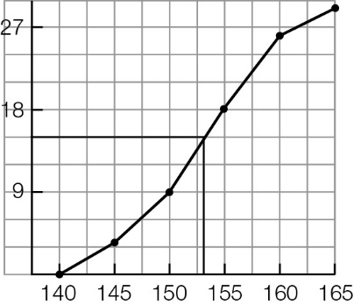

Approximately 153 cm

Question 25 4 marks [2.4]

(a)   
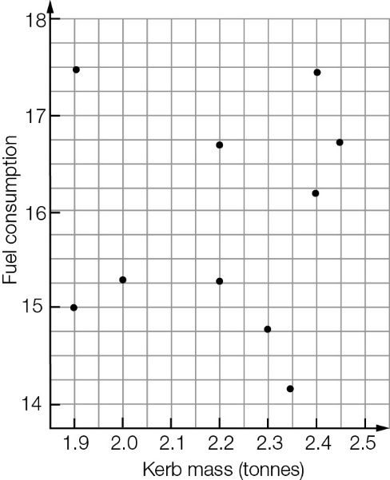

(b) There does not seem to be any relationship between these two variables.

Question 26 4 marks [2.5]

(a) Number of people is the independent variable. The number of people determines the amount of water. If you use more water it does not make more people appear in the house.

(b) Age is the independent variable. As the child grows the head increases in circumference. The age does not wait around for the head circumference to change.

Question 27 2 marks [3.2]

(a) 15a2 − 3a = 3a(5a − 1)

(b) 2x(a − 4) − 3(a − 4) = (a − 4)(2x − 3)

Question 28 3 marks [3.6]

|  |  |
| --- | --- |
| (a) 64p2 − 81q2  = (8p − 9q)(8p + 9q) | (b) (3x − 1)2 − 49  = (3x − 1 − 7)(3x − 1 + 7)  = (3x − 8)(3x + 6)  = 3(3x − 8)(x + 2) |

Question 29 6 marks [3.4]

(a) translation 4 units right

(b) translation 4 units up

(c) dilation by a factor of 

(d) dilation by a factor of 2; translation 3 units right and 5 units up

Question 30 14 marks [3.7]

|  |  |  |
| --- | --- | --- |
| (a)  = 3(x − 3) | (b)  = | (c)  =  = |
| (d)  =  = x + 2 | (e)  =  =  = | (f)  =  =  = |

Question 31 6 marks [4.3]

|  |  |  |
| --- | --- | --- |
| (a) 0 = x2 − 6x + 1 0 = x2 − 6x + 9 + 1 − 9 0 = (x − 3)2 − 8 0 =  x = 3  x = 3 | (b) 3 = 3x2 + 9x 0 = 3x2 + 9x − 3 0 = 3(x2 + 3x − 1) 0 = 3(x2 + 3x +  − 1 − ) 0 =  x = | (c) x2 = 5 − 2x 0 = x2 + 2x − 5 0 = x2 + 2x + 1 − 5 − 1 0 = (x + 1)2 − 6 0 = (x + 1 −)(x + 1 +) x = |

Question 32 6 marks [4.6] [10A]

|  |  |
| --- | --- |
| (a) 3x2 − 14x − 5 = 0 3x2 − 15x + x − 5 = 0 3x(x − 5) + 1(x − 5) = 0 (x − 5)(3x + 1) = 0 x − 5 = 0 or 3x + 1 = 0 x = 5 or x = | (b) 2x2 − 5x + 1 = 0 |

Question 33 4 marks [5.2]

|  |  |
| --- | --- |
| (a) Surface area = 2(4 ×5 + 5 × 7 + 7× 4) = 2(20 + 35 + 28) = 166 cm2 | (b) Surface area = 2 × π × 62 + 2 × π × 6 × 10 = 72π + 120π = 192π cm2 |

Question 34 4 marks [5.3]

|  |  |
| --- | --- |
| (a) | V = (4 + 14 + 4) × 5 = 22 × 5 = 110 cm3 |

(b) Cross-sectional area =  = 18 cm2

V = 18 × 3.5

= 63 cm3

Question 35 6 marks [6.2]

|  |  |  |
| --- | --- | --- |
| (a) tan(19°) =  a = 16.5 × tan(19°)  = 5.68 | (b) sin(16°49') =  b =   = 64.29 | (c) cos(19.6°) =  c =   = 12.58 |

Question 36 3 marks [6.4]

|  |  |
| --- | --- |
| PM10_PR_Sem2S_02_RR | tan(θ) =   θ =   = 0.6° |

Question 37 6 marks [6.6]

|  |  |
| --- | --- |
| (a)  PM10_PR_Sem2S_03 | Let h be the original height along the wall:  sin(70°20') =   h = 6.8 × sin(70°20')  h ≈ 6.4 m |

(b) Let b be the original horizontal distance:  
cos(70°20') =   
 b = 6.8 × cos(70°20')  
 b = 2.288...

Let c be the new horizontal distance:  
6.82 − (h − 0.5)2 = c2  
 c = 3.375...

Change in horizontal distance:  
c – b = 3.375... – 2.288...  
 = 1.09 m

Question 38 4 marks [6.4]

|  |  |
| --- | --- |
| (a) PM10_PR_Sem1SA_04_RR  tan(89.5) =  d = 1.7 × tan(89.5°)  = 194.80 m | (b) PM10_PR_Sem1SA_05_RR  tan(θ) =  θ =  = 89.00°  So, the new angle of depression is 1°. |

Question 39 3 marks [6.6]

|  |  |  |
| --- | --- | --- |
| tan(35°) =  a =  = 19.99 | sin(35°) =  b =  = 24.41 | b2 + 142 = c2  c = 28.14 |

Question 40 5 marks [7.1] [10A]

|  |  |  |
| --- | --- | --- |
| (a) d2 = 62 + 62 = 72 d =  PM10_PR_Sem1SA_06 | (b) c2 = 62 +  c2 = 36 + 72  c2 = 108 c =  PM10_PR_Sem1SA_07 | (c) tan(θ) =  θ =  = 35.26° |

Question 41 6 marks [7.3] [10A]

(a) sin(x) = , the acute angle is 41.81°  
The angles are in quadrants 3 and 4, where sine is negative.  
x = 221.81° ± 2nπ , n = 0, 1, 2, ... or 318.19° ± 2nπ, n = 0, 1, 2, ...

(b) 5tan(x) = 3  
x = 30.96°  
Also need quadrant 3 angle, where tangent is positive:  
x = 30.96° or 210.96°

(c) cos(x) =  so x = 60°  
Cosine also positive in the 4th quadrant:  
x = 60°, 300°, 420° or 660°

Question 42 6 marks [7.4] [10A]

|  |  |
| --- | --- |
| (a)    α = 17.5°  θ = 180 − (37 + 17.5) = 125.5°  a =  a = 15.96 cm | (b) 92 = 72 + 122 − 2 × 7 × 12 × cos(α) cos(α) =  α = 48.2°  122 = 72 + 92 − 2 × 7 × 9 × cos(β) cos(β) =  β = 96.4°  γ = 180 − (48.2 + 96.4)  γ = 35.4° |

Question 43 3 marks [7.6] [10A]

A = 

= × 3 × 7 × sin(56°) + × 6 × 7 × sin(56°)

= 26.114 68

The area is 26 cm2.

Short answer total marks: 110

Extended answer section

Question 44 3 marks [1.6]

Let x stand for the number of 60 cent stamps and y for the number of $1.65 stamps.  
0.6x + 1.65y = 53.25 [1]  
x + y = 45 [2]  
60x + 165y = 5325  
-60x + 60y = 2700  
105y = 2625  
y =  = 25

Greg bought 25 $1.65 stamps and 20 $0.60 stamps.

Question 45 9 marks [3.1, 5.3]

(a)

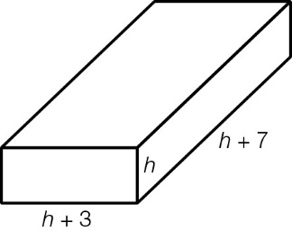

(b) V = h(h + 3)(h + 7)

(c) V = h(h2 + 10h + 21)

= h3 + 10h2 + 21h

(d) V = 15(15 + 3)(15 + 7)

= 5940 cm3

(e) V = 223 + 10 × 222 + 21 × 22

= 15 950 cm3

Question 46 10 marks [5.2, 5.3]

(a) Several dimensions possible, for example:

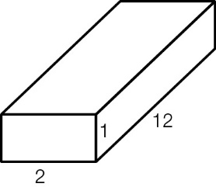

(b) There are six sets of whole numbers:  
1 × 1 × 24 = 24 1 × 2 × 12 = 24 2 × 3 × 4 = 24  
1 × 3 × 8 = 24 2 × 2 × 6 = 24 1 × 4 × 6 = 24

(c) Any three of the following:

|  |  |
| --- | --- |
| 1 × 1 × 24 = 24: 2(1 × 1 + 1 × 24 + 1 × 24) = 2(1 + 24 + 24) = 98 cm2 | 1 × 2 × 12 = 24: 2(1 × 2 + 1 × 12 + 2 × 12) = 2(2 + 12 + 24) = 76 cm2 |
| 2 × 3 × 4 = 24: 2(2 × 3 + 2 × 4 + 3 × 4) = 2(6 + 8 + 12) = 52 cm2 | 1 × 3 × 8 = 24: 2(1 × 3 + 1 × 8 + 3 × 8) = 2(3 + 8 + 24) = 70 cm2 |
| 2 × 2 × 6 = 24: 2(2 × 2 + 2 × 6 + 2 × 6) = 2(4 + 12 + 12) = 56 cm2 | 1 × 4 × 6 = 24: 2(1 × 4 + 1 × 6 + 4 × 6) = 2(4 + 6 + 24) = 68 cm2 |

Question 47 6 marks [7.1] [10A]

|  |  |  |  |
| --- | --- | --- | --- |
| (a) AC = 10 cm (3, 4, 5 triple)202 − 52 = a2 a =  = 19.364... EF = 19.36 cm | | PM10_PR_Sem1SA_10 | |
| (b) Let M be the midpoint of AD. tan(θ) =  θ = 78°20' | | | PM10_PR_Sem1SA_11 |
| (c) sin(α) = α = 75°31' | PM10_PR_Sem1SA_12 | | |

Question 48 8 marks [5.4, 5.5] [10A]

|  |  |
| --- | --- |
| (a) V =  =  = 180 cm3 | PM10_PR_Sem1SA_09 Find the length of the sloping faces:  d2 = 152 + 32  = 234  d =cm  SA = 6 × 6 + 4 ×  × 6 ×  = 36 + 12  = 219.57 cm2 |

(b) V =   
180 =   
r3 =   
r = 3.502...

The radius is 3.50 cm.

(c) SA = 4πr2  
36 + 12= 4πr2  
r2 =   
r = 4.180...

The radius is 4.18 cm.

(d) The volume and surface area of a pyramid are not connected in the same way as the volume and surface area of a sphere.

Question 49 6 marks [2.6] [10A]

(a) There appears to be a moderately strong linear relationship between the two variables.

(b) white = 0.782 × red + 2.370

(c) (i) 0.782 × 13.3 + 2.370 = 12.77 %vol

(ii) 0.782 × 14.8 + 2.370 = 13.94 %vol

(d) The first is probably more reliable as it is interpolation; the second is extrapolation.

Extended answer total marks: 42

TOTAL test marks: 172