Multiple-choice section

|  |  |  |  |  |  |  |  |  |
| --- | --- | --- | --- | --- | --- | --- | --- | --- |
| Question | 1 | 2 | 3 | 4 | 5 | 6 | 7 | 8 |
| Answer | B | A | B | B | C | C | A | C |

|  |  |  |  |  |  |  |  |  |
| --- | --- | --- | --- | --- | --- | --- | --- | --- |
| Question | 9 | 10 | 11 | 12 | 13 | 14 | 15 | 16 |
| Answer | C | B | A | B | C | D | C | A |

Question 1 [9.1]

B

AB joins the 23° and the 61° angles. The unmarked angle in the second triangle is 61° so EF.

Question 2 [9.5]

A

By elimination: B could be a trapezium; C could be a parallelogram and D could be rectangle

Question 3 [9.6] [10A]

B

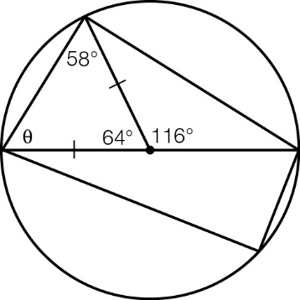

Question 4 [12.1]

B



This is a rectangular hyperbola.

Question 5 [8.1] [10A]

C

A negative cubic, so C or D  
For x = 1, y = -2, so C

Question 6 [8.4] [10A]

C

 = 

= -

Question 7 [10.1]

A

Pr(event) =  = 

Question 8 [10.5]

C

The sample space is: HHH, HHT, HTH, HTT, THH, THT, TTH, TTT

If neither of the first two were heads, then there is the reduced sample space

TTH, TTT, of which one is a successful outcome.

Question 9 [11.2] [10A]

C



Question 10 [11.3] [10A]

B



Question 11 [9.3]

A

From the information given:

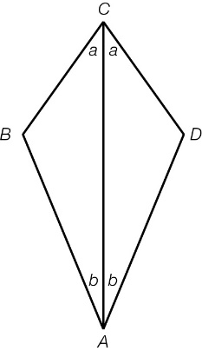

There are two angles that are equal in each triangle and they share a side, so congruent by ASA.

Question 12 [12.4] [10A]

B



Question 13 [13.1]

C

Need to substitute into the compound interest formula:

A = P(1 + r)n, where r = 4.75% but must be expressed as a decimal, 0.0475

Question 14 [13.5]

D

Annual depreciation: 0.18 × $42 000

So, after 2 years its value is:  
$(42 000 − 0.18 × 42 000 × 2)

Question 15 [13.3]

C

A = P(1 + r)n, where A = $13 555, r = 2% per quarter (so 0.02)  
t = 5 (15 months = 1.25 years)

13 550 = P(1 + 0.02)5

= P(1.02)5

P =  = 12 272.65

Question 16 [10.1]

A

Pr(event) =  = 

(The prime numbers here are 2, 3, 5 and 7 so there are 9 cards that do not show a prime number.)

Multiple-choice results: \_\_\_ / 16

Short answer section

Question 17 3 marks [9.3]

To prove: ΔBAE ≡ ΔDEA

CA = CE so ΔCAE is isosceles

∠CAE = ∠CEA

∠BCA = ∠DCE (both straight angles with ∠ACE)

∠ABC = ∠EDC (third angle in triangle)

ΔBAE ≡ ΔDEA (AAS, AE is common)

Question 18 6 marks [9.2]

(a) To prove: ΔABC ≡ ΔEDC  
∠ACB = ∠ECD (vertically opposite)  
∠CAB = ∠CED (given)  
BC = DC (given)  
So, ΔABC ≡ ΔEDC (AAS)

(b) c = 59°  
63 + 59 + a = 180  
so a = 58°  
a = b = 58°

Question 19 4 marks [9.7] [10A]

(a) OA = OB = OC (radius of circle)  
AB = BC (given)  
ΔAOC ≡ ΔBOC (SSS)  
∠AOB = ∠BOC   
So, ∠AOC = 94°

(b) OB and OD are perpendicular bisectors of AC and CE respectively.  
So, OB = OD = 7 cm

Question 20 8 marks [12.2]

|  |  |
| --- | --- |
| [10A] (a)  PM10_PR_Sem2SA_04 | (b)  PM10_PR_Sem2SA_05 |
| (c)  PM10_PR_Sem2SA_06 | (d)  PM10_PR_Sem2SA_07 |

Question 21 3 marks [8.2] [10A]

(a), (b)

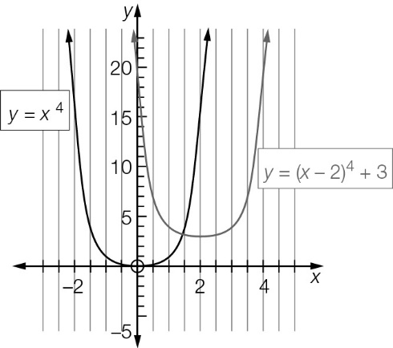

Question 22 6 marks [8.3] [10A]

|  |  |
| --- | --- |
| (a)  The quotient is x3 + 4x2 + 6x + 4.  The remainder is 0. | (b)  The quotient is 3x2 − 9x + 29.  The remainder is . |

Question 23 5 marks [10.2]

(a)

|  |  |  |  |
| --- | --- | --- | --- |
|  | Overseas | Not overseas |  |
| Smartwatch | 3 | 6 | 9 |
| no Smartwatch | 9 | 7 | 16 |
|  | 12 | 13 | 25 |

(b) 3

(c) (i)  (ii) 

Question 24 5 marks [10.4]

|  |  |
| --- | --- |
| (a) | (b) (i) 0.3025  (ii) 0.2025  (iii) 0.7975 (i.e. 1 − 0.2025) |

Question 25 3 marks [10.6]

(a) 0.85 × 0.75 = 0.6375

(b) 0.15 × 0.25 = 0.0375

(c) 0.85 × 0.75 + 0.85 × 0.25 + 0.15 × 0.75  
= 0.9625 (i.e. 1 − 0.0375)

Question 26 3 marks [11.4] [10A]

|  |  |
| --- | --- |
| (a)  =  = 12 − | (b)  =  = |

Question 27 4 marks [11.5] [10A]

|  |  |
| --- | --- |
| (a)  =  = | (b)  =  =  = |

Question 28 6 marks [13.2]

|  |  |  |
| --- | --- | --- |
| (a) A = 25 000(1 + 0.072)5  = $35 392.72 | (b) A = 25 000(1 + 0.036)10  = $35 607.18 | (c) A = 25 000(1 + 0.018)20  = $35 718.69 |

Question 29 2 marks [13.4]

|  |  |
| --- | --- |
| After 1st year: A = P(1 + r)n = 60 000(1 + 0.5625)2 = 66 939.843 75  So, interest in first year is $6939.84. | ref =  =  = 11.57% |

Question 30 2 marks [13.6]

P = 18 950(1 − 0.0075)18

= 18 950(0.9925)18

= 16 548.49

So, about 16 548 people will remain.

Question 31 4 marks [12.6] [10A]

|  |  |
| --- | --- |
| (a) 3log2(2) + log2 − log2(32) = 3log2(2) + log2(2−4) − log2(25) = 3log2(2) − 4log2(2) − 5log2(2) = -6log2(2) = −6 | (b)  =  = = 1.5 |

Short answer total marks: 64

Extended answer section

Question 32 8 marks [12.2]

(a) y = a(x + 3)(x − 1)  
-2 = a(-1 + 3)(-1 − 1)  
-2 = -4a  
a =   


(b) (x − 1)2 + (y − 1)2 = 9

(c) y =   
4 =   
a = 8  
y = 

(d) y = 2−x − 2

Question 33 14 marks [12.2]

|  |  |
| --- | --- |
| (a) (i)  PM10_PR_Sem2SA_12 | (ii) For x = 0.5, y = (0.5 − 3)(0.5 + 2) = -2.5 × 2.5 = -6.25  Turning point: (0.5, -6.25) |
| (b) (i) PM10_PR_Sem2SA_13 | (ii) (-0.7863, 8.2088) and (2.1196, -4.0607) |

(c) In cubics, the turning points are not in the middle of the two x-intercepts as in the quadratic graph.

|  |  |
| --- | --- |
| (d) (i) PM10_PR_Sem2SA_14 | (ii) (-1.5742, -2.8789), (0, 6) and (2.2537, -12.9495) |

(e) The turning points of quartic graphs are not in the middle of the two relevant x-intercepts, unless the graph is symmetrical, or is in the form y = a(x – h)4 + k (with one turning point).

Extended answer total marks: 22

TOTAL test marks: 102