Multiple choice section

Question 1 [1.5]

9 + 6 − 4 × 2 is equal to:

A 7 B 11 C 13 D 22

Question 2 [2.3]

The prime factors of 224 are:

A 2, 7 and 8 B 2, 7 and 4 C 2 and 7 D 2, 3 and 7

Question 3 [2.6]

6 + (-2) − (-3) is equal to:

A 1 B 5 C 7 D 11

Question 4 [3.4]

 is equal to:

A  B  C  D 

Question 5 [4.9]

Of the 25 cars in the car park 15 are Japanese models.  
The ratio non-Japanese models : Japanese models is:

A 2 : 3 B 2 : 5 C 3 : 2 D 3 : 5

Question 6 [4.10]

A footballer is paid $825 000 per season. If he plays 20 games in a season, this is closest to how much per game?

A $40 000 B $41 250 C $42 500 D $45 000

Question 7 [5.4]

For the rule n = 15 − 2p, when p = 3, n is equal to:

A -8 B 9 C 12 D 21

Question 8 [6.1]

200 cm + 0.3 m − 0.0006 km is equal to:

A 1.7 m B 2.9 m C 11 m D 200.3006 cm

Question 9 [7.4]

The solution to is:

A 7 B 12 C 22 D 48

Question 10 [9.4]

A sector graph is to be drawn showing the following information about the favourite type of movie for each student in Year 7 at a particular school.

|  |  |
| --- | --- |
| Movie | Number |
| Comedy | 23 |
| Action | 17 |
| Musical | 42 |
| Drama | 31 |
| Horror | 13 |

The sector representing musicals is closest to:

A 33° B 42° C 120° D 126°

Question 11 [10.1]

The translation [-3, -2] written using instructions is:

A 3 units right and 2 units down B 3 units right and 2 units up

C 3 units left and 2 units down D 3 units left and 2 units up

Question 12 [10.3]

A rotation of 100° clockwise is the same as a rotation of how many degrees anticlockwise?

A 80° B 100° C 170° D 260°

Multiple choice total:\_\_\_\_\_\_\_\_\_/12

Short answer section

Question 13 6 marks [1.2]

Evaluate the following without using a calculator.

(a) 33 + 22 (b) 42 × 33 (c) 52 − 14 + 33

Question 14 6 marks [2.1]

For each group of numbers, find (i) the LCM and (ii) the HCF.

(a) 2, 3 and 5

(i) LCM: (ii) HCF:

(b) 2, 4 and 9

(i) LCM: (ii) HCF:

(c) 5, 15 and 30

(i) LCM: (ii) HCF:

Question 15 9 marks [3.7]

Simplify the following using the correct order of operations.

(a)  (b)  (c) 

Question 16 3 marks [4.4]

Find the numbers that will correctly complete the following equations.

(a) 4.432 − \_\_\_\_\_\_ = 1.245

(b) 1.231 + \_\_\_\_\_\_ = 3.25

(c) 2.34 − \_\_\_\_\_\_ = 0.108

Question 17 4 marks [5.8]

(a) Plot the points (-2, -2), (1, 4) and (5, 12) on the number plane below.

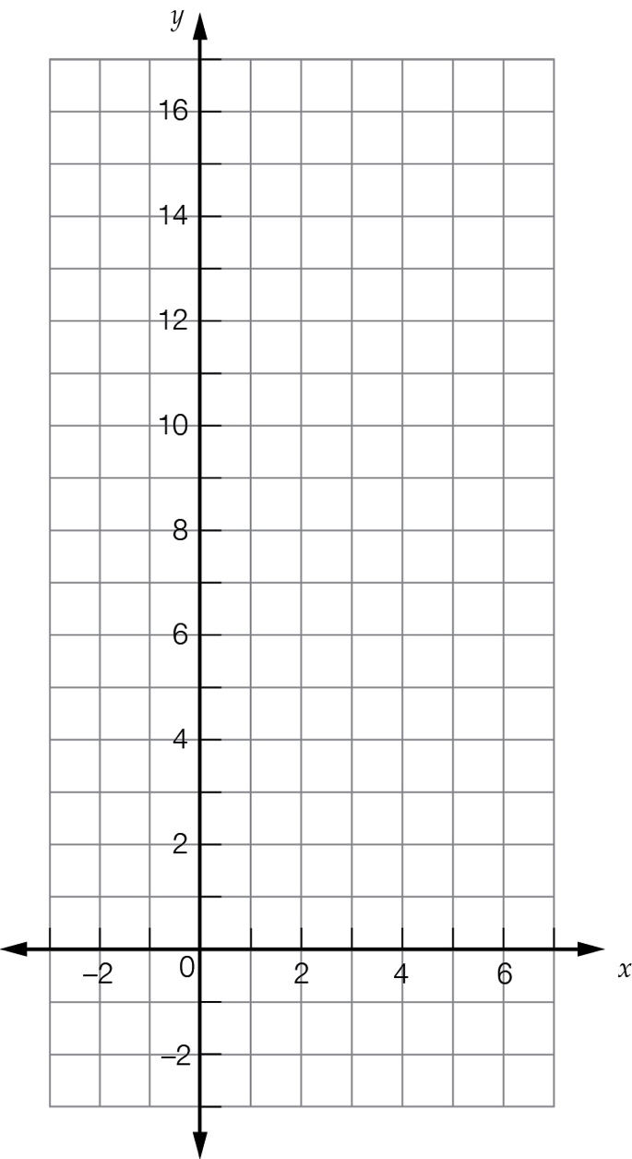

(b) Draw a straight line passing through the points.

(c) What is the y-coordinate of a point on the line if its x-coordinate is 3?

(d) What is the x-coordinate of a point on the line if its y-coordinate is 0?

Question 18 4 marks [5.9]

The following graph compares the arm span and height of five people: Alice (A), Bree (B), Caitlyn (C), Desdemona (D) and Erin (E).

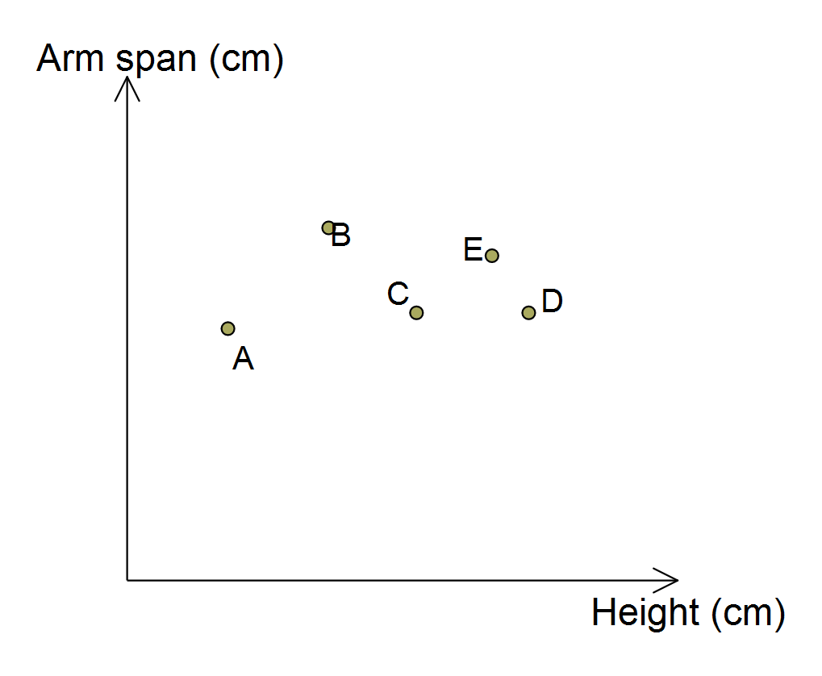

(a) List the people in order of height, from shortest to tallest.

(b) List the people in order of arm span, from shortest to longest.

(c) Do Caitlyn and Desdemona have the same height or arm span?

(d) Fatima (F) is shorter than Desdemona but has a longer arm span than Bree. Place the letter F on the graph in an appropriate place.

Question 19 3 marks [6.6]

Find the volume of the solid shown below.

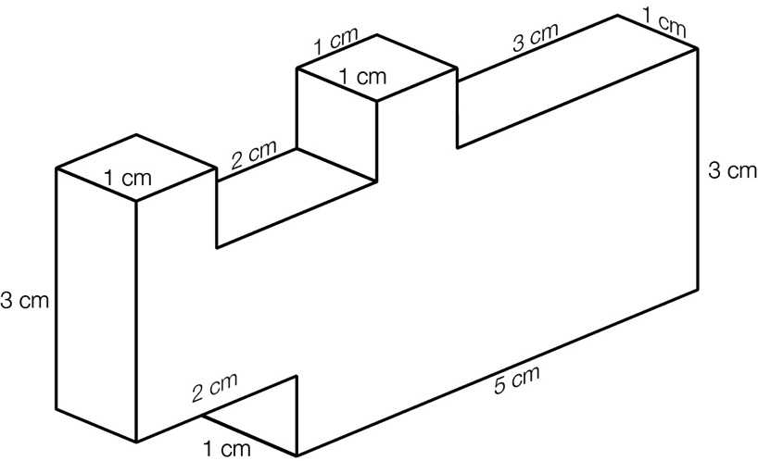

Question 20 4 marks [7.5]

A wedding reception costs $110 per person plus a room hire fee of $450.

(a) If the total cost of the reception was $12 000, form an equation and solve it to find how many people attended the reception. Let p stand for the number of people who attended the reception.

(b) If the cost needed to be kept to a maximum of $10 000, how many guests could be invited?

Question 21 6 marks [8.3]

Find the value of the pronumerals in each of the following diagrams.

(a)

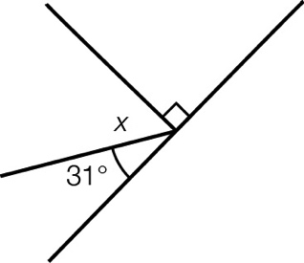

(b)

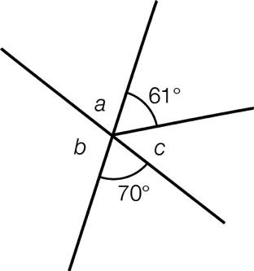

(c)

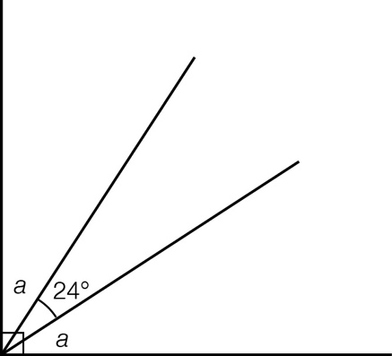

Question 22 6 marks [8.7]

Draw accurate, correctly marked examples of each of the following quadrilaterals.

(a) kite (b) rhombus (c) trapezium

Question 23 6 marks [9.2]

The following table gives the dimensions of venues where AFL football has been played.

|  |  |  |
| --- | --- | --- |
| Venue | Length (m) | Width (m) |
| MCG | 160 | 141 |
| Etihad Stadium | 159.5 | 128.8 |
| Skilled Stadium | 170 | 115 |
| SCG | 149 | 136 |
| ANZ Stadium | 160 | 118 |
| AAMI Stadium | 165 | 133 |
| Paterson’s Stadium | 175.6 | 122.4 |
| Gabba | 156 | 138 |
| Metricon Stadium | 160 | 134 |
| Manuka Oval | 162.5 | 138.4 |
| Aurora Stadium | 135 | 165 |
| TIP Stadium | 175 | 135 |

(a) Find the mean length of the AFL venues.

(b) Which venue is closest to the mean length?

(c) Find the median width of the AFL venues.

(d) Which venue is closest to the median width?

Question 24 3 marks [9.7]

(a) Write out the sample space for drawing a letter at random from the letters of the word PERSONA.

(b) What is the probability that the letter drawn is an R?

(c) What is the probability that the letter drawn is a vowel?

Question 25 4 marks [10.5]

For each of the following diagrams, use the dotted line as an axis of symmetry to complete the diagram.

|  |  |
| --- | --- |
| (a)  PM7_SmB_E_05 | (b)  PM7_SmB_E_06 |

Short answer total:\_\_\_\_\_\_\_\_\_/64

Extended answer section

Question 26 5 marks [2.7]

In the game of indoor cricket a wicket costs the batting side 5 runs. Each pair of batters continues for 4 overs of six balls each, regardless of how many wickets are taken. The following shows what happened on each ball of the four overs for one batting pair.

|  |  |  |  |
| --- | --- | --- | --- |
| Over 1 | Over 2 | Over 3 | Over 4 |
| 1 | wicket | 1 | 1 |
| 1 | 2 | 2 | 1 |
| wicket | 4 | 4 | 1 |
| 4 | 4 | wicket | wicket |
| wicket | 1 | wicket | wicket |
| 2 | 1 | 1 | 1 |

Before this pair started batting, their team had a score of 25 runs.

(a) What was the team’s score after the end of each of the four overs?

(b) How many runs, in total, did this pair contribute to the team’s score? (Deduct points due to wickets.)

Question 27 6 marks [10.7]

Draw each of the following mat plans as 3D shapes on the isometric dot paper provided.

|  |  |  |
| --- | --- | --- |
| (a)    PM7_SmB_E_07 | (b)    PM7_SmB_E_07 | (c)    PM7_SmB_E_07 |

Question 28 11 marks [4.8, 6.2, 6.3]

(a) Find the (i) perimeter and (ii) area of a square with a side length of 6 cm.

(b) One of the pairs of sides in the square is now doubled in length. Find the (i) perimeter and (ii) area of the new shape.

(c) Find the percentage increase in the (i) perimeter and (ii) area for the square and rectangle.

(d) The original square now has one of its pairs of sides tripled in length. Find the (i) perimeter and (ii) area of the new shape.

(e) Find the percentage increase in the (i) perimeter and (ii) area for the square and this second rectangle.

(f) Looking at your results for part (c) and (e), comment on the relationship between the perimeter percentage increase and the area percentage increase.

Extended answer total:\_\_\_\_\_\_\_\_\_/22

TOTAL test marks: \_\_\_\_\_\_\_\_/98