Multiple choice section

Question 1 [1.2]

The square root of 16 is:

A 2 B 4 C 32 D 256

Question 2 [1.4]

1503 rounded to the first digit is:

A 1 B 1000 C 1500 D 2000

Question 3 [2.2]

The largest prime number lower than 70 is:

A 63 B 65 C 67 D 69

Question 4 [2.7]

-8 + (-3) − (+6) is equal to:

A 1 B -5 C -11 D -17

Question 5 [3.3]

Which one of the following is closest to ?

A  B  C  D 

Question 6 [3.5]

 of of 24 is:

A 3 B 4 C 8 D 12

Question 7 [4.1]

Six tenths, five hundreds and seven ten-thousandths is equal to:

A 0.065 07 B 0.0657 C 0.6507 D 0.657

Question 8 [4.3]

0.66 expressed in simplest fraction form is:

A  B  C  D 

Question 9 [4.5]

How many decimal places will there be in the answer to 4.123 × 1.12?

A 2 B 3 C 5 D 6

Question 10 [4.7]

 written as a percentage is:

A 1.5% B 32% C 105% D 150%

Question 11 [5.1]

7 is subtracted from the product of two different numbers a and b. When written using algebra this is:

A 7 − ab B ab − 7 C 7ab D −7ab

Question 12 [5.6]

A like term for 5pq is:

A p + q B 5p C 7pq D p − q

Multiple choice total:_________/12

Short answer section

Question 13 6 marks [1.3]

Calculate the following using any suitable strategy.

(a) 950 ÷ 50 (b) 205 × 21 (c) 8100 ÷ 36

Question 14 6 marks [1.5]

Calculate the following, showing all steps of working.

(a) 24 ÷ (6 + 14 ÷7) + 5 (b) 29 − 13 × 2 + 14 ÷ 7

Question 15 7 marks [2.1]

Find the lowest common multiple (LCM) of the following sets of numbers, by first listing the multiples of each.

(a) 5 and 30 (b) 9 and 12 (c) 4, 5 and 6

Question 16 3 marks [2.7]

A 'magic square' is a square grid of numbers where the sum of each of the rows, columns and diagonals is the same number.

(a) What is the magic sum for the 3 × 3 square below?

(b) Complete the magic square.

|  |  |  |
| --- | --- | --- |
|  | -7 | -6 |
|  | -5 |  |
| -4 |  |  |

Question 17 4 marks [3.2]

Write your answers in simplest form.

(a) What fraction of an hour has passed from 2:15 am to 2:40 am?

(b) What fraction of an hour has passed from 5:42 pm to 6:02 pm?

Question 18 9 marks [3.4]

Calculate the following. Write your answers as mixed numbers in simplest form.

(a)  (b)  (c) 

Question 19 4 marks [3.6]

Students in a metalwork class use a small amount of gold leaf for a project. They each need  of a metre of the gold leaf strip and there is  of a metre of the strip available.

(a) How many students can use the gold leaf?

(b) How much gold leaf strip will be left over if the maximum number of students have used it?

Question 20 1 mark [4.2]

Oranges cost $3.99 per kg. How much would Silvana pay for 500 g if she pays with cash?

Question 21 1 mark [4.6]

A company makes a profit of 4.32 million dollars. If the profit is to be divided equally between the four company owners, how much would each owner get? (Give your answer in millions of dollars.)

Question 22 3 marks [4.8]

Larissa and Ngaio are both goal shooters for their netball teams. In a game against each other, Larissa scored 17 goals out of 21 attempts, whereas Ngaio scored 15 goals out of 19 attempts.

(a) Calculate the percentage success rate for each, rounded to 1 decimal place.

(b) Who was more accurate on the day?

Question 23 4 marks [5.3]

For the following rules, draw a flowchart and describe the rule using words.

(a)  (b) 

Question 24 4 marks [5.4]

Use each of the following rules to complete these tables of values.

(a) c = 2b

|  |  |  |  |  |  |
| --- | --- | --- | --- | --- | --- |
| b | 11 | 13 | 2 | 0 | 9 |
| c |  |  |  |  |  |

(b) q = 3p − 10

|  |  |  |  |  |  |
| --- | --- | --- | --- | --- | --- |
| p | 1 | 3 | 11 | 15 | 35 |
| q |  |  |  |  |  |

Short answer total:_________/52

Extended answer section

Question 25 9 marks [5.8]

(a) On the number plane below, plot the points (-2, -3) and (5, 11) and join them with a straight line.

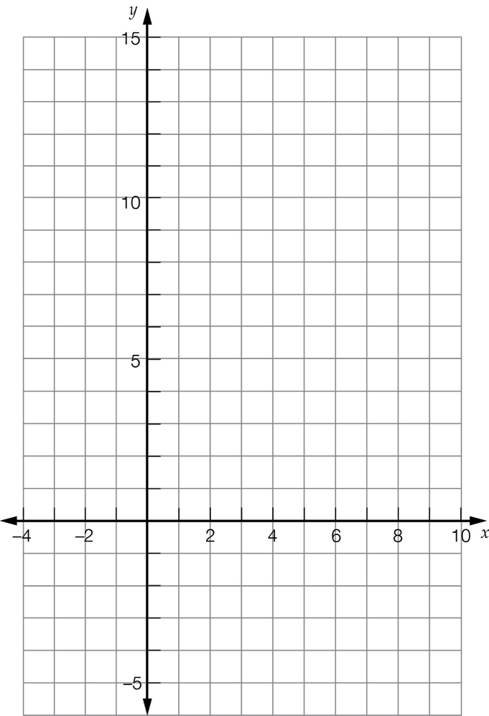

(b) Mark on the line three other points that the line passes through.

(c) Summarise the set of points in the following table of values.

|  |  |  |  |  |  |
| --- | --- | --- | --- | --- | --- |
| x | -2 | 5 |  |  |  |
| y | -3 | 11 |  |  |  |

(d) Write the rule linking the x- and y-values.

(e) Substitute x = 1 into the equation, to show that (1, 2) does not lie on the line.

(f) Plot (1, 2) on the number plane to confirm it is not on the line.

Question 26 6 marks [1.6]

Jason collects some $1 and $2 coins. He had 35 coins adding to a total of $61.

(a) How many of each type of coin did Jason have?

(b) Jason decided to give the money, in equal shares, to his three children. He also decided he would keep any money left over if it didn’t divide evenly. How much did each child receive?

(c) How many of each type of coin should each child be given?

Extended answer total:_________/15

TOTAL test marks: ________/79