Multiple choice section

|  |  |  |  |  |  |  |  |  |  |  |  |  |
| --- | --- | --- | --- | --- | --- | --- | --- | --- | --- | --- | --- | --- |
| Question | 1 | 2 | 3 | 4 | 5 | 6 | 7 | 8 | 9 | 10 | 11 | 12 |
| Answer | B | A | C | C | C | D | B | B | C | B | C | B |

Question 1 [6.2]

B

Perimeter of a square = 4 × side length

= 4 × 315 mm

= 1260 mm

= 1.26 m

Question 2 [6.6]

A

Volume = length × width × height  
= 2 × 1.2 × 0.75  
= 1.8 m3

Question 3 [7.1]

C

RHS = 45

5 × 9 = 45

Question 4 [7.3]

C

The last thing done was ÷ 2, so first thing to do when backtracking is the opposite of this: × 2

Question 5 [7.2]

C

n = 12 × 13; need to find an equation that comes from that: 

Question 6 [8.1]

D

To use a semicircular protractor you need an angle less than 180°: (360 − 310)° = 50°

Question 7 [8.3]

B

x + 135° = 180° (straight angle)

so, x = (180 − 135)° = 45°

Question 8 [8.5]

B

There are 7 sides so it is a heptagon.

Question 9 [8.7]

C

The angles in a quadrilateral add to 360°.  
(63 + 90 + 117)° = 270°

Remaining angle: (360 − 270)° = 90°

Question 10 [9.2]

B

Data in order: 1, 1, 1, 2, 2, 2, 3, 3, 3, 4

For 10 values the median is between the 5th and 6th values: both 2 so the median is 2.

Question 11 [10.1]

C

Pick one of the vertices, e.g. A, and count how many squares it has been moved.

A has moved 5 squares to the right and 2 squares up.

Question 12 [10.6]

B

Count the cubes (10); there are none hidden completely from view.

Multiple choice total: 12

Short answer section

Question 13 4 marks [6.3]

(a) Convert 750 m to km so the answer will be in km2.  
750 m = 0.75 km  
A = length × width  
= 4.7 × 0.75  
= 3.525 km2

(b) Convert 225 mm to cm so the answer will be in cm2.  
225 mm = 22.5 cm  
A = length × width  
= 22.5 × 12  
= 270 cm2

Question 14 2 marks [6.4]

(a) A = base × height  
= 12 × 5  
= 60 cm2

(b) P = sum of side lengths  
= 6 + 12 + 6 + 12  
= 36 cm

Question 15 4 marks [6.5]

Area of unshaded rectangle: 5 × 3 = 15 cm2

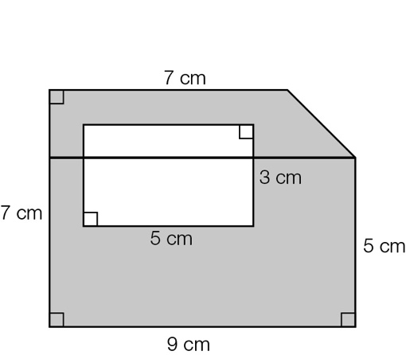

The construction line divides the shape into a trapezium and a rectangle.

Area of trapezium:  = 16 cm2

Area of rectangle: 5 × 9 = 45 cm2

Shaded area = 16 + 45 − 15 = 46 cm2

Question 16 4 marks [7.4]

|  |  |  |
| --- | --- | --- |
| (a) 5x − 2 = 13 5x = 15 x = 3 | (b) 3(x − 2) = 9 (x − 2) = 3 x = 5 | (c)  2(x + 3) = 30 (x + 3) = 15 x = 12 |

Question 17 3 marks [7.5]

(a) C = P + 12.99

(b) 77.89 = P + 12.99  
P = 77.89 − 12.99  
P = 64.9  
The paint cost $64.90.

Question 18 4 marks [8.2]

(a) ∠CFB

(b) ∠CFB and ∠BFA

(c) ∠DFC and ∠CFA or ∠DFE and ∠EFA

(d) ∠DFE and ∠BFA

Question 19 8 marks [8.4]

a: 80°: straight angle

b: 100°: vertically opposite

c: 100°: alternate

d: 100°: corresponding

(other reasons are possible)

Question 20 3 marks [8.6]

(a)

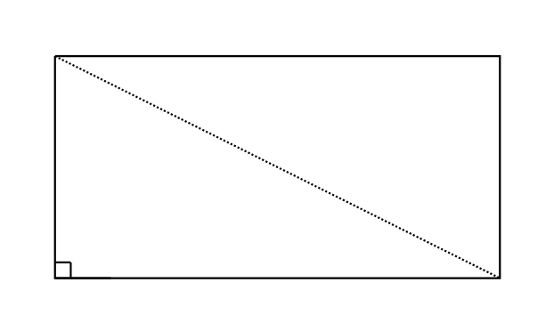

(b) (i) scalene triangles

(ii) right-angled triangles

Question 21 3 marks [9.1]

(a) You count, so discrete.

(b) You choose from a list, so categorical.

(c) You measure, so continuous.

Question 22 2 marks [9.7]

(a) 

(b) There are now only 19 chocolates, 11 of which are soft-centred, so .

Question 23 5 marks [9.3]

(a)

|  |  |
| --- | --- |
| Stem | Leaf |
| 5 | 1 3 |
| 6 | 2 7 7 |
| 7 | 1 2 |
| 8 |  |
| 9 | 9 |
| 10 | 3 8 |
| 11 |  |
| 12 | 0 |
| 13 |  |
| 14 | 5 |

(b) There are 12 data values, so the median is the mean of the 6th and 7th data values.  
Median = 

(c) Range = 145 − 51 = 94

Question 24 4 marks [10.2]

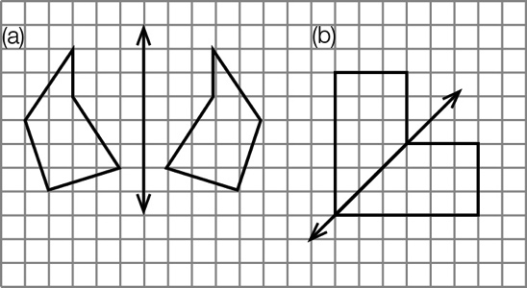

Question 25 5 marks [10.4]

(a)

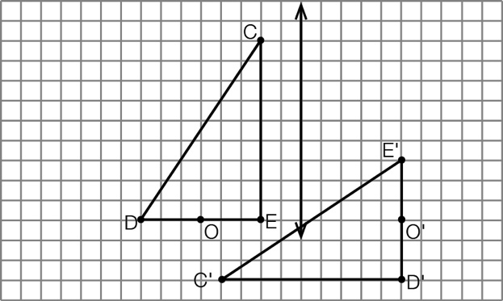

(b)

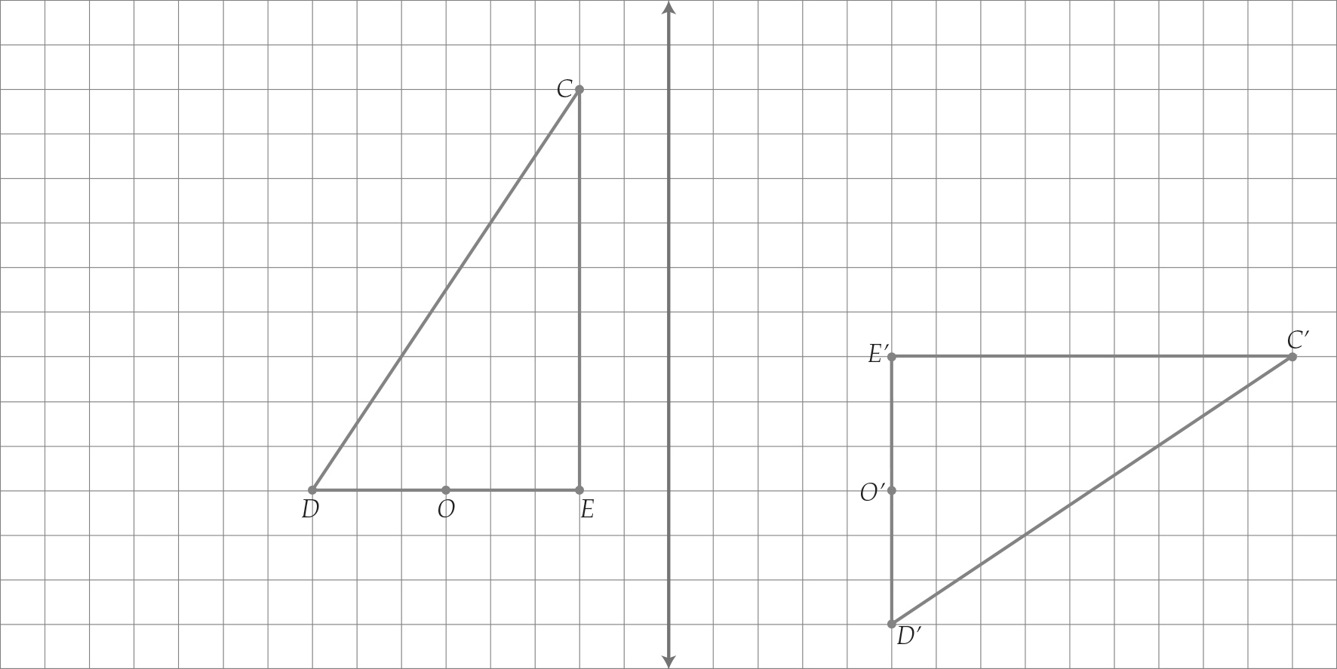

(c) The order of transformation makes a difference to the final shape obtained.

Question 26 6 marks [10.7]

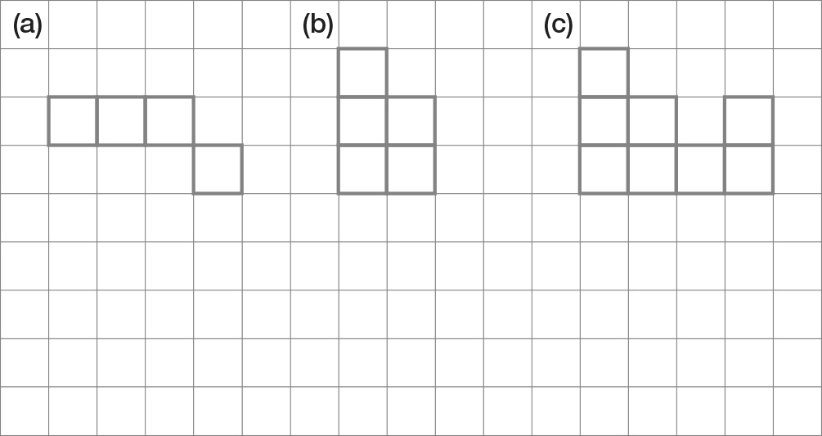

Short answer total: 57

Extended answer section

Question 27 10 marks [8.4, 8.6]

(a) a: 67°; corresponding  
b: 67°; vertically opposite  
c: 113°; straight angle

(b) d: 95°; vertically opposite  
e: 34°; angles in triangle add to 180°  
f: 35°; angles in triangle add to 360°  
g: 85°; straight angle

(c) h: 68°; vertically opposite  
m: 90°; vertically opposite a co-interior angle of 90°

n: 68°; co-interior

Question 28 7 marks [9.5]

(a) 13 days

(b) 16 mm

(c) 19 April

(d) Add and divide by 11: 65.4 mm

(e) The 2011 April rainfall is approximately 1.5 times the mean for the previous years.

Extended answer total: 17

TOTAL test marks: 86