Multiple-choice section

|  |  |  |  |  |  |  |  |  |  |  |  |  |  |  |  |  |
| --- | --- | --- | --- | --- | --- | --- | --- | --- | --- | --- | --- | --- | --- | --- | --- | --- |
| Question | 1 | 2 | 3 | 4 | 5 | 6 | 7 | 8 | 9 | 10 | 11 | 12 | 13 | 14 | 15 | 16 |
| Answer | D | C | B | C | B | D | A | B | B | B | A | C | B | A | D | D |

Question 1 [1.1]

D

reduced percentage of sugar = 90% of 27

= 0.9 × 27

= 24.3%

Question 2 [1.2]

C

profit = selling price – cost price

= $812 – $653

= $159



Question 3 [2.2]

B

Using Pythagoras’ theorem:

hypotenuse = 

= 

=  = 21.58 (2 d.p.)

Question 4 [2.5]

C

(15, 36, 39) = (3 × 5, 3 × 12, 3 × 13)

As (5, 12, 13) is a Pythagorean triple (52 + 122 = 132) and (15, 36, 39) is a multiple of (5, 12, 13), (15, 36, 39) is also a Pythagorean triple.

(15, 20, 25) = (5 × 3, 5 × 4, 5 × 5)

As (3, 4, 5) is a Pythagorean triple (32 + 42 = 52) and (15, 20, 25) is a multiple of (3, 4, 5), (15, 20, 5) is also a Pythagorean triple.

(15, 18, 21) = (3 × 5, 3 × 6, 3 × 7)

As (5, 6, 7) is not a Pythagorean triple (52 + 62 ≠ 72) and (15, 18, 21) is a multiple of (5, 6, 7), (15, 18, 21) is not a Pythagorean triple.

(15, 8, 17) is a Pythagorean triple.   
(152 + 82= 172)

Question 5 [3.2]

B





Question 6 [3.6]

D

3*h*(6*d* – 4) – 5*h*(5*d* – 8)

= 18*hd*– 12*h*– 25*hd* + 40*h*

*=* -7*hd +* 28*h*

Question 7 [3.7]

A

(2*a* + 3*b*) is a common factor.

-*y*(2*a* + 3*b*) + 7*x*(2*a* + 3*b*)

= (2*a* + 3*b*)(-*y* + 7*x*)

= (2*a* + 3*b*)(7*x* – *y*)

Question 8 [4.1]

B

*P* = 2(*L* + *W*)

*P* = 2(73.5 + 43.2)

*P* = 2 × 116.7

*P* = 233.4 m

Question 9 [4.2]

B

Shaded area = outer area – inner area

= – 

= – 

=– 

= ≈ 47 cm2

Question 10 [4.3]

B

surface area of a rectangular prism   
= 2(*lw* + *lh* + *wh*)

= 2 × (52 × 38 + 52 × 29 + 38 × 29)

= 2 × 4586

= 9172 cm2

Question 11 [4.4]

A

volume of a cylinder = *π r2h*

= *π* × 1.22 × 2.21

≈ 10 m3

as 1 kL = 1 m3, capacity ≈ 10 kL

Question 12 [5.1]

C



Question 13 [5.3]

B





Question 14 [5.4]

A

*y* = 7 – 3*x*

Where *x* = -8:

*y* = 7 – 3 × -8

= 7 + 24

= 31

≠ -17

(-8, -17) does not lie on the line.

Where *x* = -2:

*y* = 7 – 3 × -2

= 7 + 6

= 13

(-2, 13) does lie on the line.

Where *x* = 1:

*y* = 7 – 3 × 1

= 7 – 3

= 4

(1, 4) does lie on the line.

Where *x* = 9:

*y* = 7 – 3 × 9

= 7 – 27

= -20

(9, -20) does lie on the line.

Question 15 [5.6]

D

*y*-intercept: (0, 4)

*b* = 4

gradient = -5

*m* = -5

*y* = *mx* + *b*

*y* = -5*x* + 4

Rearrange by adding 5*x* to both sides.

*y* + 5*x* = -5*x* + 5*x* + 4

5*x* + *y* = 4

Question 16 [5.8]

D

*x* = 3 is a line parallel to the *x-*axis through (3,0), (3,1), (3,2)…

It is a vertical line.



As *x*2 – *x*1= 0, the gradient is undefined.

Multiple-choice total marks: 16

Short answer section

Question 17 4 marks [1.3]

Standard earnings = 8 × 12.78

= $102.24

Earnings at time-and-a half = 5 × 1.5 × 12.78

= $95.85

Earnings at double time = 3 × 2 × 12.78

= $76.68

Total earnings = $274.77

Question 18 3 marks [1.4]

Gross fortnightly earnings = $1419.23 + $253.85 = $1673.08

Gross yearly income = $1673.08 × 26 = $43 500.08

Superannuation = 0.09 × $43 500.08 = $3915.01

Annual salary package = $43 500.08 + $3915.01 = $47 415.09

Question 19 3 marks [1.6]

*I* = *PrT*

= 

= $98.21

Question 20 4 marks [2.3]

*x*2 + 3.12 = 6.32

*x*2 = 6.32 – 3.12

= 30.08

**(a)** *x* = m

**(b)** *x* = 5.48 m

Question 21 3 marks [3.1]

 = 

= *a*4 – 2*b*3 – 2

= *a*2*b*

Question 22 3 marks [3.2]

 = 

= 21 – -2 *m*-2 – -6*n*5 – -2

= 23*m*4*n*7

Question 23 5 marks [3.4]

*m*(*x* – *n*) – *mn* = *x* + *m*

*mx* – *mn* – *mn* = *x* + *m*

*mx* – 2*mn* = *x* + *m*

*mx* – *x* = 2*mn* + *m*

(*m* – 1)*x* = *m*(2*n* +1)

*x* = ** or **

Question 24 4 marks [3.5]

|  |  |
| --- | --- |
| **(a)** (*k* + 3)(*k* – 5)  = *k*2 – 5*k* + 3*k* – 15  = *k*2 – 2*k* – 15 | **(b)** (3*f* – 4)(4*f* – 5)  = 12*f* 2 – 15*f* – 16*f* + 20  = 12*f* 2 – 31*f* + 20 |

Question 25 4 marks [3.6]

|  |  |
| --- | --- |
| **(a)** (8 – *x*)2  = 64 – 2 × 8 × *x* + *x*2  = 64 – 16*x* + *x*2  **(b)** (2*x* + 3)2  = 4*x*2 + 2 × 2*x* × 3 + 32  = 4*x*2 + 12*x* + 9 |  |

Question 26 3 marks [3.6]

|  |  |
| --- | --- |
| **(a)** (*d* – *e*)(*d* + *e*) = *d*2 – *e*2  **(b)** (3*m* + 2*n*)(3*m* – 2*n*)  = (3*m*)2 – (2*n*)2  = 9*m*2 – 4*n*2 |  |

Question 27 2 marks [3.7]

|  |  |
| --- | --- |
| **(a)** 3*x* – 9*y* = 3(*x* – 3*y*) | **(b)** 4(*x* – 5) – *y*(*x* – 5) = (*x* – 5)(4 – *y*) |

Question 28 5 marks [3.8]

|  |  |
| --- | --- |
| **(a)** *pq* – *rt* + *pr* – *qt*  = *pq* + *pr* – *rt* – *qt*  = *p*(*q* + *r*) – *t*(*r* + *q*)  = (*p* – *t*)(*q* + *r*) | **(b)** *y*2 – 8*y* + 4*y* – 32  = *y*(*y* – 8) + 4(*y* – 8)  = (*y* – 8)(*y* + 4) |

Question 29 8 marks [4.1]

|  |  |
| --- | --- |
| **(a)** *P* = 2*r* +  = 2*r* +  = 2 × 6 +  = (12+ 3π)  = 21.42 cm | **(b)** *P* = 2*r* + *l*  = 2*r* +  = 2 × 4.7 +  = 20.72 m |

Question 30 4 marks [4.2]

Shaded area = *l* × *w* – 2πr2

= 34.5 × 18.2 – 2π × 32

= 627.9 – 18π

= 571.35 mm

Question 31 3 marks [4.4]

*V* = π*r*2*h*

= π × 7.32 × 16.7

= 2795.84 cm3

Question 32 8 marks [5.1]

3*m* + 4 = 5*m* – 2

5*m* – 3*m* – 2 = 3*m* – 3*m* + 4

2*m* – 2 = 4

2*m* – 2 + 2 = 4 + 2

2*m* = 6

 = 

*m* = 3

LHS = 3 × 3 + 4 RHS = 5 × 3 – 2

= 9 + 4 = 15 – 2

= 13 = 13

LHS = RHS

Question 33 5 marks [5.1]

3*x* – 4 + 2*x* + 10 + 5*x* + 27 + 8*x* – 33 = 360

18*x* = 360

*x* = 20

3*x* – 4 = 3 × 20 – 4

= 56

2*x* + 10 = 2 × 20 + 10

= 50

5*x* + 27 = 5 × 20 + 27

= 127

8*x* – 33 = 8 × 20 – 33

= 127

The angles are 56°, 50°, 127°, 127°. (This quadrilateral is a kite.)

Question 34 5 marks [5.3]

|  |  |
| --- | --- |
| (*xm*, *ym*) = (1, 8) |  |

Question 35 4 marks [5.4]

*y* = 3*x* – 2

|  |  |  |  |  |  |  |  |
| --- | --- | --- | --- | --- | --- | --- | --- |
| *x* | -3 | -2 | -1 | 0 | 1 | 2 | 3 |
| *y* | -11 | -8 | -5 | -2 | 1 | 4 | 7 |

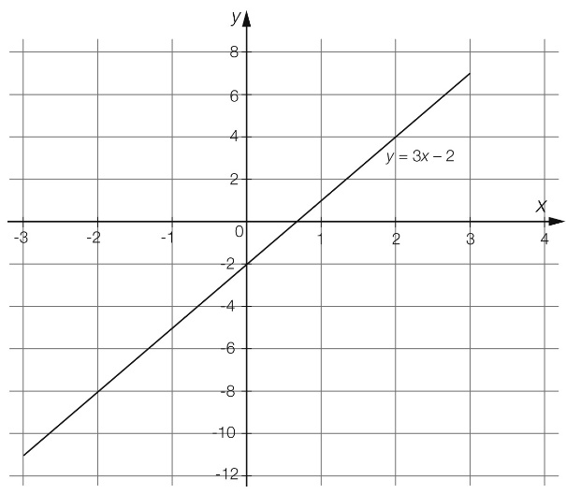

Question 36 4 marks [5.6]

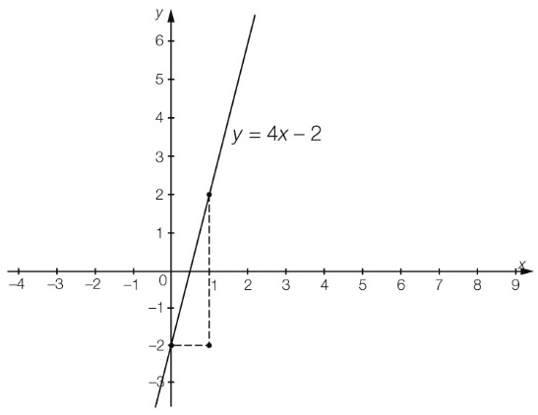

Question 37 4 marks [5.7]

|  |  |
| --- | --- |
| Where *x* = 0: -5*y* = 15  *y* = -3  Where *y* = 0: 3*x* = 15  *x* = 5 |  |

Question 38 2 marks [5.8]

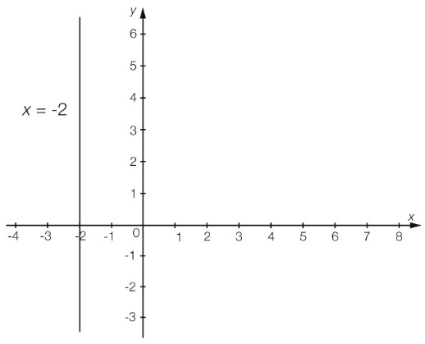

Short answer total marks: 90

Extended answer section

Question 39 7 marks [1.8]

(a) Cost for Monday = 2 × 0.30 + 29 × 0.93 + 3 × 0.28 = $28.41

Cost for Tuesday = 8 × 0.3 + 25 × 0.93 + 12 × 0.28 = $29.01

(b) Tuesday costs her more in phone usage.

**(c)** It is definitely better for her to be on a monthly plan as she has nearly spent the monthly plan charge in 2 days. To keep under $59/month, she can only average about $1.90/day (only one   
1-minute call and 2 text messages).

Question 40 7 marks [2.4]

Let *x* = the distance from the rope to the pole at the base.

*x*2 + 1.22 = 1.62

*x*2 = 2.56 – 1.44

= 1.12

*x ≈* 1.0583 m

Distance from the rope to the base of the tent

= (1.0583 – 0.6) m

= 458 mm

*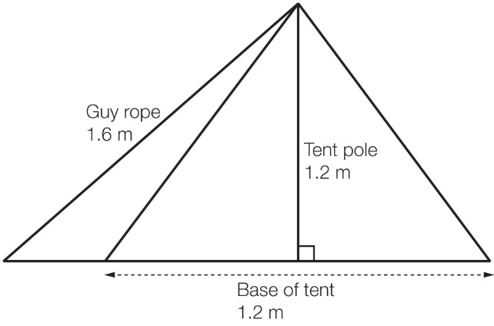*

Question 41 10 marks [4.3]

|  |  |
| --- | --- |
| **(a)** *x* =  =  = 13 cm  ACPM9_PR_1_06ssem1 | **(b)** SA = *A*1 + 2 × *A*2 + *A*3 + *A*4  = *l*1*w*1 + 2+ *l*3*w*3 + *l*4*w*4  = (12 × 2) + 2 ×  + (5 × 2) + (13 × 2)  = 24 + 60 + 10 + 26  = 120 cm2  ACPM9_PR_1_07ssem1 |

Extended answer total marks: 24

TOTAL test marks: 130