**Insert School Logo**

**Semester 1 Examination 2020**

**Question & Answer Booklet**

**PHYSICS**

**UNIT 1**

**Name: _________________________________________________________________________________________**

**Teacher: ________________________________________________________________________________________**

**Time allowed for this paper**:

Reading time before commencing work: 10 minutes

Working time for paper: 3 hours

**Materials required/recommended for this paper**

***To be provides by the supervisor***

This Question/Answer Booklet

Formulae and Data Booklet

***To be provided by the candidate***

Standard items: pens, pencils (including coloured), sharpener, correction fluid, eraser, ruler, highlighters.

Special items: up to three non-programmable calculators approved for use in the WACE examinations, drawing templates, drawing compass and a protractor.

**STRUCTURE OF THIS PAPER**



|  |  |  |  |  |  |
| --- | --- | --- | --- | --- | --- |
| **Section** | **Questions** | **Questions to be attempted** | **Suggested working time (mins)** | **Marks available** | **Percentage of exam** |
| Section One:  Short Response | 11 | 11 | 50 | 54 | 30% |
| Section Two:  Problem Solving | 6 | 6 | 90 | 90 | 50% |
| Section Three:  Comprehension | 2 | 2 | 40 | 36 | 20% |
| Total | **180** | **100** |

**INSTRUCTIONS TO CANDIDATES**



1. Write your answers in the spaces provided beneath each question. The value of each question (out of 180) is shown following each question.
2. Answers to questions involving calculations should be evaluated and given in decimal form. Final answers should be given up to three significant figures and include appropriate units.
3. Questions containing the instruction "**ESTIMATE**" may give insufficient numerical data for their solution. Give final answers to a maximum of two significant figures and include appropriate units.
4. Despite an incorrect result, credit may be obtained for method and working providing these are clearly and legibly set out.
5. Questions containing specific instructions to **show working** should be answered with a complete, logical, clear sequence of reasoning showing how the final answer was arrived at; correct answers which do not show working will not be awarded full marks.
6. Supplementary pages for the use of planning/continuing your answer to a question have been provided at the end of this Question & Answer booklet. If you use these pages to continue an answer, indicate at the original answer where the answer is continued, i.e. give the page number.
7. Extra/spare graphs have also been provided at the end of this Question & Answer booklet.



**Section One: Short Response 30% (54 marks)**

This section has 11 questions. Answer **all** questions. Answer the questions in the spaces provided.

Suggested working time: 50 minutes.

**Question 1 (4 marks)**

The diagram below shows the changes which occur between the solid, liquid and gaseous phases of a substance, with the addition of heat.

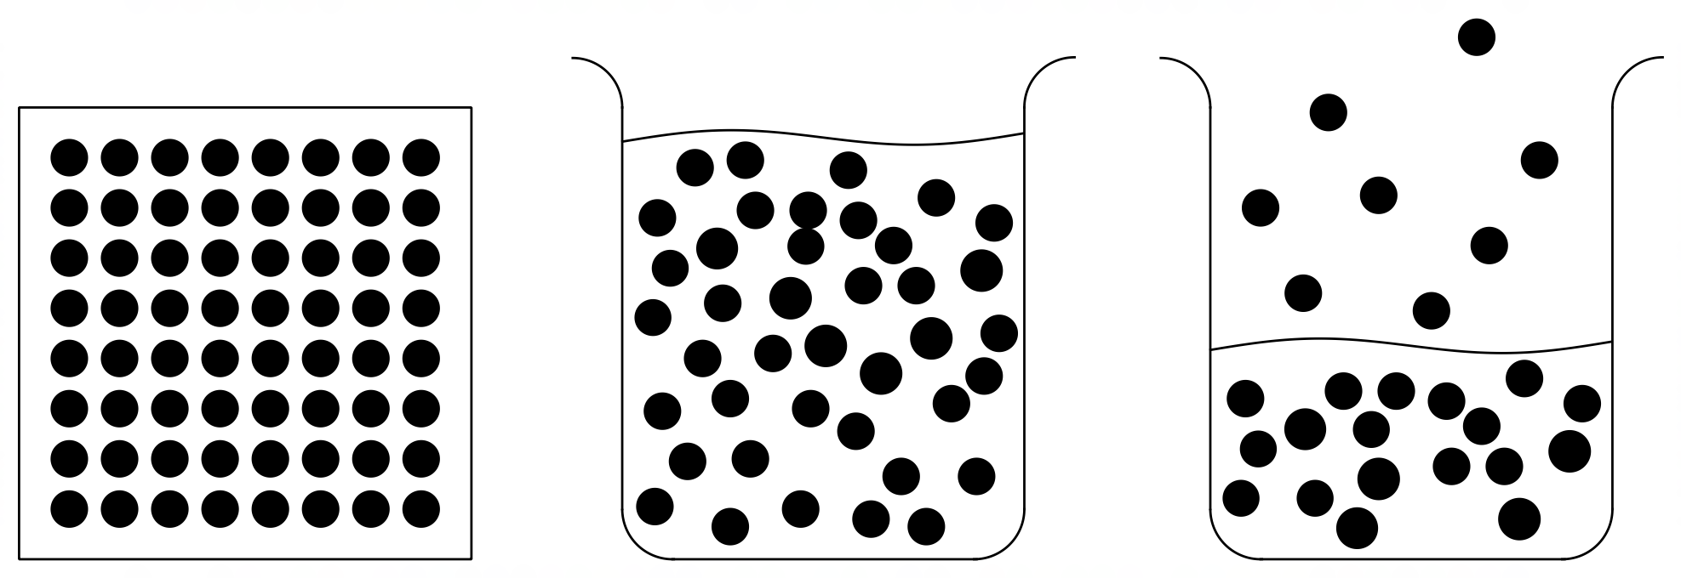

Using this diagram and your knowledge of the kinetic particle model, state and explain one change which occurs when the substance changes phase from:

(a) solid to liquid. (2 marks)

(b) liquid to gas. (2 marks)

**Question 2 (5 marks)**

Identify the products V, W, X, Y and Z in the following nuclear equations.

(a) 

(b) 

(c) 

(d) 

(e) 

**Question 3 (3 marks)**

In cold climates wind chill factor and hypothermia can pose a real threat to the health of an individual. Wind chill is when cooler, moving air replaces relatively still air near the skin, giving the person the sensation that the effective temperature has decreased. Explain why the wind chill is worsened when the person is wet or wearing wet clothes.

**Question 4 (5 marks)**

A 6.50 kg steel container (specific heat capacity 4.50 × 102 J kg–1 K–1) holds 13.0 kg of water at 24.0 °C. When 3.15 kg of a molten alloy, at its melting point of 315 °C, is poured into the water, the water reaches a final temperature of 29.1 °C. If the latent heat of fusion of the alloy is 2.30 × 104 J kg–1 determine the specific heat capacity of the alloy.

**Question 5 (5 marks)**

Albert is trying to precisely measure the resistance of a piece of fuse wire. To do so he applies a voltage across the wire and measures current passing through the wire. The meters are shown below.

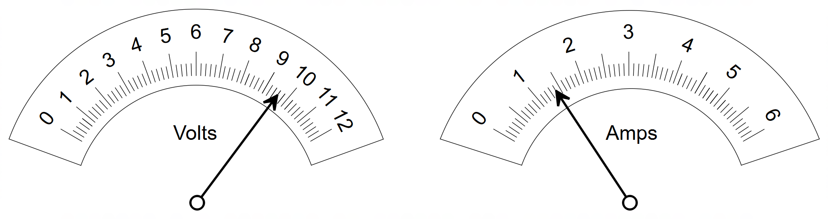

Determine the resistance of the fuse wire.

Give your answer in the form ( being the uncertainty in resistance).

**Question 6 (5 marks)**

Domestic smoke detectors use about 0.25 µg of a radioactive source of Americium-241 which produces alpha particles. Under normal operating conditions, the alpha particles ionise oxygen and nitrogen molecules in the air and an electric potential from a battery causes a small ionisation current to flow. When smoke enters the detector the smoke particles absorb alpha particles and thus reduce the ionisation current flowing in the circuit, setting off an alarm.

(a) Explain the effect that using a radioactive source which produces beta particles instead of alpha particles would have, on the operation of a domestic smoke detector. (2 marks)

(b) If the half-life of Am-241 is 450 years, how much of the original radioactive material would be left in an old smoke detector that is 50 years old. (3 marks)

**Question 7 (4 marks)**

A 416 g sample of radioisotope Promethium–147 decays into Samarium–147 as the main product.

(a) Identify and state the main decay process of Promethium–147. (1 mark)

(b) Determine the half-life of Promethium–147 if it decays to 13 g in 12 years? (3 marks)

**Question 8 (6 marks)**

After running a long-distance marathon, Tori adds a handful of ice blocks to her partly empty water bottle. Tori knows that an average ice block contains anywhere from 30 to 50 mL of water. Tori also wants to ensure that the ice doesn’t melt too quickly and therefore only selects ice blocks that are well below freezing point. Using this information estimate how many kilojoules (kJ) of energy were extracted from tap water in order to produce the ice blocks which Tori used.

**Question 9 (4 marks)**

The label on a rechargeable Lithium-Polymer (LiPo) battery reads: “11.1 volt, 1800 mAh”. The battery is being used to operate a remote-control vehicle.

1. The term “1800 mAh” refers to which quantity below? Circle your answer. (1 mark)

Current Time Energy Charge

(b) Given that the electric motor of the vehicle draws a constant current of 12 A from the battery during an operating time of 9.0 minutes, calculate the efficiency of the motor, if the motor produces 5.8 × 104 J of useful energy. (3 marks)

**Question 10 (5 marks)**

Two different motors with resistances of *R* and 2*R* are running in parallel with each other, powered by the same voltage source *V*.

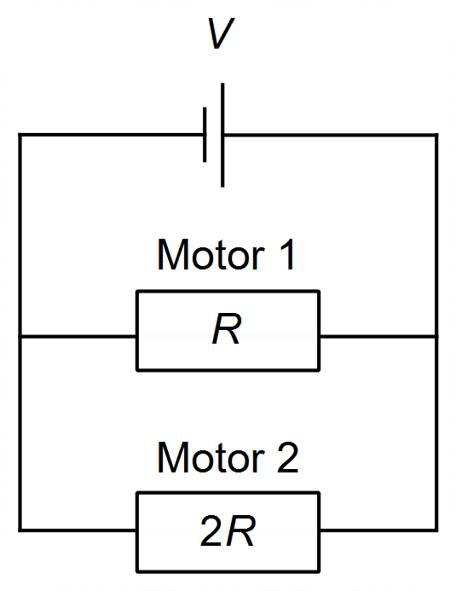

(a) On the diagram above indicate, with an arrow, the direction of conventional current through one of the motors. (1 mark)

(b) Due to unusual heating of the wires of Motor 2 its resistance halves from 2*R* to *R*. If all other factors stay the same, describe the change that occurs in the overall current drawn by the circuit, due to this unusual heating. Use relevant physics concepts to justify your answer. (4 marks)

**Question 11 (8 marks)**

The heating curve below shows the temperature change of a 285 g sample of solid coconut oil as it is heated, with a small 40 W heating element, from an initial temperature of 10 °C.

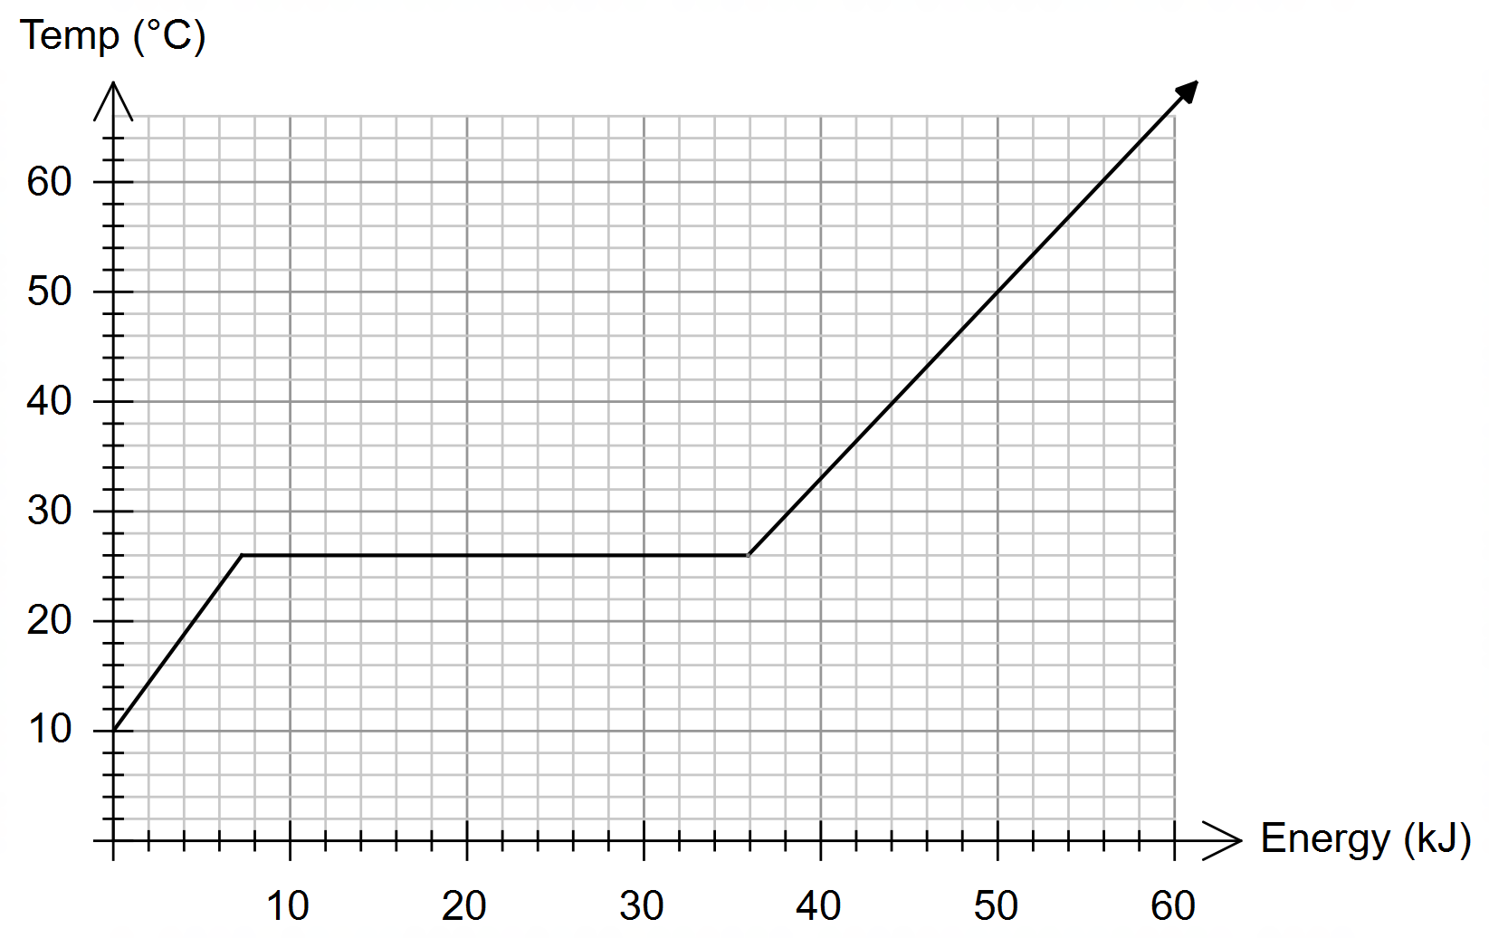

(a) How long does it take for the coconut oil to completely melt? (3 marks)

(b) Use the graph to estimate the specific heat capacity of liquid coconut oil. (5 marks)

**END OF SECTION ONE**

**Section Two: Problem Solving 50% (90 marks)**

This section contains 6 questions. Answer **all** questions. Answer the questions in the spaces provided.

Suggested working time 90 minutes.

**Question 12 (17 marks)**

Consider the circuit shown below, containing seven resistors, an ammeter and a voltmeter.

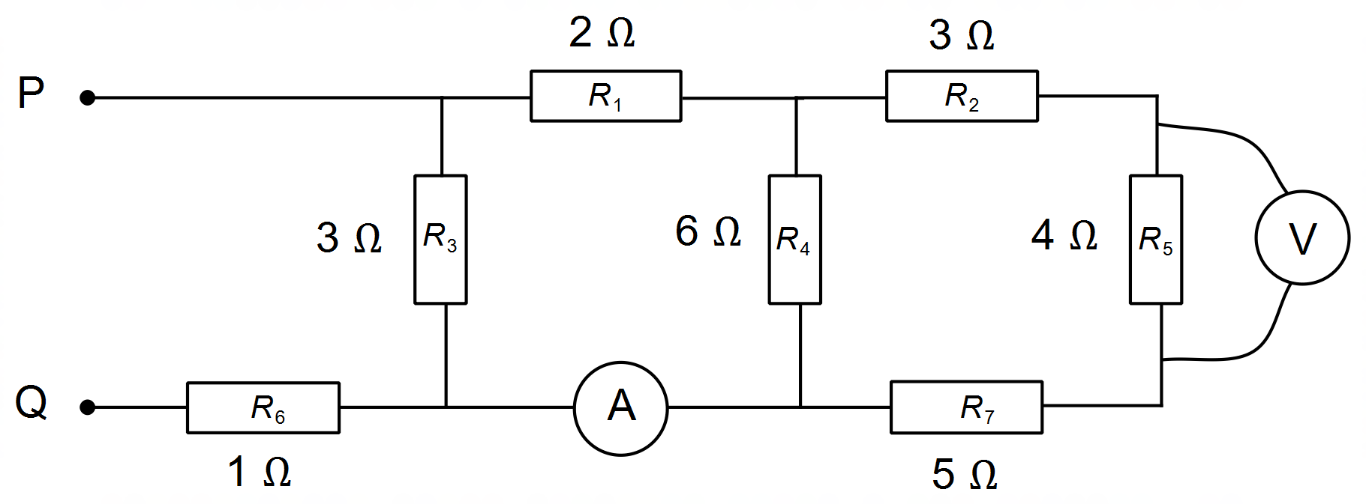

(a) Show that the total resistance between terminals P and Q is 3 Ω. (5 marks)

(b) If a voltage source of 9.0 volts is placed across the terminals P and Q:

i) Find the total current drawn by the circuit. (1 mark)

ii) Find the amount of charge drawn by the circuit in a time of 45 seconds. (2 marks)

iii) Show that the current measured at the ammeter is 1 A. (4 marks)

iv) Determine the voltage measured by the voltmeter. (5 marks)

**Question 13 (18 marks)**

A 900 MW fission reactor uses a Uranium-enriched fuel source containing Uranium–235. This fission reaction involves the absorption of Uranium–235 (235.04393 u) with a single neutron (1.00866 u) produces Strontium–94 (93.91536 u), Xenon–140 (139.92164 u), a number of neutrons and energy.

(a) Write a balanced nuclear equation for the neutron bombardment of Uranium–235 described above, clearly stating the number of neutrons produced. (3 marks)

(b) Explain why several neutrons are released and outline, using a relevant formula, the source of the energy released during this fission reaction. (3 marks)

(c) Calculate the amount of energy, in joules, produced by this nuclear reaction. (5 marks)

(d) Calculate the mass, in kilograms, of Uranium–235 fuel required to operate this nuclear reactor for one year. **Note**: if you did not calculate part (c) you may use a value of 3.0 × 10-11 J for the energy released per fission reaction of Uranium–235. (4 marks)

(e) A radiation limit for workers at the nuclear facility is set at 100 mSv per year. If an 82 kg worker at the nuclear reactor is accidentally exposed to 12 J of beta radiation from spent fuel rods, determine the Absorbed Dose, the Dose Equivalent and whether it is safe for the worker to continue working. (3 marks)

**Question 14 (21 marks)**

The rate at which heat is conducted through a material depends on several quantities relating to the physical environment and the shape and size of the material, as shown in the diagram below.

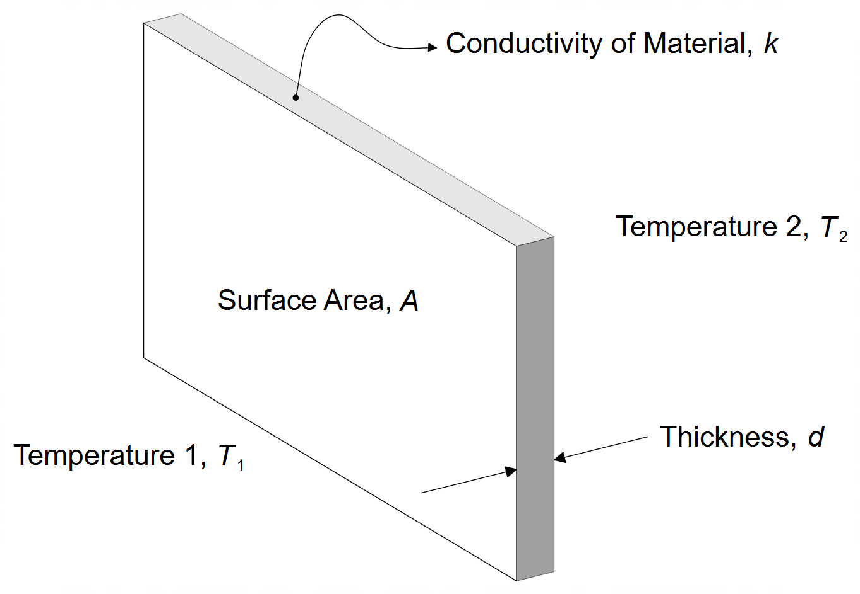

The rate at which heat is conducted through a material depends on temperature (K) on both sides of the material (*T*1 and *T*2), the surface area *A* (m2) exposed, the thickness of the material *d* (m) and the property of the material known as conductivity *k*.

The rate of heat transfer through the material is power *P* (units of J s-1) and is given by:



(a) Correctly determine the units of conductivity *k*. (1 mark)

(b) A single 1.2 m high by 2.3 m wide by 6 mm thick glass window separates a 28 °C exterior from the 18 °C interior office space. The window is letting heat in at a rate of 3.59 kW.

i) Determine the conductivity *k* of the glass window. (3 marks)

ii) Calculate the theoretical rise in temperature of the 215 kg of air within the office over a period of 15 minutes (the specific heat capacity of air is 1.10 ×103 J kg-1 K-1). (3 marks)

iii) Explain why the answer to part b) ii) is impossible. Use relevant physics concept to justify

your response. (2 marks)

(c) The owner of the office decides to replace the window with a double-glazed window in order to reduce heat transfer. The double-glazed window has identical dimensions to the single pane window (1.2 m by 2.3 m) but is 30 mm thick and consists of two panes of glass separated by a sealed section containing air.

In order to test this double-glazed window, the amount of energy conducted per second through the window and the difference in temperature across the window is recorded for eight trials, as shown below.

|  |  |  |  |  |  |  |  |  |
| --- | --- | --- | --- | --- | --- | --- | --- | --- |
| **Trial** | **1** | **2** | **3** | **4** | **5** | **6** | **7** | **8** |
| Temp Difference (K) | 2 | 3 | 6 | 9 | 12 | 14 | 17 | 19 |
| Energy Rate  (J s-1) | 24 | 30 | 72 | 100 | 125 | 155 | 192 | 212 |

i) Explain why the sealed section containing air reduces heat transfer. (1 mark)

ii) Use the data in the table above to construct a graph by plotting Energy Rate  on the vertical axis and Temp Difference on the horizontal axis. Include title, axes labels, units

and a line of best fit. (5 marks)

**(Question 14 continued)**



**(Question 14 continued)**

iii) Calculate the gradient of the line of best fit. Indicate construction lines on the graph. (3 marks)

iv) Use the value of the gradient of the line of best fit and information given in the question to determine a value for the conductivity *k* of the double-glazed window. **Note**: if you didn’t determine a value for the gradient, you may use a gradient of 11.0 J s-1 K-1. (3 marks)

**Question 15 (11 marks)**

A Light Emitting Diode (LED) is a semiconductor device that emits light when very small currents flow through it. LEDs only let current flow in one direction and are non-ohmic devices. The symbol for an LED is shown below:

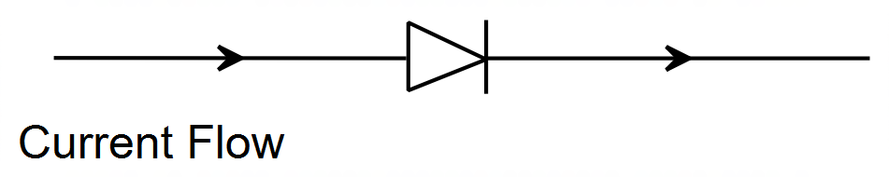

Since an LED requires only a very small current, an LED can be protected by placing the LED in series with a large resistor.

The circuit diagram below shows a simple LED circuit with a voltage source *Vs*, two red LEDs and a large resistor *R*.

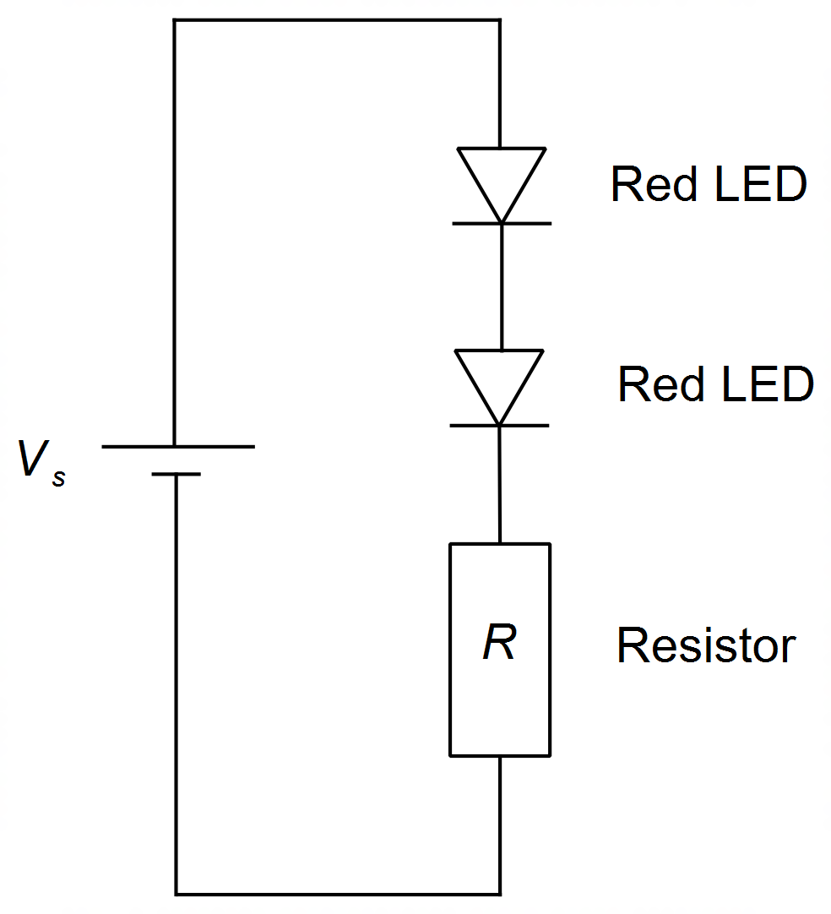

(a) Explain the term “non-ohmic”. (1 mark)

(b) Explain, using relevant physics equations, how “an LED can be protected by placing the LED in series with a large resistor.” (3 marks)

Katie is investigating the behaviour of LEDs and wants to predict how much current will flow through the LEDs and through the entire circuit but is unsure how to do so since LEDs are non-ohmic. Katie thinks that a graphical method might work. She predicts that perhaps plotting the characteristic *V*–*I* curve for each LED and a relationship between the total voltage and current will help her to be able to predict the total amount of current, by finding where these two lines intersect.

Katie uses a circuit as shown above with a resistor *R* set to 200 Ω and a voltage source of 9 V. Katie lets the voltage drop across each LED to be *VL* and the total current in the circuit to be .

(c) Show, by considering Kirchhoff’s voltage law around the circuit, that the voltage drop *VL* is given by the following expression: (3 marks)



(d) The graph below shows the *V–I* curve (solid line) for the red LEDs being used in this experiment. It also shows (dashed) the voltage drop *VL* versus total current *IT* relationship given in part (c). From this graph Katie concluded that the potential difference across each LED must be 2.55 V.

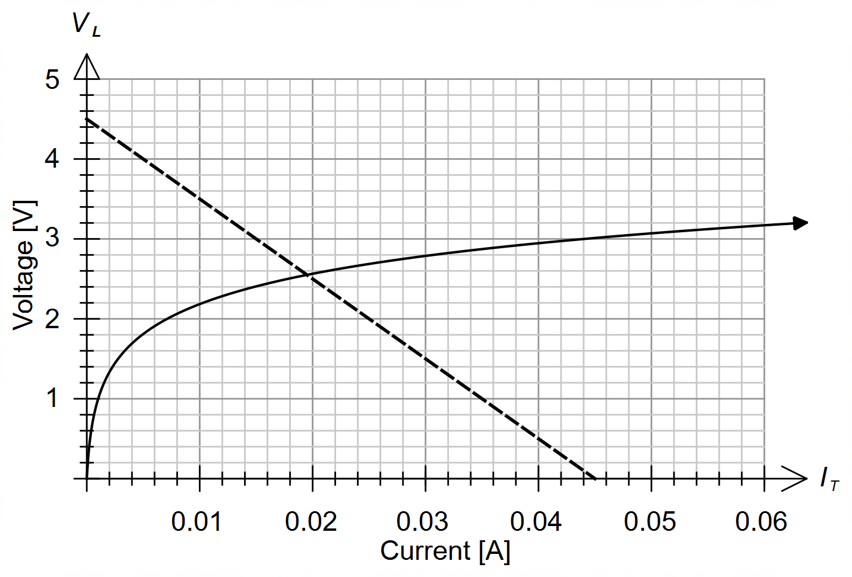

1. Using Katie’s prediction and the above graph, estimate the power consumed by this circuit. Give your answer to an appropriate number of significant figures. (3 marks)

1. Why is 2.55 V the only possible value for *VL* for this circuit? (1 mark)

**Question 16 (15 marks)**

A cook is preparing a pot of chicken noodle soup. The cook is using a gas stove whose flame produces heat at a rate of 2.8 kW and is 65% efficient (65% is useful) at heating objects on the stove.

The ingredients of the soup are:

5 L of water, at 17 °C (assume the density of water ρ = 1.00 kg L-1)

500 g chicken at 15 °C (specific heat capacity: 4.34 × 103 J kg-1 K-1)

650 g carrots at 15 °C (specific heat capacity: 3.92 × 103 J kg-1 K-1)

200 g of noodles at 15 °C (specific heat capacity: 1.60 × 103 J kg-1 K-1)

(a) The cook starts heating the water in a 1.0 kg steel pot with the lid on. If the steel pot has a specific heat capacity of 4.80 × 102 J kg-1 K-1, how long it will take for the water to boil? (4 marks)

(b) Use your knowledge of heating and cooling and the kinetic particle model to explain the benefits of boiling the water with the lid on the pot. (3 marks)

(c) The cook allows the water to boil for an extra 3 minutes, but without the lid. Determine how much water will evaporate. (3 marks)

(d) After boiling off for a bit longer, exactly 4.8 L of water is left in the pot and the pot is removed from the stove. The cook now adds all the ingredients (chicken, carrots and noodles). What is the equilibrium temperature of the hot water and pot after adding the ingredients? (5 marks)



**Question 17 (8 marks)**

An experimental technique in the field of radiography in treating aggressive brain tumours is that of Boron Neutron Capture Therapy. This technique uses the fact that when boron–10 is injected into the body of a patient it collects in the brain tumours.

The patient is then bombarded with neutrons which are strongly absorbed by the boron–10, becoming fissile boron–11 which produces lithium–7 and high-energy alpha particles which then kill the cancer cells. On average, each neutron has an energy of 0.65 eV.

(a) Write two nuclear equations describing the above two processes. (2 marks)

(b) Given that the amount of boron–10 (10.013 u) required to treat a 2.2 g brain tumour is 25 µg per gram of tumour, determine the absorbed dose administered on a 45 kg patient. (5 marks)

(c) Suggest a possible reason why an alpha source (the fission of boron–11) is used in this context rather than a beta source. (1 mark)

**END OF SECTION TWO**

**This page has been left blank intentionally**

**Questions continue on the next page**

**Section Three: Comprehension 20% (36 marks)**

This section has two questions. Answer **both** questions. Answer the questions in the spaces provided.

Suggested working time: 40 minutes.

**Question 18 (18 marks)**

**Simultaneous Photovoltaic Membrane Distillation (PV–MD)**

Typically, solar panels are quite inefficient, as they usually only capture about 15% of the solar energy incident on the panels. The remaining 85% of the solar energy is either reflected or absorbed as heat.

There have been recent attempts to harness some of the energy not used by the solar panel to produce another useful product – clean water. One such design mounts a solar panel on top of a distillation unit.

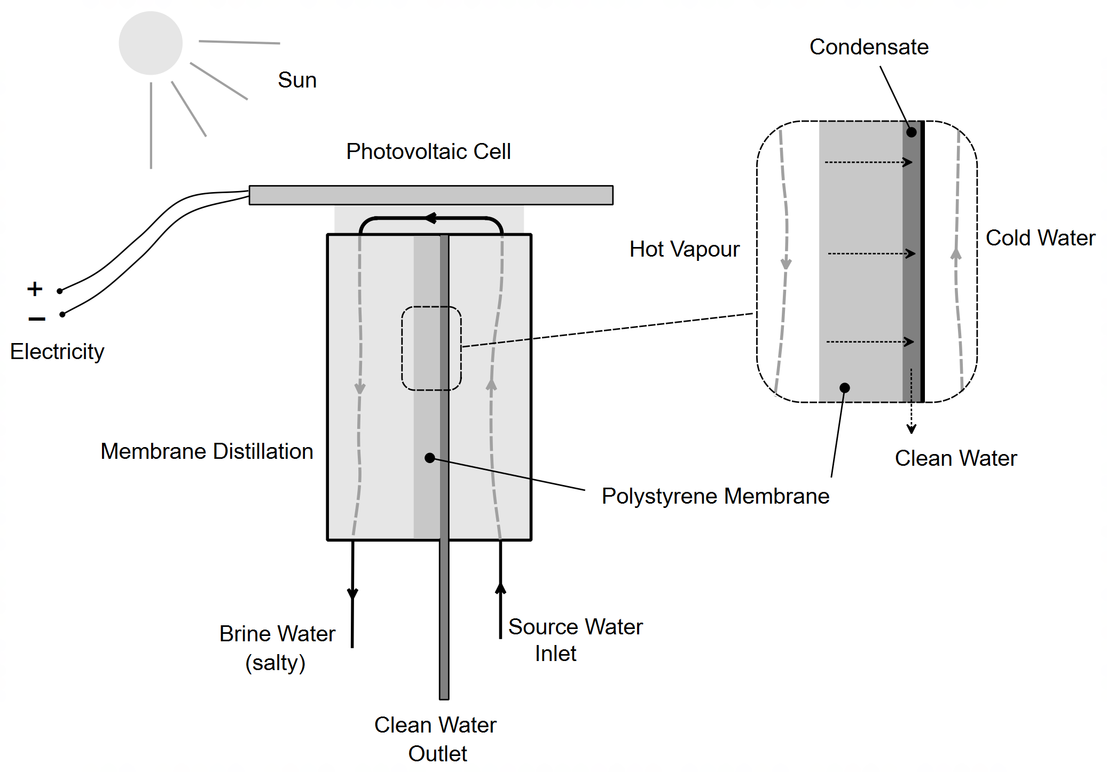

Figure 1 Schematic diagram for a typical PV-MD device

As shown in the schematic diagram of Figure 1, that whilst the solar panel produces electricity, heat from the sun heats up the PV-MD device, driving evaporation in the distillation unit below.

The water from a source (usually salty water) is pumped up into the unit, underneath the solar panel. As it absorbs heat from the solar panel, it vaporises, re-enters the distillation unit where it encounters a porous polystyrene membrane, which filters out salt and other contaminants. The water vapour eventually condenses and is collected and delivered to the clean water outlet.

The use of the thermal heat has no effect on the electricity produced by the solar cell. Not surprisingly, there is a push to install PV-MD devices in applications where both clean water and electricity is required.

Figure 2 below shows the energy flow of 100 J of solar energy incident on the PV-MD device. The solar panel is 15% efficient (converting 15 J out of every 100 J into electrical energy), 25 J is reflected as light, and of the remaining 60 J absorbed as heat, 36 J of heat is used to create clean drinking water with 24 J of heat lost to the surrounding environment.

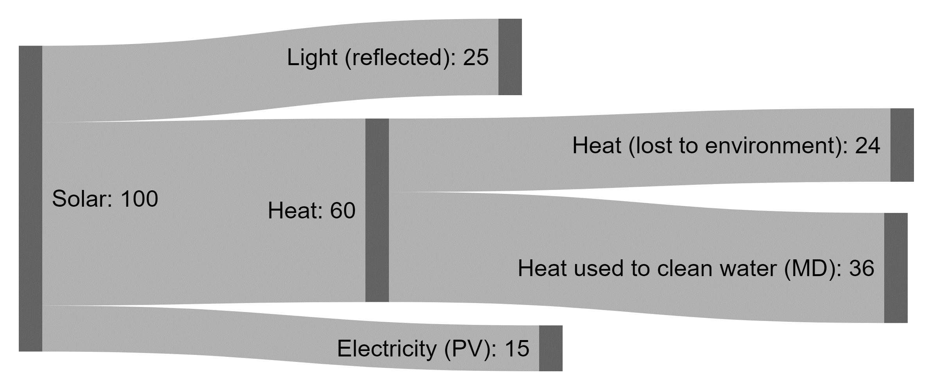

Figure 2 Energy flow diagram for 100 J of incoming solar energy

(a) State one energy transformation taking place in a typical PV–MD device. (1 mark)



(b) With reference to the design of a typical PV-MD device and the kinetic particle model, explain why the hot vapour condenses as it nears the clean water outlet. (3 marks)

(c) Using data from Figure 2, explain how a PV-MD device makes better use of solar energy than a conventional solar panel. As part of your explanation determine an overall efficiency of the PV-MD device described in Figure 2. (3 marks)

(d) The prototype used in the lab experiments consisted of a solar panel measuring 12 cm by 12 cm, placed under a lamp of intensity 1 kW m-2 (like that of the Sun) for one hour, during which time the solar panel produced 1296 C of charge. Given that the efficiency of the solar panel used is 15%:

i) determine the radiant energy incident on the solar panel in one hour. (3 marks)

ii) determine the electrical energy produced by the panel in one hour. (1 mark)

iii) determine the output current and voltage of the panel. (2 marks)

iv) making any assumptions as needed, show that the amount of clean water produced by the prototype is about 0.5 kg per hour per square meter. State your assumptions clearly.

**Note**: If you could not calculate a value for part (i) you may use a value of 5.0 × 104 J of solar energy incident on the solar panel in one hour. (5 marks)

**Question 19 (18 marks)**

**Modelling the Decay of Polonium–218**

When an isotope decays it often passes through multiple stages of decay and will produce daughter nuclei that are often radioactive and will themselves decay. As this process of decay continues, eventually the daughter nucleus is stable and will not decay any further. Depending on the stability of the intermediate nuclei, this process of decay, from beginning to end, can be extremely slow or very fast.

The sequence of radioisotopes produced when an isotope decays is called a decay chain or radioactive series and are often depicted graphically, listing the isotopes produced.

One such long decay series, is that of Uranium–238 which is shown below in Figure 3.

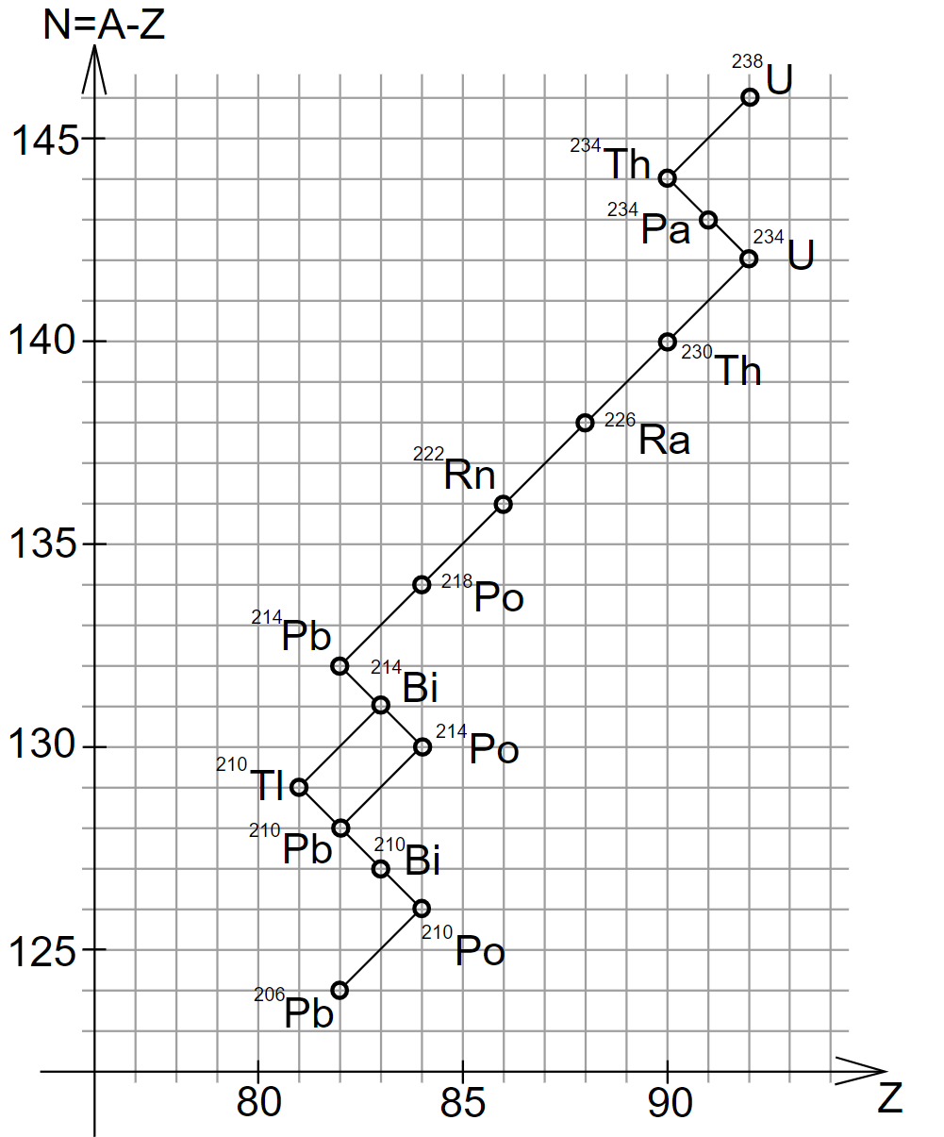

Figure 3 – Decay Series for Uranium-238

Part of the decay of Uranium–238 is that of the decay of Polonium–218. The radioactive decay series of Polonium–218 is as follows, where the mode of decay and half-lives of the relevant isotopes are indicated above the arrows:



The decay of Polonium-218 was mathematically simulated using the half-lives given, by assuming:

1. The simulation started with 1000 nuclei of Polonium-218
2. The simulation ran for 120 minutes
3. The decay series of Polonium-218 would eventually produce Lead-210 (half-life of 22 years)

Figure 4 shows a graph of how the amounts of each isotope of the decay of Polonium-218 varied over the 120-minute period.

Figure 4 – Abundance of Isotopes in the Decay Series of Polonium-218 (per 1000)

(a) Define the term “half-life”. (1 mark)

(b) What does the vertical axis represent in Figure 3 on the previous page? (1 mark)

(c) Compare the ratio of neutrons : protons for Uranium-238, Polonium-214 and Lead-206. Explain the significance of these ratios. (4 marks)

(d) In the Polonium-218 decay series, explain the basis for the assumption that most of the decayed isotopes will end up as Lead-210. (2 marks)

(e) With reference to Figure 4:

i) Why does the amount of isotope of Bismuth-214 initially increase but then, after about 40 minutes, begin to decrease? (2 marks)

ii) Explain clearly why the amount of Thallium-210 remains relatively low. (2 marks)

iii) Estimate the maximum percentage of Bismuth-214 that one would find in a sample of Polonium-218 undergoing decay? (1 mark)

(f) Another decay series is that of Thorium-232. Use the information in the table below to complete the graph of N versus Z below. Label each decay process as well as each isotope on the graph.

(5 marks)

|  |  |  |  |  |
| --- | --- | --- | --- | --- |
| Step | Decay |  | Step | Decay |
| 1 | Th-232 → Ra-228 |  | 7 | Po-216 → Pb-212 |
| 2 | Ra-228 → Ac-228 |  | 8 | Pb-212 → Bi-212 |
| 3 | Ac-228 → Th-228 |  | 9 | Bi-212 → Tl-208 |
| 4 | Th-228 → Ra-224 |  | 10 | Tl-208 → Po-212 |
| 5 | Ra-224 → Rn-220 |  | 11 | Po-212 → Pb-208 |
| 6 | Rn-220 → Po-216 |  | 12 | Pb-208 (stable) |

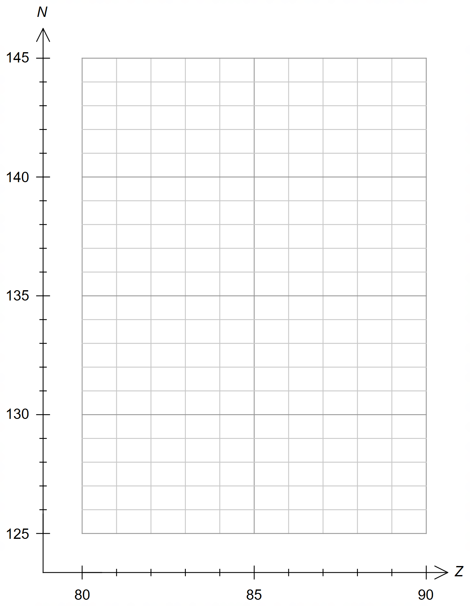

**END OF EXAMINATION**

**Extra Working Space**

**Extra Working Space**

**Extra Working Space**

**Spare Graph for Question 14**



**Spare graph for Question 19**



**Acknowledgements**

**Question 19** Picture used from Wikipedia Creative Commons, 2007, *File:Uranova rada.svg.* Retrieved July 25, 2019, from: https://commons.wikimedia.org/wiki/File:Uranova_rada.svg

**WATP acknowledges the permission of School Curriculum and Assessment Authority in**

**providing instructions to students.**