* Copyright for test papers and marking guides remains with *West Australian Test Papers*.
* The papers may only be reproduced within the purchasing school according to the advertised conditions of sale.
* Test papers must be withdrawn after use and stored securely in the school until 15th October.

**PHYSICS**

**UNITS 3 & 4**

**2020**

**Insert School Logo**

Name:

Teacher: ___________________________________________________

***TIME ALLOWED FOR THIS PAPER***

Reading time before commencing work: Ten minutes

Working time for the paper: Three hours

***MATERIALS REQUIRED/RECOMMENDED FOR THIS PAPER***

**To be provided by the supervisor:**

* This Question/Answer Booklet; Formula and Constants sheet

**To be provided by the candidate:**

* Standard items: pens, pencils, eraser or correction fluid, ruler, highlighter.
* Special items: Calculators satisfying the conditions set by the SCSA for this subject.

***IMPORTANT NOTE TO CANDIDATES***

No other items may be taken into the examination room. It is **your** responsibility to ensure that you do not have any unauthorised notes or other items of a non-personal nature in the examination room. If you have any unauthorised material with you, hand it to the supervisor **before** reading any further.

**Structure of this paper**

|  |  |  |  |  |  |
| --- | --- | --- | --- | --- | --- |
| Section | Number of questions available | Number of questions to be answered | Suggested working time  (minutes) | Marks available | Percentage of exam |
| Section One:  Short answer | 13 | 13 | 50 | 54 | 30 |
| Section Two:  Extended answer | 7 | 7 | 90 | 90 | 50 |
| Section Three:  Comprehension  and data analysis | 2 | 2 | 40 | 36 | 20 |
|  |  |  | **Total** | 180 | 100 |

**Instructions to candidates**

1. The rules for the conduct of Western Australian external examinations are detailed in the *Year 12 Information Handbook 2019.* Sitting this examination implies that you agree to abide by these rules.
2. Write your answers in this Question/Answer Booklet.
3. When calculating numerical answers, show your working or reasoning clearly. Give final answers to **three** significant figures and include appropriate units where applicable.

When estimating numerical answers, show your working or reasoning clearly. Give final answers to a maximum of **two** significant figures and include appropriate units where applicable.

1. You must be careful to confine your responses to the specific questions asked and follow any instructions that are specific to a particular question.
2. Spare pages are included at the end of this booklet. They can be used for planning your responses and/or as additional space if required to continue an answer.
   * Planning: If you use the spare pages for planning, indicate this clearly.
   * Continuing an answer: If you need to use the space to continue an answer, indicate in the original answer space where the answer is continued, i.e. give the page number. Refer to the question(s) where you are continuing your work.

**Section One: Short response 30% (54 Marks)**

This section has **thirteen** **(13)** questions. Answer **all** questions. Write your answers in the space

provided. Suggested working time for this section is 50 minutes.

**Question 1 (4 marks)**

Calculate both the maximum and minimum gravitational force that the Sun applies to Earth’s moon.

Maximum: ____________ N Minimum: _____________ N

**Question 2 (4 marks)**

Find the net force acting on the 3.00 µC in the diagram below. Include a direction.

3.00 µC

-4.00 µC

-5.00 µC

2.50 cm

2.00 cm

Net force: ___________________________

**Question 3 (4 marks)**

In relation to Young’s double slit experiment, state whether the following statements are **true** or **false**.

|  |  |
| --- | --- |
| Statement | True or False |
| The results of the double slit experiment using a beam of light supports evidence that light travels in discrete packets of energy, called photons. |  |
| The results of the double slit experiment using a beam of electrons supports evidence that matter behaves as a wave. |  |
| An electron beam directed at the slits must have a high enough density of electrons to cause an interference pattern. |  |
| Using a detector at one or more of the slits to confirm the presence of any electrons will remove the interference pattern. |  |

**Question 4 (5 marks)**

Explain how the detection of muons created in the upper atmosphere at ground level provides supporting evidence of time dilation as predicted by Einstein’s special theory of relativity.

**Question 5 (4 marks)**

Arrange the following list of matter in order of formation in the universe according to the Big Bang Theory.

* Baryons, Nuclei, Light elements, Stars, Quarks and leptons, Heavy elements

1. **_______________________ (formed first)**
2. **_______________________**
3. **_______________________**
4. **_______________________**
5. **_______________________**
6. **_______________________ (formed last)**

**Question 6 (4 marks)**

A cyclist on a banked curve is moving at a steady speed and following a horizontal circular path with a 12.0 m radius. The banked curve has an incline of 14.0°. Calculate the speed of the cyclist such that no frictional force is required to maintain the circular motion. Use a vector diagram to support your answer.

Velocity: ________________________m s-1

**Question 7 (5 marks)**

A plane’s wingtips can generate an EMF as the plane cuts flux lines of Earth’s magnetic field. The diagram below shows the plane flying at 140 km h-1 towards the top of the page while the component of Earth’s magnetic field directed out of the page is 45.0 µT. This generates a 7.88 mV potential across the plane’s wingtips.

1. Label, on the diagram of the plane, the polarity of the induced emf in the wings. (1 mark)
2. Calculate the length of the wings, from one tip to the other. (4 marks)

Length: ________________________m

**Question 8 (4 marks)**

The curve below shows the expectated spectrum of a black body using classical physics.

Relative intensity

Wavelength

On the same set of axis, draw **two (2)** new curves representing a black body spectrum using a quantum model of light – one at 1000 K and one at 5000 K. Label each curve.

**Question 9 (4 marks)**

Consider a proton accelerated to a speed of 2.89 × 108 m s-1. Calculate the magnitude of its kinetic energy.

Kinetic energy: ________________________J

**Question 10 (4 marks)**

Complete the table below concerning the forces within an atom as explained by the Standard Model.

|  |  |  |
| --- | --- | --- |
| Force within atom | Fundamental Force | Force-Carrying Gauge Boson |
| The repulsion of protons within a nucleus |  |  |
| The attraction of quarks in a nucleon |  |  |

**Question 11 (4 marks)**

A golfer hits a ball at a launch speed of 10.4 m s-1 and at a launch angle of 60.00 above the horizontal. The ball lands on a hill, 2.00 m higher than where it started. Calculate the time the ball spends in the air.

Time: ________________________s

**Question 12 (4 marks)**

An AC generator has an RMS output of 6.00 V. The generator’s coil of 35 windings rotates at 630 rpm inside a 2.00×10-2 T field. Calculate the cross-sectional area of the coils.

Area: ________________________m2

**Question 13 (4 marks)**

A simplified diagram of a DC motor’s coil within a magnetic field is shown below.

A

S

N

B

1. State the direction of the current required in wire A such that the force felt by wire A is directed down the page. (1 mark)

1. The motor uses a split ring commutator. Explain the function of this component. (3 marks)

**End of Section One**

**This page has been left blank intentionally**

**Section Two: Problem-solving 50% (90 Marks)**

This section has **seven (7)** questions. You must answer **all** questions. Write your answers in the

space provided. Suggested working time for this section is 90 minutes.

**Question 14 (14 marks)**

Jill is based on Earth while Henry flies past in a spaceship at 0.750 c. Henry has a particle accelerator, capable of firing electrons at 0.600 c as measured from the frame of the particle accelerator. He uses the particle accelerator to fire an electron from the front of his spaceship to the back, which he observes take 5.60 × 10-8 s.

1. Calculate the velocity of the electron as observed by Jill. Include a direction. (4 marks)

Velocity: ________________________m s-1 Direction: _________________________

1. Calculate the length of the spacecraft as measured by Jill on Earth. (3 marks)

Length: ________________________m

1. Which observer, Henry or Jill, will observe the shortest time for the electron to complete its journey to the back of the spacecraft. No calculation is required, but you must justify your choice referring to principles of special relativity. (3 marks)

1. Knowing that the proper time it takes for the electron to reach the back of the spacecraft is observed from the rest frame of the electron, calculate the time Jill observes for the electron to reach the back of the spacecraft. (4 marks)

Time: ________________________s

**Question 15 (14 marks)**

The emergency power supply of a hospital is shown below. Four diesel generators are connected in parallel which produces a combined voltage of 415 V and current of 80.0 A. The generators are attached to a step-up transformer which has a 1:60 turns ratio. The transformer transmits the electrical power through a 45.0 m transmission line to a second transformer, which steps down the voltage for use in the hospital. The transmission line has a resistance of 0.500 Ω m-1. A schematic of the power distribution system is given below.

Gen 1

Gen 2

Gen 3

Gen 4

Hospital

1:60

0.500 Ω m-1

415 V

80.0 A

Transformer

Transformer

1. Explain the advantage of using a step-up transformer before transmitting electrical power over any significant distance. (3 marks)

1. Calculate the output voltage of the step-up transformer. (2 marks)

Voltage: ________________________V

1. Assume the transformers are 95.0% efficient and the only significant losses come from the transformers and the transmission line.
   1. Calculate the power output from the step up transformer. (2 marks)

Power: ________________________W

* 1. The step down transformer receives 2.47×104 V. Calculate the power loss of the transmission line. (4 marks)

Power: ________________________W

1. State one feature of a transformer that is designed to maximise the efficiency of the transformer and describe how the feature achieves the increase of efficiency. (3 marks)

**Question 16 (10 marks)**

A particle consisting of four quarks and one anti-quark is called a pentaquark. Pentaquarks were theorised as early as 1964 and the first evidence of their existence obtained in 2003. However, it wasn’t until 2015 (and again in 2019) that enough data had been gathered to make a genuine claim that a particle had been discovered that matched the theoretical properties of a pentaquark.

1. Show, via a calculation, that a pentaquark has a baryon number of +1. (2 marks)
2. The equation below describes the formation of a pentaquark. A lambda baryon, $Λ_{b}^{0}$ ($bud$) decays via a $W^{-}$ boson, forming a kaon minus, $K^{-}$ ($s\overline{u}$) and the pentaquark, $P_{c}^{+}$ ($u\overline{c}cud$).
 $$Λ_{b}^{0}→ K^{-}+P_{c}^{+}$$

  1. State which fundamental force is responsible for mediating this decay. Justify your choice. (2 marks)

Force: _______________________

Justification:

* 1. Mesons are a compsite particle consisting of a quark and an antiquark. State the names of the fundamental particles of the meson in the decay reaction.

(2 marks)

* 1. Show that electric charge is conserved during this decay. (2 marks)
  2. Show that baryon number is conserved during this decay. (2 marks)

**Question 17 (14 marks)**

A conductor carrying a current of 10.0 A to the right is placed in a uniform 2.00 N C-1 electric field acting upwards (as shown in the diagram). Electrons enter the electric field at different distances from the conductor and travel parallel to the conductor at a speed of 8560 m s-1. A magnetic field is produced in the same region as the electric field by the current-carrying conductor. The electron at a perpendicular distance $r_{0}$ from the conductor (see the diagram) maintains a constant velocity while it is travelling through the two fields.

While completing this question, the effect that the charge on each electron has on other electrons can be ignored.

Electric Field

2.00 N C-1

Electrons

8560 m s-1

Conductor

10.0 A

1. State the direction of the magnetic field above the conductor. (1 mark)
2. Calculate the force on the electrons caused by the electric field. Include a direction.

(3 marks)

Force: ________________________N Direction: _______________________

1. The path followed by the electron at a distance $r_{0}$ from the conductor is shown as a dashed line. For the remaining two electrons in the diagram (above and below the electron at $r_{0}$), sketch the paths they would take as the entered the region occupied by both the electric field and the magnetic field. (2 marks)
2. Explain your choice for the electron path drawn for **one** of the electrons in part (c).

(4 marks)

1. Calculate the distance $r_{0}$. (4 marks)

$r_{0}$: ________________________ m

**Question 18 (13 marks)**

A man is moving a 35.0 kg bookshelf and is startled by a cat with a mass of 16.0 kg. The bookshelf becomes unbalanced and the man supports it as shown in the diagram below. The cat jumps on to the bottom end of the bookshelf and begins walking towards the top of it. The man always applies a force at right angles to the bookshelf to prevent it falling on to him.



500

1. The bookshelf is 2.40 m tall with a uniformly distributed mass. The man is pushing with a maximum force of 270 N at a distance of 0.600 m from the top end of the bookshelf. Calculate how far up from the bottom end of the bookshelf the cat can walk before the man is unable to support it. (4 marks)

Distance: ________________________ m

1. Calculate the magnitude of the reaction force the carpet applies to the bookshelf when the man must push with his full strength. (4 marks)

Force: ________________________ N

1. Describe how the direction of the reaction force the carpet applies to the bookshelf changes as the cat walks up the bookshelf. Explain your reasoning (no calculations required).

(5 marks)

**Question 19 (14 marks)**

A photoelectric effect experiment using copper as the target anode is shown in the diagram below.

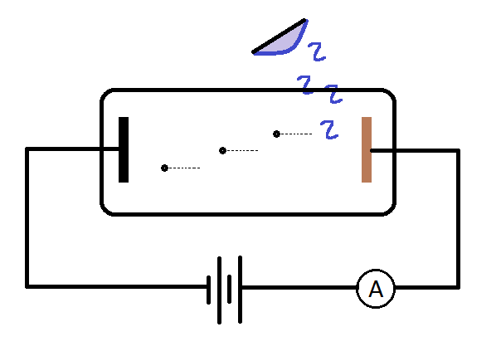

The required stopping voltage (V) to reduce the current reading in the ammeter to zero for a variety of light frequencies was recorded.

|  |  |  |
| --- | --- | --- |
| Frequency (×1015 Hz) | Stopping voltage (V) | Max Kinetic Energy of Photoelectrons (×10-19 J) |
| 1.0 ± 0.2 | - | - |
| 1.5 ± 0.2 | 1.10 | 1.76 |
| 1.9 ± 0.2 | 2.76 | 4.42 |
| 2.3 ± 0.2 | 4.42 | 7.07 |
| 2.9 ± 0.2 | 6.90 |  |

1. The lowest incident frequency used did not have a stopping potential measurement. Suggest a reason why. (2 marks)

1. Calculate the maximum kinetic energy of the photoelectrons produced from a 2.90 × 1015 Hz light source. Add this value to the table of results. (2 marks)
2. Draw a graph maximum kinetic energy ($E_{k}$) of the photoelectrons (in joules) vs frequency ($f$). Place $E_{k}$ on the vertical axis for which the scale is already provided. Add error bars for the frequency values. Include a line of best fit. (5 marks)

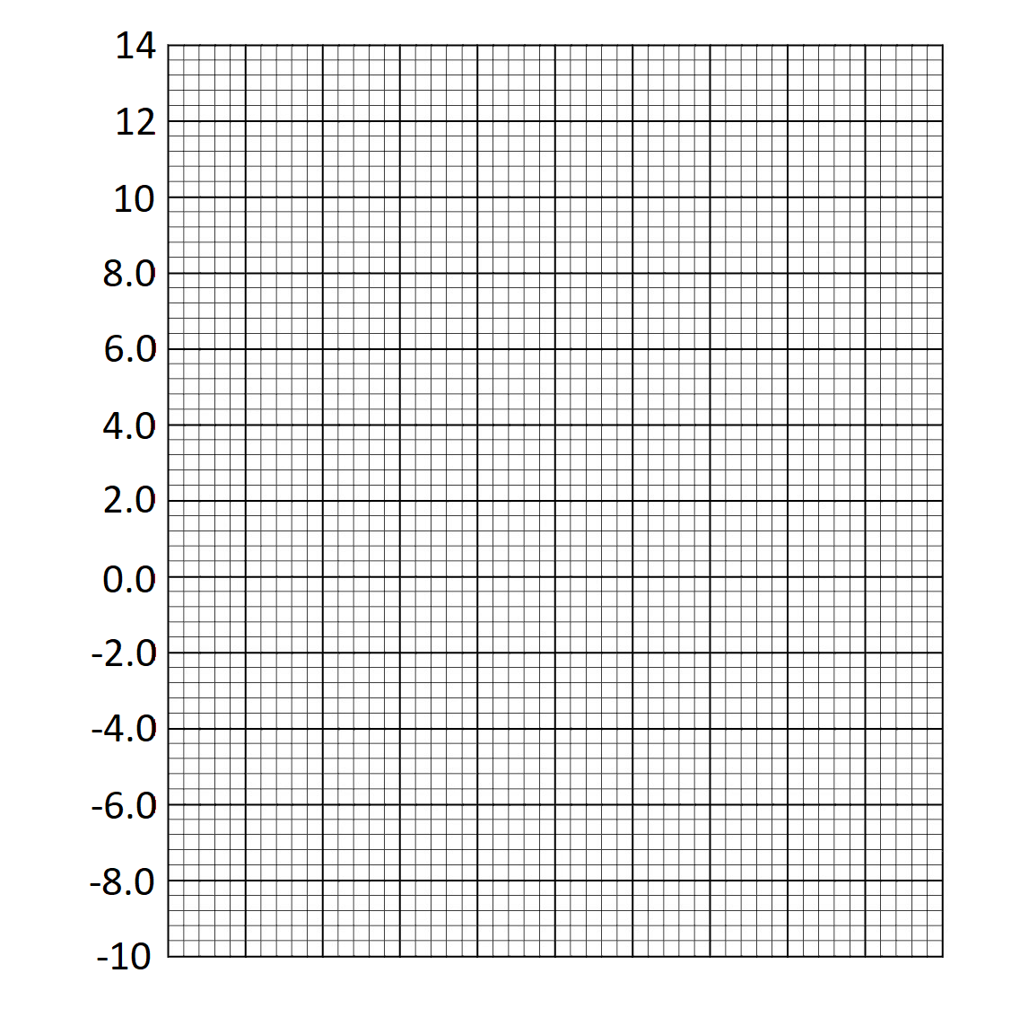

(× 10-19 J)

1. Using the graph, determine the work function ($W$) of copper. Justify your answer.

(2 marks)

Work Function: _______________________

Justification:

1. Calculate the gradient of the graph and use this value to determine Planck’s constant.

(3 marks)

Planck’s constant: ________________________ J s

**Question 20 (11 marks)**

The graph below is representative of the findings of Edwin Hubble, who researched cosmological concepts that led to the Big Bang Theory.

1. Describe the relationship that is observed within this graph. (2 marks)

1. The Steady State Theory preceded the Big Bang Theory. The Steady State Theory lost acceptance in the scientific community based on the work of Hubble. Explain how the relationship shown in the graph supports the Big Bang Theory and is in contradiction to the Steady State Theory. (3 marks)

1. Hubble’s law is described by the following equation:

$$v=H_{0}D$$

Where $v$ is the recessional velocity of a galaxy and $D$ the distance of a galaxy.

* 1. Use the graph to calculate a value for Hubble’s constant ($H_{0}$), which has units km s-1 Mpc-1. You must add construction lines to the graph to show how your answer was obtained. (3 marks)

: ________________________ km s-1 Mpc-1

* 1. At sufficiently large distances ($D$), the velocity of a galaxy ($v$) would be predicted to be larger than the speed of light. Comment on whether or not Hubble’s Law can be applied at these large distances. (3 marks)

**End of Section 2**

**This page has been left blank intentionally**

**Section Three: Comprehension 20% (36 Marks)**

This section contains **two (2)** questions. You must answer both questions. Write your answers in

the spaces provided. Suggested working time for this section is 40 minutes.

**Question 21 (18 marks)**

*X-Rays*

X-rays are used in medicine and dentistry as a diagnostic tool – to take images of suspected broken bones and checking teeth alignment. X-rays are electromagnetic waves that have a very short wavelength, varying from 1.00 pm to 10.0 nm. This allows them to penetrate through the body. As they do so, the body absorbs some of the X-rays, reducing the intensity of the X-ray beam. Denser material like bone absorbs more X-rays. This allows for an image to be taken which reveals some internal structures of the body based on differing densities – like bones and teeth against skin and muscle.

X-rays are produced for medical use by sending high-speed electrons to collide with a metal target. The setup of an X-ray tube is shown below.

High speed electron beam

High Potential Difference

Target anode

Heated cathode

X-ray

Vacuum chamber

A filament is heated to eject electrons. A very high potential difference is created between the filament (the cathode) and the target metal (the anode) – as much as 250 000 V. The electron beam hits the anode and the rapid deceleration of the electrons creates an X-ray. This process is quite inefficient, with only 1.00 % of the electron’s energy being converted into an X-ray on average. The remaining energy is lost as thermal heating of the anode – thus metals with high melting points are used. The amount of deceleration of the electrons has a broad distribution, thus the energies of the X-rays produced also has a broad distribution, with most X-rays forming at lower energies. This type of X-ray is called “bremsstrahlung”, which is German for “braking radiation”.

Another mechanism works simultaneously to produce X-rays in the X-ray tube. The high-speed electrons can knock out electrons from the inner energy levels of the atoms in the target anode. When an electron is removed from the n = 1 or n = 2 level, it leaves a space for a free electron to fill. As the free electron falls from the ionisation energy level to the inner energy level, it emits a high energy photon – an X-ray. The wavelengths of these X-rays are unique to the material that makes up the target anode and are thus are called “characteristic X-rays”. Compared to bremsstrahlung radiation, the wavelengths of characteristic X-rays are well defined, and so occur at a greater intensity at these wavelengths, forming peaks in the X-ray spectrum. An X-ray spectrum containing both bremsstrahlung and characteristic X-rays is shown below.

Y

X

1. Explain why the X-ray spectrum is continuous when X-rays are produced using an X-ray tube. (3 marks)

1. Of the two peaks, labelled X and Y in the spectrum in the article, which is caused by the removal of an n = 1 electron? Justify your choice. (3 marks)

1. Calculate the wavelength of the X-rays produced at the peak labelled X in the spectrum.

(4 marks)

Wavelength: ________________________ m

1. Suggest two (2) reasons why the X-ray tube needs to be a vacuum. (2 marks)

1. Using the classical formula for kinetic energy, calculate the speed of the electrons as they collide with the target anode. (3 marks)

Speed: ________________________ m s-1

1. With reference to your answer to part (e), explain whether this result is accurate. If you could not obtain an answer to part (e), you may assume the speed of the electrons is approximately 2.50 × 108 m s-1. (3 marks)

**Question 22 (18 marks)**

*Geosynchronous Orbit*

Satellite orbits around Earth are classified according to altitude. At one extreme is the low Earth orbit (LEO) which skims the upper atmosphere. The International Space Station orbits here, a measly 410 km above the Earth’s surface. This is so close to Earth that without constant corrections, the thin amount of atmosphere at this height would drag the station 2 km towards Earth in a month. Satellites in this orbit have very short viewing windows from a single location on the Earth but will often return to the same portion of sky quickly, particularly if the orbit is very equatorial. The advantage of this orbit is that electronic equipment is protected from harsh solar winds which are high speed charged particles ejected from the Sun.

At the other extreme of satellite orbits is the high Earth orbit (HEO). Out in HEO there is no protection against solar winds. The HEO sits above the medium Earth orbit (MEO). The boundary between the two occurs at the geosynchronous orbit (GSO). The GSO is the exact altitude at which a satellite’s orbital period matches the rotation of the Earth about its axis; these satellites take 24 hours to complete an orbit. Because GSO satellites take the exact same time to orbit as the Earth takes to rotate, it is possible they may maintain their position above the same patch of ground – they are in sync with the Earth. This is shown in the diagram below. After half an orbital period, the same land mass is below the satellite.

GSO are great to ensure that communication with the satellite is never interrupted. A ground station cannot communicate with a satellite that is in space above the far side of the planet – just as mobile phone reception does not work in an underground car park – too much solid matter blocks the signal. GSO is quite an altitude to reach though, as it is an order of magnitude higher than LEO, thus it takes significantly more energy (fuel) to reach this orbit. That said, it such a useful orbit that over 400 satellites currently reside here. When these satellites are decommissioned they are sent to a graveyard orbit that is even higher in HEO so as to keep the GSO clear for future use.

1. Suggest why satellites are protected from solar winds in LEO. (1 mark)

1. Explain why the International Space Station uses frequent thruster boosts. (5 marks)

1. Show, using suitable calculations, that the International Space Station would not be visible from a single location on Earth for very long. (4 marks)
2. Australia wants to launch a satellite that can constantly monitor cloud coverage of the Australian continent. Suggest an orbit to place the satellite in and justify your choice.

(2 marks)

1. State two (2) disadvantages of a HEO. (2 marks)

1. Calculate the altitude of the boundary between MEO and HEO. (4 marks)

Altitude: ________________________ m

**End of Questions**

**This page has been left blank intentionally**

**Additional working space**

**Spare grid for graph**



**End of examination**

**Acknowledgements**

**Question 16**

Feynmann diagram of pentaquark creation

CERN on behalf of the LHCb collaboration

<https://commons.wikimedia.org/wiki/File:Pentaquark-Feynman.svg>

CC BY 4.0

**Question 17**

[Cat](https://thepurplejournal.wordpress.com/2008/10/22/about-stray-cats-and-rewards/) Drawing by Unknown Author is licensed under [CC BY-NC-ND](https://creativecommons.org/licenses/by-nc-nd/3.0/)