Copyright for test papers and marking guides remains with *West Australian Test Papers*.

The papers may only be reproduced within the purchasing school according to the advertised conditions of sale.

Test papers must be withdrawn after use and stored securely in the school until June 12 2020.





**PSYCHOLOGY**

**ATAR YEAR 11**

**UNIT 1**

**2020**

**MARKING GUIDE**

**Section One: Research Methods 20% (31 marks)**

**Question 1 (8 marks)**

A university student decided to look at the association between exposure to the outdoors and mood. At the university campus, she surveyed students sitting outside and asked them to rate their level of mood as well as the length of time they had spent outside that day.

a) i. Identify the research method used. (1 mark)

|  |  |
| --- | --- |
| **Description** | **Marks** |
| Correlational research | 1 |
| **Total** | **1** |

ii. Outline **one** advantage of the research method stated in part (i). (1 mark)

|  |  |
| --- | --- |
| **Description** | **Marks** |
| Alternative hypotheses can be raised and tested using experimental research in the future.  *Any relevant advantage accepted for one mark* | 1 |
| **Total** | **1** |

iii. Outline **one** disadvantage of the research method stated in part (i). (1 mark)

|  |  |
| --- | --- |
| **Description** | **Marks** |
| No matter what correlation is found between the variables, it does not demonstrate causation  *Any relevant disadvantage accepted for one mark* | 1 |
| **Total** | **1** |

b) There are various methods that can be used to collect data within research, such as interviews.

Name the data collection method the university student used to obtain mood scores. (1 mark)

|  |  |
| --- | --- |
| **Description** | **Marks** |
| Likert scale/rating scale | 1 |
| **Total** | **1** |

c) Identify the type of graph that would best represent data collected by the university student. (1 mark)

|  |  |
| --- | --- |
| **Description** | **Marks** |
| Scatterplot/scattergram/scattergraph | 1 |
| **Total** | **1** |

d) State whether the research was experimental or non-experimental and include **one** reason for

your response. (2 marks)

|  |  |
| --- | --- |
| **Description** | **Marks** |
| Non-experimental research | 1 |
| **Any one of the below**  • Independent variable cannot be manipulated.  • A cause-and-effect relationship cannot be found.  • Participants are not randomly allocated. | 1 |
| **Total** | **2** |

**Question 1** (continued)

e) Research tends to involve potential sources of error in data that can arise from the experimenter

or the participants. Identify **one** source of error in data present in the university student’s

research. (1 mark)

|  |  |
| --- | --- |
| **Description** | **Marks** |
| **Any one of the below**  • Participants were not randomly selected.  • Experimenter effects.  • Participants adjusting their responses due to predictions regarding the research.  *Any relevant error in data accepted for one mark* | 1 |
| **Total** | **1** |

**Question 2 (13 marks)**

Men’s Health Magazine conducted an online questionnaire advertised in their April 2020 issue to assess the percentage of Australian men who exercise for at least one hour per week. Results from 785 men in Australia found that 50 percent of men aged between 24-30 years exercised for at least one hour per week, 45 percent of men aged 31-37 exercised for a minimum of one hour per week, 28 percent of men aged 38-44 exercised for at least one hour per week, and 20 percent of men aged 45-51 exercised for at least one hour per week.

a) i. Graph the results from the above information into the grid below. (5 marks)

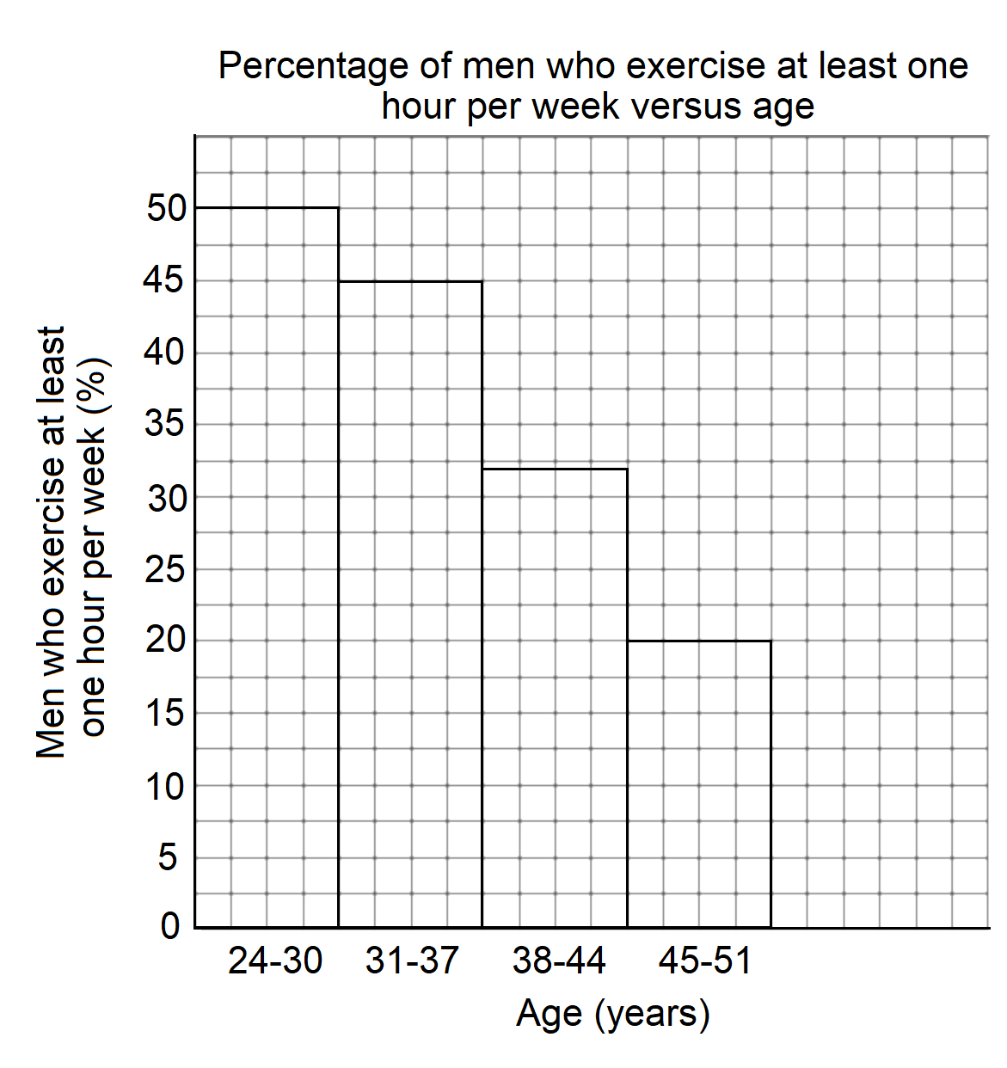

|  |  |
| --- | --- |
| **Description** | **Marks** |
| Histogram is drawn | 1 |
| Title includes both variables | 1 |
| X and Y-axis have correct headings with appropriate units of measurement | 1 |
| Both axis have appropriate scales | 1 |
| Bars are drawn to correct heights | 1 |
| **Total** | **5** |

**Question 2** (continued)

ii. Justify your choice of graph drawn in part (i). (1 mark)

|  |  |
| --- | --- |
| **Description** | **Marks** |
| Class intervals were provided/continuous data was provided | 1 |
| **Total** | **1** |

b) Identify the population used in this research. (1 mark)

|  |  |
| --- | --- |
| **Description** | **Marks** |
| Men | 1 |
| **Total** | **1** |

c) Explain the problem with the participant selection method used in this research. (3 marks)

|  |  |
| --- | --- |
| **Description** | **Marks** |
| Participants were only those who read Men’s Health Magazine therefore  only a particular group of participants were involved.  The sample is not representative of the population of Australian men. | 1  1  1 |
| **Total** | **3** |

d) Identify **one** participant right followed in the research and explain how it was followed. (2 marks)

|  |  |
| --- | --- |
| **Description** | **Marks** |
| Voluntary participation | 1 |
| Participants chose to complete the online questionnaire of their own accord  *Any relevant participant right and explanation accepted for three marks* | 1 |
| **Total** | **2** |

e) The online questionnaire was found to have high validity. Explain what this statement means.

(1 mark)

|  |  |
| --- | --- |
| **Description** | **Marks** |
| The online questionnaire measured what it was designed to measure | 1 |
| **Total** | **1** |

**Question 3 (9 marks)**

The State Library of WA has nearly 5,000 microfilm reels (documents scanned on rolls of film) stored on the 3rd floor. Dr Collard is interested in visiting the library in order to access journals, shipboard diaries and letters from ships during 1788-1988 for his university research.

a) i. Name the type of research Dr Collard will be making use of. (1 mark)

|  |  |
| --- | --- |
| **Description** | **Marks** |
| Archival research | 1 |
| **Total** | **1** |

ii. Outline **two** benefits of the type of research named in part (i). (2 marks)

|  |  |
| --- | --- |
| **Description** | **Marks** |
| • It is usually cheaper than collecting new data.  • It provides access to very large/representative samples.  • It allows the examination of data gathered over a long time period without taking  the researcher’s lifetime.  *Any relevant benefit accepted for one mark* | 1-2 |
| **Total** | **2** |

iii. Outline **two** limitations of the type of research named in part (i). (2 marks)

|  |  |
| --- | --- |
| **Description** | **Marks** |
| • Knowledge/skill is required to analyse complex/large data sets.  • Time is needed to identify appropriate data sets.  • Permission is required to access the data.  • It takes effort to understand the factors involved with the data.  *Any relevant limitation accepted for one mark* | 1 |
| **Total** | **1** |

b) Contrast between population data and sample data. (2 marks)

|  |  |
| --- | --- |
| **Description** | **Marks** |
| Population data is data collection from a whole population chosen by the researcher whereas sample data is data collected from the sample being studied. | 1  1 |
| **Total** | **2** |

c) Outline **one** disadvantage of using the mode as a measure of central tendency. (1 mark)

|  |  |
| --- | --- |
| **Description (any one of the following)** | **Marks** |
| • A set of data may have more than one mode.  • A set of data may not have a mode if each value is different.  *Any relevant disadvantage accepted for one mark* | 1 |
| **Total** | **1** |

d) Outline **one** advantage of using the mean as a measure of central tendency. (1 mark)

|  |  |
| --- | --- |
| **Description (any one of the following)** | **Marks** |
| • It takes into account all the values from the raw data set.  *Any relevant advantage accepted for one mark* | 1 |
| **Total** | **1** |

**End of Section One**

**Section Two: Short Answer 55% (94 marks)**

**Question 4 (16 marks)**

a) Describe the location and outline **one** major function of each part of the brain. (6 marks)

|  |  |  |
| --- | --- | --- |
|  | Describe location | Outline **one** major function |
| Midbrain | Sits on top of the hindbrain (1) | Receives messages from the senses (except smell) and sends them to the forebrain (1) |
| Forebrain | The top portion of the brain (1) | Responsible for higher order processes/controls how we think, feel and behave (1) |
| Hindbrain | At the base of the brain (1) | Coordinates information entering and leaving the spinal cord/responsible for coordination/responsible for balance (1) |

b) Name each neural structure labelled on the diagram below.

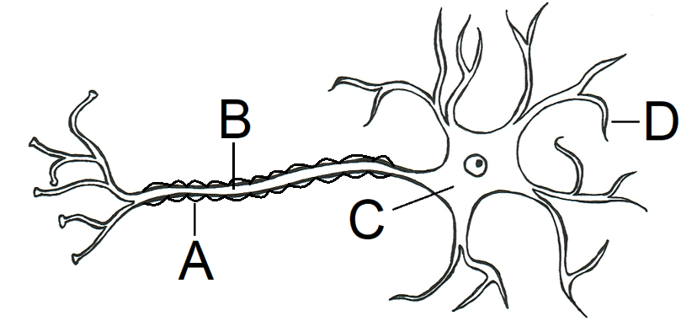

i. A (1 mark)

|  |  |
| --- | --- |
| **Description** | **Marks** |
| Myelin sheath | 1 |
| **Total** | **1** |

ii. B (1 mark)

|  |  |
| --- | --- |
| **Description** | **Marks** |
| Axon | 1 |
| **Total** | **1** |

iii. C (1 mark)

|  |  |
| --- | --- |
| **Description** | **Marks** |
| Cell body | 1 |
| **Total** | **1** |

**Question 4** (continued)

iv. D (1 mark)

|  |  |
| --- | --- |
| **Description** | **Marks** |
| Dendrite | 1 |
| **Total** | **1** |

d) Name **two** brain scanning techniques that provide pictures of the physical structures of the

brain. (2 marks)

|  |  |
| --- | --- |
| **Description** | **Marks** |
| CT/CAT scan/computed tomography scan | 1 |
| MRI scan/magnetic resonance imaging | 1 |
| **Total** | **2** |

e) i. One particular brain scanning technique shows where neurons are using energy via the

process of metabolism. Name the scanning method referred to. (1 mark)

|  |  |
| --- | --- |
| **Description** | **Marks** |
| PET scan/positron emission tomography | 1 |
| **Total** | **1** |

ii. Identify the substance that the neurons are using up through the process of metabolism. (1 mark)

|  |  |
| --- | --- |
| **Description** | **Marks** |
| Glucose | 1 |
| **Total** | **1** |

f) Name the brain scanning technique used to see brain functioning while the patient is required to

perform cognitive tasks. (1 mark)

|  |  |
| --- | --- |
| **Description** | **Marks** |
| fMRI scan/functional magnetic resonance imaging OR PET scan/positron emission tomography | 1 |
| **Total** | **1** |

g) “Only a limited number of scans can be performed on a patient due to radiation dosage

regulations” is a limitation of which brain scanning technique? (1 mark)

|  |  |
| --- | --- |
| **Description** | **Marks** |
| PET scan/positron emission tomography | 1 |
| **Total** | **1** |

**Question 5 (12 marks)**

a) State **two** reasons why people take recreational drugs. (2 marks)

|  |  |
| --- | --- |
| **Description (any two of the following)** | **Marks** |
| • To get a ‘high’.  • To alter their consciousness.  • To have fun.  • To reduce psychological distress.  • To help enhance identity.  • To feel accepted.  • To reduce a sense of alienation.  • To relax.  • As a mechanism for coping with pressure.  *Any relevant reason accepted for one mark* | 1-2 |
| **Total** | **2** |

b) Paramedics at a music festival were presented with a number of adolescents throughout the

night.

i. A young male was brought to the medical tent showing signs of hyperawareness and a high

breathing rate. Identify the class of drug he has likely taken and an example of **one** specific

drug from this group of drugs. (2 marks)

Class of drug:

|  |  |
| --- | --- |
| **Description** | **Marks** |
| Class of drug: stimulants | 1 |
| **Total** | **1** |

**One** specific drug:

|  |  |
| --- | --- |
| **Description** | **Marks** |
| Specific drug: amphetamines  Other possible stimulant drugs acceptable for one mark: caffeine, crystal methamphetamine/ice/crystal meth, cocaine, nicotine, cannabis. | 1 |
| **Total** | **1** |

ii. An 18-year-old female came stumbling into the medical tent with poor coordination and

exclaiming loudly that she had lost her friends in the crowd. Identify the class of drug she

has likely taken and an example of **one** specific drug from this group of drugs. (2 marks)

Class of drug:

|  |  |
| --- | --- |
| **Description** | **Marks** |
| Class of drug: depressants | 1 |
| **Total** | **1** |

**One** specific drug:

|  |  |
| --- | --- |
| **Description** | **Marks** |
| Specific drug: alcohol, cannabis/marijuana  Other possible depressant drugs acceptable for one mark: benzodiazepine, ketamine. | 1 |
| **Total** | **1** |

**Question 5** (continued)

c) i. Identify **two** psychological effects that cannabis can have on the body. (2 marks)

|  |  |
| --- | --- |
| **Description (any one of the following)** | **Marks** |
| • Reduces stress/anxiety.  • Increases confidence/lowers inhibitions.  • Increased feelings of excitement.  • Increased alertness.  • Altered perceptions.  *Any relevant effect accepted for one mark* | 1-2 |
| **Total** | **2** |

ii. Identify **two** physiological effects that cannabis can have on the body. (2 marks)

|  |  |
| --- | --- |
| **Description (any one of the following)** | **Marks** |
| • Reduces activity in the central nervous system.  • Decreased heart rate.  • Slower breathing rate.  • Reduced coordination.  • Increased appetite.  *Any relevant effect accepted for one mark* | 1-2 |
| **Total** | **2** |

d) Explain why a GP would tend to suggest regular exercise to a patient with depression before

prescribing them with anti-depressants. (2 marks)

|  |  |
| --- | --- |
| **Description (any one of the following)** | **Marks** |
| Exercise can improve mood/reduce low mood.  By increasing the production of mood boosting neurotransmitters/serotonin/endorphins.  *Note: dopamine can regulate mood but is not a mood boosting neurotransmitter*  *Any relevant effect accepted for one mark* | 1-2 |
| **Total** | **2** |

**Question 6 (15 marks)**

a) i. State whether or not the following statement is **true** or **false**: “all individuals presented with

an identical stimulus will process it in the same way”.

(1 mark)

|  |  |
| --- | --- |
| **Description** | **Marks** |
| False | 1 |
| **Total** | **1** |

ii. What is the term given to the process by which the body initially detects and converts

stimulus energy? (1 mark)

|  |  |
| --- | --- |
| **Description** | **Marks** |
| Sensation | 1 |
| **Total** | **1** |

iii. Explain why sensation and perception feels to us like a single event, but is in fact two related

but separate events. (2 marks)

|  |  |
| --- | --- |
| **Description** | **Marks** |
| Sensation and perception occur very quickly after each other causing the two  processes to seem to blend into one continuous process | 1  1 |
| **Total** | **2** |

b) i. The Müller-Lyer illusion (shown below) is considered to be a visual illusion. Define the term

‘visual illusion’. (1 mark)

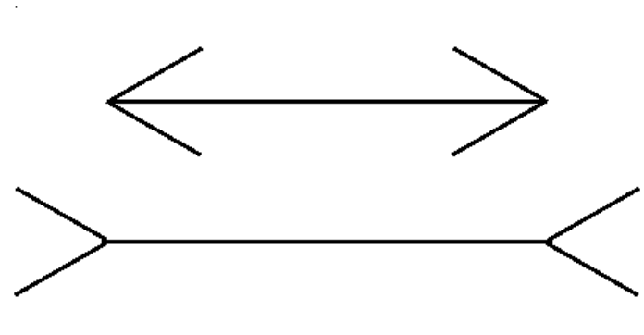

|  |  |
| --- | --- |
| **Description** | **Marks** |
| A visually perceived image that differs from reality. | 1 |
| **Total** | **1** |

ii. List **two** features of a stimulus that are consistently misjudged in visual illusions. (2 marks)

|  |  |
| --- | --- |
| **Description (any two of the following)** | **Marks** |
| • Position.  • Curvature.  • Motion.  • Size.  • Direction.  • Length.  • Colour. | 1-2 |
| **Total** | **2** |

**Question 6** (continued)

iii. Name the feature of the stimulus being consistently misjudged in the Müller-Lyer illusion.

(1 mark)

|  |  |
| --- | --- |
| **Description** | **Marks** |
| Length. | 1 |
| **Total** | **1** |

c) It is important not to assume an individual is experiencing an altered state of consciousness

based on physiological measures alone. Explain why this is the case. (2 marks)

|  |  |
| --- | --- |
| **Description** | **Marks** |
| Changes in physiological responses may not be due to an individuals’ state of consciousness  But instead may be due to a range of other reasons | 1  1 |
| **Total** | **2** |

d) Lucas works from home and living under a flight path, has become accustomed to the sound of

air planes flying low overhead to the point that he no longer notices the noise. The airport

changed flight paths due to tarmac maintenance and for a few days no planes flew over Lucas’

house. Once the maintenance was completed and the planes started flying over Lucas’ house

again, Lucas noticed the noise and it even frustrated him for the first few hours. Identify the

psychological term for this form of learning and define the term. (2 marks)

|  |  |
| --- | --- |
| **Description** | **Marks** |
| Dishabituation | 1 |
| A form of learning whereby a person has a renewed interest in a stimulus after a period of habituation.  *Any relevant definition of dishabituation accepted for one mark* | 1 |
| **Total** | **2** |

e) Leonard High School does not allow students to listen to music while doing their classwork due

to a large body of published research into the effectiveness of multi-tasking. Using psychological

terminology, explain why the school does not allow students to listen to music while they are

doing class work. (3 marks)

|  |  |
| --- | --- |
| **Description** | **Marks** |
| Listening to music at the same time as doing classwork involves divided attention.  This means that only part attention will be given to both tasks  rather than full attention given to the school work. | 1  1  1 |
| **Total** | **3** |

**Question 7 (19 marks)**

a) Individuals with hearing impairments are unable to hear the sounds of language. State **two**

methods that these individuals can use to help overcome the impact of their hearing

impairments. (2 marks)

|  |  |
| --- | --- |
| **Description (any two of the following)** | **Marks** |
| • Auslan/sign language.  • Key Word Sign/Makaton.  • Cochlear hearing implant.  • Hearing aid.  *Any relevant method accepted for one mark* | 1-2 |
| **Total** | **2** |

b) List **three** elements of body language. (3 marks)

|  |  |
| --- | --- |
| **Description (any three of the following)** | **Marks** |
| • Body posture.  • Facial expressions.  • Hand gestures.  • Eye movement.  • Touch.  • Use of space.  *Any relevant element accepted for one mark* | 1-3 |
| **Total** | **3** |

c) A secondary school principal has an enrolment interview with a year 11 student wanting to

attend the college. Identify **two** elements of body language and explain how the principal should

utilise them in order to make the student feel respected, welcome and at ease during the

interview.

(6 marks)

|  |  |
| --- | --- |
| **Description (any two of the following)** | **Marks** |
| **One** mark for identifying the element of body language, **one** mark for outlining how the body language should be utilised, **one** mark for explaining how the body language will create a welcoming environment.  • Body posture (1). The principal can sit up straight in his chair (1). This  demonstrates the principal is showing respect to the student and is paying  attention to what the student has to say (1).  • Facial expressions (1). The principal can smile at the student (1). This shows  that the principal is genuinely happy to be speaking with the student (1).  • Hand gestures (1). The principal can have his hands open on his lap (1). This  demonstrates that he is open to discussion and is not hostile (1).  • Eye movement (1). The principal can make eye contact with the student (1).  This shows that he is paying attention to what the student is saying to him (1).  • Use of space (1). The principal can sit across from the student without a desk  between them (1). This removes some space and the feeling of the principal  having authority or being intimidating (1).  *Any relevant element and explanation accepted for three marks* | 1-6 |
| **Total** | **6** |

**Question 7** (continued)

d) Contrast between effective listening and active listening. (2 marks)

|  |  |
| --- | --- |
| **Description** | **Marks** |
| Effective listening occurs when the listener tries to understand what the speaker is saying as clearly as possible whereas;  active listening involves the listener trying to empathise with the speaker/understand what the speaker is feeling. | 1  1 |
| **Total** | **2** |

e) Ayat is annoyed that during almost every psychology lesson at school, a male student in the

class, Isaac, asks to borrow a pen from her as he tends to forget to bring one to school. Identify

the **three** main steps of assertive communication and describe how Ayat can follow each step

during an interaction with Isaac. (6 marks)

|  |  |
| --- | --- |
| **Description** | **Marks** |
| Step 1: say something that shows you are trying to understand the position of the other person.  Relate to scenario: Ayat could let Isaac know that she understands that he rushes to get to school and in doing so usually forgets his pencil case.  Step 2: state the problem and how it causes you dissatisfaction.  Relate to scenario: Ayat could tell Isaac that she finds it frustrating when she is organized for school but then is constantly having to give a pen to him.  Step 3: make a specific statement about what you want to change.  Relate to scenario: Ayat could say ‘I would like you to bring your own pen to school’.  *Any relevant scenario examples accepted for one mark* | 1  1  1  1  1  1 |
| **Total** | **6** |

**Question 8 (16 marks)**

a) Define the term ‘intelligence test’. (1 mark)

|  |  |
| --- | --- |
| **Description** | **Marks** |
| A series of tasks created to assess the ability to learn, adapt to new situations and think abstractly.  *Any relevant definition accepted for one mark* | 1 |
| **Total** | **1** |

b) Simon and Binet were commissioned by the French government in 1904 to create a test for

children. Explain the purpose of this test. (2 marks)

|  |  |
| --- | --- |
| **Description** | **Marks** |
| To establish which children had low intelligence  so that they could be sent to a school that could cater for their needs/to find which children would not manage in ordinary schools. | 1  1 |
| **Total** | **2** |

c) The test created by Simon and Binet consisted of a number of items which were scored on a

pass or fail basis. Identify the number of items included in the scale. (1 mark)

|  |  |
| --- | --- |
| **Description** | **Marks** |
| 30 | 1 |
| **Total** | **1** |

d) According to Simon and Binet’s intelligence test, if a child who sat the test was able to answer

the majority of questions that other children of the same age could answer, what could be said of

the intelligence of the child? (1 mark)

|  |  |
| --- | --- |
| **Description** | **Marks** |
| The child has normal intelligence | 1 |
| **Total** | **1** |

e) Outline **two** changes that Terman, an American psychologist at Stanford University, made to

Simon and Binet’s original intelligence test. (2 marks)

|  |  |
| --- | --- |
| **Description** | **Marks** |
| • Translated the test from French into English.  • Revised the test so it was suitable for ages 2 to 85+ rather than just for children.  *Any relevant change accepted for one mark* | 1  1 |
| **Total** | **2** |

f) Both the Stanford-Binet Intelligence Scale (created by Simon, Binet then revised by Terman)

and Wechsler’s Intelligence scales separate subtests or factors into two main categories. These

two categories allow for those with limitations in reading to not be disadvantaged. Name these

**two** categories. (2 marks)

|  |  |
| --- | --- |
| **Description** | **Marks** |
| Verbal/verbal-based questions | 1 |
| Non-verbal/non-verbal based questions | 1 |
| **Total** | **2** |

**Question 8** (continued)

g) Modern tests use deviation IQs. The formula is IQ = MA/CA x 100

i. Identify what the abbreviation ‘IQ’ stands for. (1 mark)

|  |  |
| --- | --- |
| **Description** | **Marks** |
| Intelligence quotient | 1 |
| **Total** | **1** |

ii. Identify what the abbreviation ‘MA’ stands for. (1 mark)

|  |  |
| --- | --- |
| **Description** | **Marks** |
| Mental age | 1 |
| **Total** | **1** |

iii. Identify what the abbreviation ‘CA’ stands for. (1 mark)

|  |  |
| --- | --- |
| **Description** | **Marks** |
| Chronological age | 1 |
| **Total** | **1** |

h) There are advantages and disadvantages of both group and individual intelligence testing.

i. Explain how the examiner needing to have rapport or a positive relationship with the test taker

can be an advantage as well as a disadvantage in individual intelligence testing. (2 marks)

|  |  |
| --- | --- |
| **Description** | **Marks** |
| Advantage: building a positive relationship allows the test-taker to feel at ease.  Disadvantage: building a positive relationship takes time to establish. | 1  1 |
| **Total** | **2** |

ii. Outline **two** advantages of group intelligence testing. (2 marks)

|  |  |
| --- | --- |
| **Description** | **Marks** |
| • Test conditions are the same for all test-takers in the group.  • It is less expensive to run compared to individual intelligence testing.  • Test-takers can complete the test without interacting with the examiner.  • The instructions are simpler to follow than instructions for individual intelligence  testing.  *Any relevant advantage accepted for one mark* | 1-2 |
| **Total** | **2** |

**Question 9 (16 marks)**

a) After two days of torrential rain, a state of emergency was declared in Vienna after flooding

occurred. During such disasters, examples of both anti-social and pro-social behaviour occur.

i. Referring specifically to floods, describe **two** examples of anti-social behaviour that may

be evident. (2 marks)

|  |  |
| --- | --- |
| **Description (any two of the following)** | **Marks** |
| • People looting shops and businesses.  • People stealing donations collected for victims of the flood.  • People claiming benefits/insurance payouts that they are not entitled to.  *Any relevant example accepted for one mark* | 1-2 |
| **Total** | **2** |

ii. Referring specifically to floods, describe **two** examples of pro-social behaviour that may

occur. (2 marks)

|  |  |
| --- | --- |
| **Description (any two of the following)** | **Marks** |
| • People donating to charities/helping to fundraise for victims of the floods.  • People volunteering for organisations that help victims of the floods.  • People acting as volunteers for disaster relief.  *Any relevant example accepted for one mark* | 1-2 |
| **Total** | **2** |

b) People can be motivated to help others due to feeling egoistic (selfish) or empathetic. Compare

these two motivations to help others. (3 marks)

|  |  |
| --- | --- |
| **Description (any two of the following)** | **Marks** |
| Similarity: both are types of pro-social behaviour.  Difference: egoistic helping occurs when there is an ulterior motive to benefit through their actions  whereas empathetic helping is motivated by the ability to feel what the person they are helping is feeling. | 1  1  1 |
| **Total** | **3** |

c) An Australian sociologist studied the interactions that occurred between a particular category of

people. His research found that these particular people formed different groups based on

developmental stages.

i. Name the researcher described above. (1 mark)

|  |  |
| --- | --- |
| **Description** | **Marks** |
| Dexter Dunphy/ Dunphy | 1 |
| **Total** | **1** |

ii. Name the group of people he based his research on. (1 mark)

|  |  |
| --- | --- |
| **Description** | **Marks** |
| Adolescents/teenagers | 1 |
| **Total** | **1** |

**Question 9** (continued)

iii. Identify the method of research he carried out. (1 mark)

|  |  |
| --- | --- |
| **Description** | **Marks** |
| Observational research | 1 |
| **Total** | **1** |

d) Andrea and Michael grew up in the same street, went to the same primary school and then to

the same high school. They started dating in year 10 and a few years after graduating high

school got married. Using your psychological knowledge of the determinants of liking, name and

explain the factor that most likely explains the attractiveness felt between Andrea and Michael.

(2 marks)

|  |  |
| --- | --- |
| **Description** | **Marks** |
| Proximity | 1 |
| Andrea and Michael experienced physical closeness throughout their lives/were physically close together during their childhood and adolescence | 1 |
| **Total** | **2** |

e) For each of the statements below, decide whether it is describing a dyad, clique, crowd or none

of the above.

i. Andrea and Michael from question (9d). (1 mark)

|  |  |
| --- | --- |
| **Description** | **Marks** |
| Dyad | 1 |
| **Total** | **1** |

ii. All the people waiting at the Perth train station for the 8am train. (1 mark)

|  |  |
| --- | --- |
| **Description** | **Marks** |
| None of the above | 1 |
| **Total** | **1** |

iii. Year 12 students attending the ball after party. (1 mark)

|  |  |
| --- | --- |
| **Description** | **Marks** |
| Crowd | 1 |
| **Total** | **1** |

iv. Four primary school students who sit together every recess and lunch time. (1 mark)

|  |  |
| --- | --- |
| **Description** | **Marks** |
| Clique | 1 |
| **Total** | **1** |

**End of Section Two**

**Section Three: Extended Answer 25% (54 marks)**

**Question 10 (27 marks)**

Dr Edwards saw two patients last week. Tanya presented with a brain injury and after speaking with her friends and family, Dr Edwards found that she was moodier and more aggressive than before her accident. She determined that damage occurred to one pair of her lobes. Later in the week Dr Edwards had an appointment with Robert who had severe epilepsy and was scheduled for split-brain surgery (cutting the corpus callosum) a few days later. Dr Edwards flashed a picture of a cat to Robert’s left visual field. Following Robert’s surgery, Dr Edwards again flashed a picture of a cat to Robert’s left visual field.

Discuss brain functioning by referencing the damage to Tanya’s brain as well as the effects of Robert’s surgery.

In your answer you should:

• Identify the pair of lobes Tanya has most likely damaged, describe where they are located in the

brain and explain your response.

• Define the term ‘hemispheric specialisation’.

• Identify which hemisphere Robert would register the image in prior to his surgery and discuss the

best way for Robert to demonstrate what he sees after surgery and explain why.

• List **two** functions of the left hemisphere and **two** functions of the right hemisphere.

• Refer to psychological evidence and understandings.

|  |  |
| --- | --- |
| **Guide to marking extended answers** | **Marks** |
| **Tanya** | **6** |
| Lobes likely damaged: frontal lobes. Location of lobes: front of the brain. Function of frontal lobes: responsible for expressing personality. Relate to Tanya: Tanya is more aggressive than she was before her injury. Function of frontal lobes: responsible for regulating or expressing emotions. Relate to Tanya: Tanya is moodier than she was before her injury. | 1 1 1 1 1 1 |
| **Robert** | **8** |
| Description of corpus callosum: thick band of nerve fibres that connect the two hemispheres and allows information to pass between them.  Consequence of cutting corpus callosum: information can no longer pass between the two hemispheres.  *Before split-brain surgery* Information would register in Robert’s right hemisphere.  *After split-brain surgery* Robert could select/point/draw a cat with his left hand. Explanation: the information is initially registered in the right hemisphere and the right hemisphere is responsible for voluntary movement of the left side of the body. Robert will not be able to say ‘cat’ as the right hemisphere is non-verbal. | 1 1  1  1  1 1 1 1 |
| **Definition of hemispheric specialisation** | **2** |
| The idea that each hemisphere of the brain is dominant in the control of particular brain functions. | 1 1 |
| **Left hemisphere functions (any two of the following)** | **2** |
| • Controls voluntary movement of the right side of the body. • Responsible for verbal tasks. • Responsible for mathematic processes. • Responsible for reasoning/logical thought. *Any relevant function accepted for one mark* | 1-2 |
| **Right hemisphere functions (any two of the following)** | **2** |
| • Controls voluntary movement of the left side of the body. • Responsible for non-verbal tasks (writing). • Responsible for spatial awareness. • Responsible for the appreciation of art. *Any relevant function accepted for one mark* | 1-2 |
| **Use of psychological evidence** | **4** |
| **Two** or more statements are supported with a description of relevant evidence using **three** or more sentences. | 4 |
| **Two** or more statements are provided with a brief description of relevant evidence using less than **three** sentences. | 3 |
| **One** or **two** statements are supported with reference to relevant evidence. | 1-2 |
| **Examples of psychological evidence** | |
| • Phineas Gage was working on a railway when a metal rod when through his left frontal lobe. Before the accident he was patient, calm and kind. After the accident he was irritable, aggressive and had trouble problem solving. This case study showed that the frontal lobes are responsible for the expression of personality. • Research into how the brain functions was looked at by Roger Sperry who was cutting the corpus callosum in animals. With this he found that each hemisphere was specialised and were dominant in specific functions. He found that the hemispheres need to be connected in order for full brain functioning. | |
| **Quality of extended response** | **3** |
| Well-developed sentences and paragraphs **and** consistent use of appropriate psychological language **and** correct spelling, grammar and punctuation. | 3 |
| Coherent response with adequate spelling, grammar, sentence structure and paragraph structure. | 2 |
| Single paragraph response or lack of paragraph structure **and/or** poor sentence structure **and/or** very colloquial language and/or poor English expression **and/or** many spelling errors. | 0-1 |
| **Total** | **27** |

**Question 11 (27 marks)**

Matt was bored in class when he began looking out of the window, imagining how he would travel Europe next year. A few minutes later, his teacher asks him to pay attention and write an extended response on techniques used to measure consciousness. The task requires him to describe **two** techniques used to measure consciousness including the equipment/device used, an explanation of how the measurement works, an outline of how each technique indicates the state of consciousness someone is in and **one** limitation of each technique.

Write a response Matt could submit to his teacher. Begin his response by identifying the main category of consciousness Matt was in while looking out of the window, as well as the original state of consciousness he experienced.

In your answer you should:

• Define the term consciousness.

• Explain why it is difficult to determine whether an individual is in an altered state of consciousness

or not.

• Identify the category and specific state of consciousness Matt experienced when looking out of the

window.

• Discus **two** techniques used to measure consciousness; the device used and how it works.

• State **two** examples of altered states of consciousness that occur naturally and **two** examples of

altered states of consciousness that can be induced.

• Refer to psychological evidence and understandings.

|  |  |
| --- | --- |
| **Guide to marking extended answers** | **Marks** |
| **Definition of consciousness** | **1** |
| One’s awareness of internal and external events at any given moment in time | 1 |
| **Why consciousness is difficult to determine** | **1** |
| Consciousness is a hypothetical construct as it is difficult to directly observe or measure. | 1 |
| **Consciousness Matt is experiencing** | **2** |
| Category of consciousness: altered state of consciousness. Specific state of consciousness: daydreaming. | 1 1 |
| **Techniques used to measure consciousness (any two of the following)** | **12** |
| Technique: heart rate Equipment/machine used: ECG/electrocardiograph How measurement works: ECG electrodes are placed on skin around heart, electrical activity is detected, amplified and recorded on a screen or paper. How it indicates state of consciousness: heart rate in normal range = individual experiencing normal waking consciousness. Heart rate slightly faster or slower than normal range = individual may be experiencing altered state of consciousness. Limitation: change may occur due to exercise, not the state of consciousness. *Any relevant limitation accepted for one mark*  Technique: body temperature Equipment/machine used: thermometer How measurement works: a thermometer is placed under the tongue or armpit to measure temperature. How it indicates state of consciousness: 37°C = normal waking consciousness, around 36°C = individual may be experiencing altered state of consciousness, around 33°C = individual may be experiencing complete lack of consciousness. Limitation: there is only a small change in body temperature therefore it is easily misinterpreted. *Any relevant limitation accepted for one mark*  Technique: galvanic skin response Equipment/machine used: galvanic skin response How measurement works: electrodes are placed on the palm of the hand and pick up electrical conductivity of the skin. How it indicates state of consciousness: low GSR = individual may be experiencing altered state of consciousness, high GSR = normal waking consciousness. Limitation: change may be due to exercise or heat, not state of consciousness. *Any relevant limitation accepted for one mark*  Technique: electrical activity of the brain Equipment/machine used: EEG/electroencephalograph How measurement works: EEG cap with electrodes is placed on scalp and electrical activity/brain waves are shown on a computer screen. How it indicates state of consciousness: high frequency = normal waking consciousness, low frequency = individual may be experiencing altered state of consciousness. Limitation: can be difficult to differentiate between stages of consciousness. *Any relevant limitation accepted for one mark* | 1 1 1  1-2  1  1 1 1  1-2  1  1 1 1  1-2  1  1 1 1  1-2  1 |
| **Naturally occurring altered state of consciousness (any two of the following)** | **2** |
| • Sleep. • Daydreaming. • • Coma. | 1-2 |
| **Induced altered state of consciousness (any two of the following)** | **2** |
| • Hypnosis. • Anaesthetised. • Alcohol-induced state. • Meditation. • • Coma (medically induced). | 1-2 |
| **Use of psychological evidence** | **4** |
| **Two** or more statements are supported with a description of relevant evidence using **three** or more sentences. | 4 |
| **Two** or more statements are provided with a brief description of relevant evidence using less than **three** sentences. | 3 |
| **One** or **two** statements are supported with reference to relevant evidence. | 1-2 |
| **Examples of psychological evidence** | |
| • States of consciousness viewed as a continuum: states of consciousness can be displayed as a continuum from total awareness at the top and complete lack of awareness at the bottom. Matt is daydreaming which is close to the top of the continuum just before meditative state. • Consciousness is personal: consciousness is subjective and unique to each individual because it links to past experiences, thoughts, sensations and the environment. Matt’s consciousness differs from the consciousness of everyone else. • A study by Zeidan, Gordan, Merchant and Goolkasian found that mindful meditation training reduced pain sensitivity in participants who were exposed to painful electrical stimulation. Such research suggests meditation has an analgesic effect because participants use selective attention to focus on breathing and are able to ignore, to an extent, the stimulus of pain. | |
| **Quality of extended response** | **3** |
| Well-developed sentences and paragraphs **and** consistent use of appropriate psychological language **and** correct spelling, grammar and punctuation. | 3 |
| Coherent response with adequate spelling, grammar, sentence structure and paragraph structure. | 2 |
| Single paragraph response or lack of paragraph structure **and/or** poor sentence structure **and/or** very colloquial language and/or poor English expression **and/or** many spelling errors. | 0-1 |
| **Total** | **27** |