VCE Physics
Solutions to the 2017 Sample Paper
Suggested Marking Scheme in italics. (Updated March 2017)
Consequentials are indicated as “Conseq on 1”

These suggested solutions have been prepared by Vicphysics Teachers' Network. Their purpose is to assist teachers and students when using this exam paper as a revision exercise.

Every effort has been made to check the solutions for errors and typos.

Section A
1 C Like charges repel, so the electric field lines move away from each other, also the field lines originate on a positive charge and end on a negative charge, so C.
2 C Diagram X is only possible with a magnetic field with a current coming out of the page, so C. Y could be either a gravitational field or an electric field around a negative point charge, while Z can only be an electric field around a positive point charge.
3 C Using F = GMm/r², F = 6.67 x 10⁻¹¹ x 100 x 1.0 /(0.10 x 0.10) = 6.67 x 10⁻⁷ N
4 A Applying the right hand grip rule to the left hand wire with the current going up the page and in front of the solenoid, the direction of the magnetic field in the middle of the solenoid will be to the left.
5 B Using F = kQq/r², F = 9.0 x 10⁹ x 1.0 x 10⁻⁸ x 1.0 x 10⁻⁹ / (0.30 x 0.30) = 1.0 x 10⁻⁶ N
6 A A is correct, B applies to both independent and dependent variables, C applies to a controlled variable and D is another way of describing a controlled variable.
7 D A is wrong, see answer A in Q’n 6, B is wrong see answer C in Q’n 6, C is wrong both dependent and independent variables can be considered equally important, D is correct
8 A A is correct, B is wrong, see answer D in Q’n 7, C is wrong, see answer C in Q’n 7, D is wrong, it is the opposite of what is the case.
9 A The difference of the maximum value from the average as well as the difference of the minimum value is 0.03. Similarly half the difference between the two extreme readings is 0.03.
10 D A beam of electrons passing through the gap will produce a pattern that distributes the electrons to the left and the right of the narrow slit, producing a diffraction pattern. This left and right movement of electrons is along the x –axis.
11 B The work done is the area under the graph to a compression of 0.10 m. Area = 0.5 x 8000 x 0.10 = 400 J
12 B A is wrong, different meaning to the word ‘proper, B is correct, C is wrong, as this could occur in different frames producing different answers, D is wrong, an inertial frame can move at a constant speed to the rest frame and will produce a different answer.
13 A A is correct.
14 D An approaching ambulance will be heard at a higher frequency, which means a shorter wavelength. A is incorrect, the speed is unchanged, B, C are wrong about the wavelength, D is correct.
15 B The pattern is a standing wave. As the string is being plucked, the waves produced are transverse. Standing waves are produced when the waves reflected off each end meet in between travelling in opposite directions, so B. Longitudinal standing waves are produced in wind instruments.
16 D The figure shows the extreme positions, so the point S is now about to move downwards, back through the mean position to the other extreme. The point S moves through a smaller amplitude than the point to its right, while the point to its left does not move at all, it is at a node.

17 B Polarisation is a property of transverse waves only, such as light. D is wrong. Note circular wave refers to waves such as ripples that originate from a point source, which is not relevant to polarisation. Note also that light as a transverse wave can also be circularly polarised, but this is beyond the course.
18 D A: Light from an incandescent source is not coherent, but does have a wide spectrum, B: Light from an LED is neither coherent or have a wide spectrum, C: Synchrotron light can be coherent under some circumstances in modern machines and can have a wide spectrum, D is correct.
19 C A is wrong, this applies to incandescent sources, B is wrong, ‘ground state’ refers to the energy status of the atom as a system, not to individual electrons, D is wrong, right terms, but wrong way, C is correct.
20 C Using E = hc/λ , E = 4.14 x 10⁻¹⁵ x 3 x 10⁸ / (414 x 10⁻⁹) = 3.0 eV

Section B
1a 3.7 m s⁻² g = GM/r², so g = 6.67 x 10⁻¹¹ x 6.4 x 10²³ / (3.4 x 10⁶)² (1) = 3.69 = 3.7 m s⁻² (1)
1b 7.40 J Using the value from 1a, the gravitational potential energy U_{g}, of the probe at 10 m = mgh = 0.20 x 3.69 x 10 = 7.385 = 7.4 J . Note: An earlier version of this exam paper had a mass of 20 kg. The graph of U_{g}, against height will be linear and pass through the origin. As the probe falls to the surface the loss of U_{g}, the kinetic energy, E_{k} will increase. It's graph will fall from 7.40 J at a height = zero, to zero joules at 10 m. Conseq on 1a
(1 mark for each line, 1 mark for correct endpoint of 7.4 J)
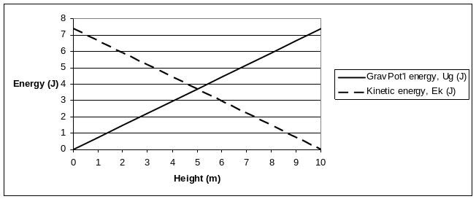

2a 1.0 x 10⁵ V m⁻¹ Using E = V/d, E = 10,000 / 0.10 (1) = 1.0 x 10⁵ V m⁻¹ (1)
2b 5.9 x 10⁷ m s⁻¹ Using Gain in E_{k} = Vq and E_{k} = ½ mv², v = √ (2Vq/m), (1)
so v = √ (2 x 10,000 x 1.6 x 10⁻¹⁹ / (9.1 x 10⁻³¹) = 5.9 x 10⁷ m s⁻¹ (1)
2c r = 1.7 cm Using r = mv/Bq with value of v from 2b ,
r = 9.1 x 10⁻³¹ x v / (0.020 x 1.6 x 10⁻¹⁹) (1), r = 1.686 x 10⁻² m, r = 1.7 cm (1)
Conseq on 2b
2d In Fig 2a, the strength of the electric field is constant and acts downwards on an electron. For an electron injected into the field from the left the path will be parabolic exactly the same as a stone thrown from the top of a cliff. (1) In fig 2b, the strength of the magnetic field is constant, but it always acts in a direction at right angles to the velocity of the electron. This means that the acceleration of the electron is constant and always directed inwards, so its path is circular, like the moon’s. (1)
3a Zero As the current is parallel to the magnetic field, (1) the magnitude of the magnetic force is zero. (1)
3b The commutator i) reverses the current, (1) ii) twice every cycle, (1) iii) when the coil is at right angles to the field. (1)
4a 8.0 V Average induced EMF = nΔΦ/Δt. The frequency is 10 Hz, so a quarter period = ¼ x 1/10 = 1/40 sec., and the change in flux = 0.50 x 0.020 (1),
so the induced emf = 20 x 0.50 x 0.020 / (1/40) (1) = 8.0 V (1)
4b The AC voltage is a sine wave (1), but as the rotation slows down, the period of the voltage will increase (1) and because of the equation in 4a, the peak voltage will also decrease. (1) Draw at least three cycles of a weakening and lengthening sine wave.
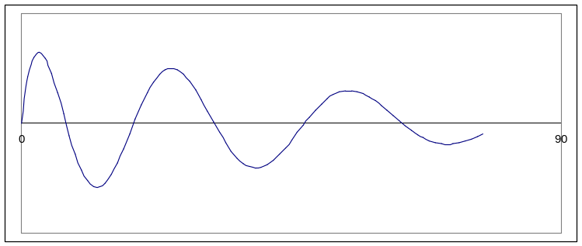
5a 21 V From the scale, the peak voltage is 30 V and the period is 80 ms. So the RMS voltage = 30 / √2 (1) = 21 V (1)
5b 12 Hz Frequency = 1/T = 1/(80 x 10⁻³) = 12.5 Hz, rounded to 12 Hz, using the rule of rounding to the nearest even number. (1)
6a 5 x 10¹ cm s⁻¹ Using v=fλ, v = 5 x 10 = 50 cm s⁻¹, 5 x 10¹ cm s⁻¹. (1) The frequency is expressed to one sig fig.
6b 31 cm P is on the second nodal line, so the path diff = 1.5λ (1) which 1.5 x 10 = 15 cm, the distance from P to Y must be 15 + 16.0 = 31 cm. (1)
6c Increasing the frequency means a shorter wavelength, the amount of spreading is proportional to the wavelength (1), so there will be less spreading. (1)
7a 1.7 Using Snell’s law, 1.00 x sin 45⁰ = n_{g} x sin 25⁰, n_{g} = 1.673 = 1.7 (1)
7b 49⁰ Using Snell’s law, 1.33 x sin θ_{c} = 1.00 x sin 90, θ_{c} = 48.75⁰ = 49⁰ (1)
7c The light is reflected back into the water(1) . Correct angle (1)

8 Radio waves, microwaves, infra-red, visible, ultra-violet, X-rays (2)
9 See list Possible transitions: 12.8 – 12.1 = 0.7 eV, 12.8 – 10.2 = 2.6 eV, 12.8 – 0 = 12.8 eV, 12.1 – 10.2 = 1.9 eV, 12.1 – 0 = 12.1 eV, 10.2 – 0 = 10.2 eV (2)
10a 9000 W Power loss = I²R (1) = 15 x 15 x 40 (1) = 9000 W (1)
10b 49400 V Voltage drop = IR = 15 x 40 (1)= 600 V (1), Input voltage at transformer = 50,000 – 600 = 49400 V (1)
10c Transformers only operate with AC voltage (1). They allow the voltage to be stepped up to high values with minimal loss of power and at the same time the output current is reduced by a similar ratio. This reduced current in the transmission lines means that the power loss is much reduced as the power loss is proportional to the current squared (1). Consequently the voltage at the end of the T'n lines is much closer to the output voltage from the step up transformer (1). At the end of the T'n lines the voltage is stepped back down to the domestic supply voltage.
11a 3.0 m s⁻¹ By the conservation of momentum, 6.0 x 2 + 2.0 x 0 = 6.0 x 1.0 x 2.0 x v (1),
v = 3.0 m s⁻¹ (1)
11b Elastic E_{k} before =1/2 x 6.0 x 2 x 2 = 12 J, E_{k} after = ½ x 6.0 x 1.0 + ½ x 2.0 x 3.0 x 3.0
E_{k} after = 12 J (1). The E_{k} are the same so the collision is elastic. (1)
Conseq on 11a
11c Pat is correct (1). The temporary loss of E_{k} is stored in the elastic spring potential energy. (1)
12a An upward arrow from the point L (1)

12b 80.2 N Using Reaction force, F_{R} – mg = mv²/r (1),
so F_{R} = 5.00 x 9.8 + 5.00 x 5.00 / 4.00 = 49 + 125/4.00 (1), F_{R} = 80.25 = 80.2 N. rounded to an even number. (1) Note: The question says 'correct to three significant figures, however the value of g is given to only two figures, so strictly speaking the correct answer is 80 N. This indicates the question is badly designed. Note: if g = 10 was used the answer is 81.2 N, or 81 N
13 This question has appeared in two versions. The early version asked to find the time of flight. The later version asked for the kinetic energy on impact.
3.0 s First find vertical speed at ground level, then find total time of flight.
To find v, define up as positive, u = + 20 sin 30⁰ = 10, a = -9.8, s = -15, v = ?,
use v² = u² + 2as, v = √(10² + 2 x 9.8 x 15) = 19.85 m s⁻¹, (1)
To find t, u = 10, a = -9.8, v = -19.85, t = ?, use v = u + at,
t = (-19.85 - 10) / (-9.8) (1), t = 3.04 s = 3.0 s. (1)
Note: if g = 10 was used, the answer is also 3.0 s.
690 J KE on impact = KE at launch + GPE at launch = ½ x 2.0 x 20² + 2.0 x 9.8 x 15
KE on impact = 400 + 294 = 694 J
Note: if g = 10 was used, the answer would be 700 J
14a The ruler is graduated to 5 cm intervals, which is quite large, so it should be possible to read the ruler to 1/5 of a interval, which is 1 cm, which is reflected in the data values of 53, 57 and 63 cm, so the error is each reading is ± 0.5 cm. However the normal graph is Force against Extension and the extension is the difference from the un-stretched length, so the error in the extension values will be twice that at ± 1.0 cm. (1) Moreover the force should be expressed in Newtons and the extension in metres. All this gives the following graph. Labels (1), scales (1), units (1), line of best fit (1)
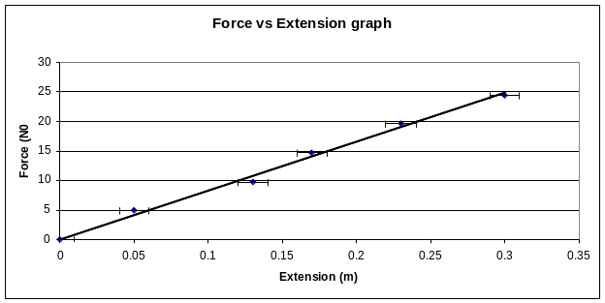
Alternatively the data in the table could be graphed with length of the spring on the y axis as the dependent variable and the number of masses attached on the x axis as the independent variable. In this instance the error bars would be vertical, but at a size of ± 0.5 cm will not be visible on the graph. To find the spring constant in N m⁻¹, the reciprocal of the gradient of this graph would be needed and then the units converted to N m⁻¹.
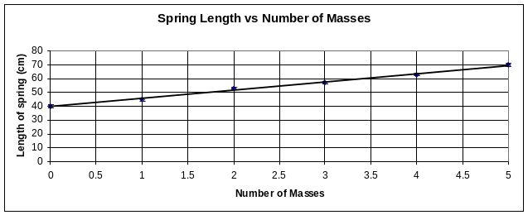
Note: The reference to a ruler with unusual graduated intervals of 5 cm suggests this is a badly designed question.
14b 82 ± 3 N m⁻¹ Spring constant is the gradient (1) and equals 82 (1). The steeper gradient could go through the left end of the top error bar, giving a gradient of 84.5, while the lower gradient could go through the right end of the same error bar gives a value of 79, so the uncertainty should be ± 3. (1)
Using the second graph, the gradient is about 6.0 cm/unit mass from (70 - 40)/5. With the uncertainty of 0.5 cm, the gradient ranges from (70.5 - 39.5)/5 to (69.5 - 40.5/5), which is from 5.8 to 6.2. To find the spring constant in N m⁻¹,
k = (1/6.0) [unit mass cm⁻¹ ] x 100 [cm m⁻¹] x 4.9 [N unit mass⁻¹] = 82 N m⁻¹. The values of 5.8 and 6.2 give an uncertainty of ± 3
14c 60 cm Let Δx be the maximum extension where the mass stops. Then the gain in spring PE equals the loss in grav PE, so ½kΔx² = mgΔx, and Δx =2mg/k (1)
Δx =2mg/k = 2 x 5 x 0.50 x 9.8 / 82 = 0.597 = 60cm. (1) Conseq on 14b
15a 2.2 x 10⁻⁵ s Time dilation, so the measured half life = t₀ γ = 2.2 x 10⁻⁶ x 10 (1) = 2.2 x 10⁻⁵ s (1)
15b 263 m As the speed of the muons are measured at 0.995 c, the value of γ should have been written as 10.0.
Length contraction, so the measured length = l/γ = 2627 / 10.0 (1)
measured length = 262.7 m = 263 m (1)
15c The speed of light is the same value in all inertial frames. (1) The consequence is that 'moving clocks' are observed to be running slower. In the muons' frame of reference, the half life is 2.2μs, but from the ground's frame of reference, the muons are moving at 0.995c and the effect of this is that the muons are taking longer to decay. (1) Consequently, there are more of them yet to decay, by the time they reach the ground.
16a 0.049 nm Using λ = h/p, and p = mv, λ = 6.63 x 10⁻³⁴ /(9.1 x 10⁻³¹ x 1.50 x 10⁷) (1)
λ = 4.86 x 10⁻¹¹ m = 0.0486 nm = 0.049 nm (1), as the mass is to 2 sig figs.
16b Increasing speed of the electrons will shorten their wavelength (1) . With a shorter wavelength there will be less spreading as the electrons are diffracted by the crystal. This means the diameter of the rings in the diffraction pattern will decrease (1).
16c 26 keV The wavelengths of the electron and the X-ray photon are the same and so are their momenta. The energy of the photon is given by E = hc/λ or E = pc. (1) The answer box specifies the unit of electron volts, so if the expression E = pc was used, which gives an answer in joules because p is the momentum of electron and of the photon in kg m s⁻¹ , the answer would then need to be converted to electron volts. Alternatively, the answer to 16a could be used with the 4.14 x 10⁻¹⁵ eV s value for h. So E = 4.14 x 10⁻¹⁵ x 3.0 x 10⁸ / (4.86 x 10⁻¹¹) (1)= 25571 eV = 26 keV. (1) Note the question says to three sig figs, but the speed of light in the formula sheet is specified to two sig figs, as is the mass of the electron. This indicates that the question is badly designed.
17a Electrons are ejected from the metal by the light with a range of energies up to a maximum value, which is set by the energy of the photons in the light and the Work Function of the metal. As the backing voltage is increased, that is, made more negative, electrons with low energy are repelled and do not reach the collector electrode, while more energetic electrons reach the collector electrode, travel through the circuit and are measured by the ammeter. (1) Eventually, as the backing voltage continues to increase, the most energetic electron fails to reach the electrode and the current reduces to zero. (1) This occurs when the backing voltage reaches the point X on the graph.
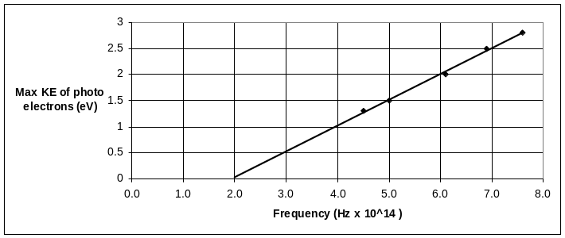
17b Correct plotting, (1), (1)
Line of best fit(1)
17c 4.9 x 10⁻¹⁵ eV s
Planck's Constant is the gradient. (1) Value = 4.9 x 10⁻¹⁵ eV s (1)
17d Dependent variable: Stopping voltage and the max KE of photoelectrons; (1)
Independent variables: Frequency (1)
17e Intensity of the light. (1) Increasing the intensity of the light increases the amount of energy hitting the metal surface every second. If one did not know the ultimate result of this experiment, it would be understandable to assume that the energy of the emitted photoelectrons would increase if more light energy was arriving at the metal surface. (1) It could also be argued from a merely experimental point of view, that if you wish to find out the effect of changing the frequency of the light, then any possible variable that might affect the energy would need to be kept constant as a controlled variable. This would also include the nature and shape of the metal surface.
17f i) Draw an error bar the same size on each of the other data points, (1) error bars correctly drawn (1) ii) Use the straight edge of a ruler to see if a straight line can be drawn through all five error bars. (1)
18a Young shone a beam of monochromatic light at a black slide that had two vertical openings. The openings were very narrow and very close together. He described the pattern of light that he observed on the screen on the other side of the black slide. (1)
He observed a pattern of bright and dark vertical lines, with a bright line in the centre of the pattern in line with the light source and a point on the slide between the vertical openings. (1) Young interpreted the bright and dark lines as evidence of interference due to light travelling by paths of different distances from the two vertical openings to a point on the screen. Interference is a phenomenon unique to waves. This experiment showed that light could behave as a wave. (1)
18b In a single photon Young's double slit experiment, the intensity of the light is reduced to such an extent that it can be calculated that there is only one photon of light in the apparatus at any one time. What is observed on the screen is a spot of light as each photon hits the screen. Each hit is discrete and at a specific point on the screen, although a seemingly random point for each photon. The fact that there is a specific point of impact means that the photon is behaving like a particle. (1) However over time the hits accumulate, and rather than there being random spread of hits, a pattern of hits emerges. The pattern is identical to the interference pattern that would have been produced if all the photons had been emitted at the same time. (1) This shows that the individual photon has wavelike properties as well. That is, the behaviour of individual discrete photons is modified by the existence of the double slit. (1)
18c Note: Einstein did not conduct photoelectric experiments. He did not draw conclusion from the experiments, rather he proposed an explanations for the results. His explanation was based on three assumptions:
- Light not only transfers energy to matter in small packets, but travels through space as a packet of energy, later to be called a photon. The energy of a photon is given by the relationship E = hf. (1)
- Each photon of light gives all of its energy to one single electron. (1)
- There is a minimum amount of energy that an electron must lose in order to escape the metal surface. This minimum energy is called Work Function and the maximum kinetic energy of an emitted photoelectron = the Photon energy - Work Function. E_{K} = hf - φ. (1)
The evidence is: (1)
- the max E_{K} depends on the frequency,
- the max E_{K} is independent of the intensity,
- there is no time delay between the arrival of the light at the metal surface and the emission of photoelectrons, even for low intensity light.
The wave model predicted that: (1)
- max E_{K} would increase with greater intensity because of the larger amplitude of the wave.
- there would be minimal dependence on frequency or wavelength as the energy of a wave is mostly in the amplitude.
- there would be a time delay for low intensity light as the energy from small amplitude waves would take some time to accumulate before an electron had enough energy to leave the surface.

