IARTV | 2003 | Biology | Solutions

Section A – Multiple choice questions (25 marks)

- A
- D
- C
- B
- C
- B
- D
- A
- C
- B
- C
- B
- D
- D
- A
- B
- B
- D
- C
- A
- A
- B
- D
- C
- A

Section B – Short answer questions (50 marks)

Question 1 (9 marks)
- (i) meiosis (½ mark)
(ii) Any two of:
  - pairing up of homologous chromosomes in B
  - 2 cell divisions
  - 4 daughter cells produced in D (2 marks)
(iii) testes (½ mark)
- (i) 6 (½ mark)
(ii) Two of each type of chromosome or 2 sets of chromosomes (½ mark)
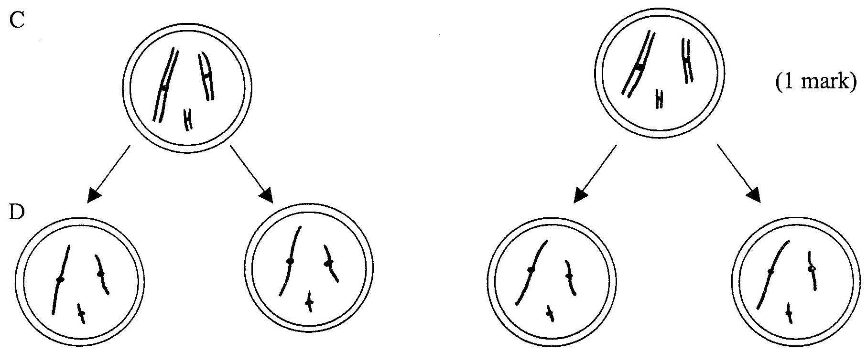 (1 mark)
- To produce haploid gametes (sex cells) with half the chromosome number for sexual reproduction. (1 mark)
- (1) Crossing-over and recombination (½ mark) in which the two inner chromatids of a pair of homologous chromosomes intertwine, break and rejoin. (½ mark)
(2) Independent assortment (½ mark) in which pairs of homologous chromosomes line up at random across the equator at Metaphase. (½ mark)

Question 2 (6 marks)
- Sex-linked recessive. (1 mark)
Sex-linked as individual (13) has inherited the defective allele from his carrier mother (6) (1 mark)
Recessive as in generations I and II, unaffected parents produce an affected child. (1 mark)
- No chance because father (7) is X^{D}Y so his daughter inherits the X^{d} allele therefore would not show the trait. (1 mark)
- Yes, as there is a 50% chance she is a carrier. (1 mark)
- 1, 6. (1 mark)

Question 3 (4 marks)
- (i) 44 chromosomes (½ mark)
(ii) 31 chromosomes (½ mark)
- (i) 53 chromosomes (½ mark)
(ii) The chromosomes in the resulting zebronkey are not homologous (½ mark)
so they cannot pair up during meiosis (½ mark)
Therefore no gametes can be produced. (½ mark)
- (i) Any one of:
  - different breeding seasons (temporal isolation)
  - different mating calls/dances (behavioural isolation)
  - different niches in the same geographical area (ecological isolation)
  - no viable gametes (reproductive isolation)
or any other reasonable suggestion (½ mark)
(ii) One example in nature that relates to (i)
For example – different mating calls in frogs
– different breeding seasons of parrots
– different courtship dances of birds
– no gametes in sterile mule etc. (½ mark)
Question 4 (8 marks)
- K – phosphate group L – deoxyribose sugar M – cytosine N – adenine ( 4 × ½ = 2 marks)
- (i) Tryptophane/Glycine/Lysine/Valine/Glycine (1 mark)
(ii) Substitution. (1 mark)
(iii) One different amino acid in polypeptide. (½ mark)
Serine replaces the first glycine (½ mark)
- (i) W – Deoxyribonucleic acid or DNA. (½ mark)
(ii) X – Restriction enzymes or restriction endonucleases (½ mark)
(iii) Y – DNA ligase (½ mark)
(iv) A – TTA (½ mark)
(v) If there are “sticky ends”, overlapping complementary bases can pair up readily to hold the two DNA strands together. (1 mark) (Note: The DNA has only one way in which it will fit into the plasmid therefore with “sticky ends” it has the correct orientation for the sense strand.)

Question 5 (8 marks)
- (i) linked genes (1 mark)
(ii) locus (1 mark)
- I^{A}I^{B} 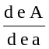 (1 mark for correct alleles; 1 mark for correct notation)
- Loci El and AMY (1 mark)
As they are linked on the same chromosome, so crossing over is possible (½ mark)
And they are the furthest apart of the loci shown, so there is a greater chance of a cross-over between them. (½ mark)
- I^{A}I^{B}ee × iiEe (½ mark)
 | I^{A}e | I^{B}e
iE | I^{A}iEe | I^{B}iEe | (1 mark)
ie | I^{A}iee | I^{B}iee
¼ chance of blood group A with round red blood cells (½ mark)

Question 6 (9 marks)
- Same species – similar organisms which can interbreed under natural conditions to produce vigorous fertile offspring. (1 mark)
- (i) Natural selection. (1 mark)
(ii) On Franklin island –
  - There was variation in the sizes of the snakes in the original population. (½ mark)
  - There were larger prey animals present for food (½ mark) therefore those larger snakes which could consume them survived and were more likely to reproduce laving more fertile offspring than the smaller snakes (1 mark)
  - Offspring of larger snakes inherit genes for larger size, so over generations (time) the percentage of larger snakes on the island increased. (1 mark)
- (i) (1) isolation (1 mark)
and one of
(2) Variation in the size of the snakes in the original population
or Different size of food which is the selective pressure (1 mark)
(ii) Divergent evolution. (1 mark)
As several new species have evolved from one common ancestral species. (1 mark)

Question 7 (6 marks)
- Any two of –
  - position of foramen magnum is further forward
  - S-shaped spine with forward curvature
  - thigh bone is angled outwards from the knee
  - increased carrying angle so knees are well under the body during walking
or any other reasonable suggestion (2 × 1= 2 marks)
- Any two of –
  - free hands for carrying, using weapons, making tools etc.
  - more efficient locomotion for low speed, long distance movement by walking
  - seeing above grass to detect predators or locate food
or any other reasonable suggestion (2 × 1= 2 marks)
- Any two of –
  - rapid sedimentation
  - low oxygen
  - low acidity
or any other reasonable suggestion (2 × 1= 2 marks)

